Additional information
Indole-carbohydrazide linked phenoxy-1,2,3-triazole-N-phenylacetamide derivatives as potent α-glucosidase inhibitors: Design, synthesis, in vitro α-glucosidase inhibition, and computational studies
Mehdi Emadi¹, Fahimeh Mosavizadeh-Marvest², Ali Asadipour², Yaghoub Pourshojaei^{2, 3}*, Samanesadat Hosseini⁴, Somayeh Mojtabavi⁵, Mohammad Ali Faramarzi⁵, Bagher Larijani⁶, Maryam Mohammadi-Khanaposhtani⁷, Mohammad Mahdavi⁶*
¹Electrical and Computer Engineering Department, Babol Noshirvani University of Technology, Babol, Iran. ²Department of Medicinal Chemistry, Faculty of Pharmacy, Kerman University of Medical Sciences, Kerman, Iran. ³Extremophile and Productive Microorganisms Research Center, Kerman University of Medical Sciences, Kerman, Iran.⁴Shahid Beheshti University of Medical Sciences, Tehran, Iran. ⁵Department of Pharmaceutical Biotechnology, Faculty of Pharmacy, Tehran University of Medical Sciences, Tehran, Iran. ⁶Endocrinology and Metabolism Research Center, Endocrinology and Metabolism Clinical Sciences Institute, Tehran University of Medical Sciences, Tehran, Iran. ⁷Cellular and Molecular Biology Research Center, Health Research Institute, Babol University of Medical Sciences, Babol, Iran.
*Correspondences:
pourshojaei@yahoo.com
Department of Medicinal Chemistry, Faculty of Pharmacy, Kerman University of Medical Sciences, Kerman, Iran, and Extremophile and Productive Microorganisms Research Center, Kerman University of Medical Sciences, Kerman, Iran.
momahdavi@tums.ac.ir
Endocrinology and Metabolism Research Center, Endocrinology and Metabolism Clinical Sciences Institute, Tehran University of Medical Sciences, Tehran, Iran.

(E)-2-(4-((4-((2-(1H-indole-2-carbonyl)hydrazono)methyl)phenoxy)methyl)-1H-1,2,3-triazol-1-yl)-N-phenylacetamide (11a)

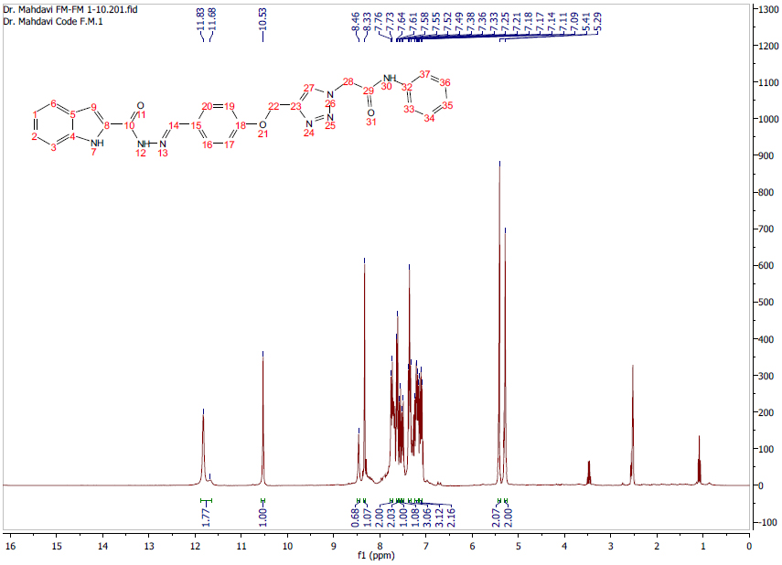
Fig. S1. ¹H NMR spectrum of product 11a

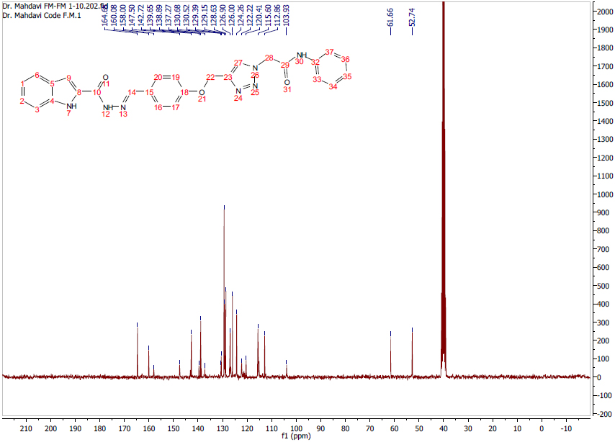
Fig. S2. ¹³CNMR spectrum of product 11a
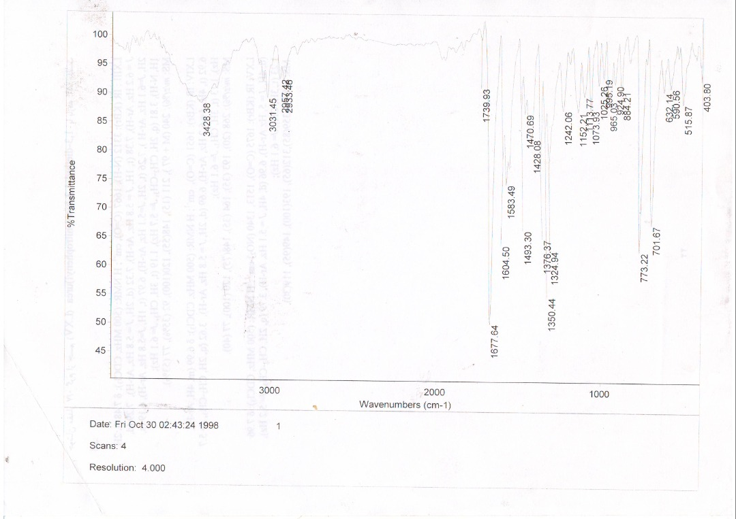
Fig. S3. IR spectrum of product 11a

(E)-2-(4-((4-((2-(1H-indole-2-carbonyl)hydrazono)methyl)phenoxy)methyl)-1H-1,2,3-triazol-1-yl)-N-(o-tolyl)acetamide (11b)

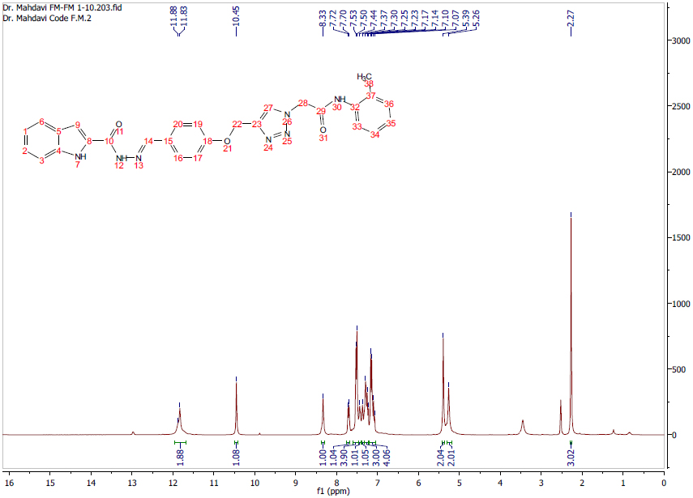
Fig. S4. ¹H NMR spectrum of product 11b

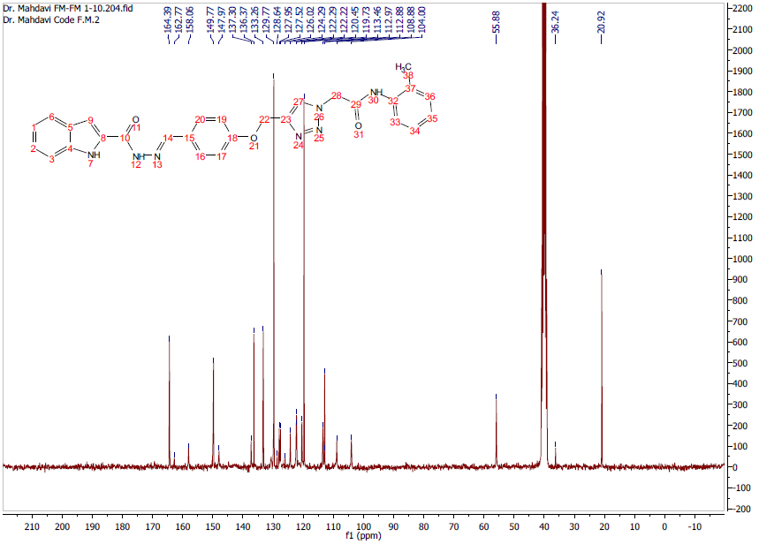
Fig. S5. ¹³CNMR spectrum of product 11b

(E)-2-(4-((4-((2-(1H-indole-2-carbonyl)hydrazono)methyl)phenoxy)methyl)-1H-1,2,3-triazol-1-yl)-N-(p-tolyl)acetamide (11c)

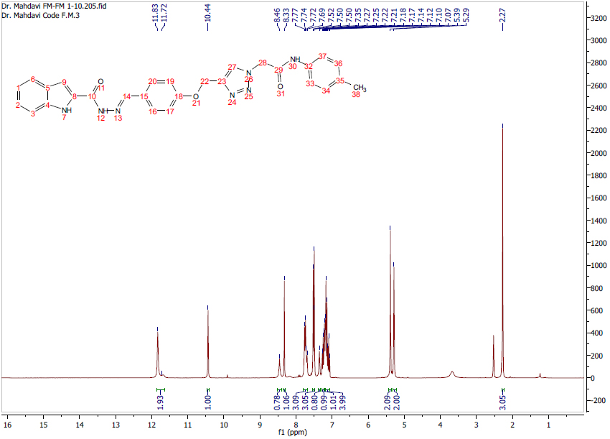
Fig. S6. ¹H NMR spectrum of product 11c

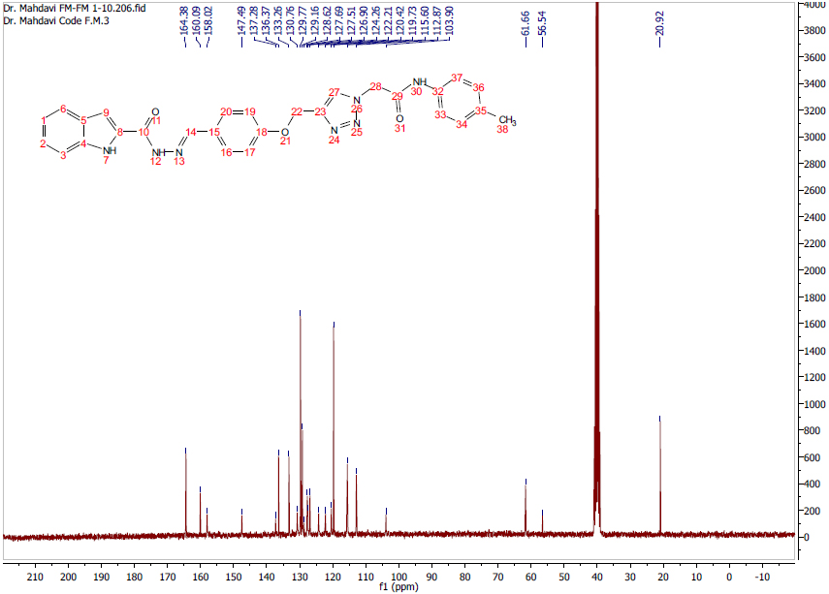
Fig. S7. ¹³CNMR spectrum of product 11c

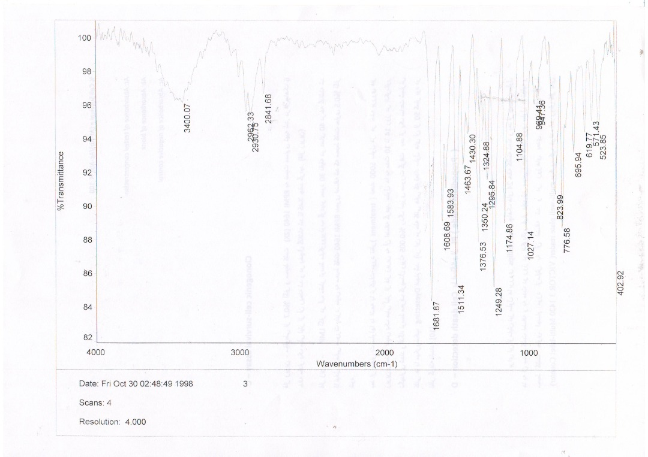
Fig. S8. IR spectrum of product 11c

(E)-2-(4-((4-((2-(1H-indole-2-carbonyl)hydrazono)methyl)phenoxy)methyl)-1H-1,2,3-triazol-1-yl)-N-(4-methoxyphenyl)acetamide (11d)

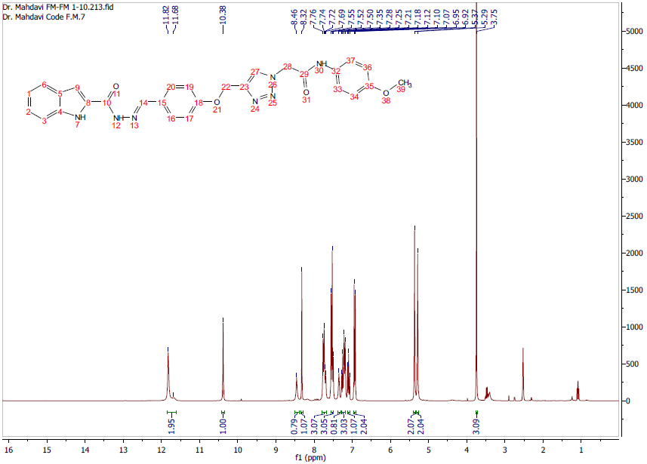
Fig. S9. ¹H NMR spectrum of product 11d

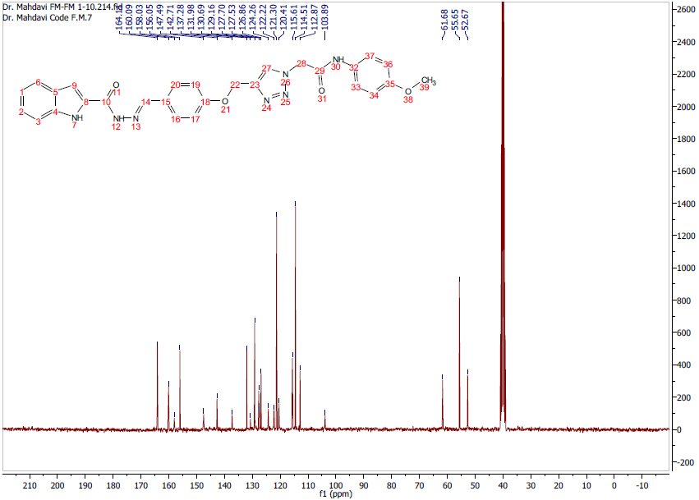
Fig. S10. ¹³CNMR spectrum of product 11d

(E)-2-(4-((4-((2-(1H-indole-2-carbonyl)hydrazono)methyl)phenoxy)methyl)-1H-1,2,3-triazol-1-yl)-N-(2-chlorophenyl)acetamide (11e)

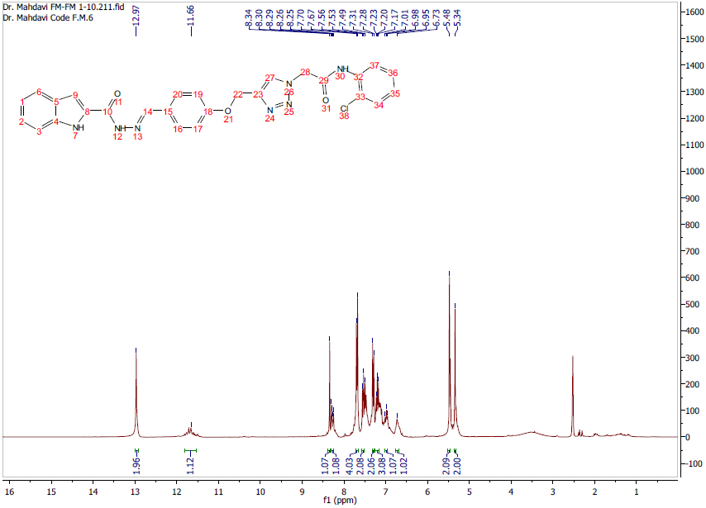
Fig. S11. ¹H NMR spectrum of product 11e

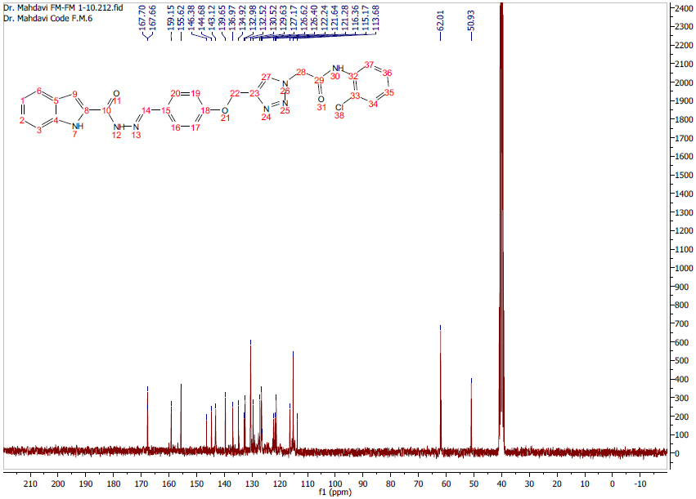
Fig. S12. ¹³CNMR spectrum of product 11e

(E)-2-(4-((4-((2-(1H-indole-2-carbonyl)hydrazono)methyl)phenoxy)methyl)-1H-1,2,3-triazol-1-yl)-N-(4-chlorophenyl)acetamide (11f)

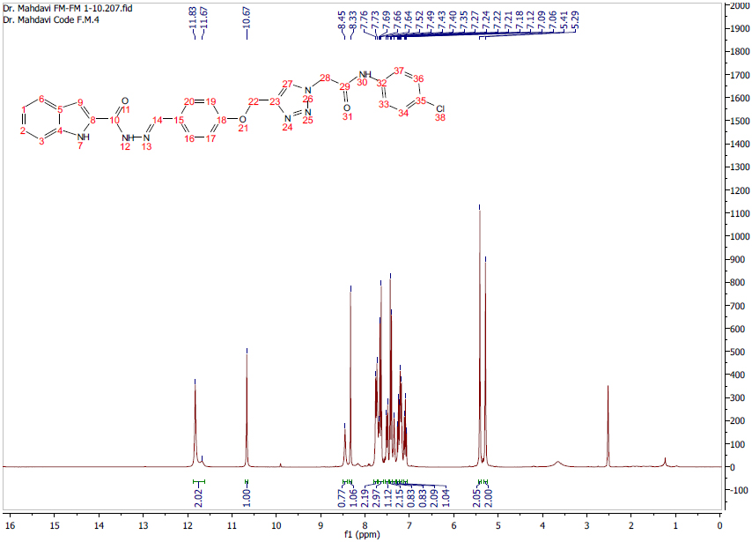
Fig. S13. ¹H NMR spectrum of product 11f

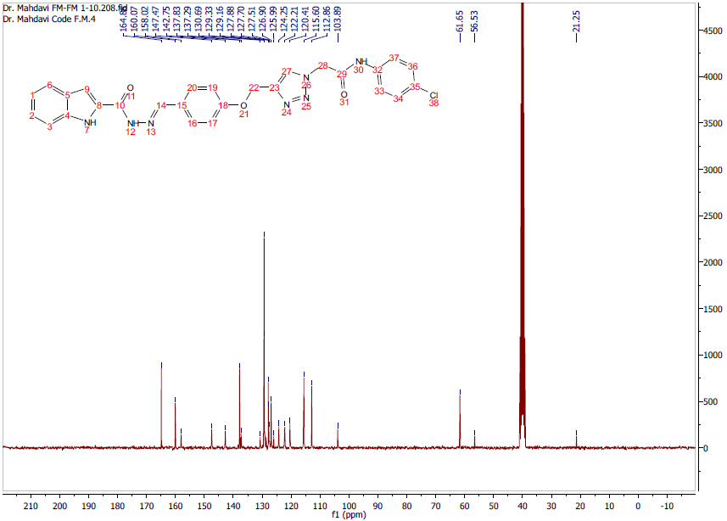
Fig. S14. ¹³CNMR spectrum of product 11f

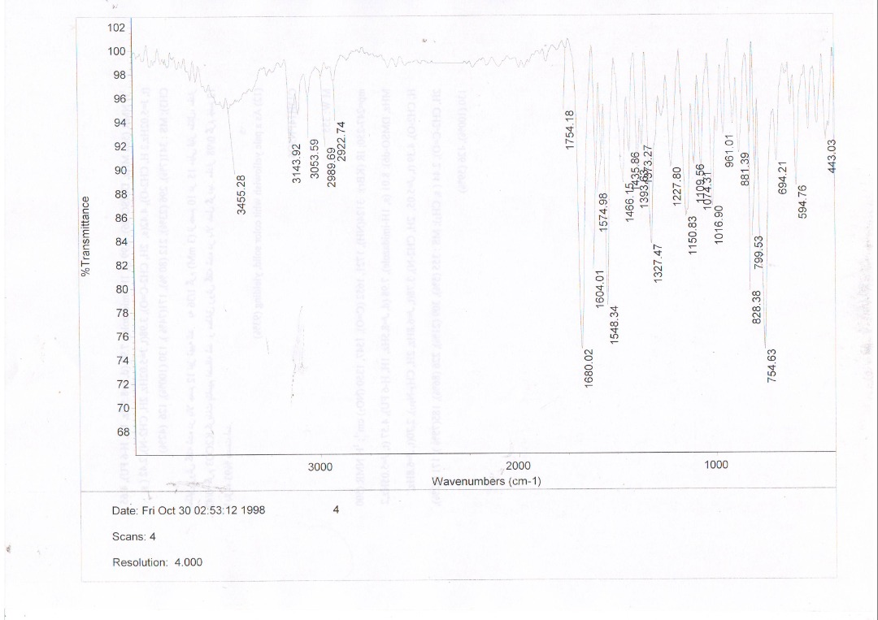
Fig. S15. IR spectrum of product 11f

(E)-2-(4-((4-((2-(1H-indole-2-carbonyl)hydrazono)methyl)phenoxy)methyl)-1H-1,2,3-triazol-1-yl)-N-(4-bromophenyl)acetamide (11g)

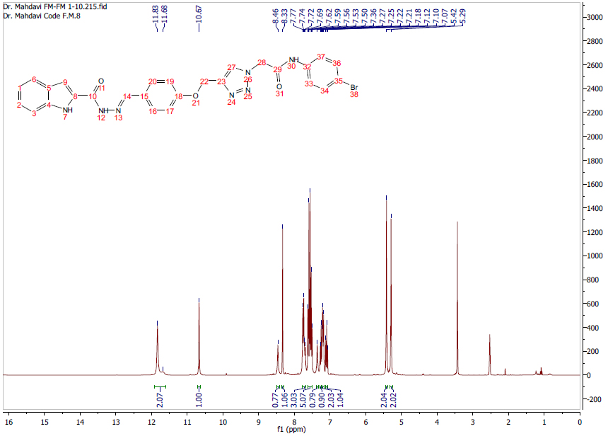
Fig. S16. ¹H NMR spectrum of product 11g

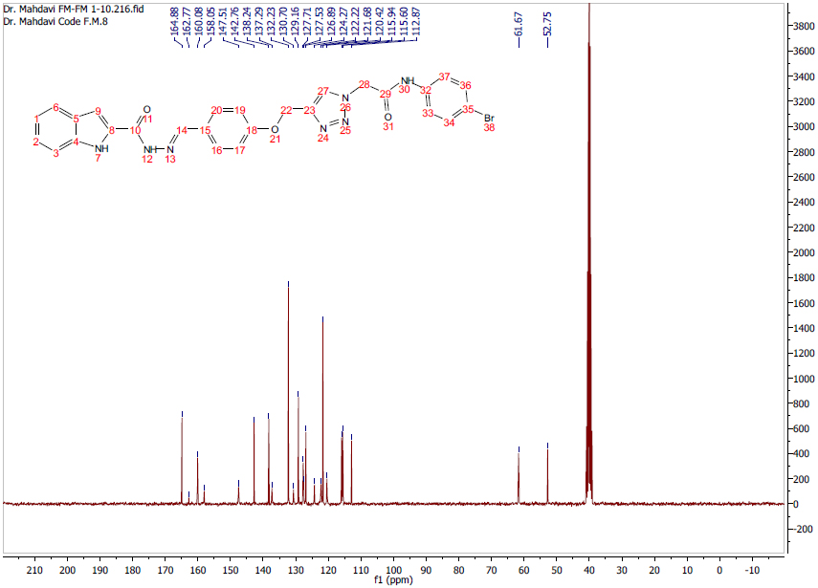
Fig. S17. ¹³CNMR spectrum of product 11g

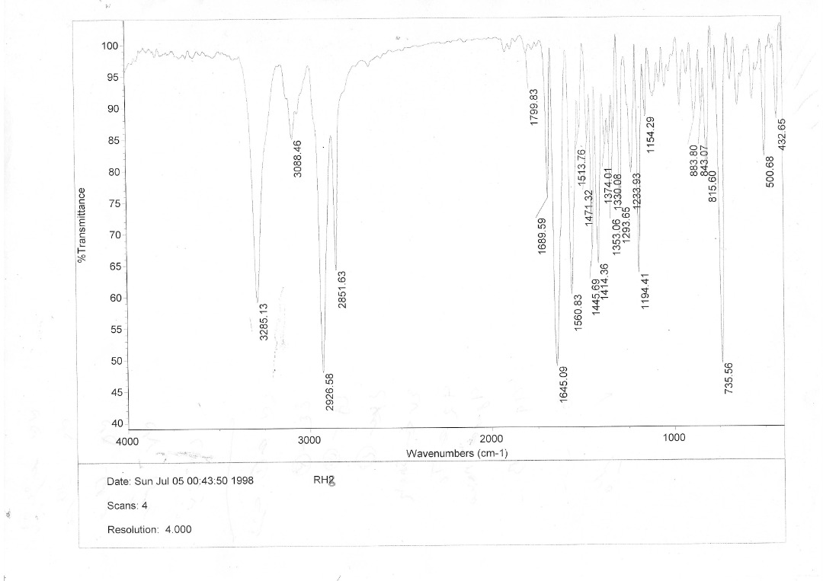
Fig. S18. IR spectrum of product 11g

(E)-2-(4-((4-((2-(1H-indole-2-carbonyl)hydrazono)methyl)phenoxy)methyl)-1H-1,2,3-triazol-1-yl)-N-(3-methyl-4-nitrophenyl)acetamide (11h)

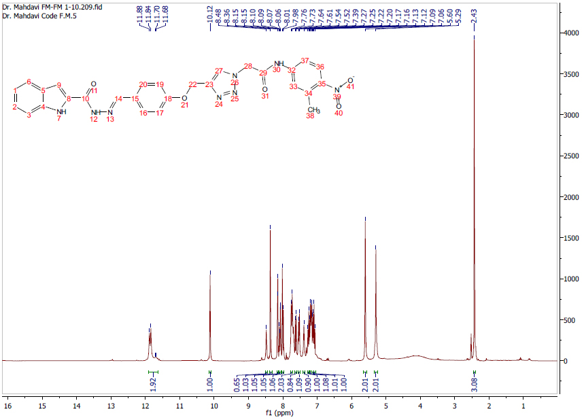
Fig. S19. ¹H NMR spectrum of product 11h

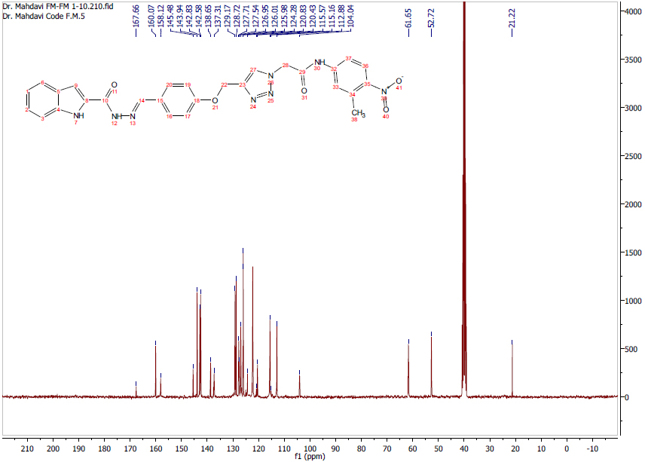
Fig. S20. ¹³CNMR spectrum of product 11h

(E)-2-(4-((4-((2-(1H-indole-2-carbonyl)hydrazono)methyl)-2-methoxyphenoxy)methyl)-1H-1,2,3-triazol-1-yl)-N-phenylacetamide (11i)

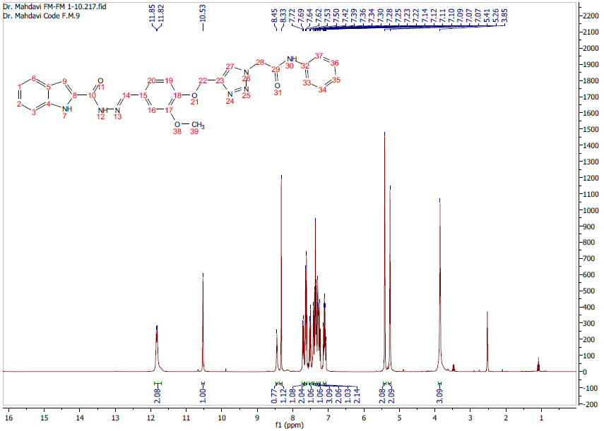
Fig. S21. ¹H NMR spectrum of product 11i

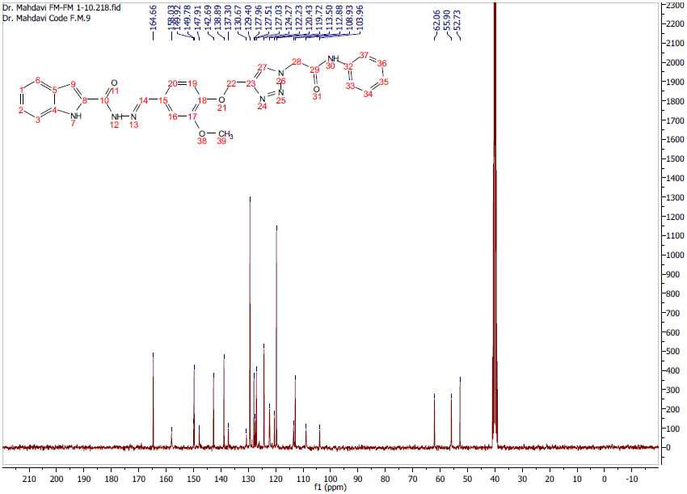
Fig. S22. ¹³CNMR spectrum of product 11i

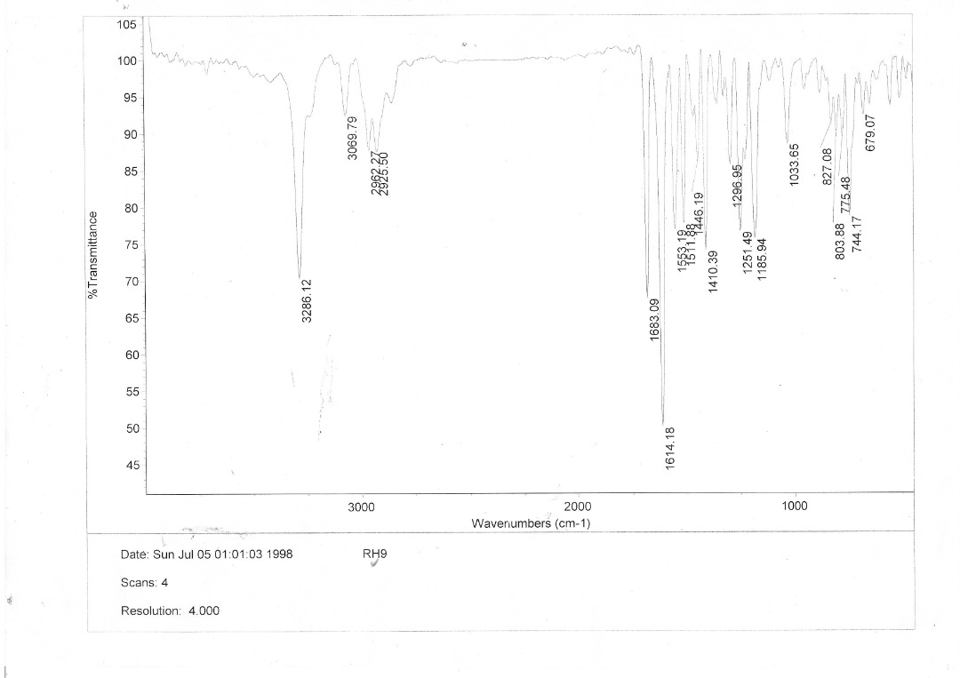
Fig. S23. IR spectrum of product 11i

(E)-2-(4-((4-((2-(1H-indole-2-carbonyl)hydrazono)methyl)-2-methoxyphenoxy)methyl)-1H-1,2,3-triazol-1-yl)-N-(4-methoxyphenyl)acetamide (11j)

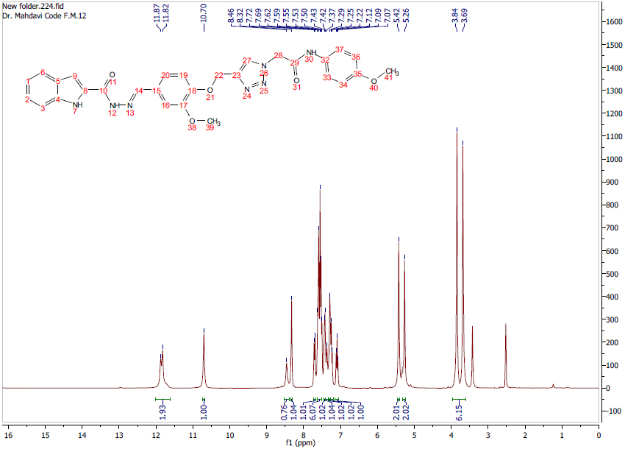
Fig. S24. ¹H NMR spectrum of product 11j

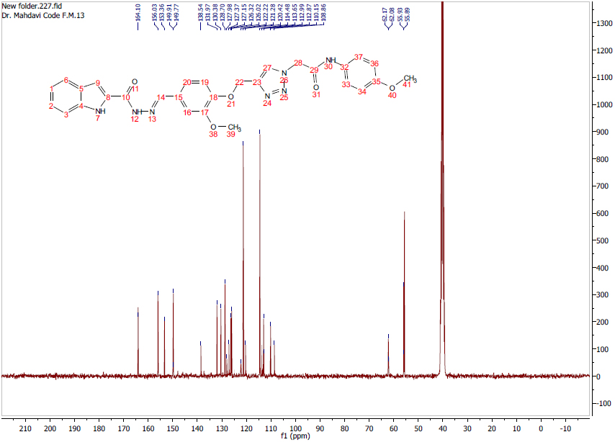
Fig. S25. ¹³CNMR spectrum of product 11j

(E)-2-(4-((4-((2-(1H-indole-2-carbonyl)hydrazono)methyl)-2-methoxyphenoxy)methyl)-1H-1,2,3-triazol-1-yl)-N-(4-chlorophenyl)acetamide (11k)

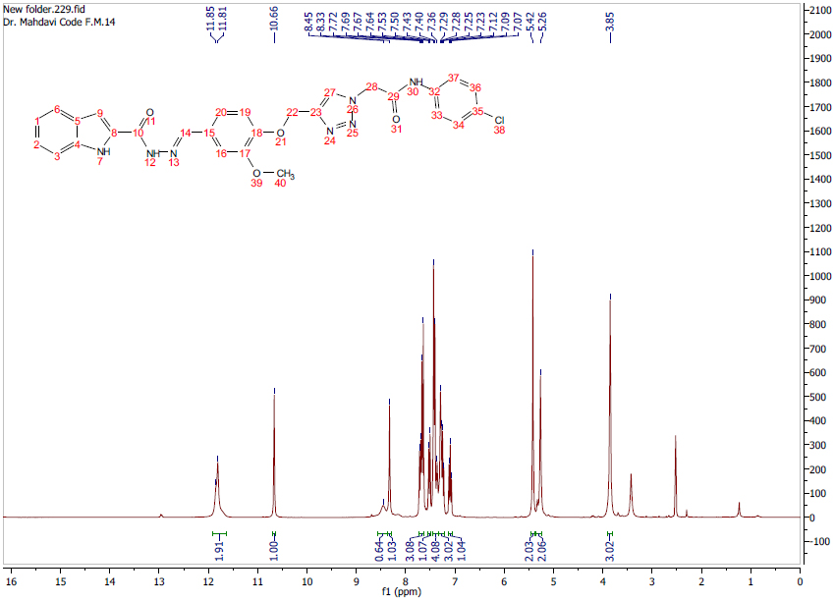
Fig. S26. ¹H NMR spectrum of product 11k

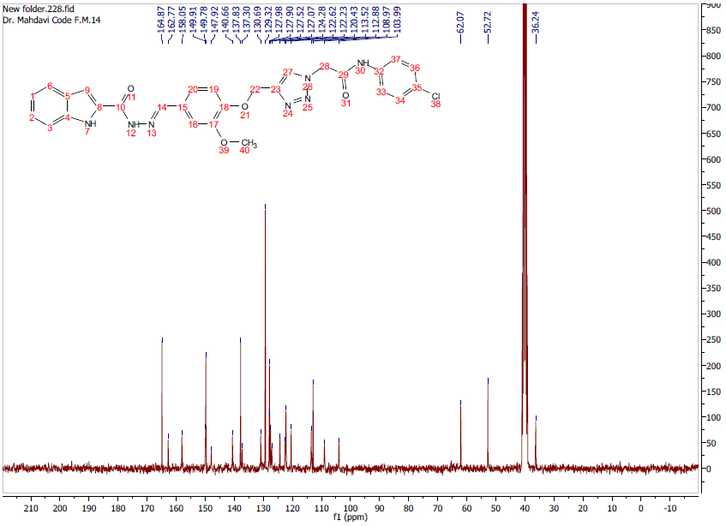
Fig. S27. ¹³CNMR spectrum of product 11k

(E)-2-(4-((4-((2-(1H-indole-2-carbonyl)hydrazono)methyl)-2-methoxyphenoxy)methyl)-1H-1,2,3-triazol-1-yl)-N-(2,3-dichlorophenyl)acetamide (11l)

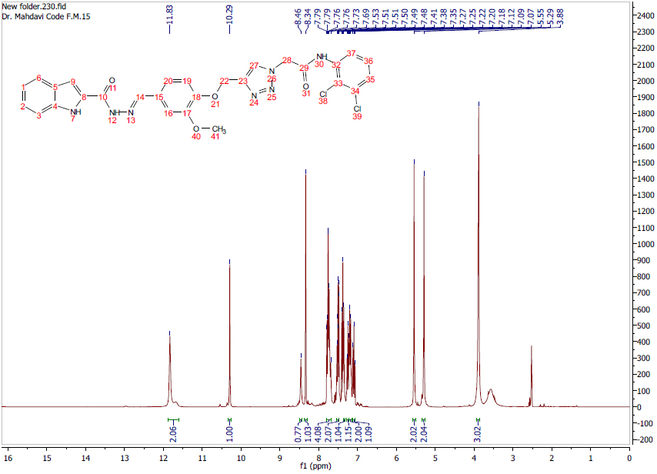
Fig. S28. ¹H NMR spectrum of product 11l

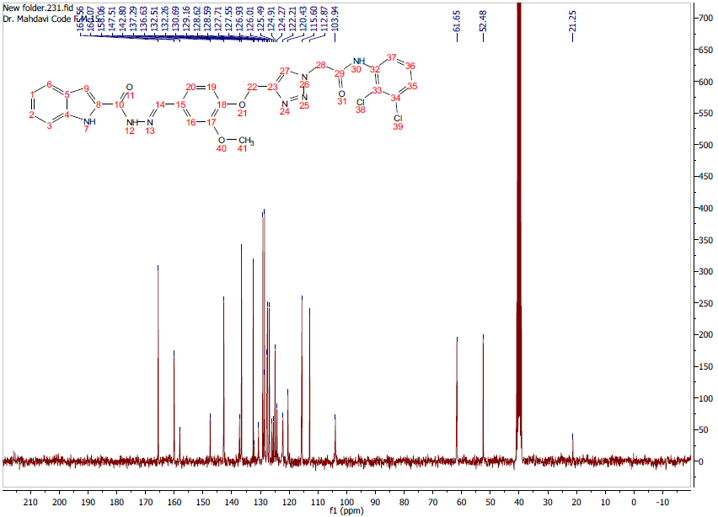
Fig. S29. ¹³CNMR spectrum of product 11l

(E)-2-(4-((4-((2-(1H-indole-2-carbonyl)hydrazono)methyl)-2-methoxyphenoxy)methyl)-1H-1,2,3-triazol-1-yl)-N-(3,5-dichlorophenyl)acetamide (11m)

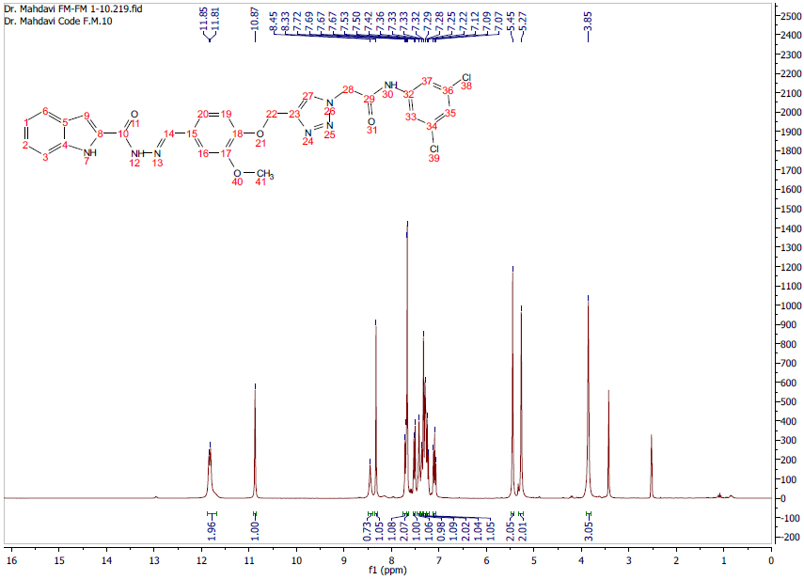
Fig. S30. ¹H NMR spectrum of product 11m

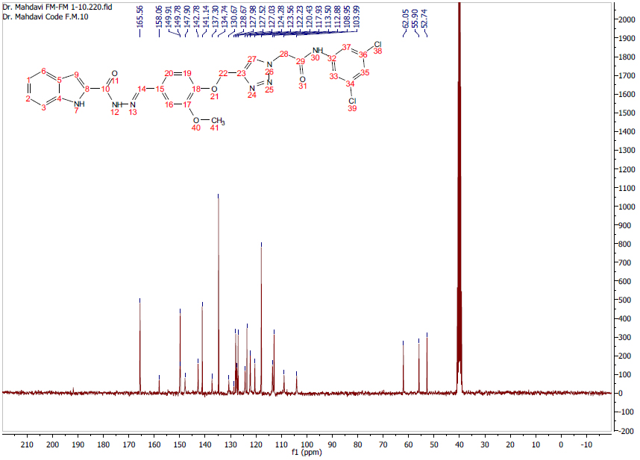
Fig. S31. ¹³CNMR spectrum of product 11m

(E)-2-(4-((4-((2-(1H-indole-2-carbonyl)hydrazono)methyl)-2-methoxyphenoxy)methyl)-1H-1,2,3-triazol-1-yl)-N-(4-bromophenyl)acetamide (11n)

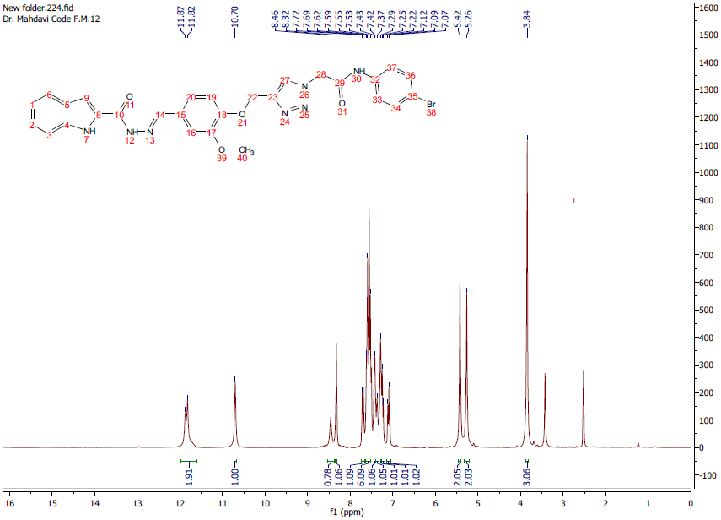
Fig. S32. ¹H NMR spectrum of product 11n

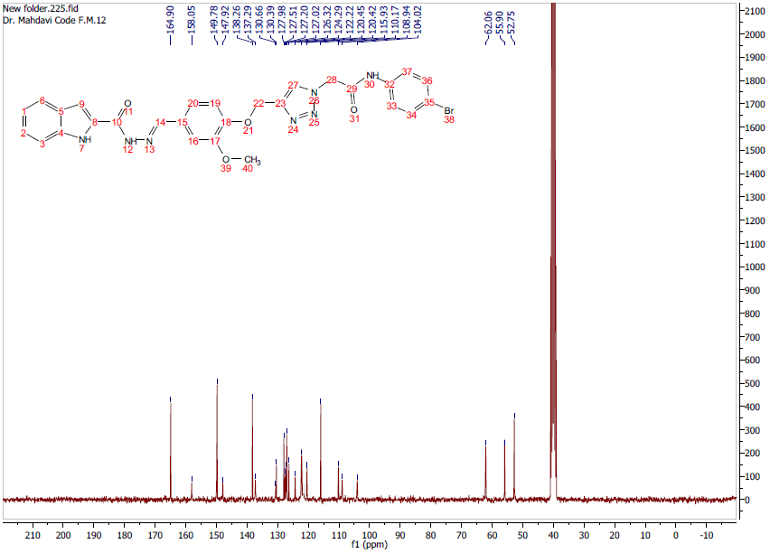
Fig. S33. ¹³CNMR spectrum of product 11n

(E)-2-(4-((4-((2-(1H-indole-2-carbonyl)hydrazono)methyl)-2-methoxyphenoxy)methyl)-1H-1,2,3-triazol-1-yl)-N-(2-chloro-3-nitrophenyl)acetamide (11o)

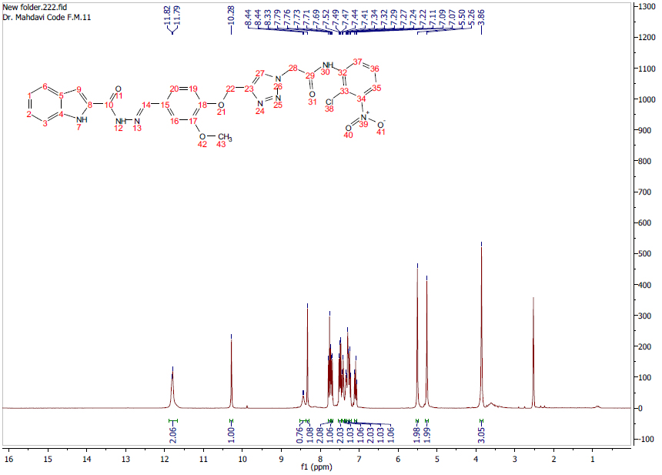
Fig. S34. ¹H NMR spectrum of product 11o

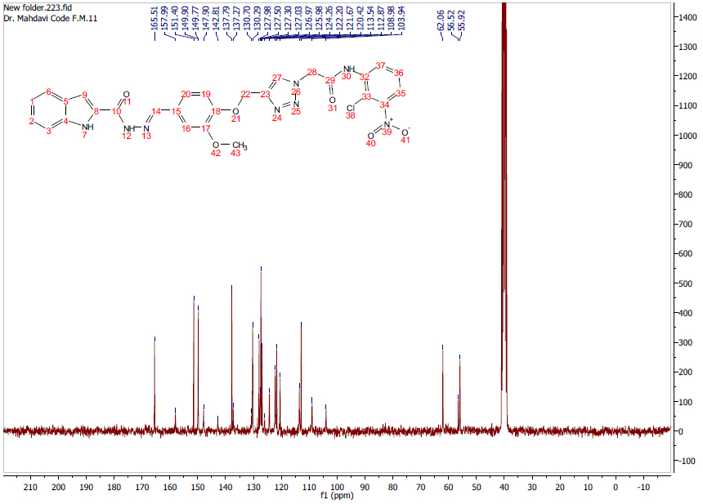
Fig. S35. ¹³CNMR spectrum of product 11o

