Supplementary data
Chalcone/1,3,4-Oxadiazole/Benzimidazole Hybrids as Novel Anti-proliferative Agents Inducing Apoptosis and Inhibiting EGFR & BRAFV^{600E}
Fatma Hagar¹ | Samar Abbas¹ | Hesham Gomaa² | Bahaa Youssif³ | Ahmed Sayed⁴ | Dalia Abdelhamid*¹ | Mohamed Abdel-Aziz¹
¹ Medicinal Chemistry Department, Faculty of Pharmacy, Minia University, Minia, Egypt
² Pharmacology Department, College of Pharmacy, Jouf University, Sakaka, Saudi Arabia
³ Pharmaceutical Organic Chemistry Department, Faculty of Pharmacy, Assiut University, Assiut, Egypt
⁴ Pharmacognosy Department, Faculty of Pharmacy, Nahda University, Benisuef, Egypt
* Corresponding Author:
Dalia Abdelhamid; e-mail: daliaa_abdelhameed@mu.edu.eg

Fig. No. |  | Page No.
S1 | ¹H NMR of compound 7a (500 MHz, DMSO-d₆) | 6
S2 | ¹³C NMR of compound 7a (125 MHz, DMSO-d₆) | 7
S3 | HRMS (ESI) spectrum of compound 7a. | 7
S4 | ¹H NMR of compound 7b (500 MHz, DMSO-d₆) | 8
S5 | ¹³C NMR of compound 7b (125 MHz, DMSO-d₆) | 9
S6 | HRMS (ESI) spectrum of compound 7b. | 9
S7 | ¹H NMR of compound 7c (500 MHz, DMSO-d₆) | 10
S8 | ¹³C NMR of compound 7c (125 MHz, DMSO-d₆) | 11
S9 | HRMS (ESI) spectrum of compound 7c. | 11
S 10 | ¹H NMR of compound 7d (500 MHz, DMSO-d₆) | 12
S 11 | ¹³C NMR of compound 7d (125 MHz, DMSO-d₆) | 13
S 12 | HRMS (ESI) spectrum of compound 7d. | 13
S 13 | ¹H NMR of compound 7e (500 MHz, DMSO-d₆) | 14
S 14 | ¹³C NMR of compound 7e (125 MHz, DMSO-d₆) | 15
S 15 | HRMS (ESI) spectrum of compound 7e. | 15
S 16 | ¹H NMR of compound 7f (500 MHz, DMSO-d₆) | 16
S 17 | ¹³C NMR of compound 7f (125 MHz, DMSO-d₆) | 17
S 18 | HRMS (ESI) spectrum of compound 7f. | 17
S 19 | ¹H NMR of compound 7g (500 MHz, DMSO-d₆) | 18
S 20 | ¹³C NMR of compound 7g (125 MHz, DMSO-d₆) | 19
S 21 | ¹H NMR of compound 7h (500 MHz, DMSO-d₆) | 20
S 22 | ¹³C NMR of compound 7h (125 MHz, DMSO-d₆) | 21
S 23 | ¹H NMR of compound 7i (500 MHz, DMSO-d₆) | 22
S 24 | ¹³C NMR of compound 7i (125 MHz, DMSO-d₆) | 23
S 25 | ¹H NMR of compound 7j (500 MHz, DMSO-d₆) | 24
S 26 | ¹³C NMR of compound 7j (125 MHz, DMSO-d₆) | 25
S 27 | ¹H NMR of compound 7k (500 MHz, DMSO-d₆) | 26
S 28 | ¹³C NMR of compound 7k (125 MHz, DMSO-d₆) | 27
S 29 | HRMS (ESI) spectrum of compound 7k. | 27
S 30 | ¹H NMR of compound 7l (500 MHz, DMSO-d₆) | 28
S 31 | ¹³C NMR of compound 7l (125 MHz, DMSO-d₆) | 29
S 32 | ¹H NMR of compound 7m (500 MHz, DMSO-d₆) | 30
S 33 | ¹³C NMR of compound 7m (125 MHz, DMSO-d₆) | 31
S 34 | HRMS (ESI) spectrum of compound 7m. | 31
S 35 | ¹H NMR of compound 7n (500 MHz, DMSO-d₆) | 32
S 36 | ¹³C NMR of compound 7n (125 MHz, DMSO-d₆) | 33
S 37 | ¹H NMR of compound 7o (500 MHz, DMSO-d₆) | 34
S 38 | ¹³C NMR of compound 7o (125 MHz, DMSO-d₆) | 35
S 39 | HRMS (ESI) spectrum of compound 7o. | 35
S 40 | ¹H NMR of compound 7p (500 MHz, DMSO-d₆) | 36
S 41 | ¹³C NMR of compound 7p (125 MHz, DMSO-d₆) | 37
S 42 | HRMS (ESI) spectrum of compound 7p. | 37
S 43 | ¹H NMR of compound 7q (500 MHz, DMSO-d₆) | 38
S 44 | ¹³C NMR of compound 7q (125 MHz, DMSO-d₆) | 39
S 45 | HRMS (ESI) spectrum of compound 7q. | 39
S 46 | ¹H NMR of compound 7r (500 MHz, DMSO-d₆) | 40
S 47 | ¹³C NMR of compound 7r (125 MHz, DMSO-d₆) | 41
S 48 | ¹H NMR of compound 7s (500 MHz, DMSO-d₆) | 42
S 49 | ¹³C NMR of compound 7s (125 MHz, DMSO-d₆) | 43
S 50 | HRMS (ESI) spectrum of compound 7s. | 43
S 51 | ¹H NMR of compound 7t (500 MHz, DMSO-d₆) | 44
S 52 | ¹³C NMR of compound 7t (125 MHz, DMSO-d₆) | 45
S 53 | HRMS (ESI) spectrum of compound 7t. | 45
S 54 | ¹H NMR of compound 7u (500 MHz, DMSO-d₆) | 46
S 55 | ¹³C NMR of compound 7u (125 MHz, DMSO-d₆) | 47
S 56 | ¹H NMR of compound 7v (500 MHz, DMSO-d₆) | 48
S 57 | ¹³C NMR of compound 7v (125 MHz, DMSO-d₆) | 49
S 58 | HRMS (ESI) spectrum of compound 7v. | 49
S 59 | ¹H NMR of compound 7w (500 MHz, DMSO-d₆) | 50
S 60 | ¹³C NMR of compound 7w (125 MHz, DMSO-d₆) | 51
S 61 | HRMS (ESI) spectrum of compound 7w. | 51
S 62 | ¹H NMR of compound 7x (500 MHz, DMSO-d₆) | 52
S 63 | ¹³C NMR of compound 7x (125 MHz, DMSO-d₆) | 53
S 64 | One dose mean graph of nine different cancer cell line panels for compound 7a | 54
S 65 | One dose mean graph of nine different cancer cell line panels for compound 7b | 55
S 66 | One dose mean graph of nine different cancer cell line panels for compound 7c | 56
S 67 | One dose mean graph of nine different cancer cell line panels for compound 7d | 57
S 68 | One dose mean graph of nine different cancer cell line panels for compound 7e | 58
S 69 | One dose mean graph of nine different cancer cell line panels for compound 7f | 59
S 70 | One dose mean graph of nine different cancer cell line panels for compound 7g | 60
S 71 | One dose mean graph of nine different cancer cell line panels for compound 7h | 61
S 72 | One dose mean graph of nine different cancer cell line panels for compound 7k | 62
S 73 | One dose mean graph of nine different cancer cell line panels for compound 7l | 63
S 74 | One dose mean graph of nine different cancer cell line panels for compound 7m | 64
S 75 | One dose mean graph of nine different cancer cell line panels for compound 7n | 65
S 76 | One dose mean graph of nine different cancer cell line panels for compound 70 | 66
S 77 | One dose mean graph of nine different cancer cell line panels for compound 7p | 67
S 78 | One dose mean graph of nine different cancer cell line panels for compound 7q | 68
S 79 | One dose mean graph of nine different cancer cell line panels for compound 7r | 69
S 80 | One dose mean graph of nine different cancer cell line panels for compound 7u | 70
S 81 | One dose mean graph of nine different cancer cell line panels for compound 7v | 71
 | List of Tables

Table NO |  |  | Page NO
1  2 | Table S1. Cell growth inhibition % from the NCI's in vitro human tumor cell screen for compounds 7a:7e and 7k:7o.  Table S2. Cell growth inhibition % from the NCI's in vitro human tumor cell screen for compounds 7p, 7q, 7r, 7u, 7v and 7f to 7h. |  | 72-75  76-78
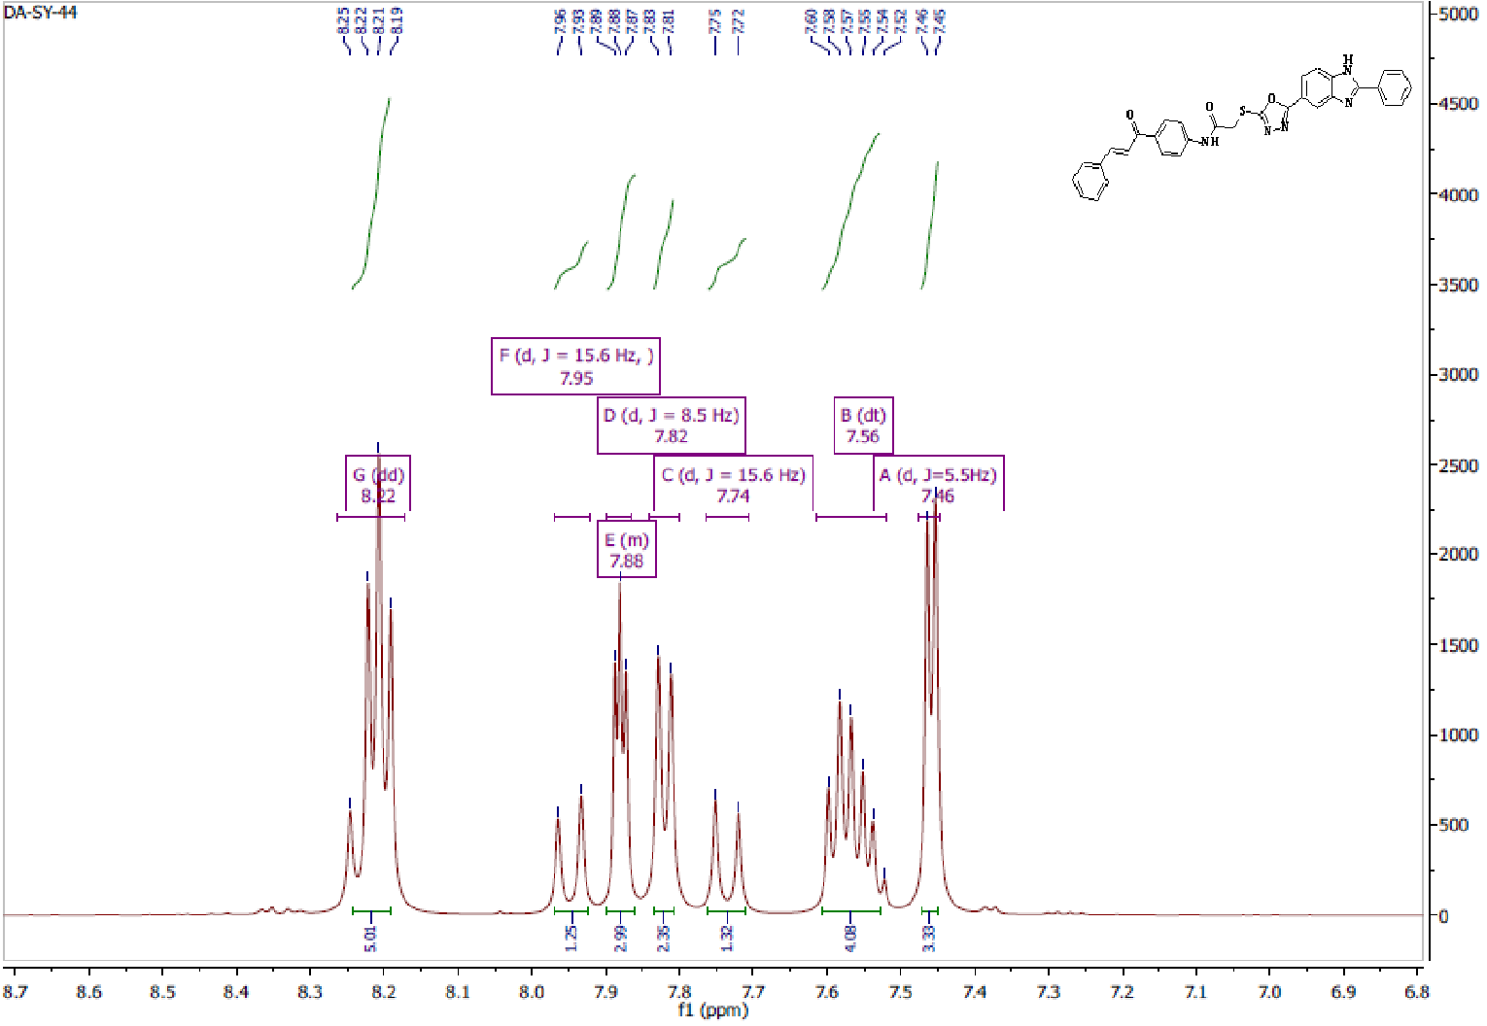
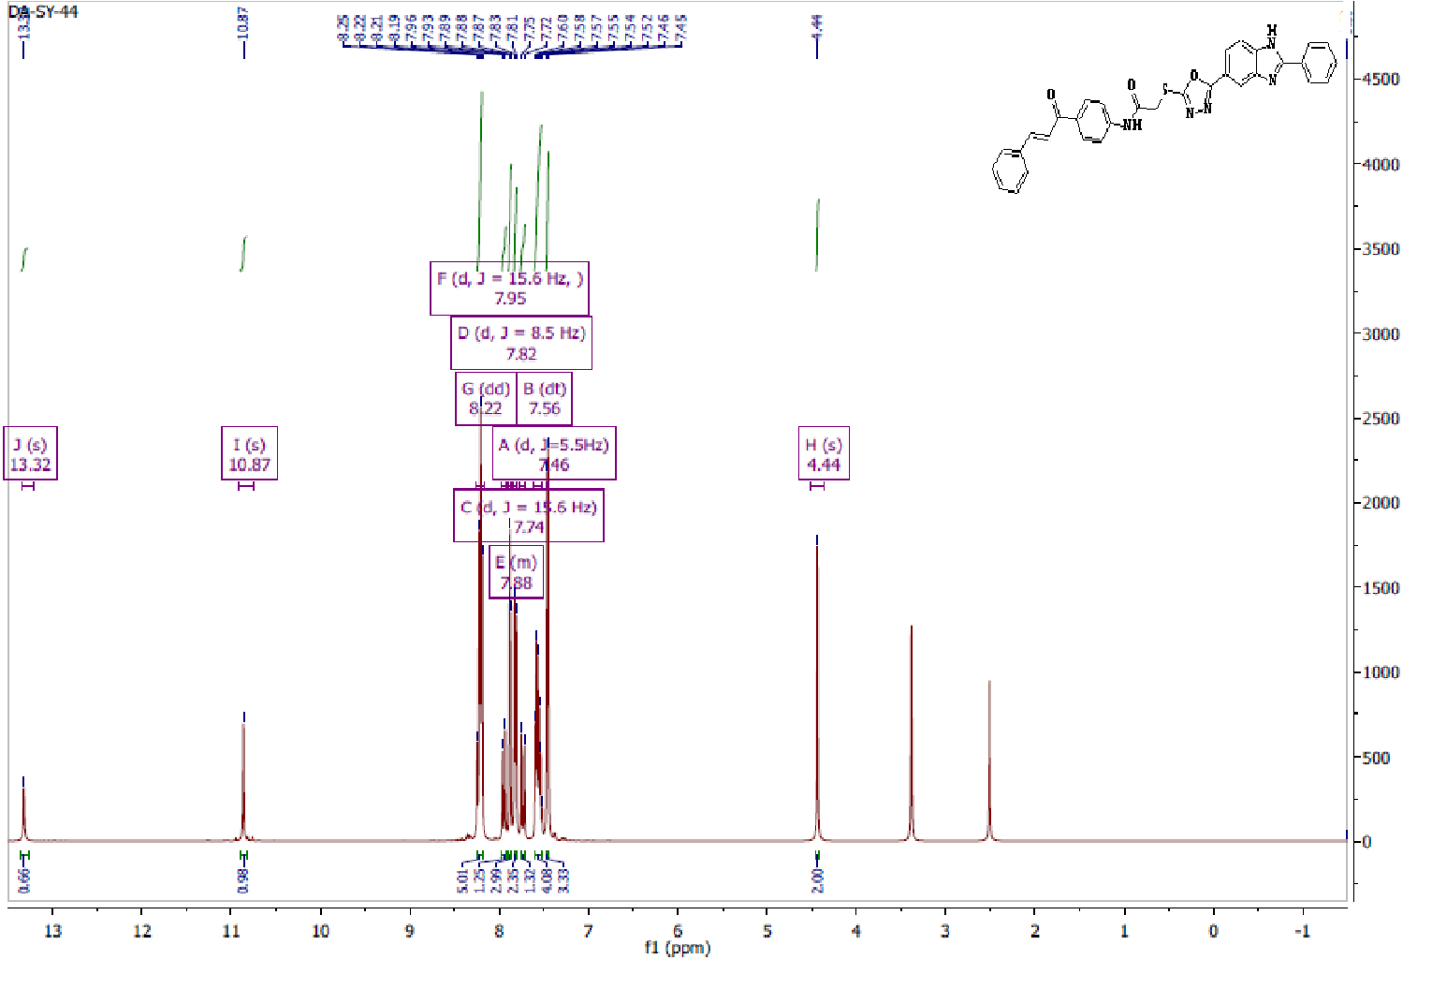
Fig. S1. ¹H NMR of compound 7a (500 MHz, DMSO-d₆)

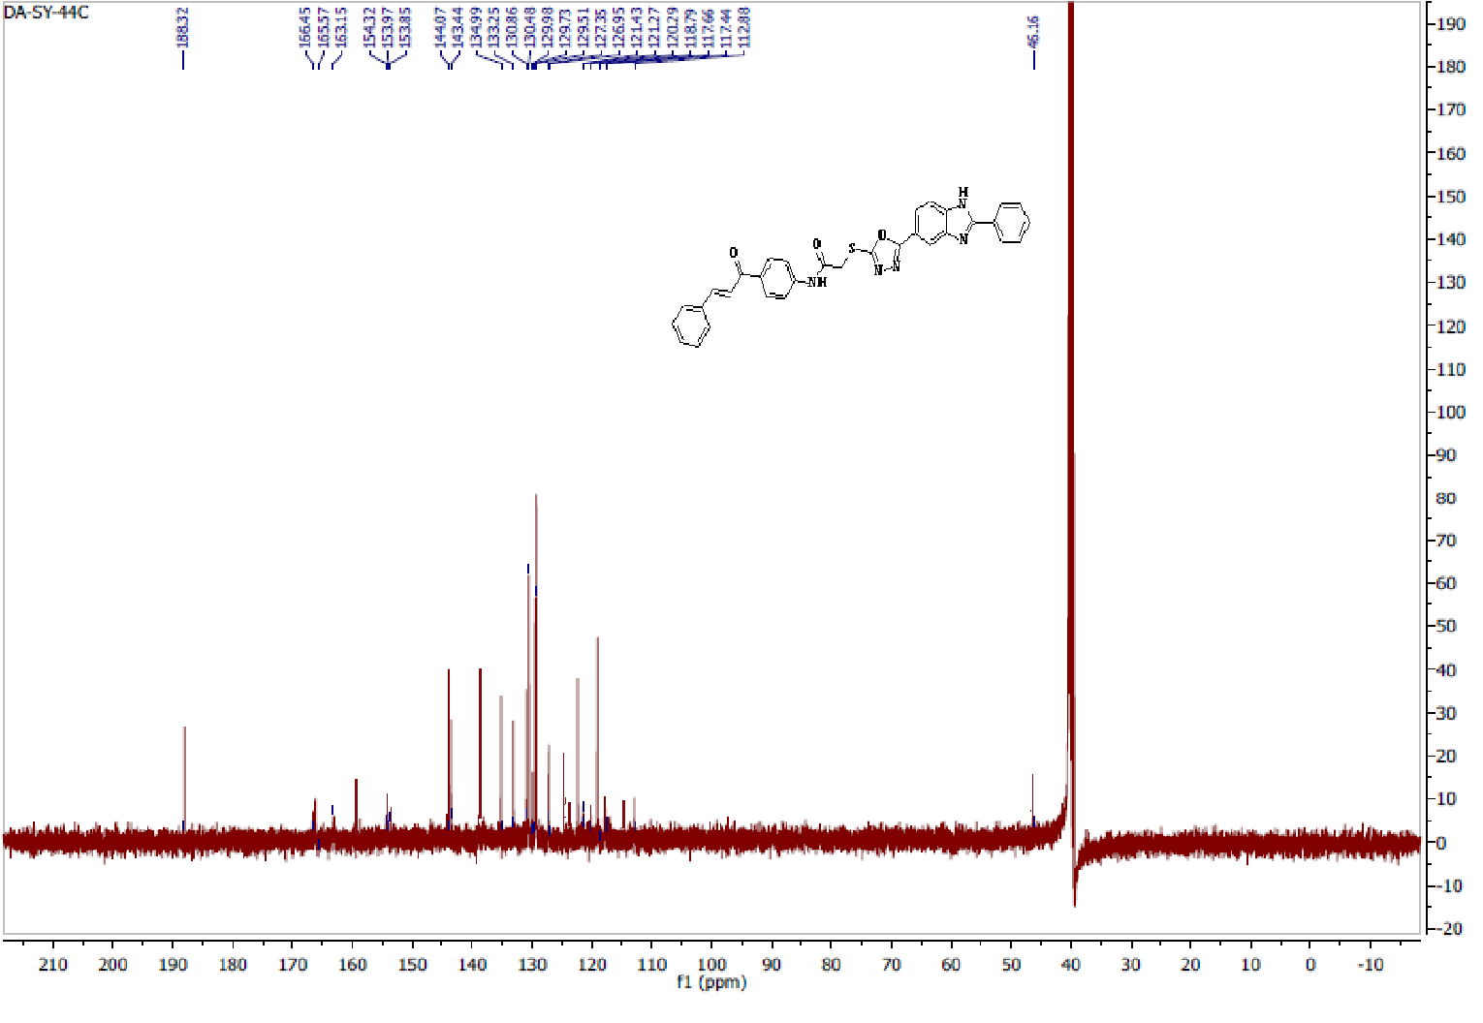
Fig. S2. ¹³C NMR of compound 7a (125 MHz, DMSO-d₆)
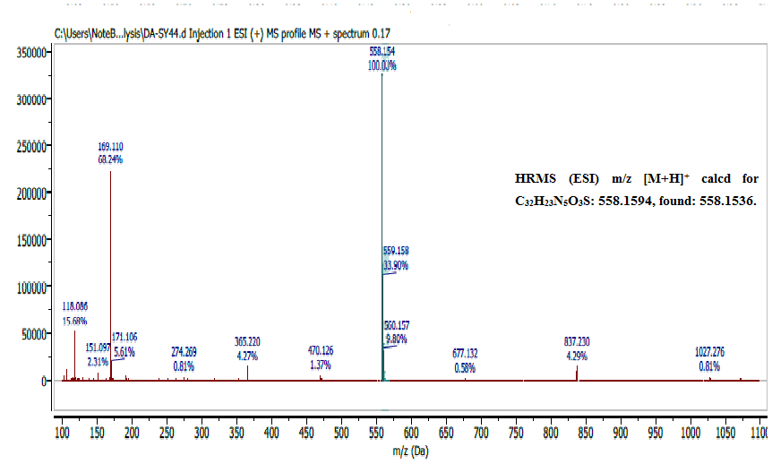
Fig. S3: HRMS (ESI) spectrum of compound 7a.

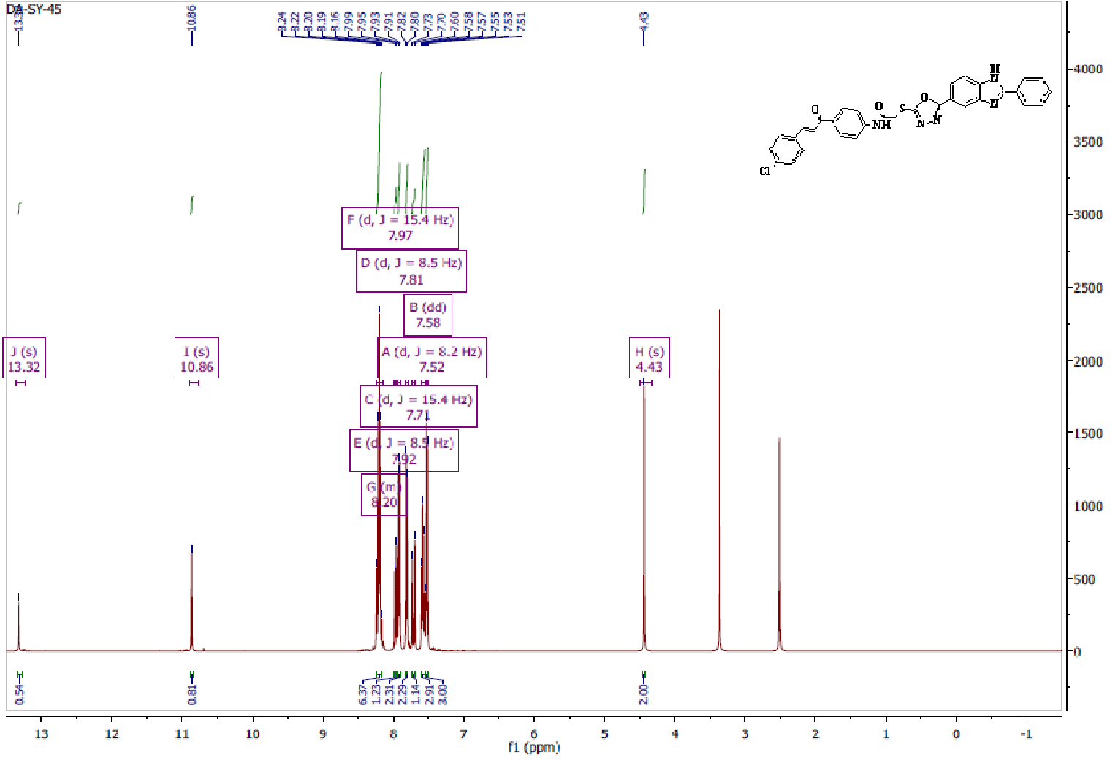
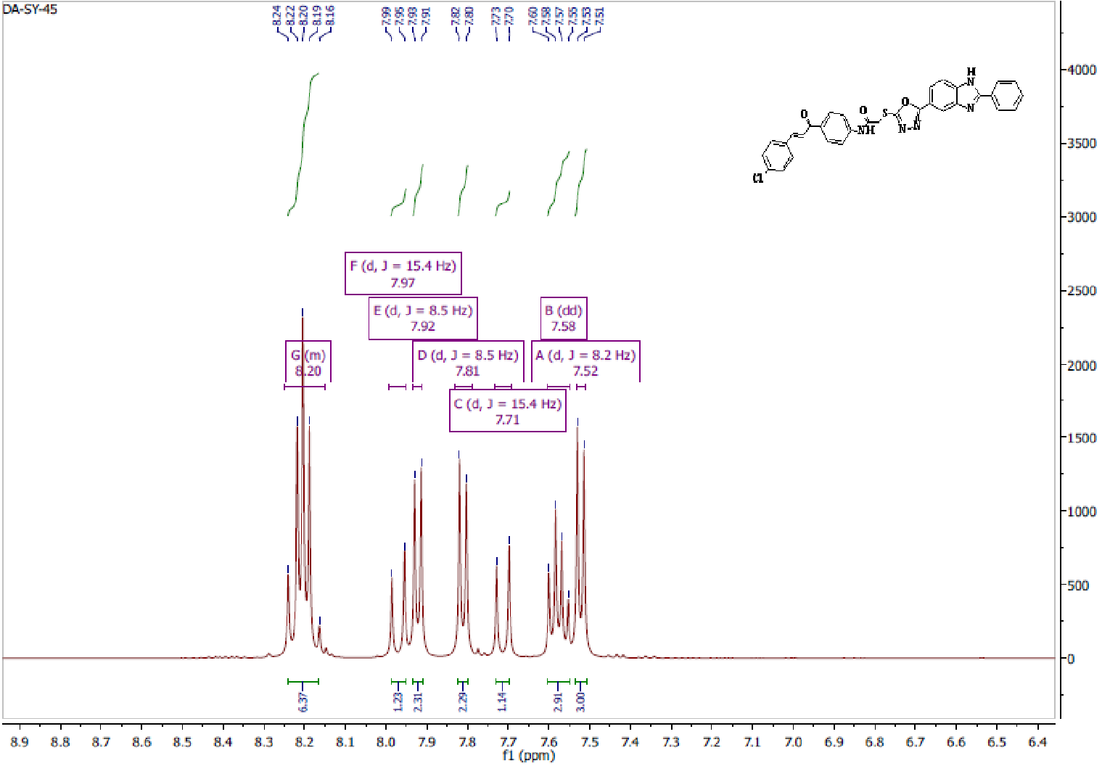
Fig. S4. ¹H NMR of compound 7b (500 MHz, DMSO-d₆)

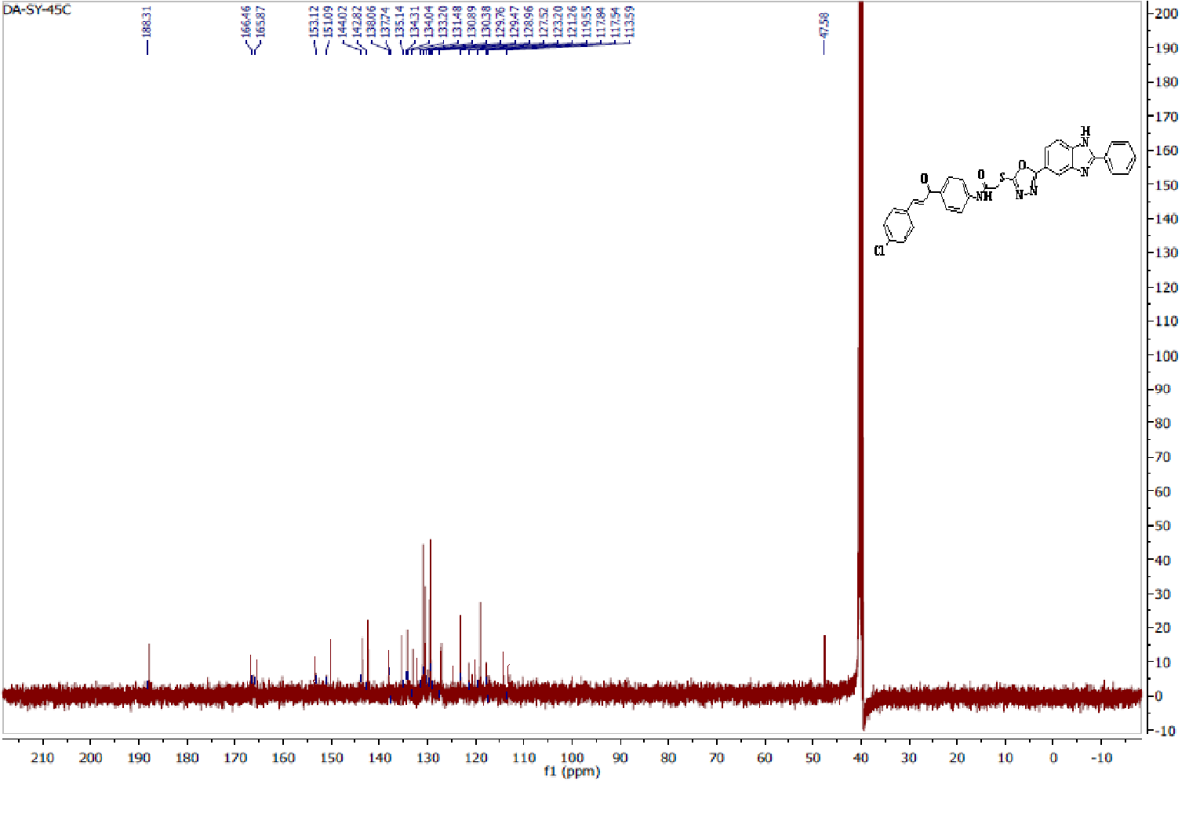Fig. S5. ¹³C NMR of compound 7b (125 MHz, DMSO-d₆)
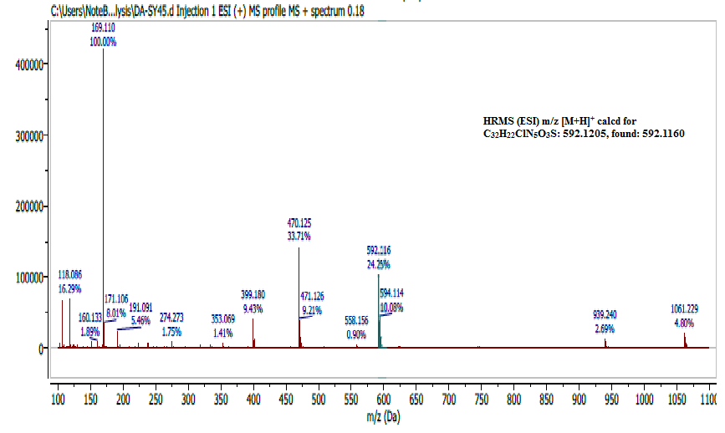
Fig. S6: HRMS (ESI) spectrum of compound 7b.

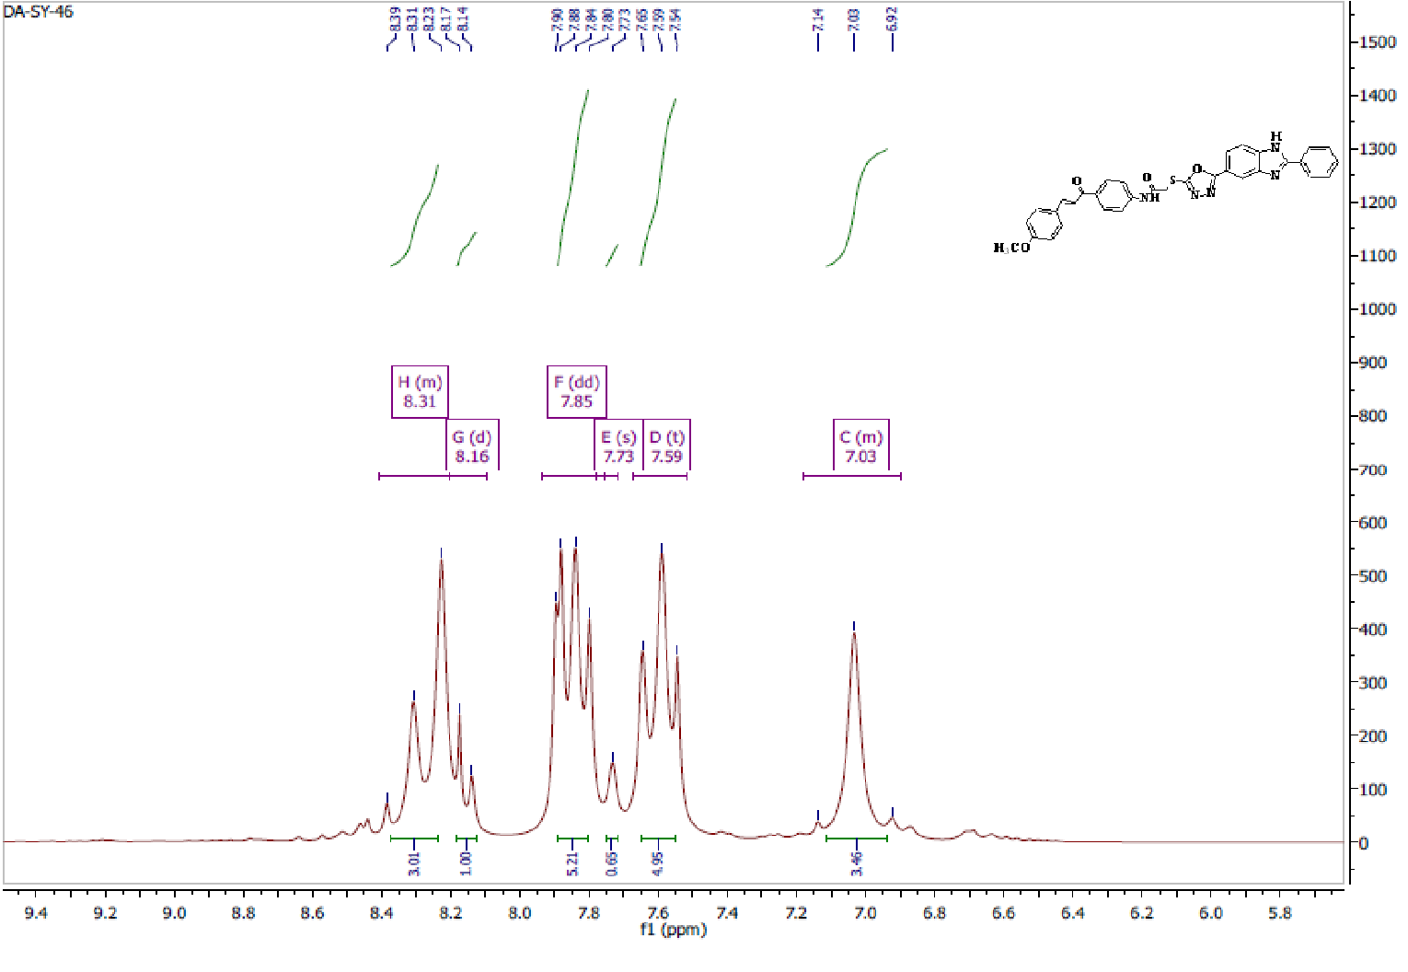

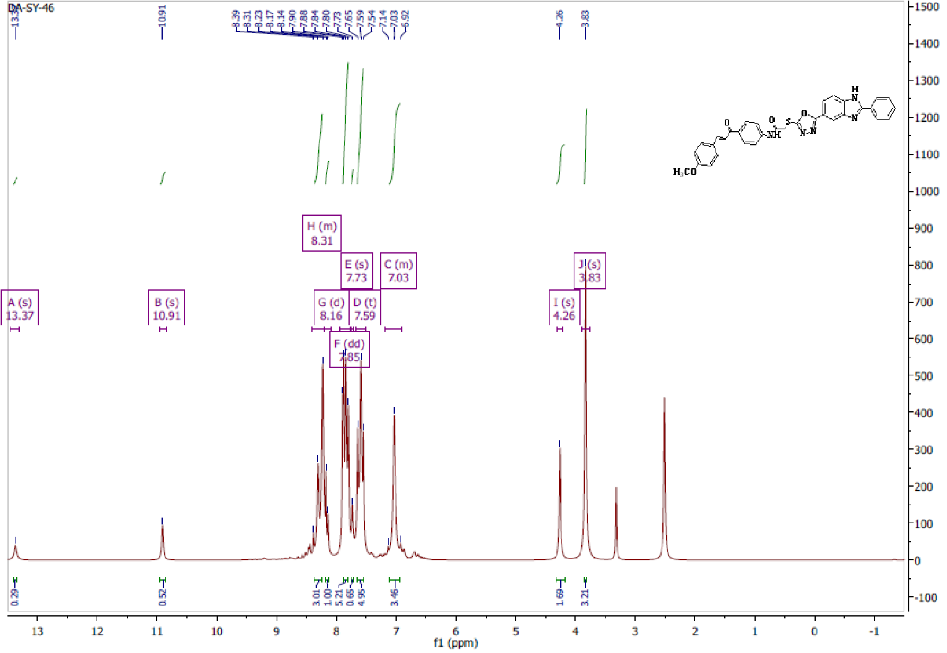
Fig. S 7. ¹H NMR of compound 7c (500 MHz, DMSO-d₆)

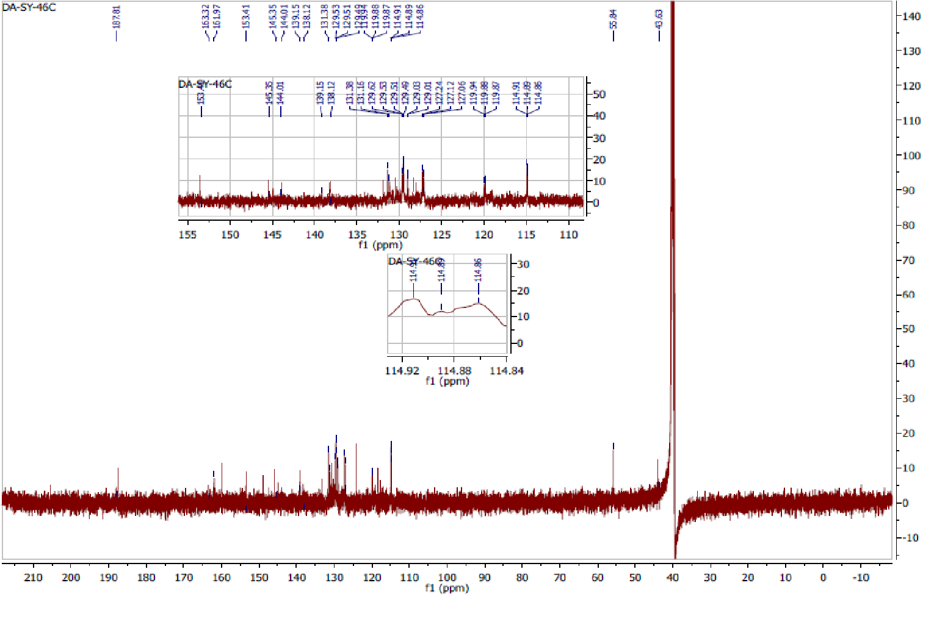
Fig. S 8. ¹³C NMR of compound 7c (125 MHz, DMSO-d₆)

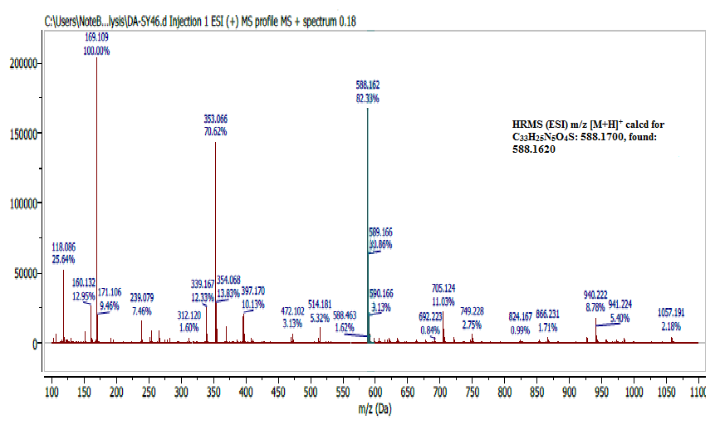
Fig. S 9: HRMS (ESI) spectrum of compound 7c.

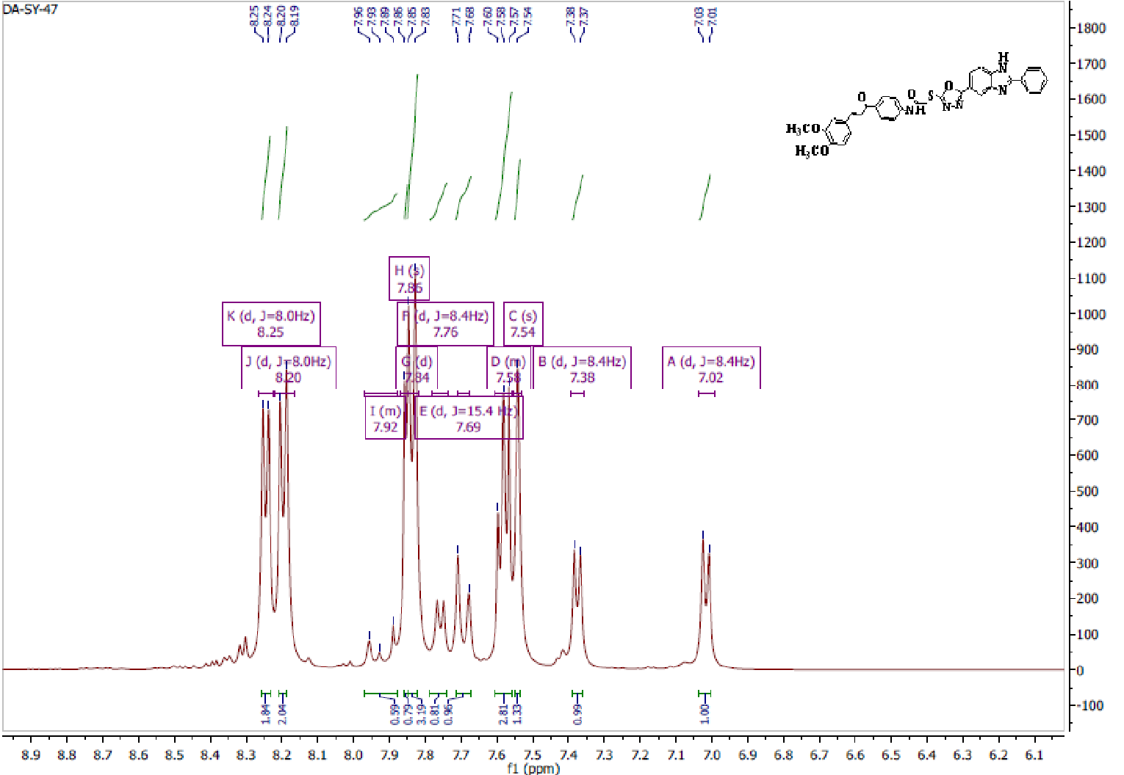
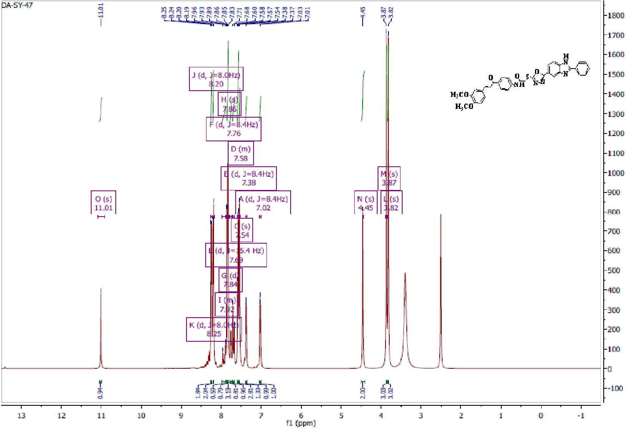
Fig. S 10. ¹H NMR of compound 7d (500 MHz, DMSO-d₆)

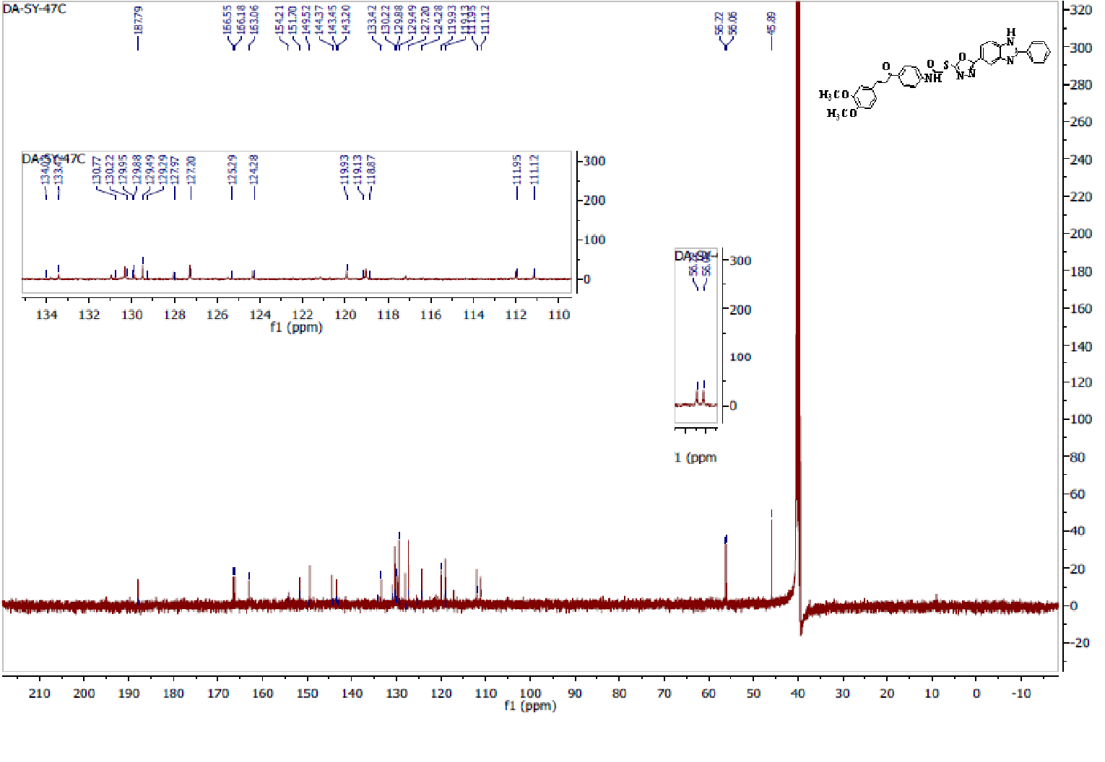
Fig. S 11. ¹³C NMR of compound 7d (125 MHz, DMSO-d₆)
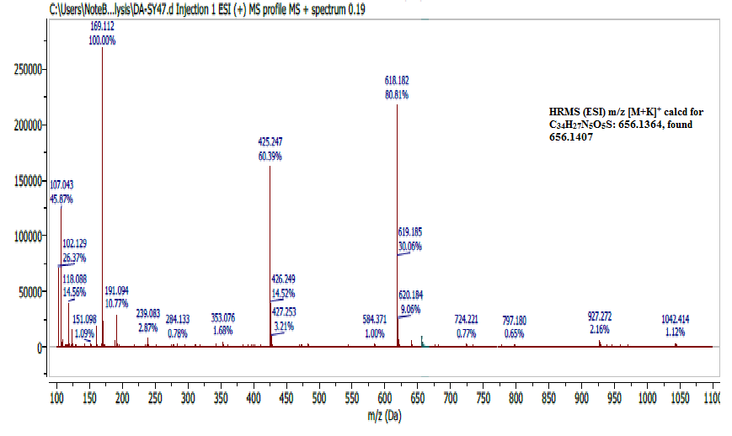
Fig. S 12: HRMS (ESI) spectrum of compound 7d.

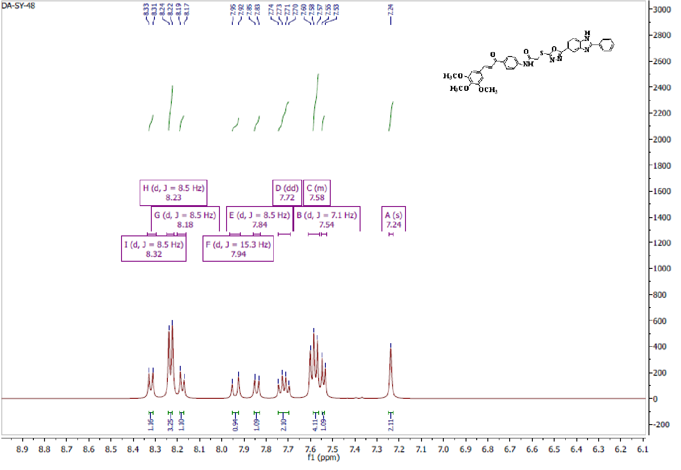
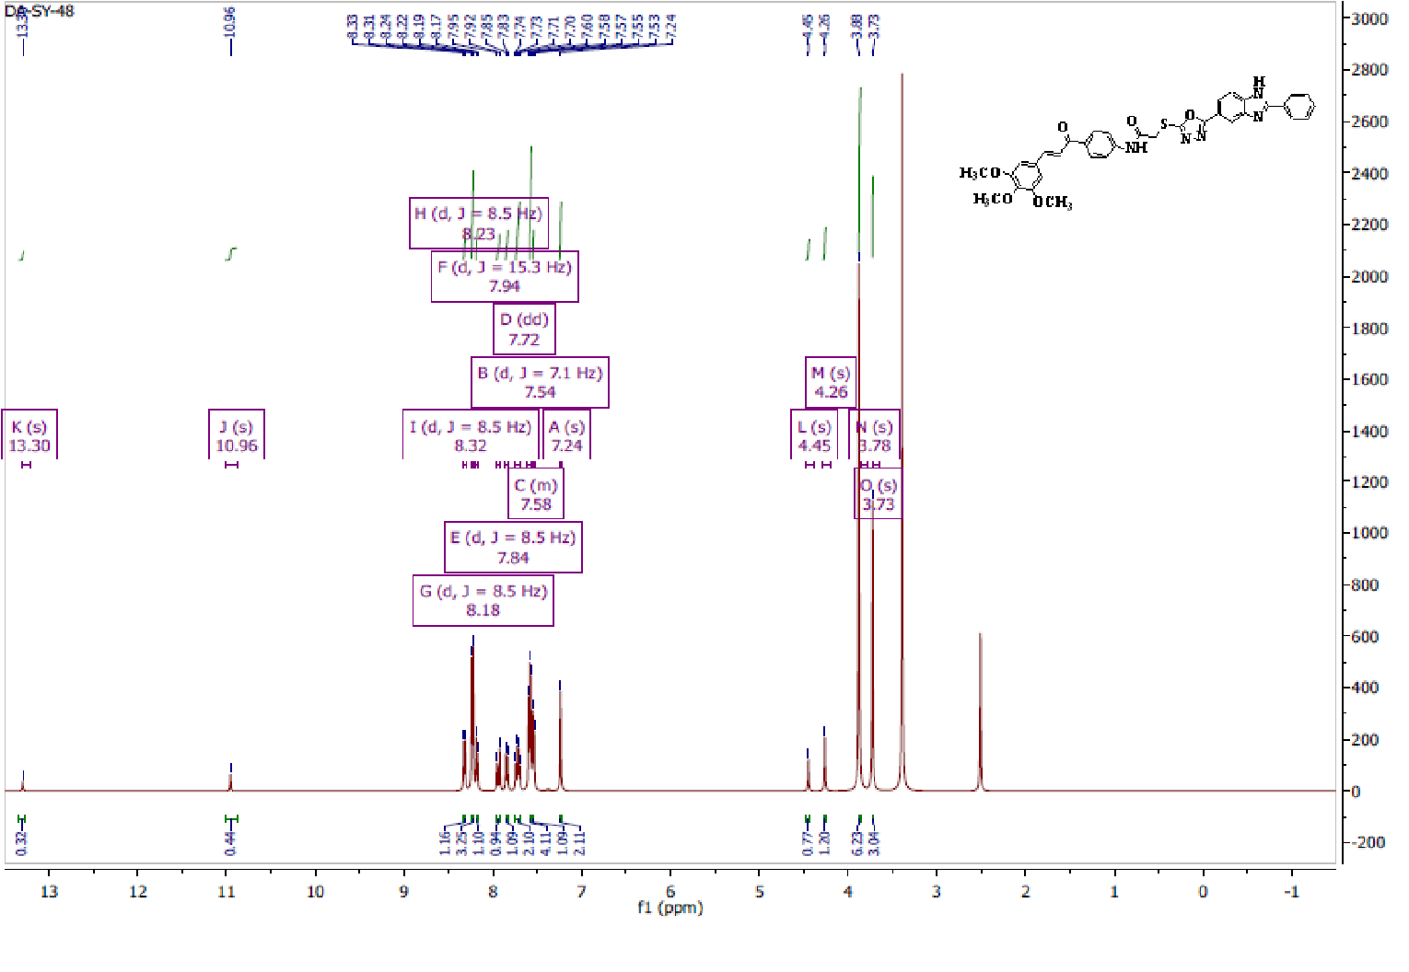
Fig. S 13. ¹H NMR of compound 7e (500 MHz, DMSO-d₆)

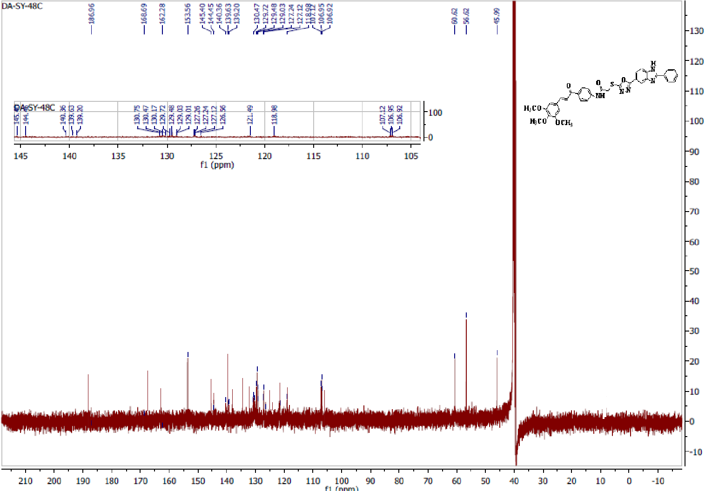
Fig. S 14. ¹³C NMR of compound 7e (125 MHz, DMSO-d₆).

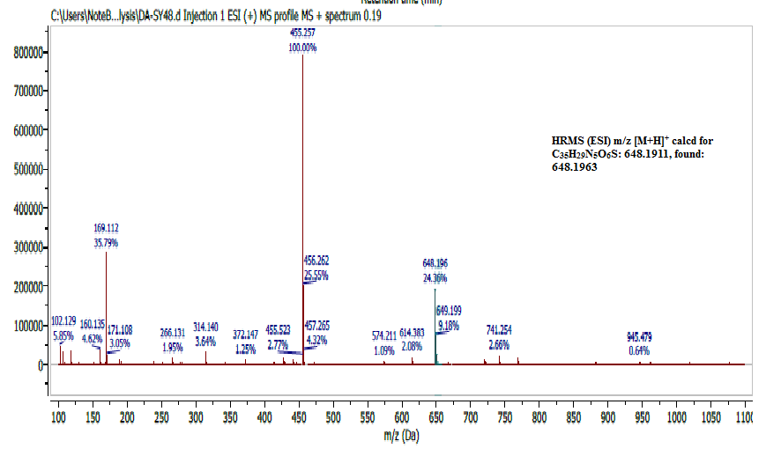
Fig. S 15: HRMS (ESI) spectrum of compound 7e.

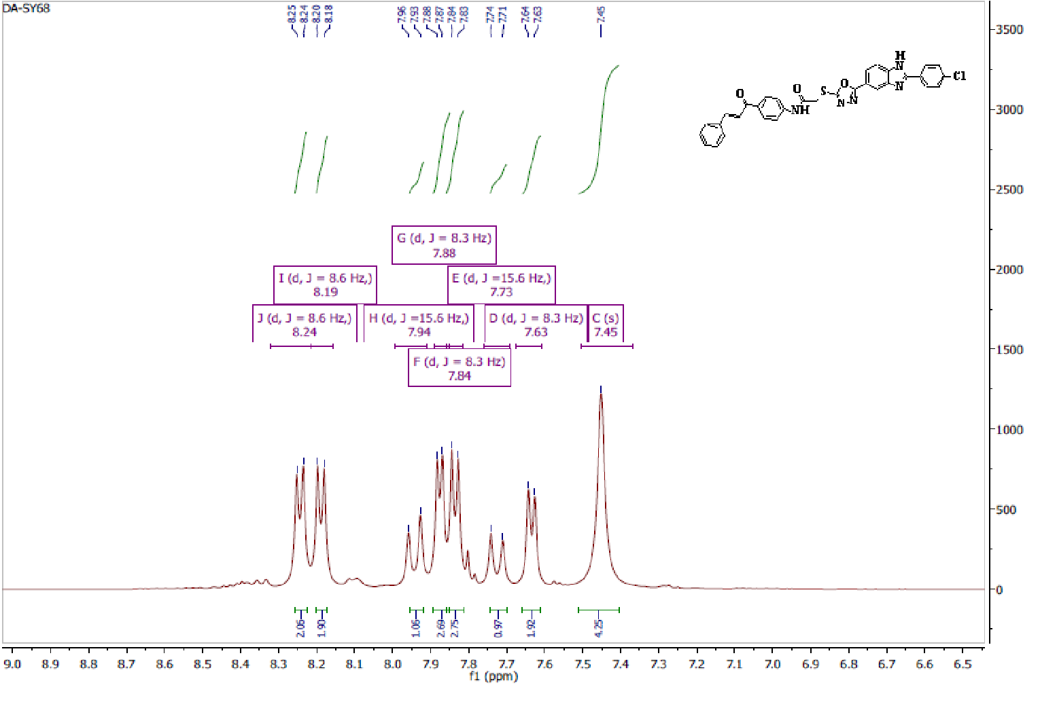
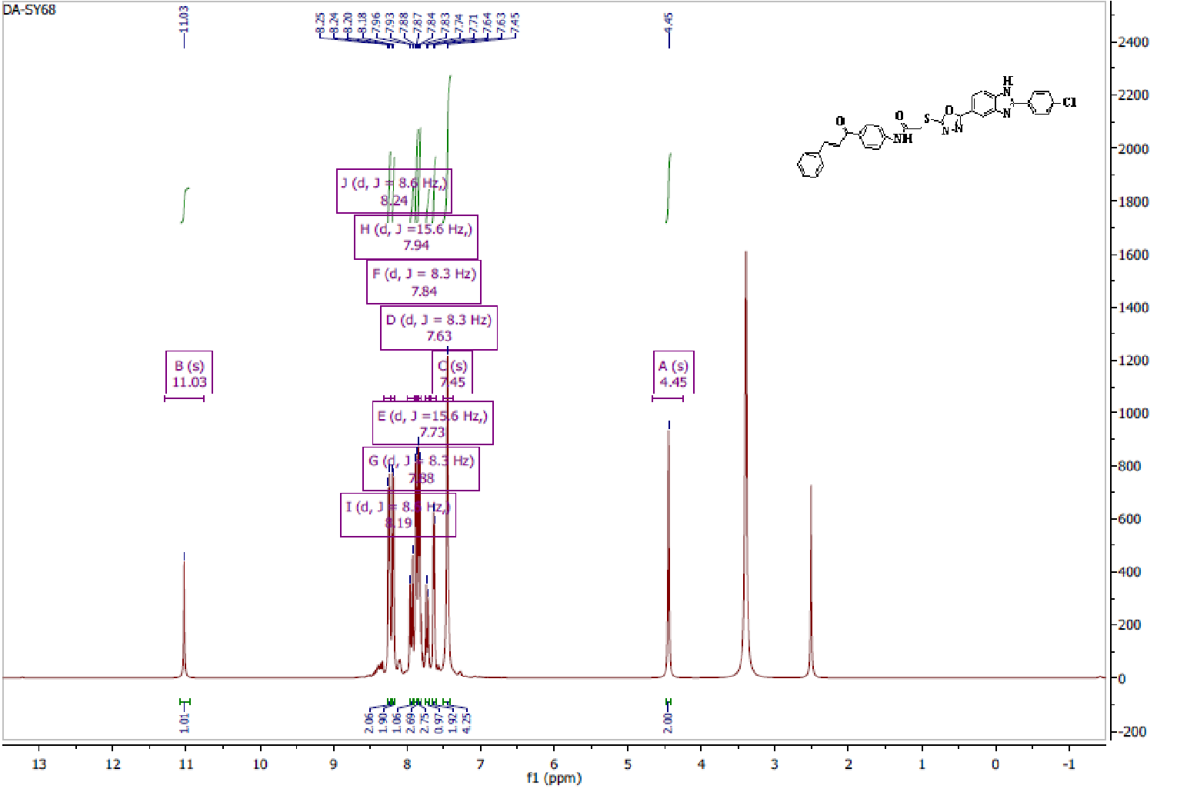
Fig. S 16. ¹H NMR of compound 7f (500 MHz, DMSO-d₆)
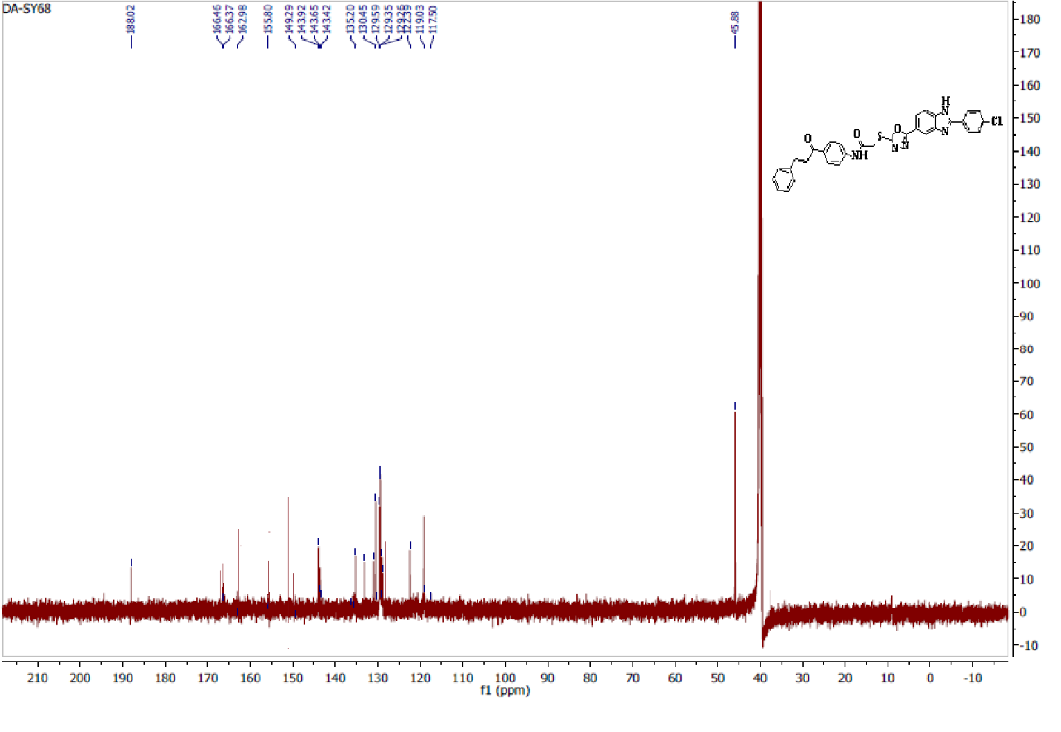
Fig. S 17. ¹³C NMR of compound 7f (125 MHz, DMSO-d₆)

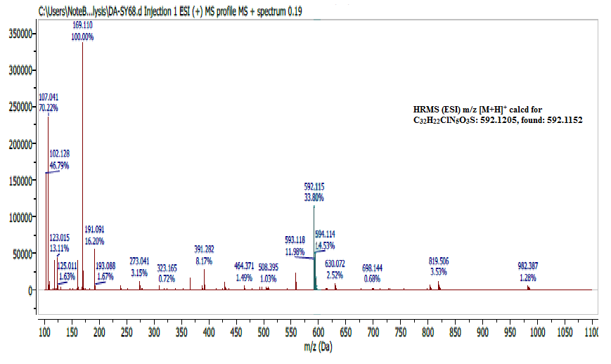
Fig. S 18: HRMS (ESI) spectrum of compound 7f.

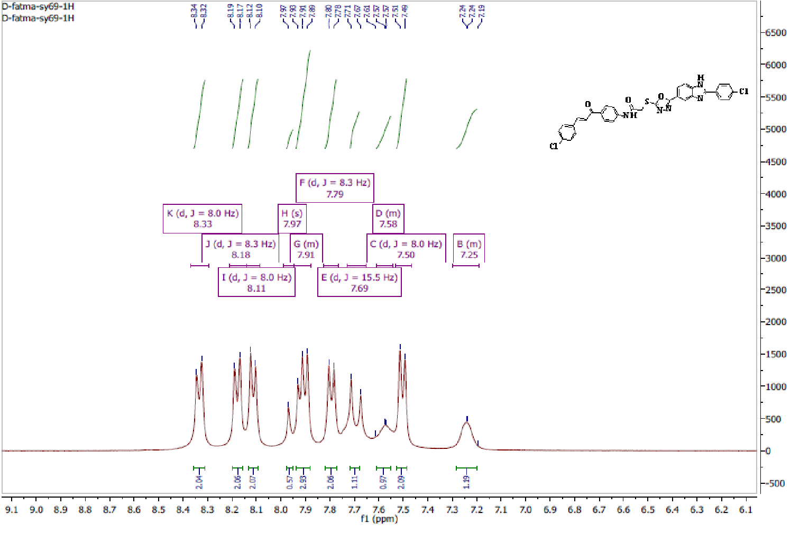
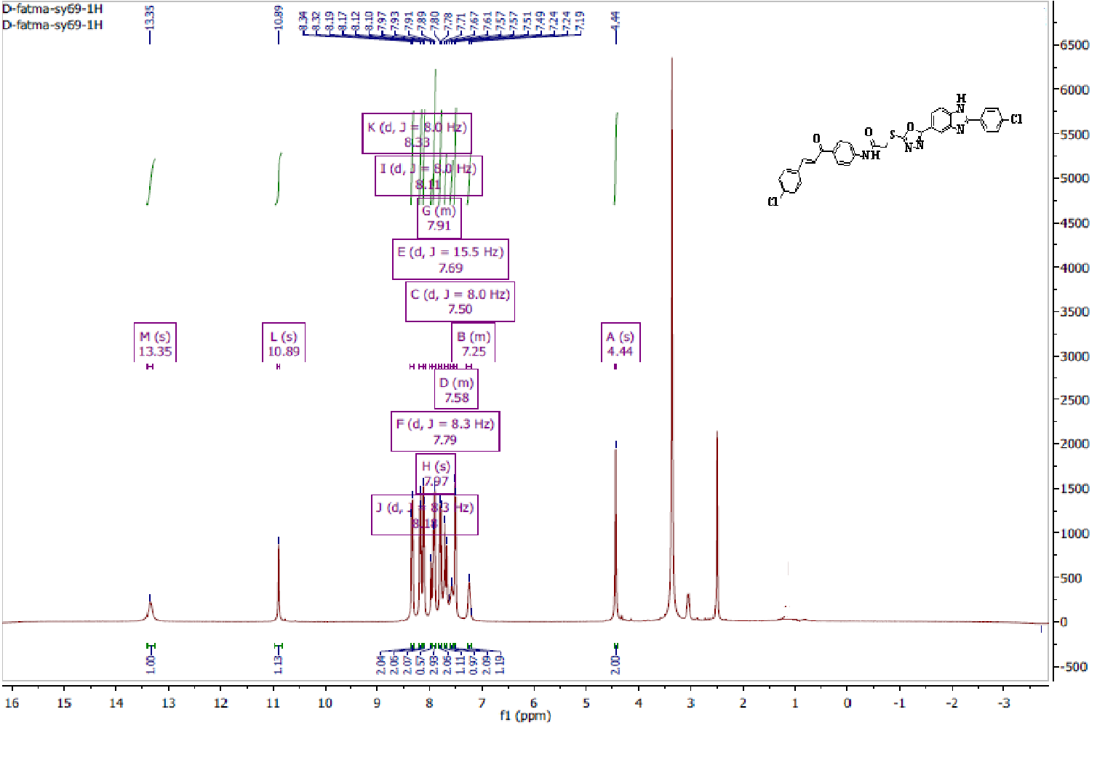

Fig. S 19. ¹H NMR of compound 7g (500 MHz, DMSO-d₆)
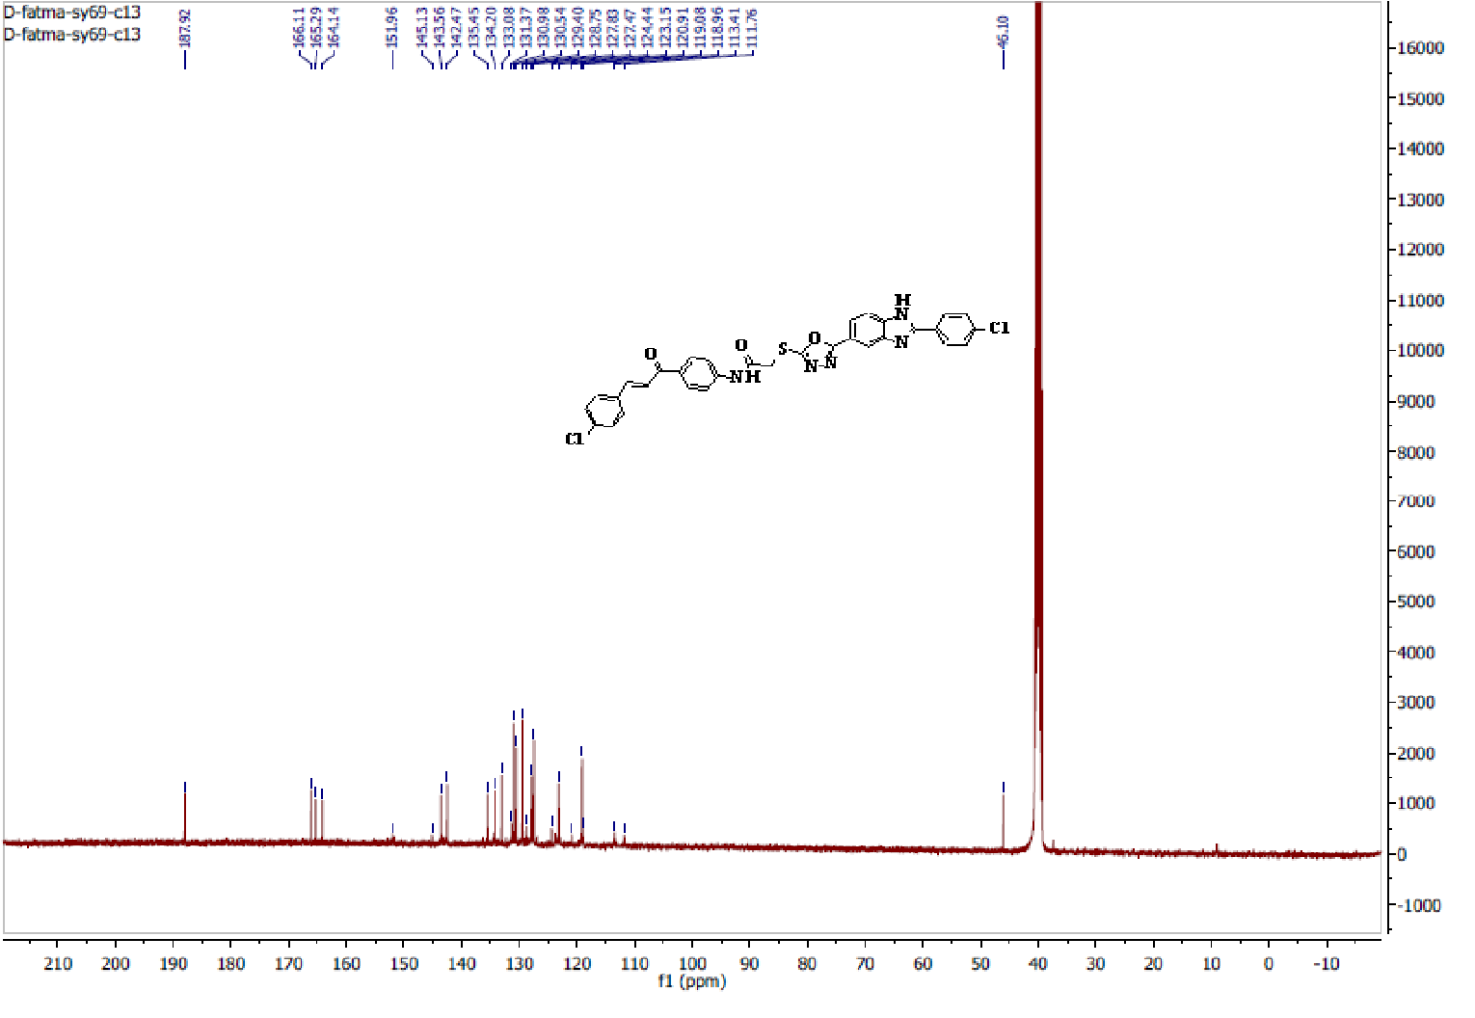
Fig. S 20. ¹³C NMR of compound 7g (125 MHz, DMSO-d₆)

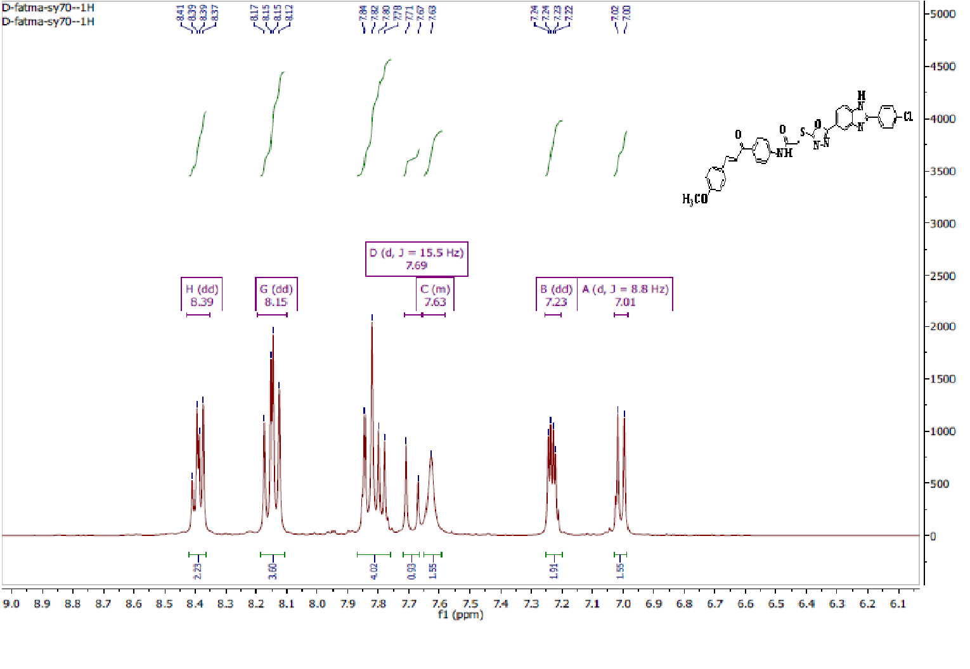
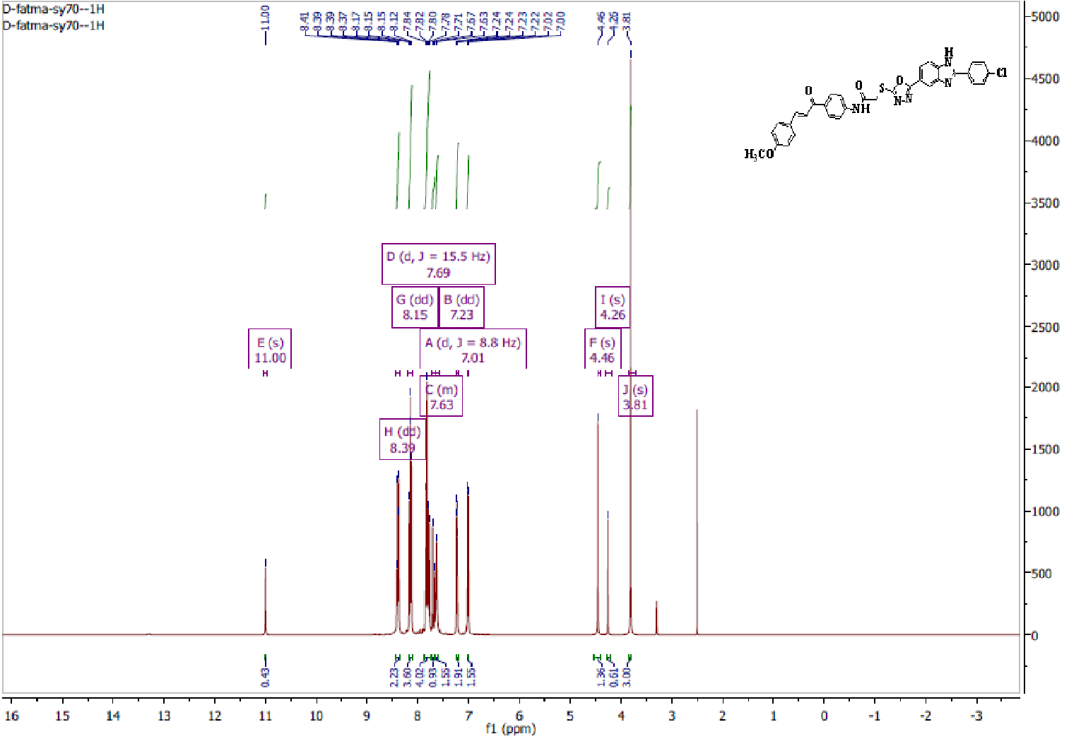
Fig. S 21. ¹H NMR of compound 7h (500 MHz, DMSO-d₆)

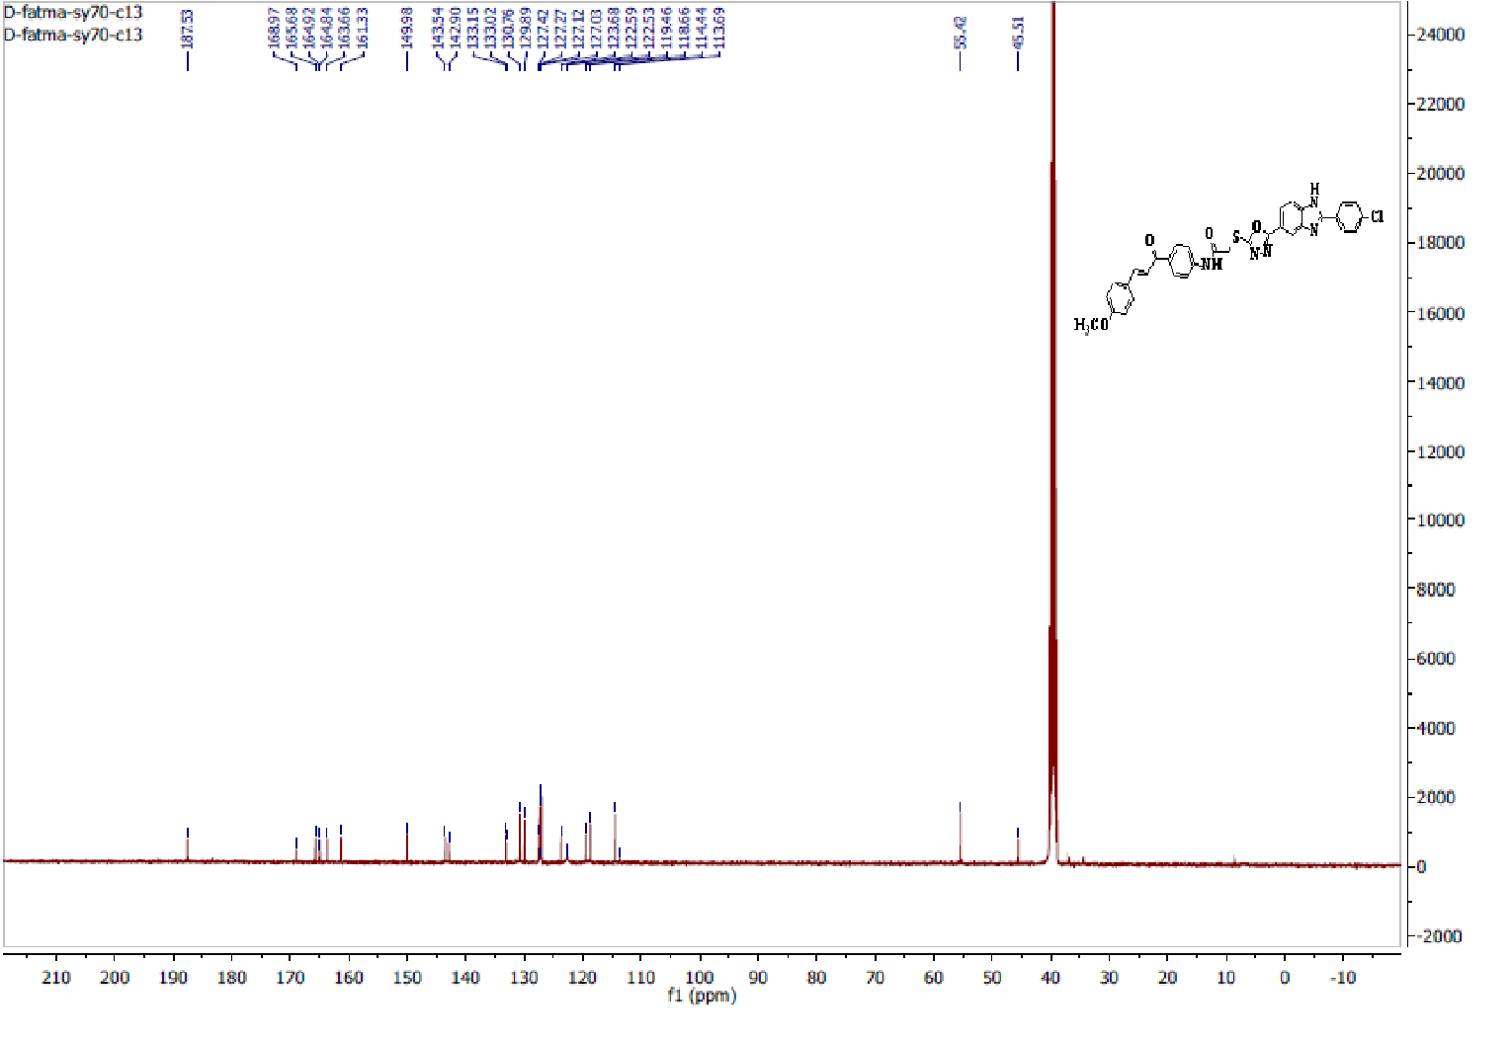
Fig.S22. ¹³C NMR of compound 7h (125 MHz, DMSO-d₆)

.

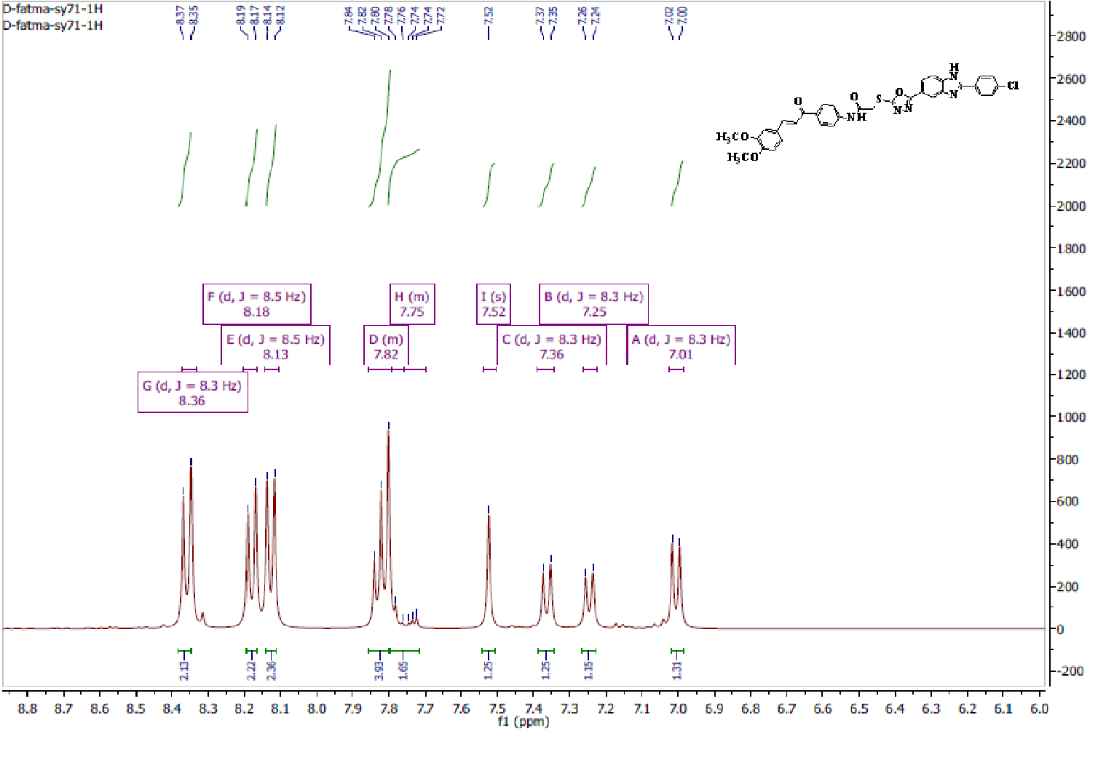
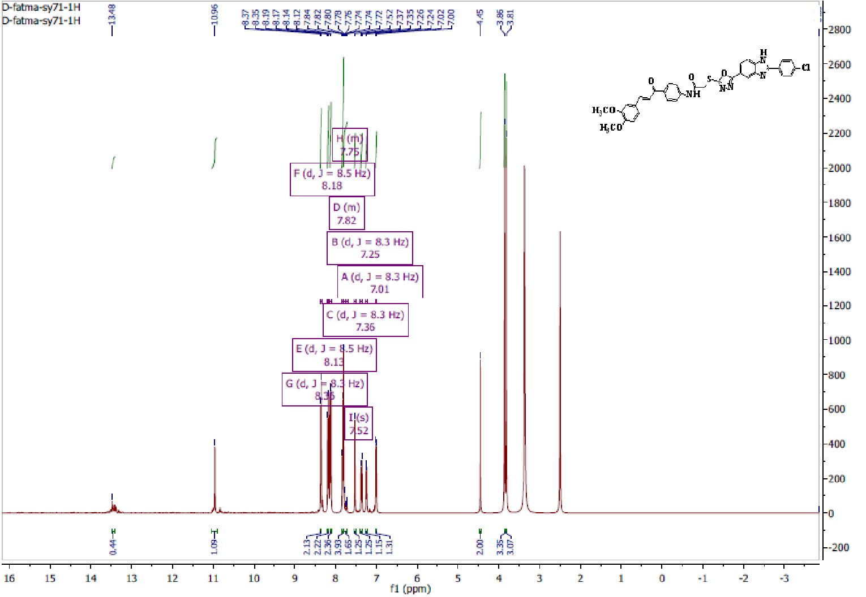
Fig.S23. ¹H NMR of compound 7i (500 MHz, DMSO-d₆)

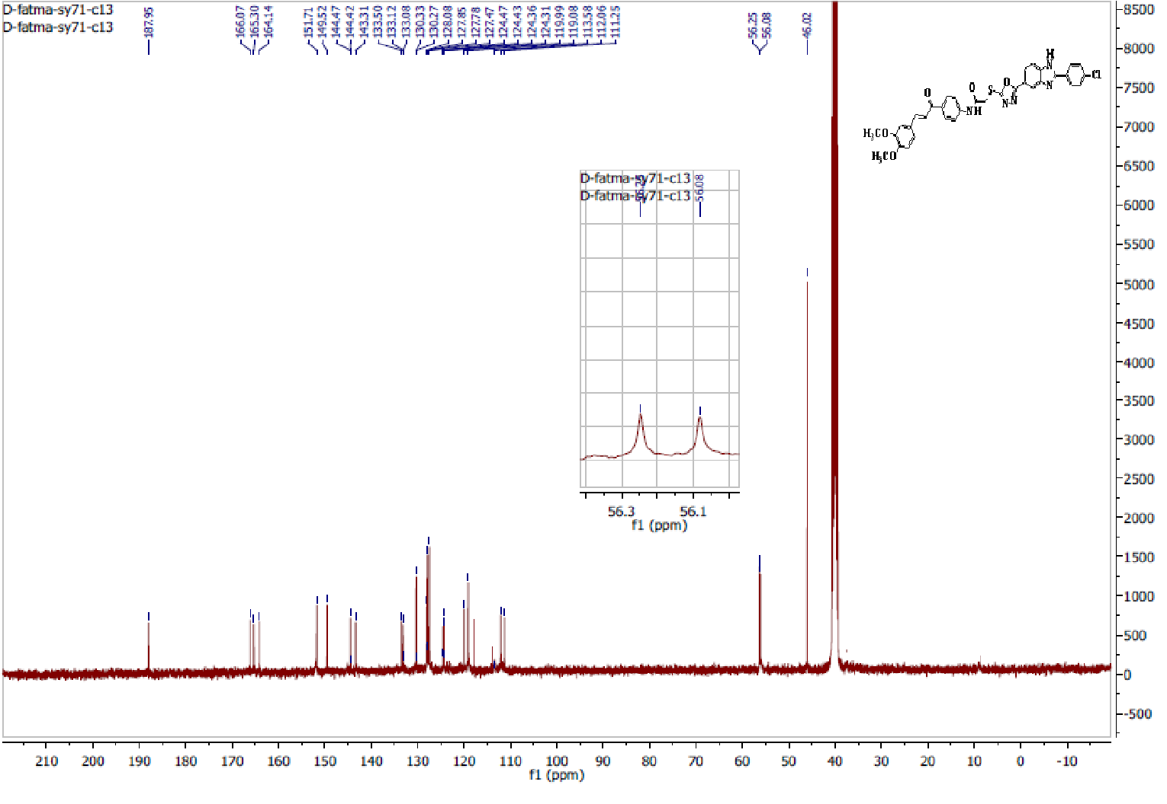
Fig.S24. ¹³C NMR of compound 7i (125 MHz, DMSO-d₆)

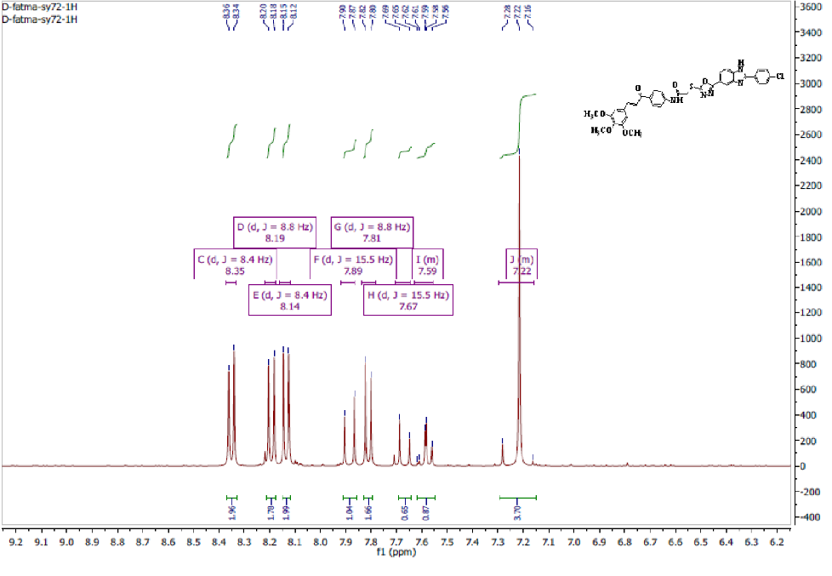

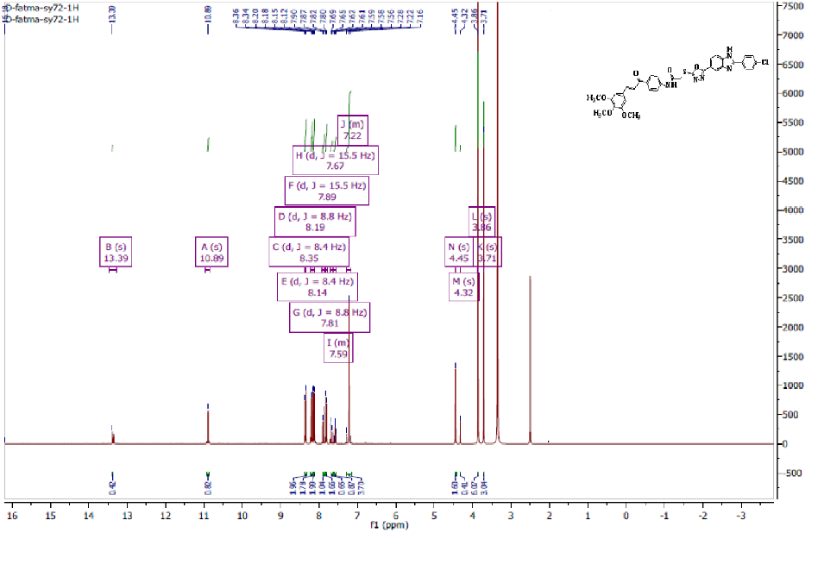
Fig.S25. ¹HNMR of compound 7j (500 MHz, DMSO-d₆)
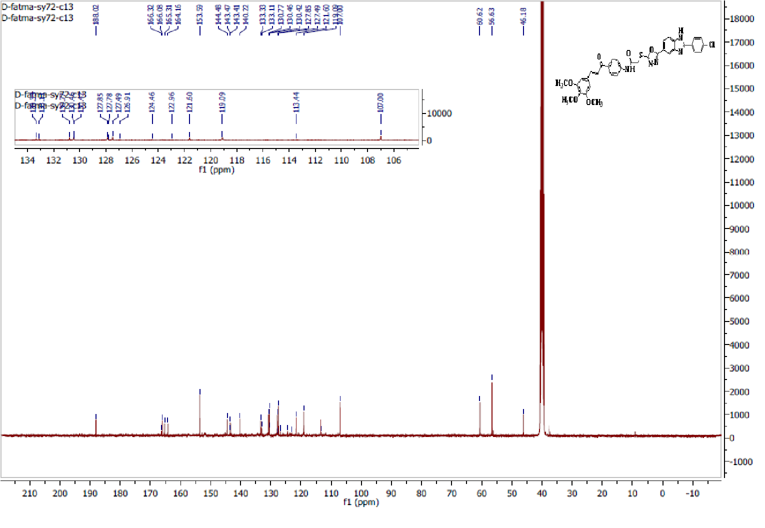
Fig.S26. ¹³C NMR of compound 7j (125 MHz, DMSO-d₆)

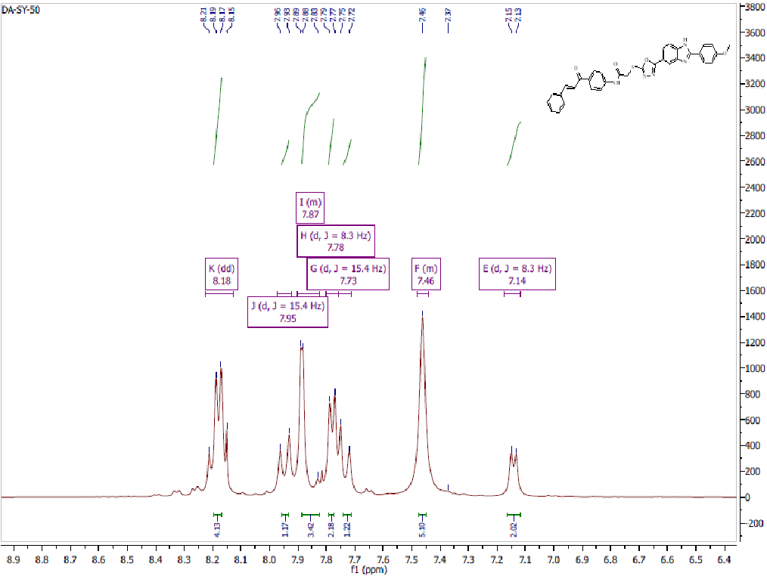
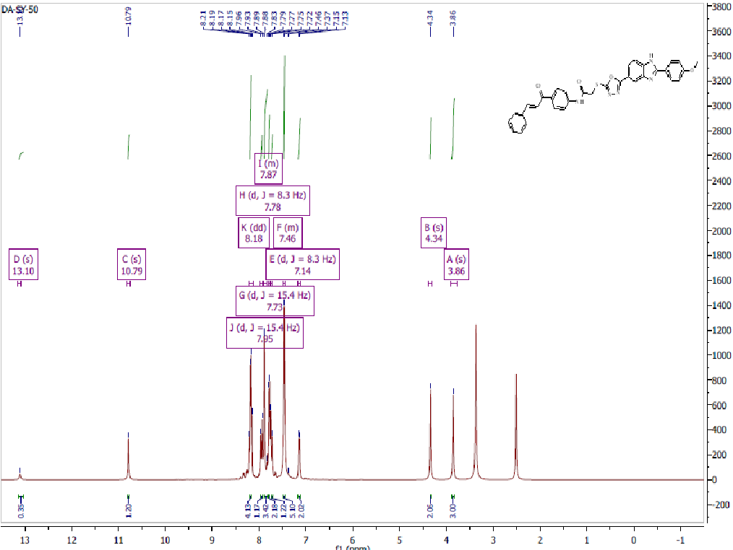
Fig.S27. ¹H NMR of compound 7k (500 MHz, DMSO-d₆)

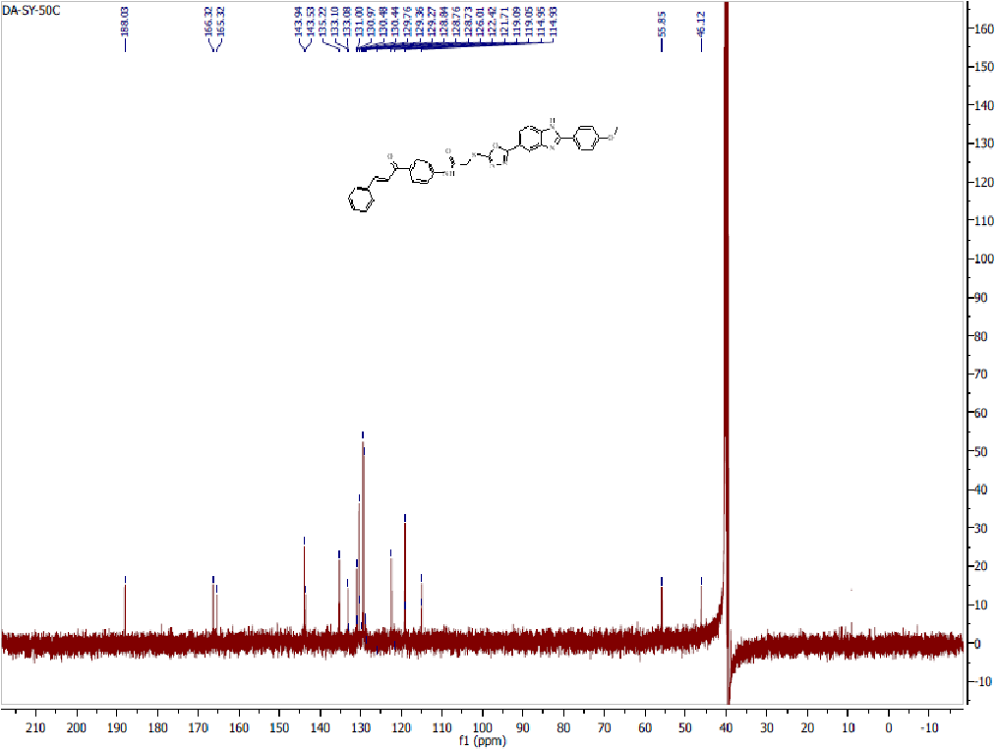
Fig.S28. ¹³C NMR of compound 7k (125 MHz, DMSO-d₆)
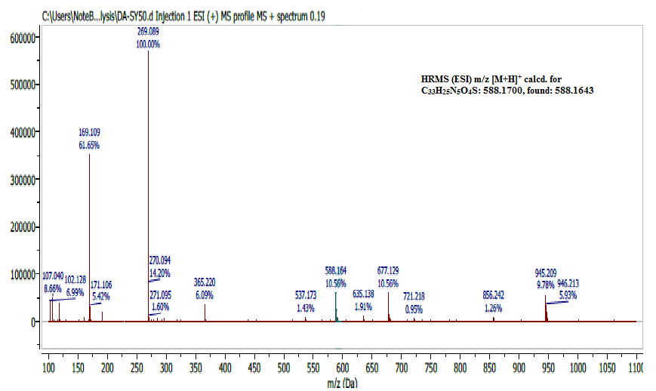
Fig.S29. HRMS (ESI) spectrum of compound 7k.

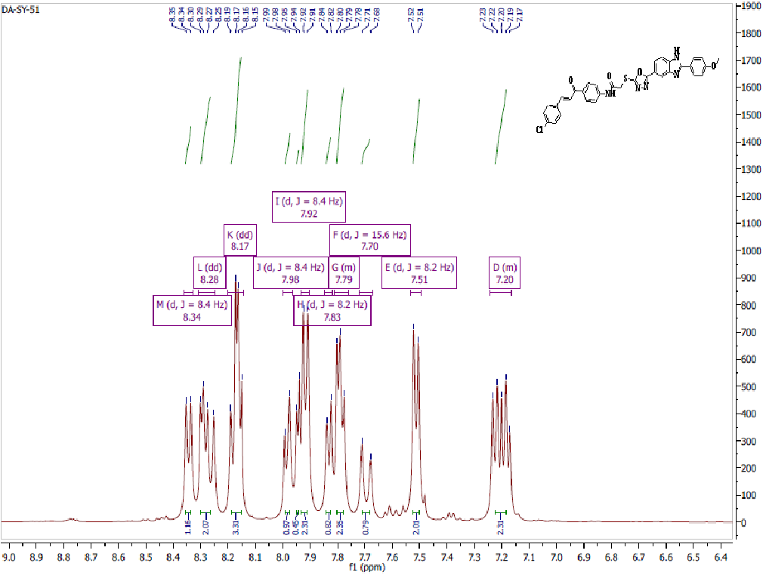
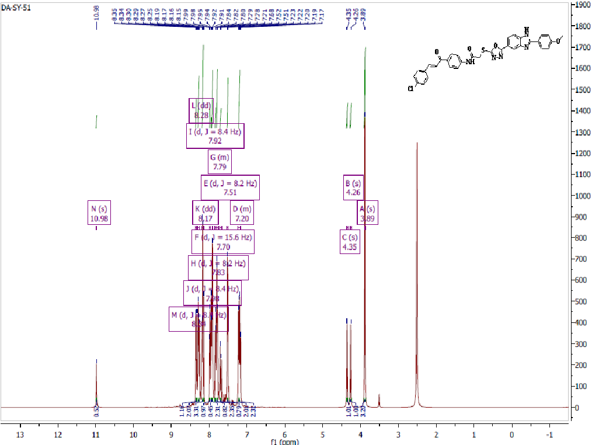
Fig.S30. ¹H NMR of compound 7l (400 MHz, DMSO-d₆)
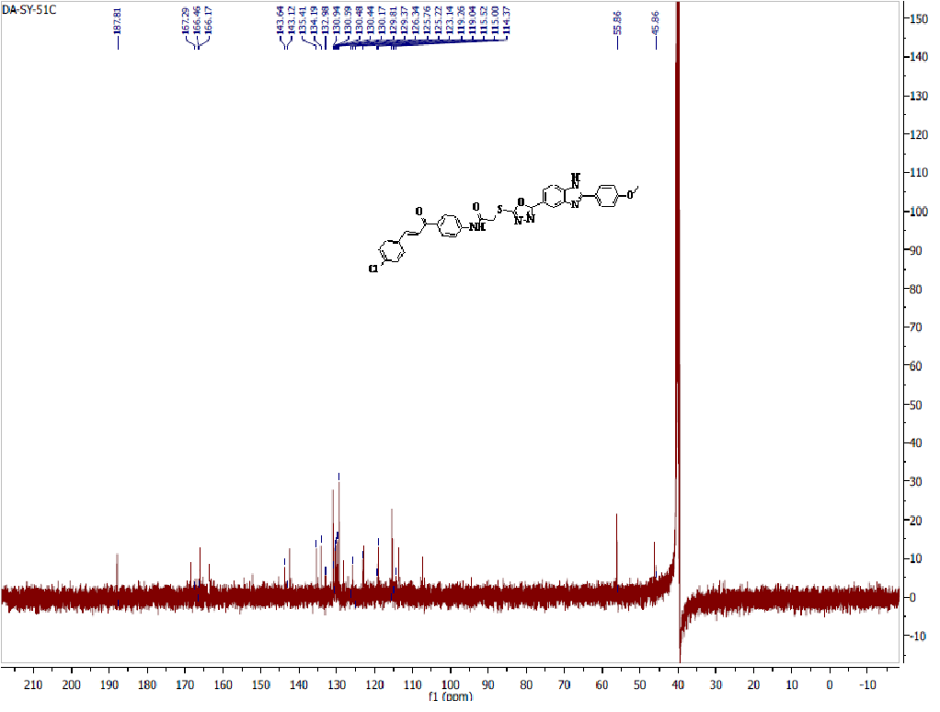
Fig.S31. ¹³C NMR of compound 7l (125 MHz, DMSO-d₆)

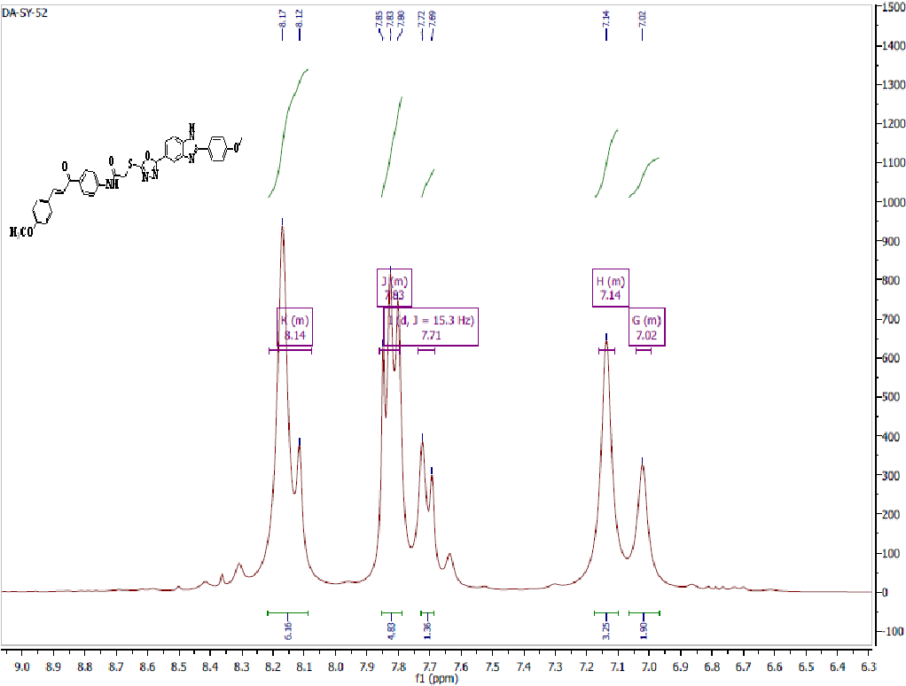
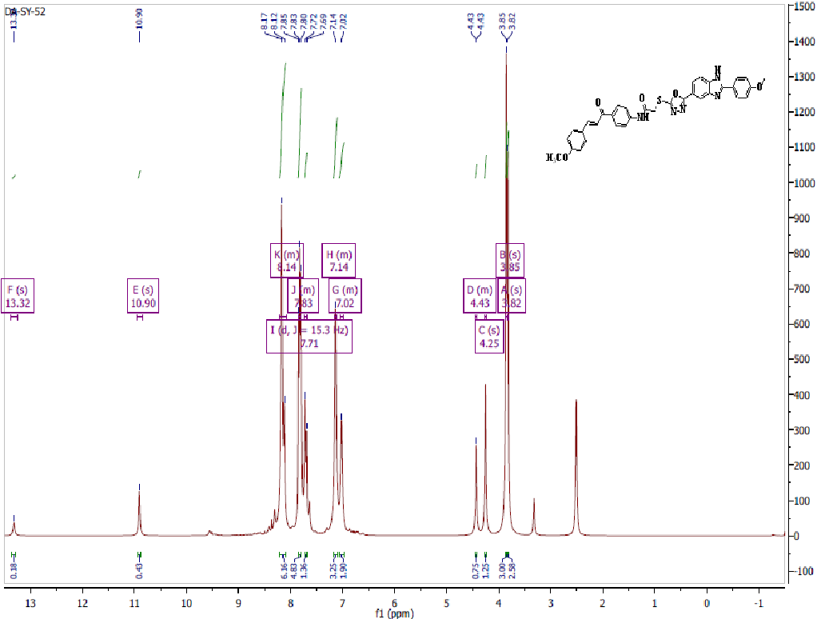
Fig.S32. ¹H NMR of compound7m (500 MHz, DMSO-d₆)
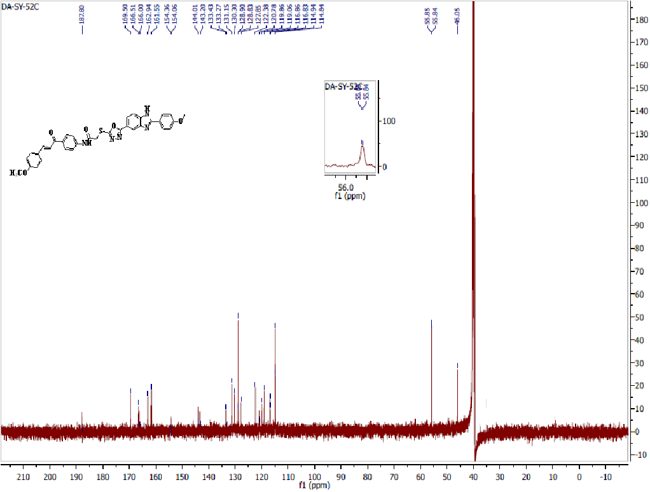
Fig.S33. ¹³C NMR of compound 7m (125 MHz, DMSO-d₆)

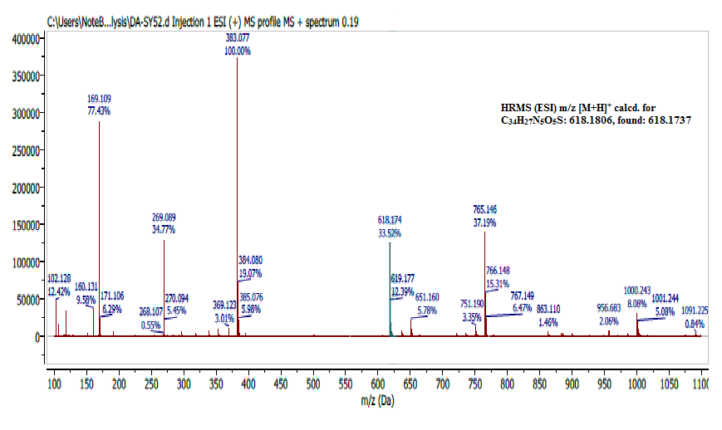
Fig.S34. HRMS (ESI) spectrum of compound 7m.

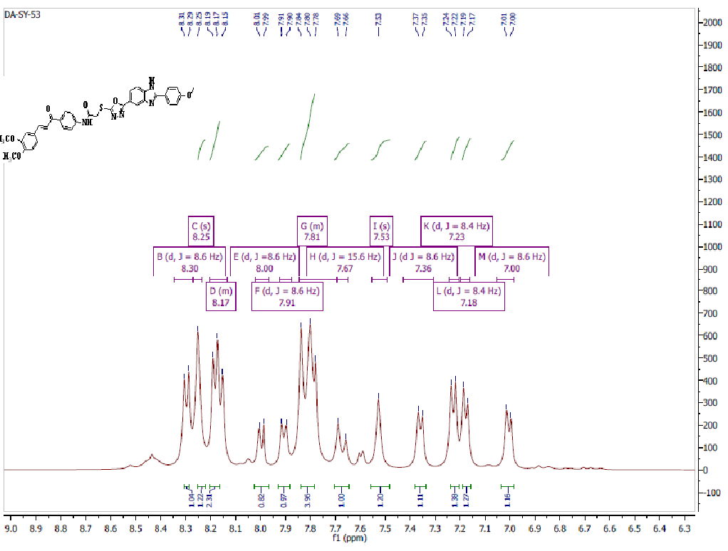
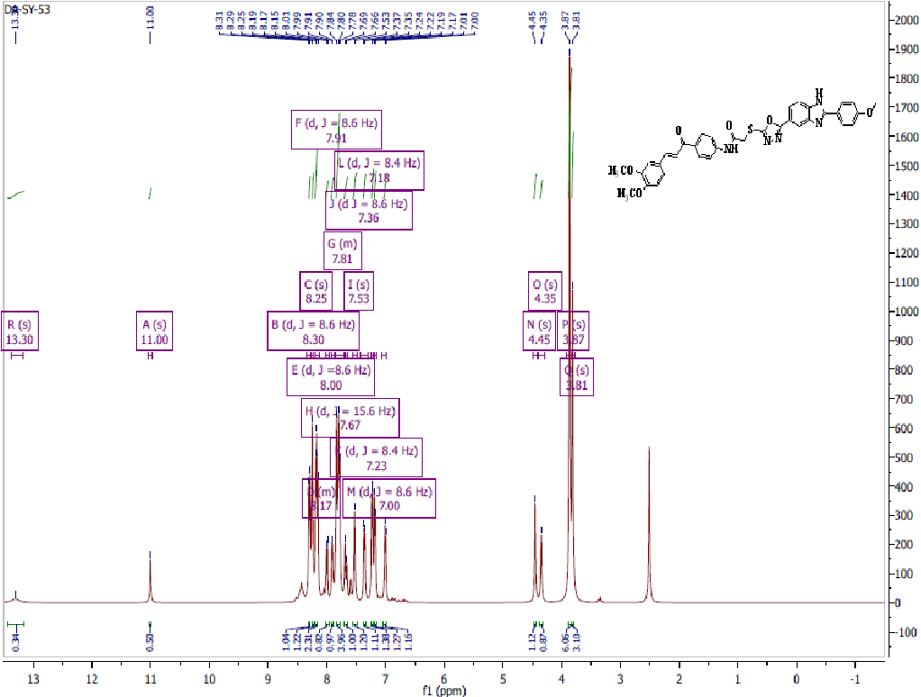
Fig.S35. ¹H NMR of compound 7n (500 MHz, DMSO-d₆)
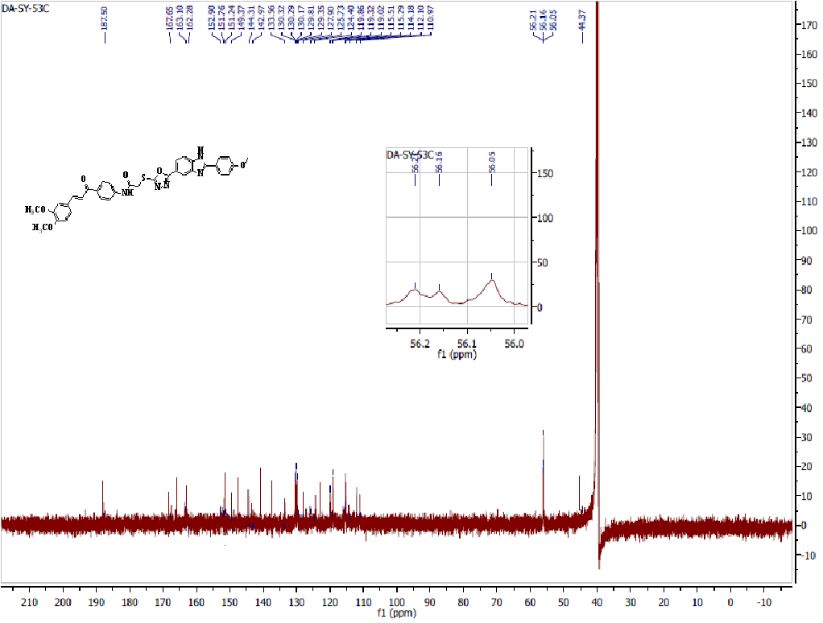
Fig.S36. ¹³C NMR of compound 7n (125 MHz, DMSO-d₆)

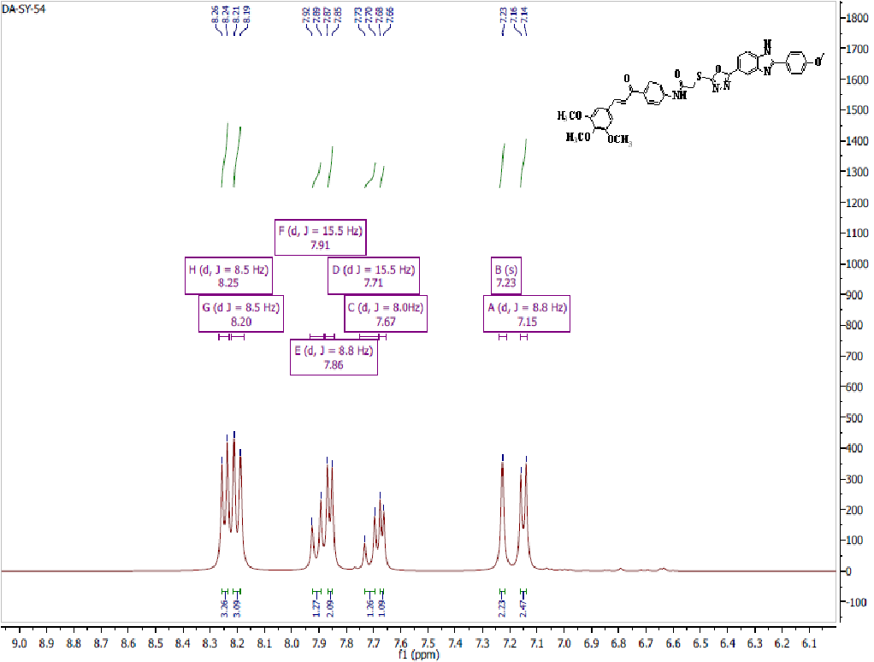
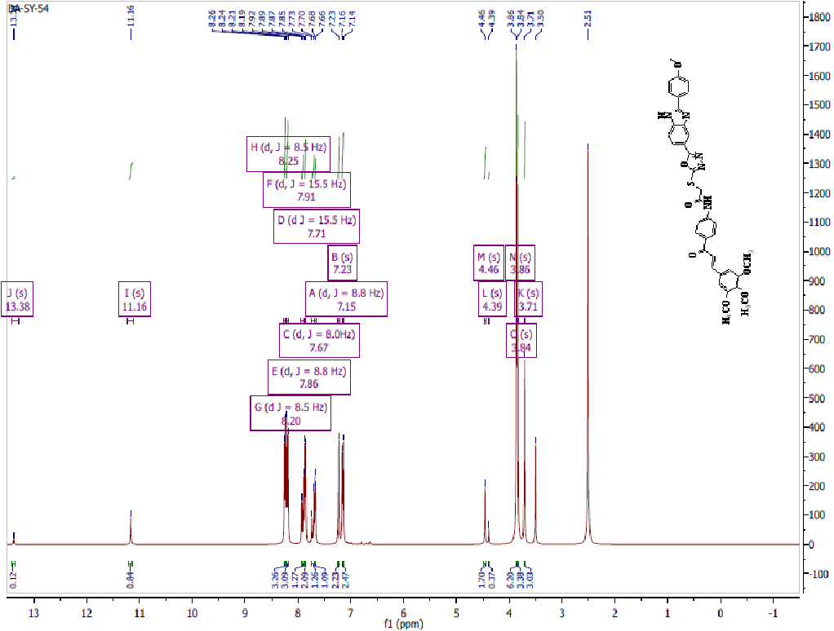
Fig.S37. ¹H NMR of compound 7o (500 MHz, DMSO-d₆)
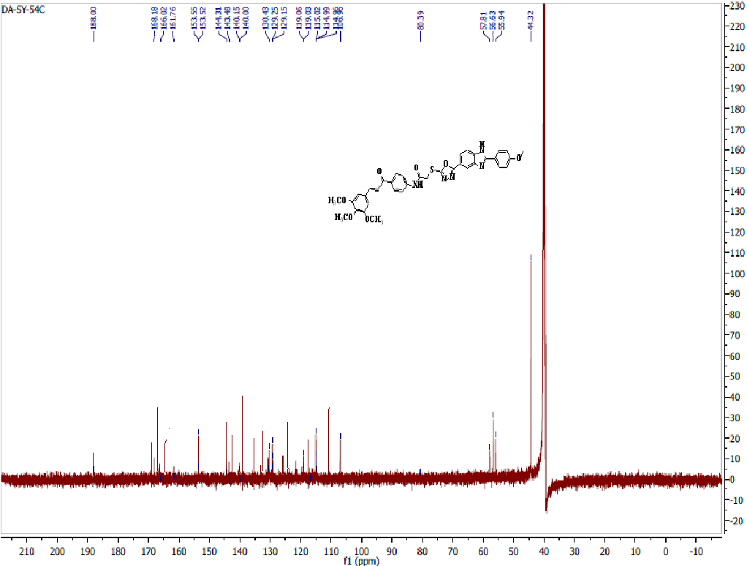
Fig38. ¹³C NMR of compound 7o (125 MHz, DMSO-d₆)

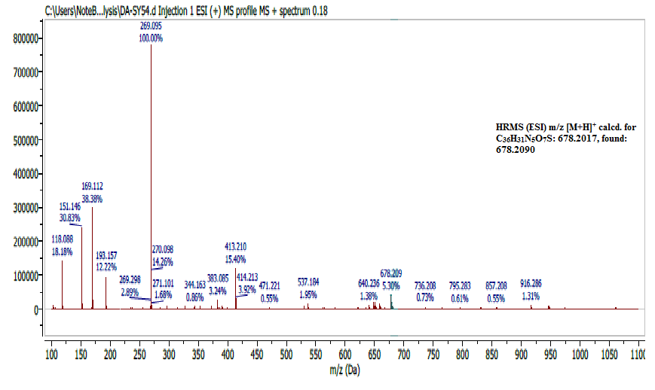
Fig.S39. HRMS (ESI) spectrum of compound 7o.

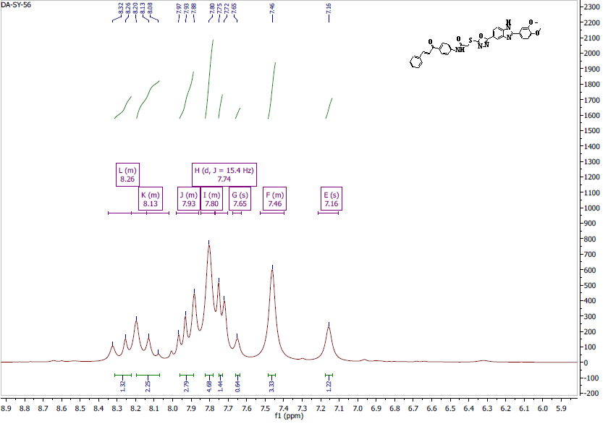
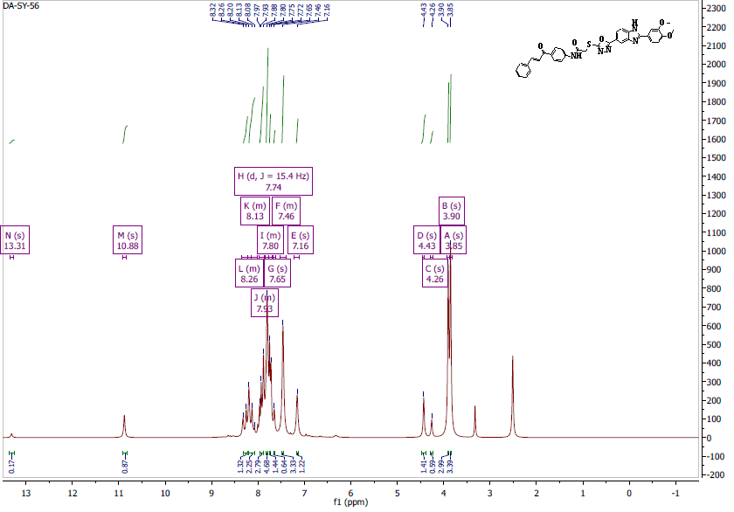
Fig.S40. ¹H NMR of compound 7p (500 MHz, DMSO-d₆)

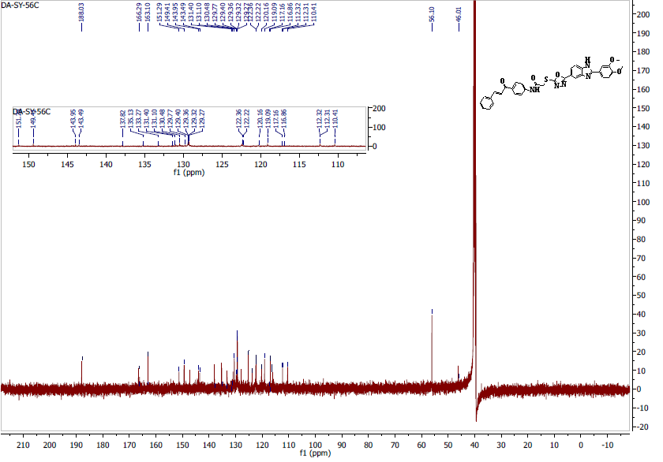

Fig.S41. ¹³C NMR of compound 7p (125 MHz, DMSO-d₆)

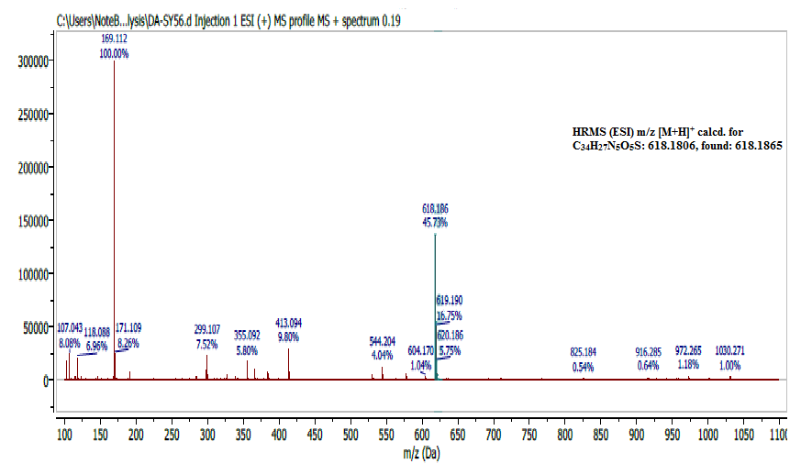
Fig.S42. HRMS (ESI) spectrum of compound 7p.

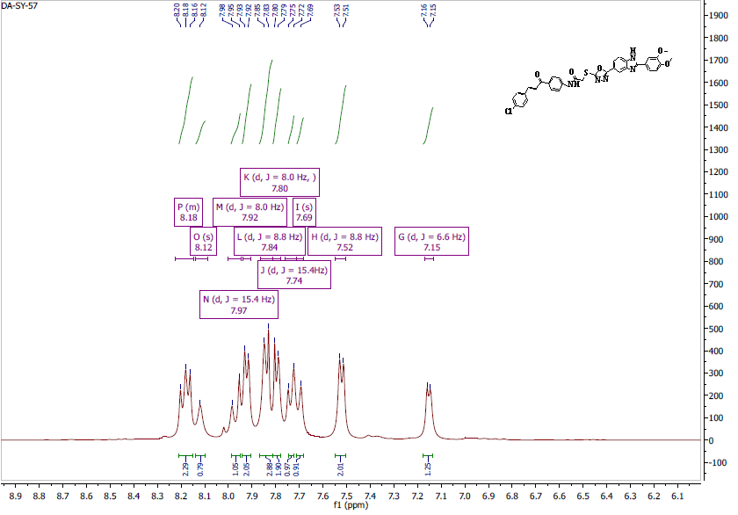
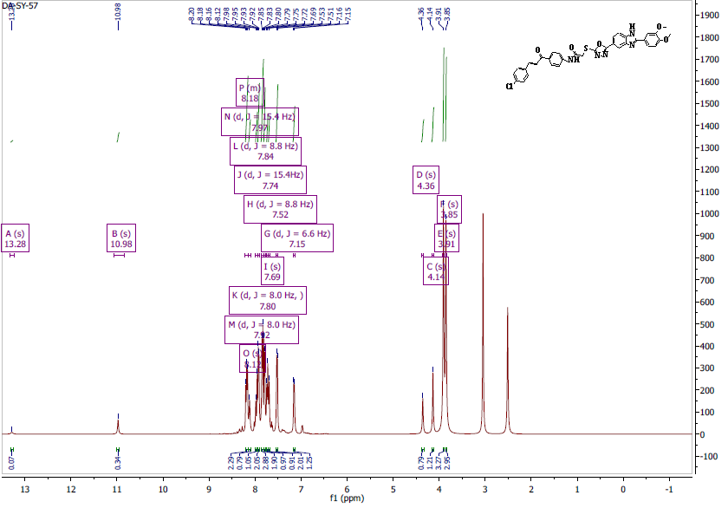
Fig.S43. ¹H NMR of compound 7q (400 MHz, DMSO-d₆)

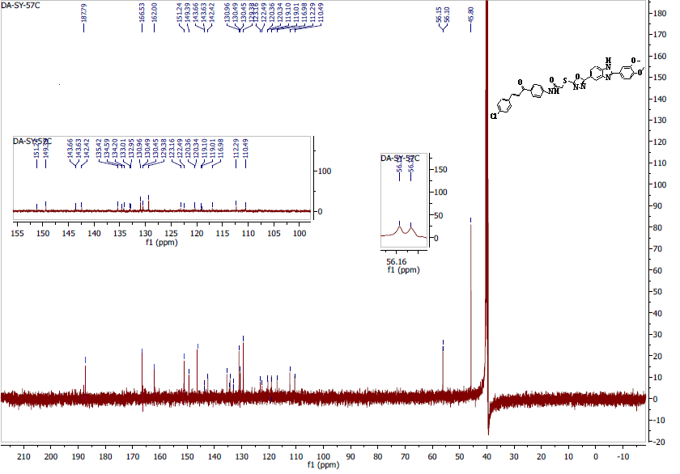
Fig.S44. ¹³C NMR of compound 7q (100 MHz, DMSO-d₆)

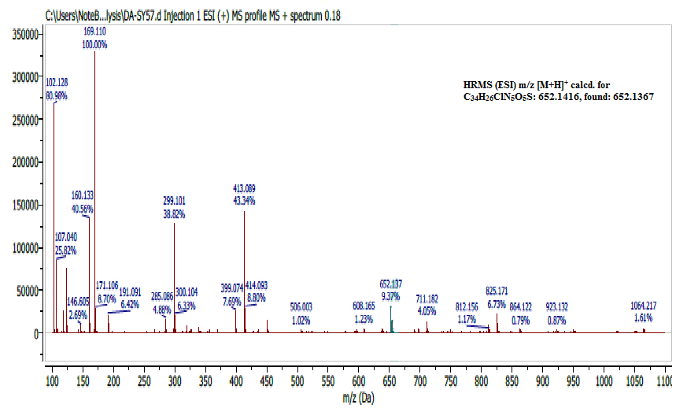
Fig.S 45. HRMS (ESI) spectrum of compound 7q
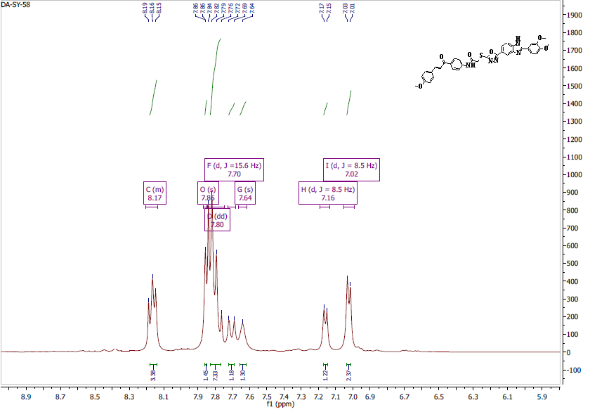
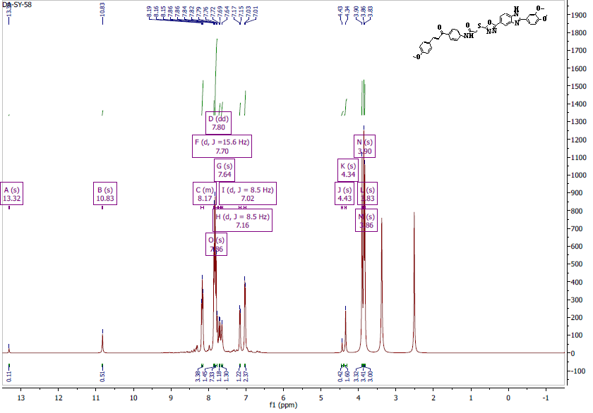
Fig.S46. ¹H NMR of compound 7r (500 MHz, DMSO-d₆)
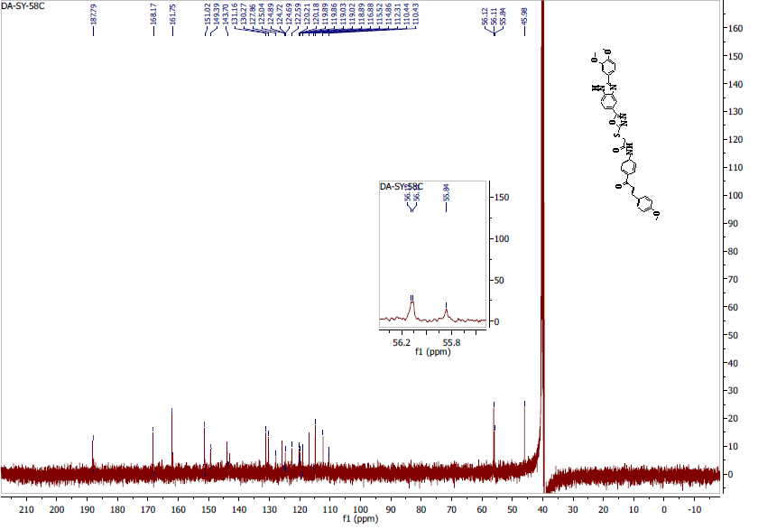
Fig.S47 ¹³C NMR of compound 7r (125 MHz, DMSO-d₆)

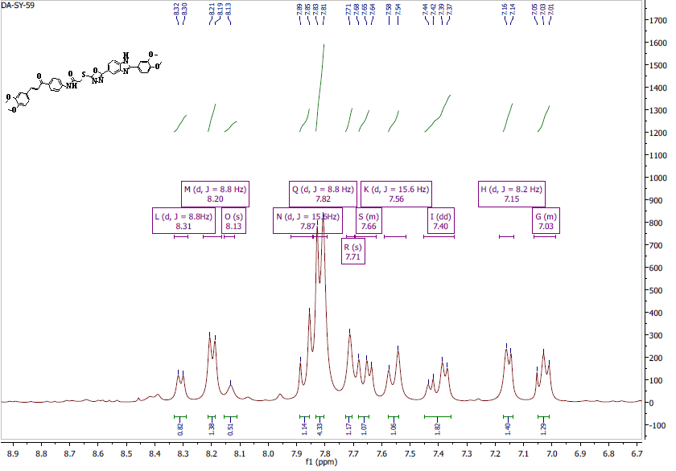
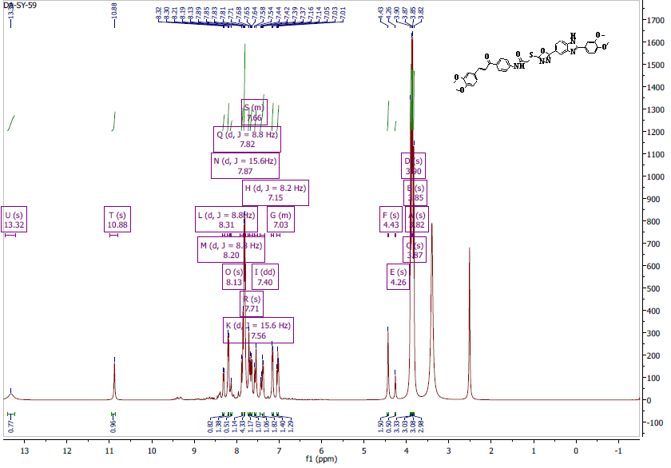
Fig.S48. ¹H NMR of compound 7s (500 MHz, DMSO-d₆).

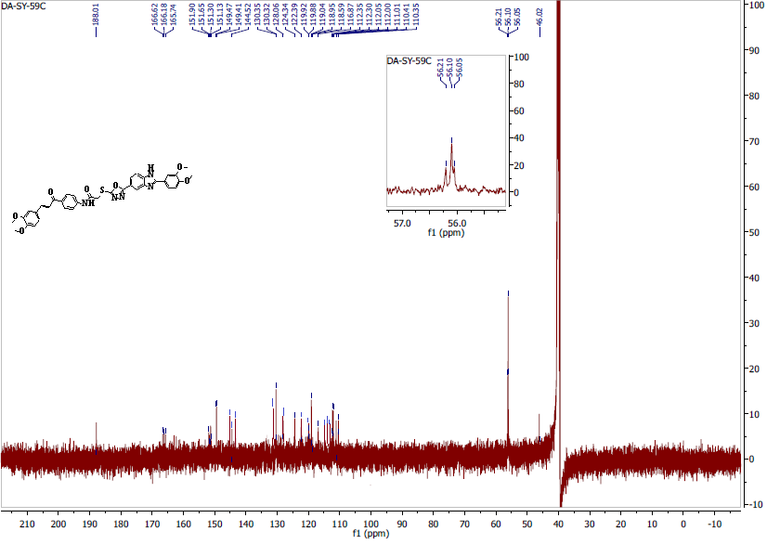
Fig.S49. ¹³C NMR of compound 7s (125 MHz, DMSO-d₆)

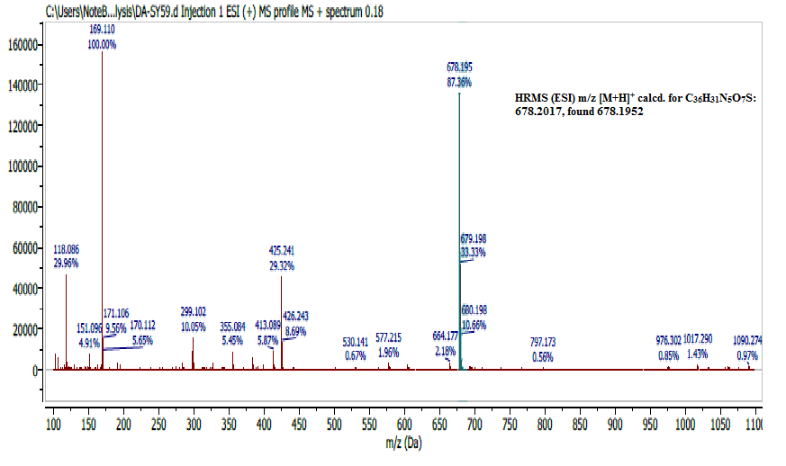
Fig.S 50: HRMS (ESI) spectrum of compound 7s.

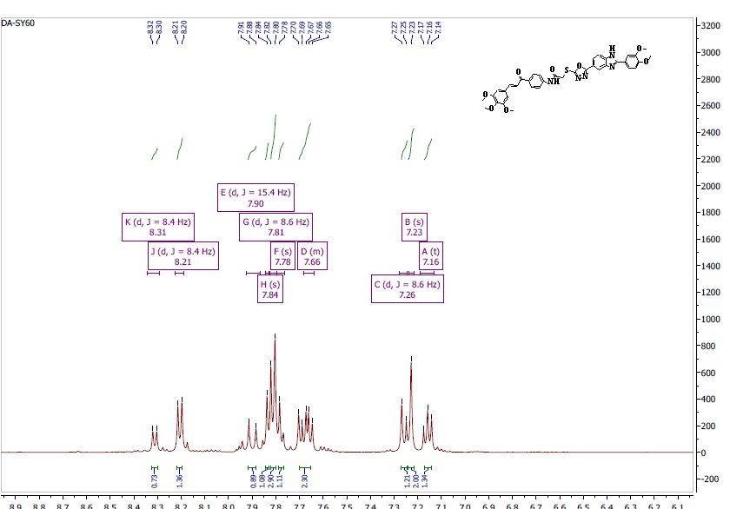
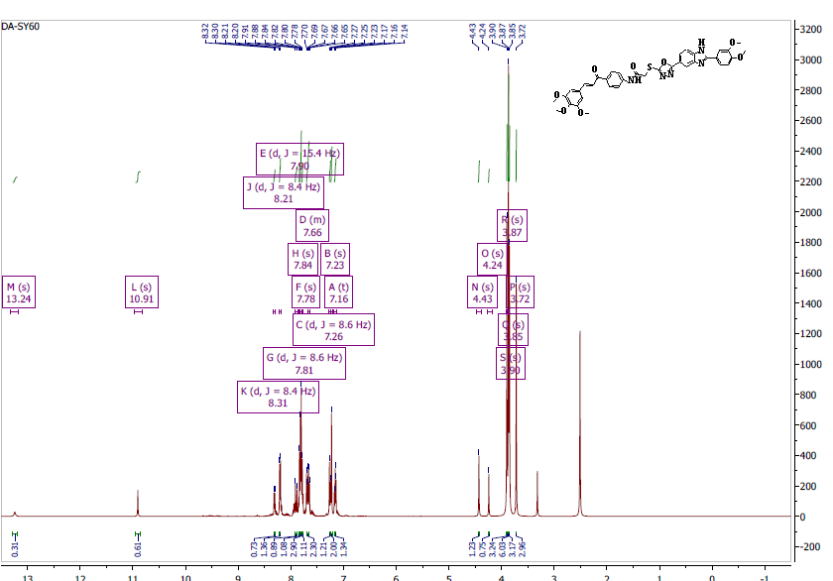
Fig.S51. ¹H NMR of compound 7t (500 MHz, DMSO-d₆)

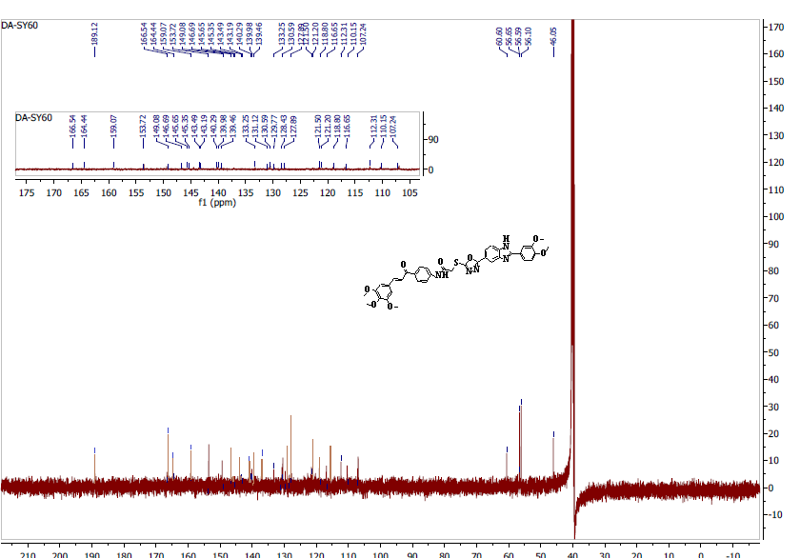
Fig.S52. ¹³C NMR of compound 7t (125 MHz, DMSO-d₆)

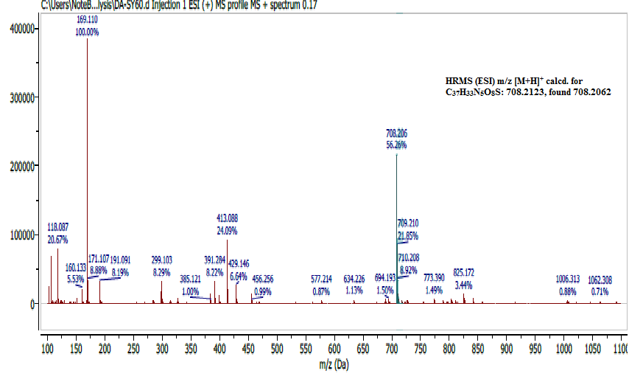
Fig.S 53: HRMS (ESI) spectrum of compound 7t.
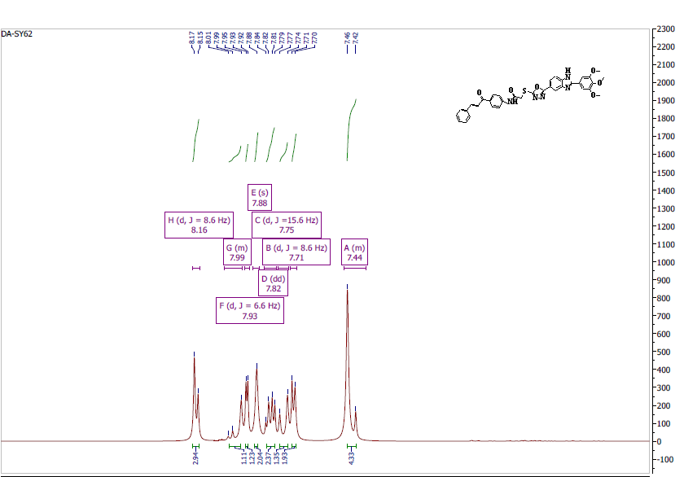
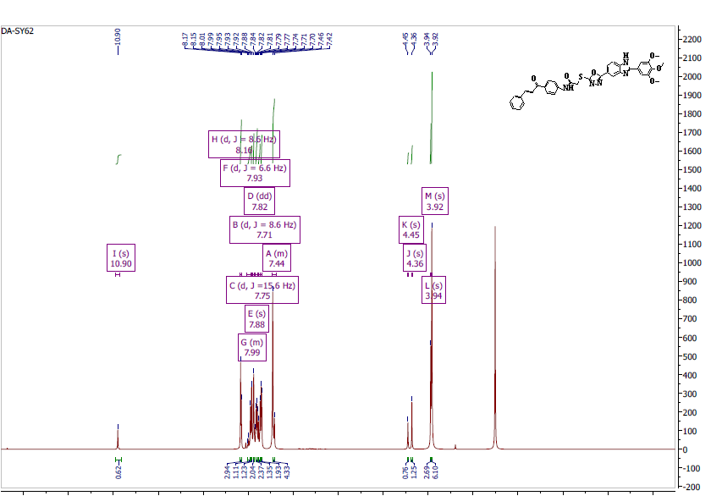
Fig.S54. ¹H NMR of compound 7u (500 MHz, DMSO-d₆)

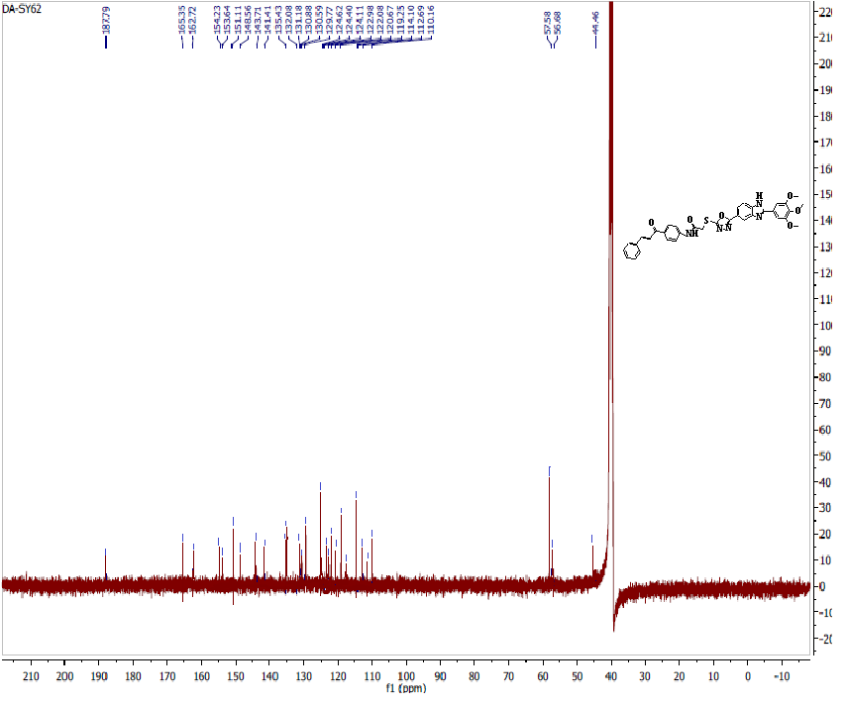
Fig.S55. ¹³C NMR of compound 7u (125 MHz, DMSO-d₆)

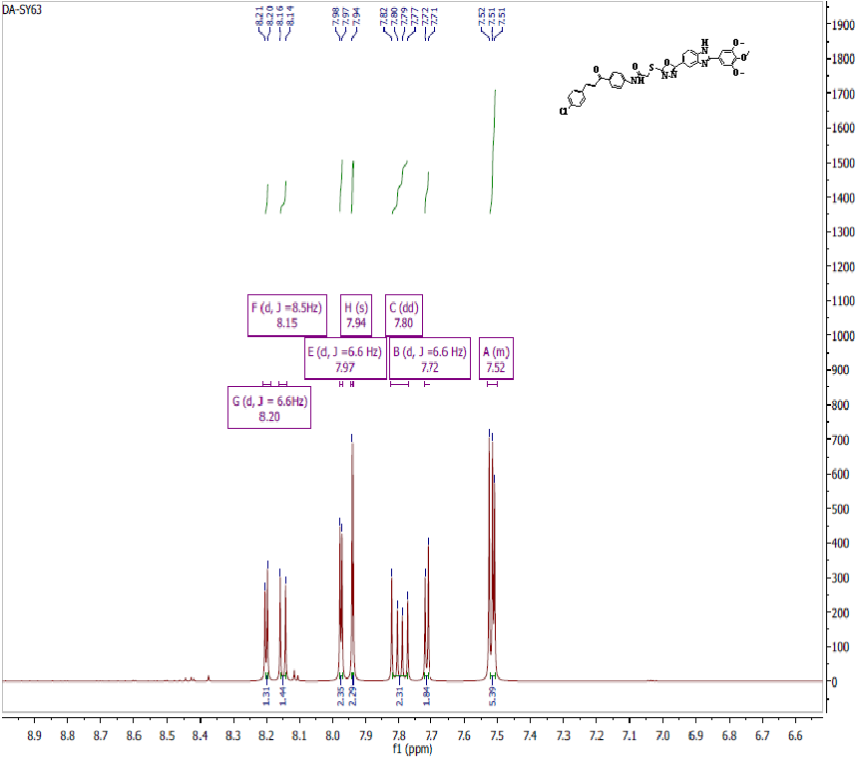
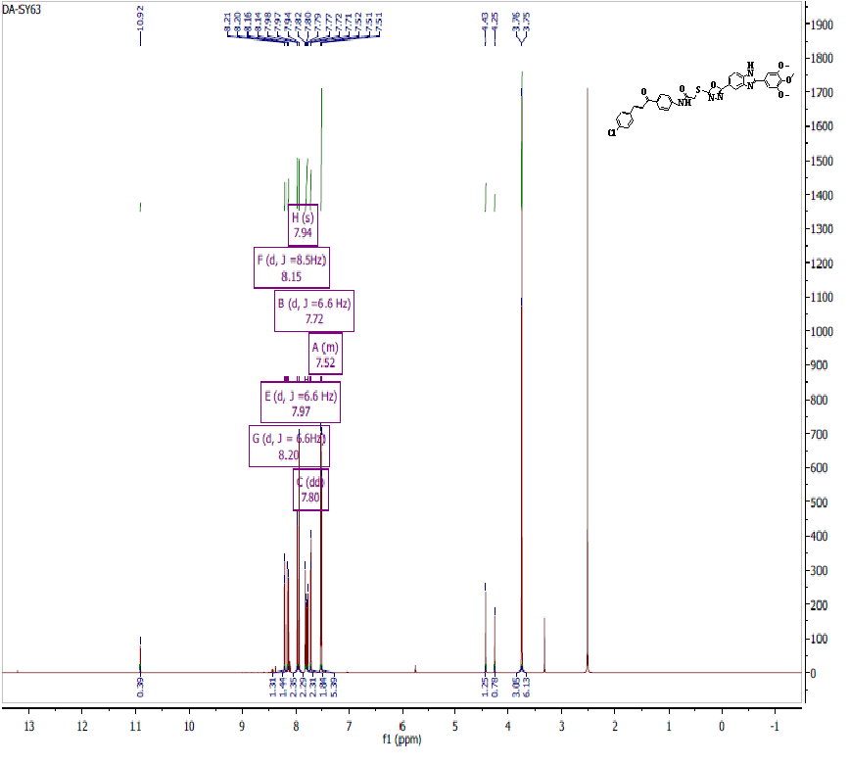
Fig.S56. ¹H NMR of compound 7v (500 MHz, DMSO-d₆).

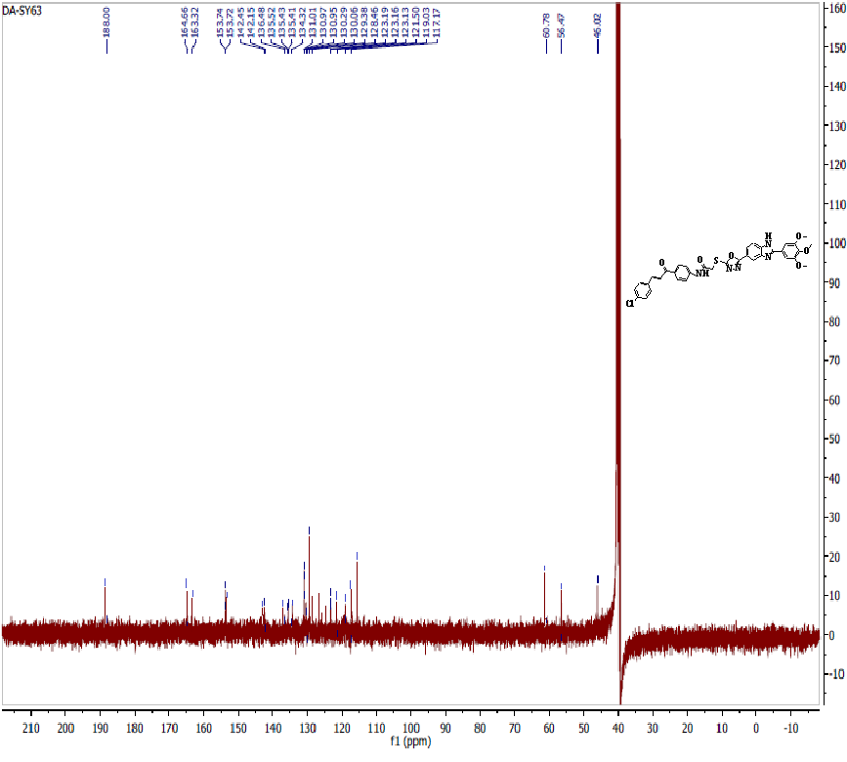
Fig.S57. ¹³C NMR of compound 7v (125 MHz, DMSO-d₆)

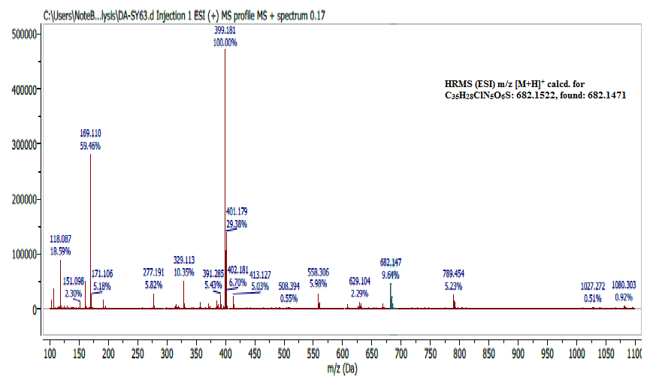
Fig.S58. HRMS (ESI) spectrum of compound 7v.
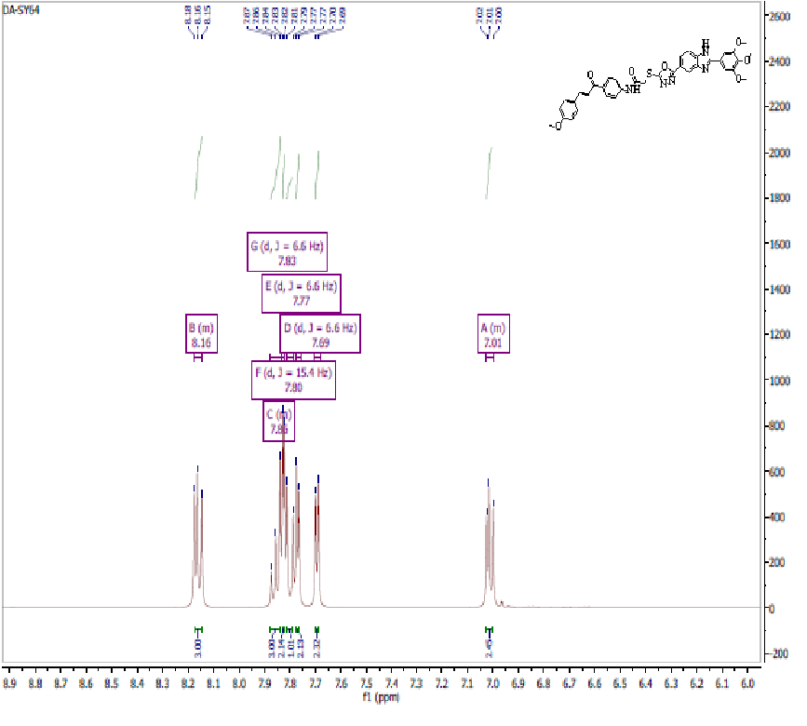
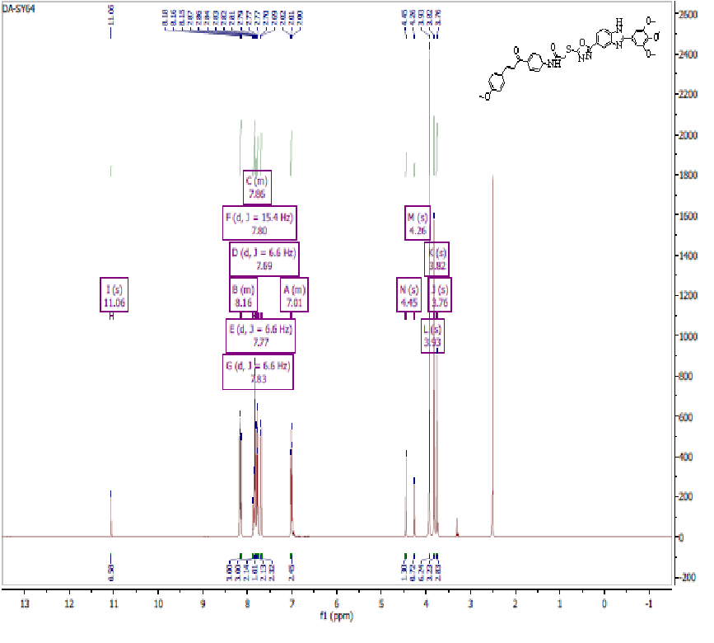
Fig.S59. ¹H NMR of compound 7w (500 MHz, DMSO-d₆)
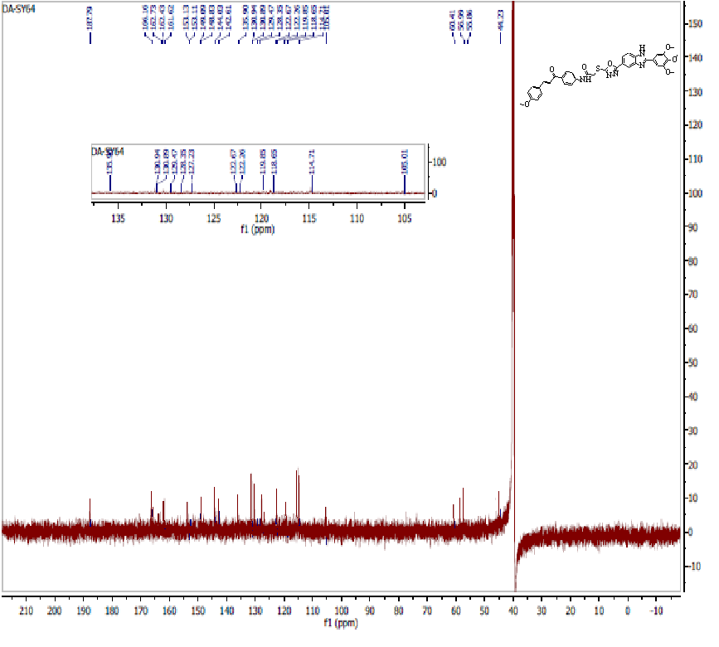
Fig.S60. ¹³C NMR of compound 7w (125 MHz, DMSO-d₆)
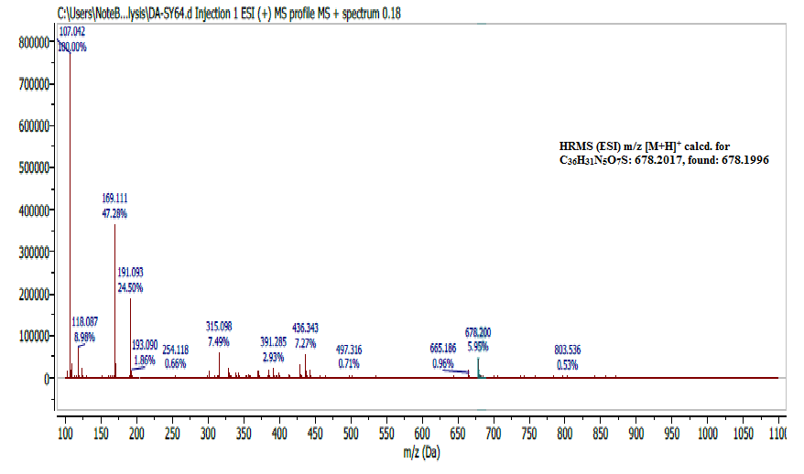
Fig.S61. HRMS (ESI) spectrum of compound 7w.

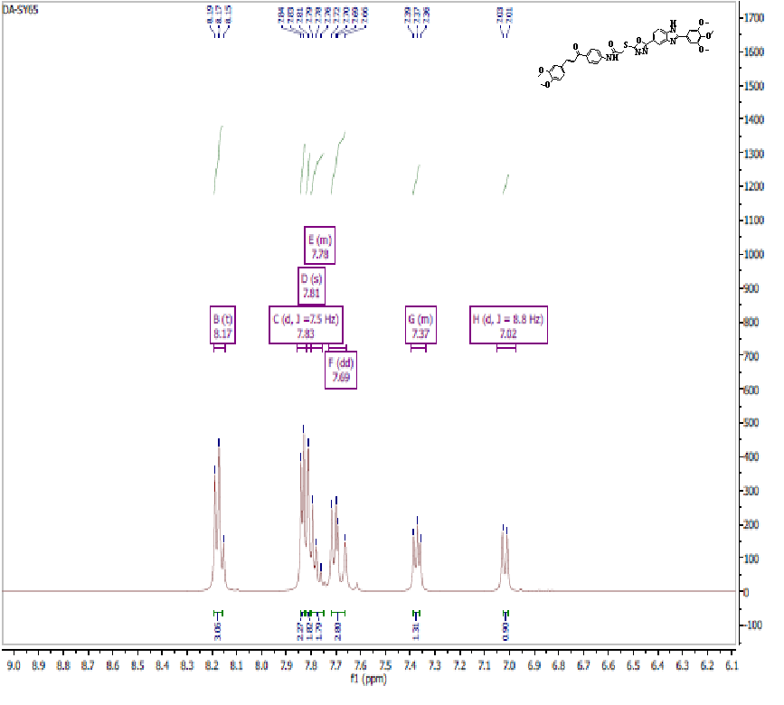
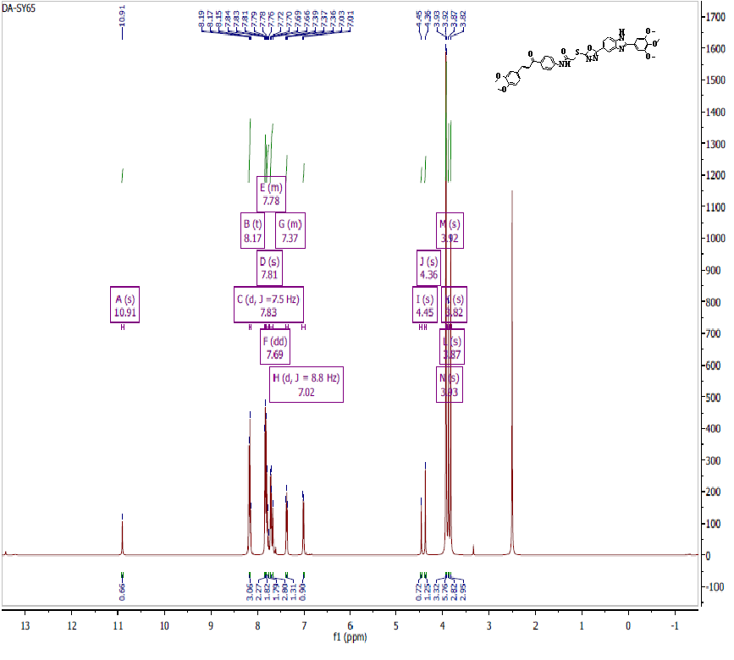
Fig.S62. ¹H NMR of compound 7x (500 MHz, DMSO-d₆)
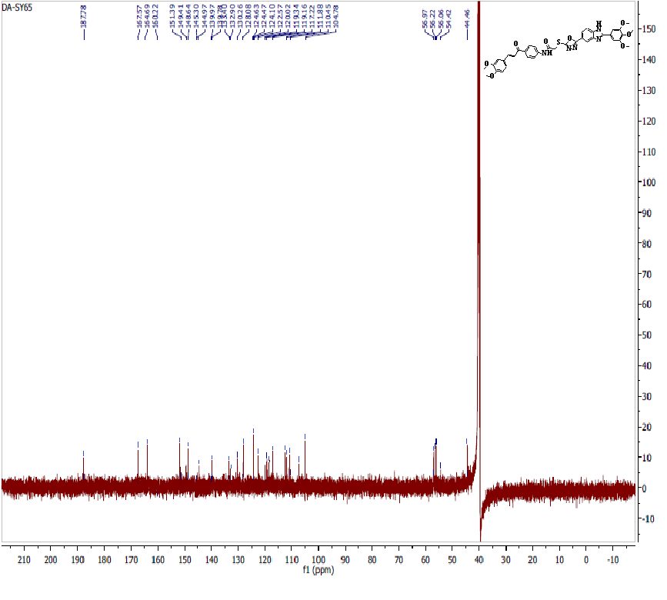
Fig.S63. ¹³C NMR of compound 7x (125 MHz, DMSO-d₆)

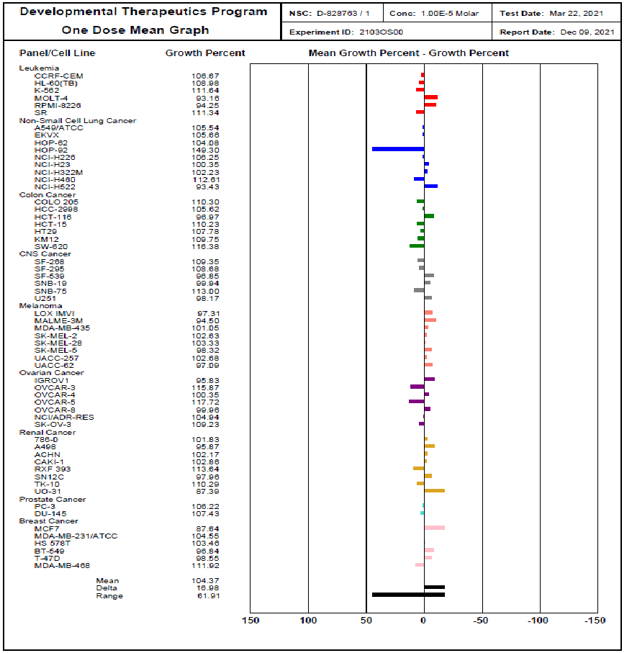
Fig.S64. one dose mean graph of nine different cancer cell line panels for compound 7a

Fig.S65.One dose mean graph of nine different cancer cell line panels for compound 7b
Fig.S66. one dose mean graph of nine different cancer cell line panels for compound 7c
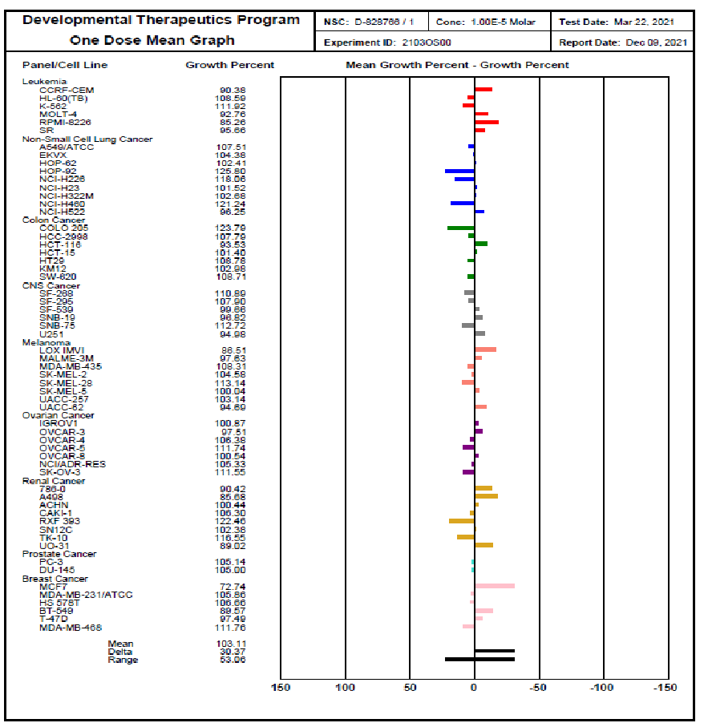
Fig.S67. one dose mean graph of nine different cancer cell line panels for compound 7d

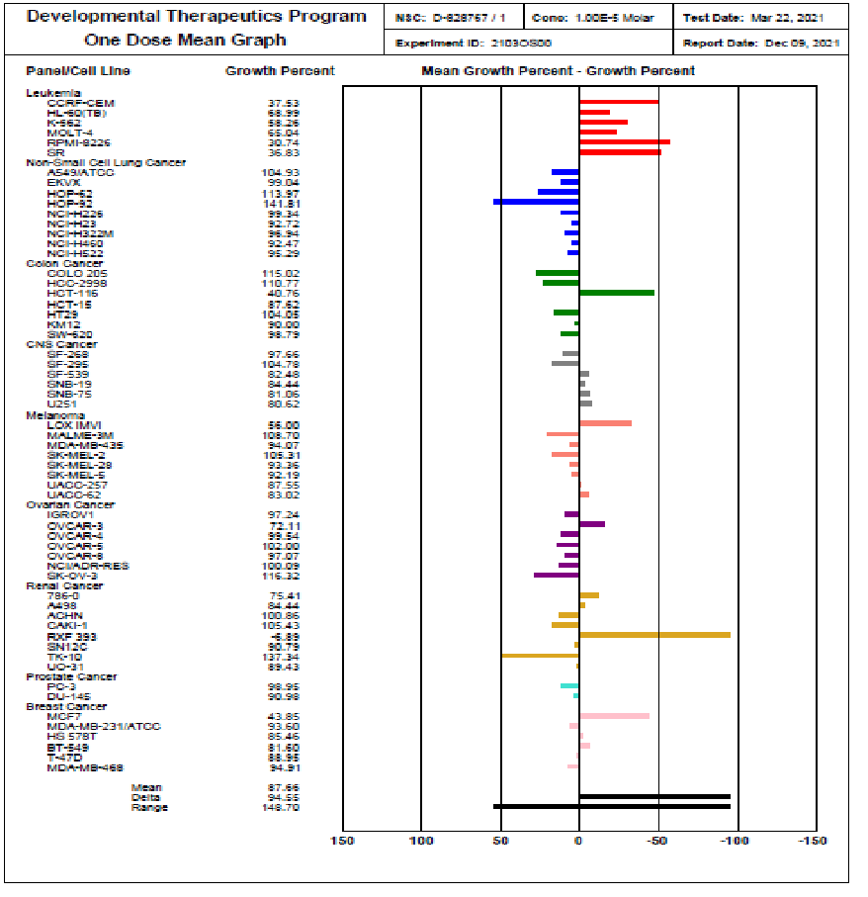
Fig.S68.One dose mean graph of nine different cancer cell line panels for compound 7e
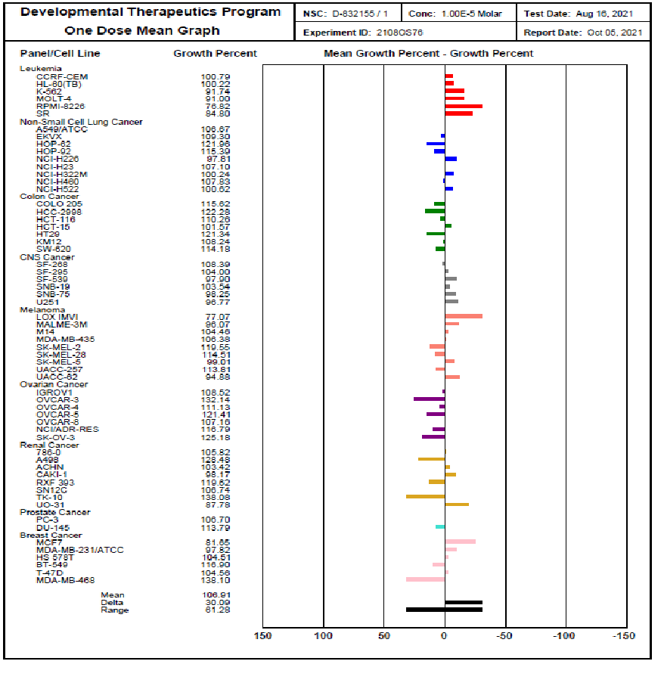
Fig.S69.One dose mean graph of nine different cancer cell line panels for compound 7f
Fig.S70.One dose mean graph of nine different cancer cell line panels for compound 7g
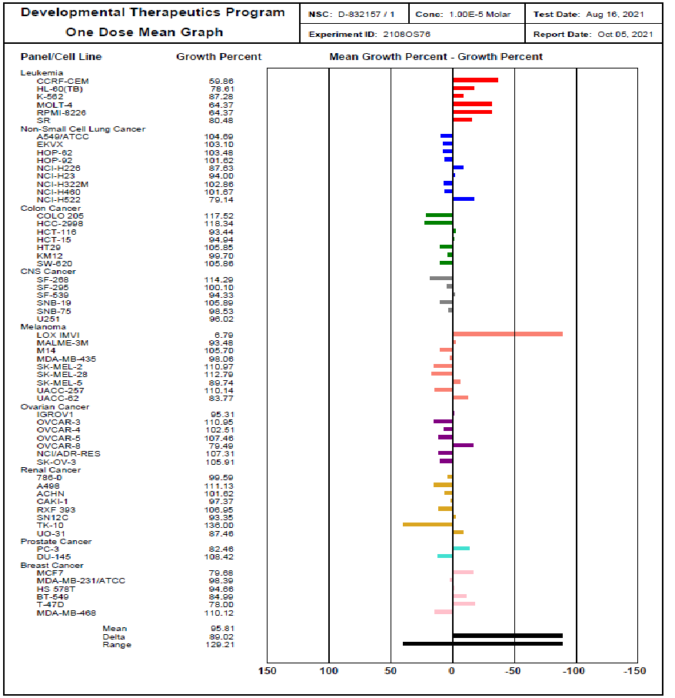
Fig.S71.One dose mean graph of nine different cancer cell line panels for compound 7h
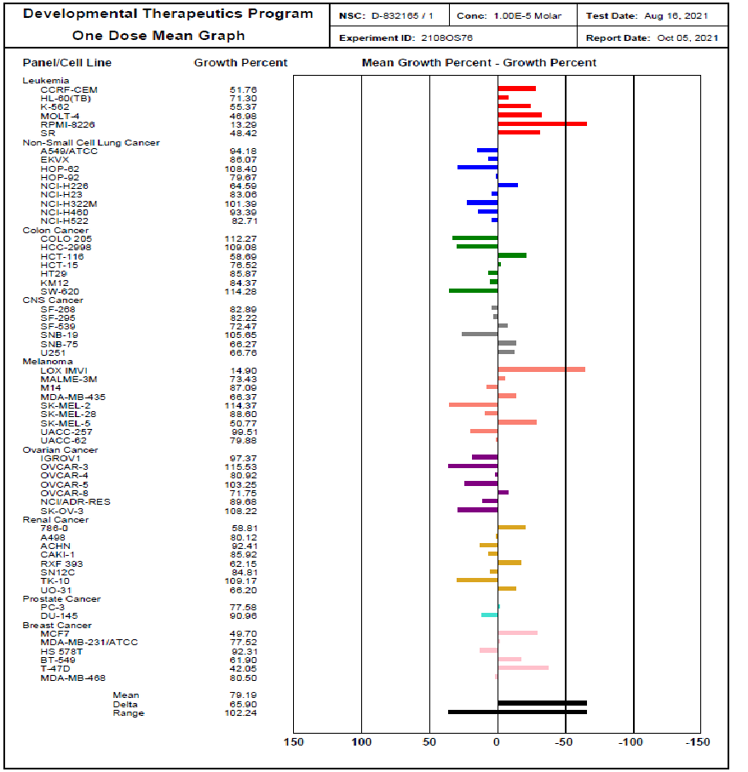
Fig.S72.One dose mean graph of nine different cancer cell line panels for compound 7k
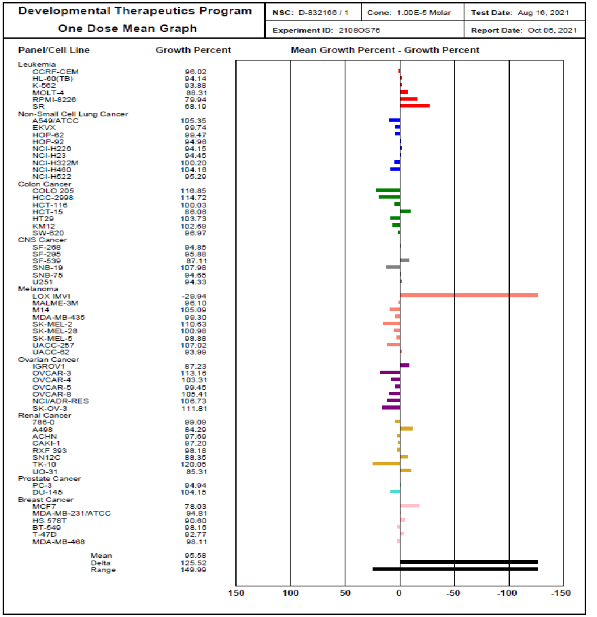
Fig.S73.One dose mean graph of nine different cancer cell line panels for compound 7l
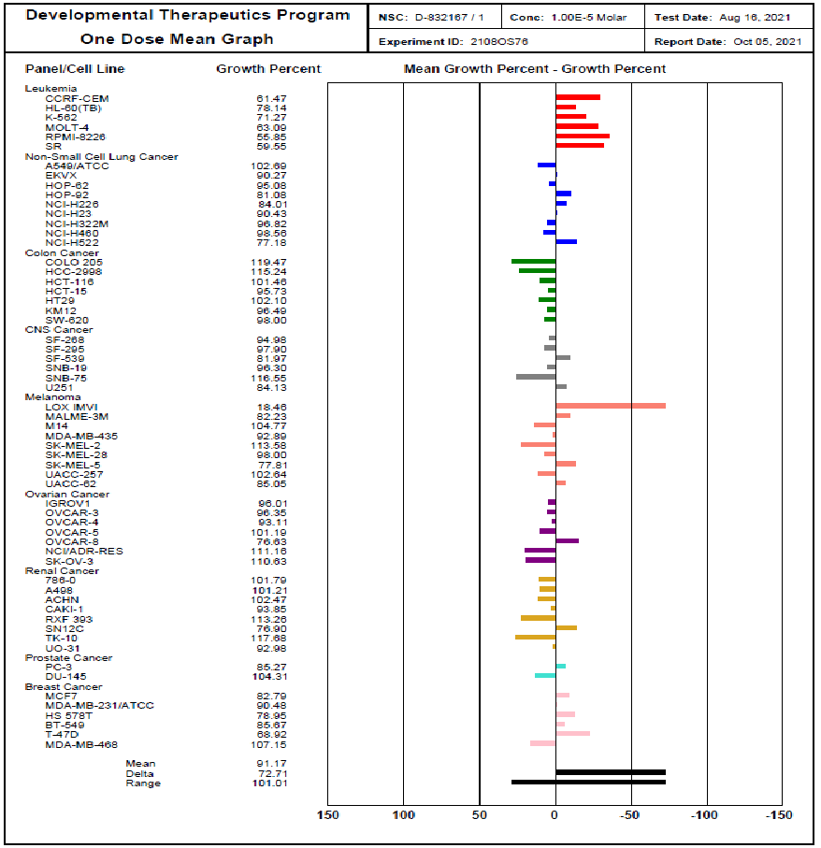
Fig.S74.One dose mean graph of nine different cancer cell line panels for compound 7m
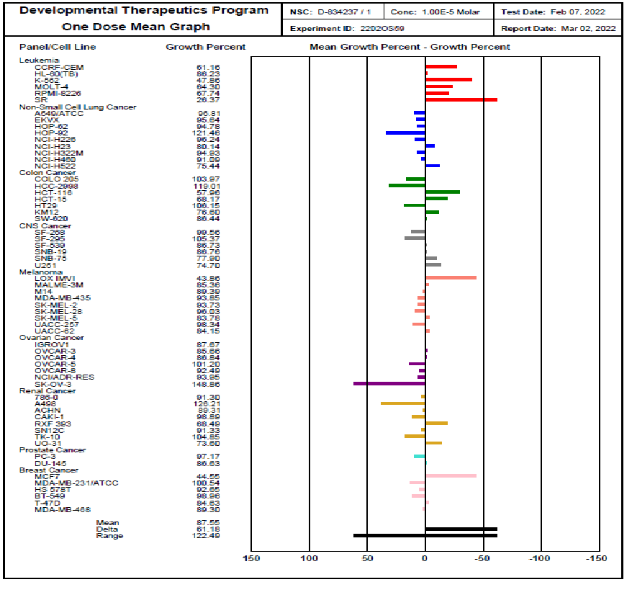
Fig75.One dose mean graph of nine different cancer cell line panels for compound 7n
Fig.S76.One dose mean graph of nine different cancer cell line panels for compound 7o
Fig.S77.One dose mean graph of nine different cancer cell line panels for compound 7p
Fig.S78.One dose mean graph of nine different cancer cell line panels for compound 7q.
Fig.S79.One dose mean graph of nine different cancer cell line panels for compound 7r.
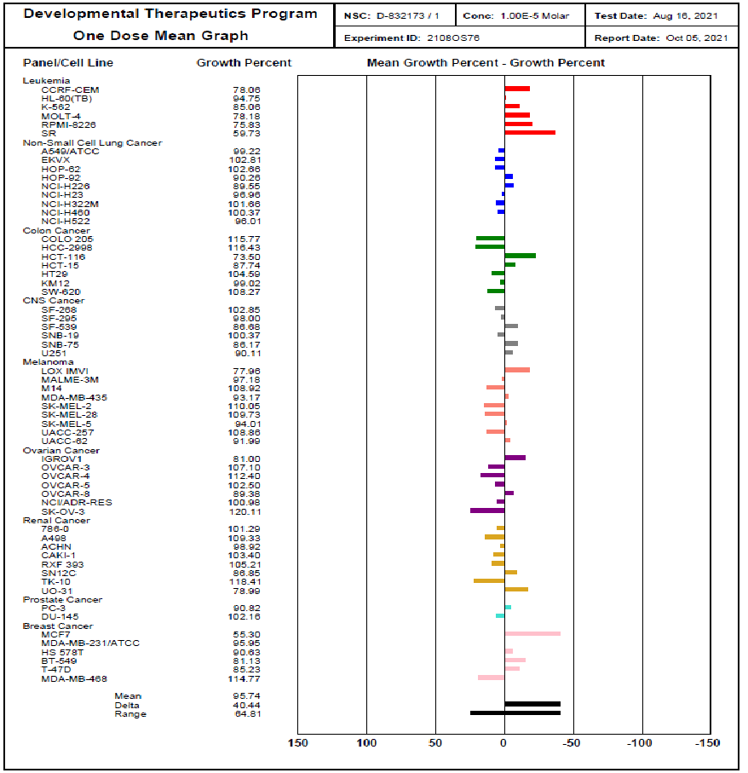
Fig.S80.One dose mean graph of nine different cancer cell line panels for compound 7u.

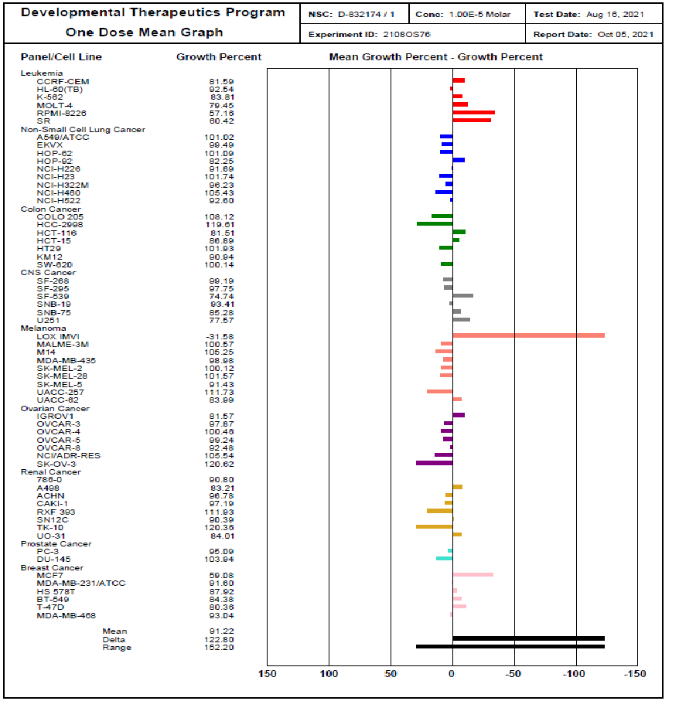
Fig.S81.One dose mean graph of nine different cancer cell line panels for compound 7v.

Table S1. Cell growth inhibition % from the NCI's in vitro human tumor cell screen for compounds 7a:7e and 7k:7o.
Leukemia
Panel/ Cell lines | Compounds
Panel/ Cell lines | 7a |  | 7b |  | 7c |  | 7d |  | 7e | 7k | 7l | 7m |  | 7n | 7o
CCRF-CEM | 0 |  | 0 |  | 34.46 |  | 9.62 |  | 62.47 | 48.24 | 3.98 |  | 38.53 | 38.84 | 0
HL-60(TB) | 0 |  | 0 |  | 5.24 |  | 0 |  | 31.01 | 28.70 | 5.86 |  | 21.86 | 13.77 | 0
K-562 | 0 |  | 0 |  | 3.83 |  | 0 |  | 41.74 | 44.63 | 6.12 |  | 28.73 | 52.14 | 8.26
MOLT-4 | 6.84 |  | 6.55 |  | 23.88 |  | 7.24 |  | 34.98 | 53.02 | 11.69 |  | 36.91 | 35.70 | 9.00
RPMI-8226 | 5.75 |  | 12.23 |  | 50.87 |  | 14.74 |  | 69.26 | 86.71 | 20.06 |  | 44.15 | 32.26 | 23.18
SR | 0 |  | 3.59 |  | 12.71 |  | 4.34 |  | 63.17 | 51.58 | 31.81 |  | 40.45 | 73.63 | 15.20
Non-Small Cell Lung Cancer
A549/ATCC | 0 | 0 |  | 0 |  | 0 |  |  | 0 | 5.82 | 0 |  | 0 | 3.19 | 0
EKVX | 0 | 0 |  | 0 |  | 0 |  |  | 0.96 | 13.93 | 0.26 |  | 9.73 | 4.36 | 0
HOP-62 | 0 | 0 |  | 0 |  | 0 |  |  | 0 | 0 | 0.53 |  | 4.92 | 5.22 | 0
HOP-92 | 0 | 0 |  | 0 |  | 0 |  |  | 0 | 20.33 | 5.04 |  | 18.92 | 0 | 0
NCI-H226 | 0 | 3.63 |  | 2.2 |  | 0 |  |  | 0.66 | 35.41 | 5.85 |  | 15.99 | 3.76 | 2.19
NCI-H23 | 0 | 0 |  | 7.79 |  | 0 |  |  | 7.28 | 16.94 | 5.55 |  | 9.57 | 19.86 | 0
NCI-H322M | 0 | 0 |  | 0 |  | 0 |  |  | 3.06 | 0 | 0 |  | 3.18 | 5.07 | 0
NCI-H460 | 0 | 0 |  | 0 |  | 0 |  |  | 7.53 | 6.61 | 0 |  | 1.44 | 8.91 | 0
NCI-H522  Table 1. Cell growth inhibition % from the NCI's in vitro human tumor cell screen for compounds 9a-o | 6.57 | 11.64 |  | 8.81 |  | 3.75 |  |  | 4.71 | 17.29 | 4.71 |  | 22.82 | 24.56 | 0
Panel/ cell line | Compounds  F2  F3  F4  F19  F20  F21  F22  F23  F24
Panel/ cell line | 7a | 7b |  | 7c |  | 7d |  |  | 7e | 7k | 7l |  | 7m | 7n | 7o
Colon cancer
COLO 205 | 0 | 0 |  | 0 |  | 0 |  |  | 0 | 0 | 0 |  | 0 | 0 | 0
HCC-2998 | 0 | 0 |  | 0 |  | 0 |  |  | 0 | 0 | 0 |  | 0 | 0 | 0
HCT-116 | 3.03 | 8.66 |  | 15.08 |  | 6.47 |  |  | 59.24 | 41.31 | 0 |  | 0 | 42.04 | 0
HCT-15 | 0 | 0 |  | 3.81 |  | 0 |  |  | 12.38 | 23.48 | 13.94 |  | 4.27 | 31.83 | 0
HT29 | 0 | 0 |  | 1.01 |  | 0 |  |  | 0 | 14.13 | 0 |  | 0 | 0 | 0
KM12 | 0 | 0 |  | 1.55 |  | 0 |  |  | 10.00 | 15.63 | 0 |  | 3.51 | 23.40 | 0
SW-620 | 0 | 0 |  | 0 |  | 0 |  |  | 1.21 | 0 | 3.03 |  | 2 | 13.56 | 0
CNS Cancer
SF-268 | 0 | 0 |  | 0 |  | 0 |  |  | 2.34 | 17.11 | 5.15 |  | 5.02 | 0.44 | 0
SF-295 | 0 | 0 |  | 1.65 |  | 0 |  |  | 0 | 17.78 | 4.12 |  | 2.10 | 0 | 0
SF-539 | 3.15 | 4.06 |  | 8.76 |  | 0.34 |  |  | 17.52 | 27.53 | 12.89 |  | 18.03 | 13.27 | 2.10
SNB-19 | 0.06 | 3.92 |  | 7.28 |  | 3.18 |  |  | 15.56 | 0 | 0 |  | 3.70 | 13.24 | 0
SNB-75 | 0 | 0 |  | 0 |  | 0 |  |  | 18.94 | 33.73 | 5.35 |  | 0 | 22.10 | 1.75
U251 | 1.83 | 7.14 |  | 17.24 |  | 5.02 |  |  | 19.38 | 33.24 | 5.67 |  | 15.87 | 25.30 | 3.23
Prostate Cancer
PC-3 | 0 | 0.53 |  | 5.12 |  | 0 |  |  | 1.05 | 22.42 | 5.06 |  | 14.73 | 2.83 | 0
DU-145 | 0 | 0 |  | 0 |  | 0 |  |  | 9.02 | 9.04 | 0 |  | 0 | 13.37 | 0
Table S1(continuous). Cell growth inhibition % from the NCI's in vitro human tumor cell screen for compounds 7a:7e and 7k:7o.
Panel/Cell Line | Compounds  F1  F2  F3  F4  F19  F20  F21  F22  F23  F24
Panel/Cell Line | 7a | 7b |  | 7c |  | 7d |  |  | 7e | 7k | 7l |  | 7m | 7n | 7o
Melanoma
LOX IMVI | 2.69 | 12.87 |  | 6.46 |  | 13.49 |  | 44.00 |  | 85.10 | 129.94 |  | 81.54 | 56.14 | 22.93
MALME-3M | 5.5 | 0 |  | 8.64 |  | 2.37 |  | 0 |  | 26.57 | 3.90 |  | 17.77 | 14.64 | 3.93
M14 | - | - |  | - |  | - |  | - |  | 12.91 | 0 |  | 0 | 10.61 | 0
MDA-MB-435 | 0 | 0 |  | 0 |  | 0 |  | 5.93 |  | 33.63 | 0.7 |  | 7.11 | 6.15 | 0
SK-MEL-2 | 0 | 0 |  | 2.65 |  | 0 |  | 0 |  | 0 | 0 |  | 0 | 6.27 | 0
SK-MEL-28 | 0 | 0 |  | 0 |  | 0 |  | 6.64 |  | 11.40 | 0 |  | 2.00 | 3.97 | 0
SK-MEL-5 | 1.68 | 3.35 |  | 16.82 |  | 0 |  | 7.81 |  | 49.23 | 1.12 |  | 22.19 | 16.22 | 0.99
UACC-257 | 0 | 0 |  | 0 |  | 0 |  | 12.45 |  | 0.49 | 0 |  | 0 | 1.66 | 0
UACC-62 | 2.91 | 11.64 |  | 9.5 |  | 5.31 |  | 16.98 |  | 20.12 | 6.01 |  | 14.95 | 15.85 | 5.12
Ovarian Cancer
IGROV1 | 4.17 | 15.31 |  | 0 |  | 0 |  |  | 2.76 | 2.63 | 12.77 |  | 3.99 | 12.33 | 0
OVCAR-3 | 0 | 0 |  | 0 |  | 2.49 |  |  | 27.89 | 0 | 0 |  | 3.65 | 14.34 | 0
OVCAR-4 | 0 | 0 |  | 0 |  | 0 |  |  | 0.46 | 19.08 | 0 |  | 6.89 | 13.16 | 0
OVCAR-5 | 0 | 0 |  | 0 |  | 0 |  |  | 0 | 0 | 0.55 |  | 0 | 0 | 0
OVCAR-8 | 0.04 | 2.36 |  | 9.58 |  | 0 |  |  | 2.93 | 28.25 | 0 |  | 23.37 | 7.51 | 0
NCI/ADR-RES | 0 | 0 |  | 0 |  | 0 |  |  | 0 | 10.32 | 0 |  | 0 | 6.05 | 0
SK-OV-3 | 0 | 0 |  | 0 |  | 0 |  |  | 0 | 0 | 0 |  | 0 | 0 | 0
Table S1. Cell growth inhibition % from the NCI's in vitro human tumor cell screen for compounds 7a:7e and 7k:7o.
Panel/Cell Line | Compounds
Panel/Cell Line | 7a | 7b |  | 7c |  | 7d |  | 7e |  | 7k | 7l |  | 7m | 7n | 7o
Renal cancer
786-0 | 0 | 2.96 |  | 22.55 |  | 9.58 |  | 24.59 |  | 41.19 | 0.91 |  | 0 | 8.70 | 0
A498 | 4.13 | 6.84 |  | 22.56 |  | 14.32 |  | 15.56 |  | 19.88 | 15.71 |  | 0 | 0 | 0
ACHN | 0 | 0 |  | 2.58 |  | 0 |  | 0 |  | 7.59 | 2.31 |  | 0 | 10.69 | 0
CAKI-1 | 0 | 1.52 |  | 0 |  | 0 |  | 0 |  | 14.08 | 2.80 |  | 6.15 | 1.11 | 1.83
RXF 393 | 0 | 0 |  | 8.38 |  | 0 |  | 106.89 |  | 37.85 | 1.82 |  | 0 | 31.51 | 0
SN 12C | 2.04 | 9.80 |  | 3.32 |  | 0 |  | 9.21 |  | 15.19 | 11.65 |  | 23.10 | 8.67 | 0
TK-10 | 0 | 0 |  | 0 |  | 0 |  | 0 |  | 0 | 0 |  | 0 | 0 | 0
UO-31 | 12.61 | 25.50 |  | 8.67 |  | 10.98 |  | 10.57 |  | 33.80 | 14.69 |  | 7.02 | 26.40 | 12.22
Breast cancer
MCF7 | 12.36 | 16.81 |  | 27.48 |  | 27.26 |  | 56.15 |  | 50.3 | 21.97 |  | 17.21 | 55.45 | 18.35
MDA-MB-231/ATCC | 0 | 4.03 |  | 0 |  | 0 |  | 6.4 |  | 22.48 | 5.19 |  | 9.52 | 0 | 2.18
HS 578T | 0 | 0 |  | 0 |  | 0 |  | 14.54 |  | 7.69 | 9.40 |  | 21.05 | 7.35 | 0
BT-549 | 3.16 | 1.92 |  | 18.67 |  | 10.43 |  | 18.40 |  | 38.10 | 1.84 |  | 14.33 | 1.04 | 0
T-47D | 1.45 | 12.32 |  | 47.65 |  | 2.51 |  | 11.05 |  | 57.95 | 7.23 |  | 31.08 | 15.37 | 0
MDA-MB-468 | 0 | 0 |  | 0 |  | 0 |  | 5.09 |  | 19.50 | 1.89 |  | 0 | 10.70 | 0

Table S2. Cell growth inhibition % from the NCI's in vitro human tumor cell screen for compounds 7p, 7q, 7r, 7u, 7v and 7f to 7h.
Panel /Cell Lines | Compounds
Panel /Cell Lines | 7p | 7q | 7r | 7u | 7v | 7f | 7g | 7h
Leukemia
CCRF-CEM | 11.61 | 0 | 38.56 | 21.94 | 18.41 | 0 | 13.58 | 40.14
HL-60(TB) | 0 | 11.28 | 20.87 | 5.25 | 7.46 | 0 | 13.97 | 21.39
K-562 | 8.36 | 7.27 | 21.95 | 14.94 | 16.19 | 8.26 | 18.64 | 12.72
MOLT-4 | 19.51 | 24.22 | 34.45 | 21.82 | 20.55 | 9.00 | 22.16 | 35.36
RPMI-8226 | 35.97 | 24.53 | 14.65 | 24.17 | 42.84 | 23.18 | 95.05 | 35.63
SR | 16.41 | 27.01 | 30.61 | 40.27 | 39.58 | 15.20 | 50.25 | 19.54
Non-Small Cell Lung Cancer
A549/ATCC | 0 | 0 | 0 | 0.78 | 0 | 0 | 4.52 | 0
EKVX | 0 | 8.14 | 3.51 | 0 | 0.51 | 0 | 6.19 | 0
HOP-62 | 0 | 0 | 0 | 0 | 0 | 0 | 2.12 | 0
HOP-92 | 1.64 | 0 | 5.88 | 9.74 | 17.75 | 0 | 5.81 | 0
NCI-H226 | 1.84 | 1.46 | 2.08 | 10.45 | 8.31 | 2.19 | 14.04 | 12.37
NCI-H23 | 0.22 | 0 | 5.15 | 3.04 | 0 | 0 | 0 | 6.00
NCI-H322M | 0 | 4.21 | 1.05 | 0 | 3.77 | 0 | 4.64 | 0
NCI-H460 | 0 | 0 | 0 | 0 | 0 | 0 | 0 | 0
NCI-H522 | 1.56 | 1.57 | 14.26 | 3.99 | 7.40 | 0 | 11.61 | 20.86
Prostate Cancer
PC-3 | 0 | 2.29 | 7.58 | 9.18 | 4.91 | 0 | 12.31 | 17.54
DU-145 | 0 | 0 | 0 | 0 | 0 | 0 | 0 | 0

Continued Table S2. Cell growth inhibition % from the NCI's in vitro human tumor cell screen for compounds 7p, 7q, 7r, 7u, 7v and 7f to 7h.

Panel/ Cell Lines | Compounds
Panel/ Cell Lines | 7p | 7q | 7r | 7u | 7v | 7f | 7g | 7h
Colon Cancer
COLO 205 | 0 | 0 | 0 | 0 | 0 | 0 | 0 | 0
HCC-2998 | 0 | 0 | 0 | 0 | 0 | 0 | 0 | 0
HCT-116 | 10.31 | 0 | 3.79 | 26.50 | 18.49 | 0 | 22.16 | 6.56
HCT-15 | 8.17 | 2.92 | 2.32 | 12.26 | 13.11 | 0 | 10.23 | 5.06
HT29 | 0 | 0 | 0 | 0 | 0 | 0 | 0 | 0
KM12 | 0.98 | 0 | 0 | 0.98 | 9.06 | 0 | 0.67 | 0.30
SW-620 | 0 | 0 | 0 | 0 | 0 | 0 | 0 | 0
CNS Cancer
SF-268 | 0 | 0 | 0 | 0 | 0.81 | 0 | 0.08 | 0
SF-295 | 5.09 | 1.96 | 3.20 | 2.00 | 2.25 | 0 | 7.04 | 0
SF-539 | 16.36 | 16.20 | 7.36 | 13.32 | 25.26 | 2.10 | 15.71 | 5.67
SNB-19 | 0 | 0 | 0 | 0 | 6.59 | 0 | 0.54 | 0
SNB-75 | 9.72 | 0 | 1.88 | 13.83 | 14.72 | 1.75 | 9.09 | 1.47
U251 | 6.84 | 0 | 0 | 9.89 | 22.43 | 3.23 | 17.80 | 3.98
Melanoma
LOX IMIV | 111.79 | 96.83 | 20.17 | 22.04 | 131.58 | 22.93 | 124.15 | 93.21
MALME-3M | 2.95 | 4.86 | 8.71 | 2.82 | 0 | 3.93 | 0 | 6.52
M14 | 0 | 0 | 0 | 0 | 0 | 0 | 0 | 0
MDA-MB-435 | 0 | 0 | 0 | 6.83 | 1.02 | 0 | 0.11 | 1.94
SK-MEL-2 | 0 | 0 | 0 | 0 | 0 | 0 | 0 | 0
SK-MEL-28 | 0 | 0 | 0 | 0 | 0 | 0 | 0 | 0
SK-MEL-5 | 4.49 | 2.38 | 10.83 | 5.99 | 8.57 | 0.99 | 6.32 | 10.26
UACC-257 | 0 | 0 | 0 | 0 | 0 | 0 | 0 | 0
UACC-62 | 4.99 | 1.95 | 11.02 | 8.01 | 16.01 | 5.12 | 16.80 | 16.23
Table 2(continuous). Cell growth inhibition % from the NCI's in vitro human tumor cell screen for compounds 7p, 7q, 7r, 7u, 7v and 7f to 7h.

Panel/Cell Line | Compounds
Panel/Cell Line | 7p | 7q | 7r | 7u | 7v | 7f | 7g | 7h
Ovarian Cancer
IGROV1 | 3.63 | 8.10 | 2.07 | 29.00 | 18.43 | 0 | 14.45 | 4.69
OVCAR-3 | 0 | 0 | 0 | 0 | 2.13 | 0 | 0 | 0
OVCAR-4 | 0 | 0 | 0 | 0 | 0 | 0 | 0 | 0
OVCAR-5 | 0.55 | 4.80 | 0 | 0 | 0.76 | 0 | 0 | 0
OVCAR-8 | 0 | 0 | 11.10 | 10.62 | 7.52 | 0 | 2.88 | 20.51
NCI/ADR-RES | 0 | 0 | 0 | 0 | 0 | 0 | 0 | 0
SK-OV-3 | 0 | 0 | 0 | 0 | 0 | 0 | 0 | 0
Renal Cancer
786-0 | 0.75 | 0 | 0 | 0 | 9.2 | 0 | 7.38 | 0.41
A498 | 0 | 0 | 0 | 0 | 16.79 | 0 | 9.85 | 0
ACHN | 3.66 | 5.74 | 2.15 | 1.08 | 3.22 | 0 | 1.98 | 0
CAKI-1 | 2.96 | 0 | 0.08 | 0 | 2.81 | 1.83 | 16.36 | 2.63
RXF 393 | 0 | 0 | 0 | 0 | 0 | 0 | 0 | 0
SN 12C | 5.25 | 5.10 | 6.98 | 13.15 | 9.61 | 0 | 15.11 | 6.65
TK-10 | 0 | 0 | 0 | 0 | 0 | 0 | 0 | 0
UO-31 | 11.48 | 12.99 | 12.39 | 21.01 | 15.99 | 12.22 | 24.68 | 12.54
Breast Cancer
MCF7 | 21.71 | 24.14 | 24.69 | 44.70 | 40.92 | 18.35 | 44.78 | 20.32
MDA-MB-231/ATCC | 8.78 | 4.84 | 4.13 | 4.05 | 8.40 | 2.18 | 9.38 | 1.61
HS 578T | 3.94 | 3.98 | 13.23 | 9.37 | 12.08 | 0 | 11.03 | 5.34
BT-549 | 5.86 | 0 | 5.47 | 28.87 | 15.62 | 0 | 0.37 | 15.01
T-47D | 13.05 | 10.55 | 28.88 | 14.77 | 19.64 | 0 | 12.92 | 22.00
MDA-MB-468 | 0 | 0 | 0 | 0 | 6.96 | 0 | 0 | 0

Docking poses EGFR | No | Docking poses EGFR | No
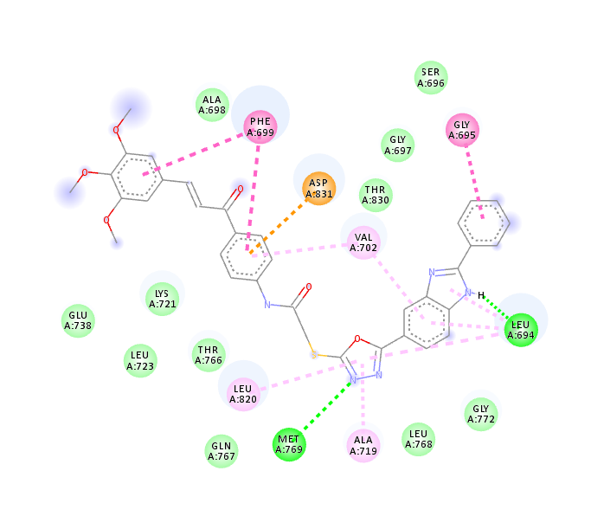 | 7e | 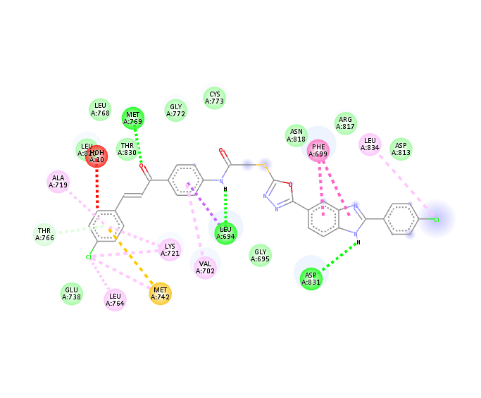 | 7g
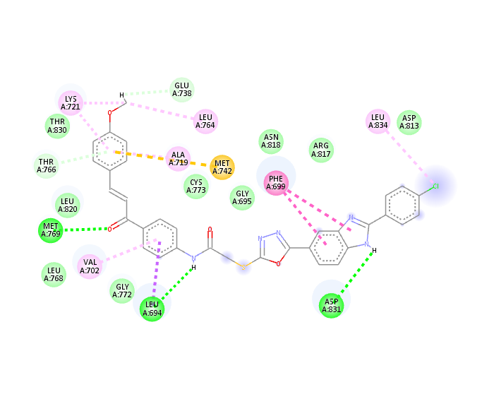 | 7h | 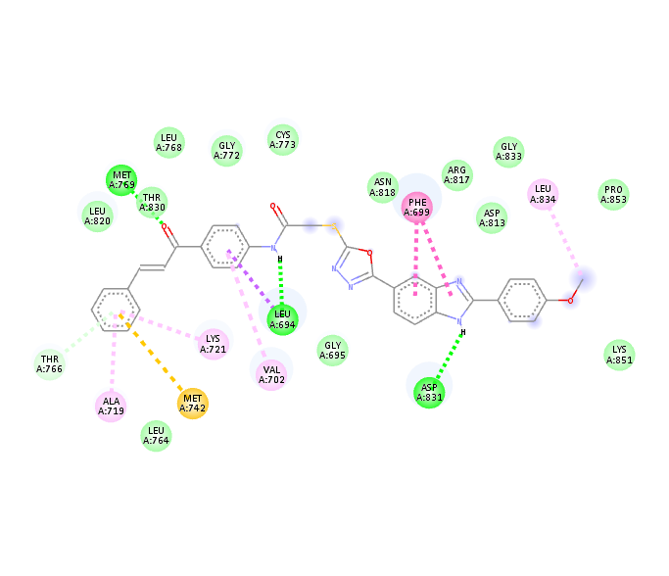 | 7k
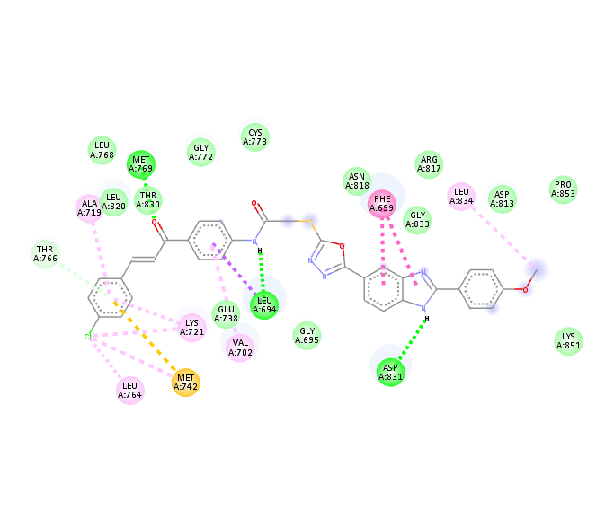 | 7l | 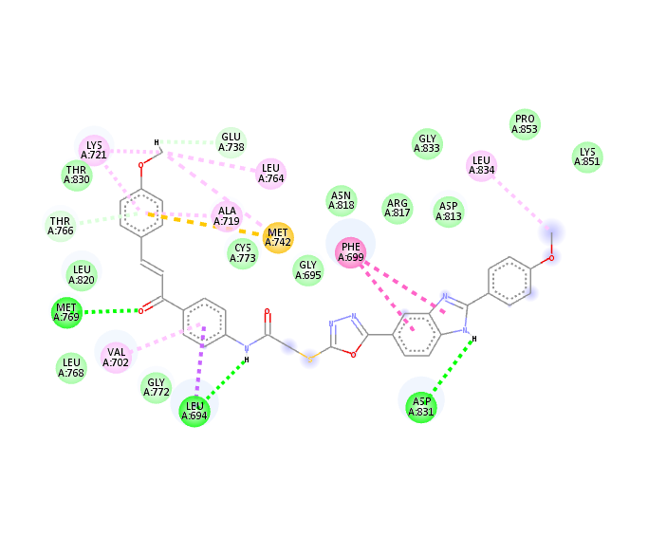 | 7m
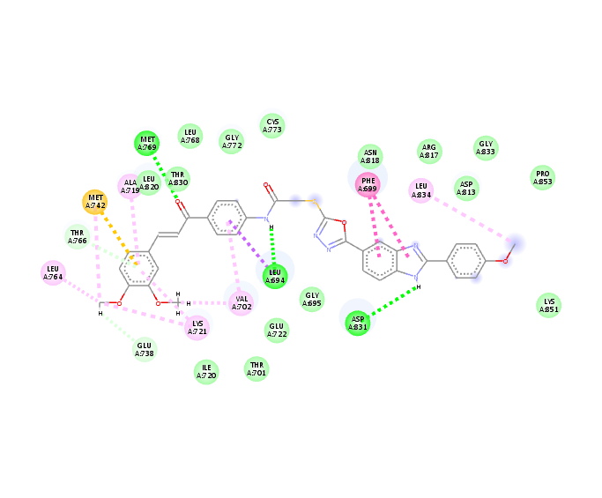 | 7n | 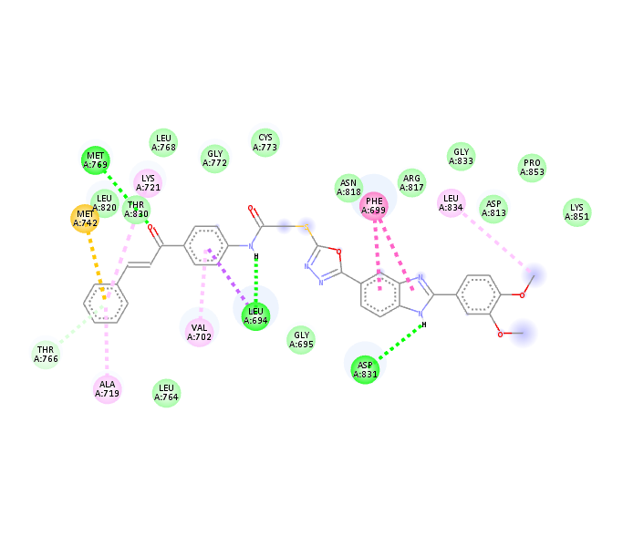 | 7p
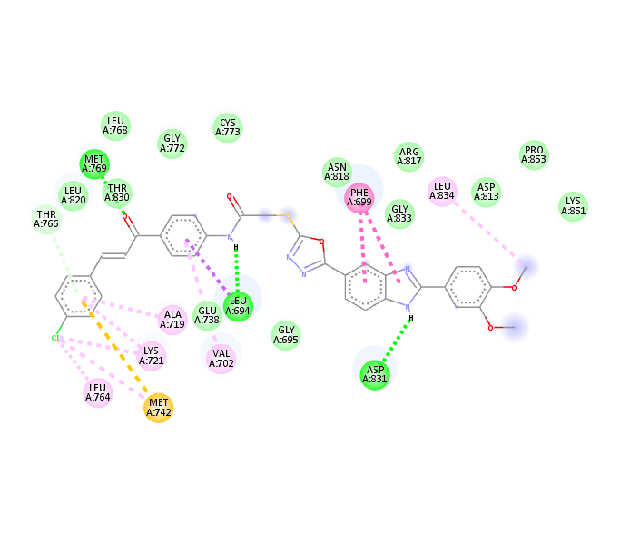 | 7q

Docking poses BRAF | NO | Docking poses BRAF | NO
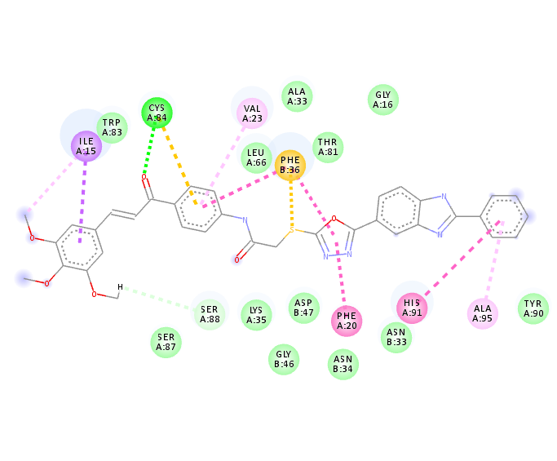 | 7e | 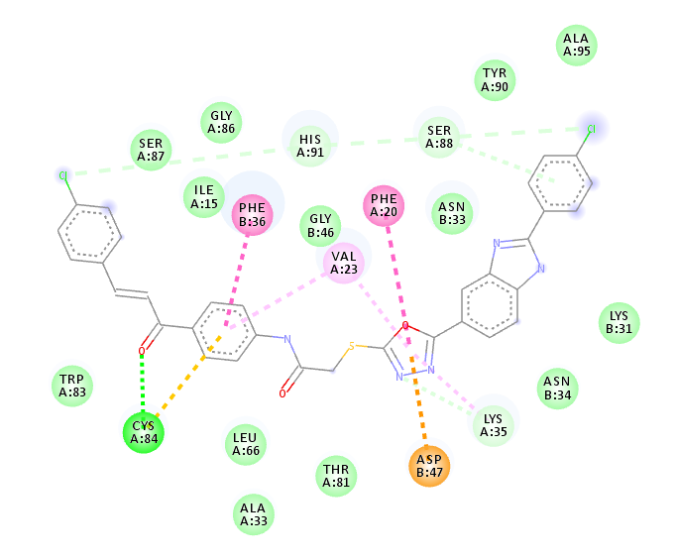 | 7g
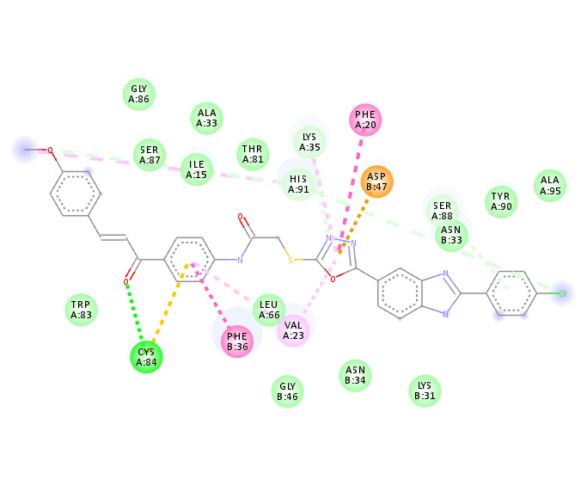 | 7h | 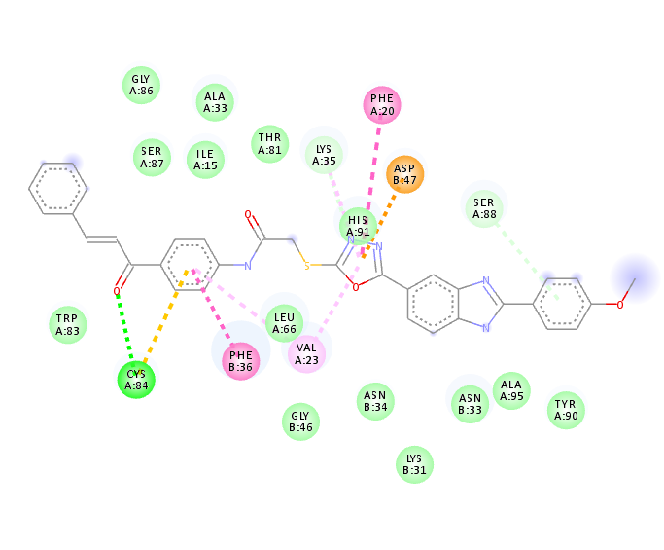 | 7k
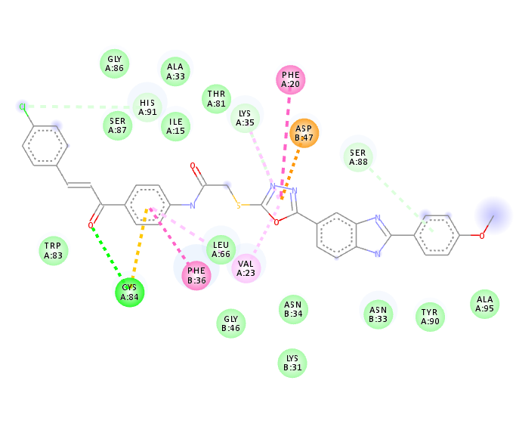 | 7l | 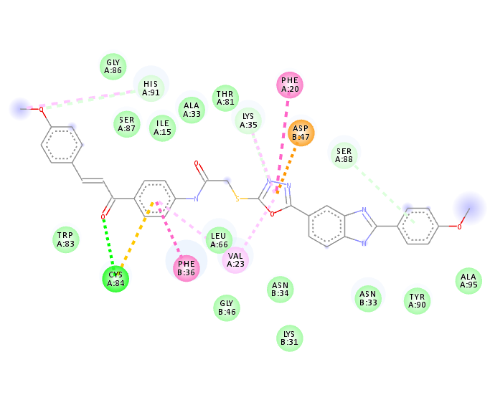 | 7m
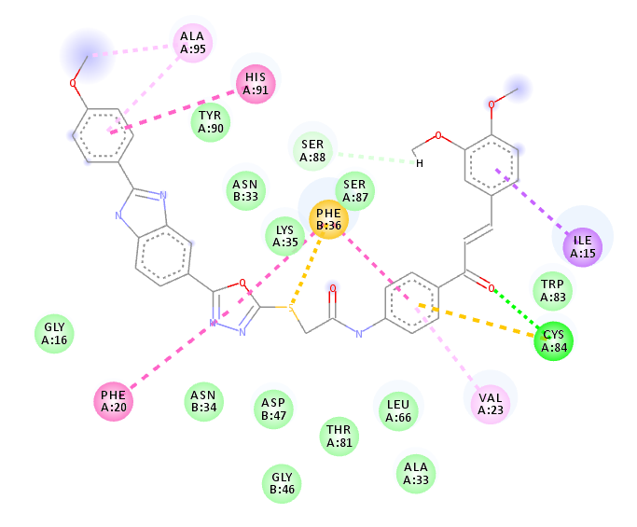 | 7n | 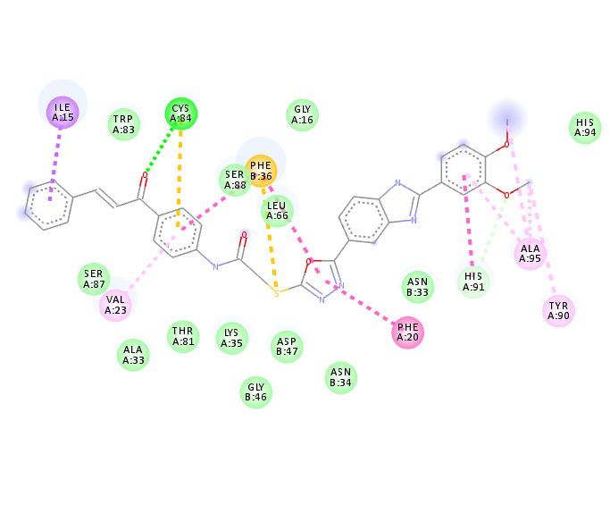 | 7p
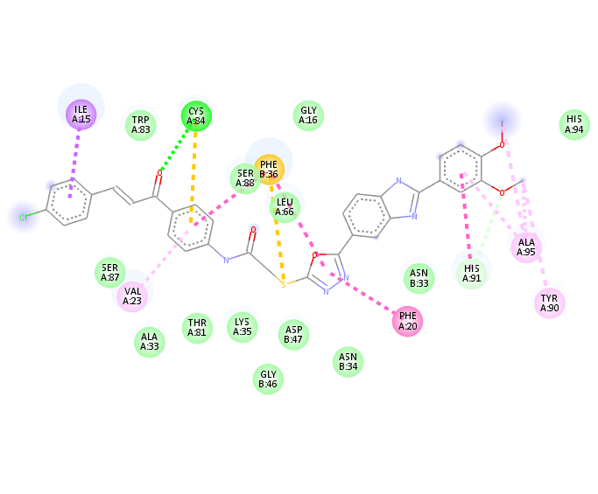 | 7q

