Synthesis of inventive biphenyl and azabiphenyl derivatives as potential insecticidal agents against the cotton leafworm, Spodoptera littoralis.

Eslam A Ghaith,^{a*} Hajar A. Ali,ª Mohamed A. Ismail,ª Abd El-Aziz S. Fouda,ª and
M. Abd El Salam, ^{b}
(a) Chemistry Department, Faculty of Science, Mansoura University, 35516 Mansoura, Egypt
(b) Plant Protection Research Institute, ARC, Dokki, Giza, Egypt
Corresponding author: Eslam A Ghaith
abdelghaffar@mans.edu.eg

Additional file

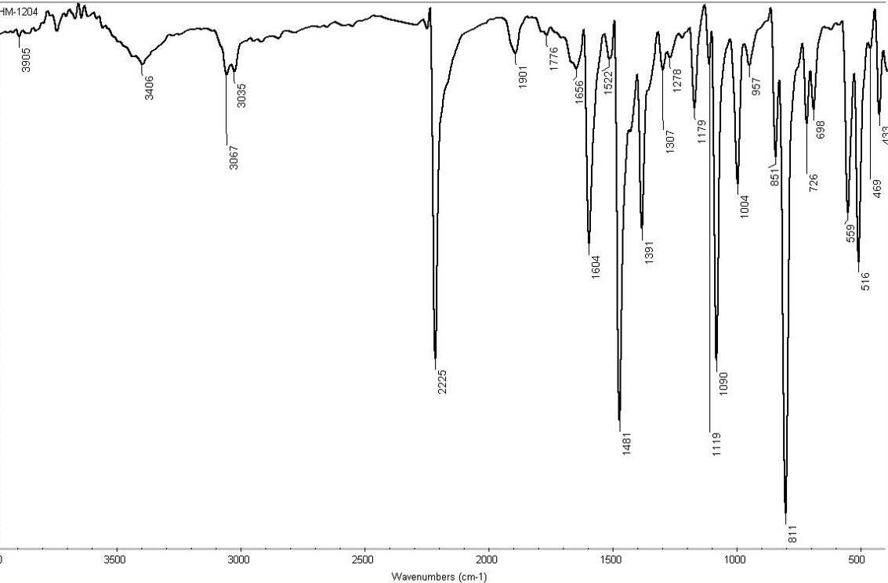

Fig. S1: IR spectrum of Compound 3a

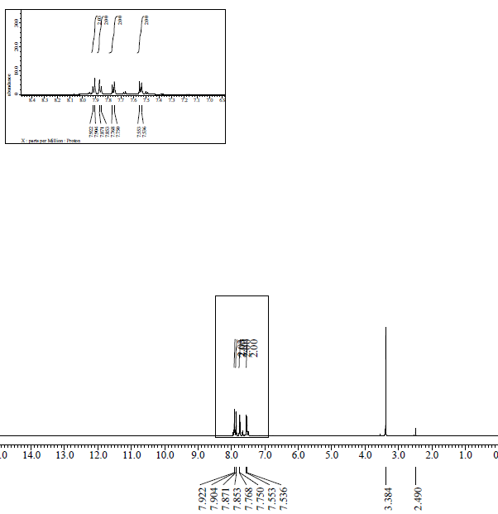

Fig. S2: ¹H-NMR spectrum of compound 3a

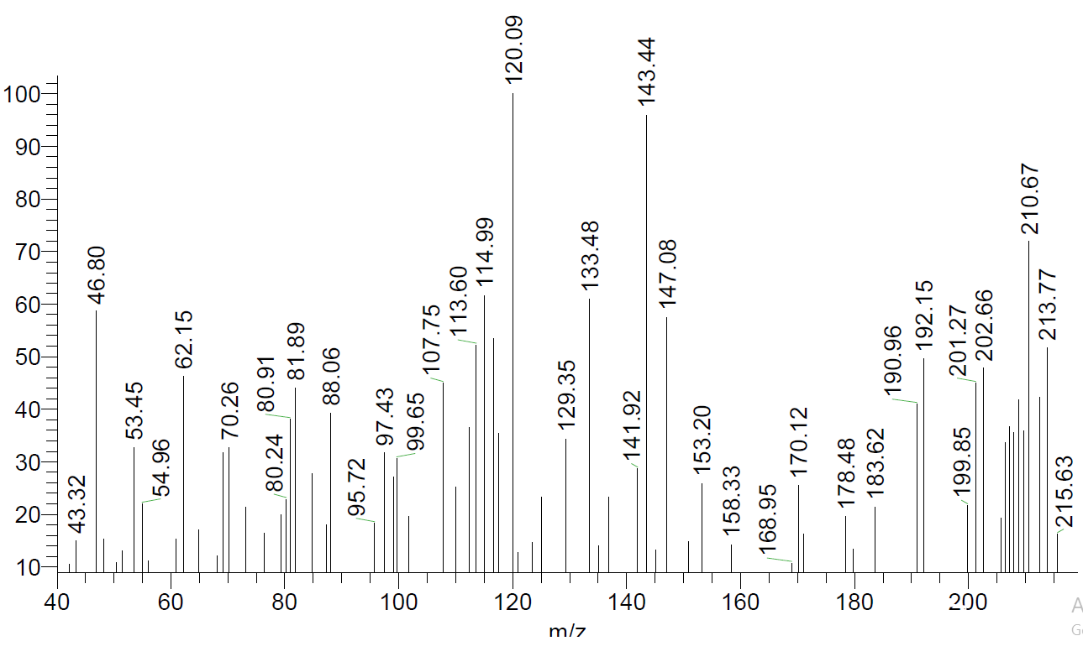
Fig. S3: Mass spectrum of compound 3a

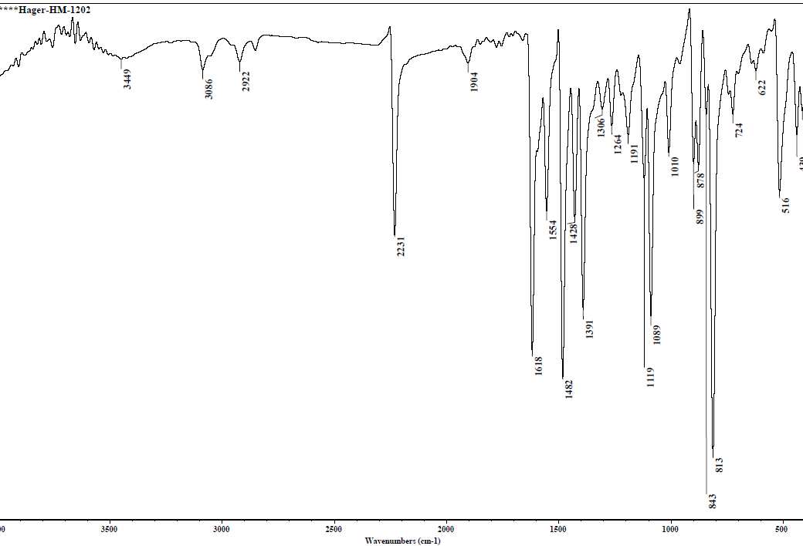

Fig. S4: IR spectrum of compound 3b

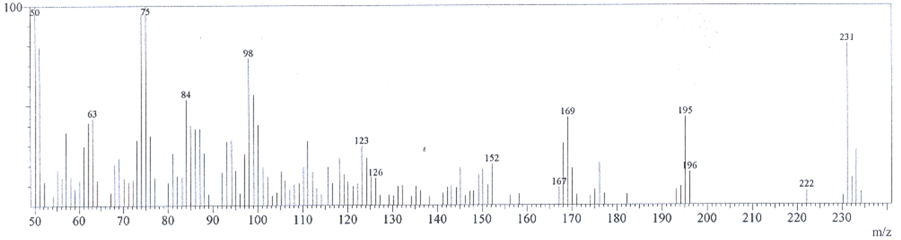

Fig. S5: Mass spectrum of compound 3b

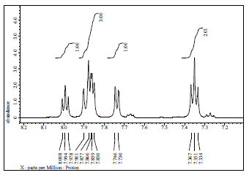
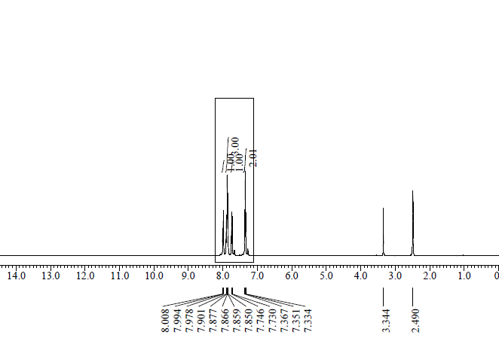
Fig. S6: ¹H-NMR spectrum of compound 3c

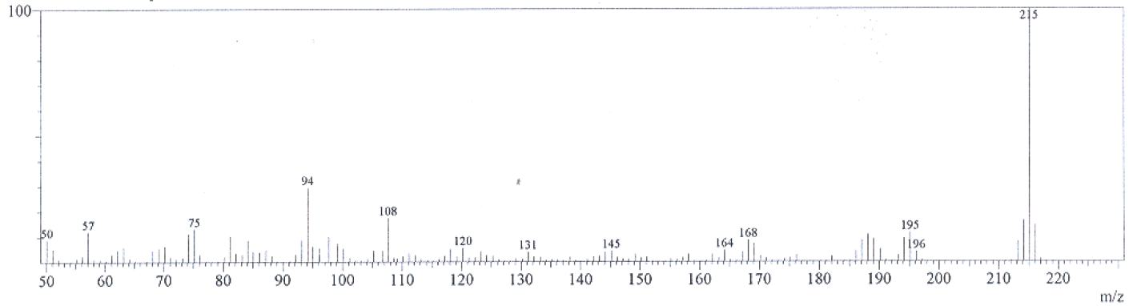
Fig. S7: Mass spectrum of compound 3c

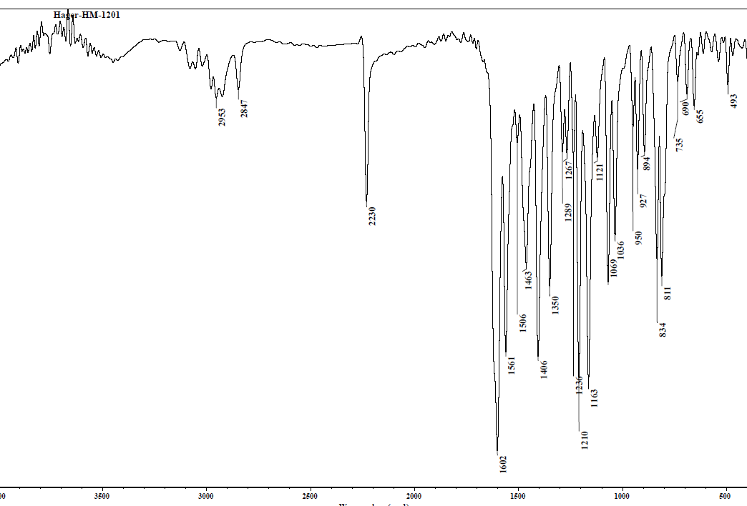

Fig. S8: IR spectrum of compound 3d

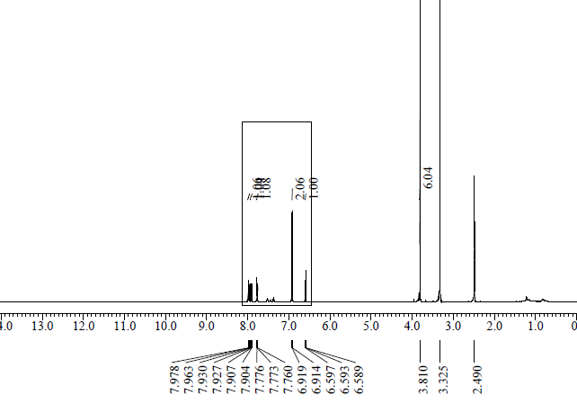
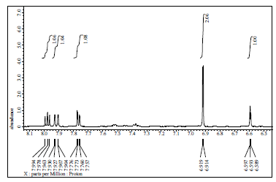
Fig. S9: ¹H-NMR spectrum of compound 3d

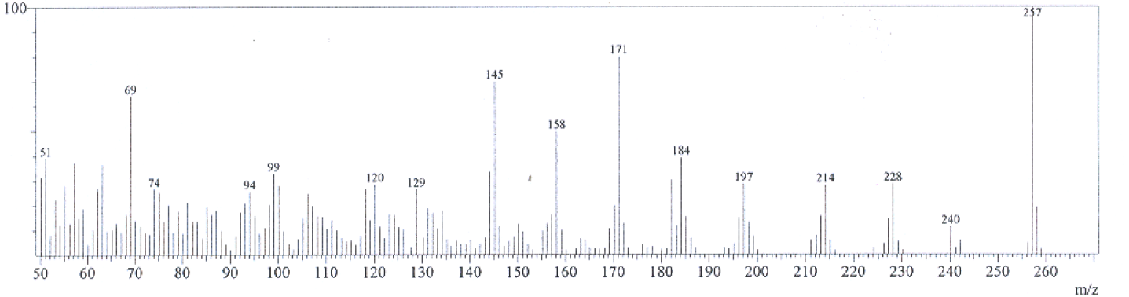

Fig. S10: Mass spectrum of compound 3d

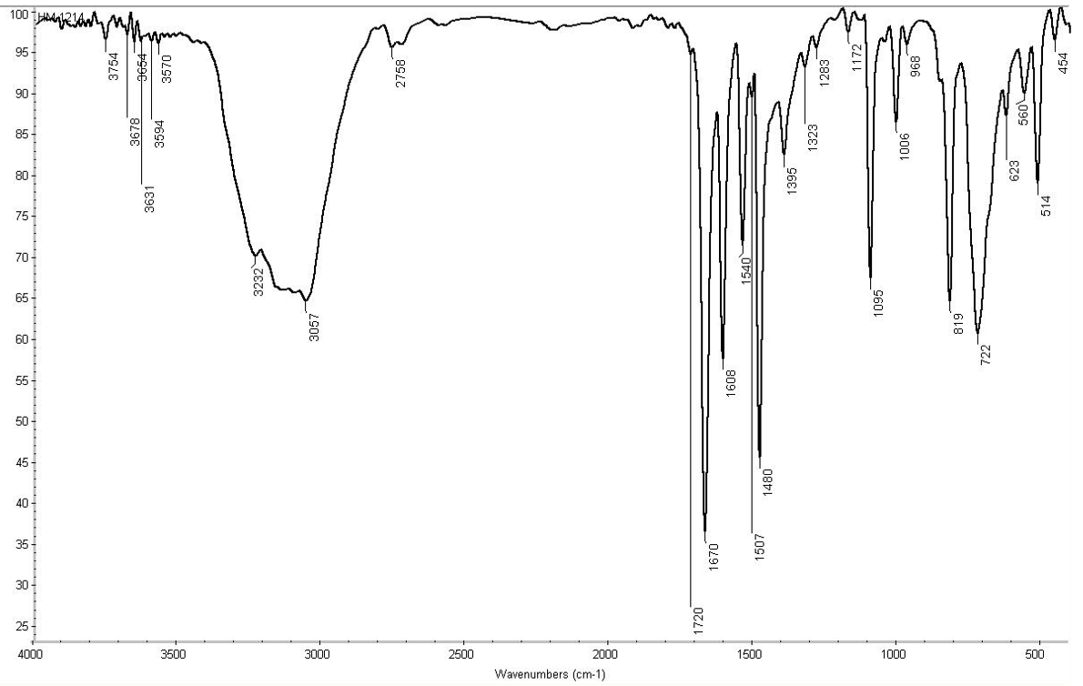

Fig. S11: IR spectrum of compound 4a

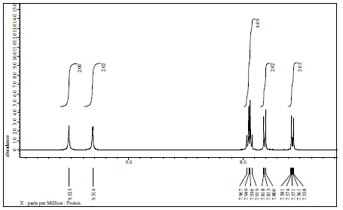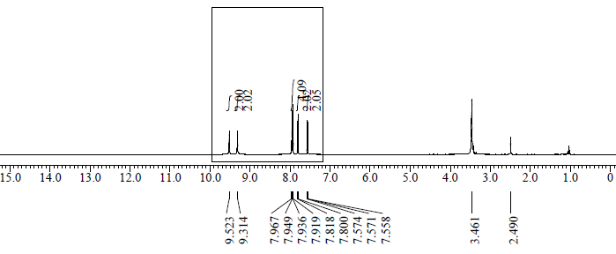

Fig. S12: ¹H-NMR spectrum of compound 4a

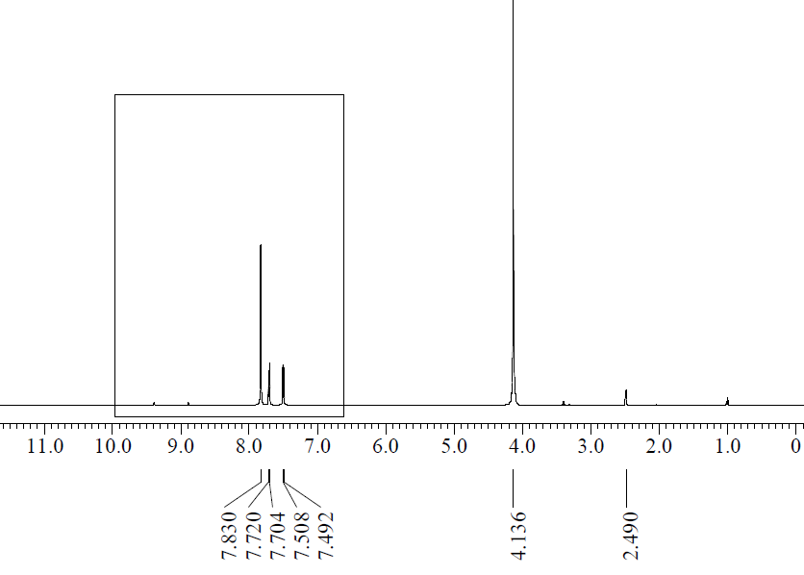
Fig. S13: ¹H-NMR (D₂O) spectrum of compound 4a

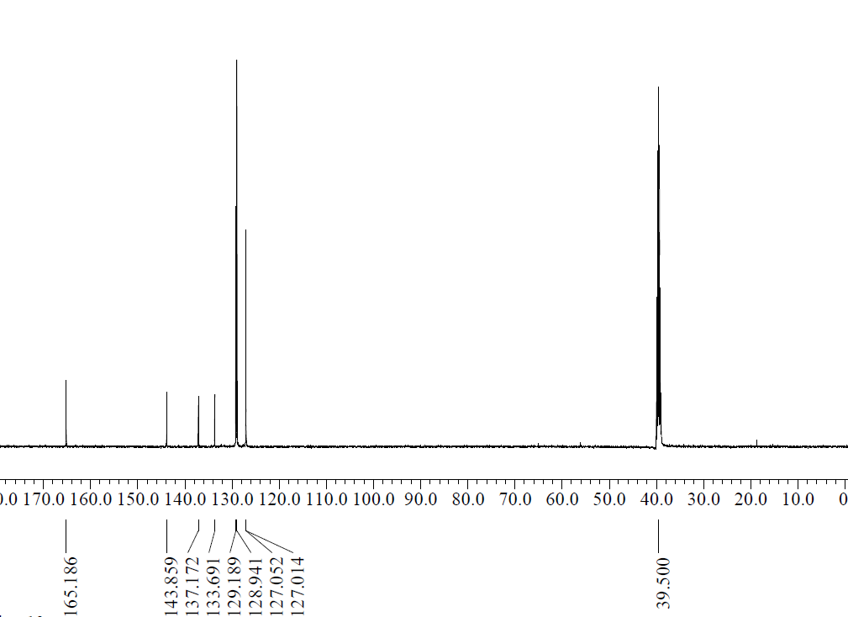

Fig. S14: ¹³C-NMR spectrum of compound 4a
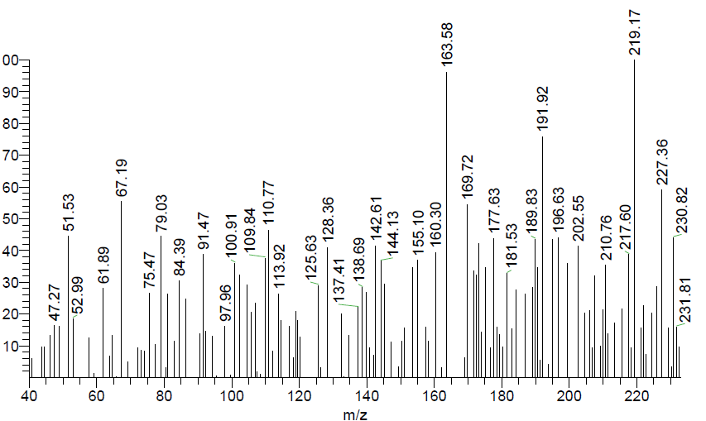

Fig. S15: Mass spectrum of compound 4a

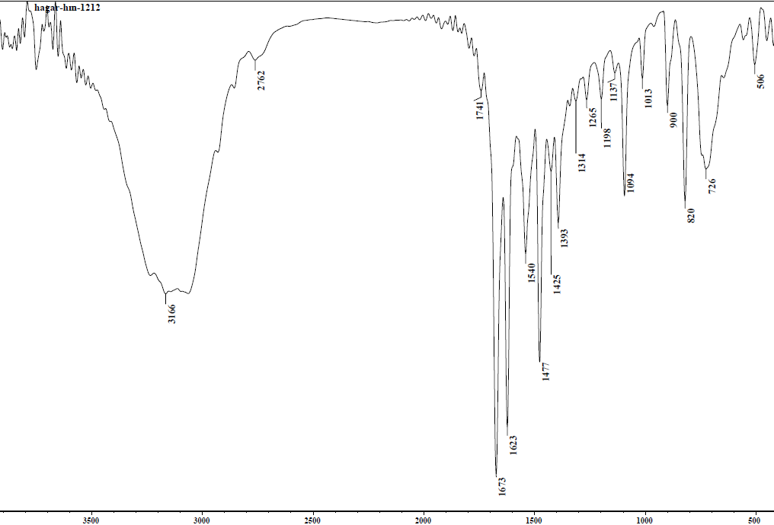
Fig. S16: IR spectrum of compound 4b

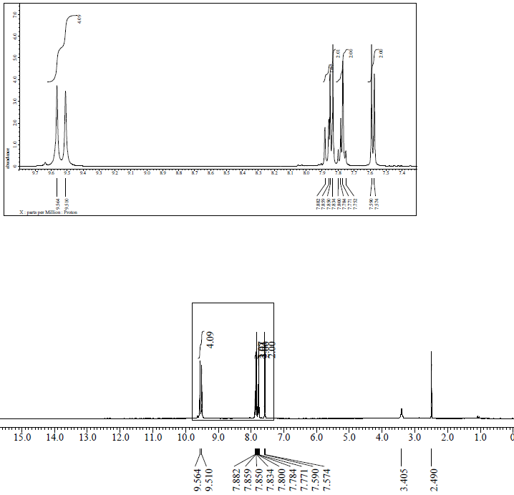
Fig. S17: ¹H-NMR spectrum of compound 4b

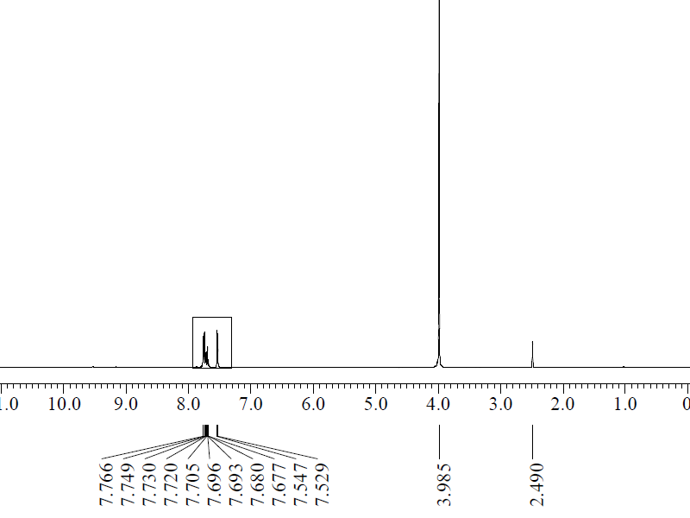
Fig. S18: ¹H-NMR (D₂O) spectrum of compound 4b

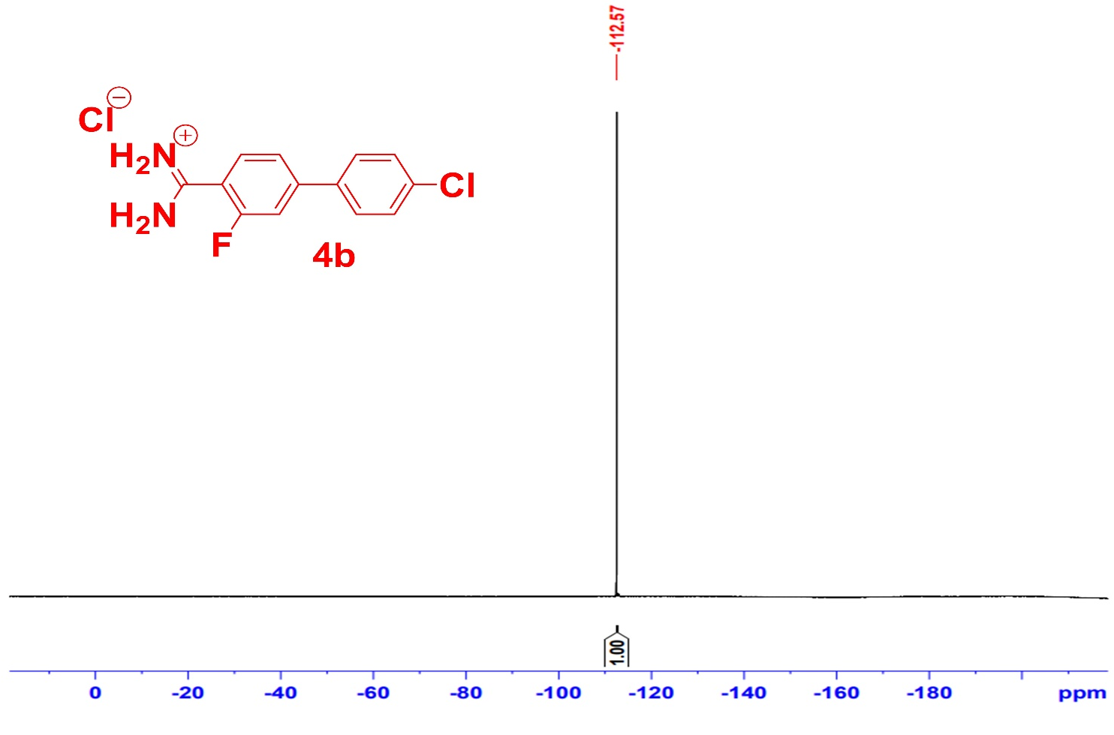
Fig. S19: ¹⁹F-NMR spectrum of compound 4b

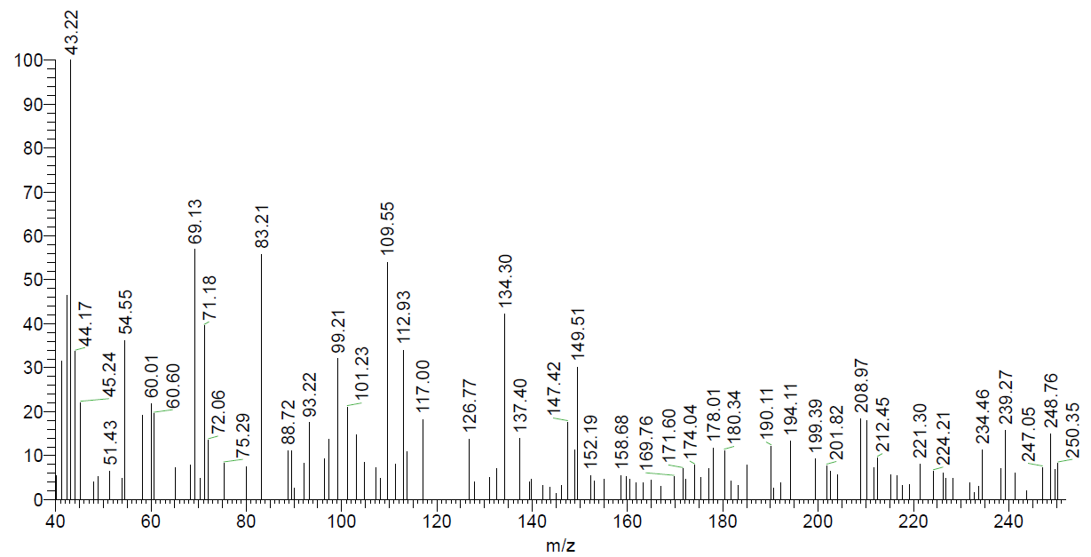
Fig. S20: Mass spectrum of compound 4b

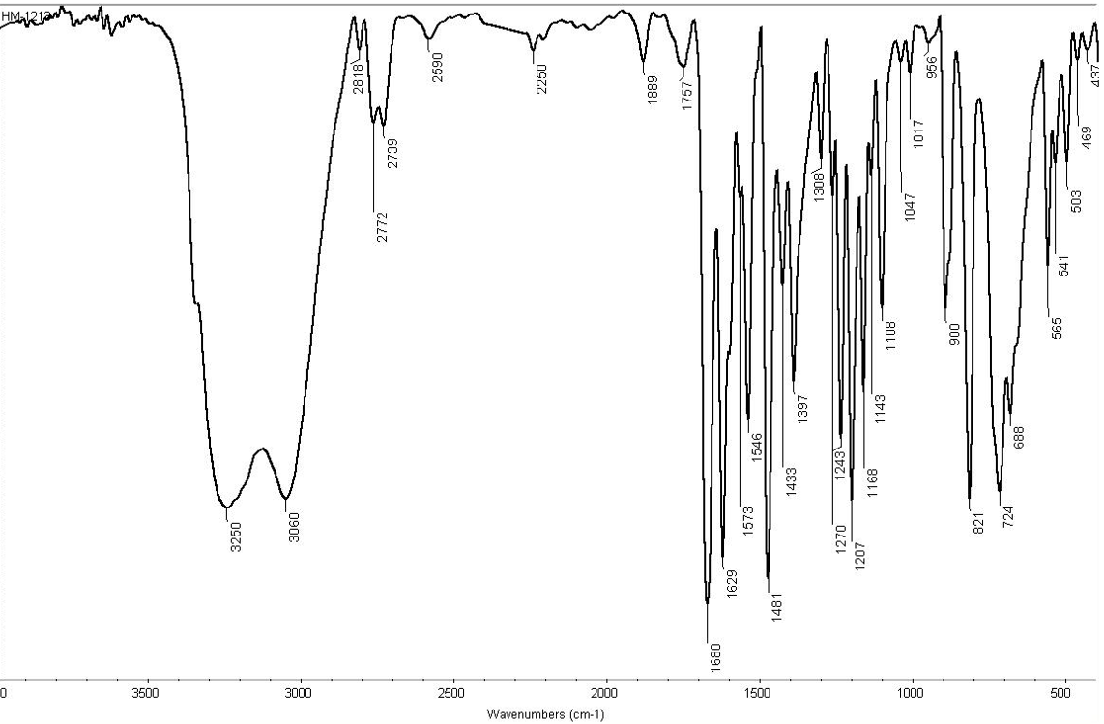 Fig. S21: IR spectrum of compound 4c

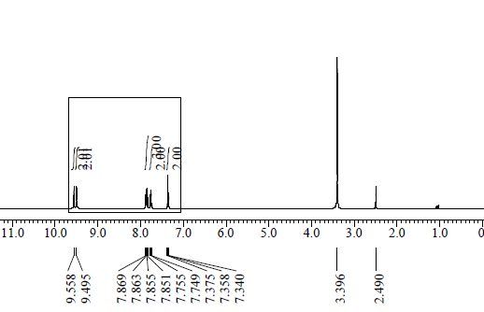
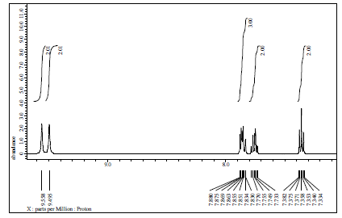
Fig. S22: ¹H-NMR spectrum of compound 4c

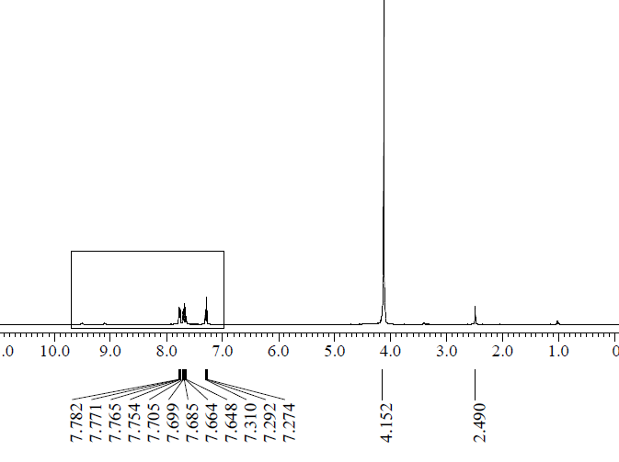
Fig. S23: ¹H-NMR (D₂O) spectrum of compound 4c

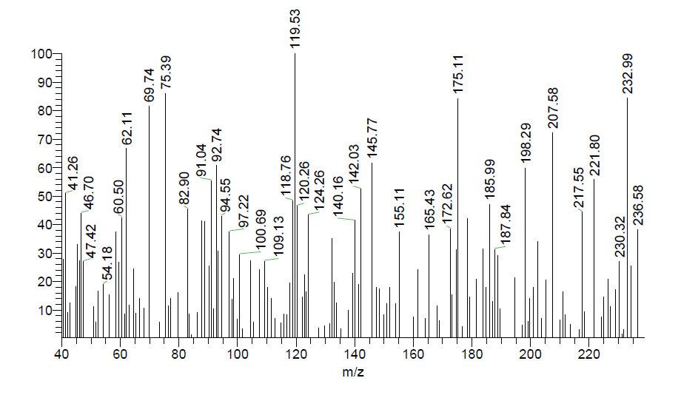
Fig. S24: Mass spectrum of compound 4c

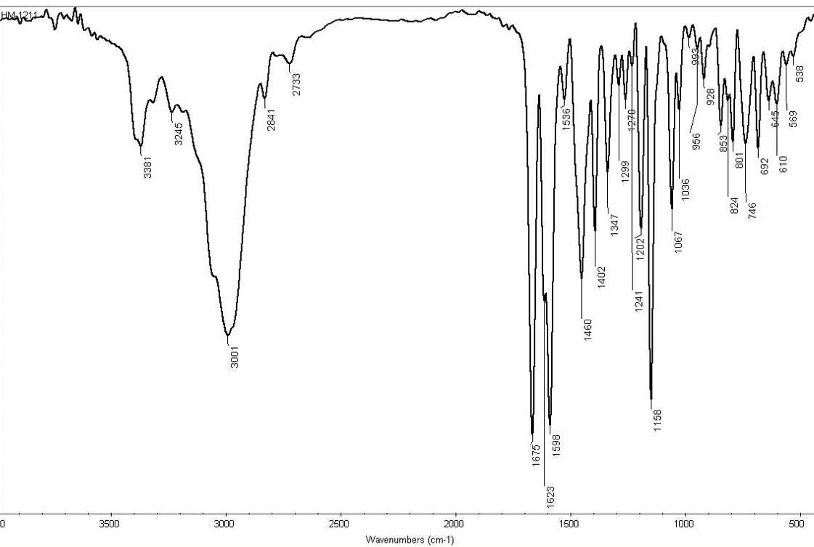
Fig. S25: IR spectrum of compound 4d

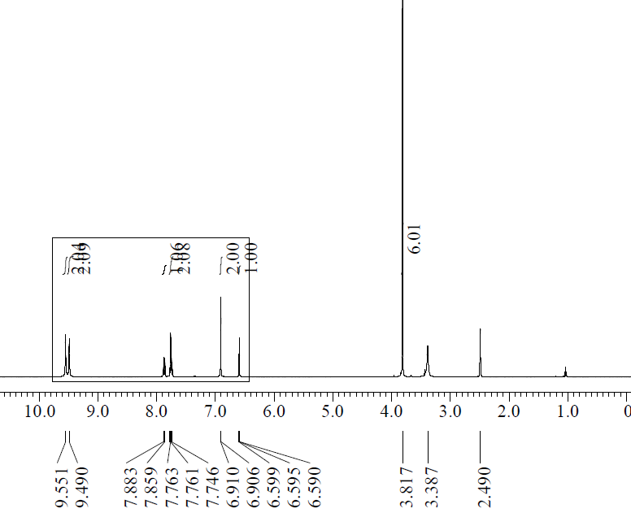
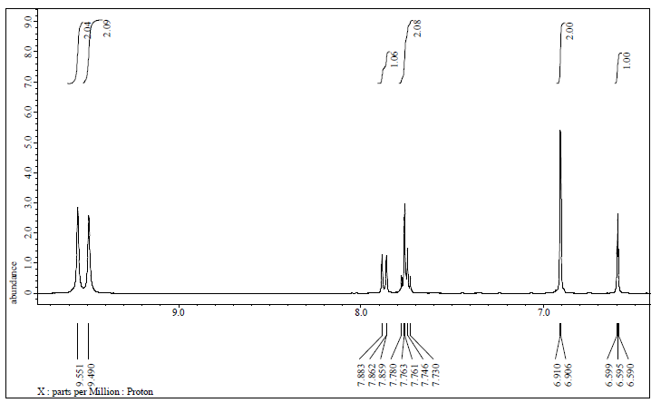
Fig. S26: ¹H-NMR spectrum of compound 4d

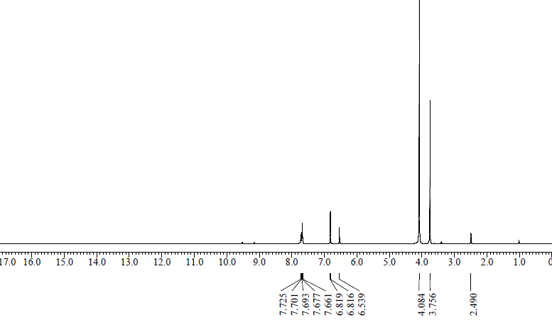

Fig. S27: ¹H-NMR (D₂O) spectrum of compound 4d
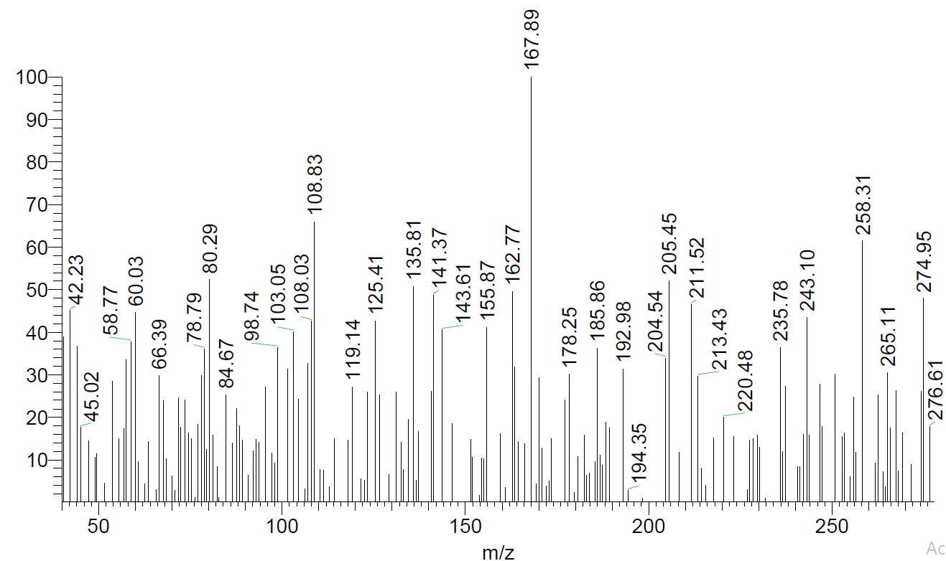
Fig. S28: Mass spectrum of compound 4d

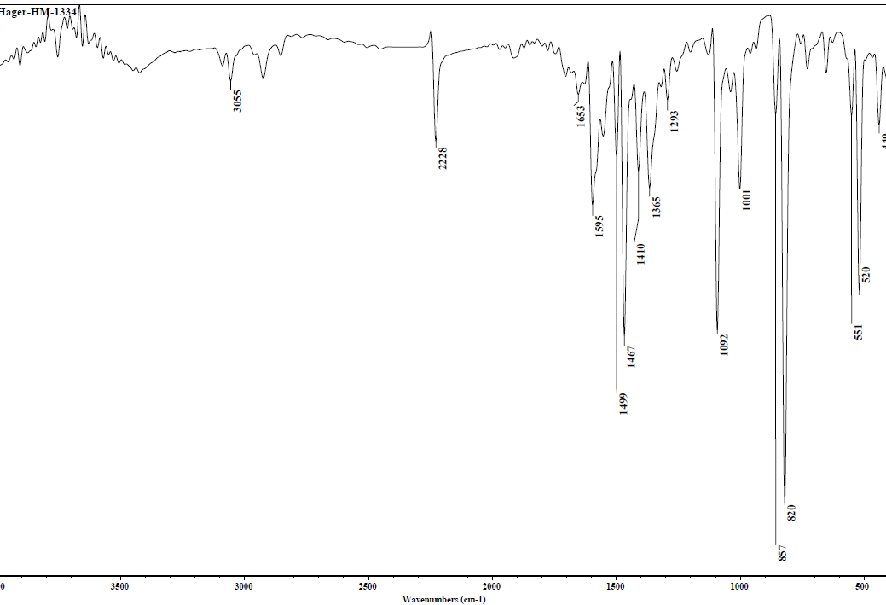
Fig. S29: IR spectrum of compound 7a
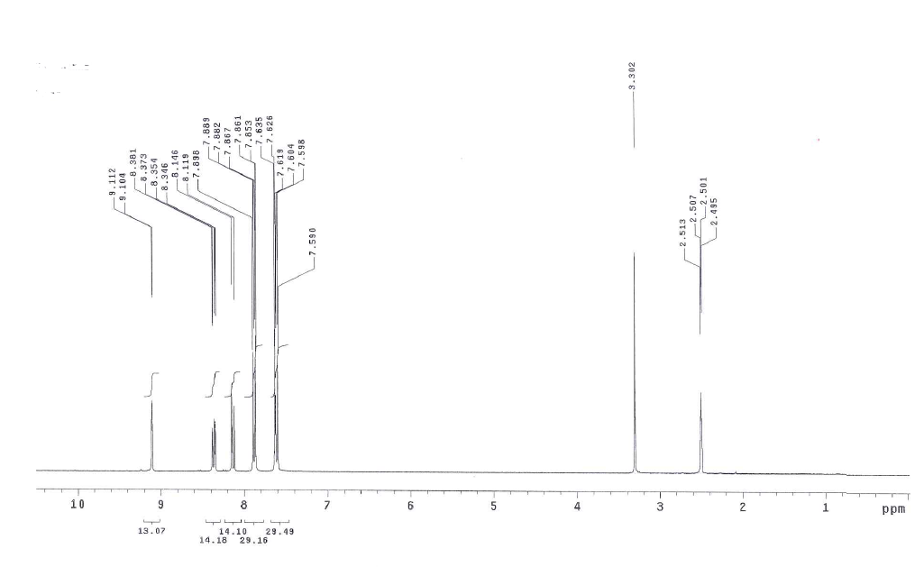
Fig. S30: ¹H-NMR spectrum of compound 7a
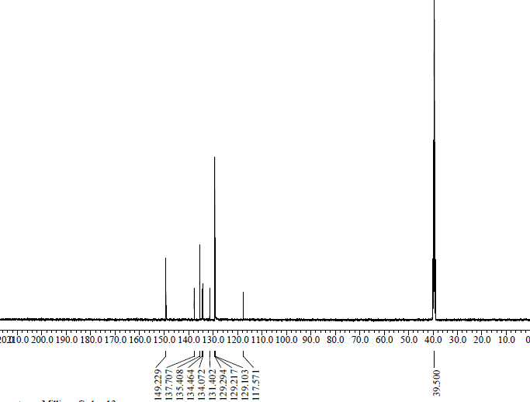
¹³C-NMR spectrum of compound 7a Fig. S31:

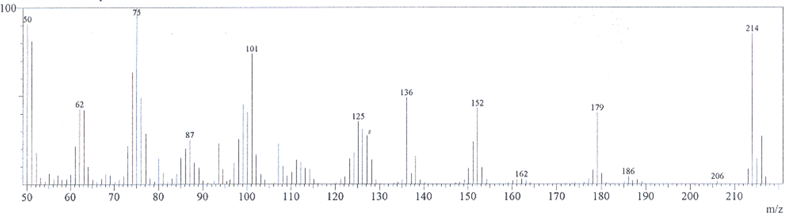
Fig. S32: Mass spectrum of compound 7a

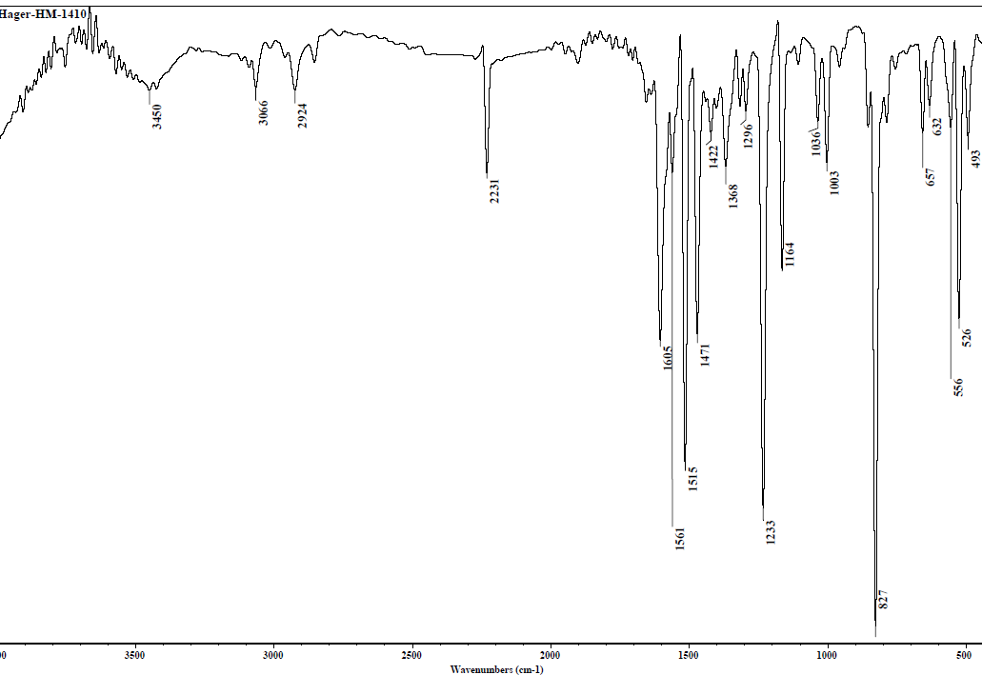

Fig. S33: IR spectrum of compound 7b

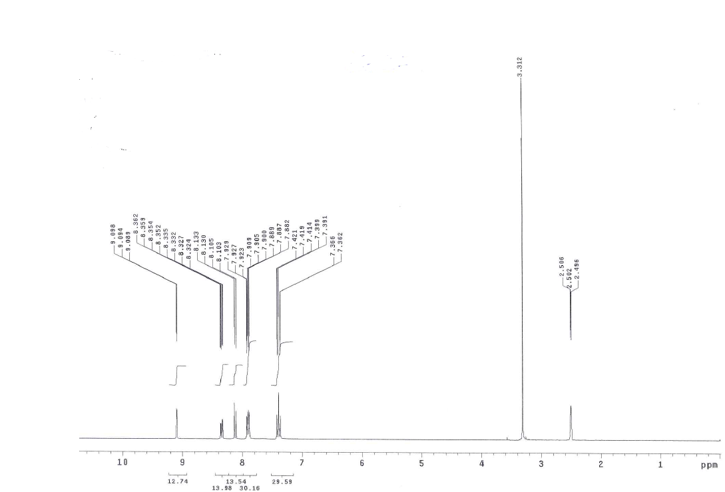
¹H-NMR spectrum of compound 7b Fig. S34:

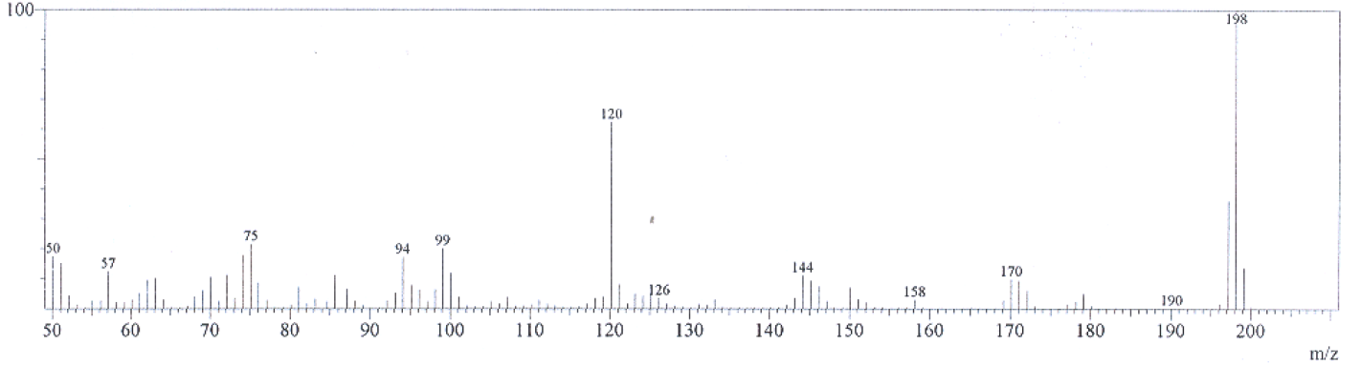
Fig. S35: Mass spectrum of compound 7b

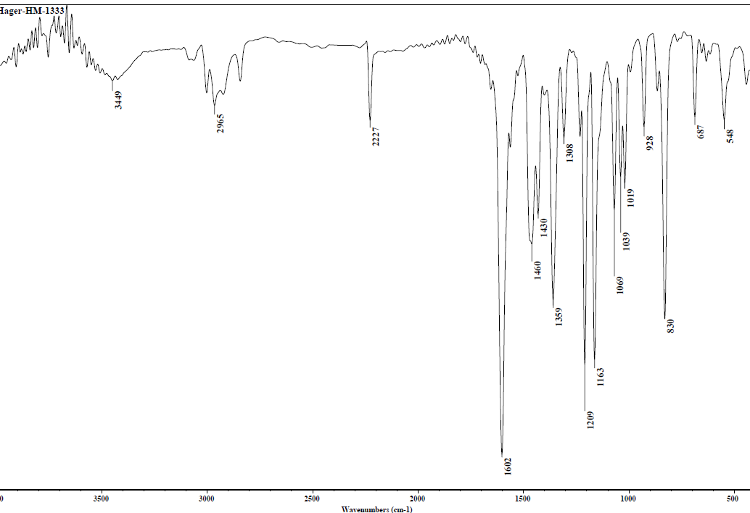

Fig. S36: IR spectrum of compound 7c

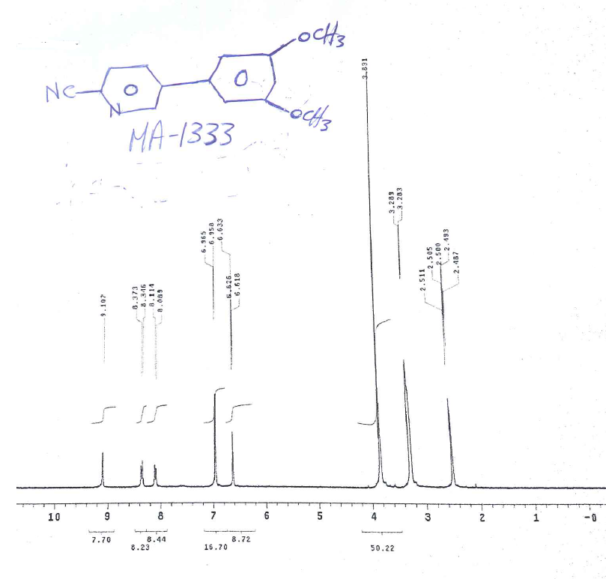
¹H-NMR spectrum of compound 7c Fig. S37:
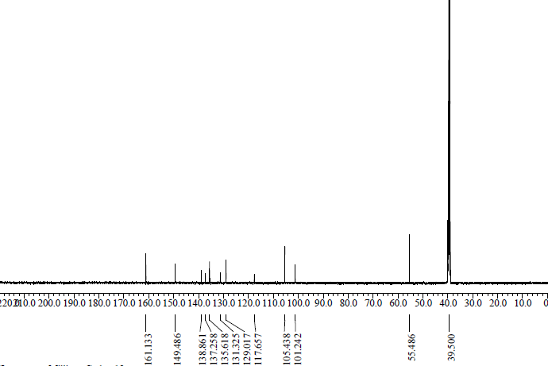

Fig. S38: ¹³C-NMR spectrum of compound 7c

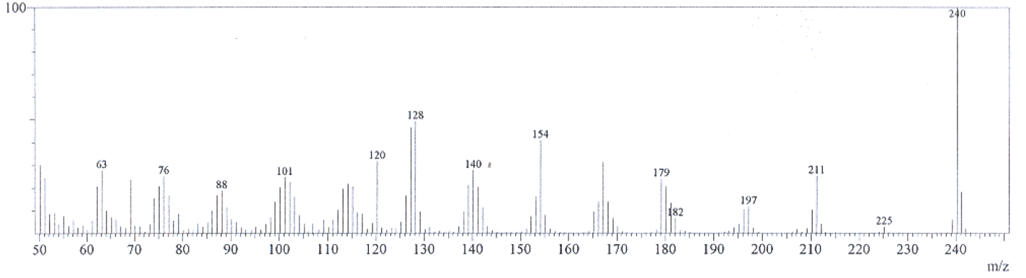
Fig. S39: Mass spectrum of compound 7c
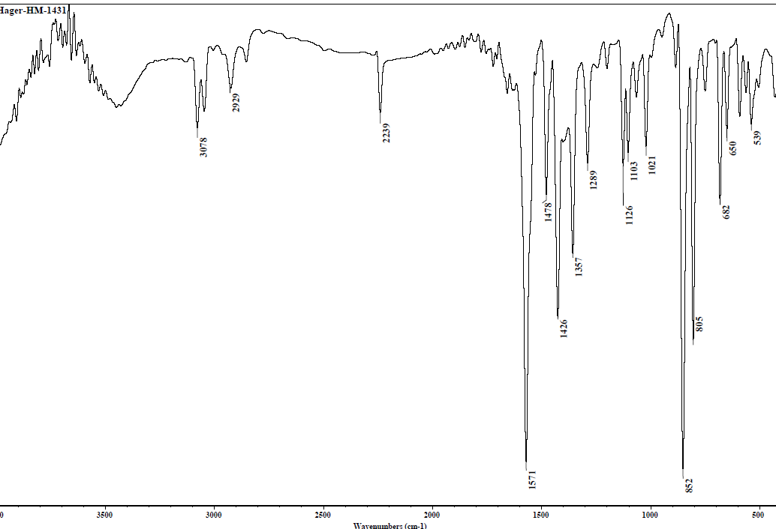
Fig. S40: IR spectrum of compound 7d
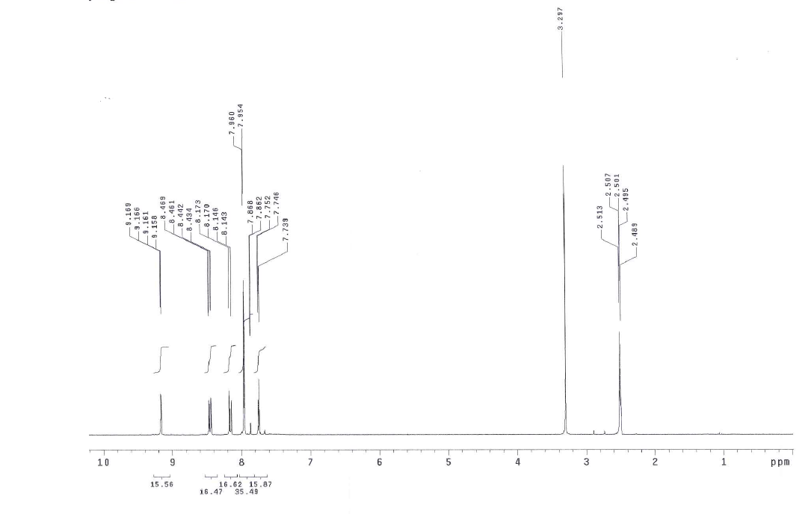
Fig. S41: ¹H-NMR spectrum of compound 7d

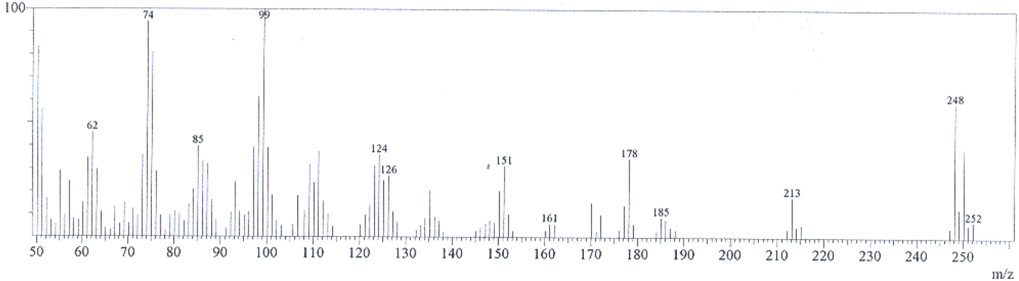
Fig. S42: Mass spectrum of compound 7d

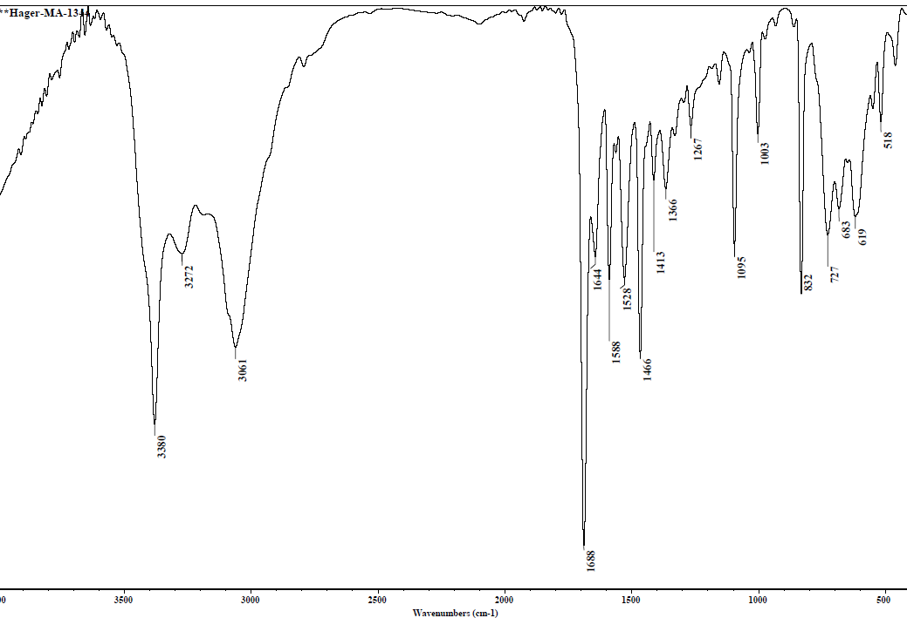

Fig. S43: IR spectrum of compound 8a
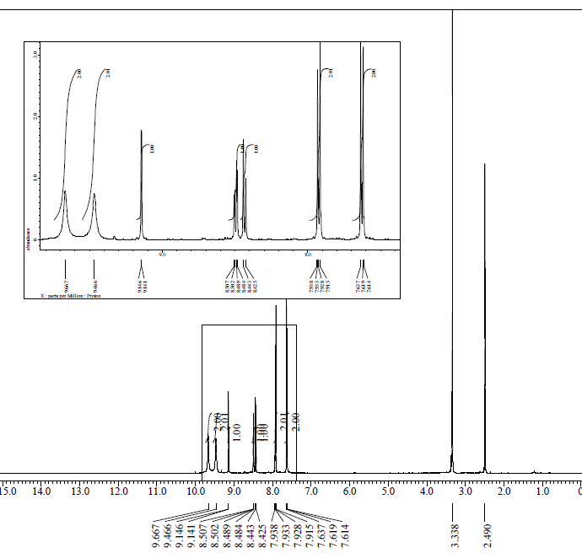

Fig. S44: ¹H-NMR spectrum of compound 8a
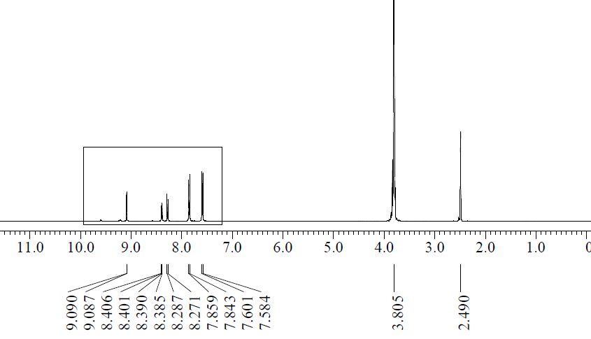
¹H-NMR (D₂O) spectrum of compound 8a Fig. S45:
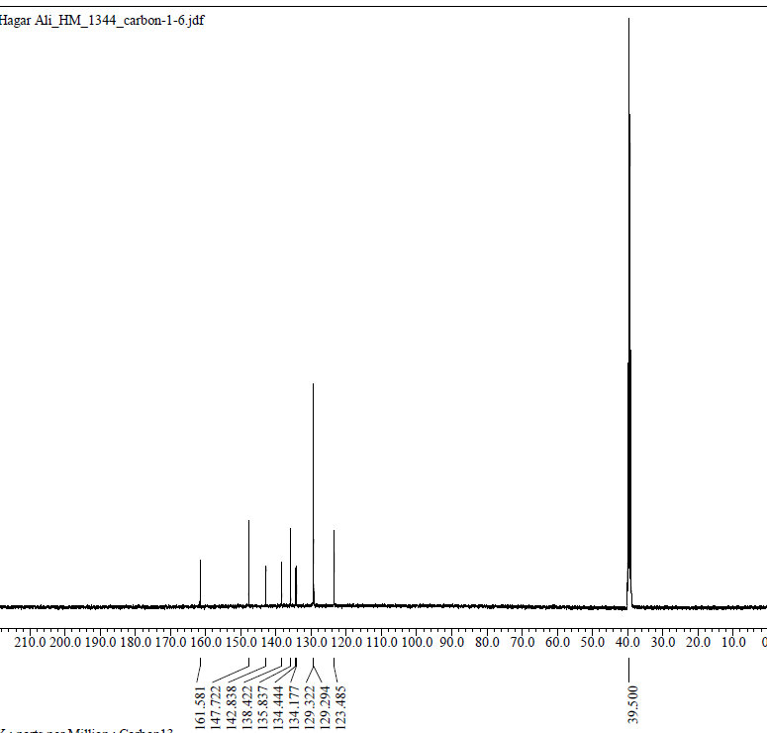

Fig. S46: ¹³C-NMR spectrum of compound 8a

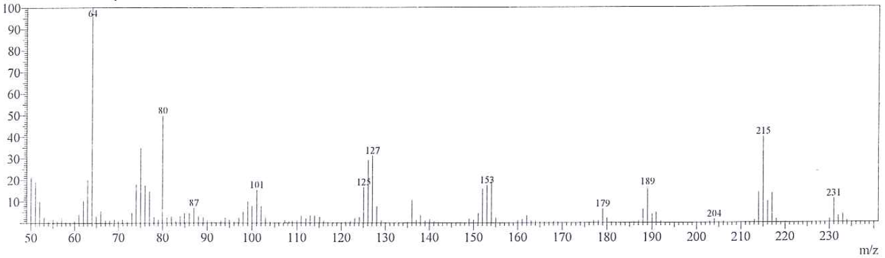
Fig. S47: Mass spectrum of compound 8a

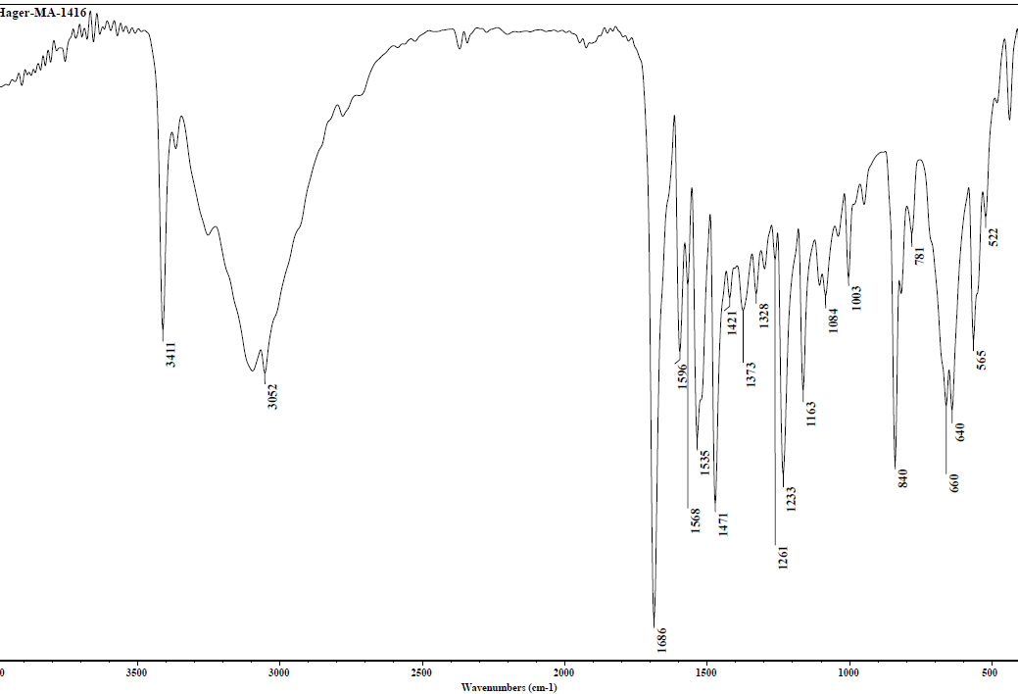
Fig. S48: IR spectrum compound 8b
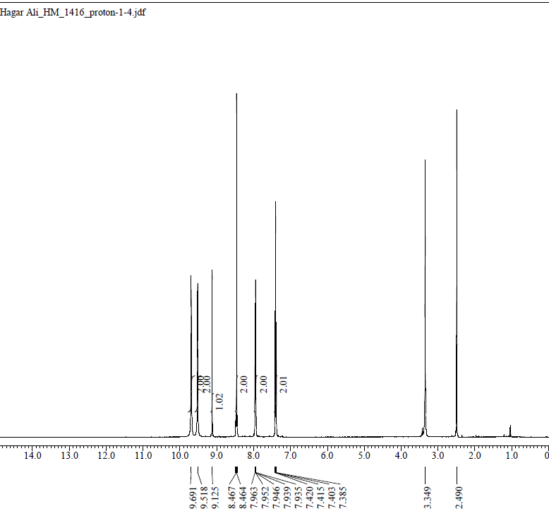

Fig. S49: ¹H-NMR spectrum of compound 8b
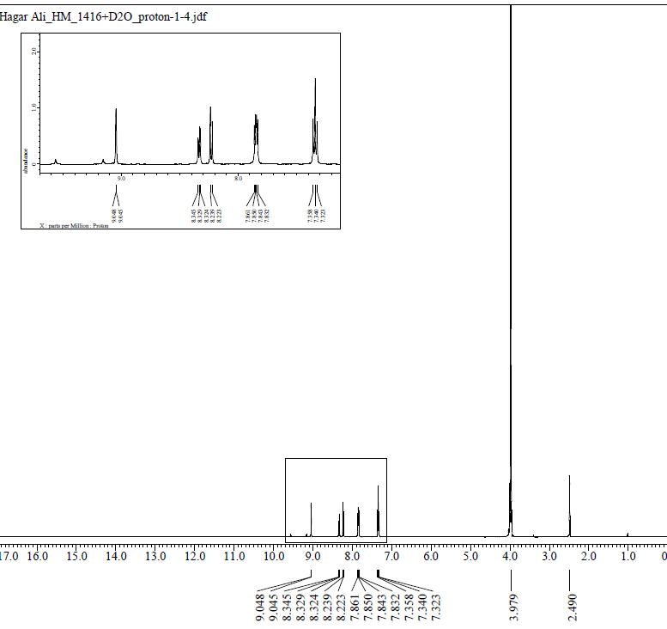
Fig. S50: ¹H-NMR (D₂O) spectrum of compound 8b

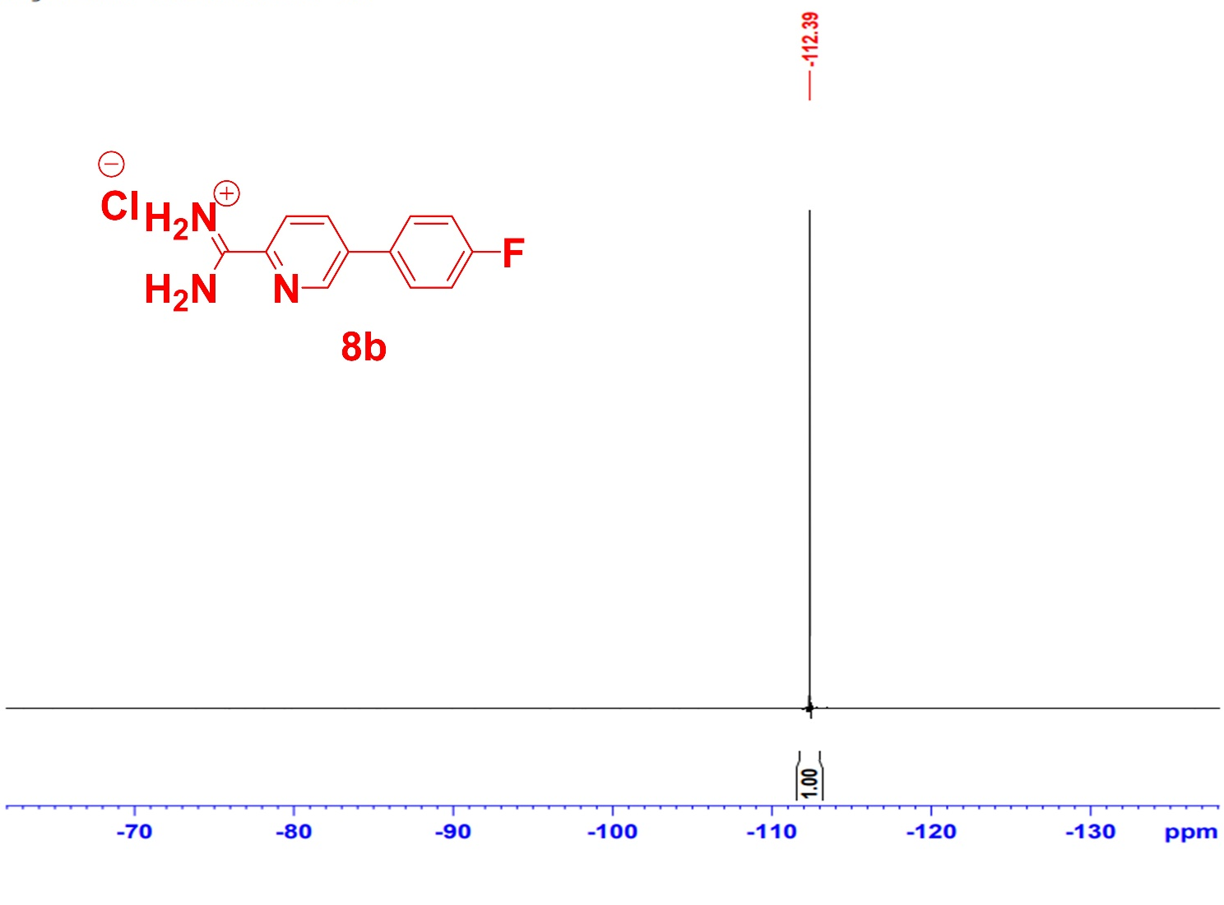
Fig. S51: ¹⁹F-NMR spectrum of compound 8b

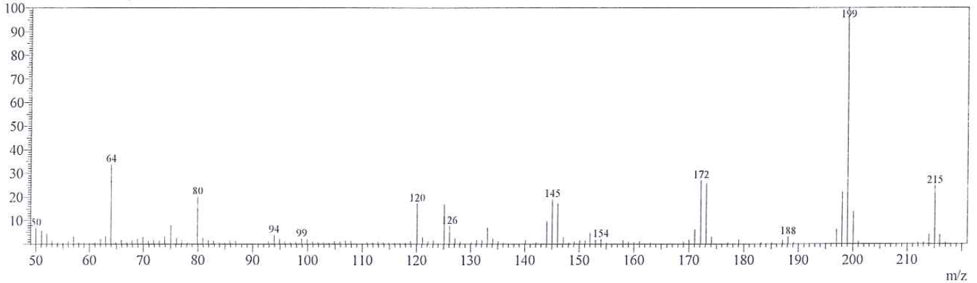
Fig. S52: Mass spectrum of compound 8b

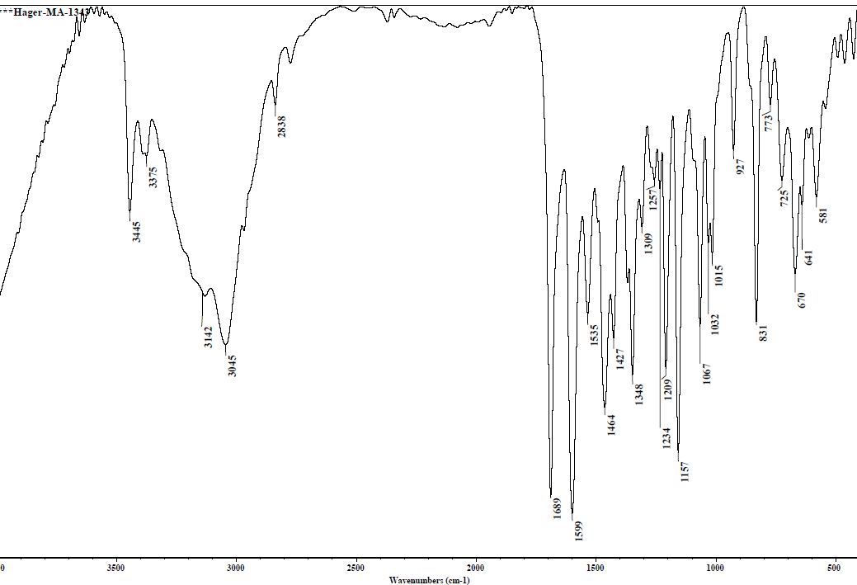

Fig. S53: IR spectrum of compound 8c

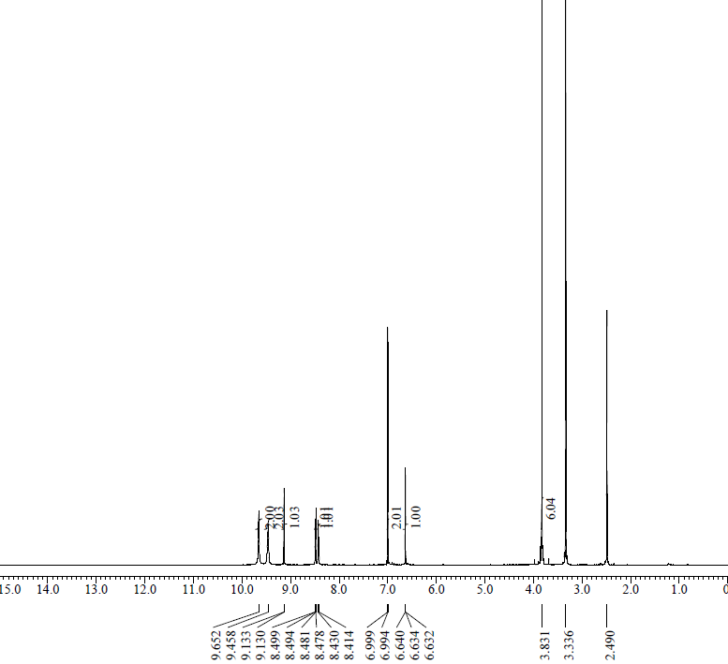

¹H-NMR spectrum of compound 8c Fig. S54:

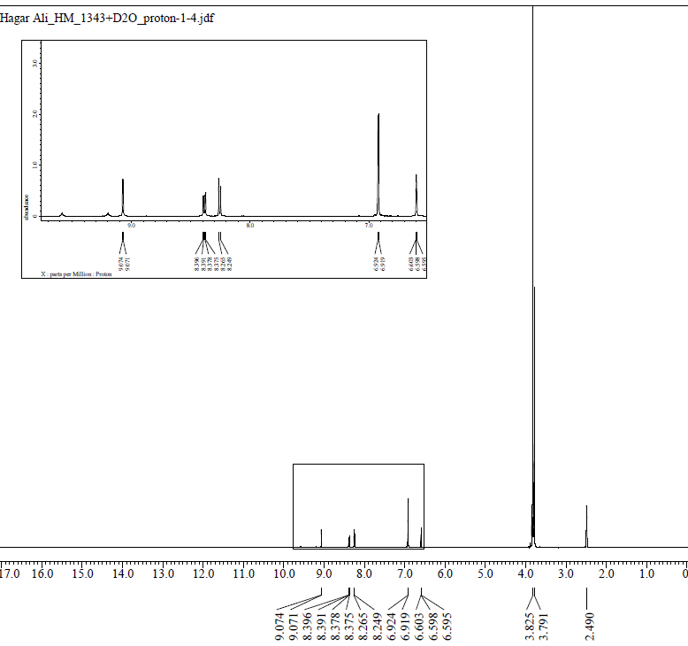
Fig. S55: ¹H-NMR (D₂O) spectrum of compound 8c
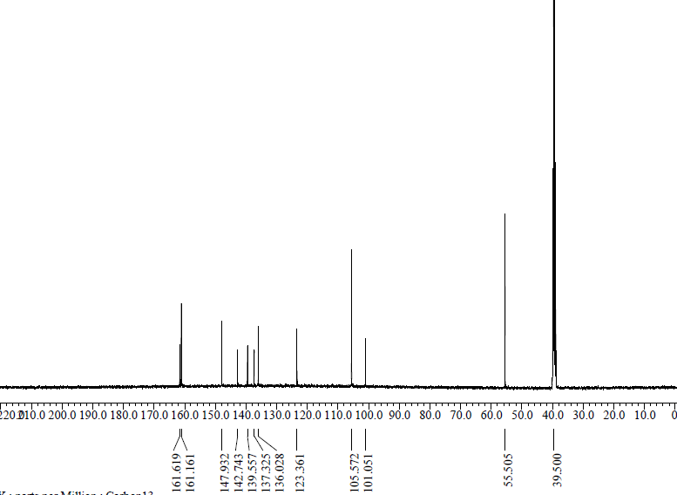

Fig. S56: ¹³C-NMR spectrum of compound 8c

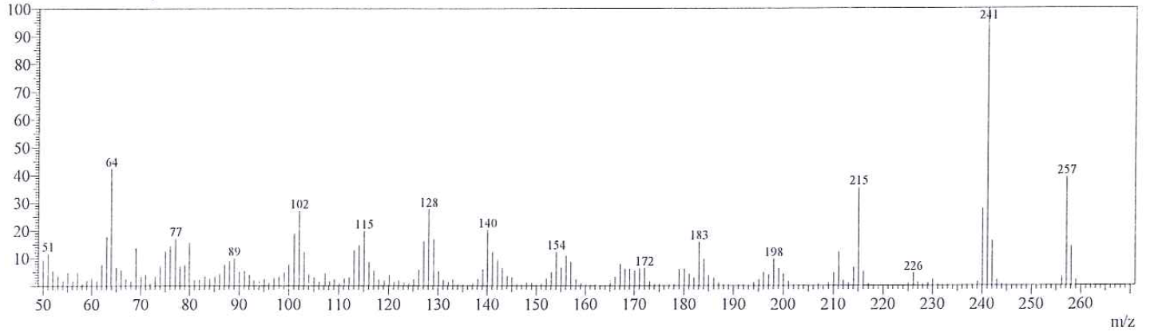
Fig. S57: Mass spectrum of compound 8c

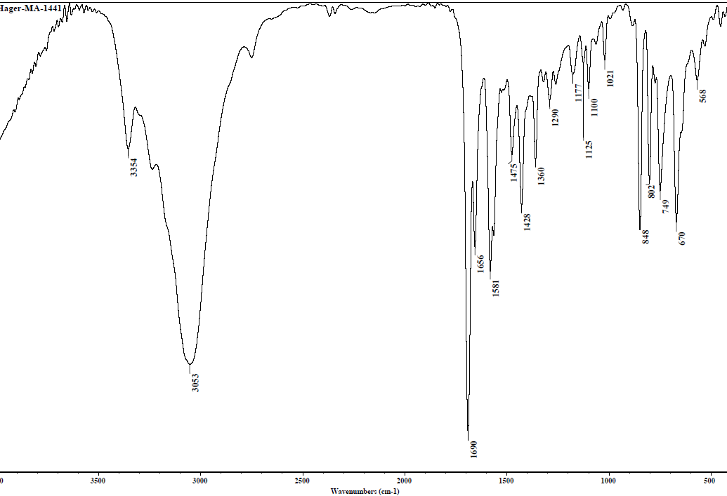

Fig. S58: IR spectrum of compound 8d

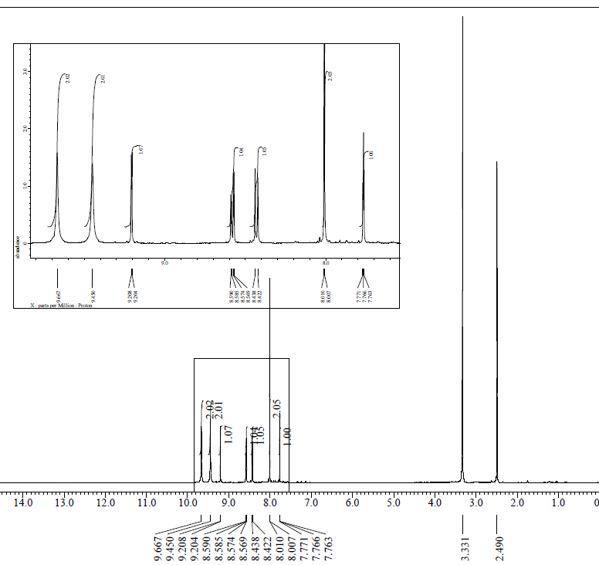

Fig. S59: ¹H-NMR spectrum of compound 8d
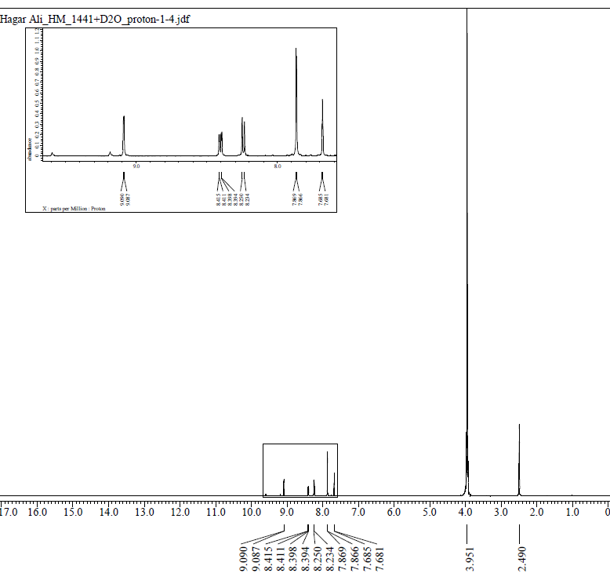
Fig. S60: ¹H-NMR (D₂O) spectrum of compound 8d

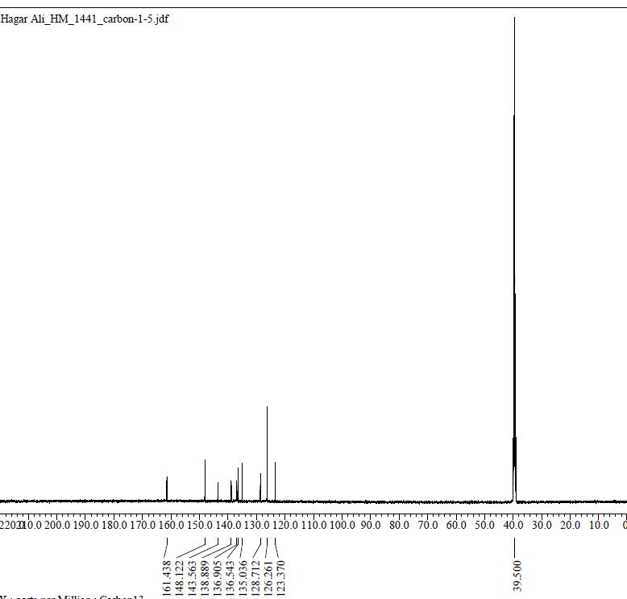

¹³C-NMR spectrum of compound 8d Fig. S61:

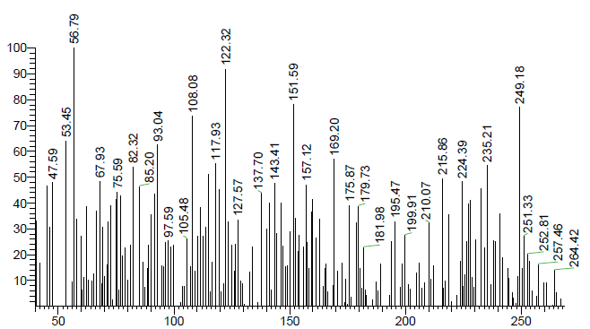

Fig. S62: Mass spectrum of compound 8d

General:
Melting points (uncorrected) were measured using a Gallenkamp melting-point apparatus and were uncorrected. The reaction mixture was monitored by using thin-layer chromatography (TLC) which was made on silica gel 60 F₂₅₄ precoated aluminum sheets and visualized under ultraviolet (UV) light. Also, Infrared (IR) spectra were recorded using KBr wafer technique on a Thermo scientific Nicolet iS10 FT-IR Spectrometer. A JEOL 500 MHz, a Bruker 400 MHz & a Varian Unity Plus 300 MHz spectrometers were used for recording ¹H- NMR, ¹³C-NMR and ¹⁹F-NMR spectra as the chemical shifts (δ) were measured in parts per million (ppm) relative to the used CDCl₃ or DMSO-d₆ as solvents and self-internal standard. In case of cationic amidines NH₂ & ⁺NH₂ of cationic group were exchangeable with D₂O. Electron impact mass spectra were determined at 70 eV on Varian MAT 311Kratos instrument (Micro-analytical center, Faculty of Science, Cairo University. All chemicals and solvents were used as received from Sigma Aldrich and Fisher scientific companies.

