Additional file 1
Nitrophenylpiperazine derivatives as novel tyrosinase inhibitors; design, synthesis, and in silico evaluations

Mehdi Asadi¹, Fahime Fayazi², Aida Iraji^{3,4}, Reyhaneh Sabourian⁵, Homa Azizian¹, Mannan Hajimahmoodi⁵, Bagher Larijani⁶, Mohammad Mahdavi⁶*, Massoud Amanlou^{2,7}*
¹ Department of Medicinal Chemistry, School of Pharmacy, Iran University of Medical Sciences, Tehran, Iran.
² Department of Medicinal Chemistry, Faculty of Pharmacy, Tehran University of Medical Sciences, Tehran, Iran.
³ Stem Cells Technology Research Center, Shiraz University of Medical Sciences, Shiraz, Iran.
⁴ Central Research Laboratory, Shiraz University of Medical Sciences, Shiraz, Iran.
⁵ Drug and Food Control Department, Faculty of Pharmacy, Tehran University of Medical Sciences, Tehran, Iran.
⁶ Endocrinology and Metabolism Research Center, Endocrinology and Metabolism Clinical Sciences Institute, Tehran University of Medical Sciences, Tehran, Islamic Republic of Iran.
⁷ Experimental Medicine Research Center, Tehran University of Medical Sciences, Tehran, Iran.

*Correspondence: Massoud Amanlou, amanlou@tums.ac.ir

2-(4-(4-nitrophenyl)piperazin-1-yl)ethyl benzoate (4a)
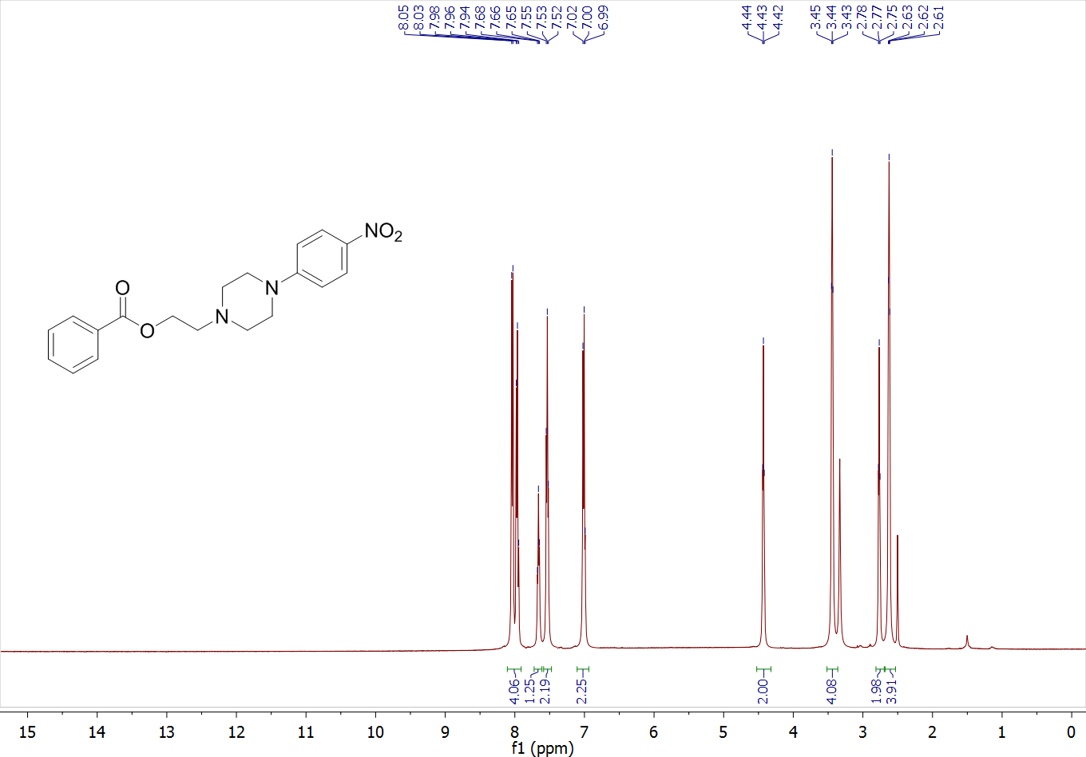
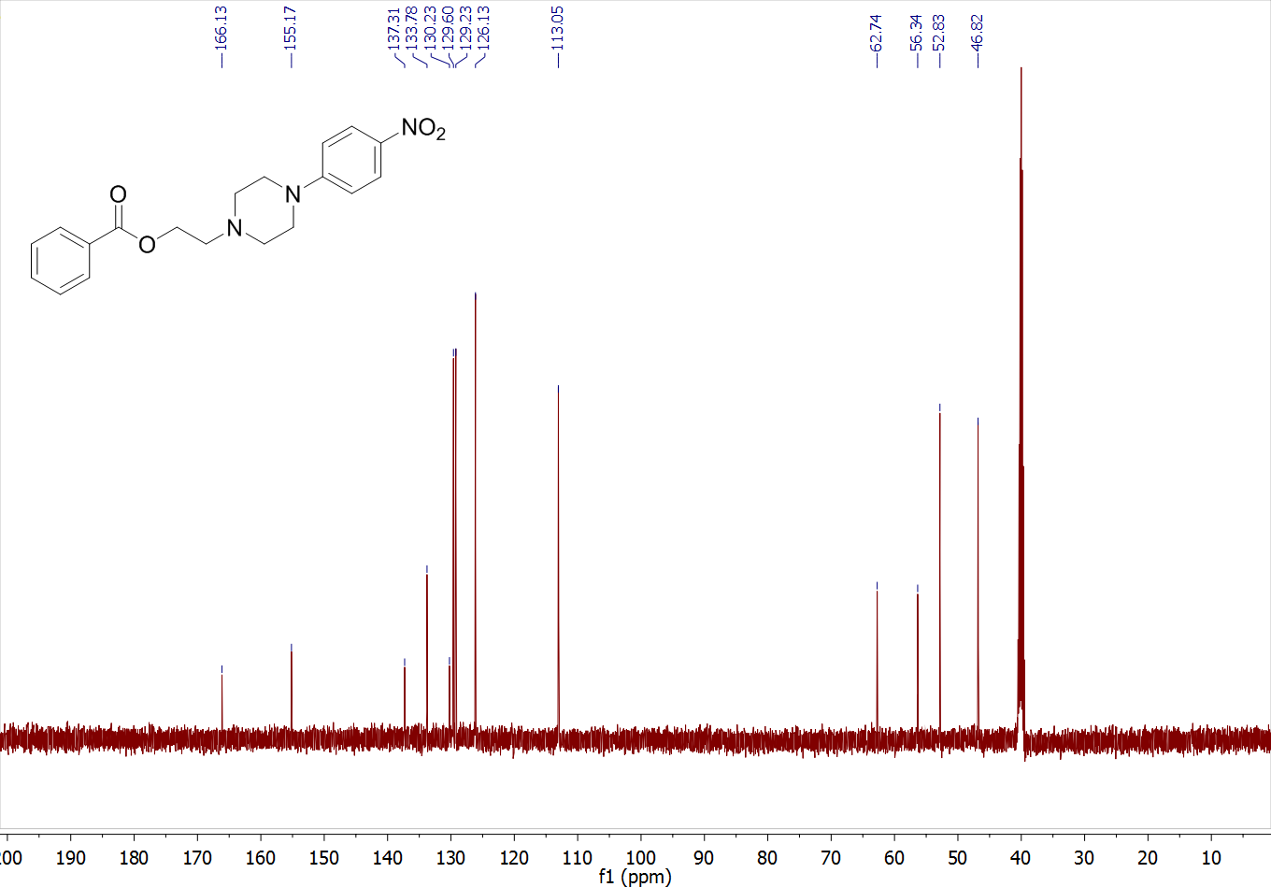
2-(4-(4-nitrophenyl)piperazin-1-yl)ethyl 2-bromobenzoate (4b)
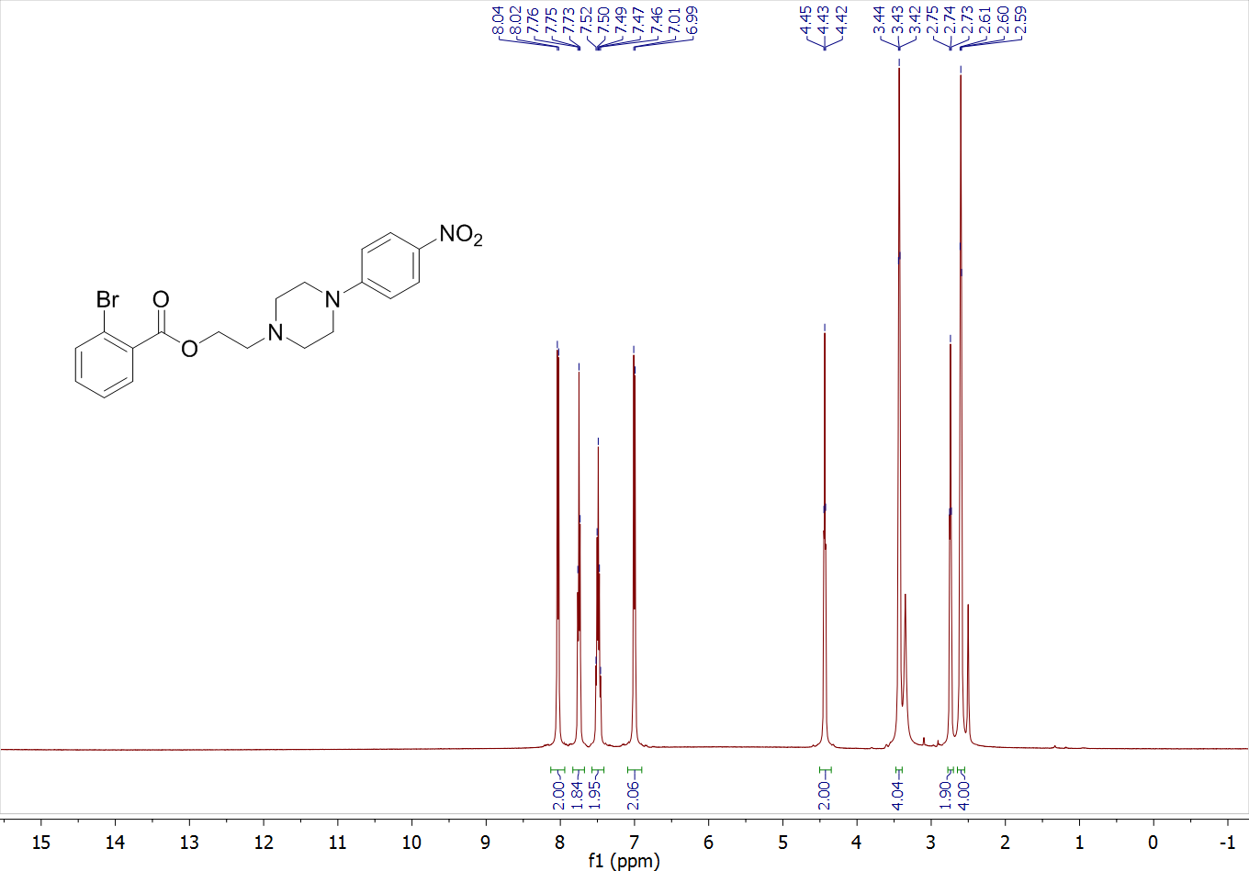
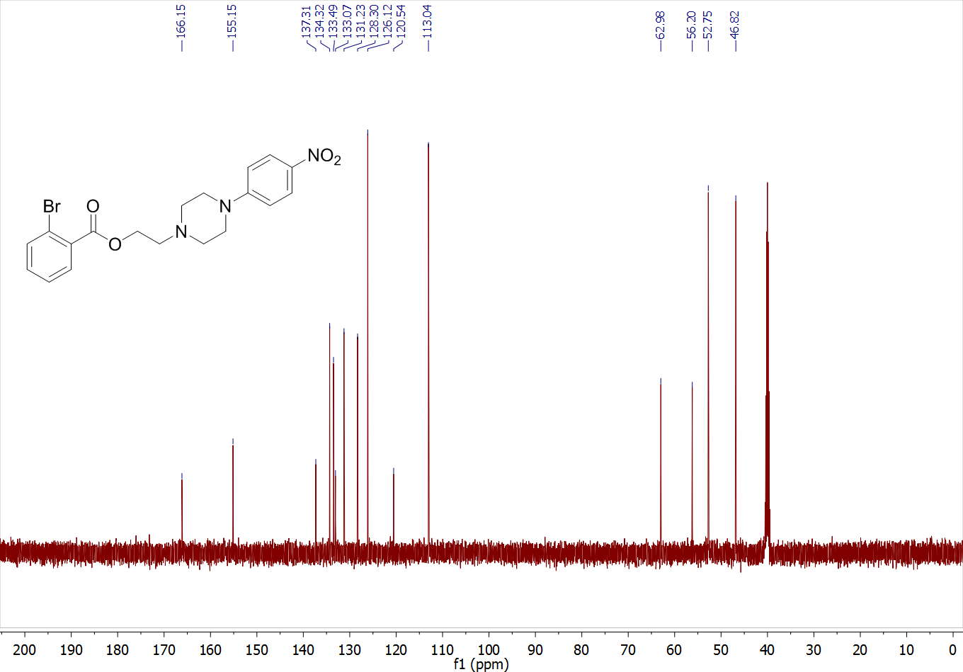
2-(4-(4-nitrophenyl)piperazin-1-yl)ethyl 2,4-dichlorobenzoate (4c)
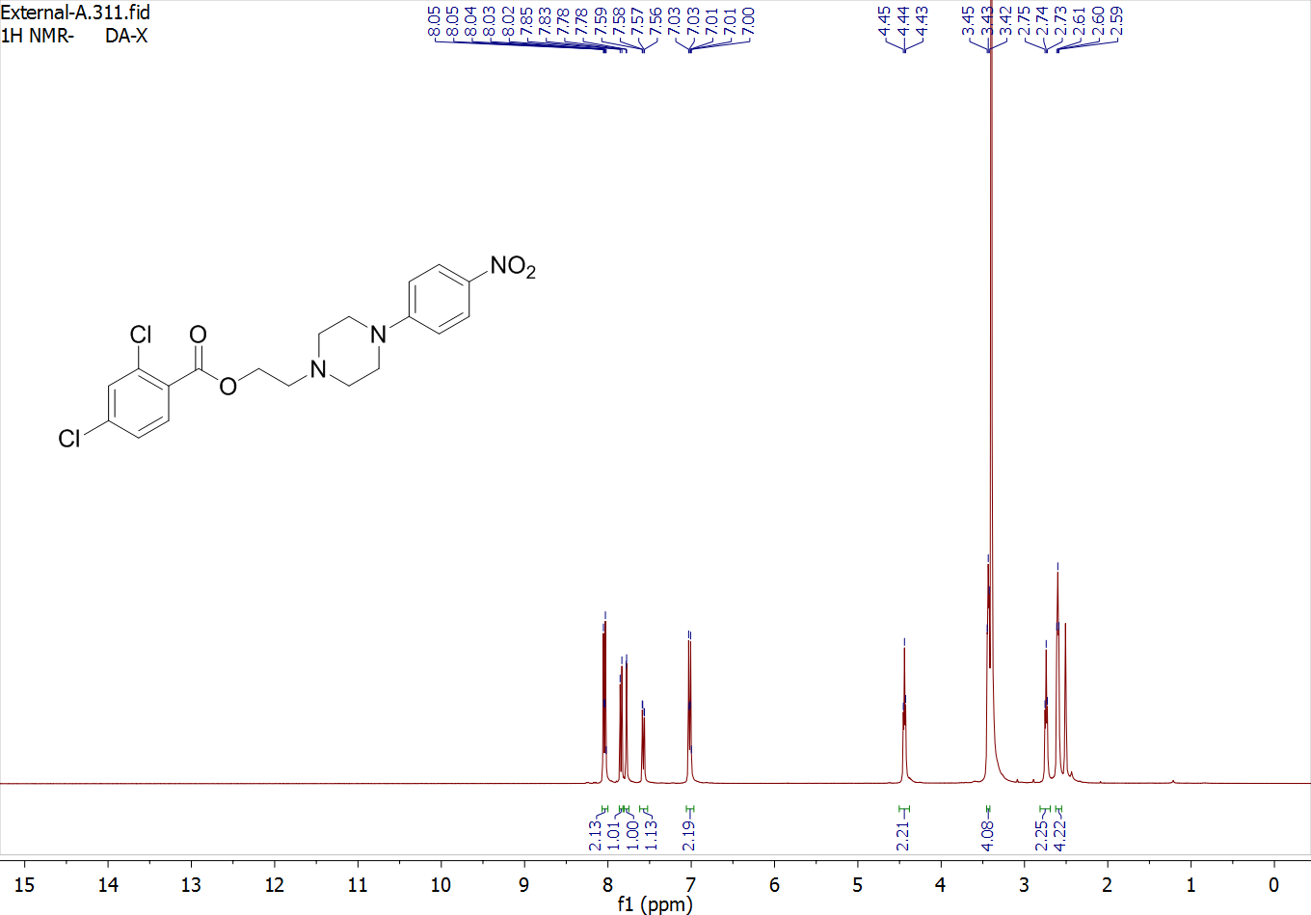
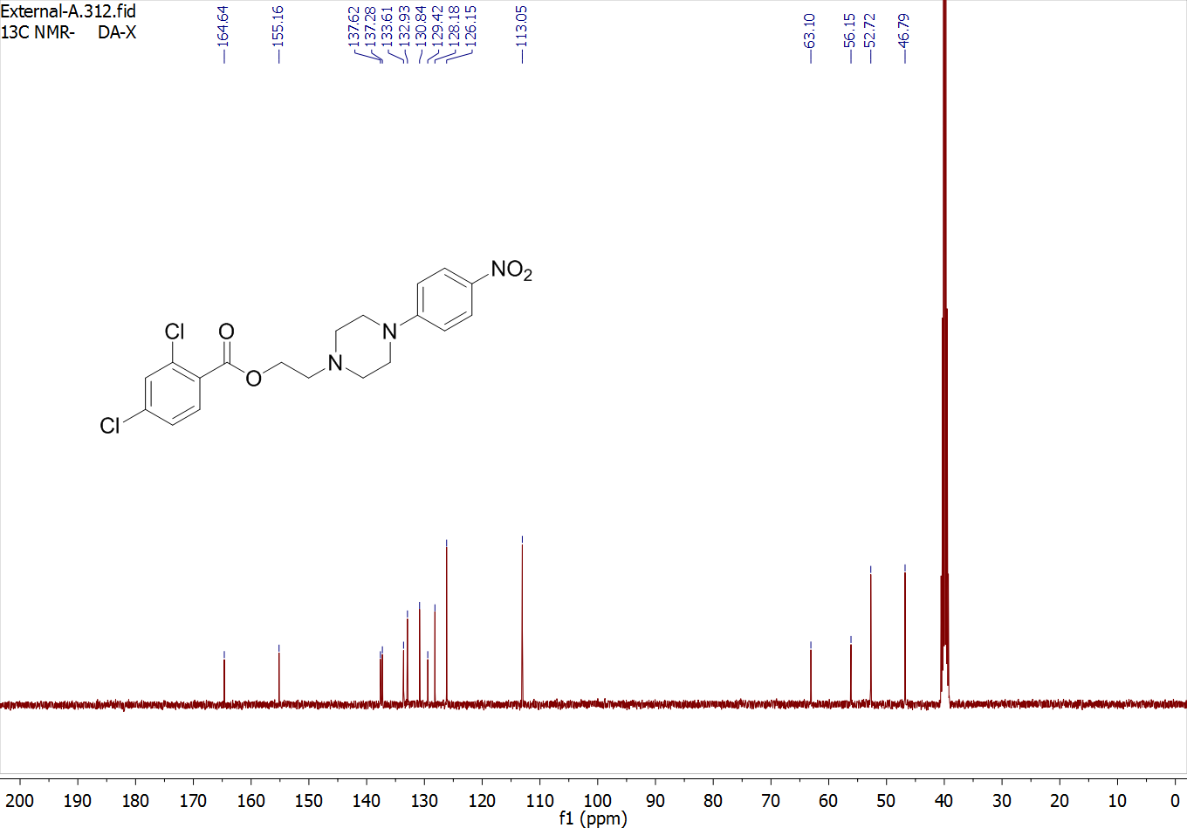

2-(4-(4-nitrophenyl)piperazin-1-yl)ethyl 4-nitrobenzoate (4d)
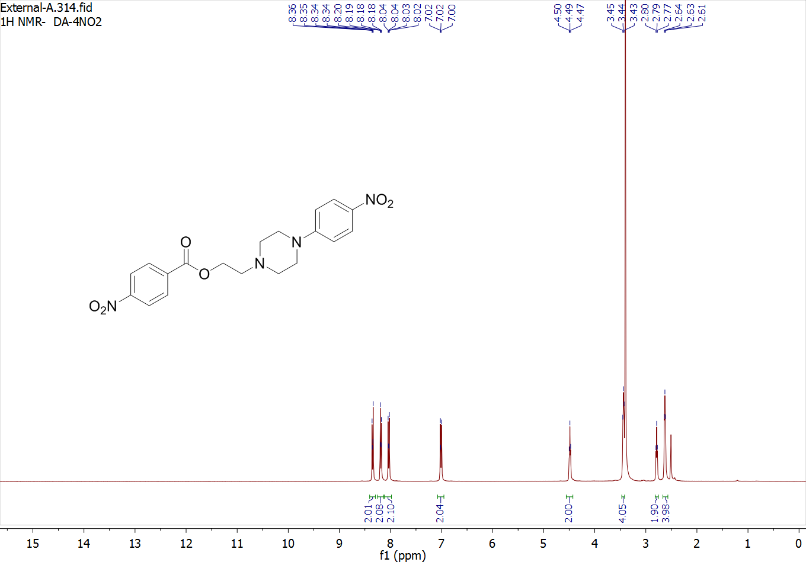
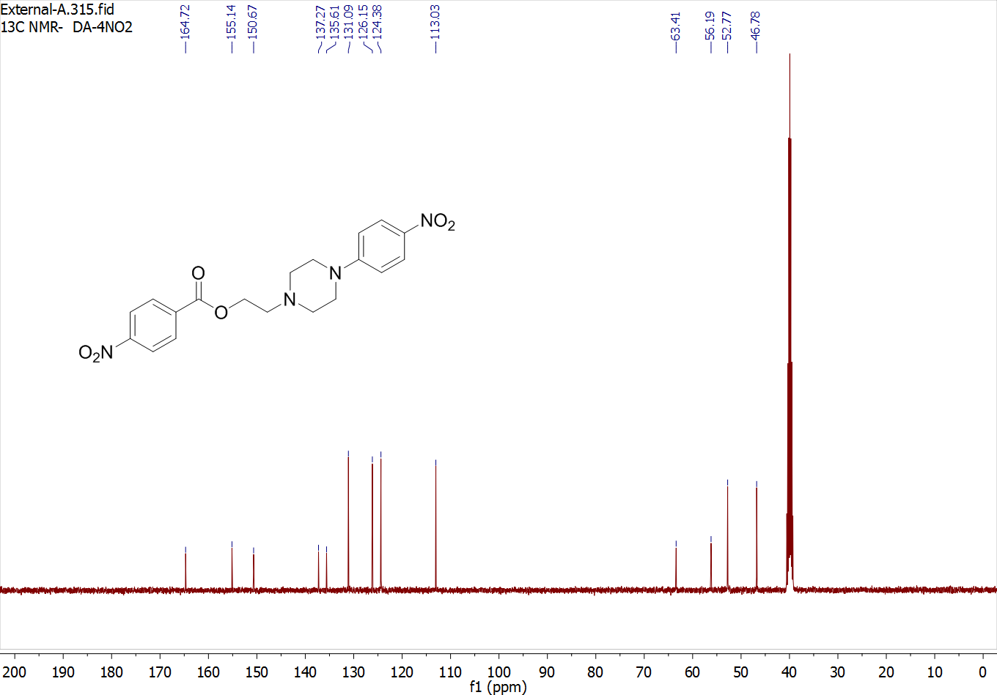
2-(4-(4-nitrophenyl)piperazin-1-yl)ethyl 3-nitrobenzoate (4e)
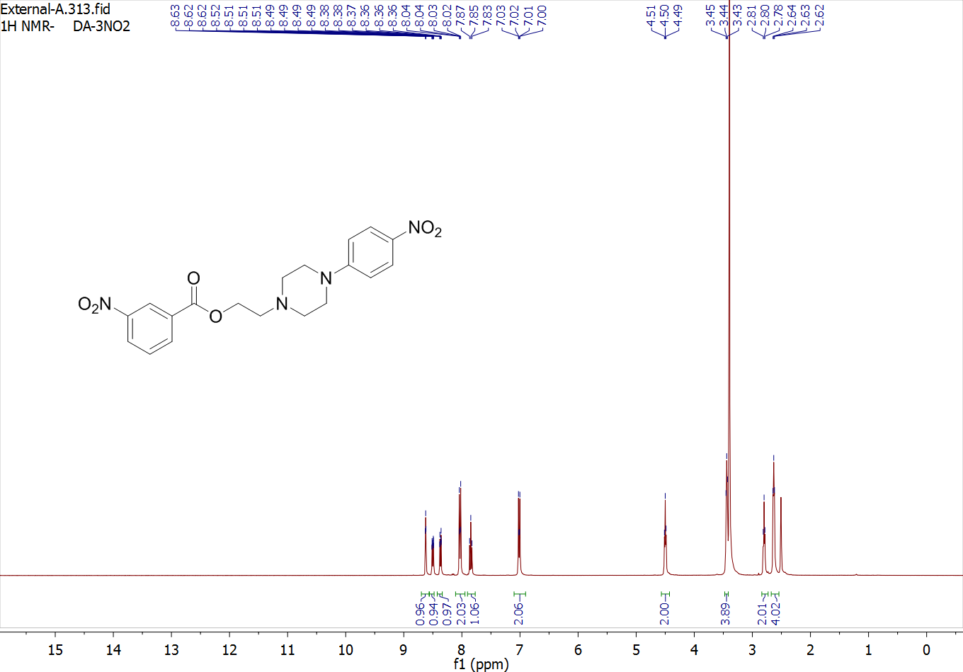
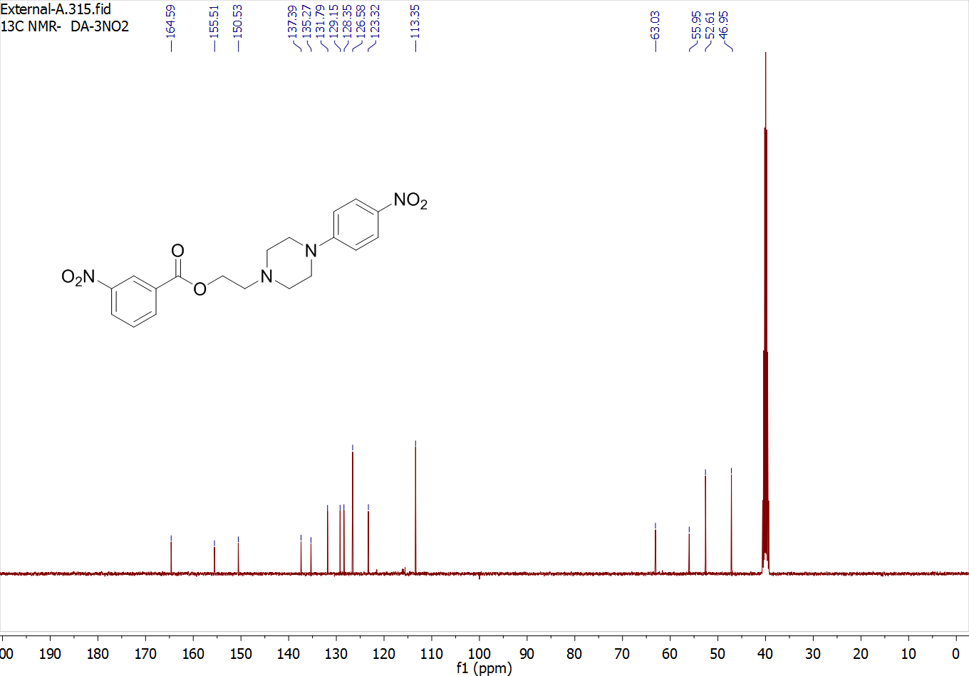

2-(4-(4-nitrophenyl)piperazin-1-yl)ethyl 2-chloro-4-nitrobenzoate (4f)
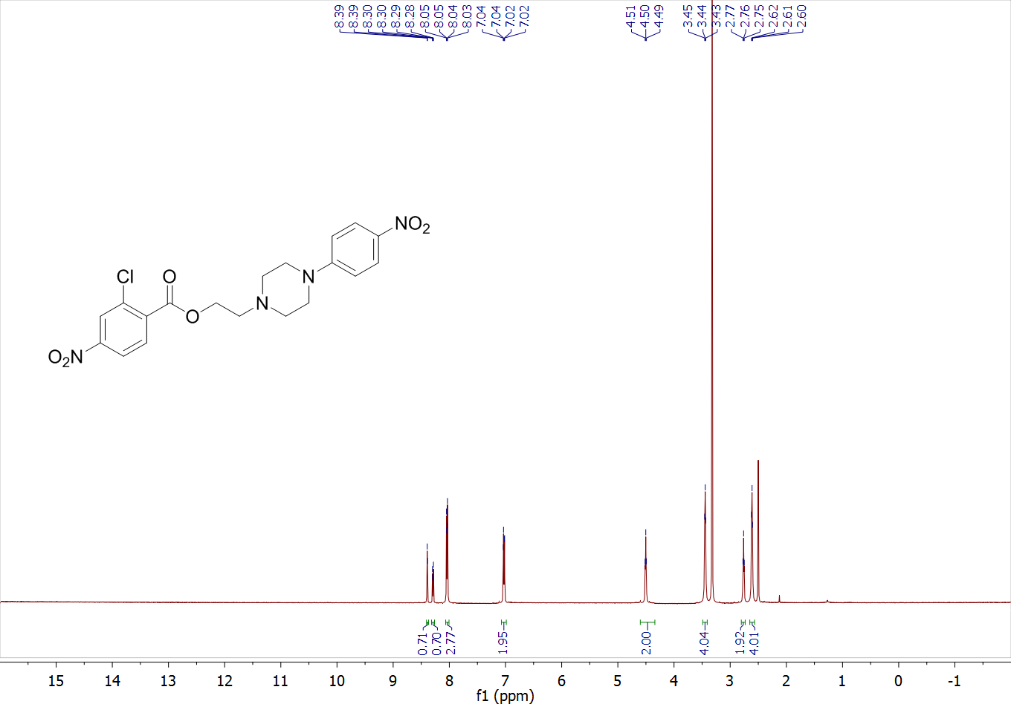
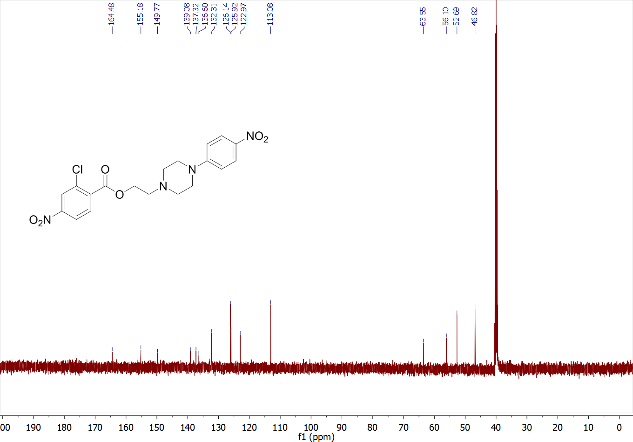
2-(4-(4-nitrophenyl)piperazin-1-yl)ethyl 2-(4-methoxyphenyl)acetate (4g)
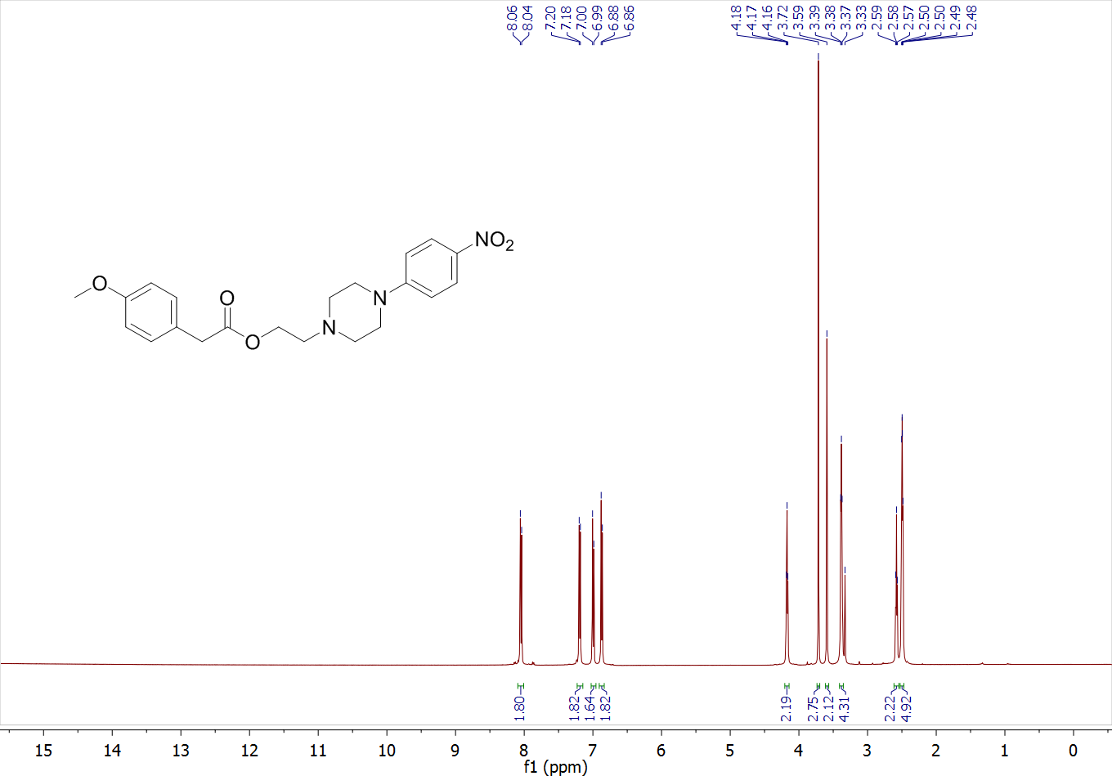
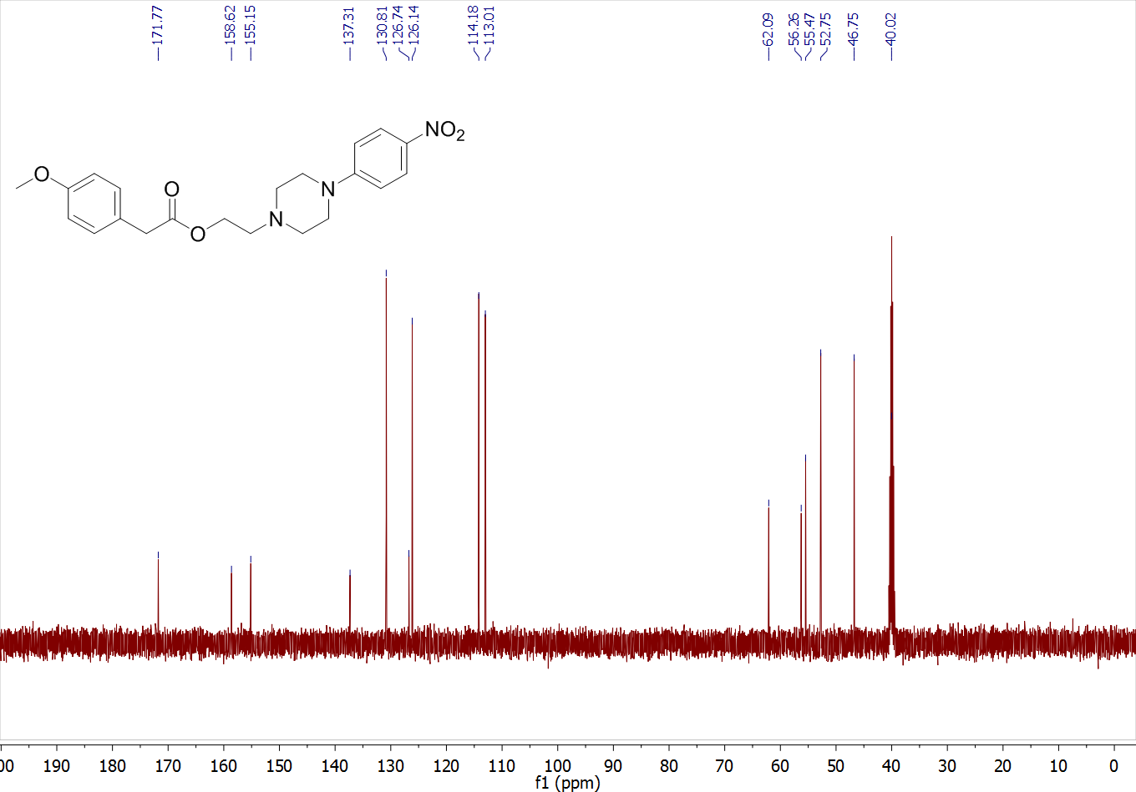
2-(4-(4-nitrophenyl)piperazin-1-yl)ethyl 6-formyl-2,3-dimethoxybenzoate (4h)
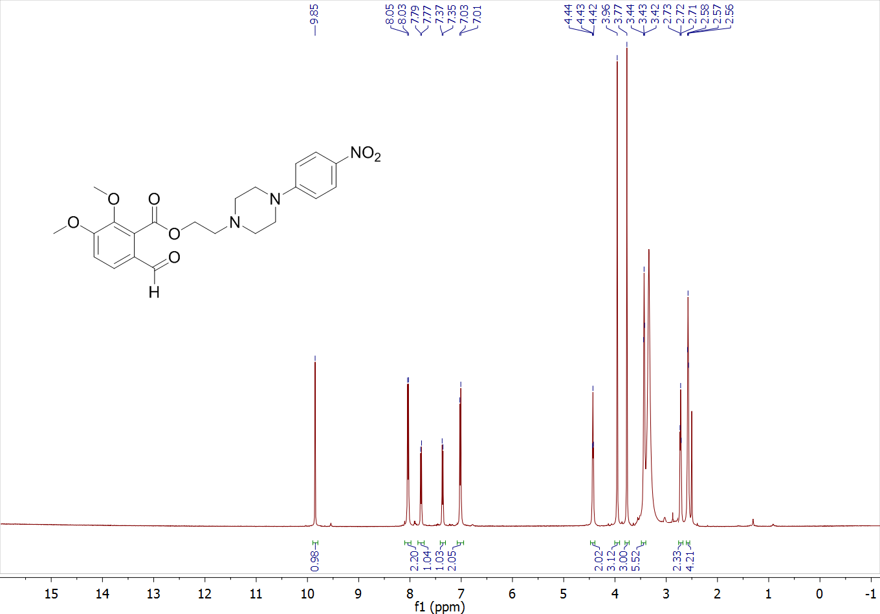
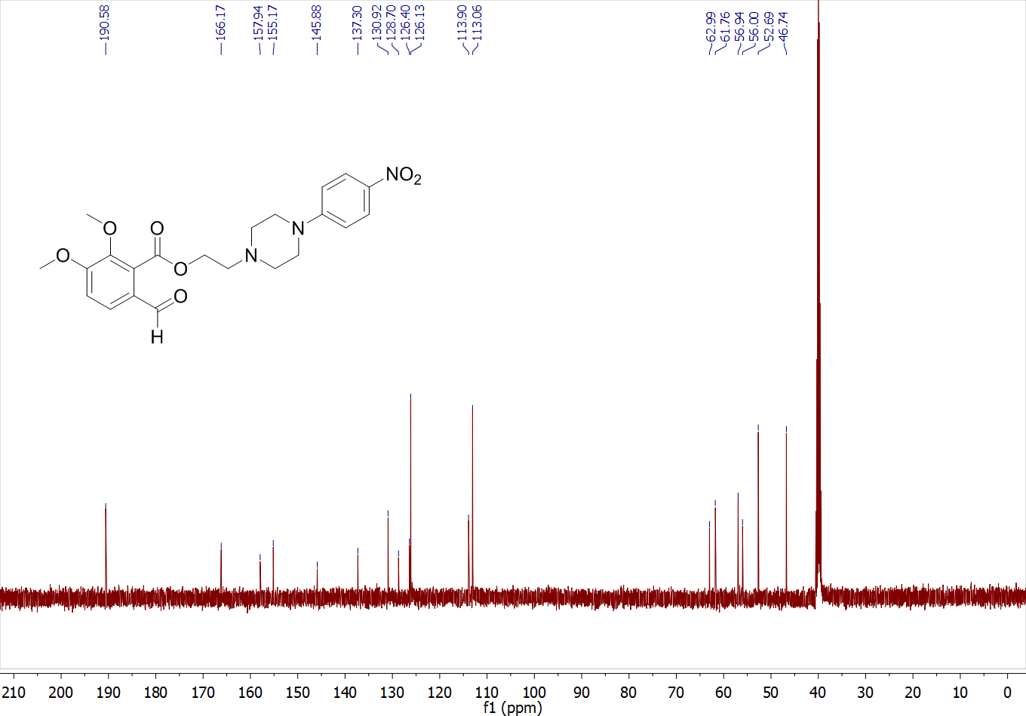
2-(4-(4-nitrophenyl)piperazin-1-yl)ethyl 2-phenylacetate (4i)
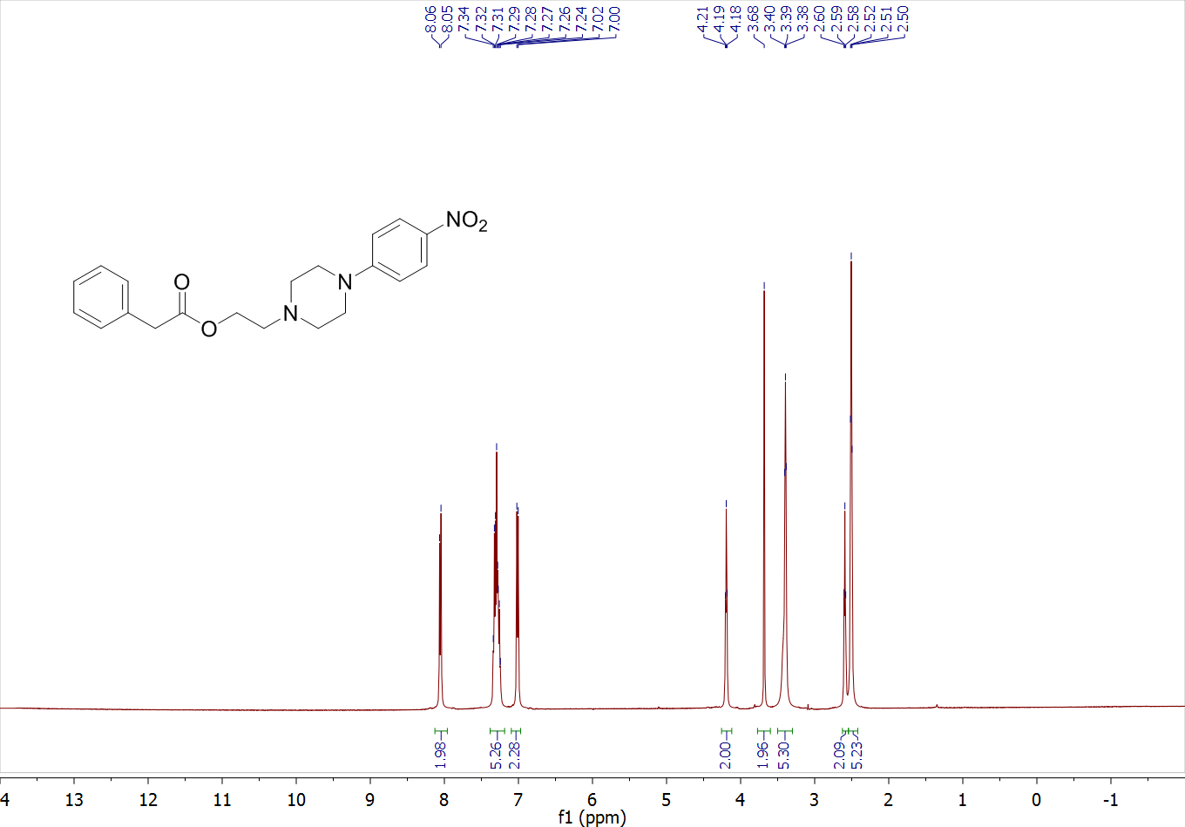
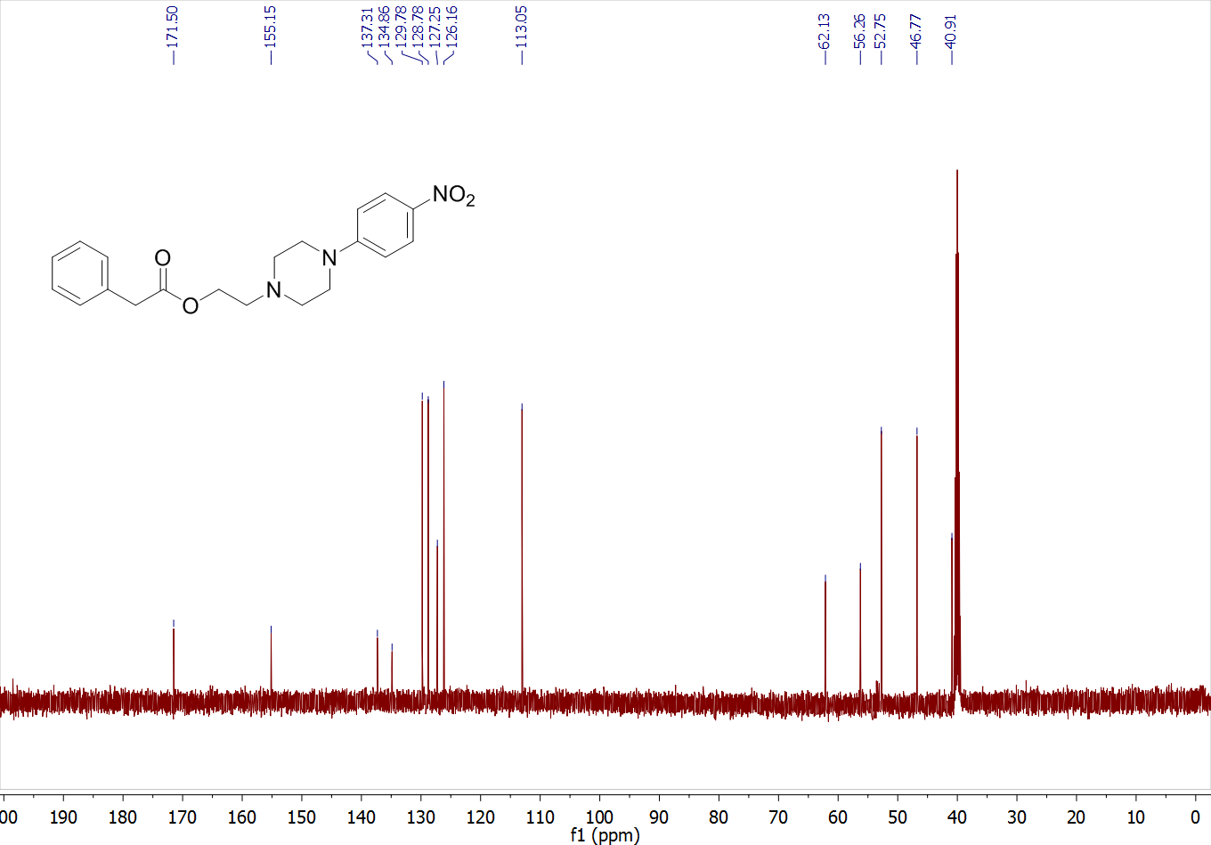

2-(4-(4-nitrophenyl)piperazin-1-yl)ethyl cinnamate (4j)
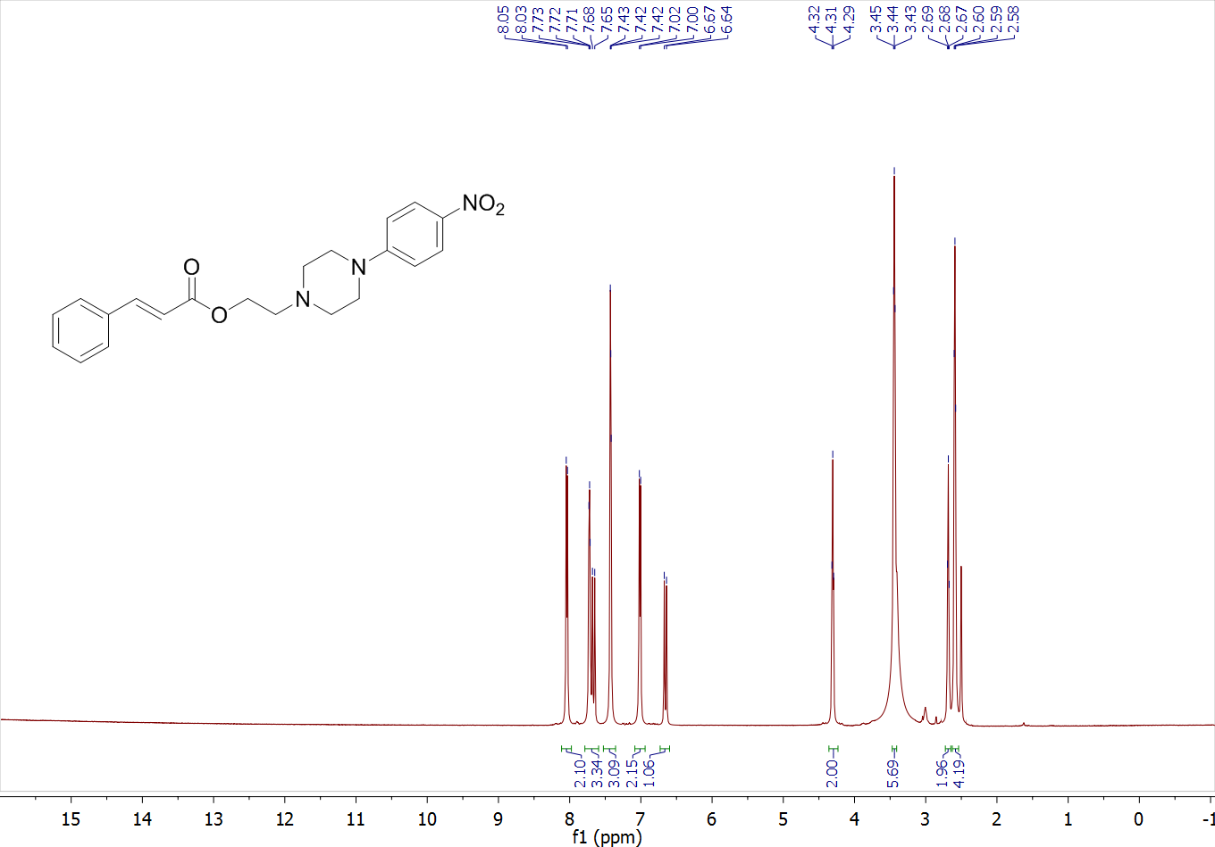
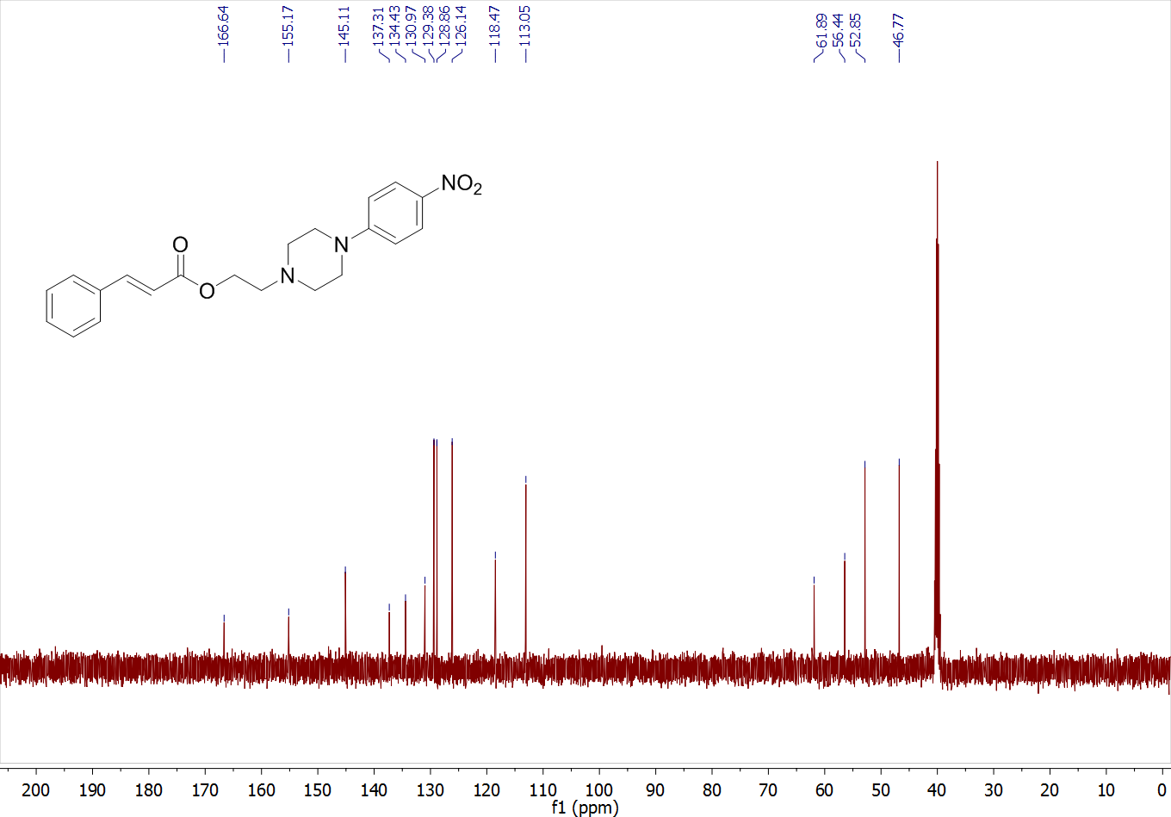
2-(4-(4-nitrophenyl)piperazin-1-yl)ethyl nicotinate (4k)
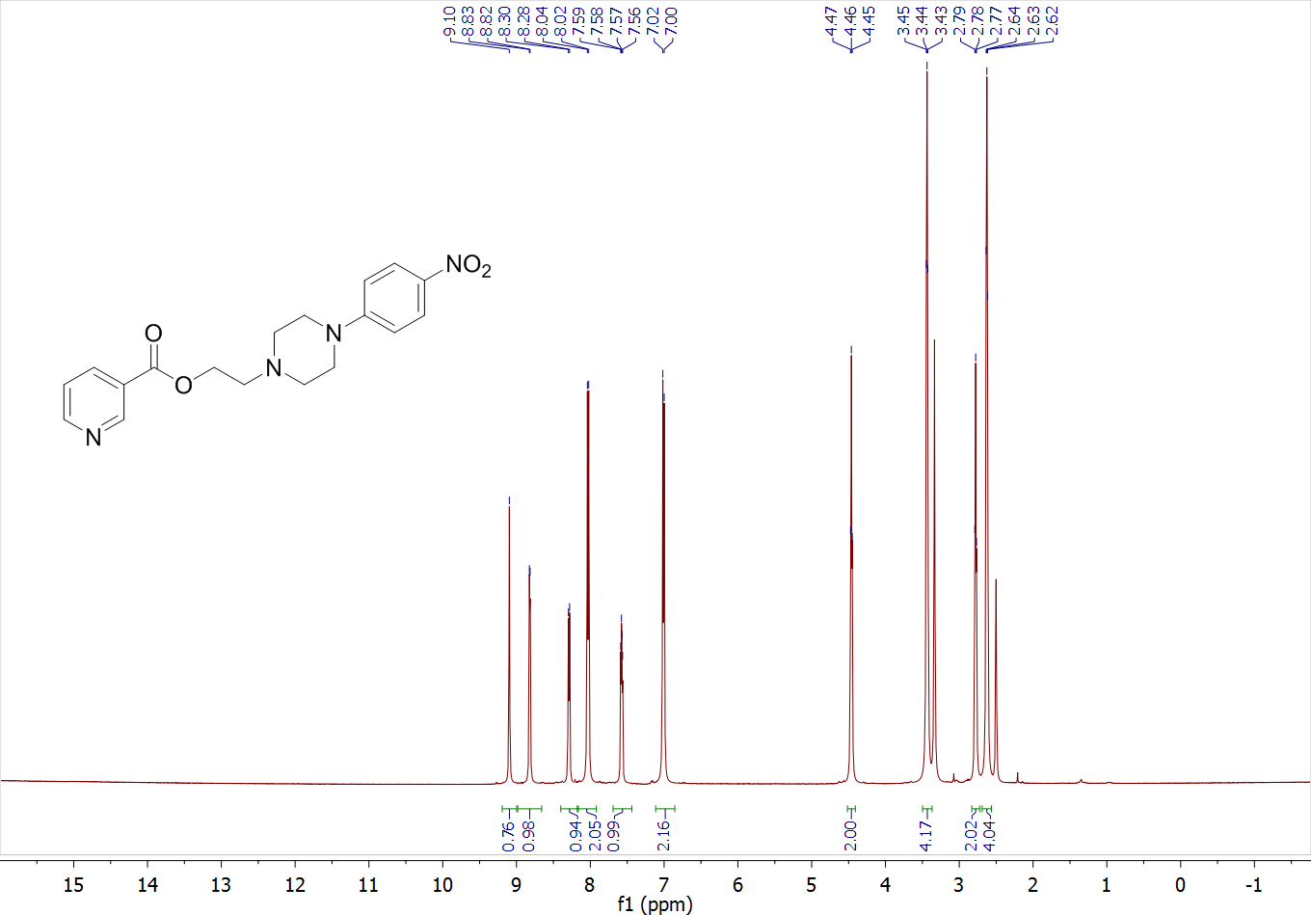
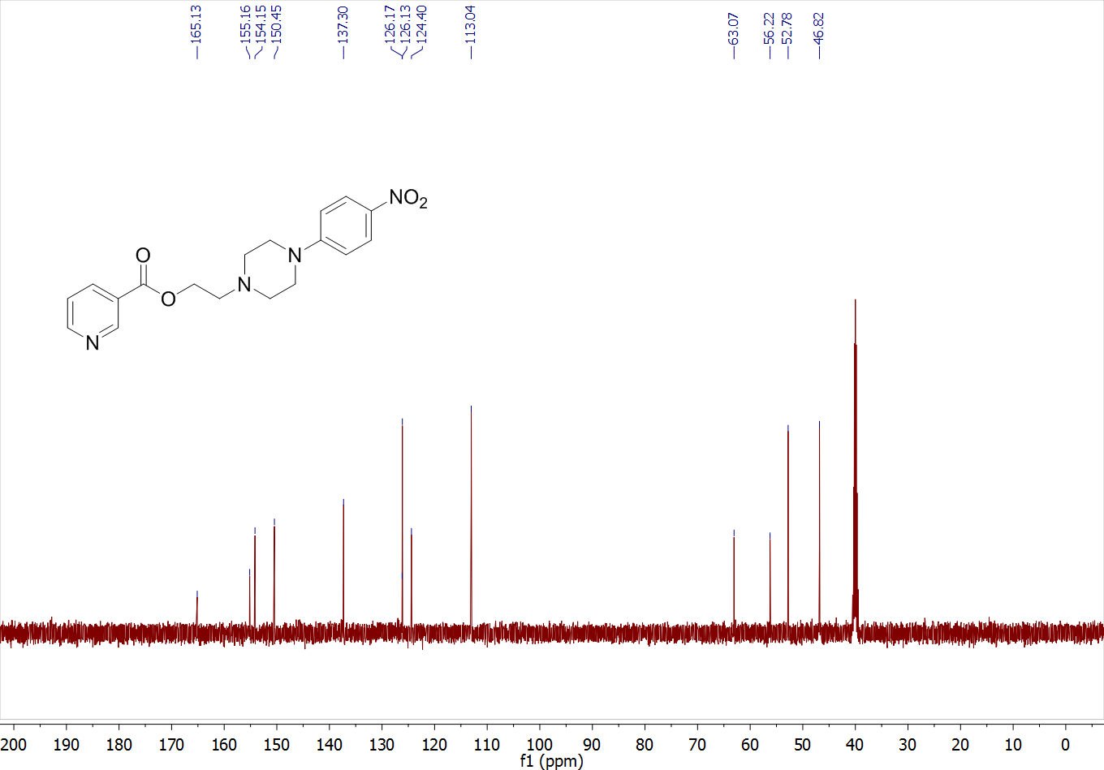
2-(4-(4-nitrophenyl)piperazin-1-yl)ethyl 1H-indole-2-carboxylate (4l)
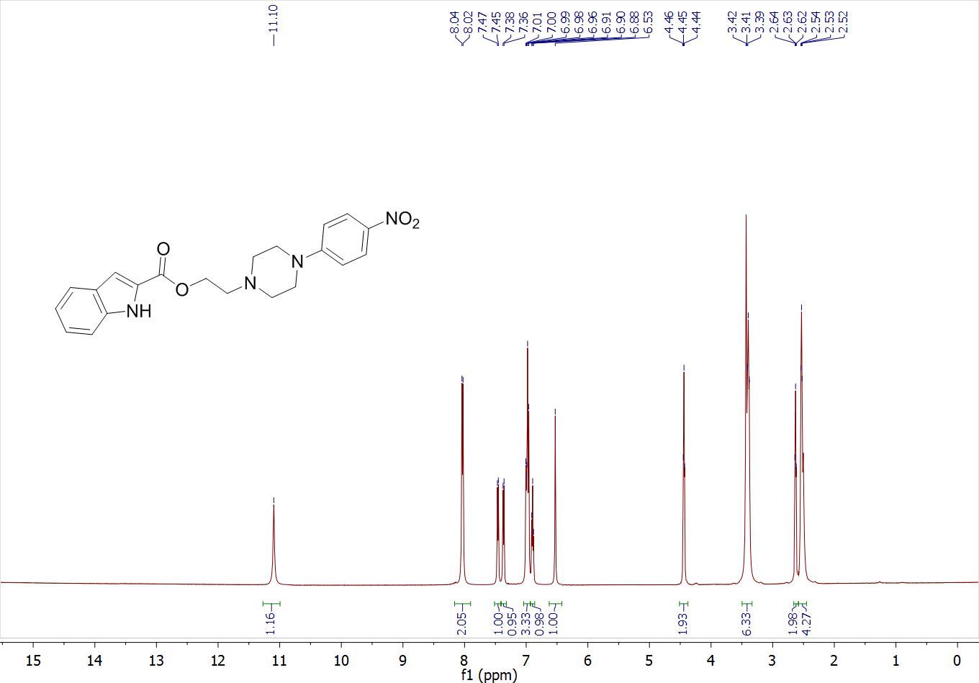
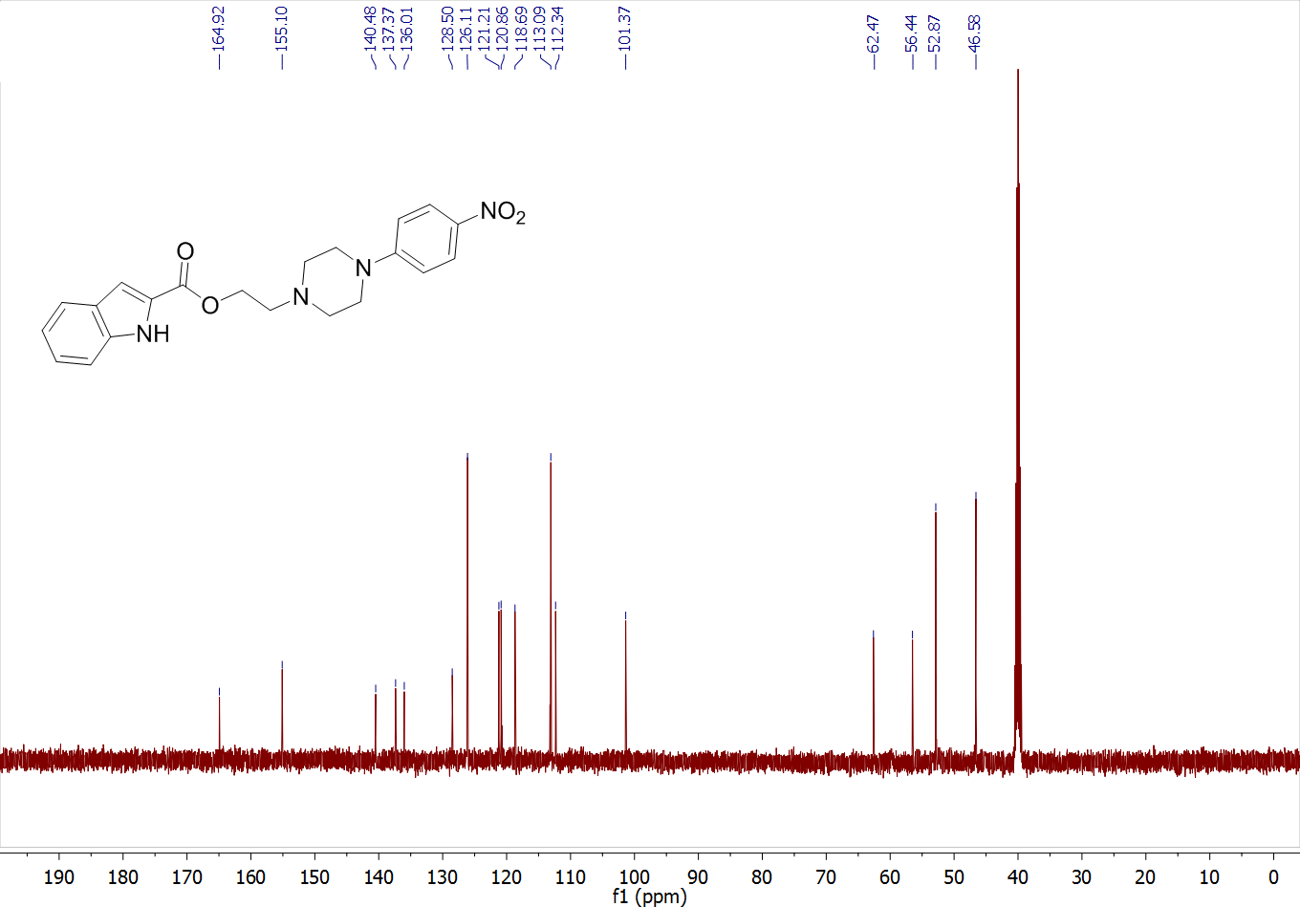
2-(4-(4-nitrophenyl)piperazin-1-yl)ethyl 5-nitrofuran-2-carboxylate (4m)
