Additional file for
Modified nano magnetic Fe₂O₃-MgO as a high active multifunctional heterogeneous catalyst for environmentally beneficial carbon-carbon synthesis

Ehsan Kamali , Fahim Dreekvandy Abolfazl Mohammadkhani, Akbar Heydari*.
¹Chemistry Department, Tarbiat Modares University, Tehran, PO Box:14155-4838, Iran
E-mail: Heydar_a@modares.ac.ir , Ehsan.kamali@modares.ac.ir, M_abolfazl@modares.ac.ir, F.dreekvandy@modares.ac.ir

Characterization of Products
The compounds 3a, 3b, 3c, 3d, 3e, 3f, 3g, 3h, 3i, 3g, 3k, 3l,3m, 3n, 4a,4b,4c,4d,4e,4f,4g,4h are known compounds and were reported previously. 5a and 5b are reported at the first time .
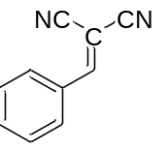2-benzylidenemalononitrile (3a) M.P. 82 (Lit[1]. M.P. : 82-83 ºC) ¹H NMR (400 MHz, CDCl₃) δ 7.98 – 7.90 (m, 2H), 7.81 (s, 1H), 7.70 – 7.62 (m, 1H), 7.61 – 7.53 (m, 2H). IR(KBr): 3234, 3031, 2223,1637, 1591, 1217 cm⁻¹

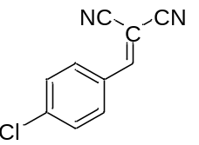 2-(4-chlorobenzylidene)malononitrile (3b) M.P.: 162-163 ᵒC (Lit. [1] M.P. 162-163ºC). ¹H NMR (400 MHz, DMSO) δ 8.54 (s, 1H), 7.99 – 7.91 (m, 2H), 7.75 – 7.67 (m, 2H). Molecular weight:188, Molecular weight found :188.2 IR(KBr): 3240 , 2986, 2229, 1638, 1448, 1048, 973, 847, 786, cm⁻¹

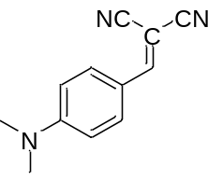2-(4-(dimethylamino)benzylidene)malononitrile(3c) M.P. 182(Lit[2]. M.P. 182ºC) ¹H NMR (400 MHz, CDCl₃) δ 7.88 – 7.80 (m, 2H), 7.49 (s, 1H), 6.75 – 6.67 (m, 2H), 3.17 (s, 6H). IR(KBr): 3234,2921,2209,1637,1616,1385 cm⁻¹
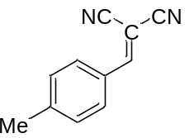2-(4-methylbenzylidene)malononitrile (3d) M.P. 131-134 (Lit[1]. M.P. 136-137ºC) ¹H
NMR (400 MHz, CDCl₃) δ 7.87 – 7.81 (m, 2H), 7.75 (s, 1H), 7.38 – 7.33 (m, 2H), 2.48 (s, 3H). IR(KBr): 3232,2918,2223,1637,1617,1588,1384,1191 cm⁻¹

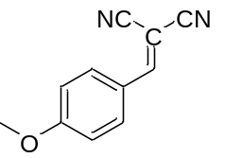 2-(4-methoxybenzylidene)malononitrile (3e) M.P.: 110-112ᵒC (Lit. [1]. M.P. 113ºC) ¹H NMR (400 MHz, CDCl₃) δ 7.98 – 7.90 (m, 2H), 7.68 (s, 1H), 7.08 – 7.00 (m, 2H), 3.94 (s, 3H). IR(KBr): 3230, 3027, 2923, 2222,1627,1606,1571,1384,1277,1021cm⁻¹
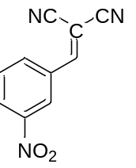 2-(3-nitrobenzylidene)malononitrile (3f) M.P. 100-101 (Lit[3]. M.P. 99-101 ºC) ¹H NMR (400 MHz, CDCl₃) δ 8.69 (t, J = 2.0 Hz, 1H), 8.50 (ddd, J = 8.3, 2.2, 1.0 Hz, 1H), 8.39 – 8.31 (m, 1H), 7.93 (s, 1H), 7.82 (t, J = 8.1 Hz, 1H).IR(KBr): 3083,2225,1596,1355,1215 cm⁻¹

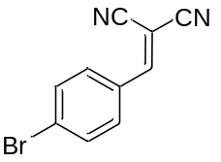 2-(4-bromobenzylidene)malononitrile (3g), M.P. 165-166 (Lit. M.P. 162-163[4] ºC) ¹H NMR (400 MHz, CDCl₃) δ 7.83 – 7.77 (m, 2H), 7.74 (s, 1H), 7.73 – 7.66 (m, 2H). IR(KBr): 3027,2225,1637,1578,822 cm⁻¹
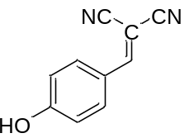2-(4-hydroxybenzylidene)malononitrile (3h), M.P. 183-184(Lit. [3] M.P. 186 ºC) ¹H NMR (400 MHz, CDCl₃) δ 7.88 – 7.77 (m, 2H), 7.56 (s, 1H), 6.89 – 6.75 (m, 2H), 5.58 (s, 1H). IR(KBr): 3413, 3236, 3036, 2917, 2220, 1638,1616,1558,1384,1161cm⁻¹

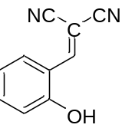2-(2-hydroxybenzylidene)malononitrile (3i) M.P. =73-74(Lit. [5] M.P. 163-164 ºC) ¹H NMR (400 MHz, CDCl₃) δ 7.79 (s, 1H), 7.55 (ddd, J = 8.6, 7.4, 1.6 Hz, 1H), 7.41 (dd, J = 7.7, 1.7 Hz, 1H), 7.24 (td, J = 7.6, 1.1 Hz, 1H), 7.18 (d, J = 8.3 Hz, 1H). IR(KBr):3294,3024,2917,2847,2231,1653,1610,1261,1041. cm⁻¹

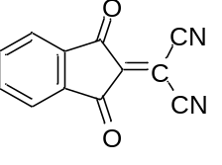2-(1,3-dioxo-1,3-dihydro-2H-inden-2-ylidene)malononitrile (3j) M.P. =281(Lit. [6] M.P. 281ºC) ¹H NMR (400 MHz, DMSO) δ 8.11 – 7.89 (m, 4H). IR(KBr): 3240, 2918 , 2104 ,1750 ,1712 ,1678 ,1637 ,1616 ,1421, 1222,1093 cm⁻¹

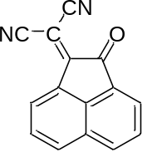 2-(2-oxoacenaphthylen-1(2H)-ylidene)malononitrile (3k) M.P. =244-246(Lit. [7]M.P. 244-246ºC) 1H NMR (400 MHz, CDCl3) δ 8.60 (d, J = 7.3 Hz, 1H), 8.34 – 8.29 (m, 2H), 8.20 (d, J = 7.0 Hz, 1H), 7.94 – 7.87 (m, 2H). IR(KBr): 3238, 2920,2228, 1719, 1637,166,1420,cm⁻¹
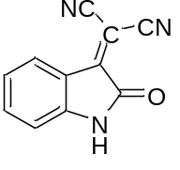2-(2-oxoindolin-3-ylidene)malononitrile (3l) M.P. =215-217(Lit. [8] M.P. 215-217ºC) IR(KBr-ethyl acetate ): 3269,3111,2876,2233,1736,1718,1625,1589,cm⁻¹
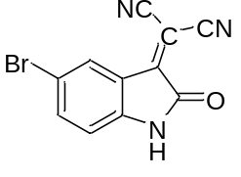2-(5-bromo-2-oxoindolin-3-ylidene)malononitrile (3m): M.P. . =228-230(Lit. [9]M.P. 228-230ºC) IR(KBr): 3234, 3058, 2958, 2929, 2268, 1713, 1621, 1390, 1265,981, 893, 741 cm⁻¹
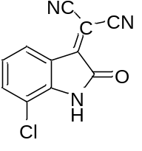2-(7-chloro-2-oxoindolin-3-ylidene)malononitrile (3n): M.P.: 245-246 ^{O}C (Lit. [9]M.P. 245-246 ºC) . IR(KBr): 3193, 3072, 2988, 2929, 2859, 2223, 1723, 1620, 1587, 740 cm⁻¹
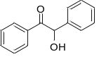2-hydroxy-1,2-diphenylethan-1-one (4a) White solide; M.P. :132-135 ℃(Lit. [10] M.P. 133-134 ºC); IR(KBr) ν (Cm⁻¹): 3406, 3060, 2926, 1675, 1569, 1489, 1447, 1387, 1262, 1200, 1067, 973, 832, 748, 694, 599, 509 ; ms Molecular weight found :: 211
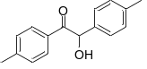 2-hydroxy-1,2-di-p-tolylethan-1-one (4b) White powder; M.P. :65-67℃(Lit [10]. M.P. 84-85 ºC); ¹H NMR (400 MHz, DMSO-d₆) : δ 7.84 (d, J=12.0, 2H), 7.26 – 7.17 (m, 4H), 7.13-711 (d, J=8, 2H), 5.90 (s, 1H), 4.60 (bs, 1H), 2.35 (s, 3H), 2.29 (s, 3H). ¹³C NMR (100 MHz, DMSO- d₆) :199.5 ,144.8 ,138.2, 136., 130.9, 129.9 ,129.7 ,1129.6 ,129.3 ,129.2 ,127.6 ,84.8, 29.6 ,21.6 ,21.1 .IR (KBr) ν (Cm-1): 3457, 3028, 2922, 1676, 1607, 1511, 1396, 1247, 1180, 1078, 973, 814, 723, 659, 576, 503 ; Ms Molecular weight found : 240
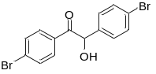1,2-bis(4-bromophenyl)-2-hydroxyethan-1-one (4c) Yellow solid; M.P. :94-96 ℃ Lit[10]. M.P. 94-96 ºC) ; IR (KBr) ν (Cm⁻¹): 3438, 2919, 2852, 1669, 1580, 1481, 1393, 1267, 1175, 1070, 1008, 817, 753, 607, 523, 461 ;ms Molecular weight found :: 367.9
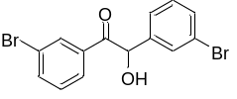1,2-bis(3-bromophenyl)-2-hydroxyethan-1-one (4d) Solid; M.P. : 76-77 ℃ Lit. [11] M.P. 75-77 ºC); IR (KBr) ν (Cm⁻¹): 3427, 3065, 2922, 2854, 1686, 1576, 1470, 1418, 1260, 1193, 1073, 990, 886, 782, 740, 690 ; ms Molecular weight found :: 368
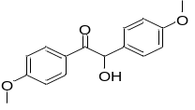2-hydroxy-1,2-bis(4-methoxyphenyl)ethan-1-one (4e) Solid ; M.P. : 109-11℃ Lit. [10]. M.P. 110-112 ; IR (KBr) ν (Cm⁻¹): 3420, 2924, 2853, 1680, 1608, 1511, 1441, 1277, 1172, 1106, 1022, 846, 761, 695, 605, 513: Molecular weight found :: 272
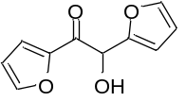1,2-di(furan-2-yl)-2-hydroxyethan-1-one (4f) White solid; M.P. :134-135℃ ; Lit. [12] M.P. 134-135 IR (KBr) ν (Cm⁻¹): 3416, 3147, 3124, 3093, 1674, 1592, 1523, 1444, 1383, 1307, 1209, 1141, 1016, 926, 883, 755, 596 ; Molecular weight found :: 192
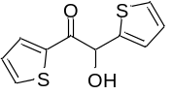2-hydroxy-1,2-di(thiophen-2-yl)ethan-1-one (4g )Yellow Solid ; M.P. : 107-108℃; Lit. [13] M.P. 108-109 ; IR (KBr) ν (Cm⁻¹): 3440, 3068, 2945, 1641, 1453, 1392, 1274, 1091, 1022, 939, 882, 789, 584 ; Molecular weight found :: 224
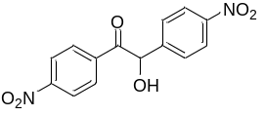 2-hydroxy-1,2-bis(4-nitrophenyl)ethan-1-one (4h) Solid; M.P. : 239 ℃ ; Lit. [14]M.P. 239-240 IR (KBr) ν (Cm⁻¹): 3410, 3062, 2924, 1682, 1632, 1595, 1511, 1435, 1279, 1170, 1109, 844, 768, 693, 603, 507 ; Molecular weight found : 302
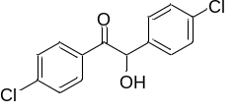1,2-bis(4-chlorophenyl)-2-hydroxyethan-1-one (4i)M.P.:87-89 [10] IR (KBr) ν (Cm⁻¹): 3463,2986,1893,1743,1374,1243,1048,937,847,608; Molecular weight found : 280
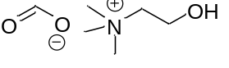 Choline Formate red- liquid (5a) : ¹H NMR (400 MHz, MeOD) δ 8.57 (s, 1H), 4,96 (s,) 4.04 (dq, J = 7.9, 2.9 Hz, 2H), 3.68 – 3.46 (m, 2H), 3.27 (d, J = 1.2 Hz, 9H). ¹³C NMR (100 MHz, MeOD) δ 168.94, 159.82, 67.71, 55.76, 54.14 – 53.16 (m). IR( KBr ): 3457 ,2960 ,2851 ,2164 ,1648 ,1484 ,1484 ,1385 ,1135 cm⁻¹ Molecular weight found :149
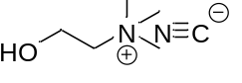 Choline cyanide (5b) orange- liquid: ¹H NMR (400 MHz, MeOD) : δ 4,91 (s,HOD) 4.08 – 4.04 (m, 2H), 3.66 – 3.61 (d, J=8 Hz 2H), 3.33 (S, 9H). ¹³C NMR (100 MHz, MeOD) δ 163.27 (C-N) [15], 67.83 – 67.62 (m), 55.47, 53.99 – 53.76 (m). IR( KBr ): 3375 ,3186,3060,2914,2201,1915,1719,1655,1600,1482, 1350,1204,1083,812,619,570 cm⁻¹ Molecular weight found :131

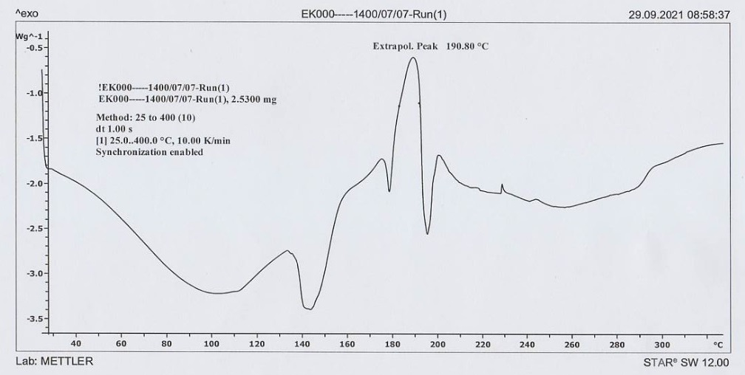
FigureS₁ DSC of choline cyanide
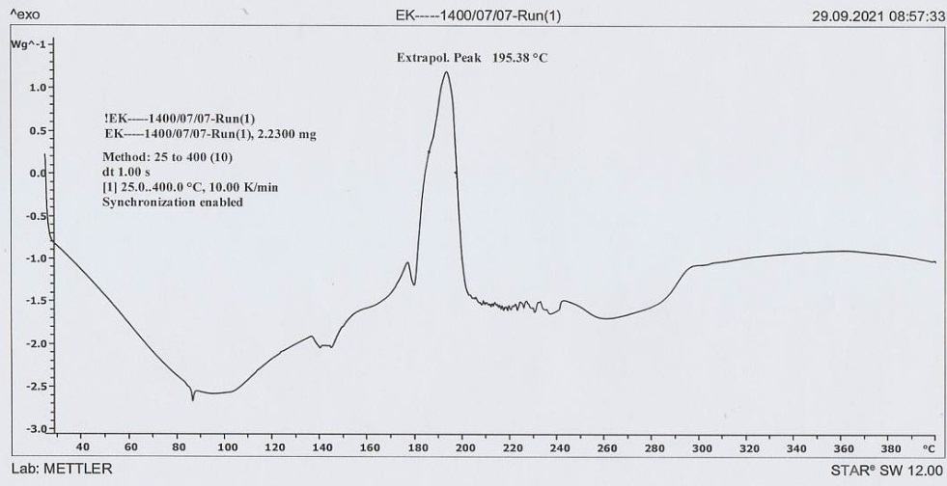
FigureS₂ DSC of choline formate

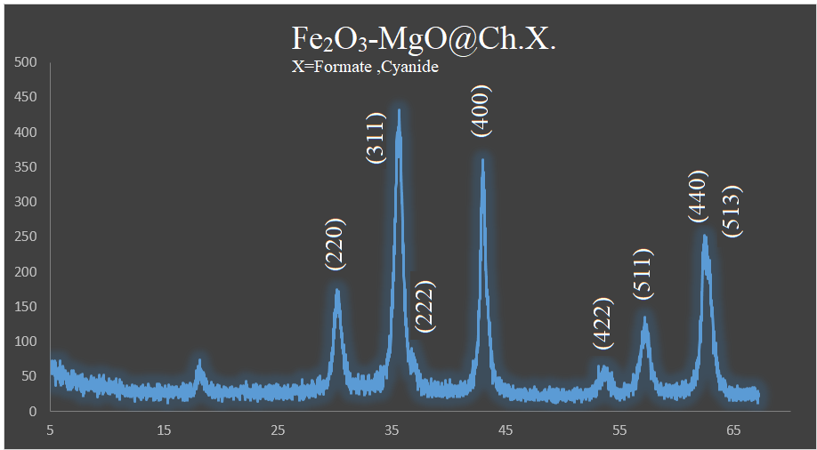
Figure. S₃. XRD of reuse Fe₂O₃-MgO@Ch.F and Fe₂O₃/MgO@Ch.CN

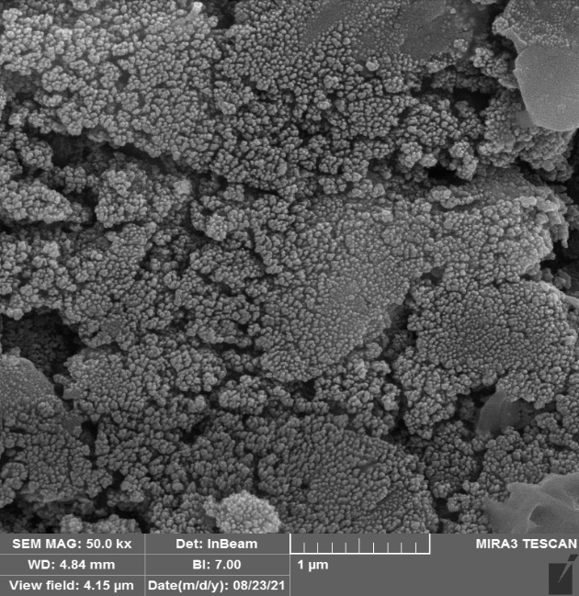
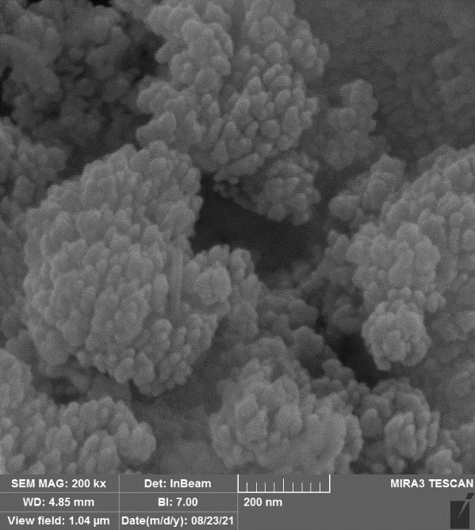

(B)
(A)

Figure. S₄ SEM images of reuse γ-Fe₂O₃/MgO@Ch.F (A) and γ-Fe₂O₃/MgO@Ch.CN (B)

Figure S₅. VSM of reuse γ-Fe₂O₃/MgO@Ch.F. and γ-Fe₂O₃/MgO@Ch.CN

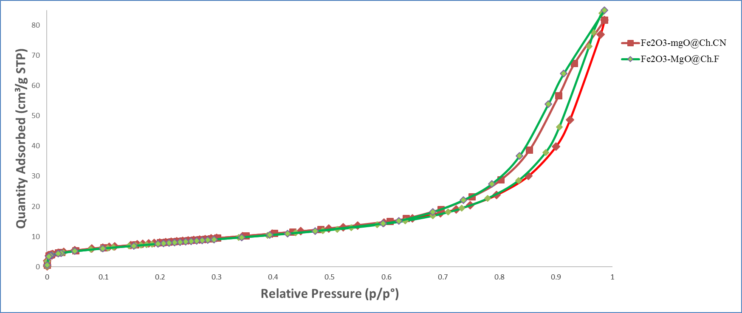
Figure. S₆. BET results of Fe₂O₃-MgO@Ch.CN and Fe₂O₃/MgO@Ch.F.

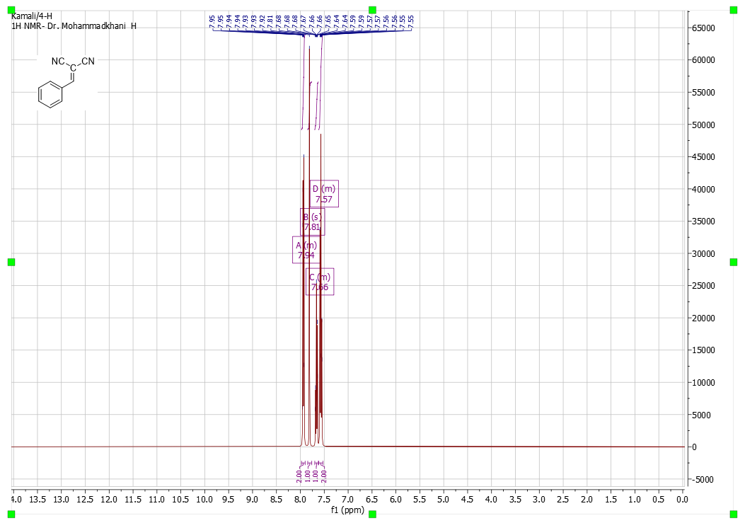
FigureS₇ the ¹H NMR spectrum of 3a in CDCl₃
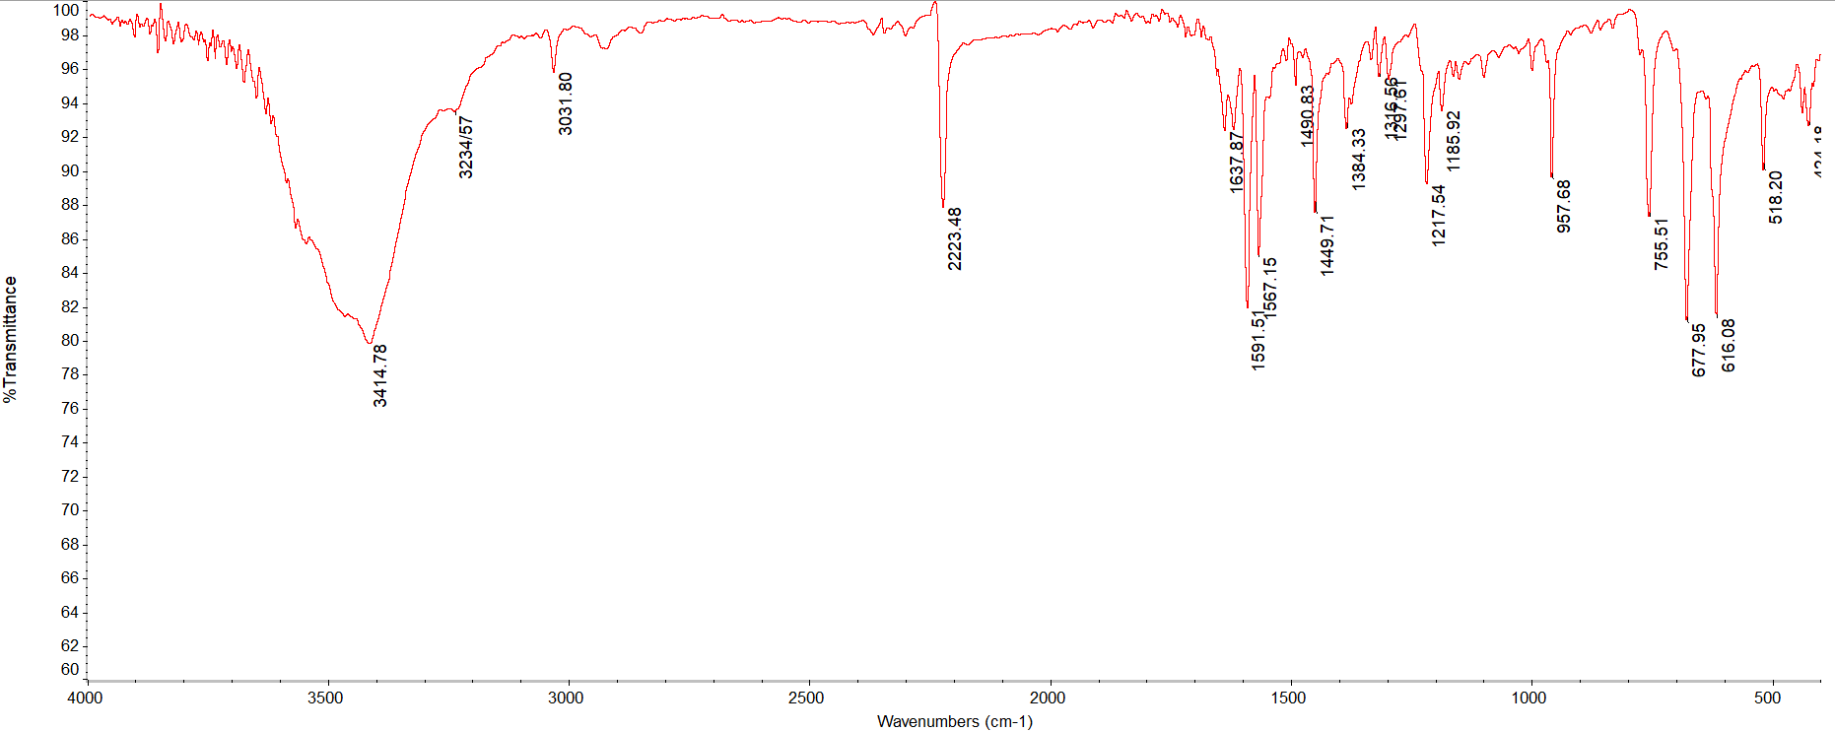
FigureS₈the FT-IR spectrum of 3a

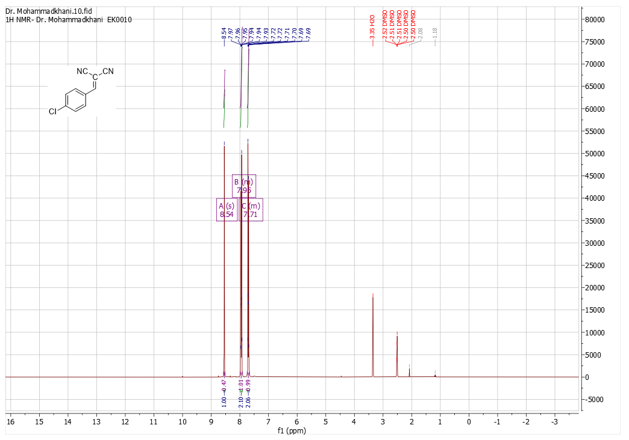
FigureS₈ the ¹H NMR spectrum of 3b in CDCl₃
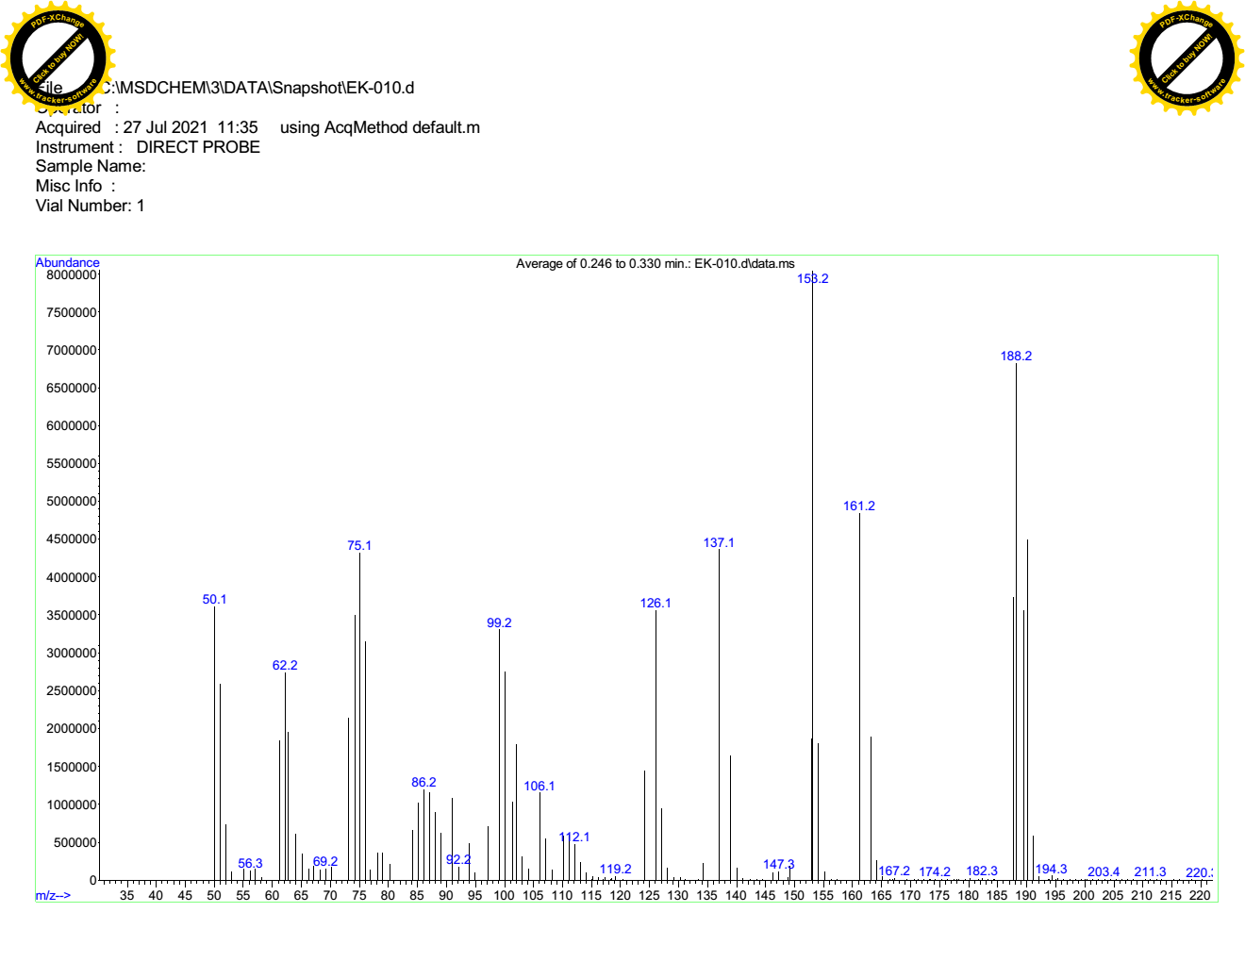
FigureS₁₀ Mass spectrum of 3b
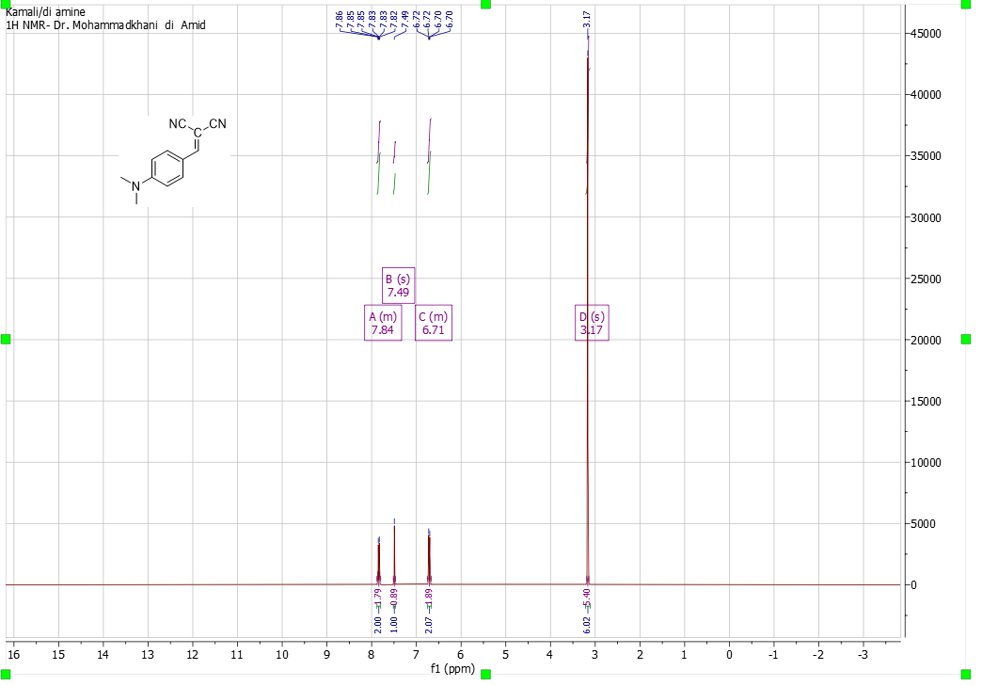
. FigureS₁₁the ¹H NMR spectrum of 3c in CDCl₃
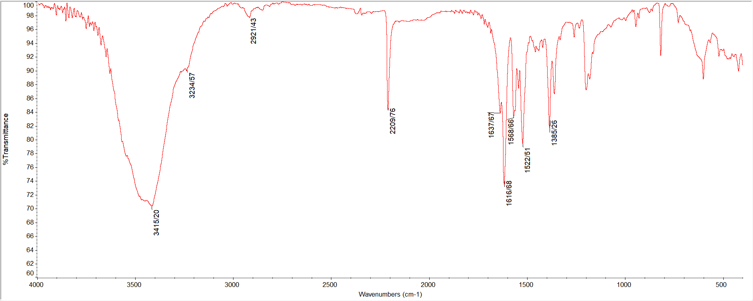
. FigureS₁₂ the FT-IR spectrum of 3c

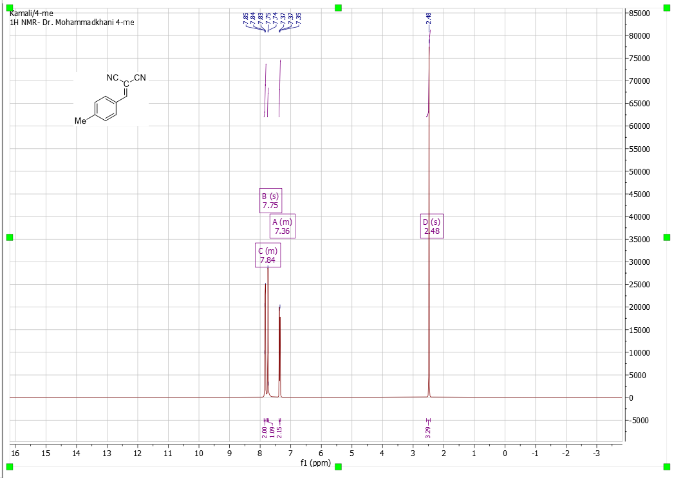
. FigureS₁₃the ¹H NMR spectrum of 3d in CDCl₃
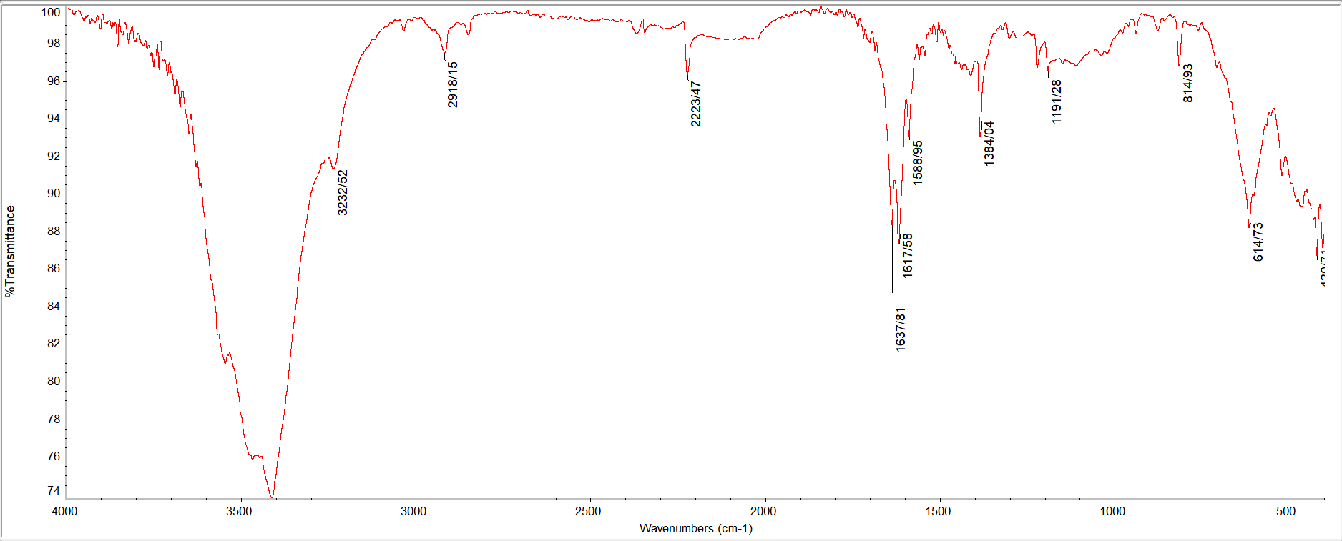
. FigureS₁₄ the ¹H NMR spectrum of 3d in CDCl₃

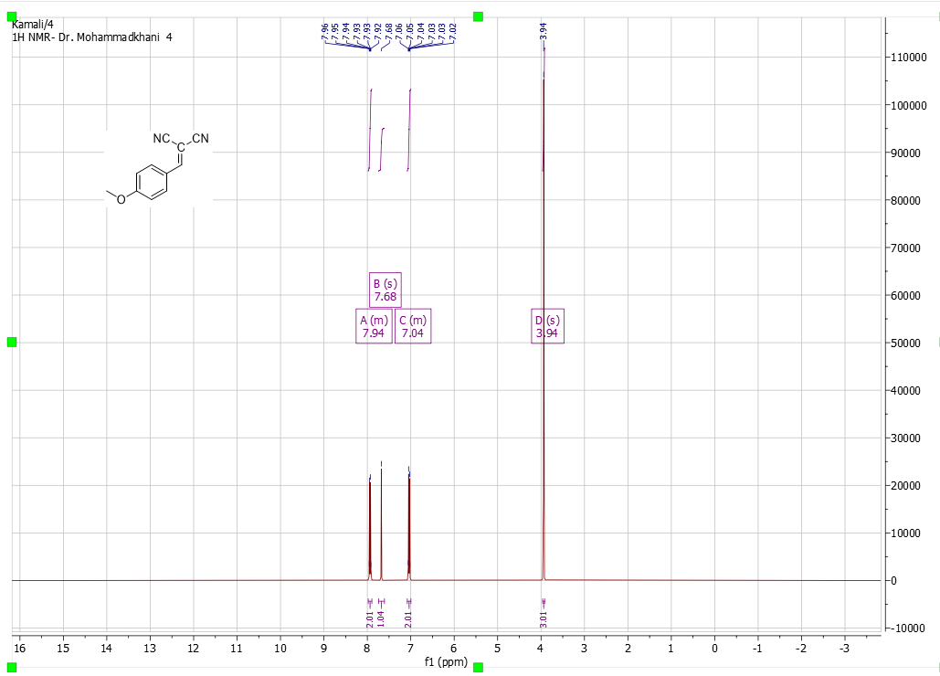
. FigureS₁₅the ¹H NMR spectrum of 3e in CDCl₃
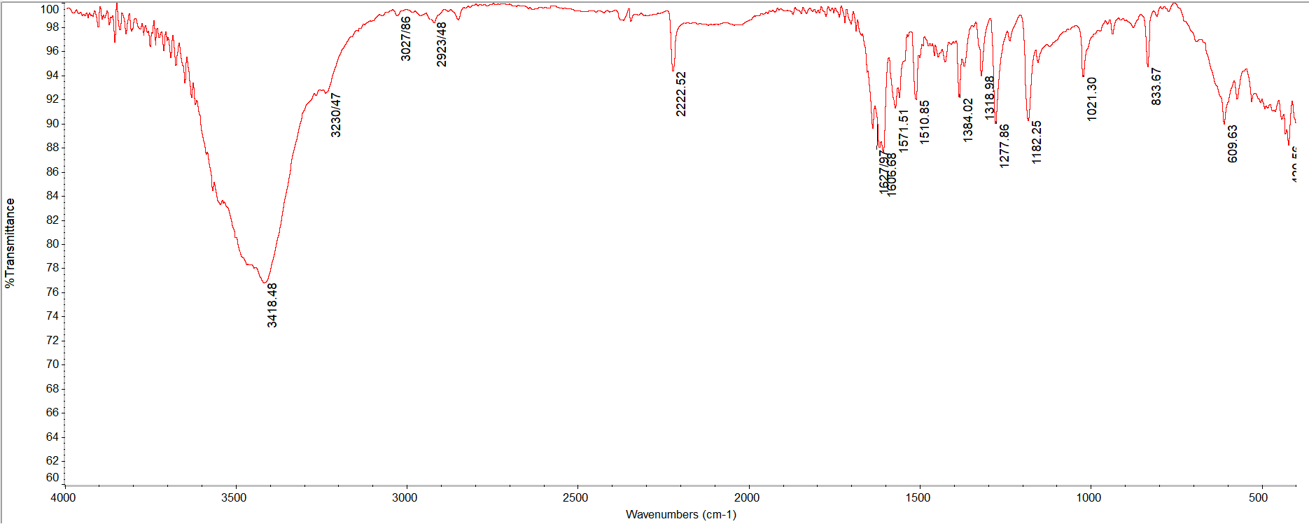
FigureS₁₆ the FT-IR spectrum of 3e

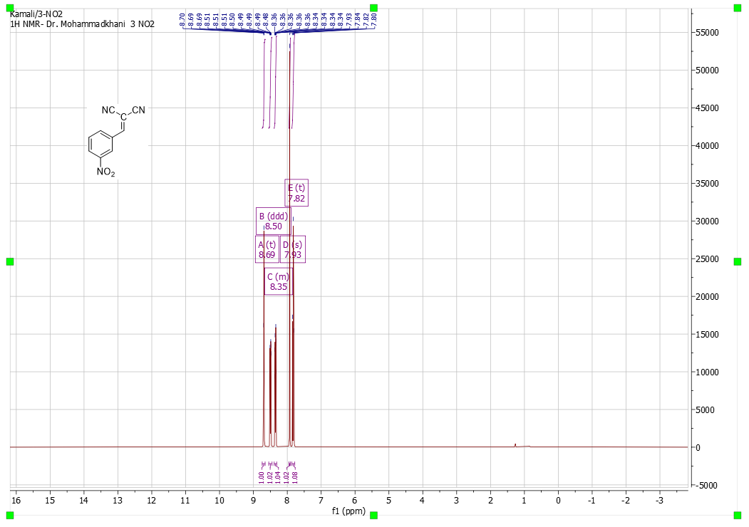
. FigureS₁₇the ¹H NMR spectrum of 3f in CDCl₃
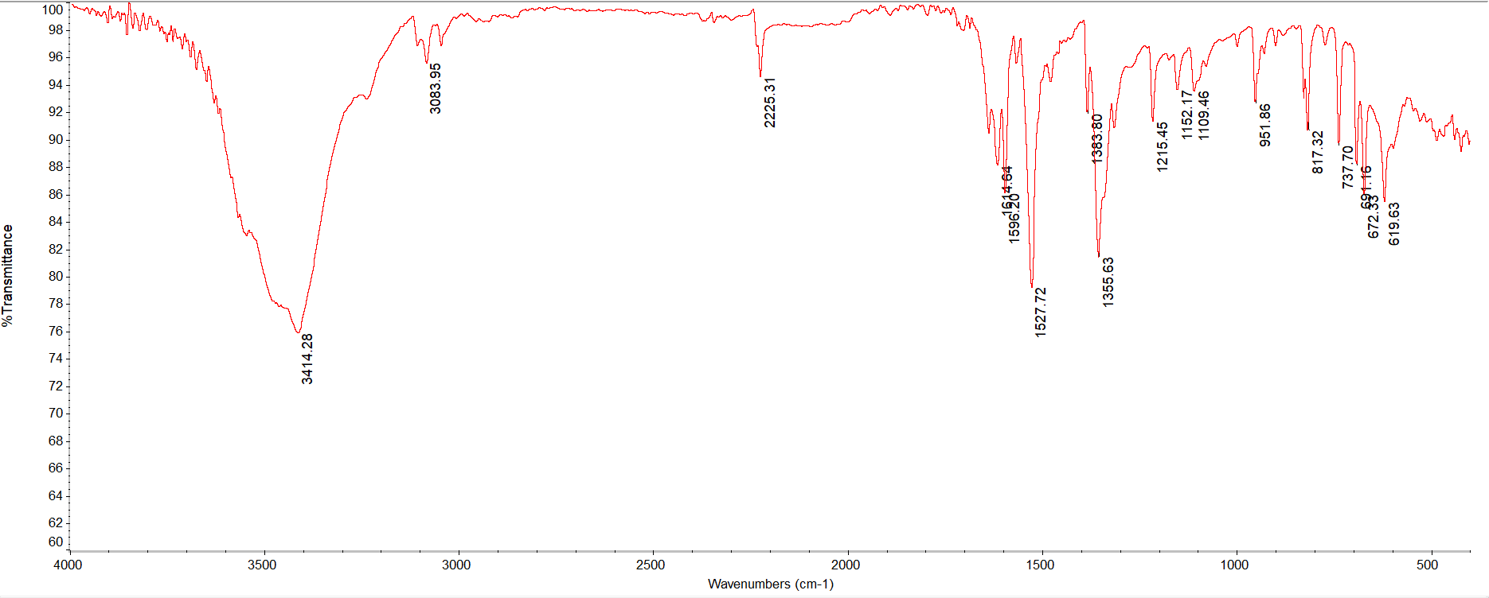
FigureS₁₈the FT-IR spectrum of 3f

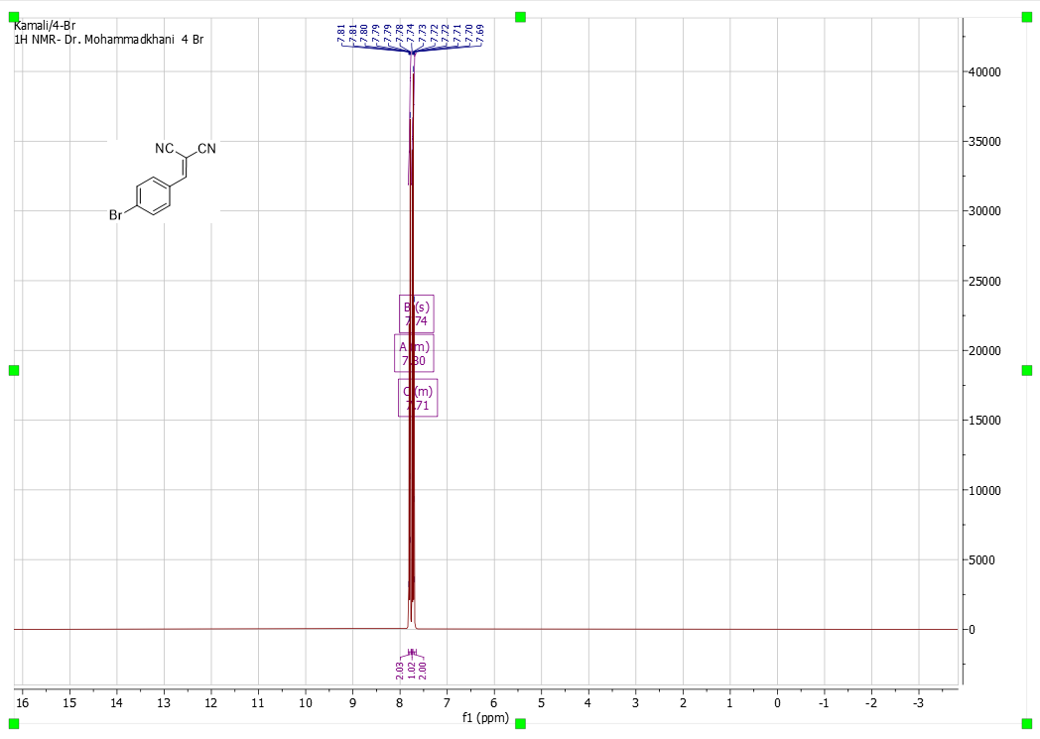
. FigureS₁₉the ¹H NMR spectrum of 3g in CDCl₃
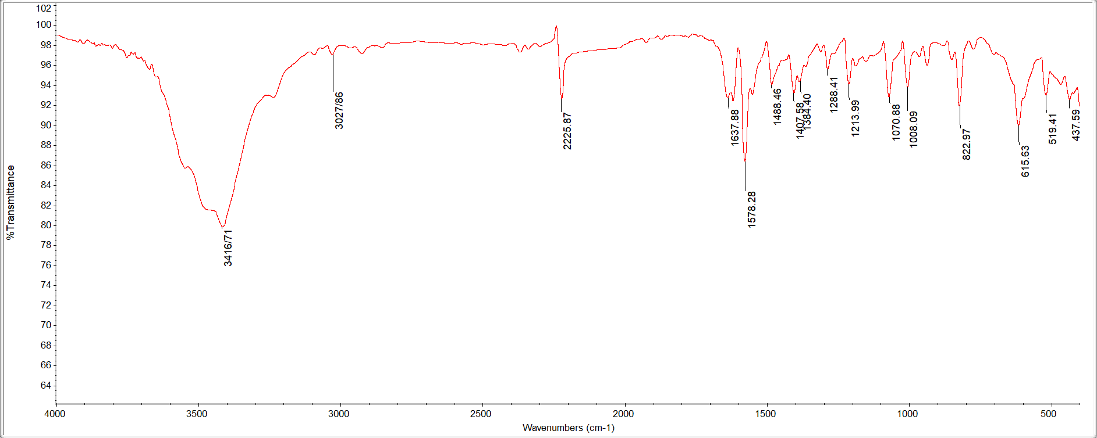
FigureS₂₀ the FT-IR spectrum of 3g
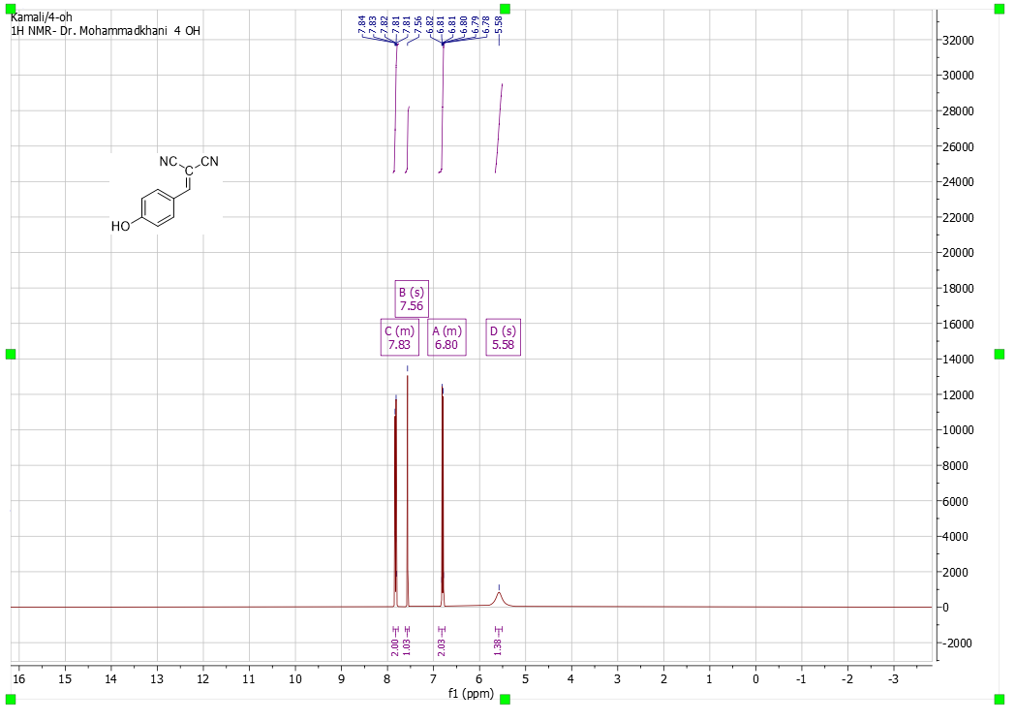
FigureS₂₁the ¹H NMR spectrum of 3h in CDCl₃
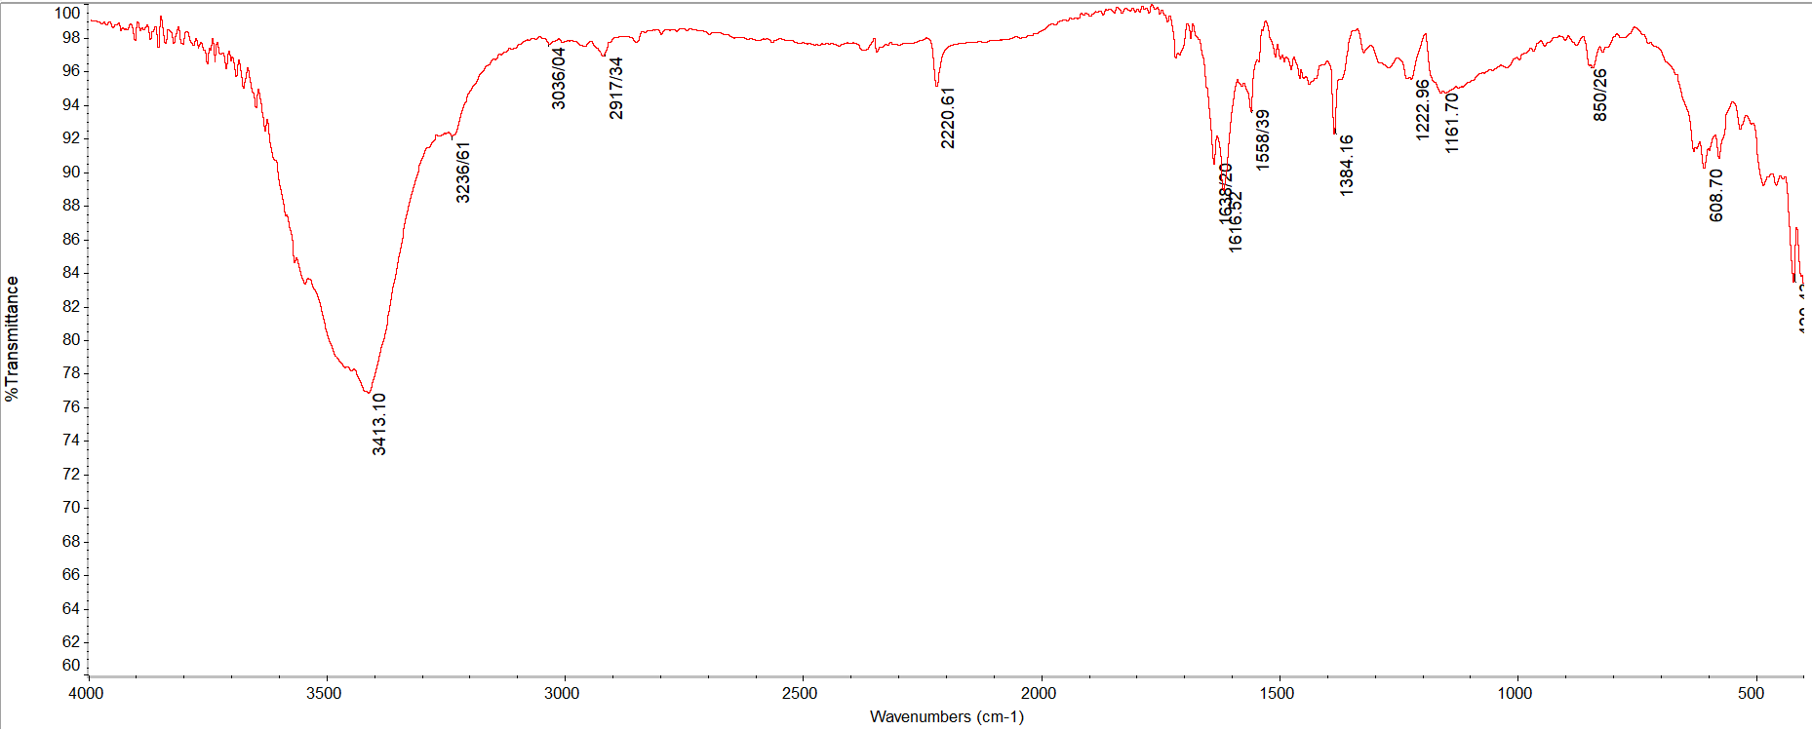
FigureS₂₂the FT-IR spectrum of 3h

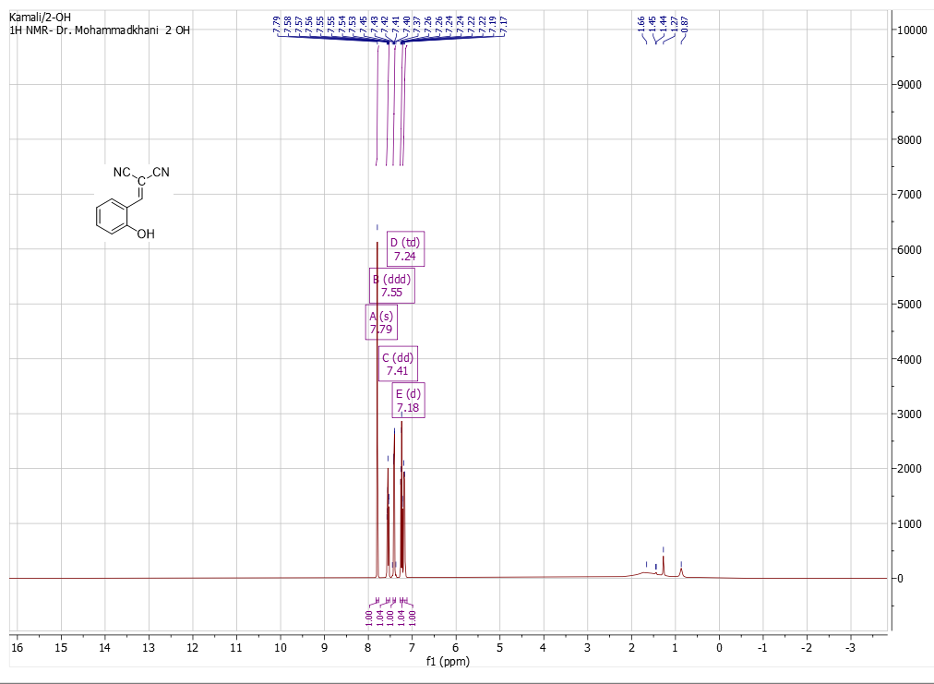
FigureS₂₃ the ¹H NMR spectrum of 3i in CDCl₃
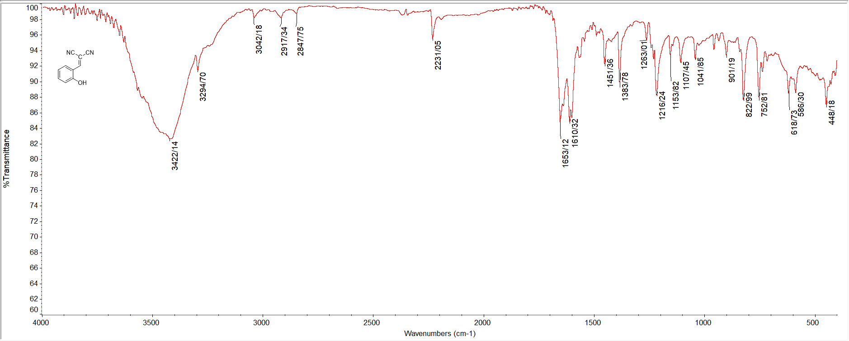
FigureS₂₄ the FT-IR spectrum of 3i

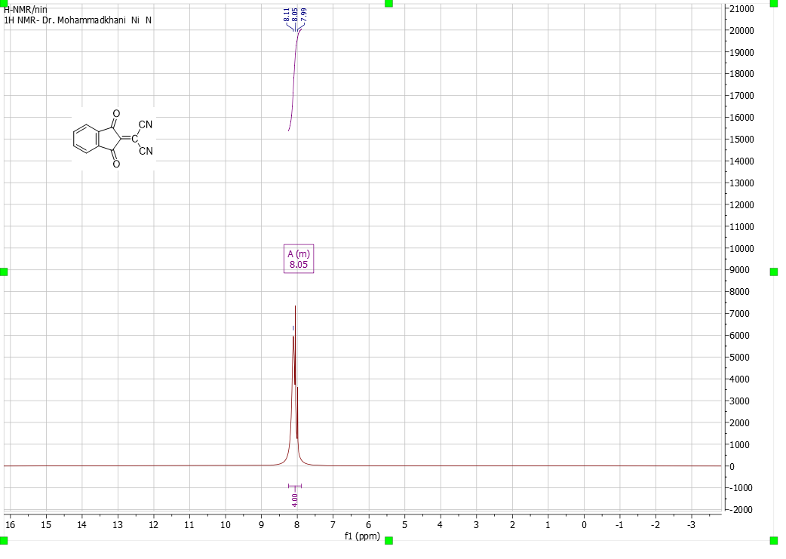
FigureS₂₅ the ¹H NMR spectrum of 3j in CDCl₃
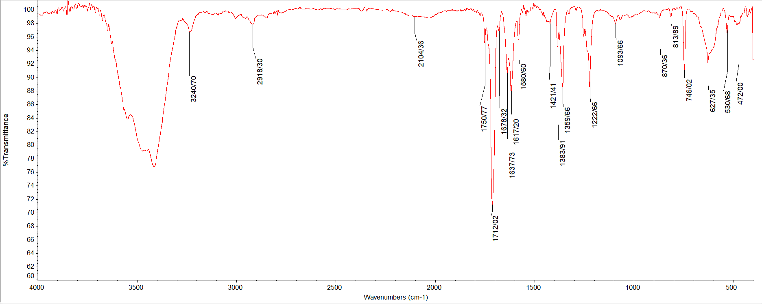
FigureS₂₆the FT-IR spectrum of 3j

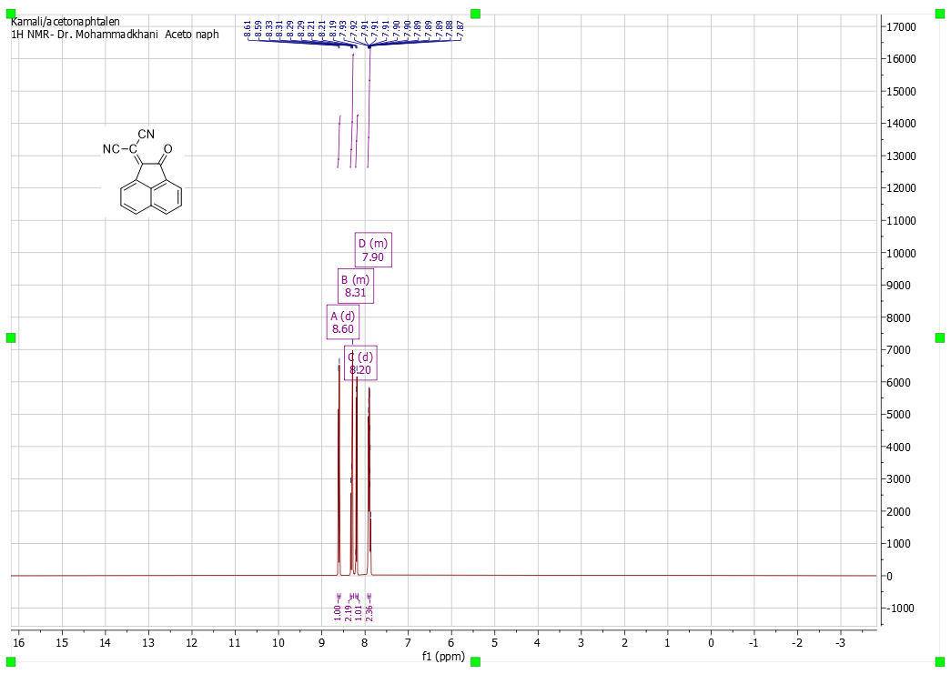
FigureS₂₇ the 1H NMR spectrum of 3k in CDCl₃
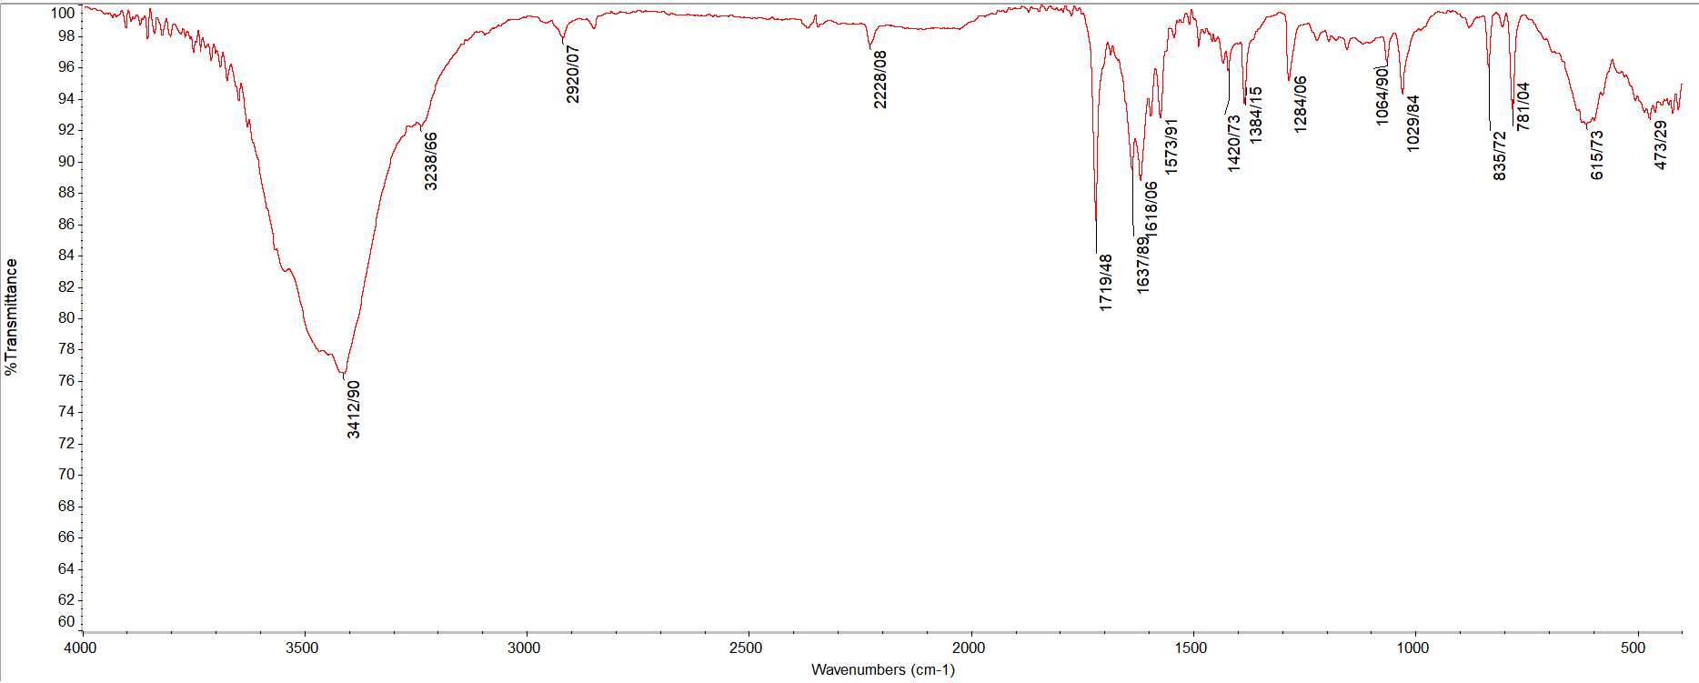
FigureS₂₈the FT-IR spectrum of 3k
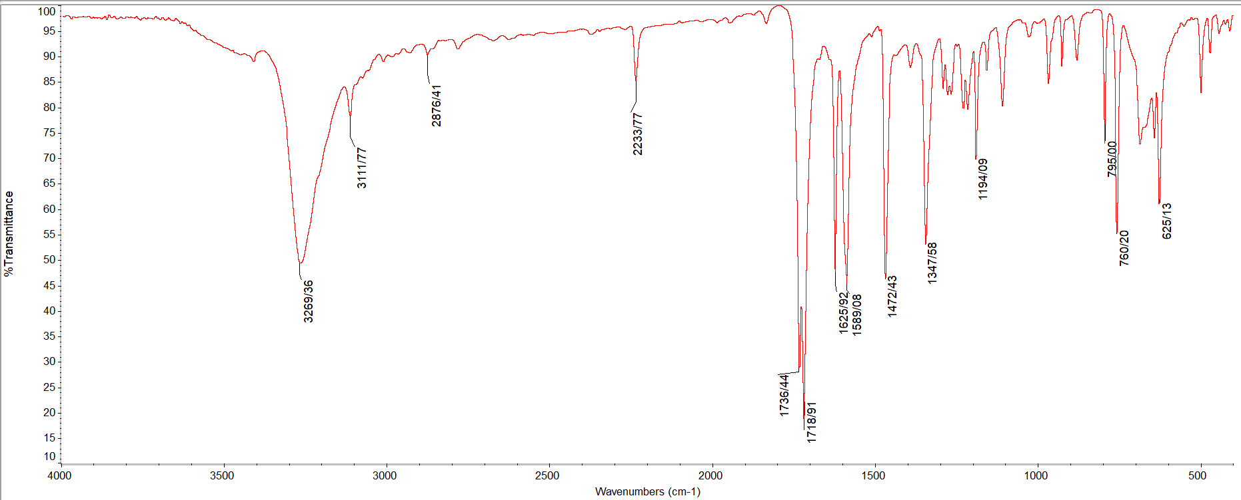
FigureS₂₉ the FT-IR spectrum of 3l in CDCl₃
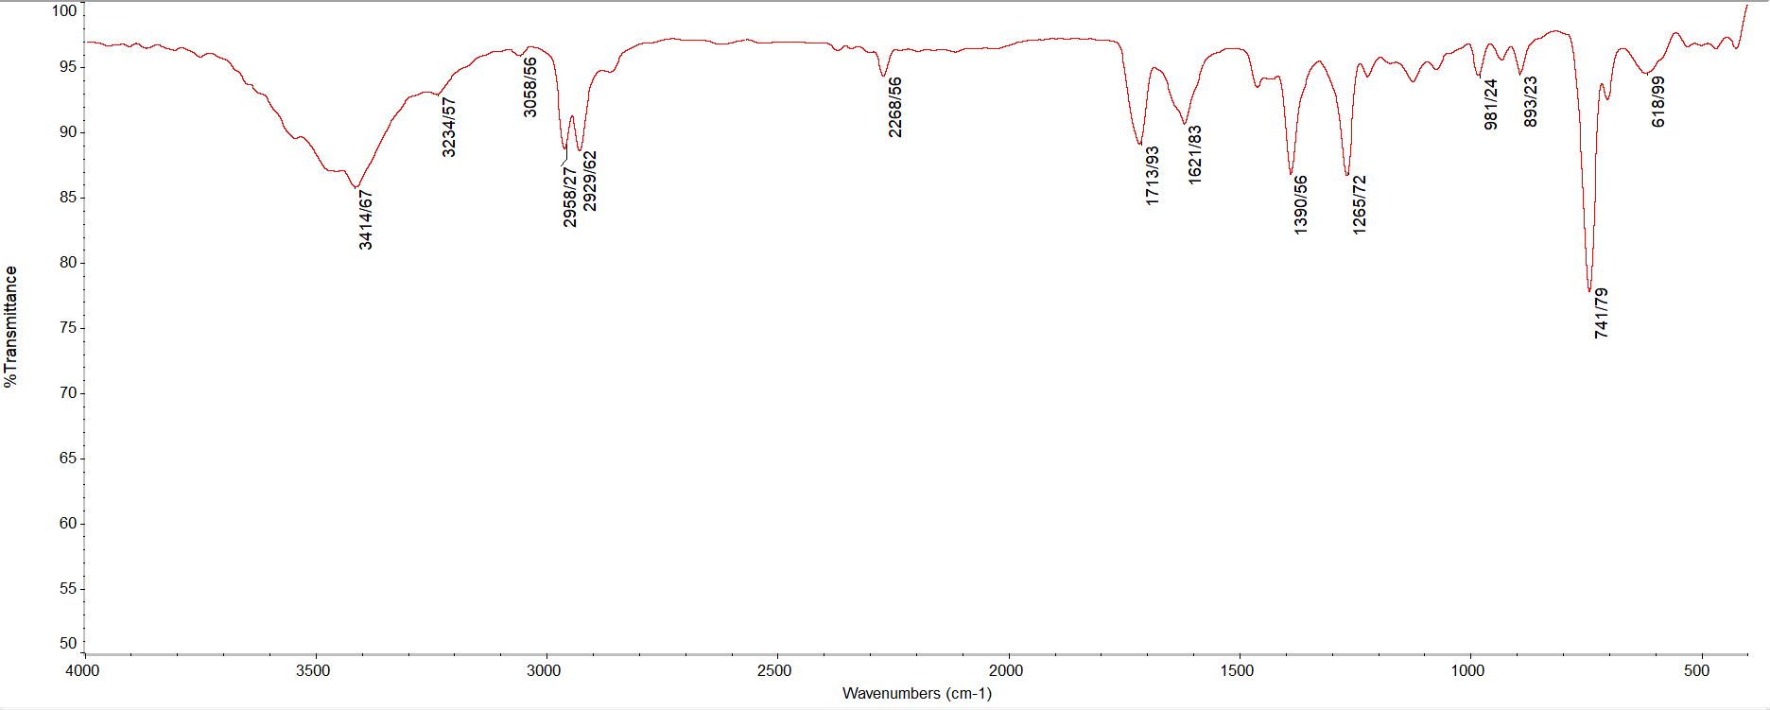
FigureS₃₀ the FT-IR spectrum of 3m
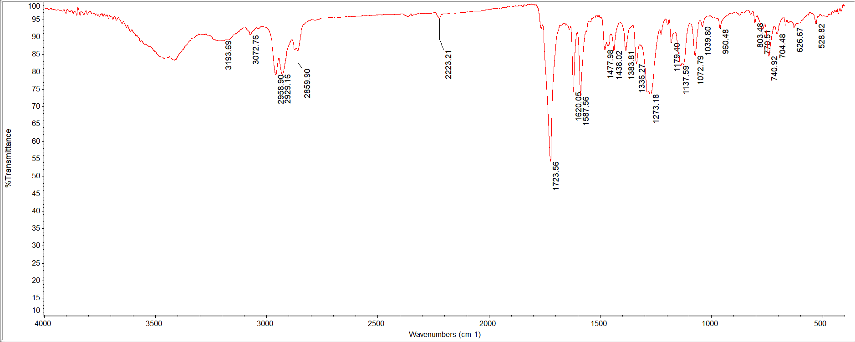
FigureS₃₁ the the FT-IR spectrum 3n
211
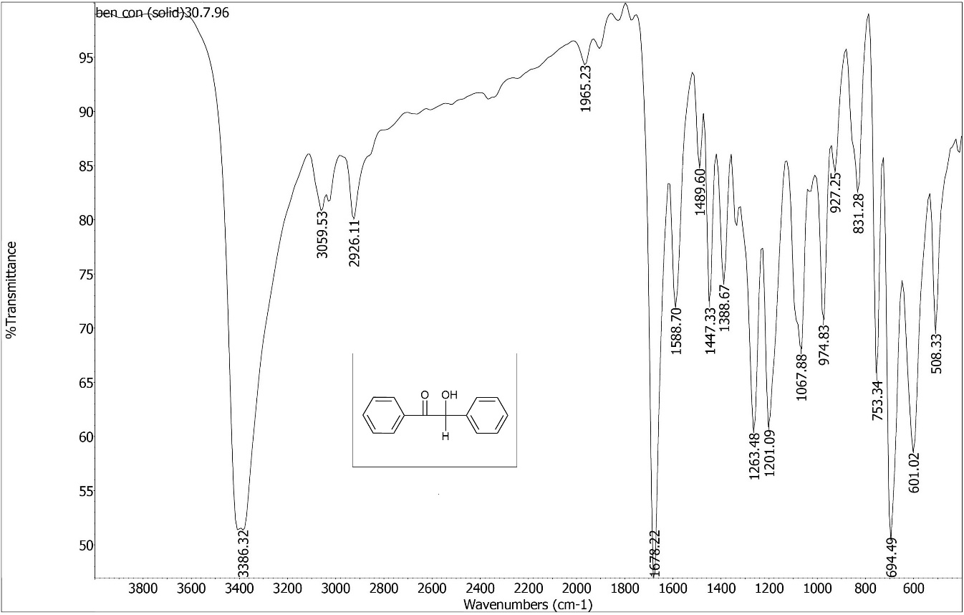
FigureS₃₂ the the FT-IR spectrum 4a

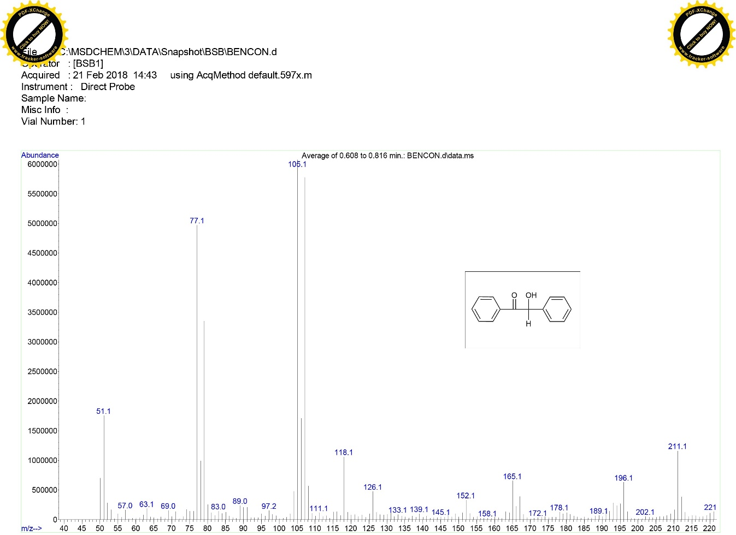

FigureS₃₃ Mass spectrum of 4a

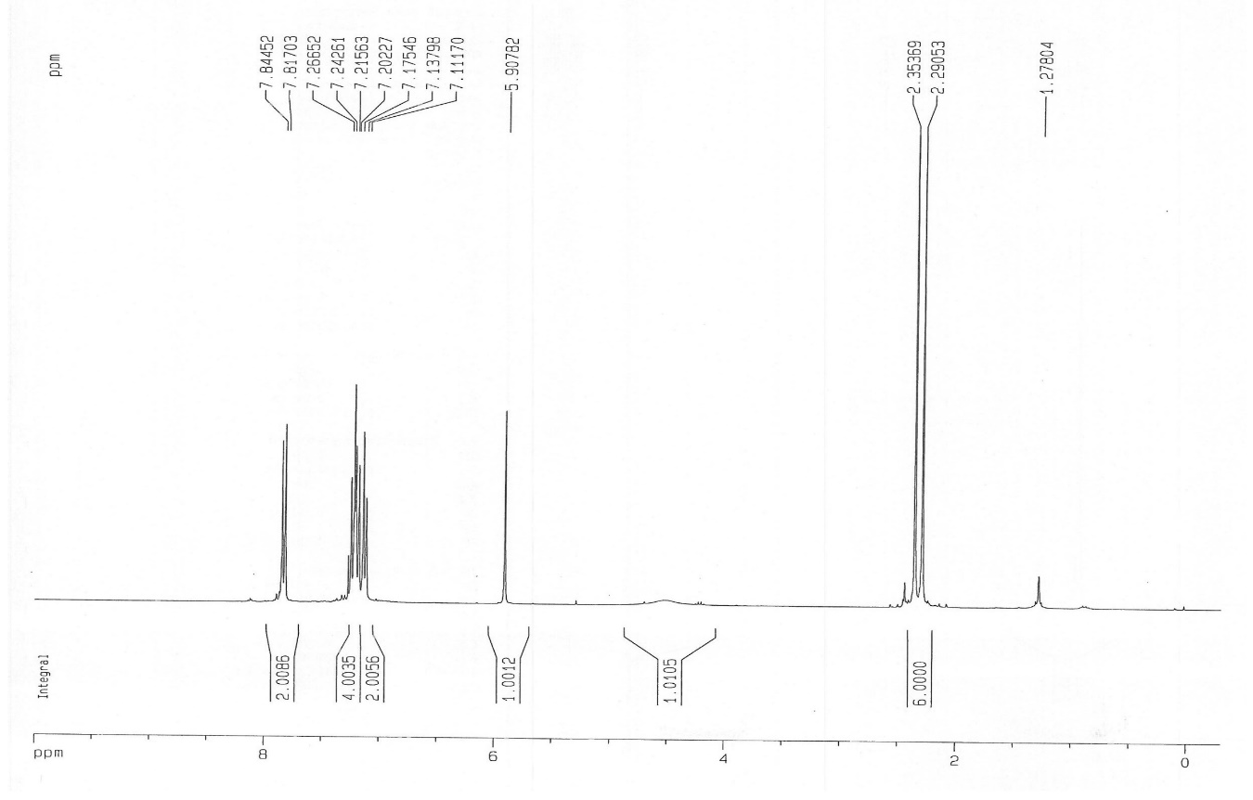
FigureS₃₄ the ^{1H} NMR spectrum of 4b in DMSO

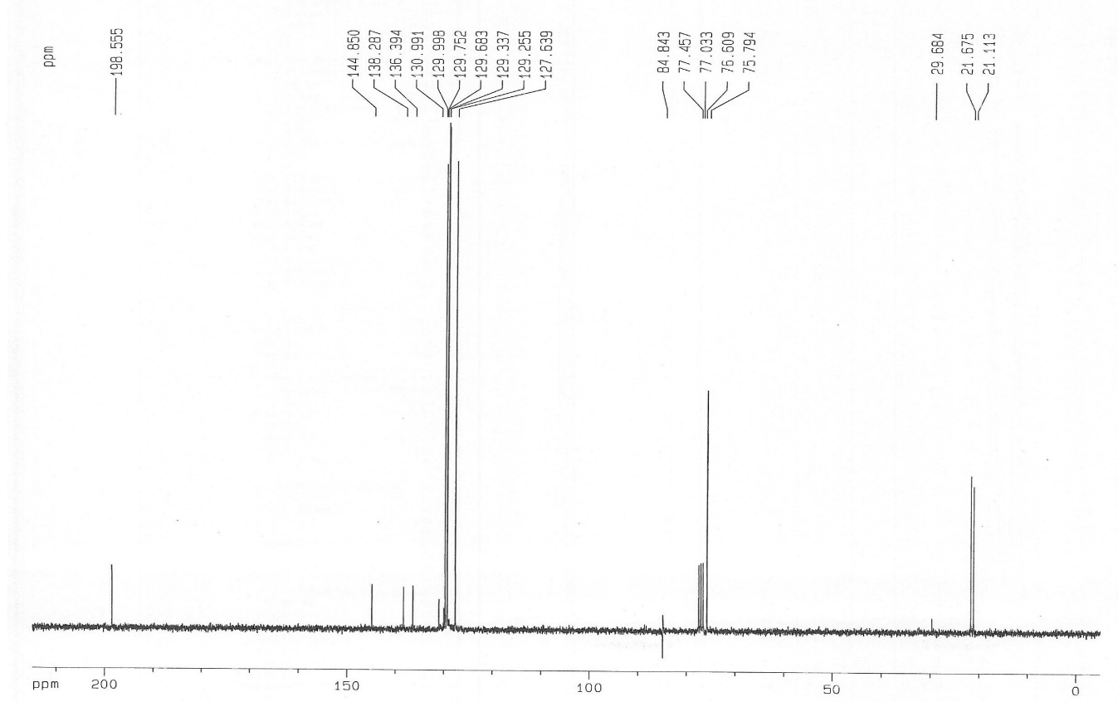
FigureS₃₅ the ¹³C NMR spectrum of 4b in DMSO

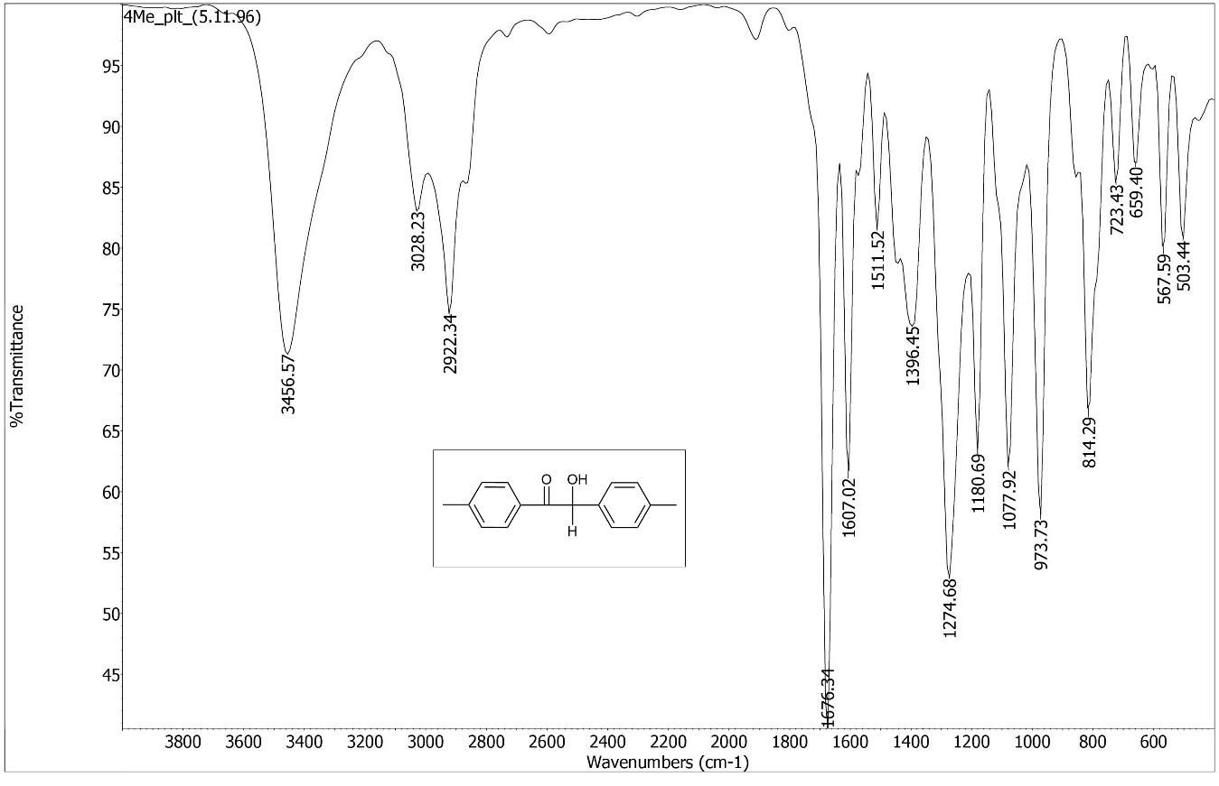
FigureS₃₆ the the FT-IR spectrum 4b

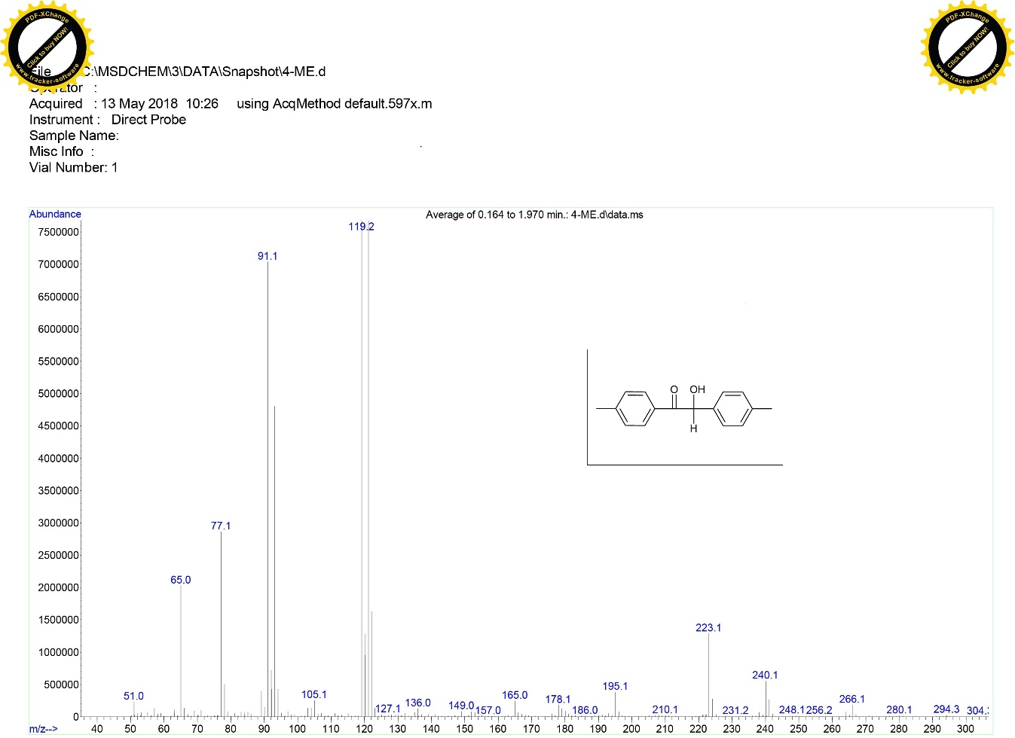
FigureS₃₇ Mass spectrum of 4b

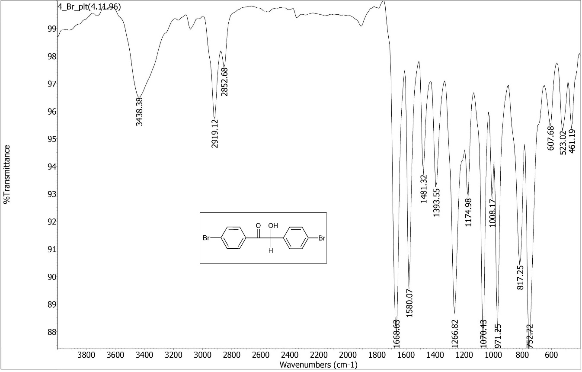
FigureS₃₈ the the FT-IR spectrum 4c

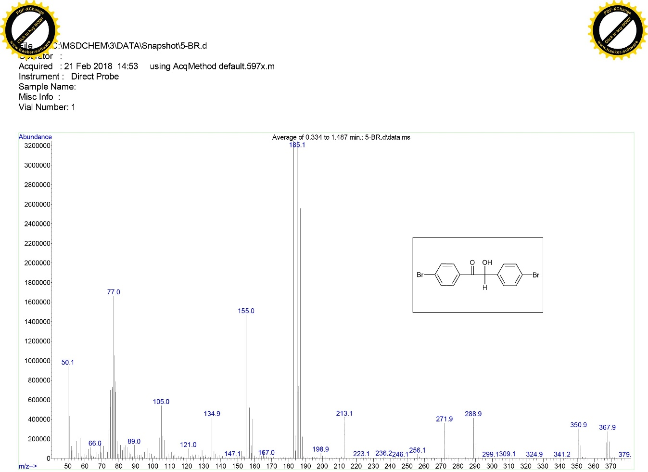
FigureS₃₉ Mass spectrum of 4c

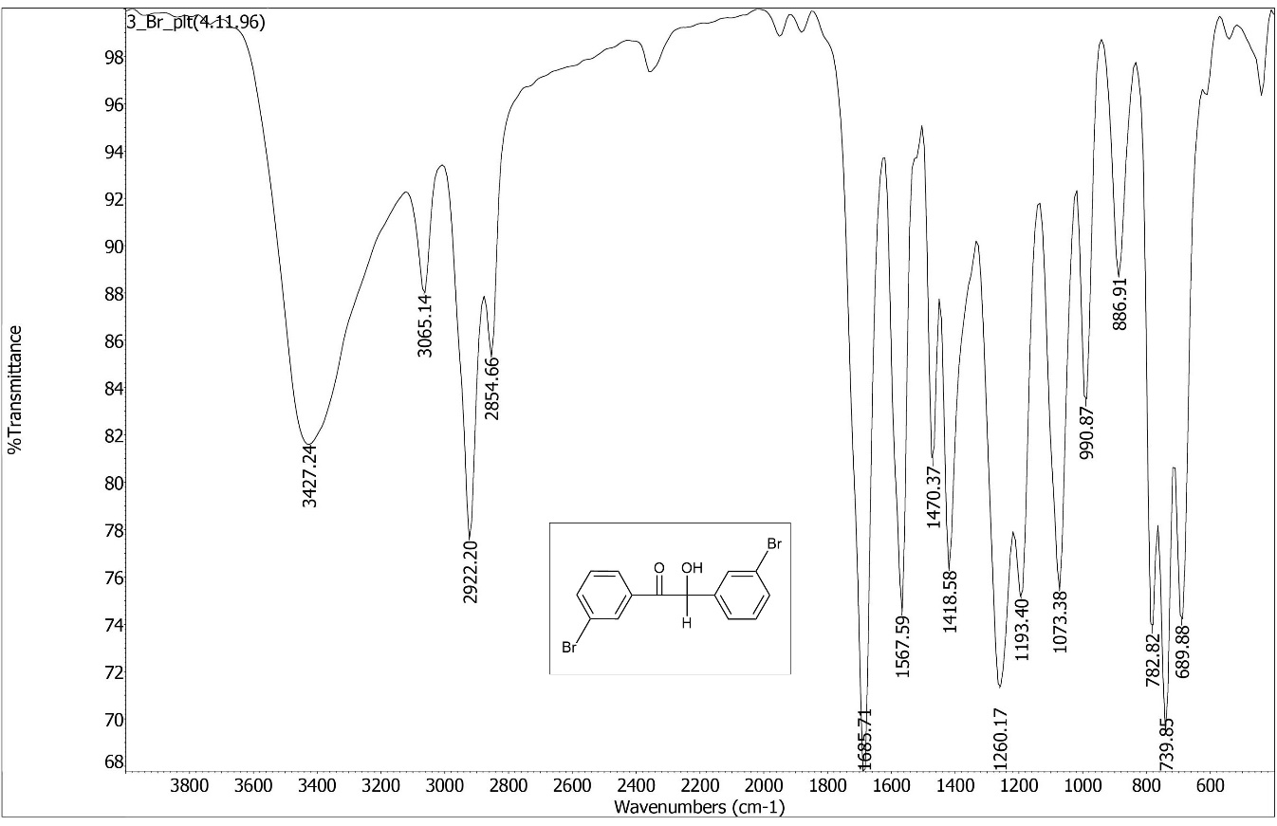
FigureS₄₀ the the FT-IR spectrum 4d

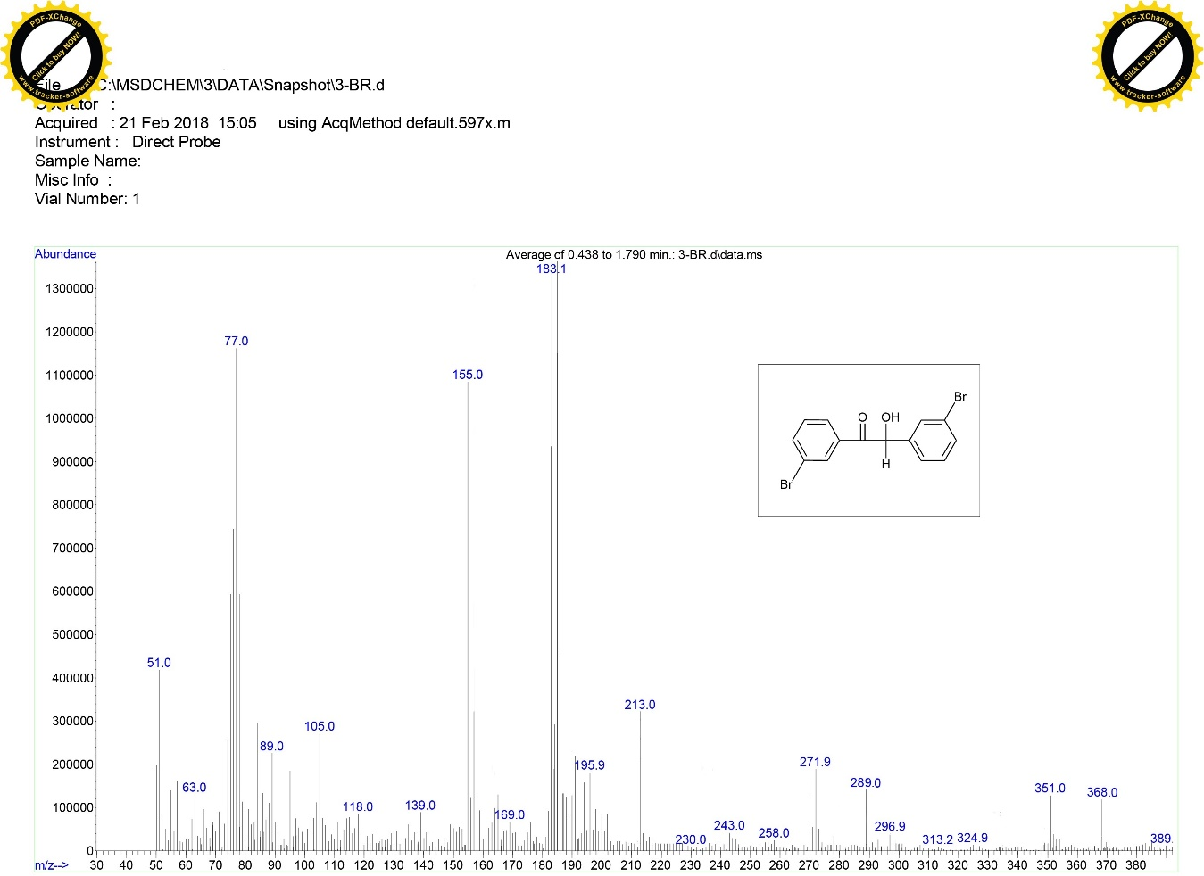
FigureS₄₁ Mass spectrum of 4d

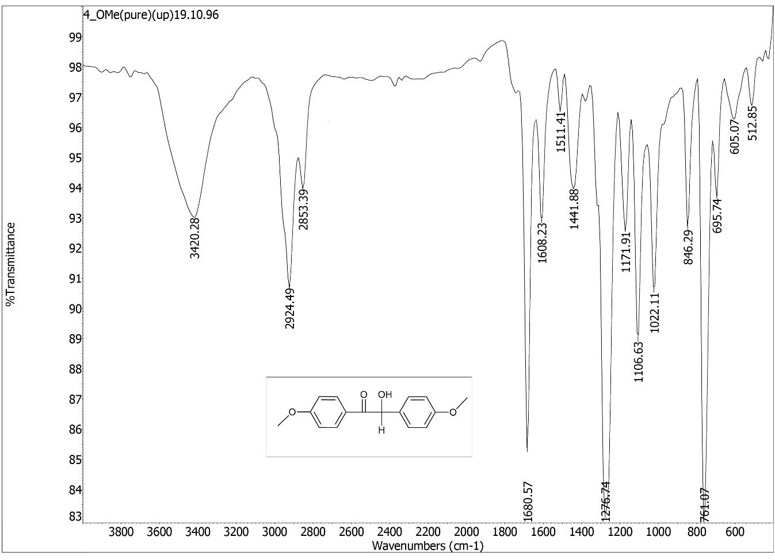
FigureS₄₂ the the FT-IR spectrum 4e

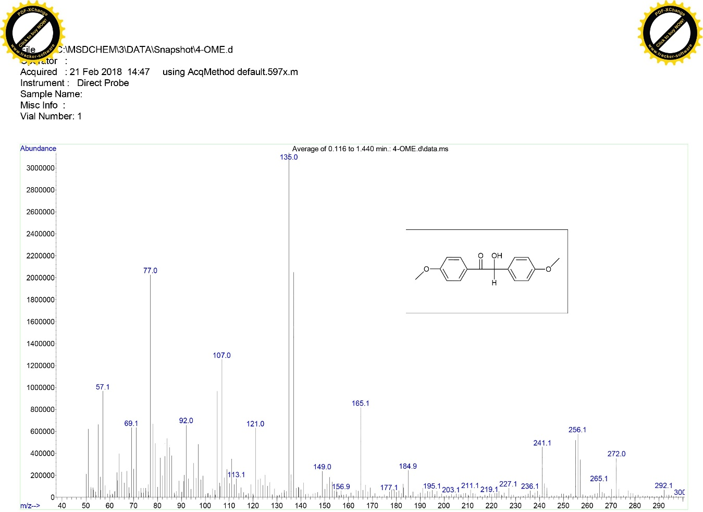
FigureS₄₃ Mass spectrum of 4e

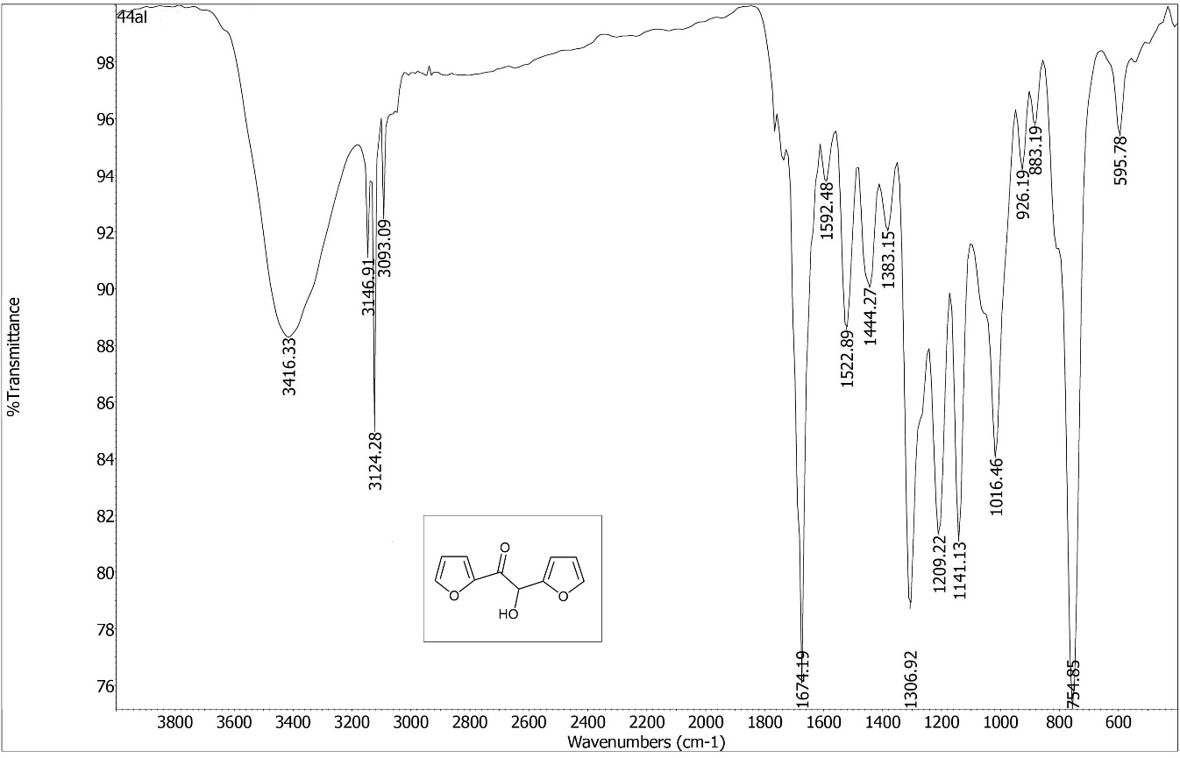
FigureS₄₄ the the FT-IR spectrum 4f

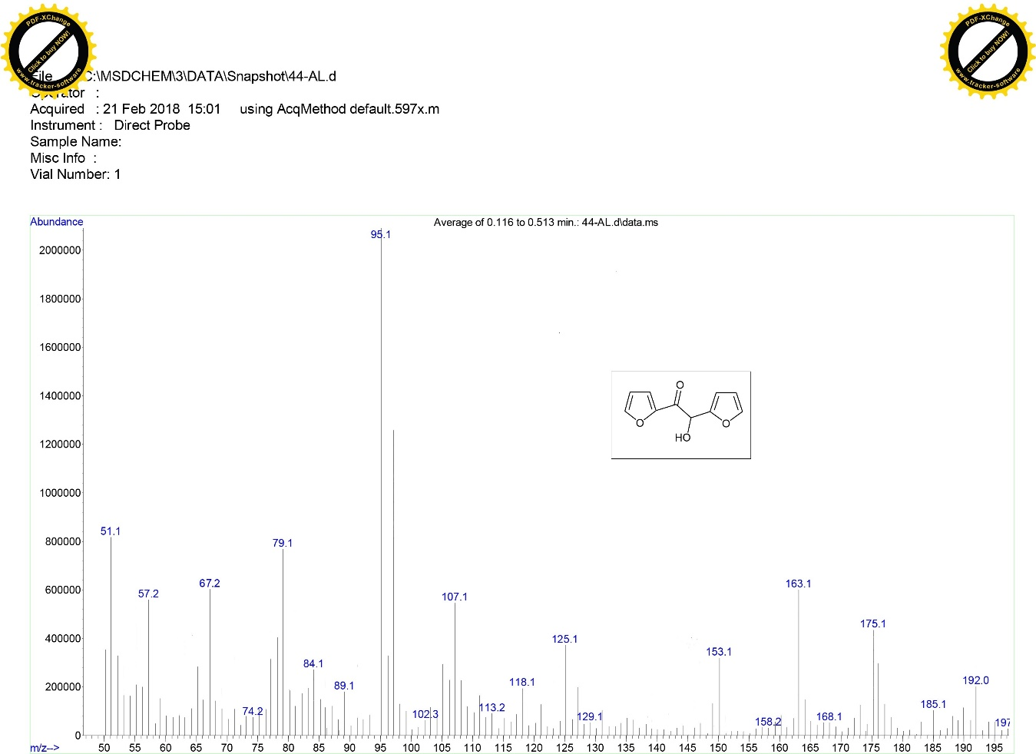
FigureS₄₅ Mass spectrum of 4f

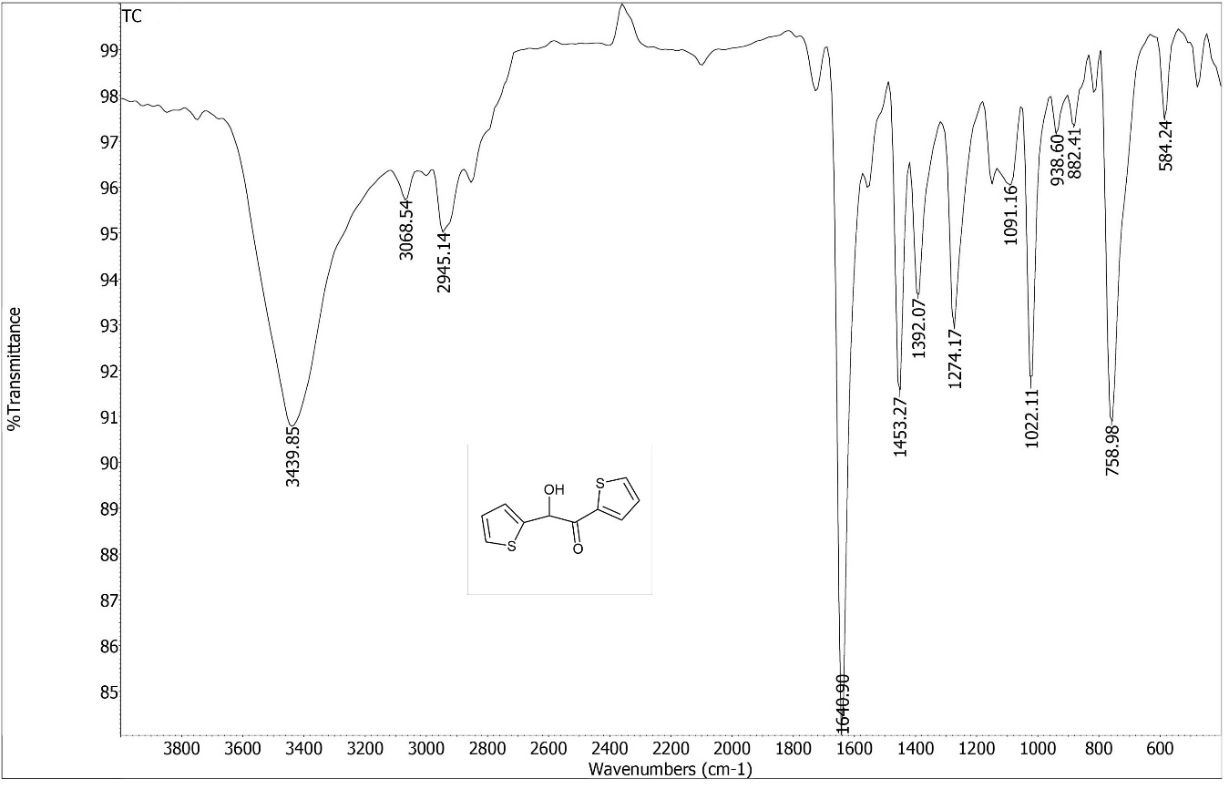
FigureS₄₆ the the FT-IR spectrum 4g

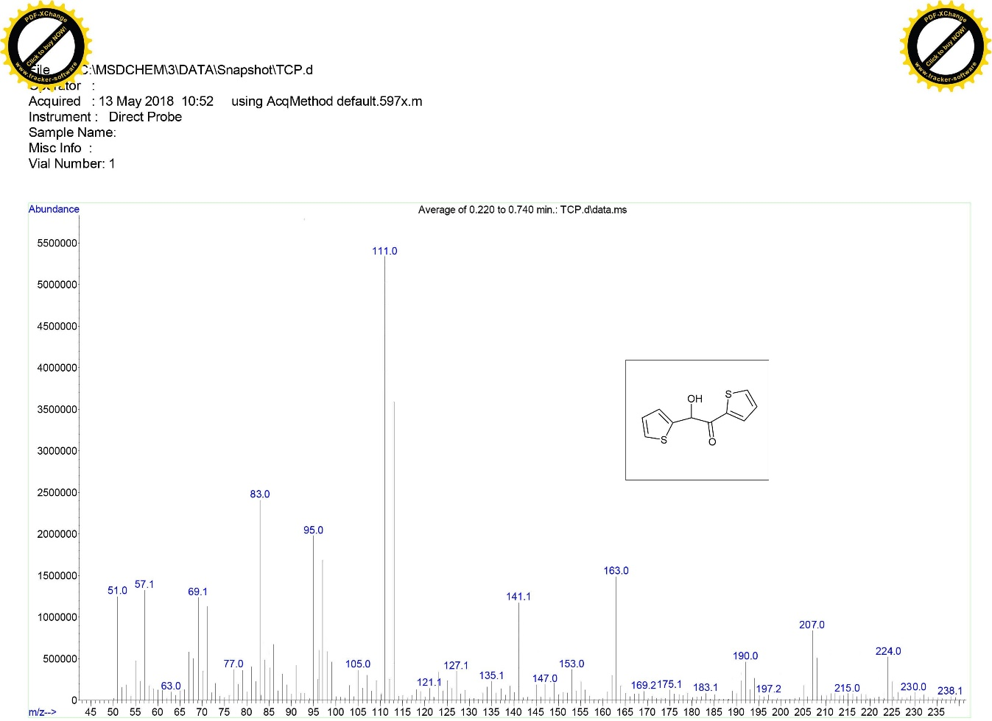
FigureS₄₇ Mass spectrum of 4g

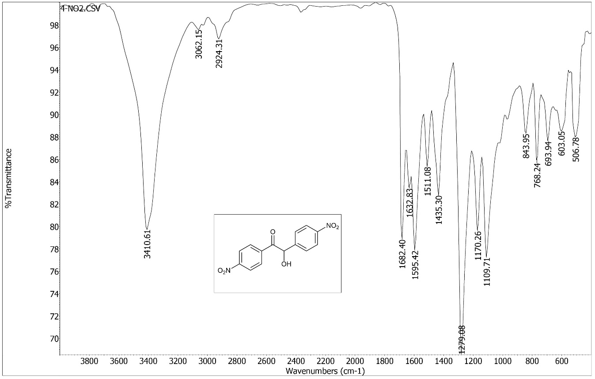
FigureS₄₈ the the FT-IR spectrum 4h
7

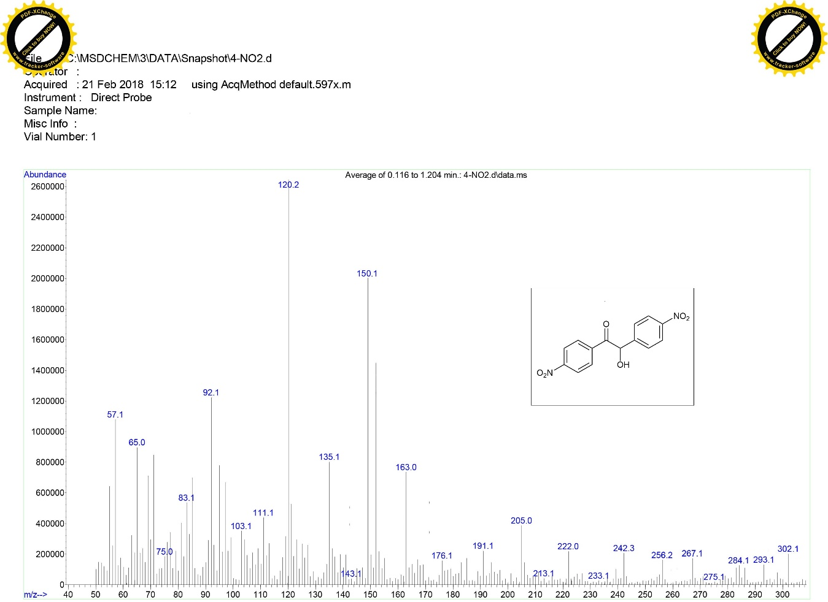
FigureS₄₉ Mass spectrum of 4h
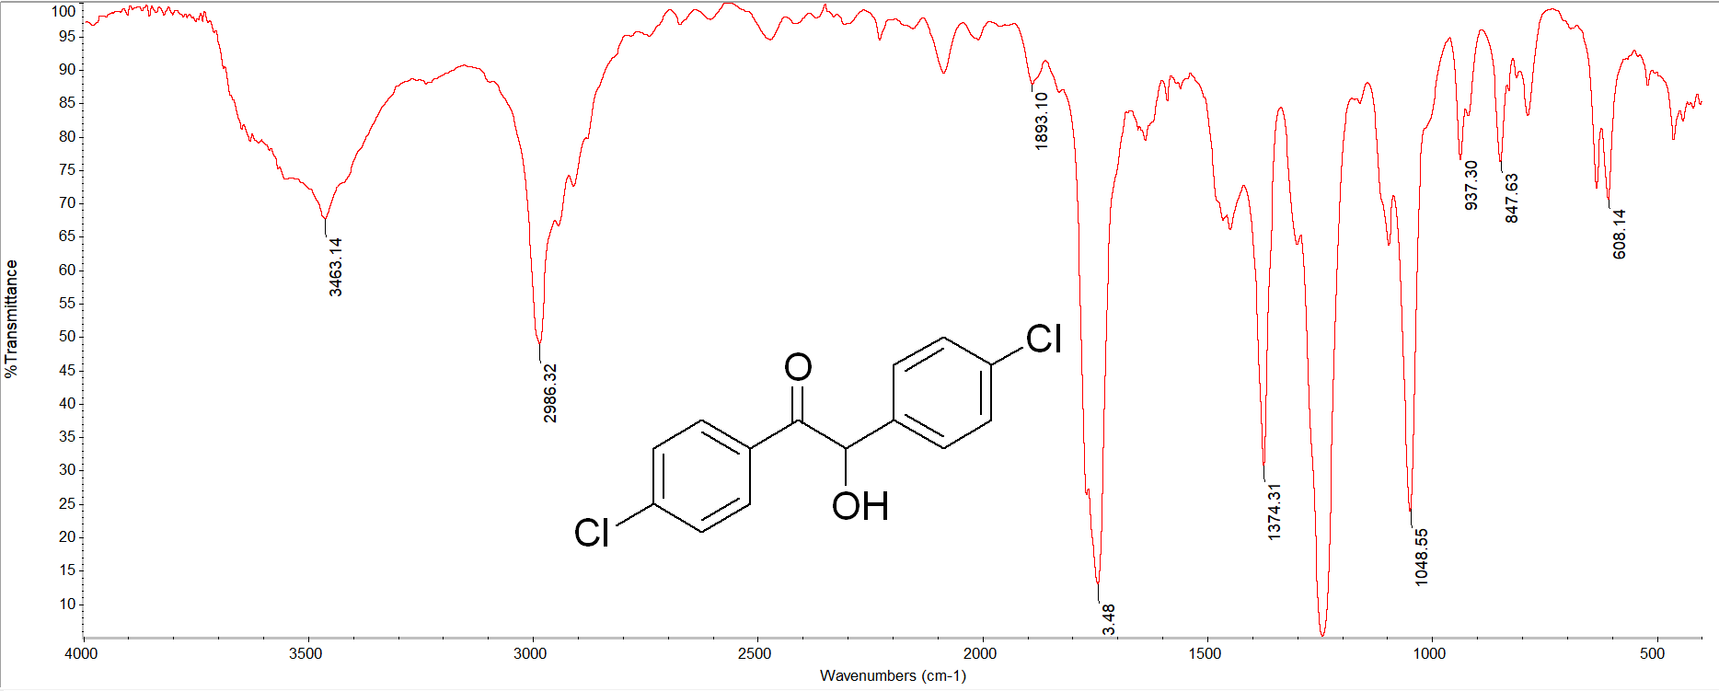
FigureS₅₀ the the FT-IR spectrum 4i

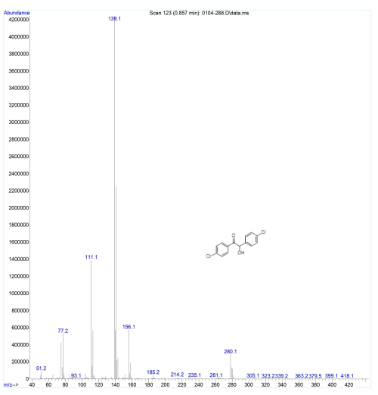
FigureS₅₁ Mass spectrum of 4i

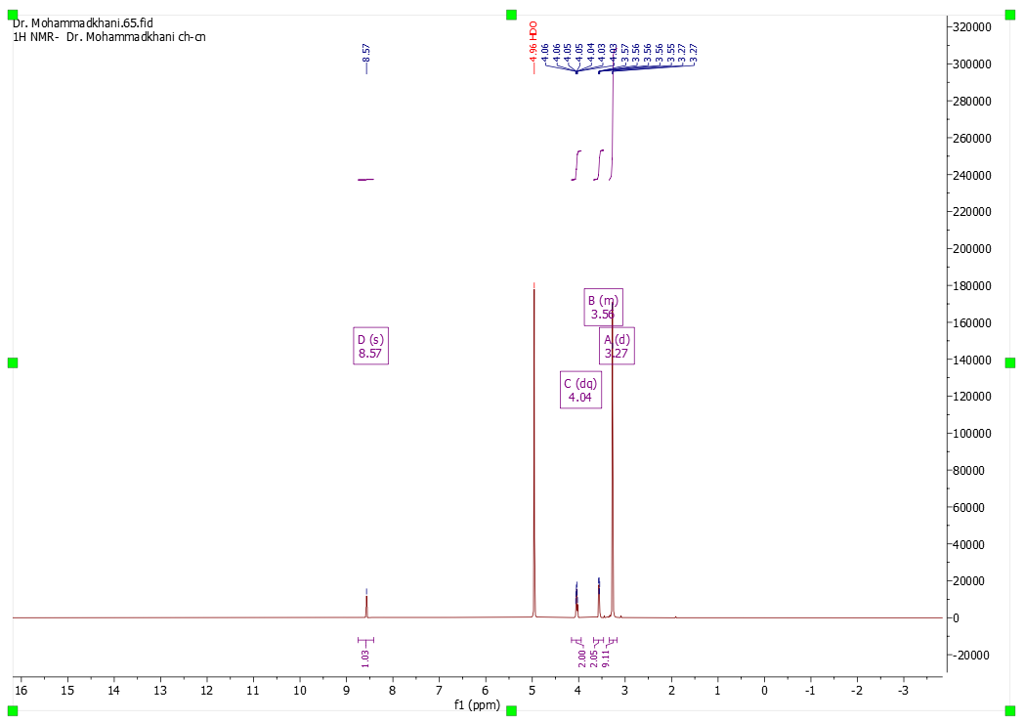
FigureS₅₂ the ¹H NMR spectrum of 5a in MeOD
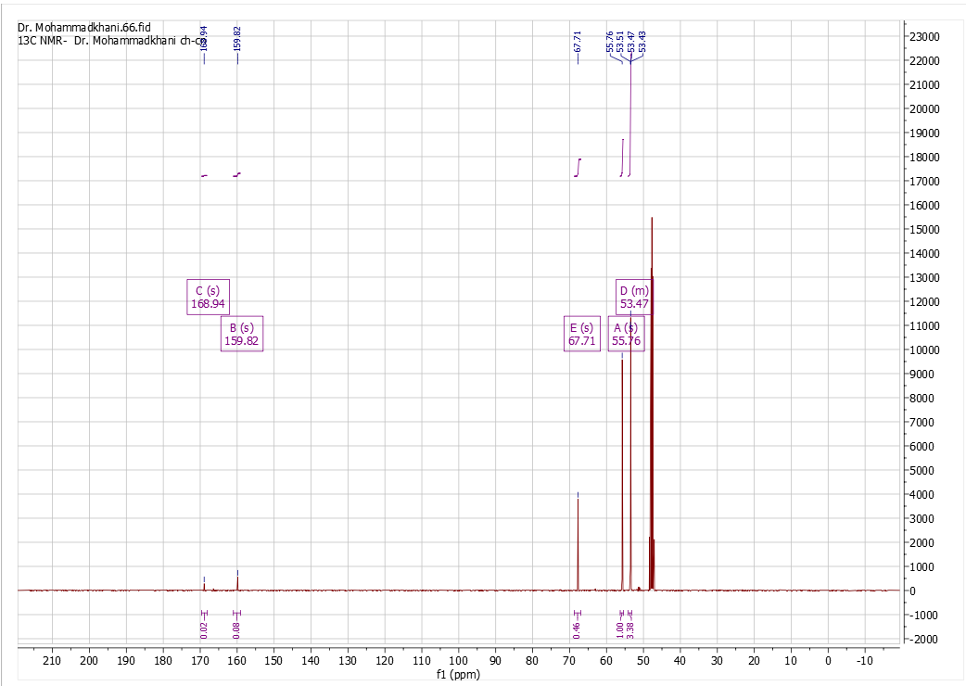
FigureS₅₃ the ¹³C NMR spectrum of 5a in MeOD

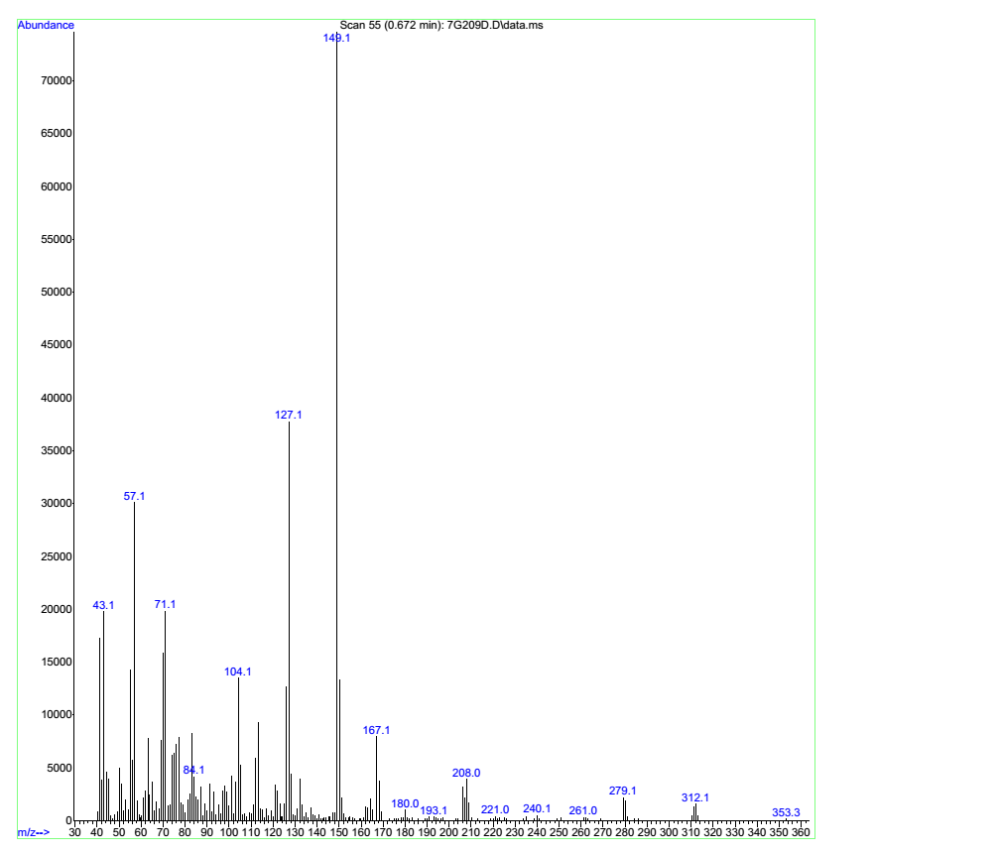
FigureS₅₄ the Mas^{s} spectrum of 5a
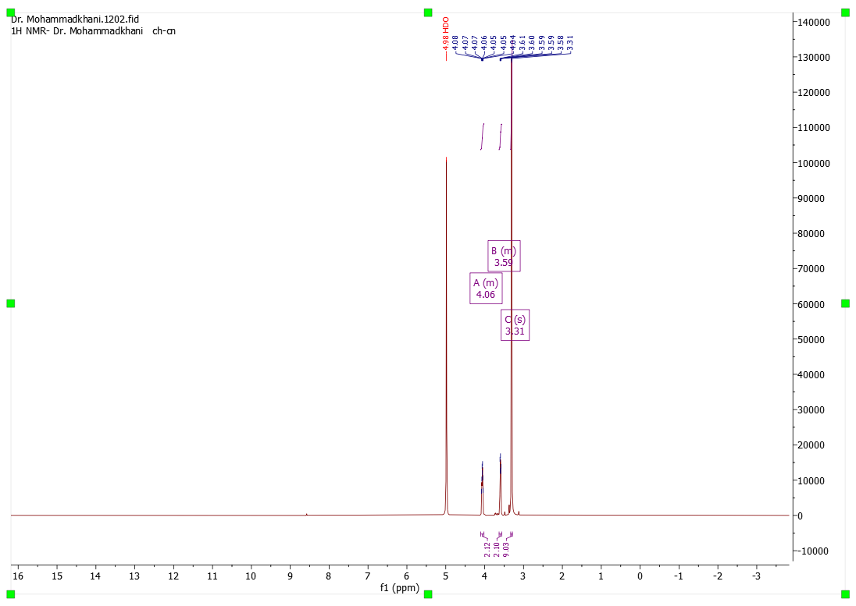
FigureS₅₅ the ¹H NMR spectrum of 5b in MeOD
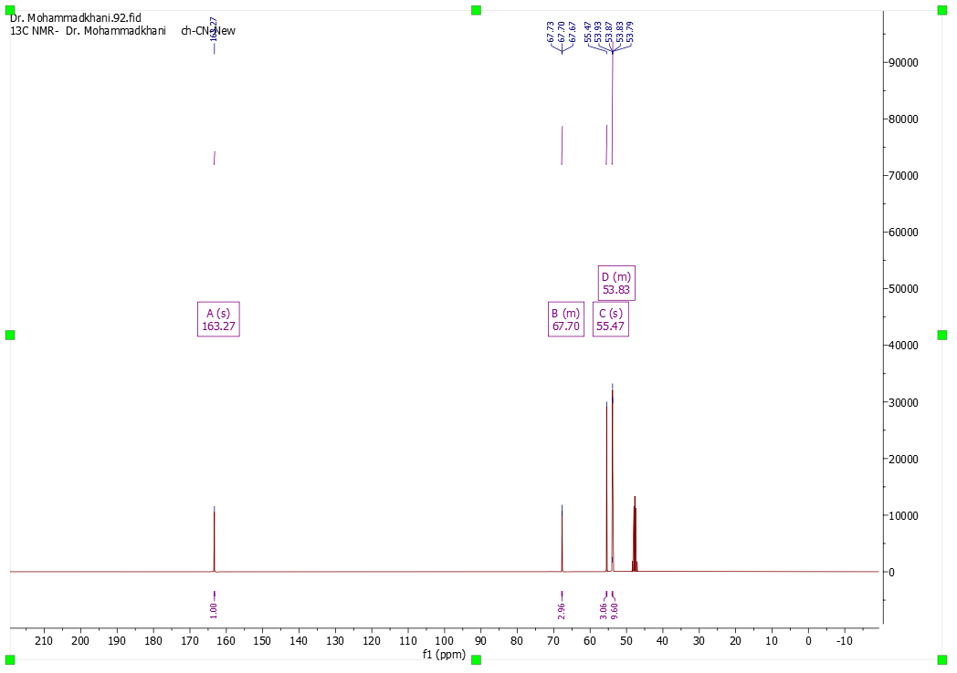
FigureS₅₆ the ¹³C NMR spectrum of 5b in MeOD

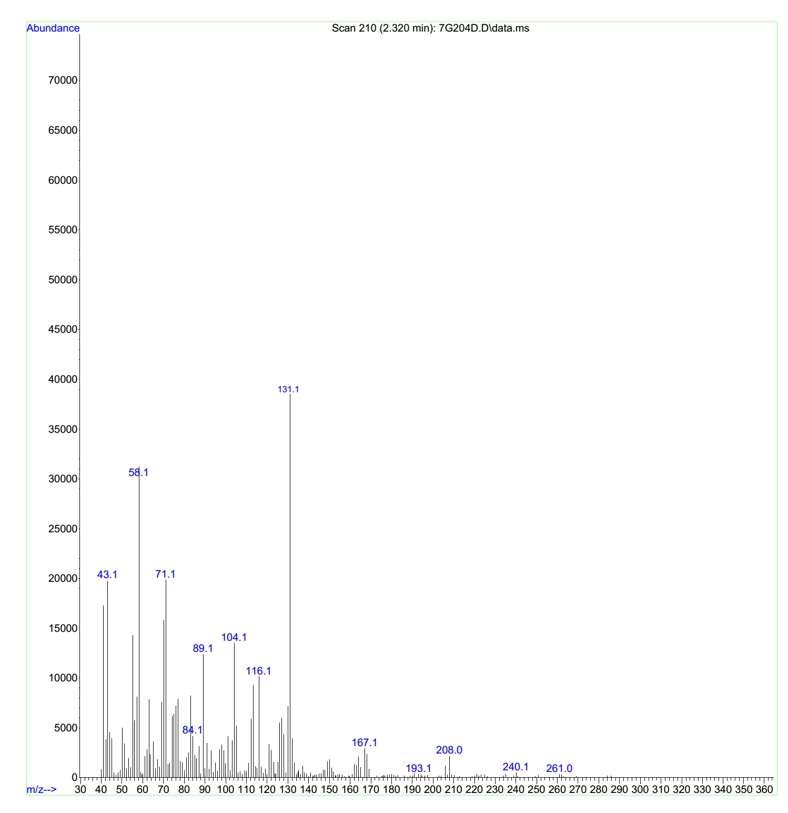
FigureS₅₇ the Mas^{s} spectrum of 5b

Reference
[1]. Yang H, Dong H, Zhang T, Zhang Q, Zhang G, Wang P, Liu Q (2019) Calcined dolomite: an efficient and recyclable catalyst for synthesis of α, β-unsaturated carbonyl compounds. Catal Lett 149(3):778-787.
[2]. Klikar M, Kityk I, Kulwas D, Mikysek T, Pytela O, Bureš F (2017) Multipodal arrangement of push–pull chromophores: a fundamental parameter affecting their electronic and optical properties New J Chem 41(4):1459-1472.
[3]. Zhang J, Jiang T, Han B, Zhu A, Ma X (2006) Knoevenagel condensation catalyzed by 1, 1, 3, 3‐tetramethylguanidium lactate. Synth Commun 36(22):3305-3317.
[4]. Jimenez DE, Ferreira IM, Birolli WG, Fonseca LP, Porto AL (2016) Synthesis and biocatalytic ene-reduction of Knoevenagel condensation compounds by the marine-derived fungus Penicillium citrinum CBMAI 1186. Tetrahedron 72(46):7317-7322.
[5]. Taduri AK, Devi BR (2014) Alum-Cs2CO3 as a new recyclable solid base catalyst for the efficient syntheses of arylidenemalononitriles, esters and arylcinnamic acids in water Asian J Chem 26(7):1938-1942.
[6]. Junek H, Sterk H (1968) Synthesen mit nitrilen, 19. mitt.: die partielle retro-michael-addition von tetracyanäthylen an indandion-1, 3.Tetrahedron Lett 9(40):4309-4310.
[7]. Dandia A, Jain AK, Bhati DS (2011) Direct construction of novel dispiro heterocycles through 1, 3-dipolar cycloaddition of azomethine ylides. Tetrahedron lett 52(41):5333-5337.
[8]. Ahadi S, Yasaei Z, Bazgir A (2010) A clean and one‐pot synthesis of spiroindoline‐pyranopyrazoles. J Heterocycl Chem 47(5):1090-1094.
[9]. Tan Z-Y, Wu K-X, Huang L-S, Wu R-S, Du Z-Y, Xu D-Z (2020) Iron-catalyzed cross-dehydrogenative coupling of indolin-2-ones with active methylenes for direct carbon–carbon double bond formation. Green Chem 22(2):332-335.
[10]. Shen G, Liu H, Chen J, He Z, Zhou Y, Wang L, Luo Y, Su Z, Fan B (2021) Zinc salt-catalyzed reduction of α-aryl imino esters, diketones and phenylacetylenes with water as hydrogen source. Org Biomol Chem 19(16):3601-3610.
[11]. Demir AS, Şeşenoglu Ö, Eren E, Hosrik B, Pohl M, Janzen E, Kolter D, Feldmann R, Dünkelmann P, Müller M (2002) Enantioselective synthesis of α‐hydroxy ketones via benzaldehyde lyase‐catalyzed C− C bond formation reaction. Adv Synth Catal 344(1):96-103.
[12]. Hartman W, Dickey J (1933) The preparation of furil. J Am Chem Soc 55(3):1228-1229.
[13]. Fragnelli MC, Hoyos P, Romano D, Gandolfi R, Alcántara AR, Molinari F (2012) Molinari F: Enantioselective reduction and deracemisation using the non-conventional yeast Pichia glucozyma in water/organic solvent biphasic systems: preparation of (S)-1, 2-diaryl-2-hydroxyethanones (benzoins).Tetrahedron 68(2):523-528.
[14]. Banas T, Z S (1972) CONDENSATION REACTIONS OF SOME PARA NITROBENZALDEHYDES. Roczniki Chemii 46(2):179-&.
[15]. Bläsing K, Harloff J, Schulz A, Stoffers A, Stoer P, Villinger A (2020) Salts of HCN-Cyanide Aggregates: [CN(HCN)2]− and [CN(HCN)3]−.Angew Chem Int Ed 59(26):10508-10513.

