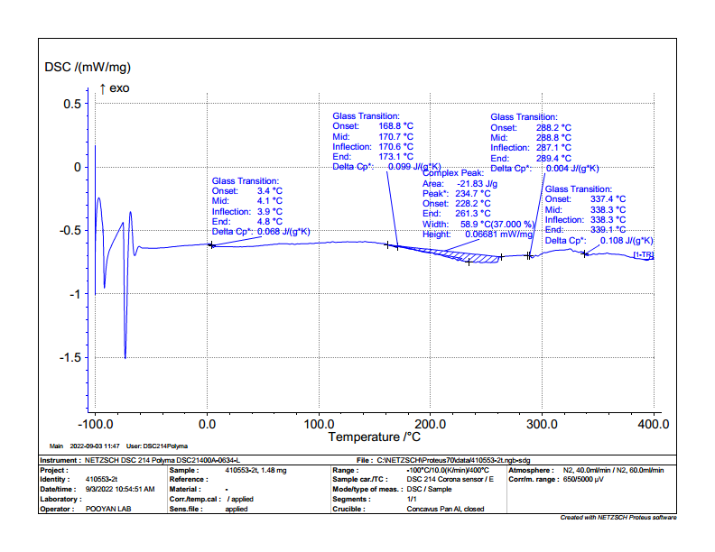
Supplementary figures 1: DSC thermogram of Physical mix 1
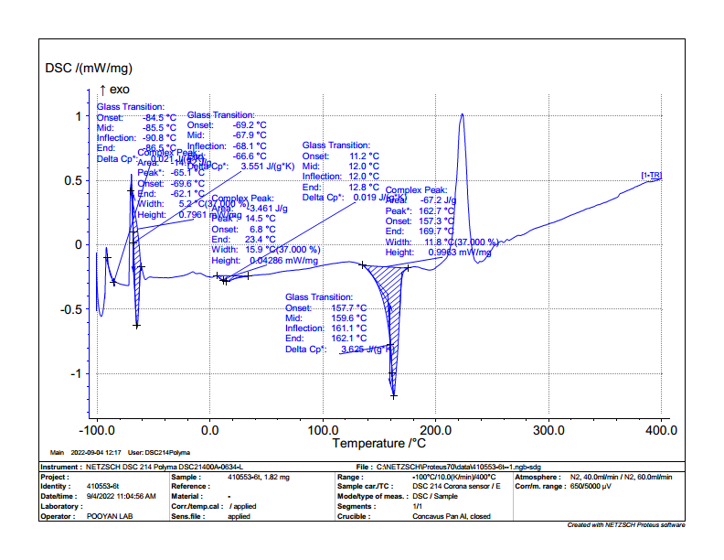
Supplementary figures 2: DSC thermogram of free-DOX 1
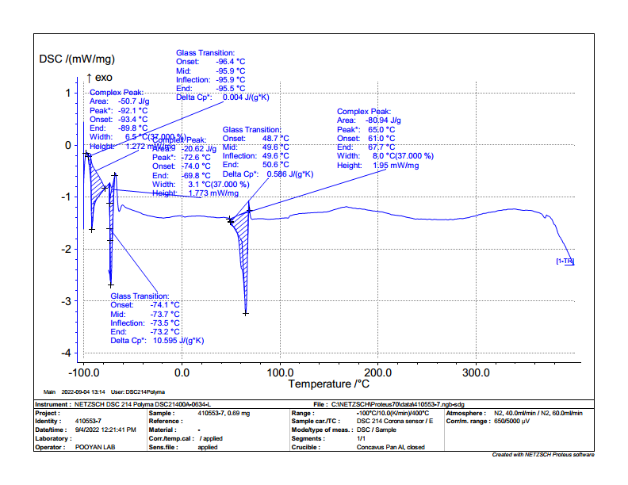
Supplementary figures 3: DSC thermogram of free-PLGA
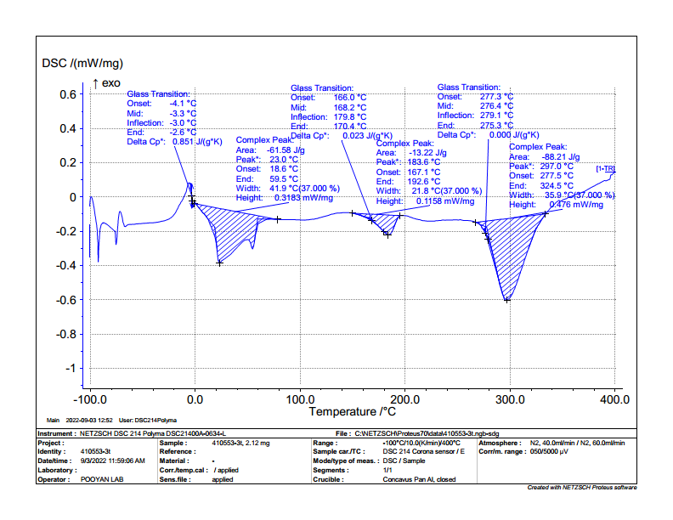
Supplementary figures 4: DSC thermogram of free-RIF
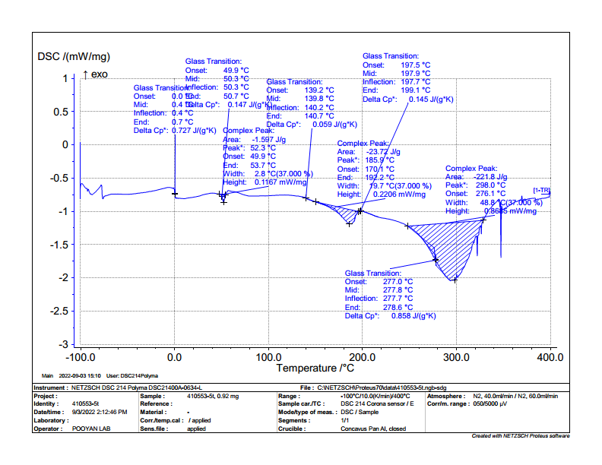
Supplementary figures 5: DSC thermogram of PLGA-DOX
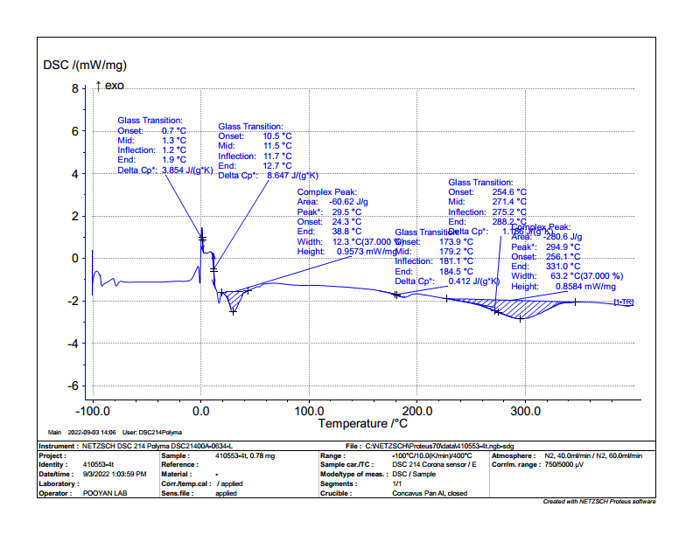
Supplementary figures 6: DSC thermogram of PLGA-DOX-RIF

