Synthesis of new two 1,2-disubstituted benzimidazole compounds: Their in vitro anticancer and in silico molecular docking studies
Sevtap Caglar Yavuz*
*Correspondence:
Sevtap Caglar Yavuz
sevtap.yavuz@erzincan.edu.tr
Department of Medical Services and Technicians, Ilic Dursun Yildirim Vocational School, Erzincan Binali Yildirim University, Erzincan, Turkey

1D NMR, IR and LC/MS spectra of compounds 2a and 2b
1D Nuclear Magnetic Resonance of products were taken in DMSO-d₆ solvent by a Bruker AVANCE III 400 MHz NMR spectrometer. IR spectra of compounds were taken with Thermo Scientific Nicolet 6700 spectrometer. LC-MS/MS spectra were recorded using a Shimadzu 8040 LC-MS spectrophotometer.

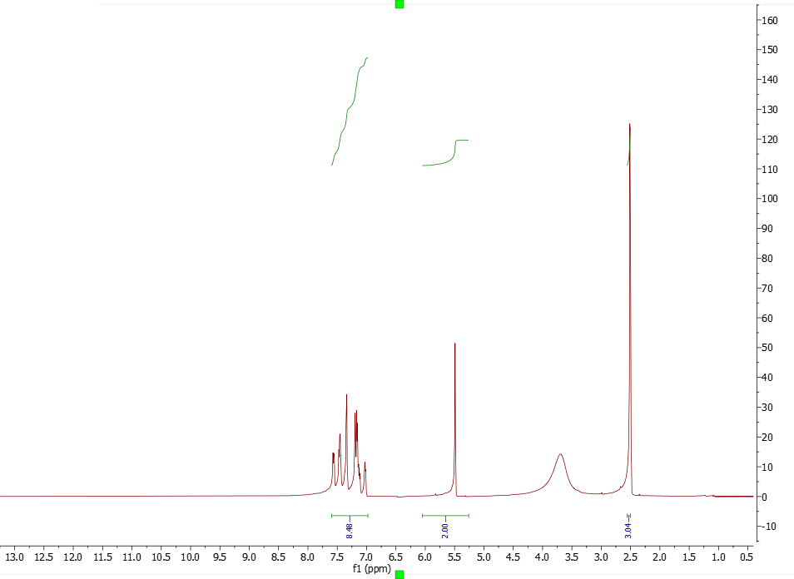
Fig. S1 ¹H NMR spectrum of product 2a
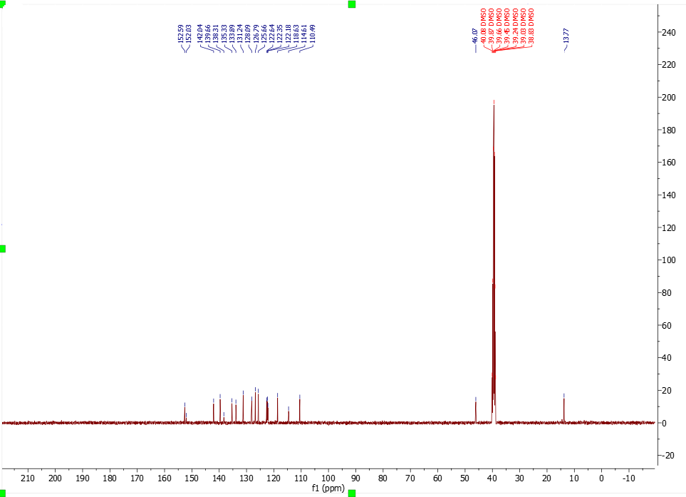

Fig. S2 ¹³C NMR spectrum of product 2a

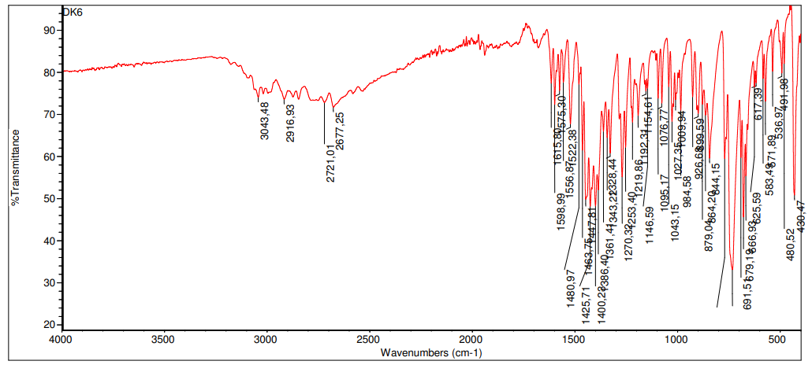
Fig. S3 IR spectrum of product 2a
Fig. S4 LC-MS spectrum of product 2a
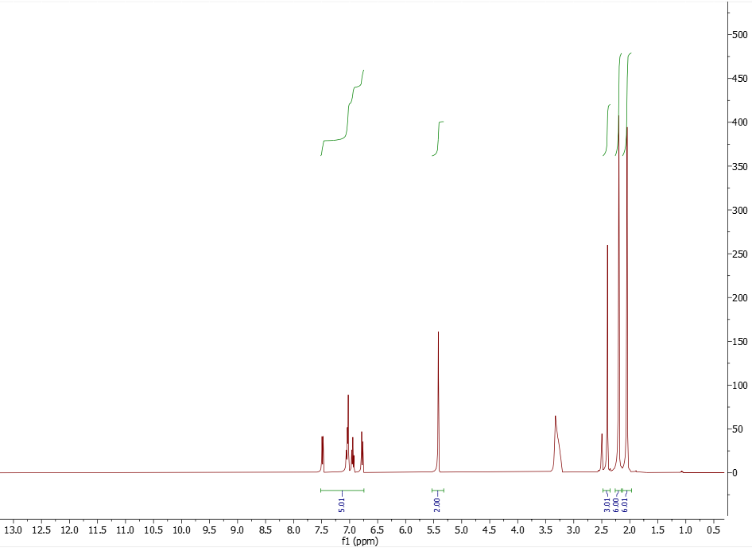
Fig. S5 ¹H NMR spectrum of product 2b

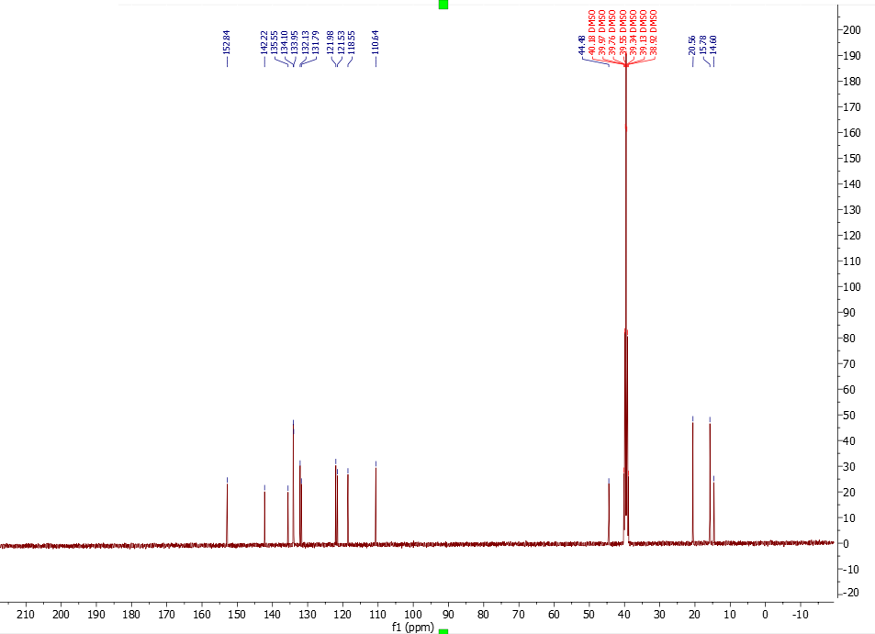
Fig. S6 ¹³C NMR spectrum of product 2b

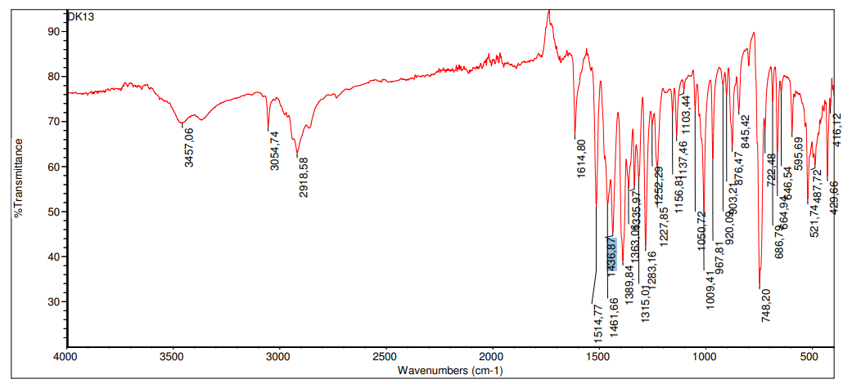
Fig. S7 IR spectrum of product 2b

Fig. S8 LC-MS spectrum of product 2b

