Supplementary Tables

Table S1. Optimization of chromatographic conditions for the determination of studied drugs by the proposed micellar UPLC method
Parameter |  | No of theoretical plates (N) |  | Tailing factor (T) |  | Resolution Factor (R_{s})
 |  | MLK | FEX | MLK | FEX | MLK | FEX
Conc of SDS | 0.01  0.02  0.03  0.04 | 7214  7260  7271  7201 | 6710  6796  6721  6786 | 1.13  1.19  1.12  1.12 | 1.13  1.14  1.17  1.19 | 4.12  4.27  4.07  4.15 | 4.87  4.92  4.84  4.85
% of pentanol  (% v/v) | 5  10  15  20 | 7258  7168  7260  7111 | 6753  6745  6796  6674 | 1.12  1.09  1.19  1.11 | 1.11  1.15  1.14  1.12 | 4.16  4.24  4.27  4.25 | 4.79  4.82  4.92  4.85
pH | 3  3.5  4  4.5 | 7214  7260  7201  7101 | 6670  6796  6710  6646 | 1.12  1.19  1.11  1.12 | 1.13  1.14  1.13  1.13 | 4.12  4.27  4.17  4.15 | 4.87  4.92  4.90  4.90
Conc of buffer | 0.02  0.03  0.04  0.05 | 7212  7223  7211  7260 | 6710  6766  6770  6796 | 1.13  1.14  1.12  1.19 | 1.11  1.14  1.13  1.14 | 3.97  4.14  4.10  4.27 | 4.87  4.82  4.84  4.92
Flow rate | 0.6  0.8  1.0  1.2 | 7224  7125  7260  7161 | 6710  6576  6796  6636 | 1.13  1.15  1.19  1.12 | 1.13  1.14  1.14  1.08 | 4.12  4.23  4.27  4.15 | 4.68  4.82  4.92  4.55
Column temp. | 30  40  50 | 7124  7260  7151 | 6621  6796  6672 | 1.13  1.19  1.12 | 1.12  1.14  1.13 | 4.07  4.27  3.97 | 4.63  4.92  4.58

Parameters | Obtained value |  | Reference value
Parameters | MLK | FEX | Reference value
Retention time (R_{t}) | 3.54 | 1.67 | --
Number of theoretical plates (N) | 7260 | 6796 | N>2000
Resolution factor (R_{s}) | 4.92 |  | ≥2
Tailing factor (T) | 1.19 | 1.14 | ≤2
Table S2. System suitability data for the proposed micellar UPLC method

Table S3: Determination of MLK and FEX in laboratory-prepared mixtures by the proposed methods.

Lab prepared mixture  (µg mL⁻¹) |  | Micellar UPLC method |  | Lab prepared mixture  (µg mL⁻¹) |  | Spectroscopic methods
 |  |  |  |  |  | Second derivative ²D |  | Third derivative ³D |  |  |  | Ratio Difference RD
MLK | FEX | MLK | FEX | MLK | FEX | MLK | FEX | MLK |  |  | FEX | MLK | FEX
MLK | FEX | 230 nm |  | MLK | FEX | 341 nm | 213.6 nm | 295 nm | 336.4 nm | 346 nm | 235 nm | ΔP 250-245 nm | ΔP 227-217 nm
10 | 10 | 100.32 | 101.21 | 10 | 10 | 101.62 | 100.58 | 98.82 | 99.40 | 101.74 | 99.12 | 101.80 | 100.70
20 | 20 | 97.85 | 99.54 | 20 | 10 | 101.40 | 99.74 | 102.05 | 100.90 | 98.15 | 98.64 | 101.77 | 100.42
2 | 14 | 102.12 | 99.76 | 10 | 20 | 98.15 | 98.45 | 100.76 | 99.61 | 101.33 | 101.56 | 98.78 | 99.52
5 | 60 | 98.26 | 100.65 | 3 | 36 | 101.30 | 99.41 | 98.93 | 100.09 | 99.83 | 100.33 | 101.42 | 100.30
20 | 240 | 98.34 | 100.87 | 4 | 48 | 98.72 | 100.64 | 101.01 | 101.00 | 101.08 | 99.9 | 102.04 | 99.63
 |  |  |  | 5 | 60 | 98.65 | 101.39 | 100.48 | 99.34 | 100.72 | 101.87 | 100.08 | 98.85
Mean %  ± SD |  | 98.42  ±1.68 | 100.40  ±722 | Mean %  ± SD |  | 99.97  ±1.62 | 100.04  ±1.05 | 100.34  ±1.25 | 100.06  ±0.74 | 100.48  ±1.31 | 100.24  ±1.29 | 100.98  ±1.29 | 99.90  ± 0.69

-Reported method (Mustafa et al., 2017) for determination of Montelukast sodium nm

Supplementary Figure

Fig. S1: (A) Ratio spectra of MLK 3- 50 µg mL⁻¹ using 15 µg mL⁻¹ FEX as divisor. (B) Ratio spectra of FEX 3- 60 µg mL⁻¹ using 5 µg mL⁻¹ MLK as divisor

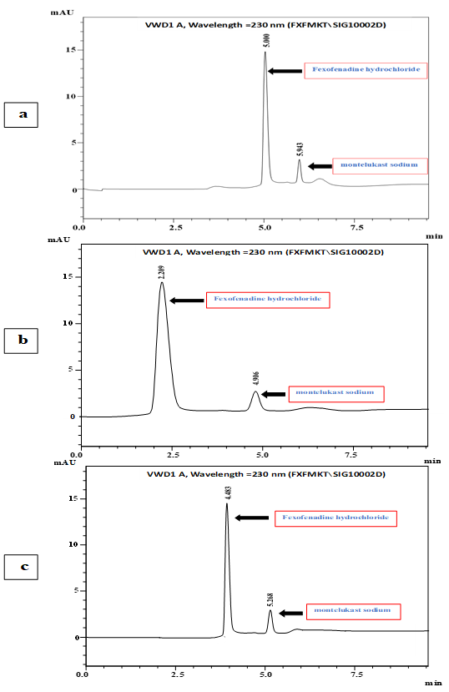
Fig. S2: Optimization chromatograms of selection of column demonstrating the separation of 4 μg mL⁻¹ MLK and 48 μg mL⁻¹ FEX laboratory-prepared mixture. (a) Kinetex C18 (100 x 4.6 mm, 2.6 μm), (b) Zorbax Eclipse XDB-C18 (150 x 4.6 mm, 5 μm), and (c) Monolithic RP-C18 (100 x 4.6 mm).

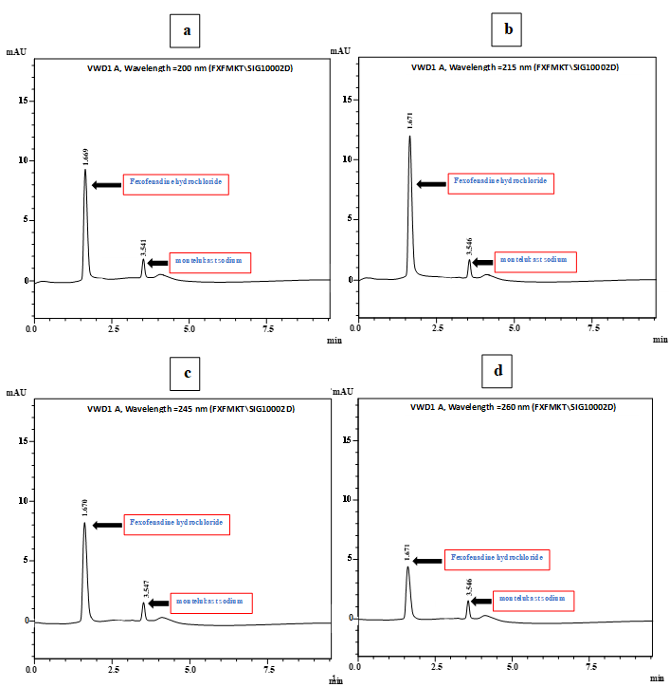

Fig. S3: Optimization chromatograms of selection of detection wavelength demonstrating the separation of 4 μg mL⁻¹ MLK and 48 μg mL⁻¹ FEX laboratory-prepared mixture. (a) 200 nm, (b) 215 nm, (c) 245 nm, and (d) 260 nm.

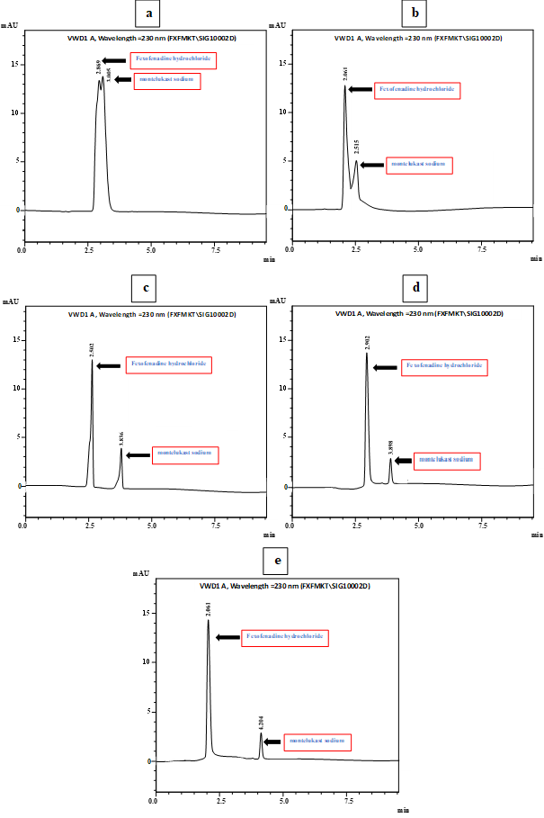
Fig. S4: Optimization chromatograms of selection of mobile phase organic modifiers demonstrating the separation of 4 μg mL⁻¹ MLK and 48 μg mL⁻¹ FEX laboratory-prepared mixture. (a) methanol, (b) ethanol, (c) acetonitrile, (d) n-propanol, and (e) n-butanol

Fig. S5. Typical NEMI pictograms.

.
Fig. S6. The ComplexGAPI pictogram, with the original GAPI pictogram greyed out in the background, and particular fields of the added hexagonal glyph grouped and colour-coded for clarity.

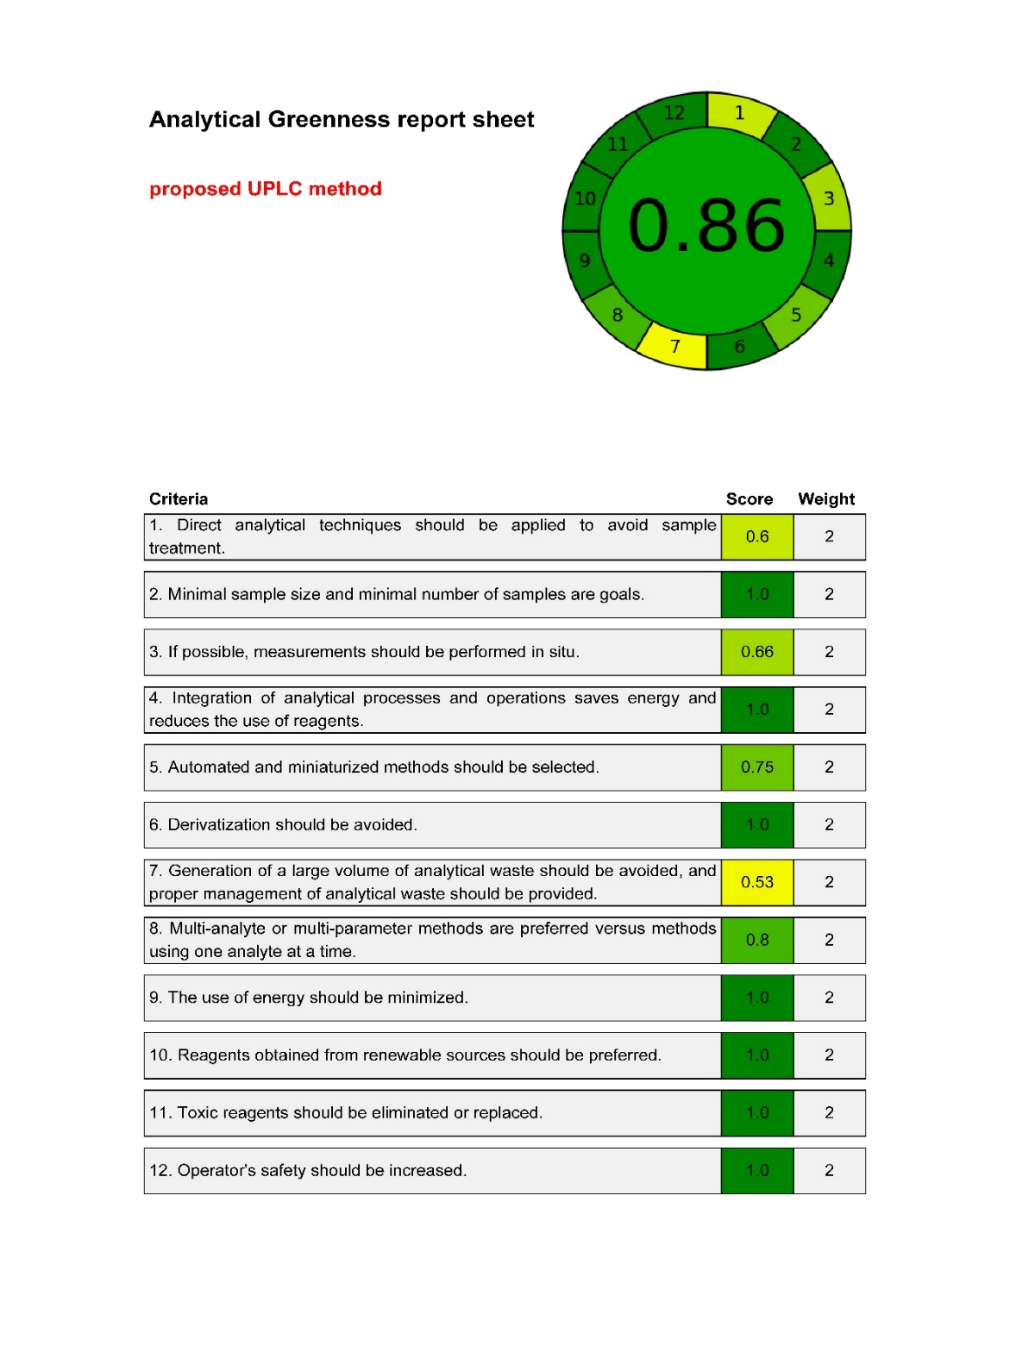
Fig. S7. Analytical greenness report sheets for the proposed UPLC method by AGREE tool.

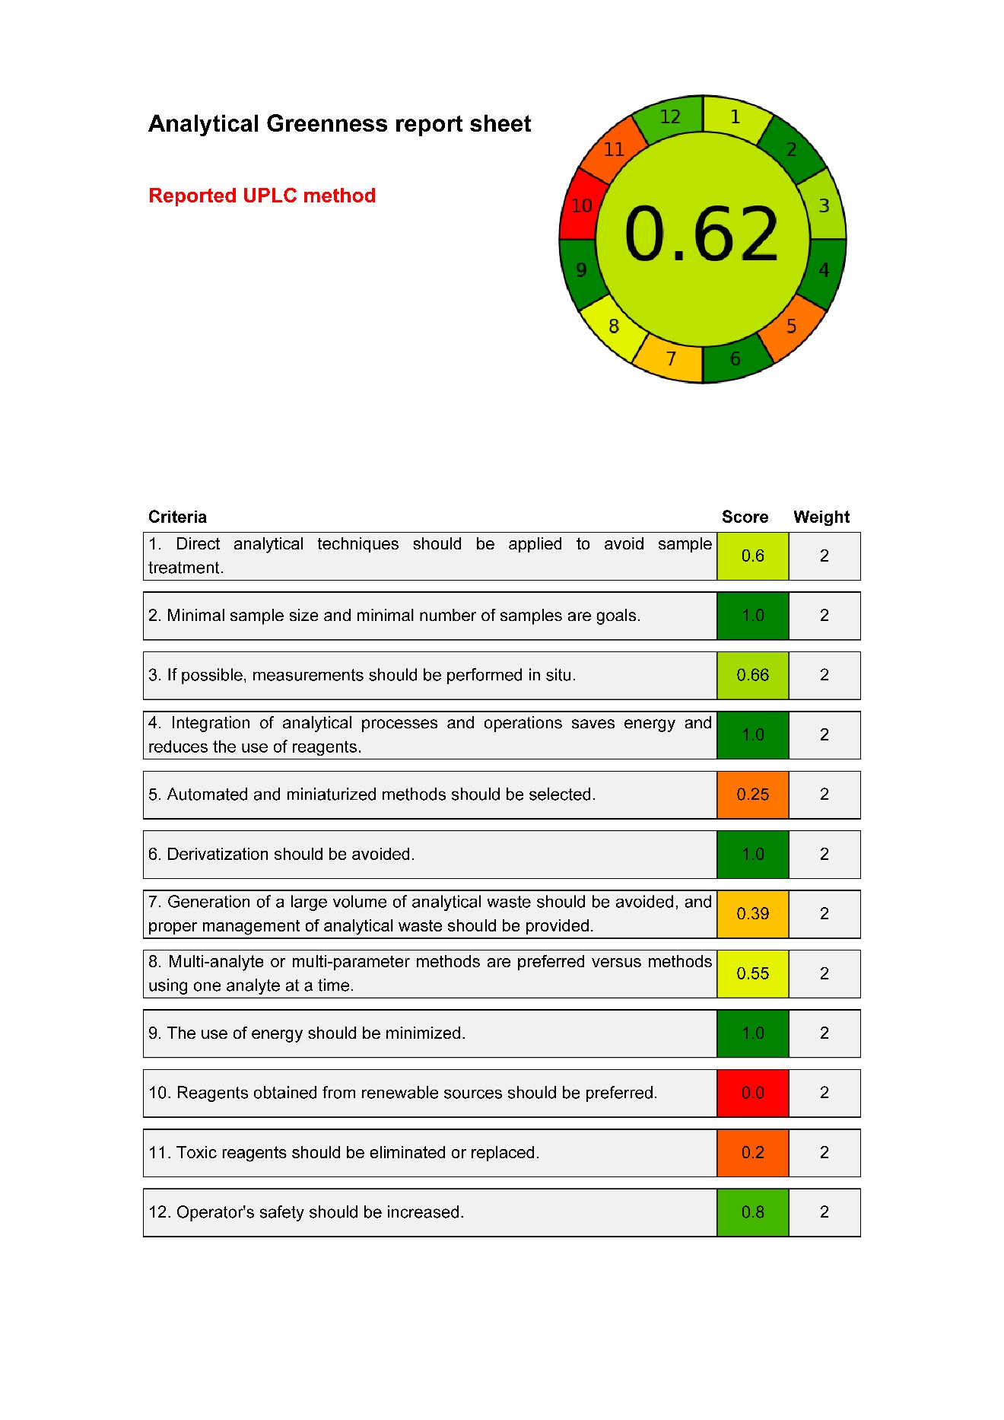

Fig. S8. Analytical greenness report sheets for the reported UPLC method [25] by AGREE tool.
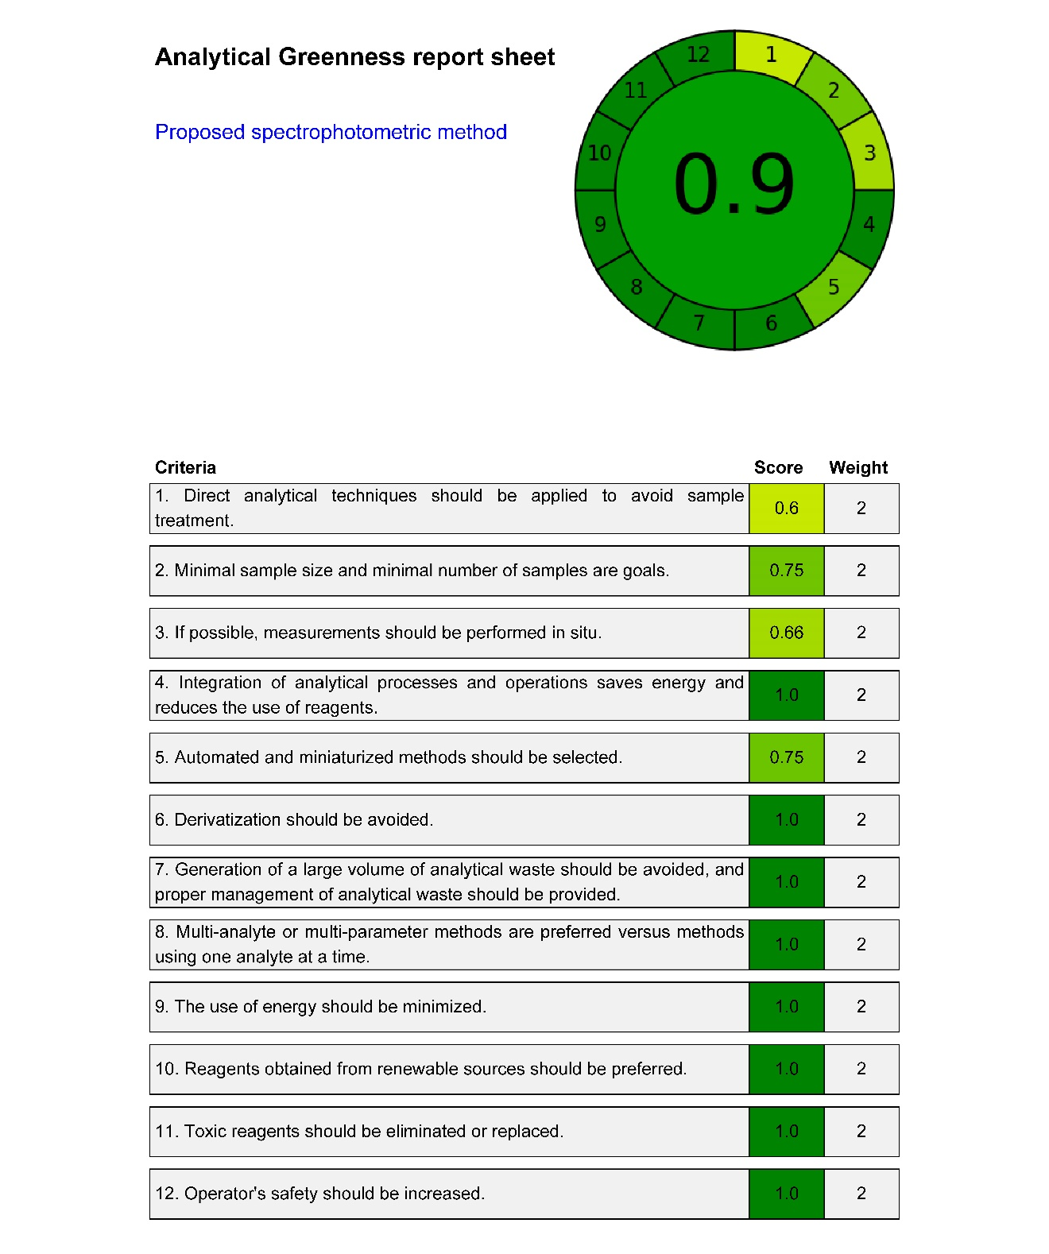
Fig. S9. Analytical greenness report sheets for the proposed spectrophotometric method by AGREE tool.

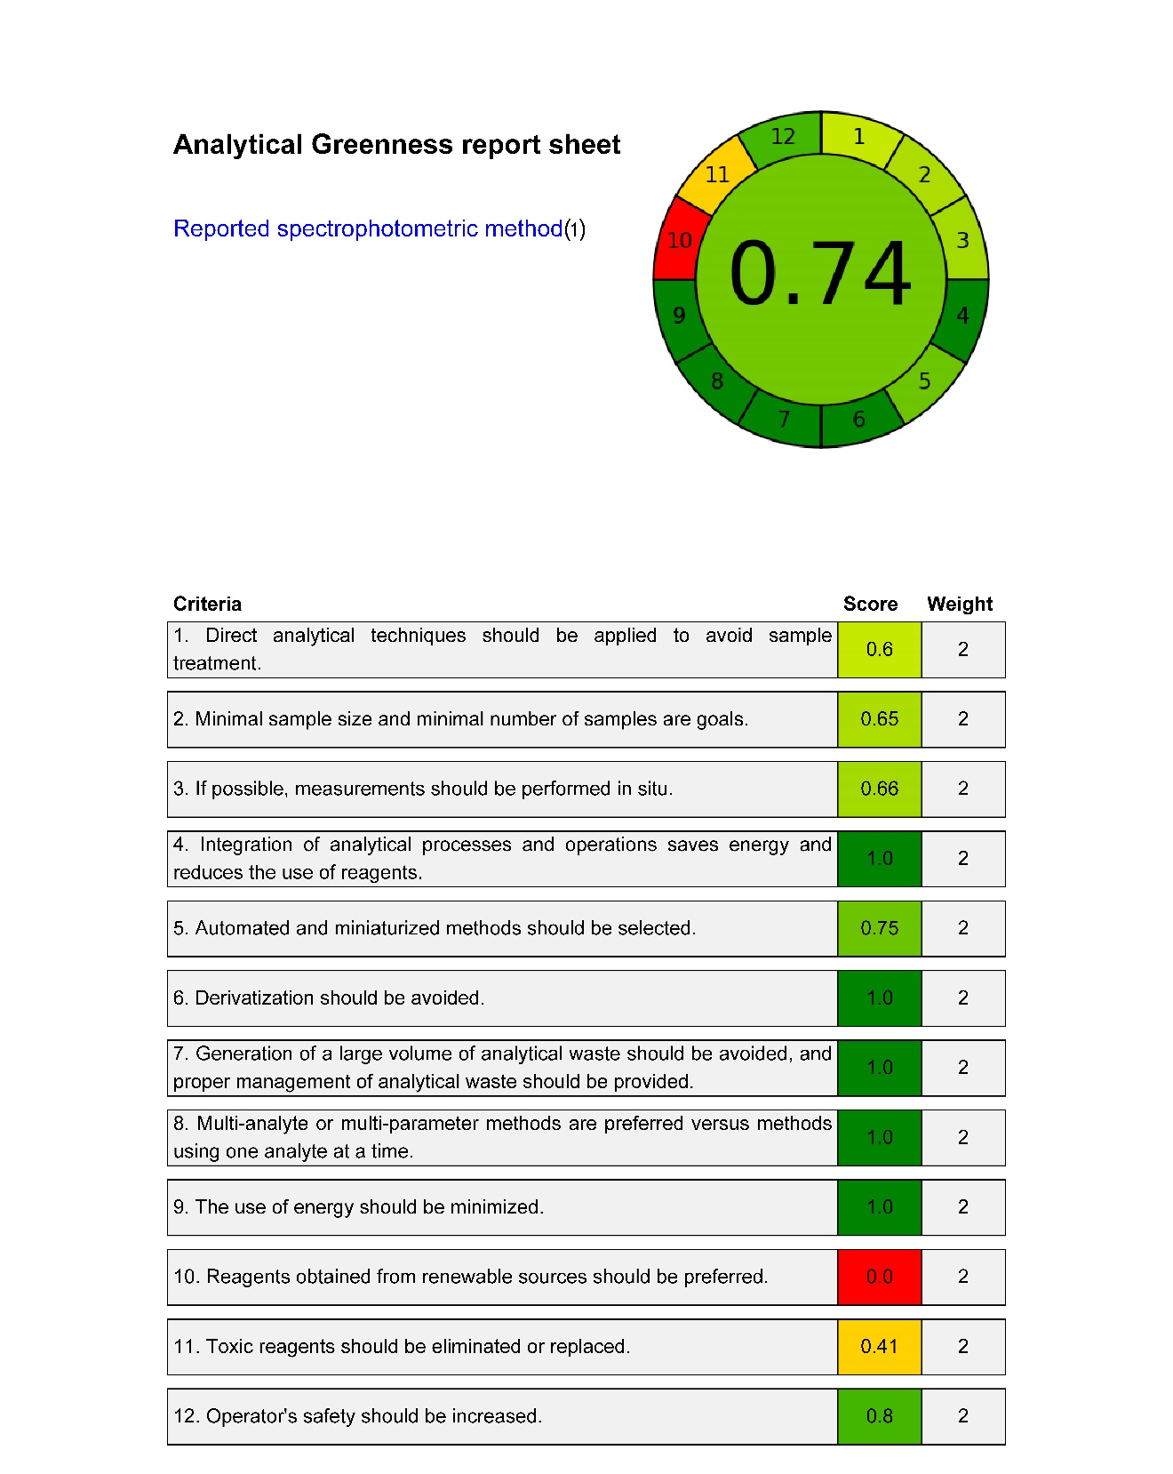

Fig. S10. Analytical greenness report sheets for the reported spectrophotometric method [15] by AGREE tool.

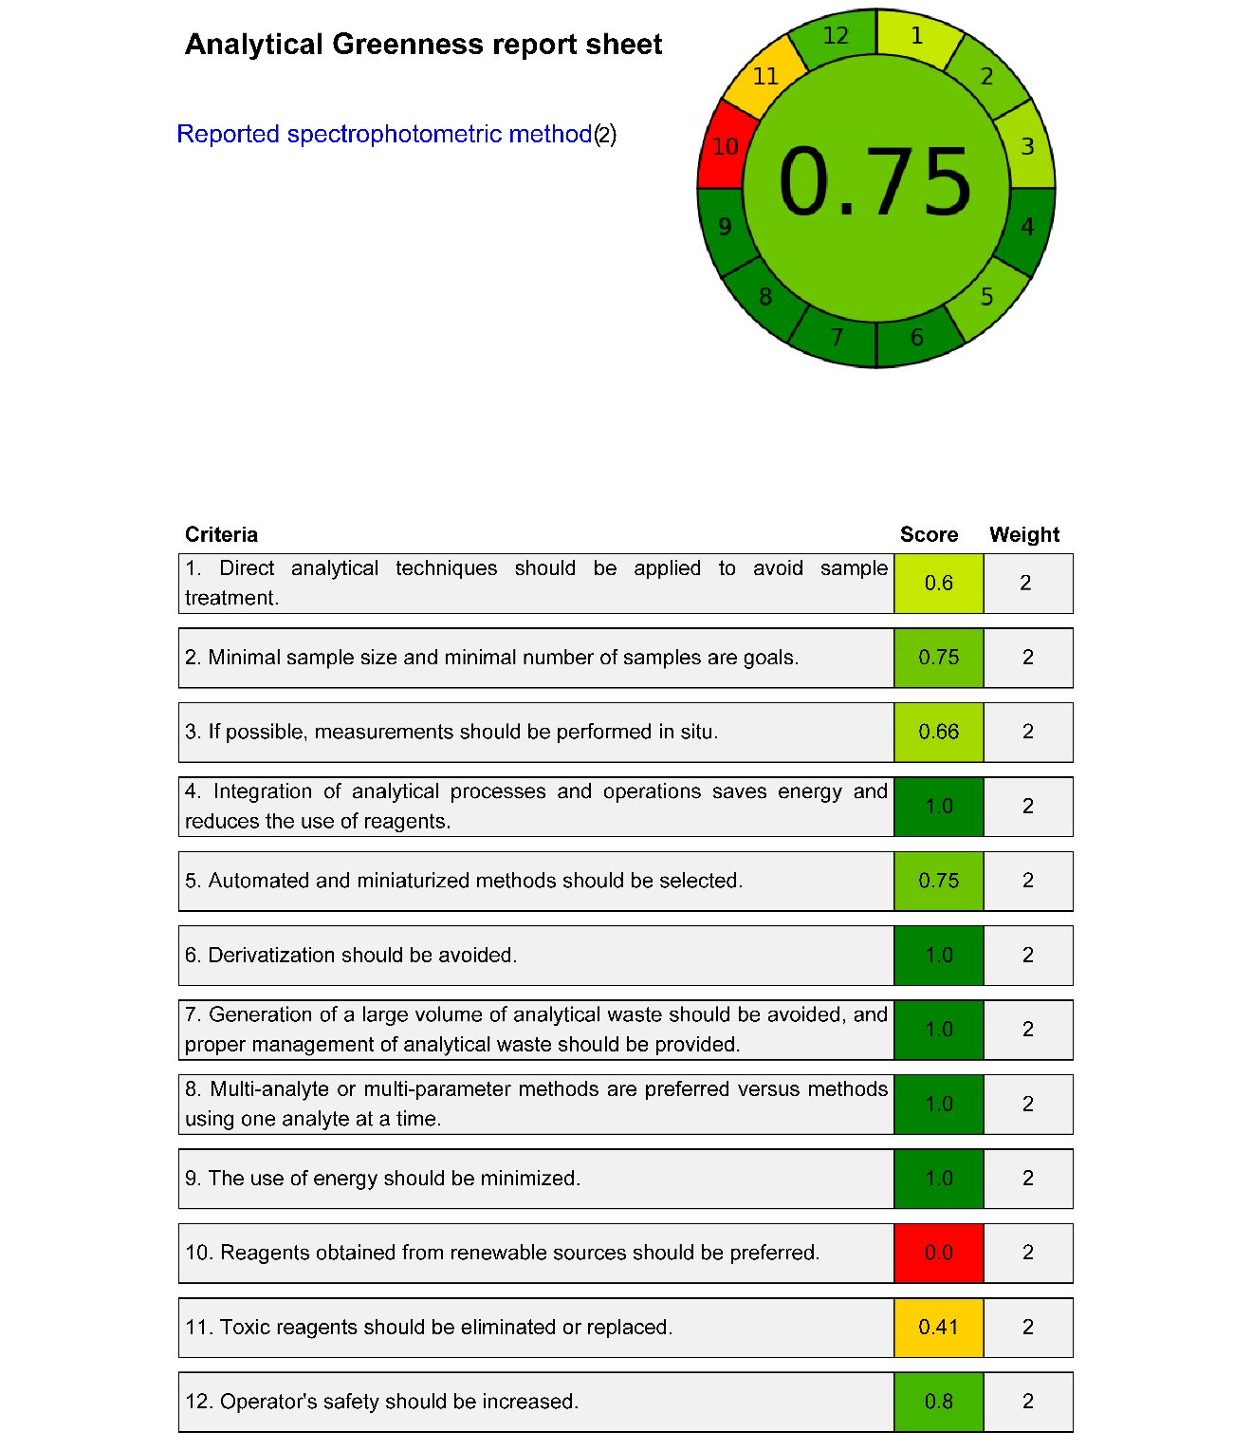

Fig. S11. Analytical greenness report sheets for the reported spectrophotometric method [16] by AGREE tool.
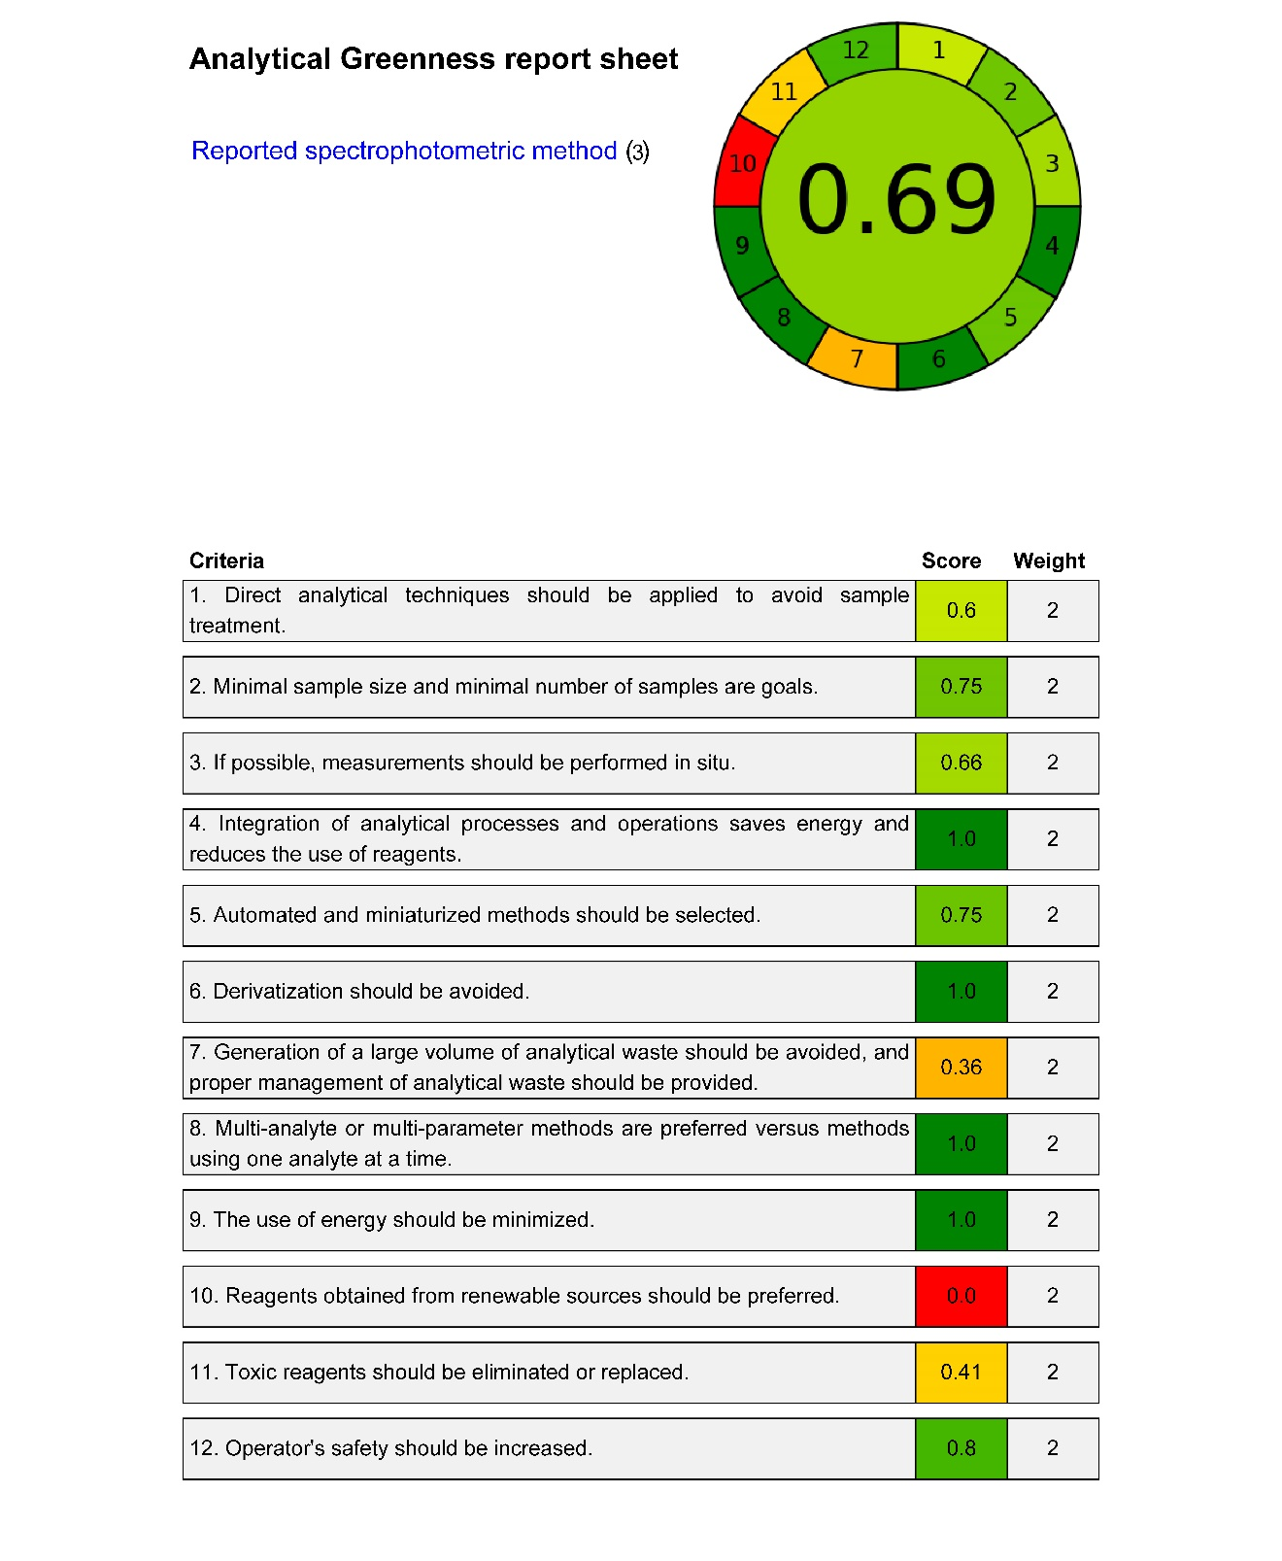

Fig. S12. Analytical greenness report sheets for the reported spectrophotometric method [17] by AGREE tool.
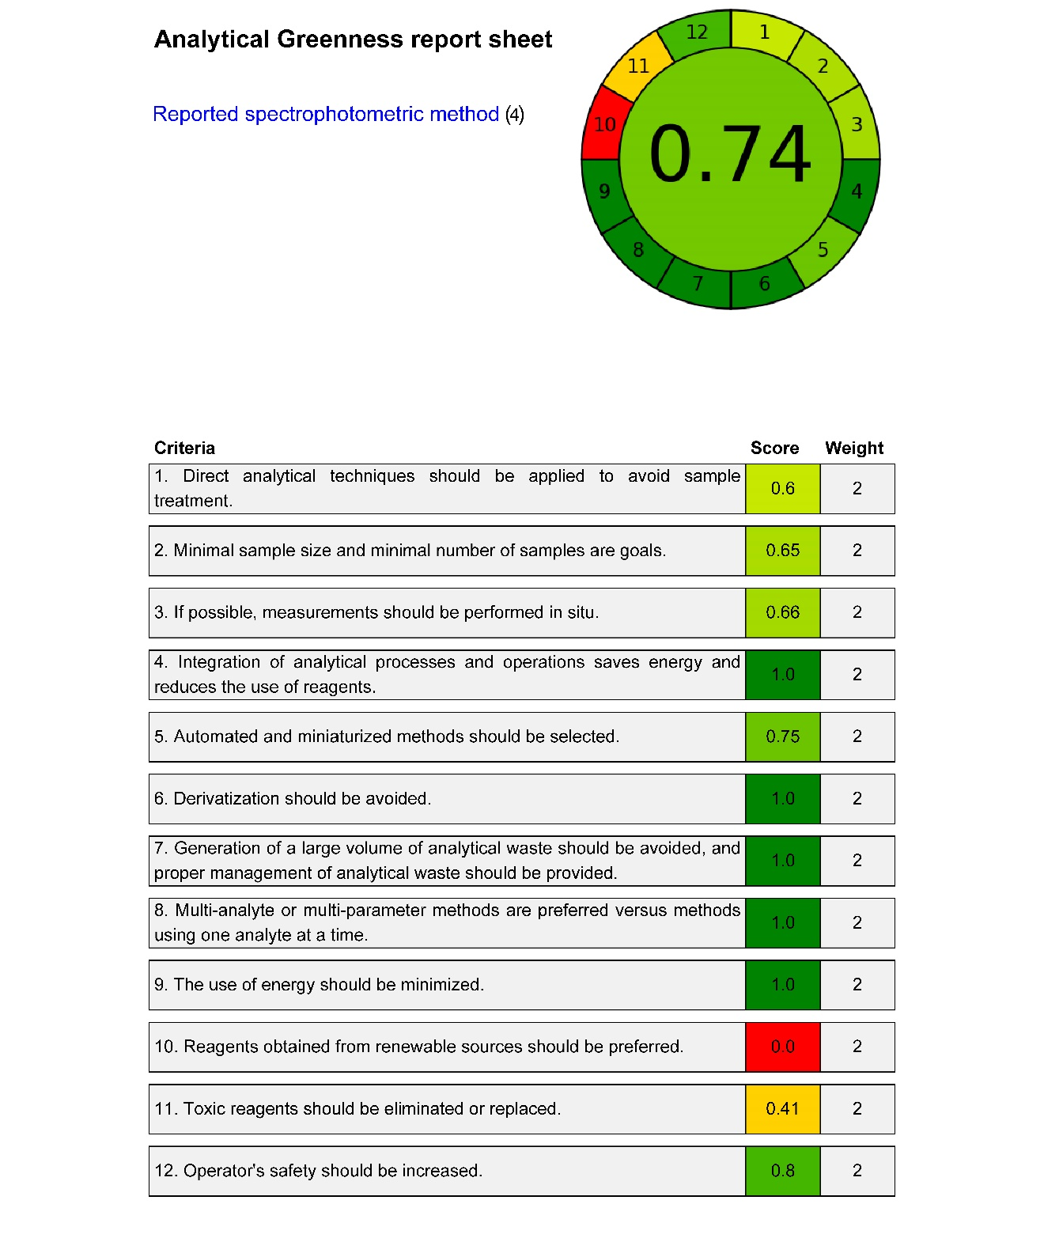

Fig. S13. Analytical greenness report sheets for the reported spectrophotometric method [18] by AGREE tool.
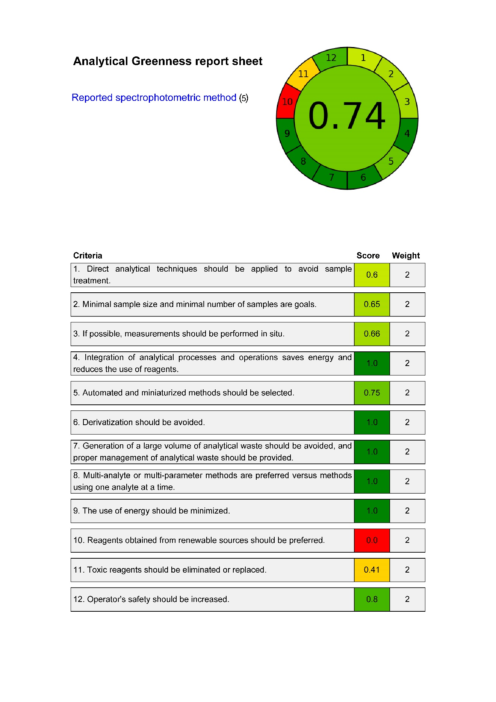
Fig. S14. Analytical greenness report sheets for the reported spectrophotometric method [19] by AGREE tool.
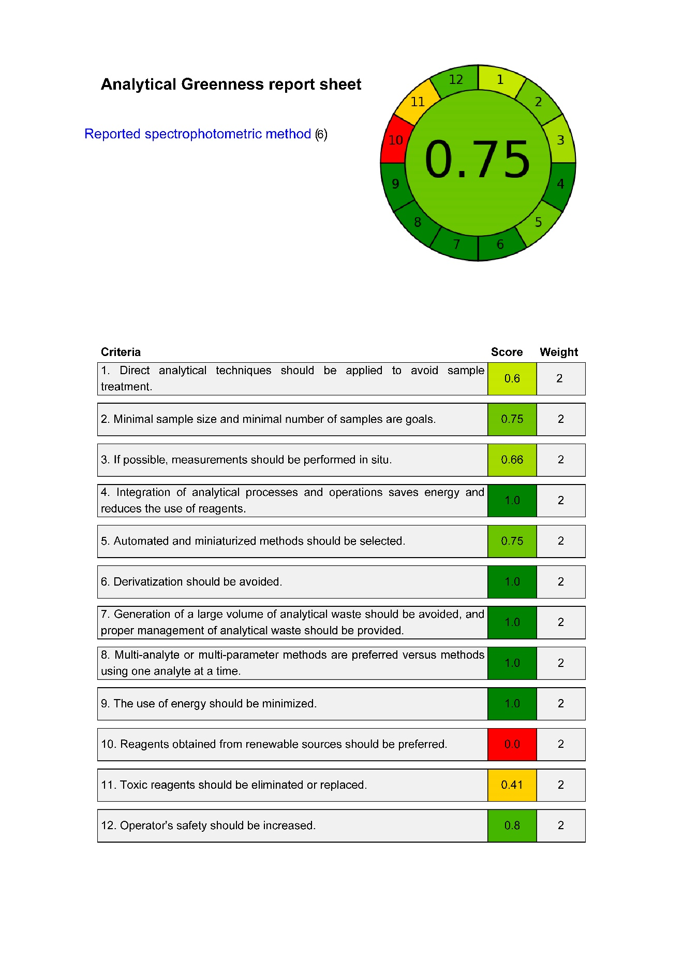
Fig. S15. Analytical greenness report sheets for the reported spectrophotometric method [20] by AGREE tool.

Fig. S16. Comparison of the redness, greenness, blueness, and whiteness profiles of the proposed and reported UPLC methods, obtained by the RGB 12 algorithm.

Fig. S17. Comparison of the redness, greenness, blueness, and whiteness profiles of the proposed and reported spectrophotometric methods, obtained by the RGB 12 algorithm.

