Supplementary File
Synthesis and PASS-Assisted Evaluation of New Heterocyclic Compounds Containing Hydroquinoline Scaffolds
Gizachew Mulugeta Manahelohe ^{[1]*}, Khidmet Safarovich Shikhaliev ^{[2]}
[1] Department of Chemistry, University of Gondar, P.o.Box 196, Gondar; Ethiopia
[2] Department of Chemistry, Voronezh State University, Universitetskaya pl. 1, 394006, Voronezh, Russian Federation
* Corresponding author: gizachewm75@gmail.com
¹H-NMR and ¹³C-MR spectra of the Synthesized Compounds
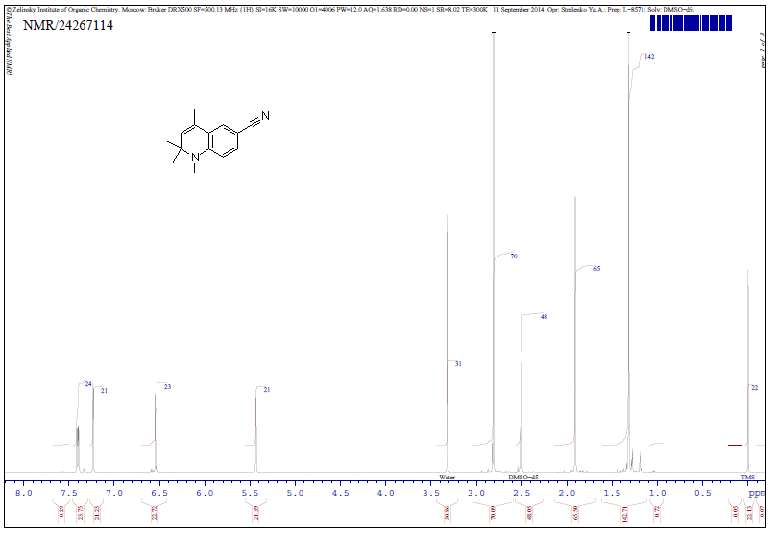
Figure S1. ¹H-NMR spectrum of 1,2,2,4-tetramethyl-1,2-dihydroquinoline-6-carbonitrile 7.
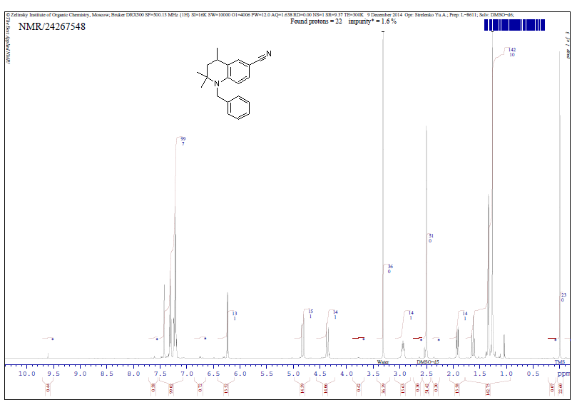
Figure S2. ¹H-NMR spectrum of 1-benzyl-2,2,4-trimethyl-1,2,3,4-tetrahydroquinoline-6-carbonitrile 8.

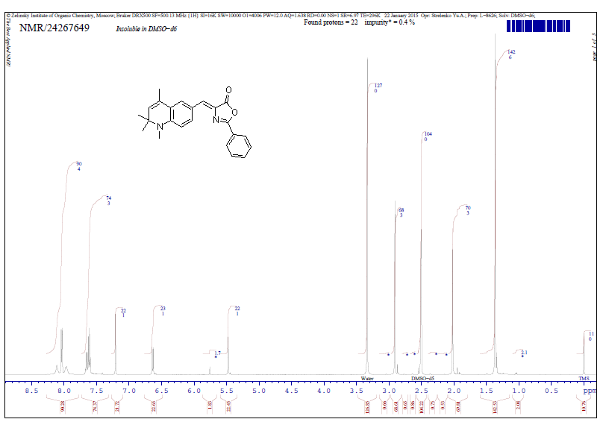
Figure S3. ¹H-NMR spectrum of (Z)-2-phenyl-4-((1,2,2,4-tetramethyl-1,2-dihydroquinolin-6-yl)methylene)oxazol-5(4H)-one 9a.
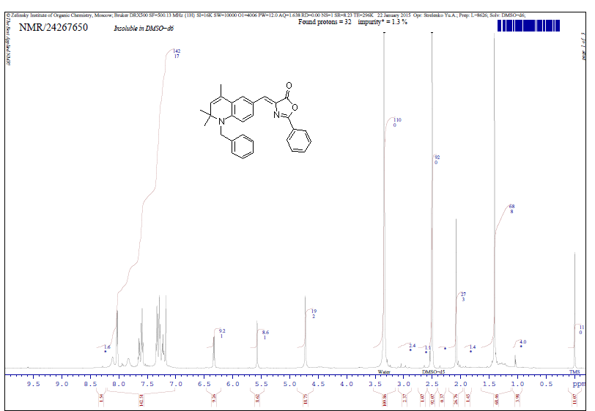
Figure S4. ¹H-NMR spectrum of (Z)-4-((1-benzyl-2,2,4-trimethyl-1,2-dihydroquinolin-6-yl)methylene)-2-phenyloxazol-5(4H)-one 9b.
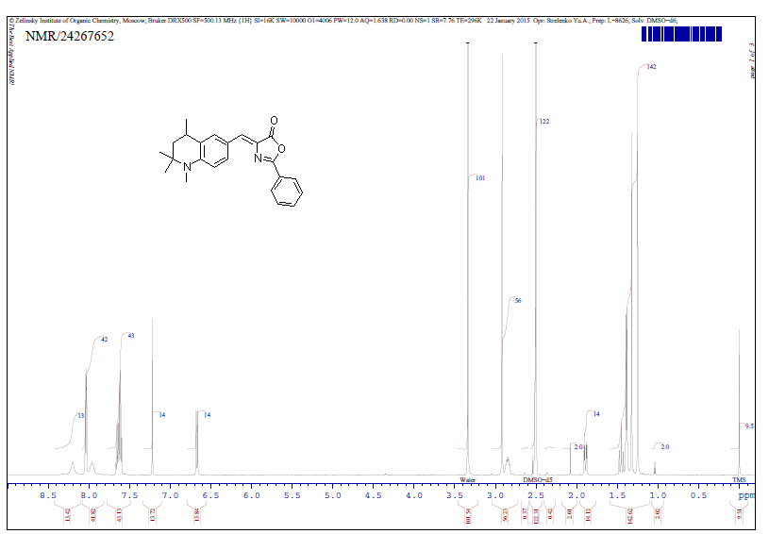
Figure S5. ¹H-NMR spectrum of (Z)-2-phenyl-4-((1,2,2,4-tetramethyl-1,2,3,4-tetrahydroquinolin-6-yl)methylene)oxazol-5(4H)-one 10a.
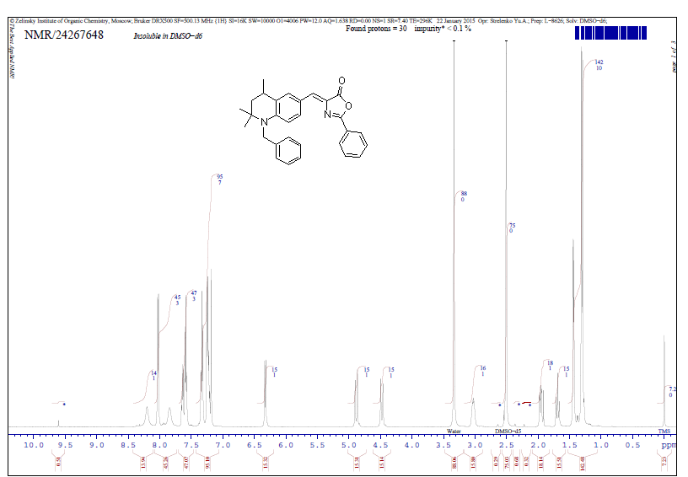
Figure S6. ¹H-NMR spectrum of (Z)-4-((1-benzyl-2,2,4-trimethyl-1,2,3,4-tetrahydroquinolin-6-yl)methylene)-2-phenyloxazol-5(4H)-one 10b.
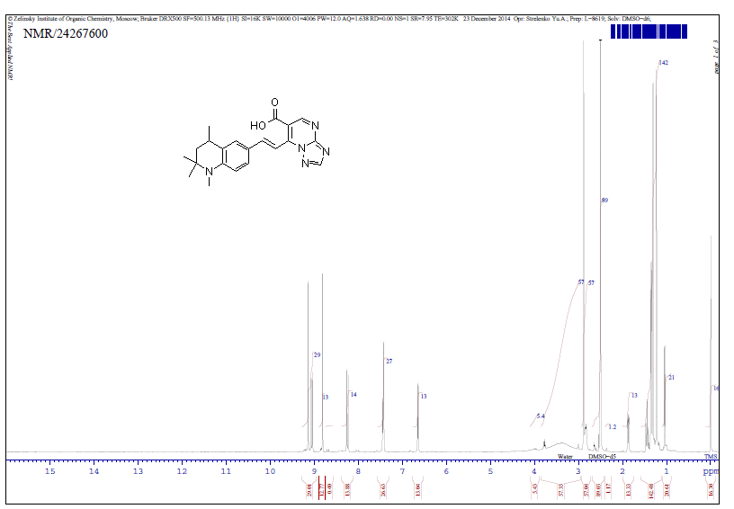
Figure S7. ¹H-NMR spectrum of (E)-7-(2-(1,2,2,4-tetramethyl-1,2,3,4-tetrahydroquinolin-6-yl)vinyl)-[1,2,4]triazolo[1,5-a]pyrimidine-6-carboxylic acid 12a.
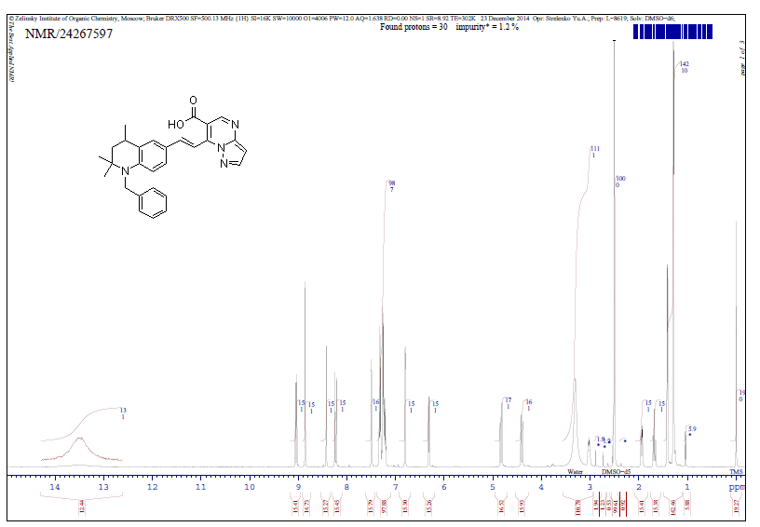
Figure S8. ¹H-NMR spectrum of (E)-7-(2-(1-benzyl-2,2,4-trimethyl-1,2,3,4-tetrahydroquinolin-6-yl)vinyl)pyrazolo[1,5-a]pyrimidine-6-carboxylic acid 12b.
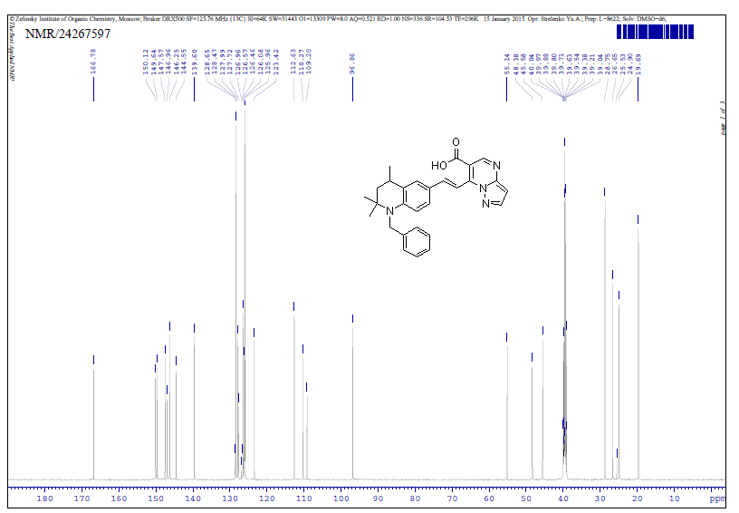
Figure S9. ¹³C-NMR spectrum of (E)-7-(2-(1-benzyl-2,2,4-trimethyl-1,2,3,4-tetrahydroquinolin-6-yl)vinyl)pyrazolo[1,5-a]pyrimidine-6-carboxylic acid 12b.
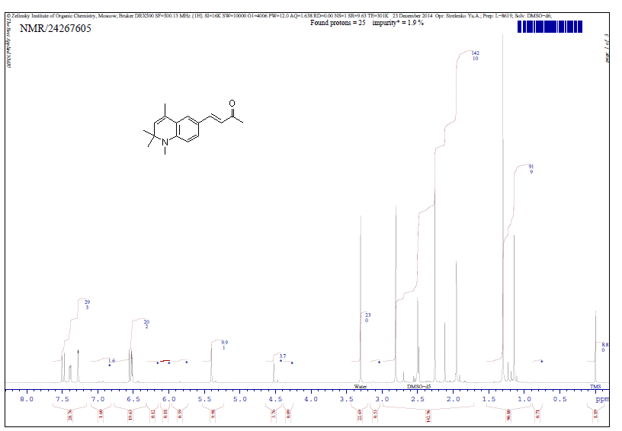
Figure S10. ¹H-NMR spectrum of (E)-4-(1,2,2,4-tetramethyl-1,2-dihydroquinolin-6-yl)but-3-en-2-one 13a.
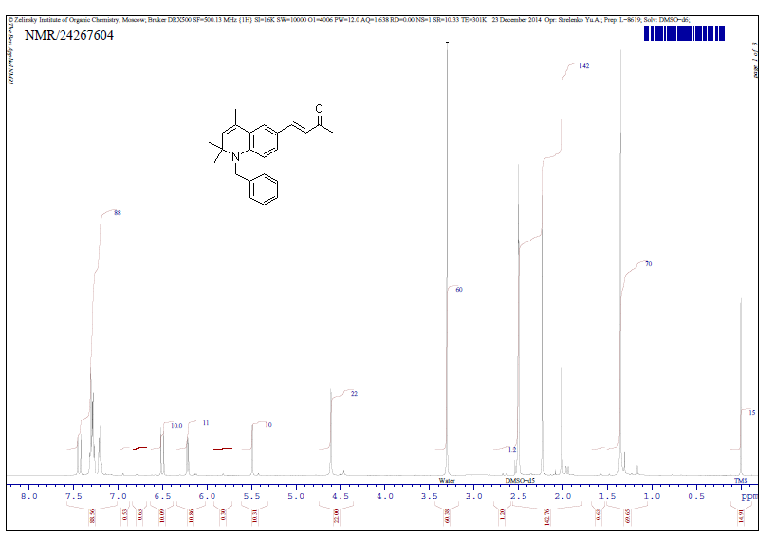
Figure S11. ¹H-NMR spectrum of (E)-4-(1-benzyl-2,2,4-trimethyl-1,2-dihydroquinolin-6-yl)but-3-en-2-one 13b.
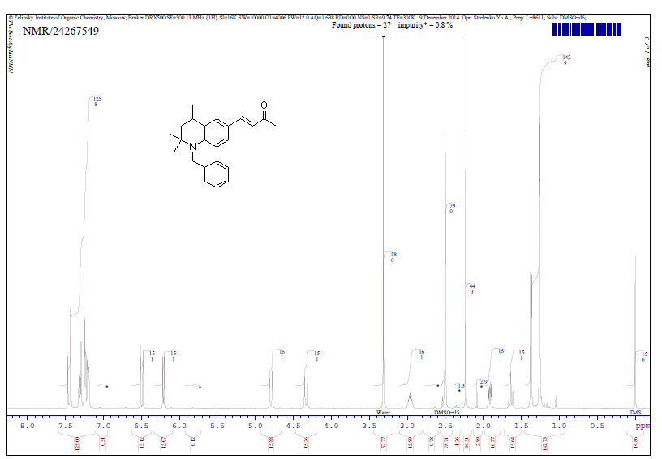
Figure S12. ¹H-NMR spectrum of (E)-4-(1-benzyl-2,2,4-trimethyl-1,2,3,4-tetrahydroquinolin-6-yl)but-3-en-2-one 14.

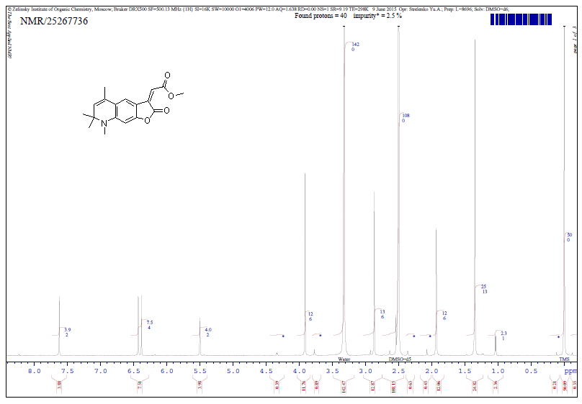
Figure S13. ¹H-NMR spectrum of methyl (Z)-2-(5,7,7,8-tetramethyl-2-oxo-7,8-dihydrofuro[3,2-g]quinolin-3(2H)-ylidene)acetate 16.
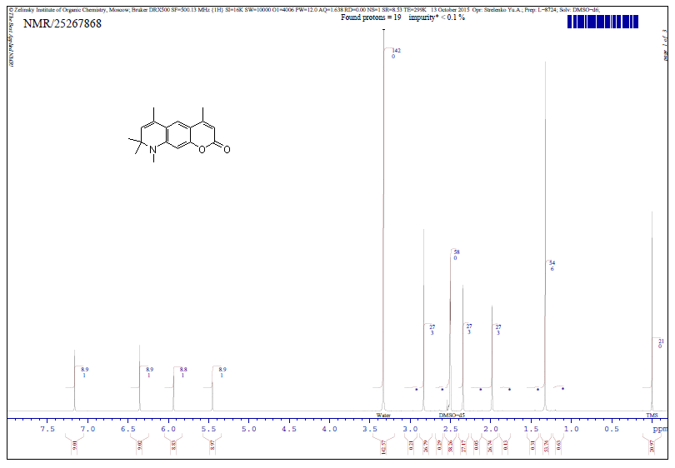
Figure S14. ¹H-NMR spectrum of 4,6,8,8,9-pentamethyl-8,9-dihydro-2H-pyrano[3,2-g]quinolin-2-one 17.
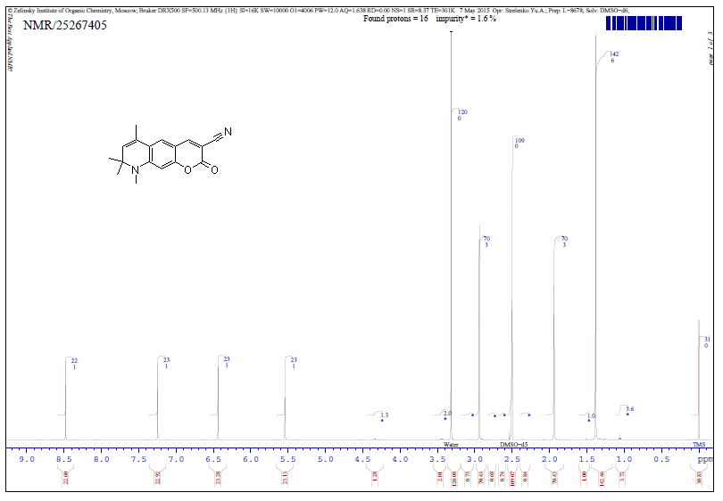
Figure S15. ¹H-NMR Spectrum of 6,8,8,9-tetramethyl-2-oxo-8,9-dihydro-2H-pyrano[3,2-g]quinoline-3-carbonitrile 19a.
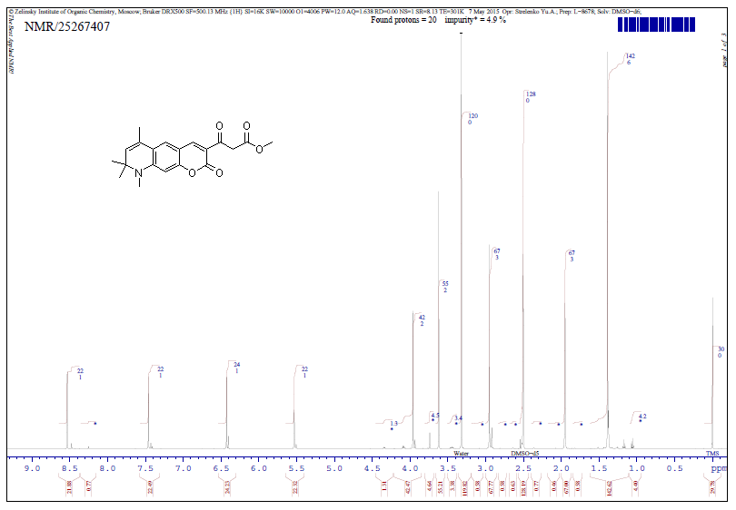
Figure S16. ¹H-NMR spectrum of methyl 3-oxo-3-(6,8,8,9-tetramethyl-2-oxo-8,9-dihydro-2H-pyrano[3,2-g]quinolin-3-yl)propanoate 19b.
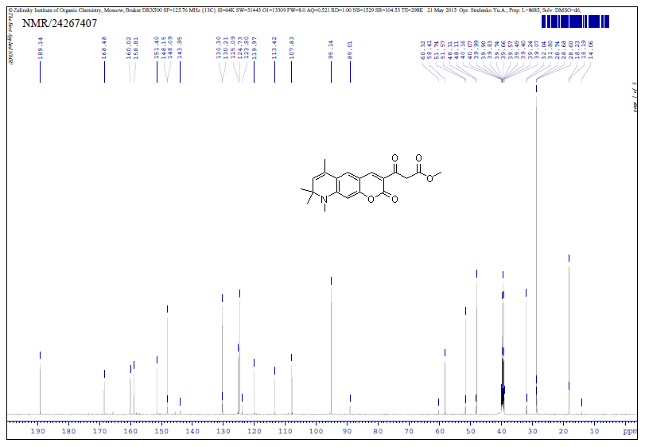
Figure S17. ¹³C-NMR Spectrum of of methyl 3-oxo-3-(6,8,8,9-tetramethyl-2-oxo-8,9-dihydro-2H-pyrano[3,2-g]quinolin-3-yl)propanoate 19b
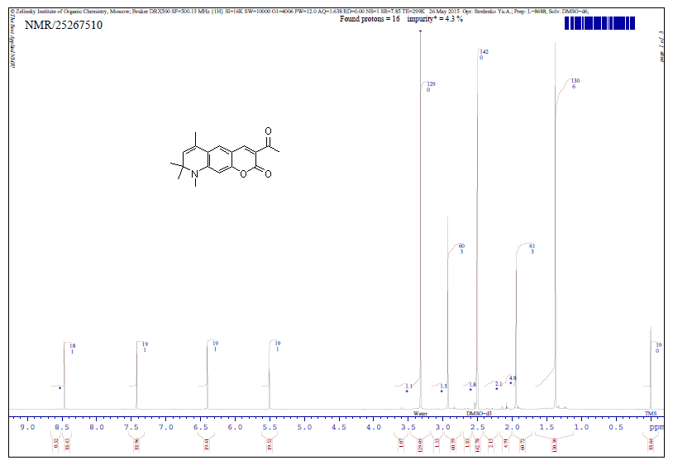
Figure S18. ¹H-NMR Spectrum of 3-acetyl-6,8,8,9-tetramethyl-8,9-dihydro-2H-pyrano[3,2-g]quinolin-2-one 19c.
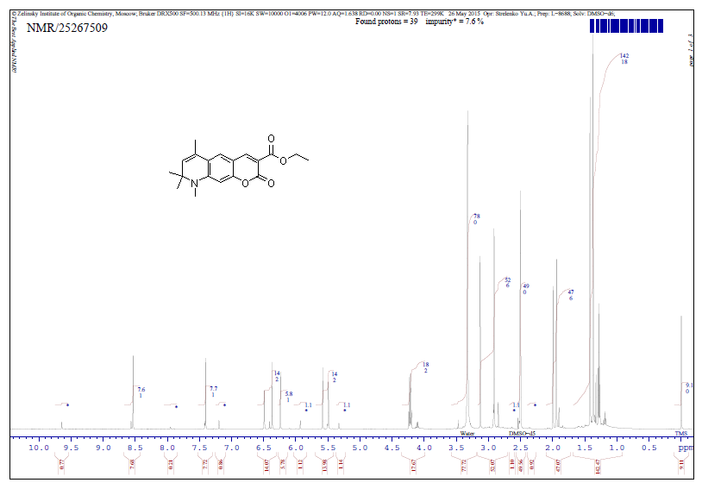
Figure S19. ¹H-NMR Spectrum of ethyl 6,8,8,9-tetramethyl-2-oxo-8,9-dihydro-2H-pyrano[3,2-g]quinoline-3-carboxylate 19d.
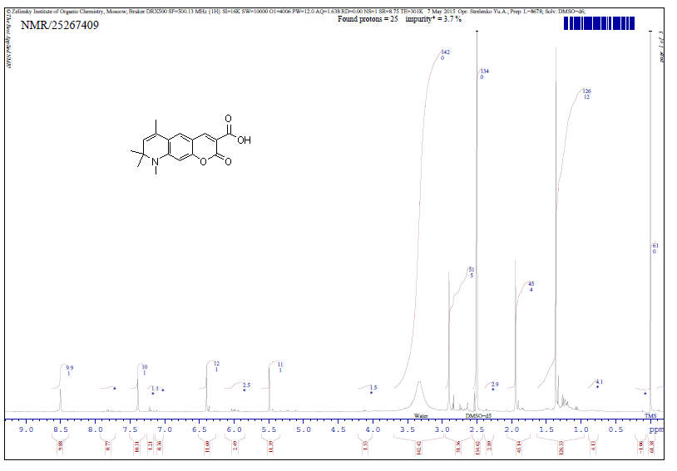
Figure S20. ¹H-NMR Spectrum of 6,8,8,9-tetramethyl-2-oxo-8,9-dihydro-2H-pyrano[3,2-g]quinoline-3-carboxylic acid 21.
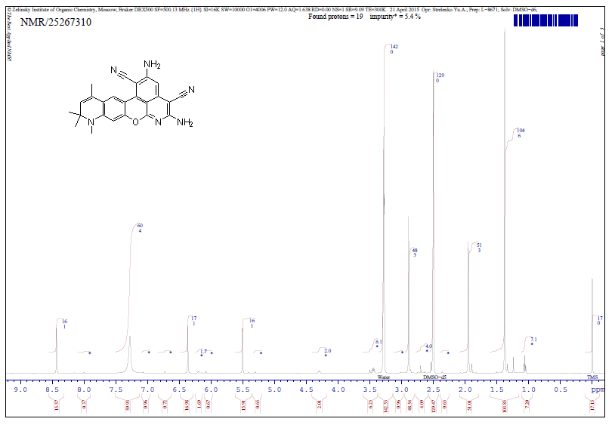
Figure S21. ¹H-NMR Spectrum of 2,5-diamino-9,10,10,12-tetramethyl-9,10-dihydropyrido[4',3',2':8,1]isochromeno[4,3-g]quinoline-1,4-dicarbonitrile 22.

