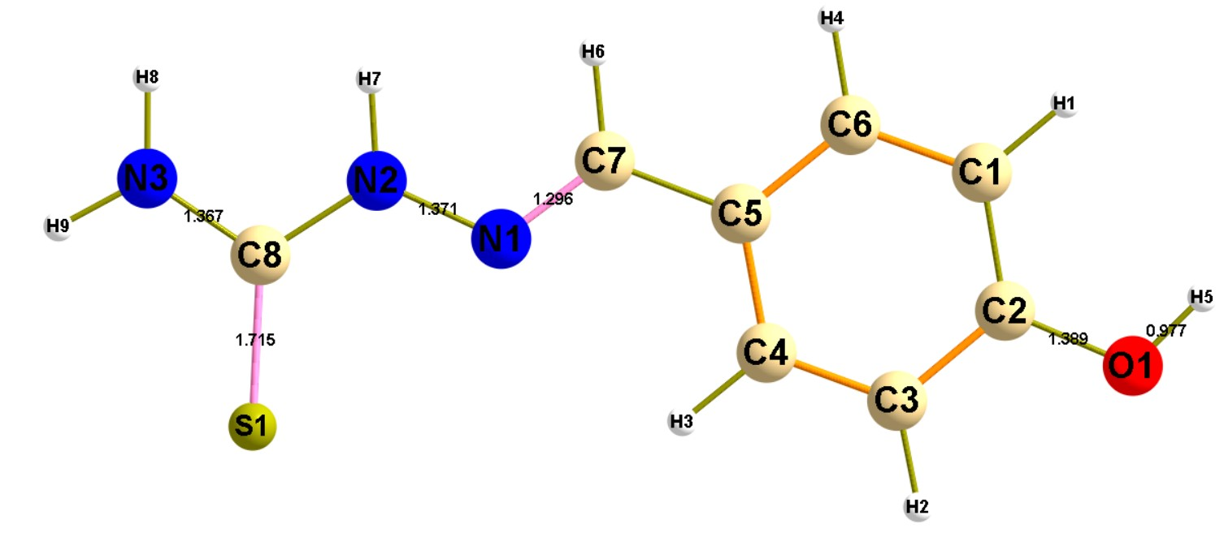
Supplementary figure 1. Optimized structure of TSC Schiff base with intersetd bond lengths
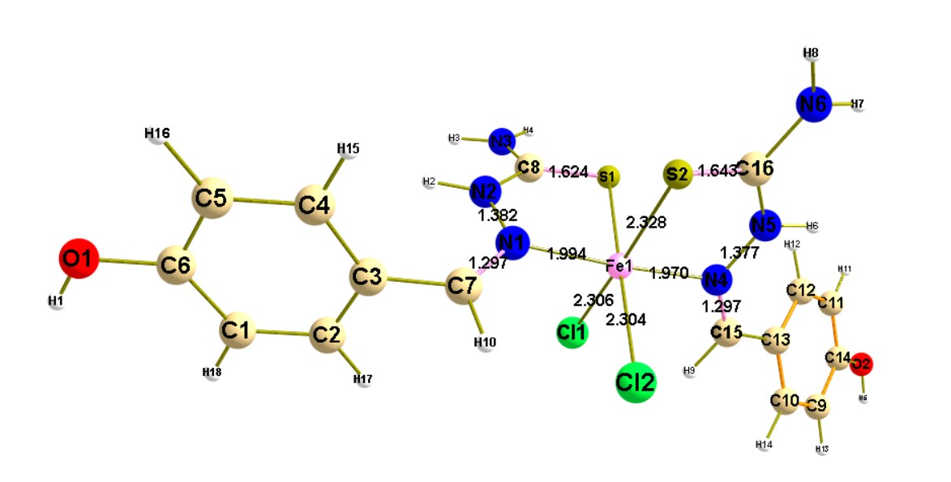
Supplementary figure 2. Optimized structure of Fe (II) complex with intersetd bond lengths

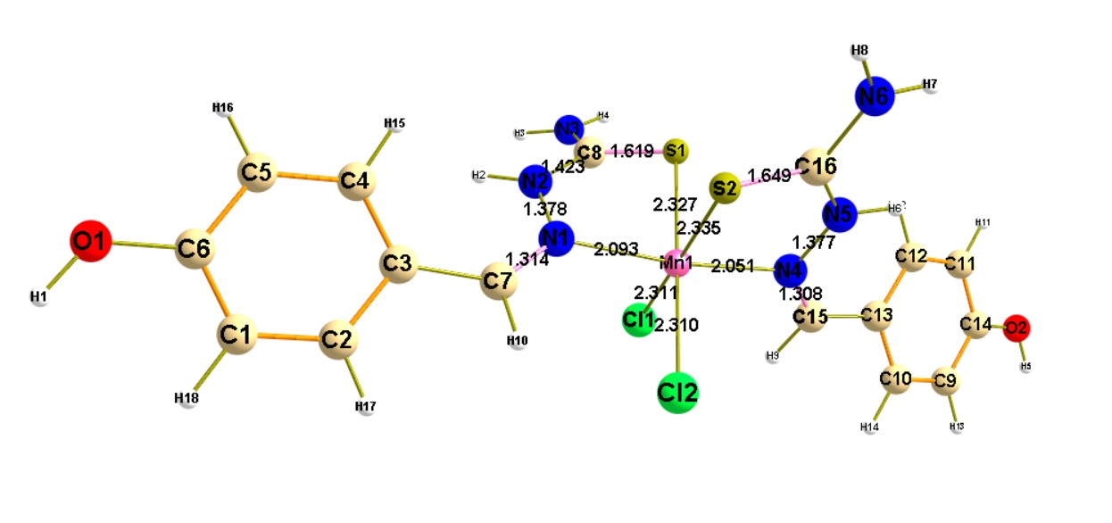 Supplementary figure 3. Optimized structure of Mn (II) complex with intersetd bond lengths

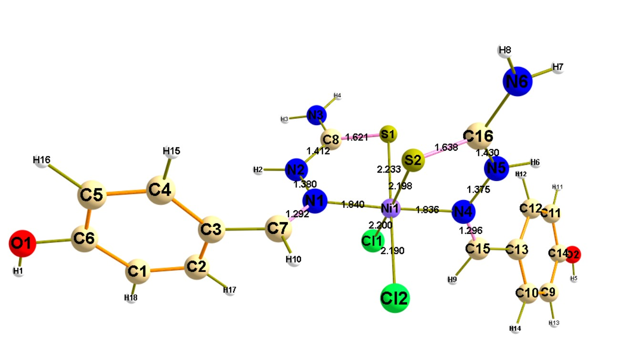
Supplementary figure 4. Optimized structure of Ni (II) complex with intersetd bond lengths

Supplementary table 1. Cartesian coordinates of Schiff base TSC
Atom | x | y | z
C | -3.6482 | -1.01014 | -6.2E-05
C | -3.88806 | 0.369057 | 5.3E-06
C | -2.81734 | 1.276919 | 7.57E-05
C | -1.51154 | 0.805023 | 7.7E-05
C | -1.24732 | -0.58392 | -9.5E-07
C | -2.33281 | -1.47794 | -7.2E-05
O | -5.16647 | 0.911409 | 5.41E-05
C | 0.114924 | -1.10331 | -9.4E-06
N | 1.144197 | -0.31621 | 1.89E-05
N | 2.389943 | -0.88944 | 2.88E-06
C | 3.544902 | -0.13708 | 1.43E-05
S | 3.612766 | 1.576869 | -9E-05
N | 4.680575 | -0.89735 | 0.000111
H | -4.47726 | -1.71272 | -9.6E-05
H | -3.03518 | 2.33811 | 0.000127
H | -0.67492 | 1.494109 | 0.000127
H | -2.14806 | -2.54867 | -0.00013
H | -5.85648 | 0.220418 | -0.0003
H | 0.228261 | -2.19617 | -3.8E-05
H | 2.456196 | -1.90769 | 1.15E-05
H | 4.68244 | -1.90763 | 0.000178
H | 5.562203 | -0.4116 | 3.53E-05

Supplementary table 2. Cartesian coordinates of Fe(II) complex
Atom | x | y | z
C | 5.9214 | -2.1353 | -0.0654
C | 4.5964 | -1.8333 | -0.3681
C | 4.2112 | -0.5118 | -0.6109
C | 5.1635 | 0.5173 | -0.5637
C | 6.5011 | 0.2096 | -0.2803
C | 6.8818 | -1.1157 | -0.0243
O | 8.1676 | -1.4001 | 0.2619
H | 8.46 | -2.3037 | 0.451
C | 2.7901 | -0.2677 | -0.8961
N | 1.9676 | 0.2399 | -0.0314
N | 2.3808 | 0.5915 | 1.2402
C | 1.4193 | 0.9236 | 2.2336
N | 1.7812 | 0.934 | 3.6045
H | 3.3552 | 0.4548 | 1.5453
H | 2.7324 | 0.6747 | 3.8993
H | 1.0779 | 1.1472 | 4.3285
S | -0.1227 | 1.2418 | 1.8342
C | -6.057 | -2.3096 | -0.3714
C | -4.7401 | -1.9979 | -0.709
C | -6.2255 | -0.2401 | 0.8683
C | -4.9079 | 0.0783 | 0.5267
C | -4.1476 | -0.8008 | -0.2697
C | -6.801 | -1.4359 | 0.43
O | -8.0552 | -1.7498 | 0.8103
H | -8.4661 | -2.5935 | 0.5732
C | -2.6901 | -0.6394 | -0.4974
N | -1.9652 | 0.4361 | -0.4676
N | -2.4405 | 1.7276 | -0.5032
C | -1.5179 | 2.7775 | -0.7977
N | -1.978 | 4.1121 | -0.9291
H | -3.4415 | 1.9483 | -0.5437
H | -2.9669 | 4.3452 | -0.7649
H | -1.3282 | 4.8651 | -1.202
S | 0.0522 | 2.4458 | -1.1522
Fe | -0.0089 | 0.284 | -0.2902
Cl | -0.0342 | -1.8194 | 0.6535
Cl | 0.03 | -0.7264 | -2.361
H | -2.184 | -1.5845 | -0.5961
H | 2.4447 | -0.6554 | -1.8342
H | -6.786 | 0.4265 | 1.5114
H | -4.4893 | 0.9702 | 0.9635
H | -6.4848 | -3.2455 | -0.7079
H | -4.17 | -2.7104 | -1.2943
H | 4.8776 | 1.5441 | -0.7582
H | 7.2416 | 0.9991 | -0.2558
H | 3.8592 | -2.6275 | -0.3907
H | 6.1957 | -3.1623 | 0.1379

Supplementary table 3. Cartesian coordinates of Mn(II) complex
Atom | x | y | z
C | 6.638746 | -1.65514 | -0.68901
C | 5.248788 | -1.5504 | -0.84027
C | 4.515409 | -0.45691 | -0.33132
C | 5.267584 | 0.56176 | 0.329761
C | 6.675917 | 0.461492 | 0.458088
C | 7.360998 | -0.64962 | -0.04661
O | 8.705528 | -0.74148 | 0.081061
H | 9.210737 | -1.49595 | -0.26298
C | 2.998546 | -0.46356 | -0.59412
N | 2.041211 | 0.066858 | 0.132772
N | 2.302412 | 0.593285 | 1.379691
C | 1.223022 | 1.033791 | 2.196502
N | 1.34248 | 1.026864 | 3.604549
H | 3.20551 | 0.426904 | 1.83989
H | 2.201164 | 0.685124 | 4.053795
H | 0.533688 | 1.283284 | 4.191495
S | -0.19581 | 1.477609 | 1.555284
C | -6.50012 | -1.9835 | -0.15109
C | -5.12283 | -1.88056 | -0.37355
C | -6.53426 | 0.273377 | 0.69706
C | -5.14528 | 0.388878 | 0.457954
C | -4.40911 | -0.70061 | -0.089
C | -7.21209 | -0.91327 | 0.3924
O | -8.53631 | -1.02721 | 0.6402
H | -9.02625 | -1.84521 | 0.459397
C | -2.89613 | -0.75834 | -0.24356
N | -2.04464 | 0.203465 | -0.48757
N | -2.41639 | 1.474742 | -0.86449
C | -1.42307 | 2.373026 | -1.37341
N | -1.79373 | 3.687622 | -1.7498
H | -3.40178 | 1.759164 | -0.92425
H | -2.76396 | 4.010768 | -1.63364
H | -1.09317 | 4.339653 | -2.13345
S | 0.13374 | 1.893554 | -1.62992
Mn | -0.01666 | 0.017342 | -0.24737
Cl | -0.15628 | -1.82186 | 1.14465
Cl | 0.171328 | -1.41855 | -2.04645
H | -2.4942 | -1.74178 | -0.05449
H | 2.718569 | -0.99316 | -1.49243
H | -7.08801 | 1.094287 | 1.144837
H | -4.66793 | 1.307379 | 0.768542
H | -7.01156 | -2.90917 | -0.38391
H | -4.60596 | -2.74144 | -0.77048
H | 4.803083 | 1.456945 | 0.71934
H | 7.248484 | 1.248637 | 0.942442
H | 4.737027 | -2.35173 | -1.35044
H | 7.15859 | -2.52173 | -1.08014

Supplementary table 4. Cartesian coordinates of Ni(II) complex
Atom | x | y | z
C | 5.570116 | -2.16219 | -0.28848
C | 4.281285 | -1.69445 | -0.5005
C | 4.04008 | -0.32158 | -0.57929
C | 5.080385 | 0.597662 | -0.42888
C | 6.377964 | 0.126942 | -0.20306
C | 6.627441 | -1.25355 | -0.14262
O | 7.882648 | -1.69983 | 0.048485
H | 8.084517 | -2.64655 | 0.06393
C | 2.670729 | 0.082469 | -0.84406
N | 1.775847 | 0.128435 | 0.086339
N | 2.096595 | -0.03789 | 1.418043
C | 1.143984 | 0.380404 | 2.373174
N | 1.377431 | 0.233964 | 3.762478
H | 3.009294 | -0.39784 | 1.732618
H | 2.215545 | -0.25493 | 4.104626
H | 0.70931 | 0.620727 | 4.446695
S | -0.19572 | 1.128442 | 1.849324
C | -5.85368 | -2.1373 | -0.82967
C | -4.6115 | -1.65449 | -1.22324
C | -5.94374 | -0.45673 | 0.914194
C | -4.69856 | 0.041562 | 0.511306
C | -4.01742 | -0.575 | -0.54933
C | -6.51284 | -1.55867 | 0.260459
O | -7.66827 | -2.083 | 0.713248
H | -8.0363 | -2.8979 | 0.340575
C | -2.58157 | -0.36993 | -0.7715
N | -1.81793 | 0.637548 | -0.48495
N | -2.22087 | 1.939087 | -0.29806
C | -1.19659 | 2.912023 | -0.52212
N | -1.46164 | 4.303118 | -0.5053
H | -3.20744 | 2.22698 | -0.25687
H | -2.38888 | 4.666275 | -0.25439
H | -0.71415 | 4.969982 | -0.7594
S | 0.296846 | 2.407079 | -0.96767
Ni | -0.02011 | 0.357761 | -0.23935
Cl | -0.30075 | -1.67208 | 0.561969
Cl | 0.09433 | -0.46066 | -2.26729
H | -2.11714 | -1.3003 | -1.05132
H | 2.429772 | 0.279509 | -1.87519
H | -6.43563 | -0.02785 | 1.777252
H | -4.24022 | 0.820341 | 1.104044
H | -6.27151 | -2.99672 | -1.33875
H | -4.08101 | -2.16722 | -2.01862
H | 4.886478 | 1.662842 | -0.48268
H | 7.188719 | 0.833003 | -0.08452
H | 3.465248 | -2.40018 | -0.61925
H | 5.740032 | -3.2296 | -0.24492

Supplementary figure 5. Docking score and 3D, 2D interactions of the the synthesized complex [FeL₂Cl₂] with target bacterial enzyme 4XWA,
Supplementary figure 6. Docking score and 3D, 2D interactions of the the synthesized complex [MnL₂Cl₂] with target bacterial enzyme 4XWA,
Supplementary figure 7. Docking score and 3D, 2D interactions of the the synthesized complex [NiL₂Cl₂] with target bacterial enzyme 4XWA,
Supplementary figure 8. Docking Results of the co-crystalized control, (a) crystallographic protein structure including the control, (b) 3D-binding mode of the control in the active stie, (c) 2D-map representing the type of interactions present through control-docking

