Novel pyrrole based triazole moiety as therapeutic hybrid: Synthesis, characterization and anti-Alzheimer potential with molecular mechanism of protein ligand profile
Shoaib Khan^{1*}, Tayyiaba Iqbal¹, Muhammad Bilal Khan¹, Rafaqat Hussain², Yousaf Khan³, Hany W. Darwish⁴
¹Department of Chemistry, Abbottabad University of Science and Technology, Abbottabad-22500, Pakistan.
²College of Biology, Hunan University Changsha, Hunan-410082, P. R. China
³Department of Chemistry, COMSATS University Islamabad-45550, Islamabad Pakistan.
⁴Department of Pharmaceutical Chemistry, College of Pharmacy, King Saud University, P.O. Box 2457, Riyadh 11451, Saudi Arabia.

∗Corresponding author: shoaibkhanswati@gmail.com (S. Khan)
---------------------------------------------------------------------------------------------------------------------
Supplementary Information
S.1 Spectral Analysis
- (E)-4-((4-fluorobenzylidene)amino)-5-(4-nitro-1H-pyrrol-2-yl)-2,4-dihydro-3H-1,2,4-triazole-3-thione
¹H NMR (600MHz, DMSO-d₆): δ 12.59 (s, 1H, H-triazole thione), 11.41 (s, 1H, H-pyrrole), 8.73 (s, 1H, H-imines), 8..32 (s, 1H, H-pyrrole), 7.90 (d, J = 7.77 Hz, 2H, Ar-H), 7.54 (s, 1H, H-pyrrole)7.38 (d, J = 7.77 Hz, 2H, Ar-H),; ¹³C NMR (125 MHz, DMSO-d₆): δ 174.9, 172.5, 160.7 (d, J_{CF} = 249.2 Hz), 158.8, 150.5, 150.5, 146.8 (d, J_{CF} = 6.7 Hz), 138.7, 128.1, 127.7, 119.7 (d, J_{CF} = 8.9 Hz), 118.5, 116.6; HREI MS: m/z calcd for C₁₃H₉FN₆O₂S [M]⁺ 332.31 Found 332.39
- (E)-4-((3,4-dichlorobenzylidene)amino)-5-(4-nitro-1H-pyrrol-2-yl)-2,4-dihydro-3H-1,2,4-triazole-3-thione
¹H NMR (600MHz, DMSO-d₆): δ 12.29 (s, 1H, H-triazole thione), 11.29 (s, 1H, H-pyrrole), 8.97 (s, 1H, H-imines), 8.40 (s, 1H, Ar-H), 7.87 (s, 1H, H-pyrrole), 7.54 (s, 1H, H-pyrrole), 7.32 (d, J = 7.77 Hz, 1H, Ar-H), 6.87 (d, J = 7.38 Hz, 1H, Ar-H); ¹³C NMR (125 MHz, DMSO-d₆): δ 175.7, 174.2, 150.8, 149.3, 138.5, 137.5, 135.7, 134.9, 134.7, 131.5, 128.8, 125.7, 112.0; HREI MS: m/z calcd for C₁₃H₈Cl₂N₆O₂S [M]⁺ 383.21 Found 383.72
- (E)-4-((4-chloro-2-nitrobenzylidene)amino)-5-(4-nitro-1H-pyrrol-2-yl)-2,4-dihydro-3H-1,2,4-triazole-3-thione
¹H NMR (600MHz, DMSO-d₆): δ 12.51 (s, 1H, H-triazole thione), 11.71 (s, 1H, H-pyrrole), 8.81 (s, 1H, Ar-H), 8.17 (s, 1H, H-imines), 7.49 (d, J = 7.77 Hz, 1H, Ar-H), 7.29 (s, 1H, H-pyrrole), 6.71 (d, J = 7.38 Hz, 1H, Ar-H), 6.29 (s, 1H, H-pyrrole); ¹³C NMR (125 MHz, DMSO-d₆): δ 175.6, 173.7, 164.8, 164.1, 161.6, 159.9, 157.6, 155.5, 153.2, 152.5, 151.3, 108.3, 103.6; HREI MS: m/z calcd for C₁₃H₈ClN₇O₄S [M]⁺ 393.76 Found 393.42
- (E)-4-((4-chloro-3-nitrobenzylidene)amino)-5-(4-nitro-1H-pyrrol-2-yl)-2,4-dihydro-3H-1,2,4-triazole-3-thione
¹H NMR (600MHz, DMSO-d₆): δ 12.13 (s, 1H, H-triazole thione), 11.50 (s, 1H, H-pyrrole), 9.45 (s, 1H, H-imines), 8.51 (s, 1H, Ar-H), 7.92 (d, J = 7.77 Hz, 1H, Ar-H), 7.59 (s, 1H, H-pyrrole), 7.29 (s, 1H, H-pyrrole), 6.67 (d, J = 7.38 Hz, 1H, Ar-H),; ¹³C NMR (125 MHz, DMSO-d₆): δ 173.3, 171.5, 164.8, 164.8, 161.5, 159.9, 157.6, 155.5, 153.2, 152.5, 151.6, 123.3, 118.7; HREI MS: m/z calcd for C₁₃H₈ClN₇O₄S [M]⁺ 393.76 Found 393.43
- (E)-5-(4-nitro-1H-pyrrol-2-yl)-4-((4-phenoxybenzylidene)amino)-2,4-dihydro-3H-1,2,4-triazole-3-thione
¹H NMR (600MHz, DMSO-d₆): δ 12.42 (s, 1H, H-triazole thione), 11.30 (s, 1H, H-pyrrole), 8.33 (s, 1H, H-imines), 8.30 (s, 1H, H-pyrrole), 8.18 (d, J = 7.38 Hz, 2H, Ar-H), 7.99 (dd, J = 7.77, 1.25 Hz, 2H, Ar-H), 7.93 (t, J = 7.51 Hz, 1H, Ar-H), 7.80 (d, J = 7.87 Hz, 2H, Ar-H), 7.71 (dd, J = 7.55, 2.35 Hz, 2H, Ar-H), 7.44 (s, 1H, H-pyrrole); ¹³C NMR (125 MHz, DMSO-d₆): δ 175.8, 171.5, 163.9, 161.3, 159.8, 141.5, 139.5, 137.7, 132.7, 129.3, 129.2, 128.7, 126.0, 122.8, 121.4, 120.5, 116.3, 116.1, 115.3; HREI MS: m/z calcd for C₁₉H₁₄N₆O₃S [M]⁺ 406.42 Found 406.13
- (E)-5-(4-nitro-1H-pyrrol-2-yl)-4-((2,4,6-trihydroxybenzylidene)amino)-2,4-dihydro-3H-1,2,4-triazole-3-thione
¹H NMR (600MHz, DMSO-d₆): δ 12.41 (s, 1H, H-triazole thione), 11.91 (s, 1H, H-pyrrole), 10.17 (s, 1H, Ar-OH), 9.64 (s, 2H, Ar-OH), 9.39 (s, 1H, H-imines), 8.79 (s, 1H, H-pyrrole), 8.59 (s, 1H, Ar-H), 7.79 (s, 1H, Ar-H), 6.80 (s, 1H, H-pyrrole); ¹³C NMR (125 MHz, DMSO-d₆): δ 176.2, 174.7, 161.7, 160.3, 159.7, 151.0, 150.1, 142.5, 133.8, 129.8, 120.9, 118.9, 110.7; HREI MS: m/z calcd for C₁₃H₁₀N₆O₅S [M]⁺ 362.32 Found 362.13
- (E)-5-(4-nitro-1H-pyrrol-2-yl)-4-((4-(trifluoromethyl)benzylidene)amino)-2,4-dihydro-3H-1,2,4-triazole-3-thione
¹H NMR (600MHz, DMSO-d₆): δ 12.31 (s, 1H, H-triazole thione), 11.84 (s, 1H, H-pyrrole), 9.47 (s, 1H, H-imines), 8.50 (s, 1H, H-pyrrole), 8.09 (d, J = 7.38 Hz, 2H, Ar-H), 7.59 (d, J = 7.53 Hz, 2H, Ar-H), 7.37 (s, 1H, H-pyrrole); ¹³C NMR (125 MHz, DMSO-d₆): δ 175.5, 173.9, 172.8, 172.4, 163.2 (q, J_{CF} = 37.6 Hz), 160.4, 152.6, 145.1, 143.6 (d, J_{CF} = 4.7 Hz), 142.8, 139.6, 134.6, 133.2 (q, J_{CF} = 273.4 Hz), 131.3, 129.3; HREI MS: m/z calcd for C₁₄H₉F₃N₆O₂S [M]⁺ 382.32 Found 382.13
- (E)-4-((3,5-dichlorobenzylidene)amino)-5-(4-nitro-1H-pyrrol-2-yl)-2,4-dihydro-3H-1,2,4-triazole-3-thione
¹H NMR (600MHz, DMSO-d₆): δ 12.17 (s, 1H, H-triazole thione), 11.27 (s, 1H, H-pyrrole), 8.81 (s, 1H, H-imines), 8.23 (s, 1H, H-pyrrole), 7.49 (s, 2H, Ar-H), 7.41 (s, 1H, Ar-H), 6.56 (s, 1H, H-pyrrole); ¹³C NMR (125 MHz, DMSO-d₆): δ 174.7, 172.4, 164.7, 162.5, 161.7, 154.0, 153.5, 145.5, 138.8, 132.8, 132.7, 123.7, 121.7, 113.5; HREI MS: m/z calcd for C₁₃H₈Cl₂N₆O₂S [M]⁺ 383.21 Found 382.43
- (E)-4-((3-fluoro-5-hydroxybenzylidene)amino)-5-(4-nitro-1H-pyrrol-2-yl)-2,4-dihydro-3H-1,2,4-triazole-3-thione
¹H NMR (600MHz, DMSO-d₆): δ 12.52 (s, 1H, H-triazole thione), 11.27 (s, 1H, H-pyrrole), 10.18 (s, 1H, Ar-OH), 9.21 (s, 1H, H-imines), 8.01 (s, 1H, H-pyrrole), 7.49 (s, 1H, Ar-H), 6.77 (s, 2H, Ar-H), 6.47 (s, 1H, H-pyrrole); ¹³C NMR (125 MHz, DMSO-d₆): δ 174.2, 172.2, 165.9 (d, J_{CF} = 249.1 Hz), 160.0, 154.2, 152.1, 142.5, 142.5 (d, J_{CF} = 7.0 Hz), 138.8, 130.2, 122.8 (d, J_{CF} = 14.2 Hz), 121.4, 113.1 (d, J_{CF} = 22.7 Hz), 112.5, 110.3; HREI MS: m/z calcd for C₁₃H₉FN₆O₃S [M]⁺ 348.31 Found 348.03
- (E)-4-((4-bromo-3-chlorobenzylidene)amino)-5-(4-nitro-1H-pyrrol-2-yl)-2,4-dihydro-3H-1,2,4-triazole-3-thione
¹H NMR (600MHz, DMSO-d₆): δ 12.51 (s, 1H, H-triazole thione), 11.74 (s, 1H, H-pyrrole), 9.39 (s, 1H, H-imines), 8.30 (s, 1H, H-pyrrole), 7.62 (s, 1H, Ar-H), 7.49 (d, J = 7.35 Hz, 1H, Ar-H), 7.23 (d, J = 7.47 Hz, 1H, Ar-H), 6.62 (s, 1H, H-pyrrole); ¹³C NMR (125 MHz, DMSO-d₆): δ 174.1, 172.5, 152.4, 150.0, 140.5, 140.5, 136.8, 128.7, 120.8, 119.7, 120.8, 119.7, 111.2, 110.5, 108.2; HREI MS: m/z calcd for C₁₃H₈BrClN₆O₂S [M]⁺ 427.66 Found 427.23
- (E)-4-((4-fluoro-2-hydroxybenzylidene)amino)-5-(4-nitro-1H-pyrrol-2-yl)-2,4-dihydro-3H-1,2,4-triazole-3-thione
¹H NMR (600MHz, DMSO-d₆): δ 12.56 (s, 1H, H-triazole thione), 11.61 (s, 1H, H-pyrrole), 10.16 (s, 1H, Ar-OH), 9.63 (s, 1H, H-imines), 9.43 (s, 1H, H-pyrrole), 8.49 (d, J = 7.35 Hz, 1H, Ar-H), 8.32 (s, 1H, Ar-H), 7.86 (d, J = 7.47 Hz, 1H, Ar-H), 7.53 (s, 1H, H-pyrrole); ¹³C NMR (125 MHz, DMSO-d₆): δ 173.6, 169.6, 155.8 , 149.6, 135.7, 129.7, 127.6, 121.3, 118.7, 118.6, 117.3, 112.6, 102.9; HREI MS: m/z calcd for C₁₃H₉FN₆O₃S [M]⁺ 348.31 Found 348.13
- (E)-4-((4-fluoro-3-hydroxybenzylidene)amino)-5-(4-nitro-1H-pyrrol-2-yl)-2,4-dihydro-3H-1,2,4-triazole-3-thione
¹H NMR (600MHz, DMSO-d₆): δ 12.31 (s, 1H, H-triazole thione), 11.49 (s, 1H, H-pyrrole), 10.24 (s, 1H, Ar-OH), 9.50 (s, 1H, H-imines), 8.93 (s, 1H, H-pyrrole), 8.33 (d, J = 7.35 Hz, 1H, Ar-H), 7.90 (d, J = 7.47 Hz, 1H, Ar-H), 7.13 (s, 1H, H-pyrrole); ¹³C NMR (125 MHz, DMSO-d₆): δ 174.1, 172.5, 154.4 (d, J_{CF} = 248.2 Hz), 152.0, 142.3, 138.2 (d, J_{CF} = 6.7 Hz), 130.7, 122.8, 121.7 (d, J_{CF} = 8.9 Hz), 113.7, 112.5, 110.4; HREI MS: m/z calcd for C₁₃H₉FN₆O₃S [M]⁺ 348.31 Found 348.13
- (E)-4-((4-fluoro-3-nitrobenzylidene)amino)-5-(4-nitro-1H-pyrrol-2-yl)-2,4-dihydro-3H-1,2,4-triazole-3-thione
¹H NMR (600MHz, DMSO-d₆): δ 12.35 (s, 1H, H-triazole thione), 11.49 (s, 1H, H-pyrrole), 9.34 (s, 1H, H-imines), 8.87 (s, 1H, Ar-H), 8.49 (d, J = 7.16 Hz, 1H, Ar-H), 8.01 (s, 1H, H-pyrrole), 7.50 (s, 1H, H-pyrrole), 6.79 (d, J = 7.35 Hz, 1H, Ar-H),; ¹³C NMR (125 MHz, DMSO-d₆): δ 175.1, 174.2, 143.8 (d, J_{CF} = 249.6 Hz), 142.2, 133.5, 130.2, 128.2 (d, J_{CF} = 7.2 Hz), 127.7, 124.4 (d, J_{CF} = 9.1 Hz), 120.8, 118.4, 101.5; HREI MS: m/z calcd for C₁₃H₈FN₇O₄S [M]⁺ 377.31 Found 377.13
- (E)-4-((4-methoxybenzylidene)amino)-5-(4-nitro-1H-pyrrol-2-yl)-2,4-dihydro-3H-1,2,4-triazole-3-thione
¹H NMR (600MHz, DMSO-d₆): δ 12.13 (s, 1H, H-triazole thione), 11.42 (s, 1H, H-pyrrole), 9.23 (s, 1H, H-imines), 8.09 (d, J = 7.16 Hz, 2H, Ar-H), 7.73 (d, J = 7.35 Hz, 2H, Ar-H), 7.49 (s, 1H, H-pyrrole), 6.79 (s, 1H, H-pyrrole), 3.70 (s, 3H, O-CH₃); ¹³C NMR (125 MHz, DMSO-d₆): δ 174.7, 172.5, 156.7, 155.5, 154.4, 146.0, 145.5, 137.5, 128.8, 125.7, 115.7, 113.6, 105.7, 52.5; HREI MS: m/z calcd for C₁₄H₁₂N₆O₃S [M]⁺ 344.35 Found 344.13
- (E)-4-((3,4-dibromobenzylidene)amino)-5-(4-nitro-1H-pyrrol-2-yl)-2,4-dihydro-3H-1,2,4-triazole-3-thione
¹H NMR (600MHz, DMSO-d₆): δ 12.24 (s, 1H, H-triazole thione), 11.22 (s, 1H, H-pyrrole), 9.37 (s, 1H, H-imines), 8.94 (s, 1H, H-pyrrole), 8.36 (s, 1H, Ar-H), 7.50 (d, J = 7.35 Hz, 1H, Ar-H), 7.27 (d, J = 7.35 Hz, 1H, Ar-H), 6.59 (s, 1H, H-pyrrole); ¹³C NMR (125 MHz, DMSO-d₆): δ 175.4, 169.6, 164.6, 150.8, 145.6, 135.7, 129.7, 127.6, 121.3, 118.6, 117.3, 112.6, 103.9; HREI MS: m/z calcd for C₁₃H₈Br₂N₆O₂S [M]⁺ 472.12 Found 472.01
- (E)-4-((4-(dimethylamino)-2-hydroxybenzylidene)amino)-5-(4-nitro-1H-pyrrol-2-yl)-2,4-dihydro-3H-1,2,4-triazole-3-thione
¹H NMR (600MHz, DMSO-d₆): δ 12.39 (s, 1H, H-triazole thione), 11.27 (s, 1H, H-pyrrole), 8.98 (s, 1H, H-imines), 8.66 (s, 1H, H-pyrrole), 8.08 (d, J = 7.35 Hz, 2H, Ar-H), 7.54 (s, 1H, Ar-H), 7.32 (d, J = 7.35 Hz, 2H, Ar-H), 4.15 (s, 6H. -N(CH₃)₂; ¹³C NMR (125 MHz, DMSO-d₆): δ 174.8, 161.7, 161.2, 160.2, 147.5, 141.5, 139.7, 137.8, 132.8, 128.6, 123.7, 122.3, 121.6, 120.6, 54.8 ; HREI MS: m/z calcd for C₁₅H₁₅N₇O₃S [M]⁺ 373.39 Found 373.09
S.2 AChE and BuChE assay protocols
With a little bit modification, inhibitory potential against AChE and BuChE was investigated according to the reported protocol [52]. The total volume of the reaction mixture was kept at 100 µL, containing 60 µL of Na₂HPO₄ buffer with a concentration of 50 mM and a pH of 7.7. Added test compound (well-1) with volume of 10µL and a concentration of 0.5mM followed by the addition of an enzyme of 10 µL (0.005 unit well-1). Pre-incubation of substances at 37ºC for 10 min was achieved. Reaction was started by addition of 10µL of 0.5mM well-1 substrate (acetylthiocholine iodide/ butyrylthiochloine chloride) followed by addition of 10µL DTNB (0.5mM well-1). Absorbance at 405nm was measured after 15 min of incubation at 37ºC using the 96-well plate reader Synergy HT, BioTek, US. All experiments were done with their respective controls in triplicate. Standard drug used was Donepezil. The % inhibition was computed using the following equation
Inhibition (%) = Control – Test/control x 100
Control EZ-Fit Enzyme kinetics software (Perrella Scientific Inc. Amherst, USA) was used for the calculation of IC₅₀ values.
S.3 Molecular docking protocol
The crystal structure was retrieved from the protein data bank (PDB) and further, the structure was optimized by removing the water molecules, hetero atoms, and cofactors. Hydrogen bonds, missing atoms, and charges were computed. The synthesized pyrrole derived triazole based Schiff base scaffolds used in these docking studies was prepared and optimized using built and Ligand Preparation module implemented in Discovery Studio 2018 (Dassault Systemes BIOVIA, USA). For the purpose of docking; MOE tool was used, Ligand preparation includes generating various tautomer’s, assigning bond orders and stereochemistry [53].

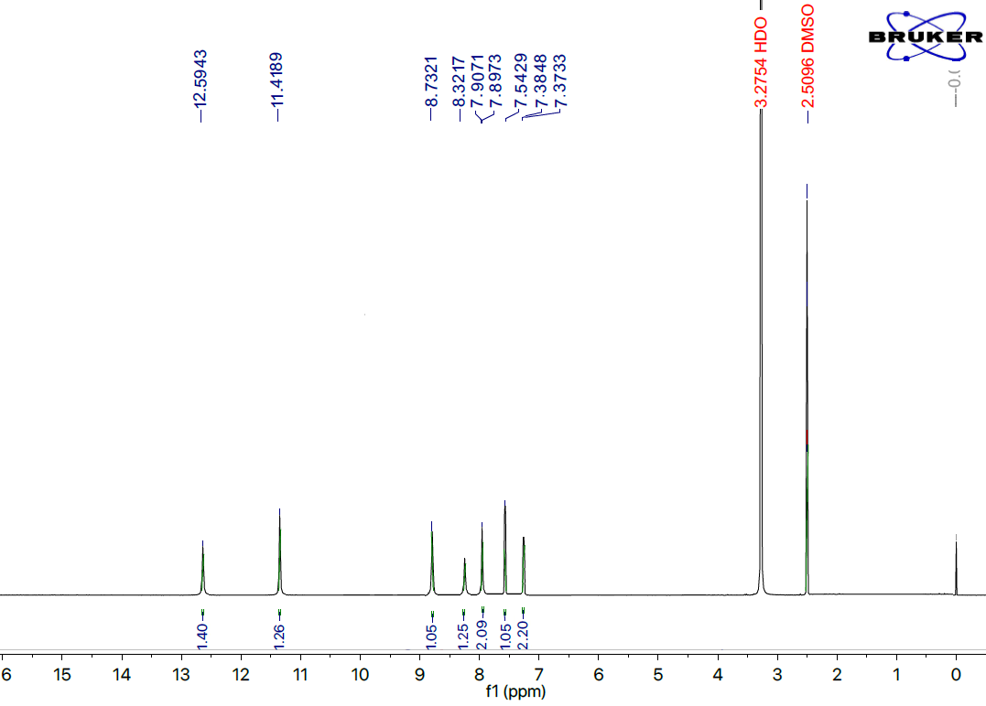
Figure S1. ¹HNMR for the compound 1 (E)-4-((4-fluorobenzylidene)amino)-5-(4-nitro-1H-pyrrol-2-yl)-2,4-dihydro-3H-1,2,4-triazole-3-thione

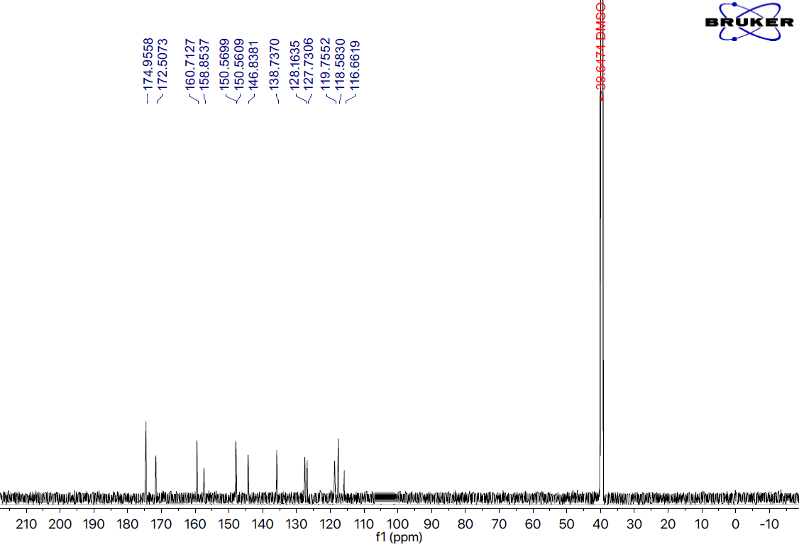
Figure S2. ¹³CNMR for the compound 1 (E)-4-((4-fluorobenzylidene)amino)-5-(4-nitro-1H-pyrrol-2-yl)-2,4-dihydro-3H-1,2,4-triazole-3-thione
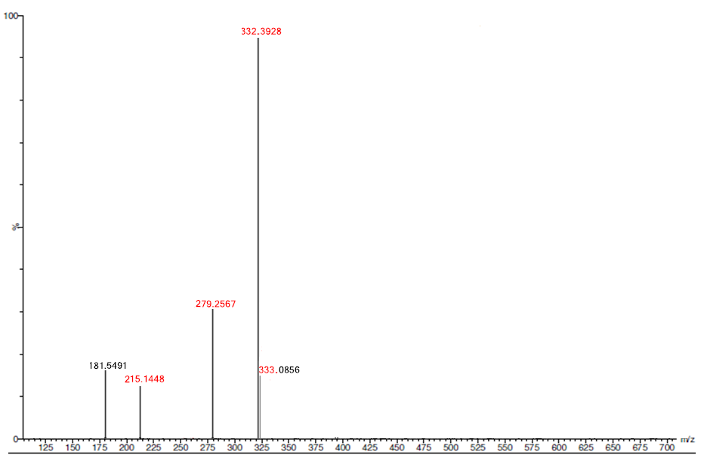
Figure S3. HRMS for the compound 1 (E)-4-((4-fluorobenzylidene)amino)-5-(4-nitro-1H-pyrrol-2-yl)-2,4-dihydro-3H-1,2,4-triazole-3-thione
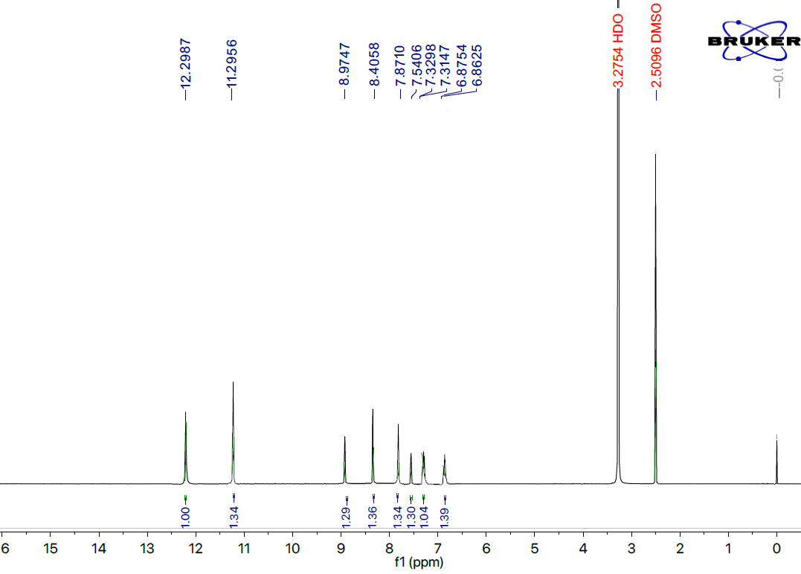
Figure S4. ¹HNMR for the compound 2 (E)-4-((3,4-dichlorobenzylidene)amino)-5-(4-nitro-1H-pyrrol-2-yl)-2,4-dihydro-3H-1,2,4-triazole-3-thione
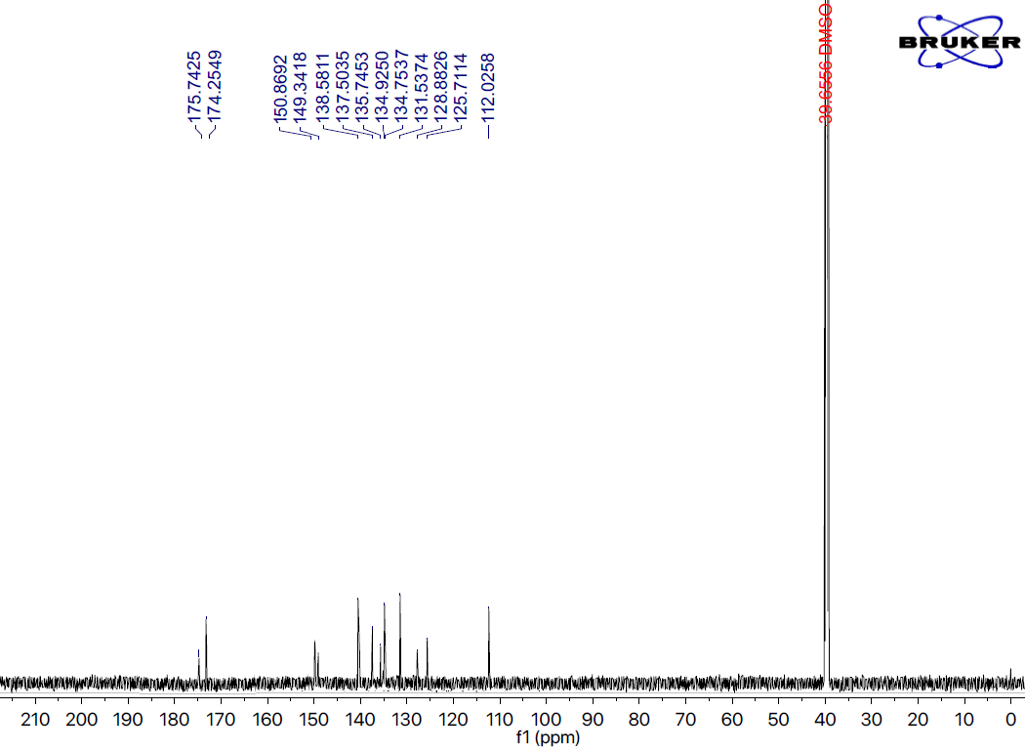
Figure S5. ¹³CNMR for the compound 2 (E)-4-((3,4-dichlorobenzylidene)amino)-5-(4-nitro-1H-pyrrol-2-yl)-2,4-dihydro-3H-1,2,4-triazole-3-thione
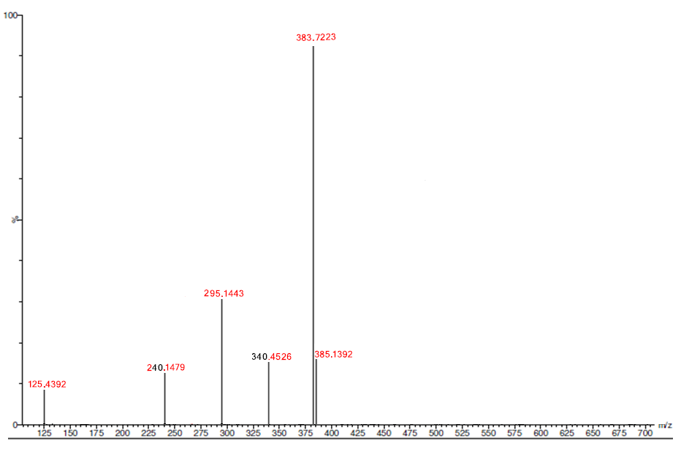
Figure S6. HRMS for the compound 2 (E)-4-((3,4-dichlorobenzylidene)amino)-5-(4-nitro-1H-pyrrol-2-yl)-2,4-dihydro-3H-1,2,4-triazole-3-thione
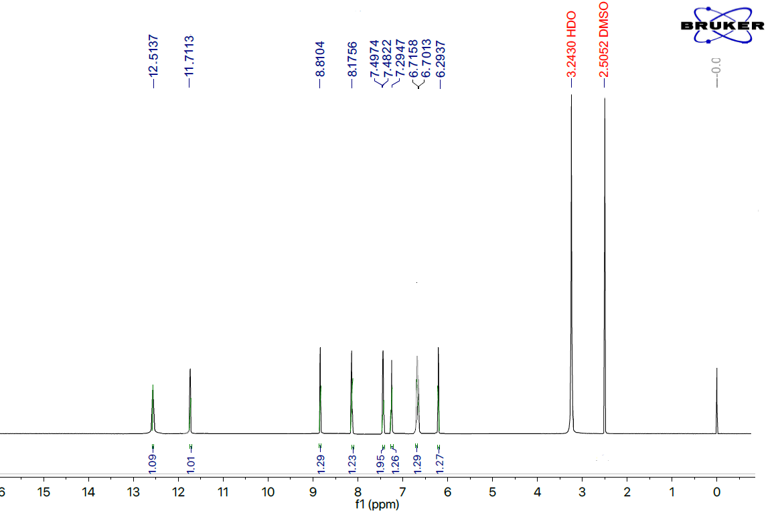
Figure S7. ¹HNMR for the compound 3 (E)-4-((4-chloro-2-nitrobenzylidene)amino)-5-(4-nitro-1H-pyrrol-2-yl)-2,4-dihydro-3H-1,2,4-triazole-3-thione
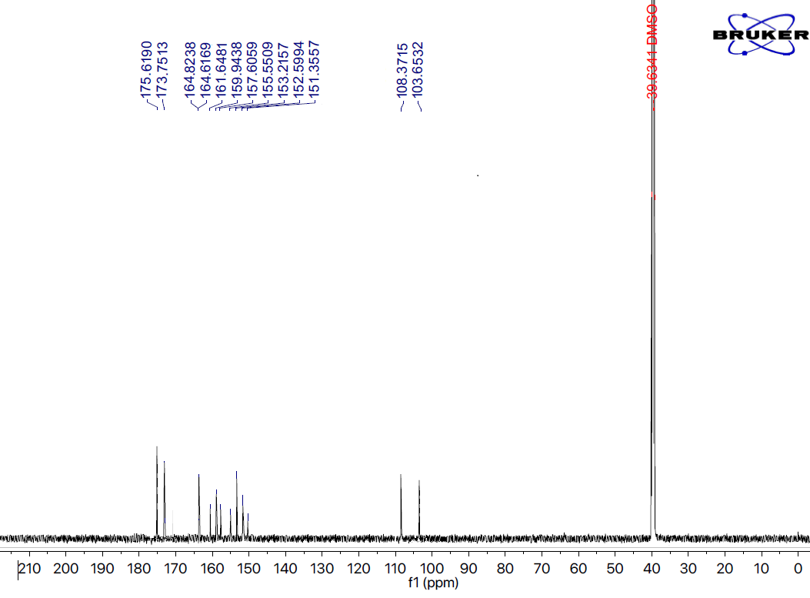
Figure S8. ¹³CNMR for the compound 3 (E)-4-((4-chloro-2-nitrobenzylidene)amino)-5-(4-nitro-1H-pyrrol-2-yl)-2,4-dihydro-3H-1,2,4-triazole-3-thione
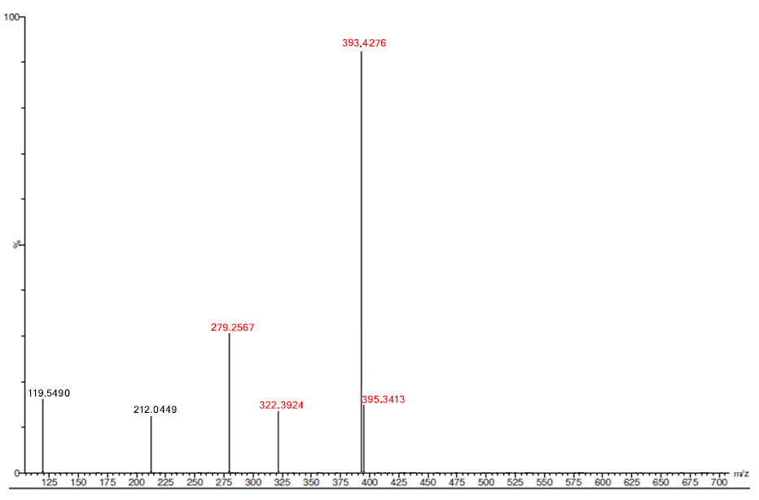
Figure S9. HRMS for the compound 3 (E)-4-((4-chloro-2-nitrobenzylidene)amino)-5-(4-nitro-1H-pyrrol-2-yl)-2,4-dihydro-3H-1,2,4-triazole-3-thione
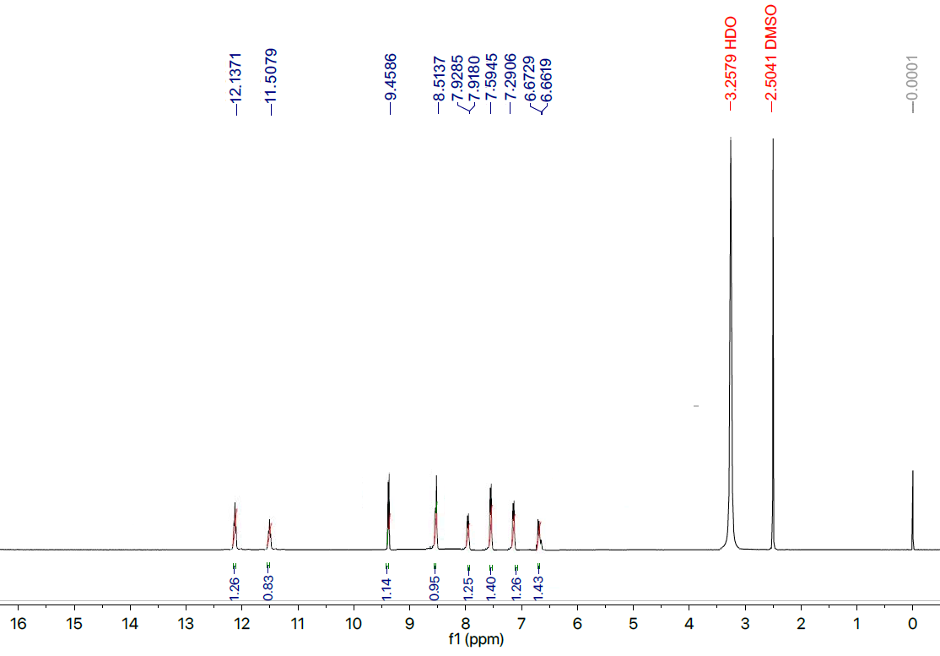
Figure S10. ¹HNMR for the compound 4 (E)-4-((4-chloro-3-nitrobenzylidene)amino)-5-(4-nitro-1H-pyrrol-2-yl)-2,4-dihydro-3H-1,2,4-triazole-3-thione
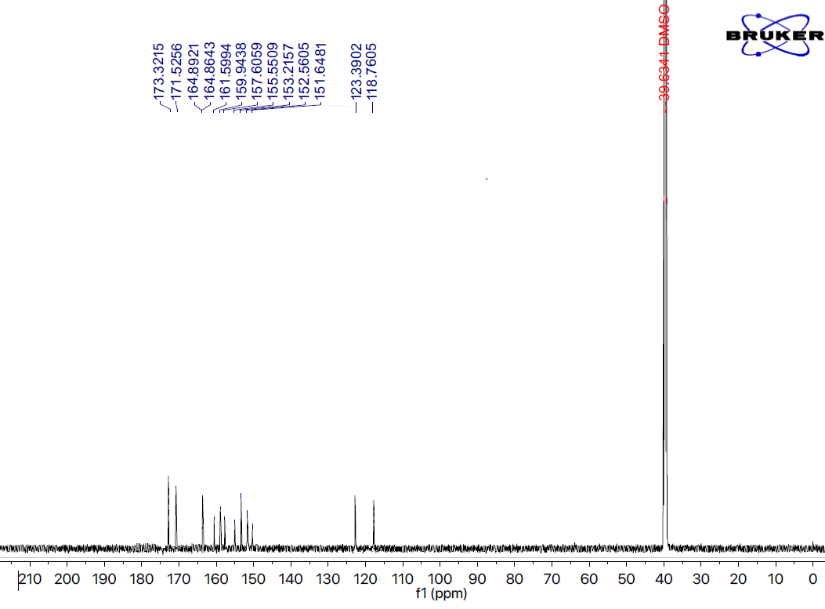
Figure S11. ¹³CNMR for the compound 4 (E)-4-((4-chloro-3-nitrobenzylidene)amino)-5-(4-nitro-1H-pyrrol-2-yl)-2,4-dihydro-3H-1,2,4-triazole-3-thione
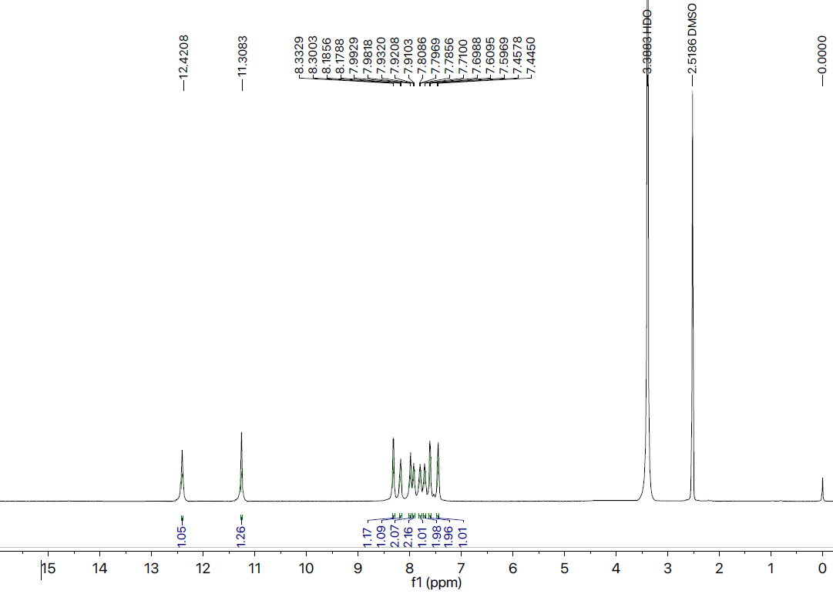
Figure S12. ¹HNMR for the compound 5 (E)-5-(4-nitro-1H-pyrrol-2-yl)-4-((4-phenoxybenzylidene)amino)-2,4-dihydro-3H-1,2,4-triazole-3-thione
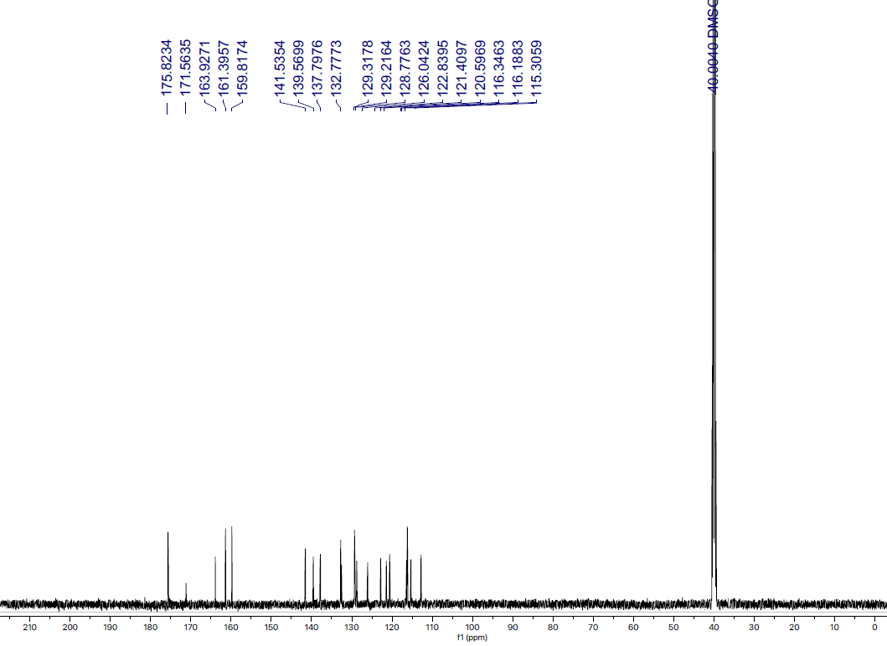
Figure S13. ¹³CNMR for the compound 5 (E)-5-(4-nitro-1H-pyrrol-2-yl)-4-((4-phenoxybenzylidene)amino)-2,4-dihydro-3H-1,2,4-triazole-3-thione

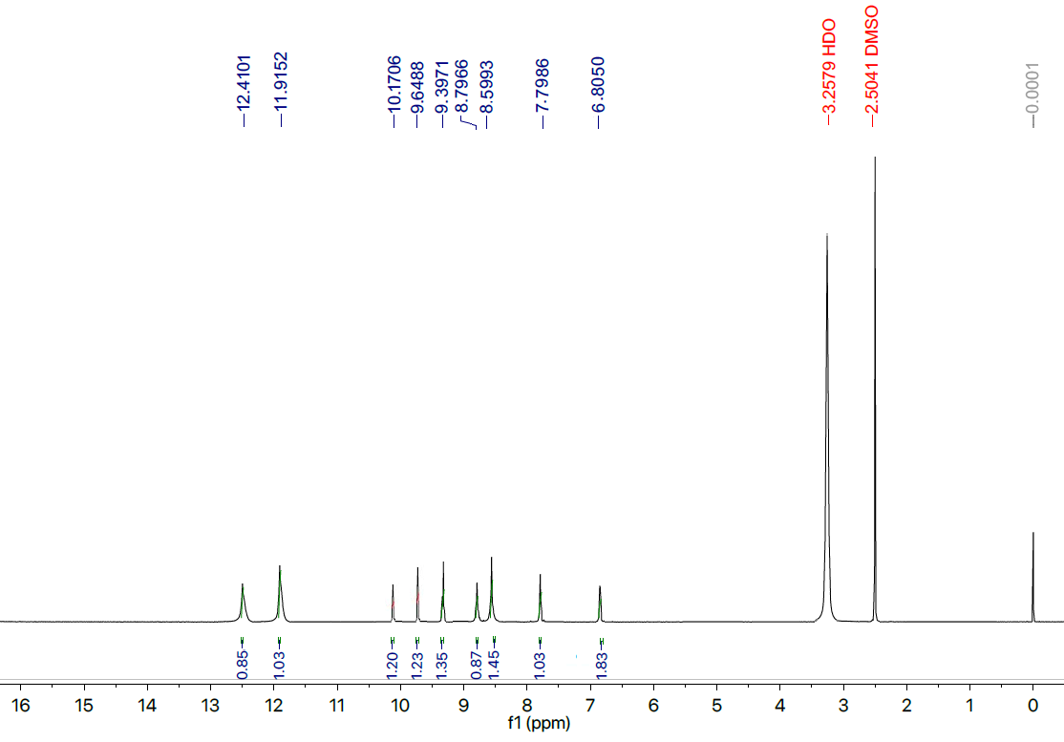
Figure S14. ¹HNMR for the compound 6 (E)-5-(4-nitro-1H-pyrrol-2-yl)-4-((2,4,6-trihydroxybenzylidene)amino)-2,4-dihydro-3H-1,2,4-triazole-3-thione
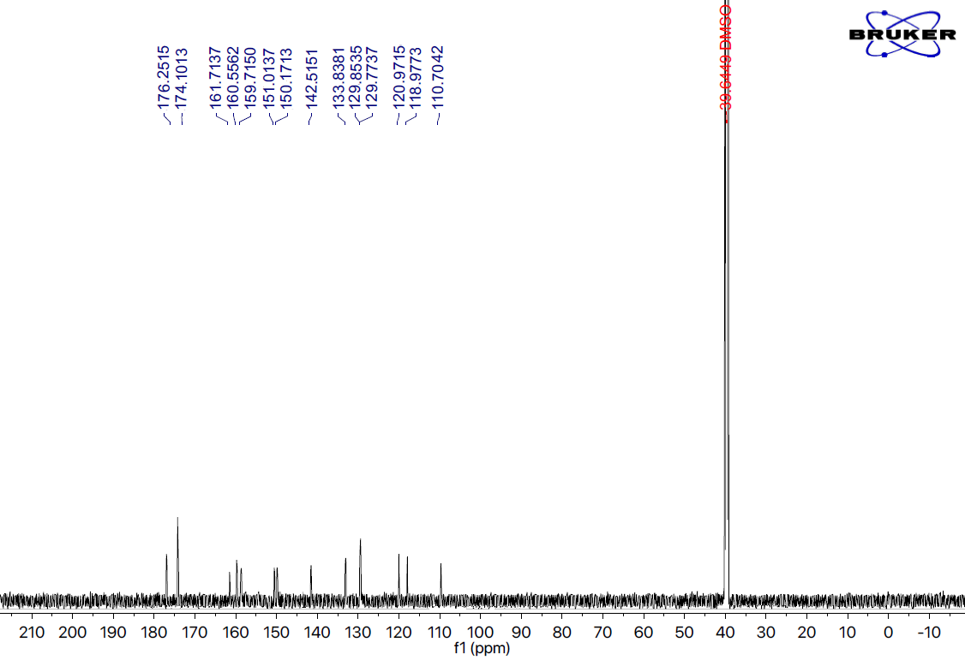
Figure S15. ¹³CNMR for the compound 6 (E)-5-(4-nitro-1H-pyrrol-2-yl)-4-((2,4,6-trihydroxybenzylidene)amino)-2,4-dihydro-3H-1,2,4-triazole-3-thione
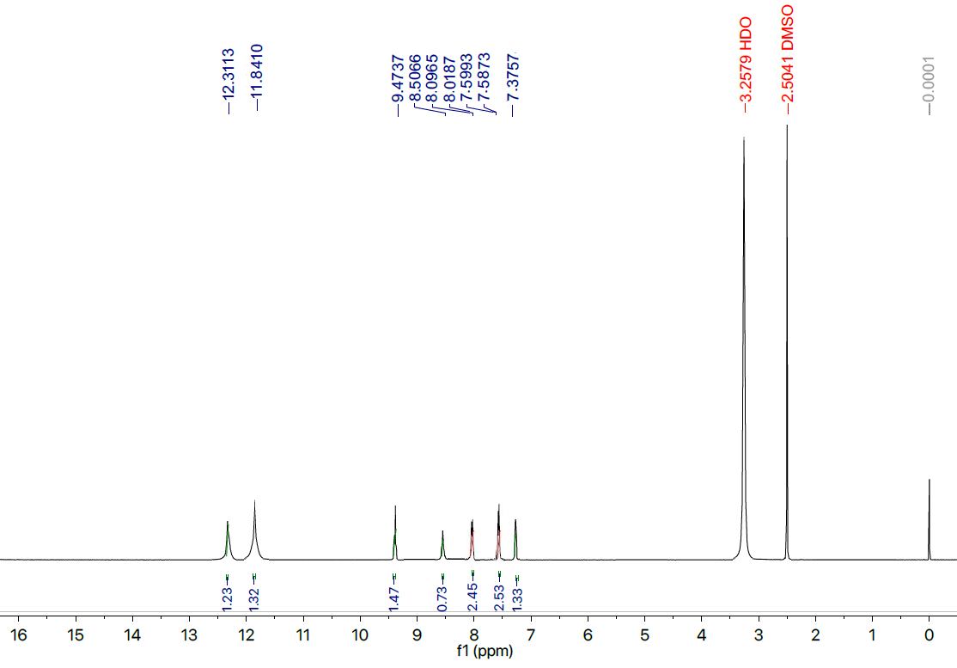
Figure S16. ¹HNMR for the compound 7 (E)-5-(4-nitro-1H-pyrrol-2-yl)-4-((4-(trifluoromethyl)benzylidene)amino)-2,4-dihydro-3H-1,2,4-triazole-3-thione
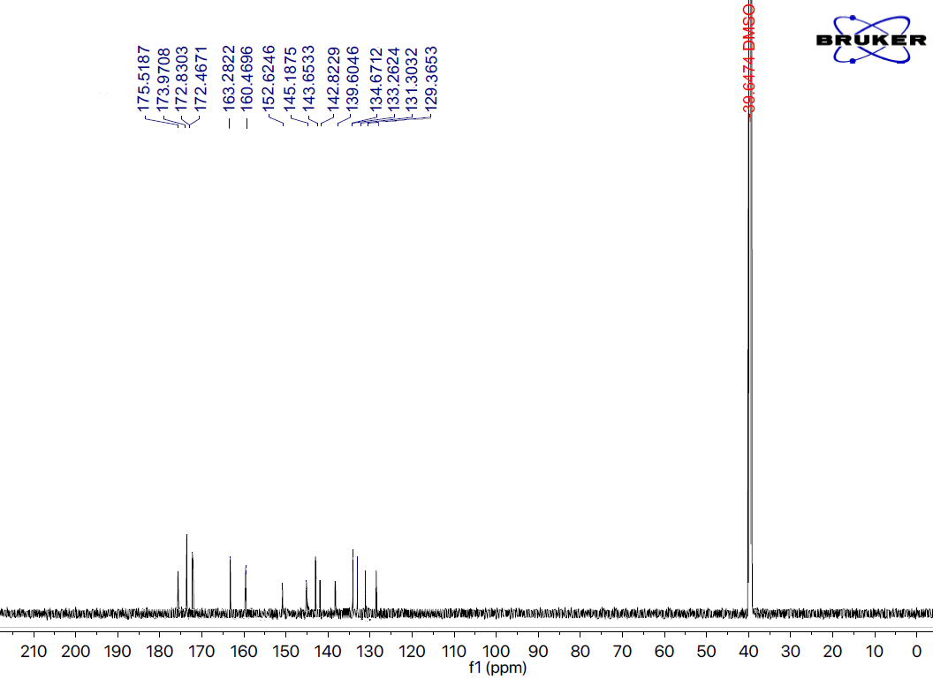
Figure S17. ¹³CNMR for the compound 7 (E)-5-(4-nitro-1H-pyrrol-2-yl)-4-((4-(trifluoromethyl)benzylidene)amino)-2,4-dihydro-3H-1,2,4-triazole-3-thione

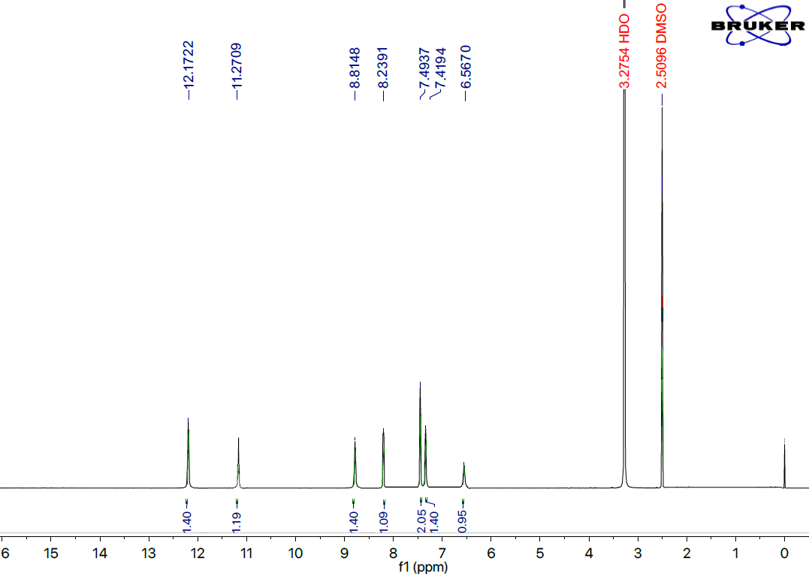
Figure S18. ¹HNMR for the compound 8 (E)-4-((3,5-dichlorobenzylidene)amino)-5-(4-nitro-1H-pyrrol-2-yl)-2,4-dihydro-3H-1,2,4-triazole-3-thione
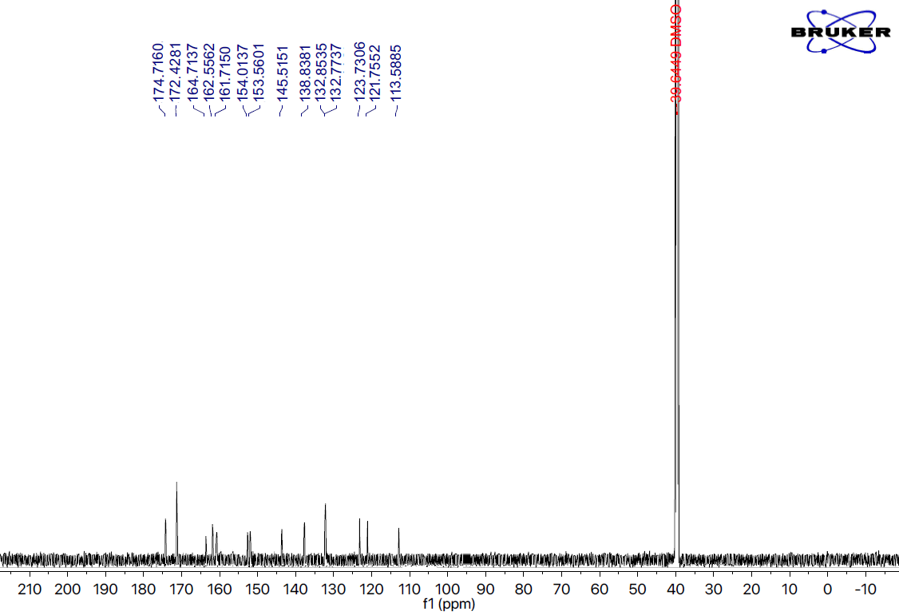
Figure S19. ¹³CNMR for the compound 8 (E)-4-((3,5-dichlorobenzylidene)amino)-5-(4-nitro-1H-pyrrol-2-yl)-2,4-dihydro-3H-1,2,4-triazole-3-thione
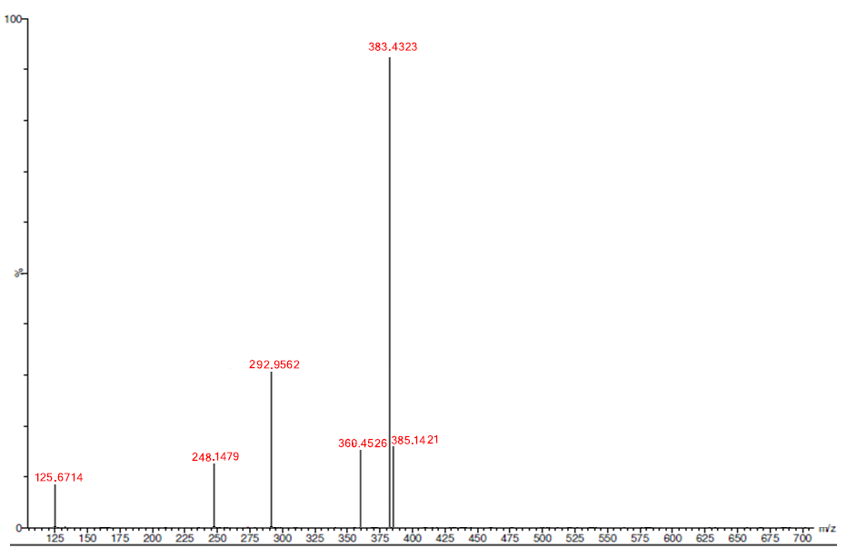
Figure S20. HRMS for the compound 8 (E)-4-((3,5-dichlorobenzylidene)amino)-5-(4-nitro-1H-pyrrol-2-yl)-2,4-dihydro-3H-1,2,4-triazole-3-thione
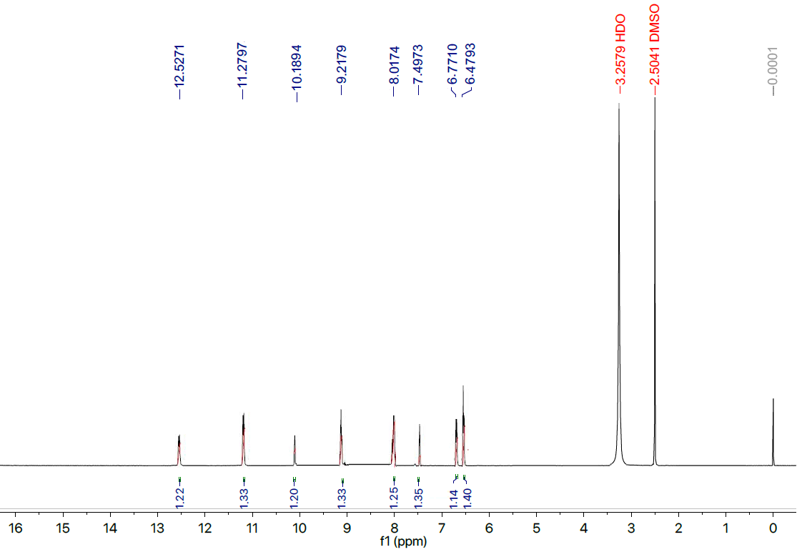
Figure S21. ¹HNMR for the compound 9 (E)-4-((3-fluoro-5-hydroxybenzylidene)amino)-5-(4-nitro-1H-pyrrol-2-yl)-2,4-dihydro-3H-1,2,4-triazole-3-thione
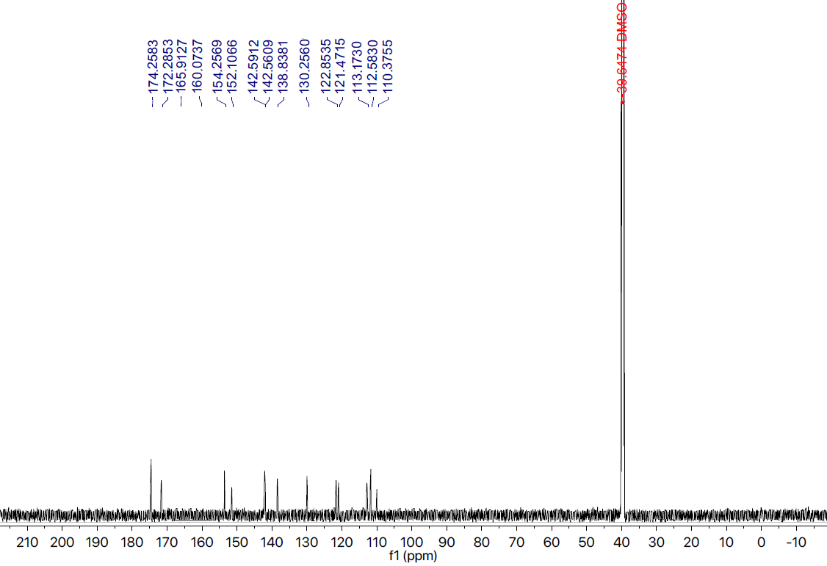
Figure S22. ¹³CNMR for the compound 9 (E)-4-((3-fluoro-5-hydroxybenzylidene)amino)-5-(4-nitro-1H-pyrrol-2-yl)-2,4-dihydro-3H-1,2,4-triazole-3-thione
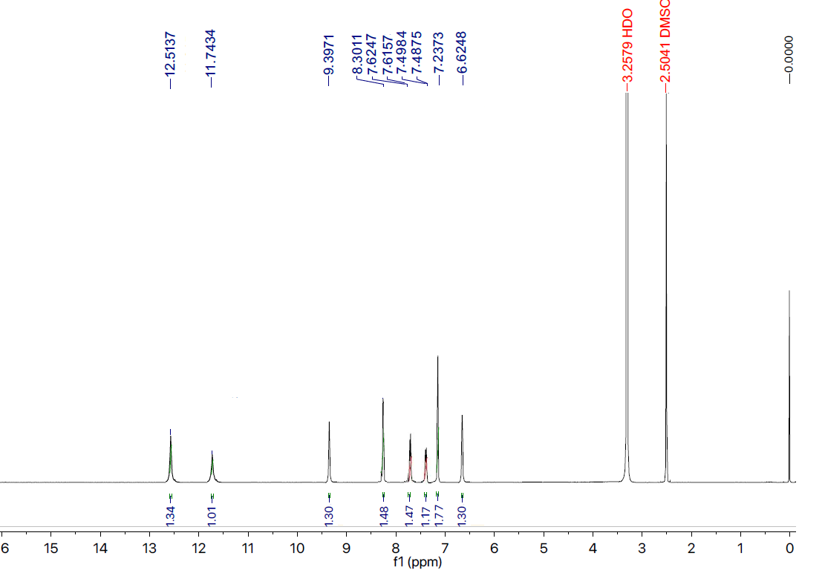
Figure S23. ¹HNMR for the compound 10 (E)-4-((4-bromo-3-chlorobenzylidene)amino)-5-(4-nitro-1H-pyrrol-2-yl)-2,4-dihydro-3H-1,2,4-triazole-3-thione
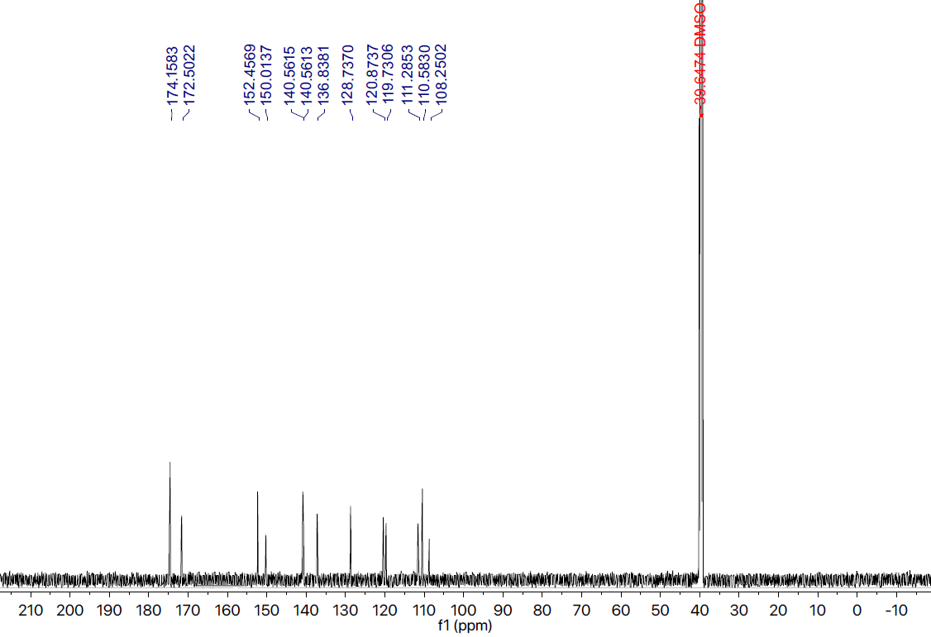
Figure S24. ¹³CNMR for the compound 10 (E)-4-((4-bromo-3-chlorobenzylidene)amino)-5-(4-nitro-1H-pyrrol-2-yl)-2,4-dihydro-3H-1,2,4-triazole-3-thione
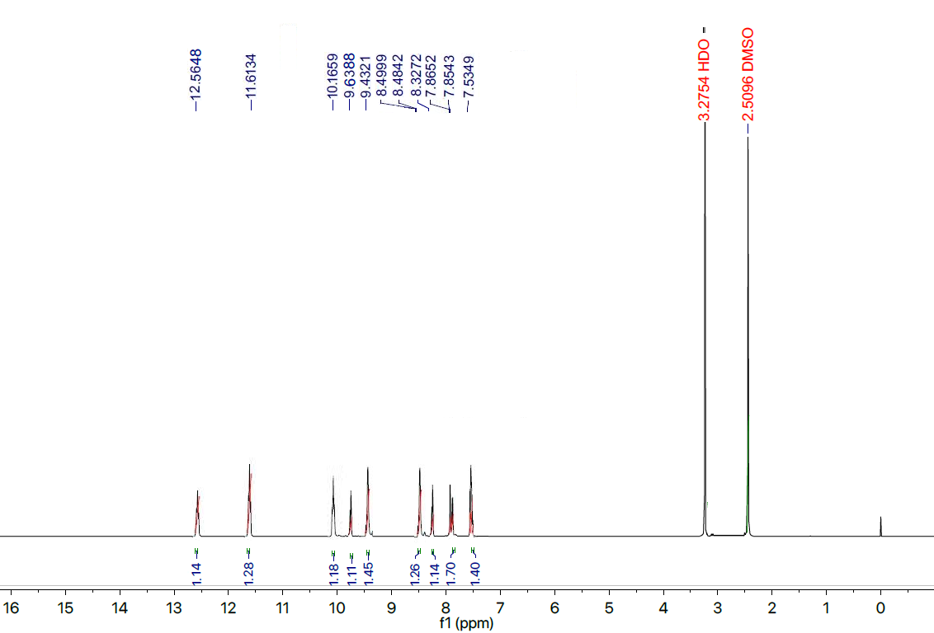
Figure S25. ¹HNMR for the compound 11 (E)-4-((4-fluoro-2-hydroxybenzylidene)amino)-5-(4-nitro-1H-pyrrol-2-yl)-2,4-dihydro-3H-1,2,4-triazole-3-thione
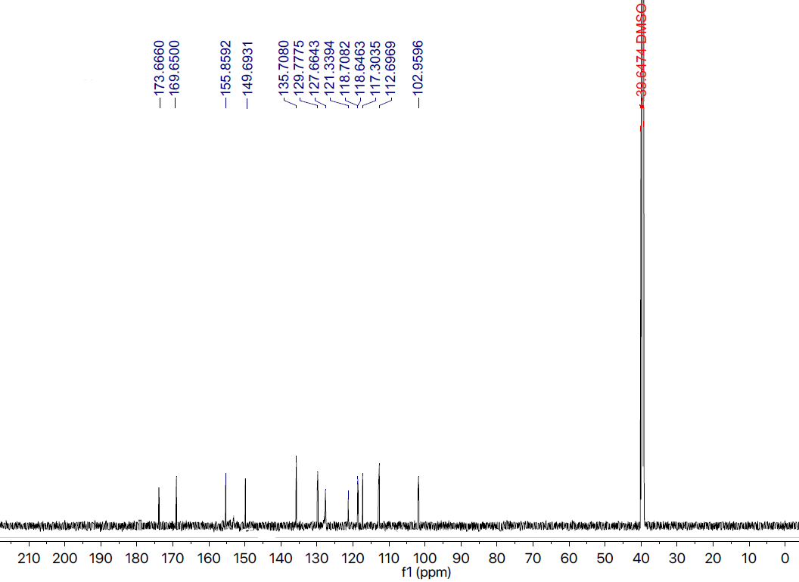
Figure S26. ¹³CNMR for the compound 11 (E)-4-((4-fluoro-2-hydroxybenzylidene)amino)-5-(4-nitro-1H-pyrrol-2-yl)-2,4-dihydro-3H-1,2,4-triazole-3-thione
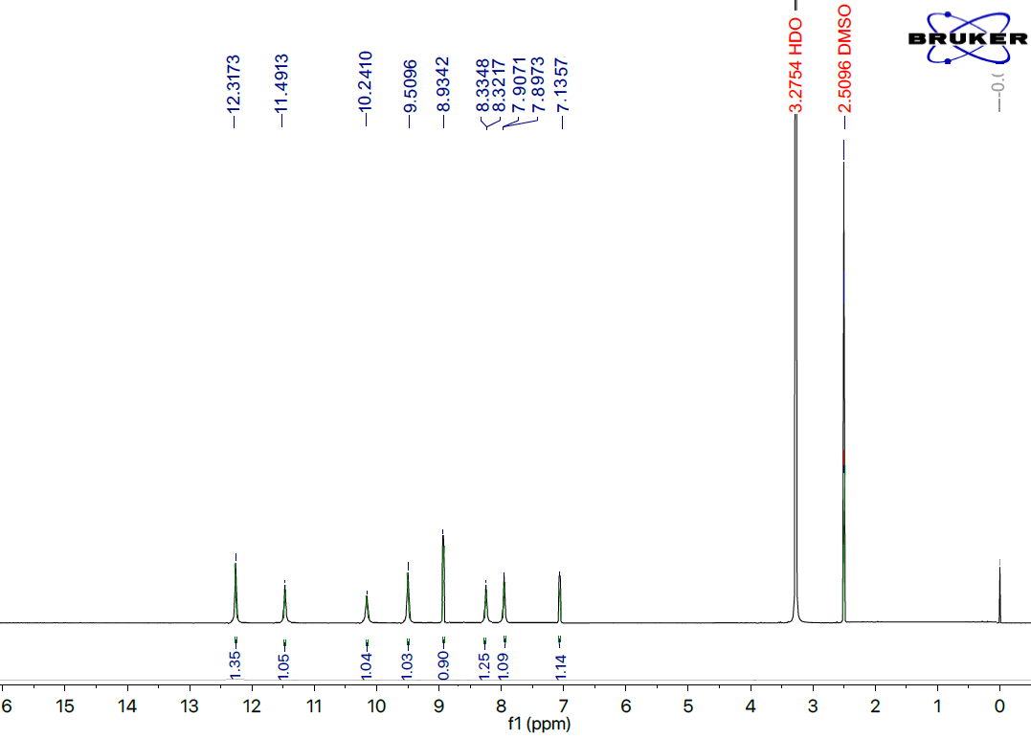
Figure S27. ¹HNMR for the compound 12 (E)-4-((4-fluoro-3-hydroxybenzylidene)amino)-5-(4-nitro-1H-pyrrol-2-yl)-2,4-dihydro-3H-1,2,4-triazole-3-thione
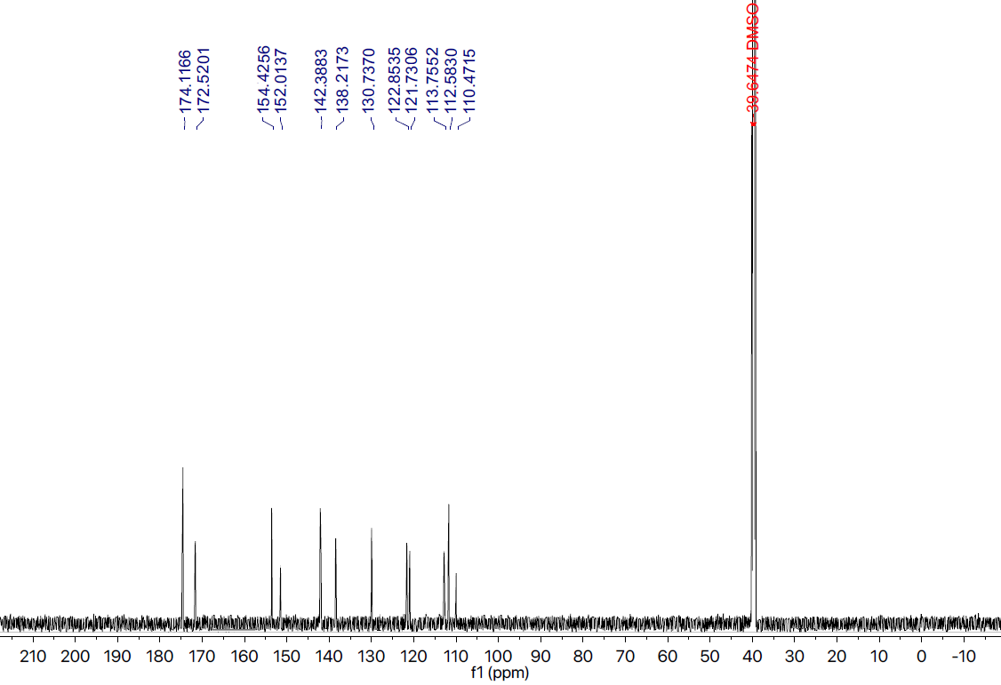
Figure S28. ¹³CNMR for the compound 12 (E)-4-((4-fluoro-3-hydroxybenzylidene)amino)-5-(4-nitro-1H-pyrrol-2-yl)-2,4-dihydro-3H-1,2,4-triazole-3-thione
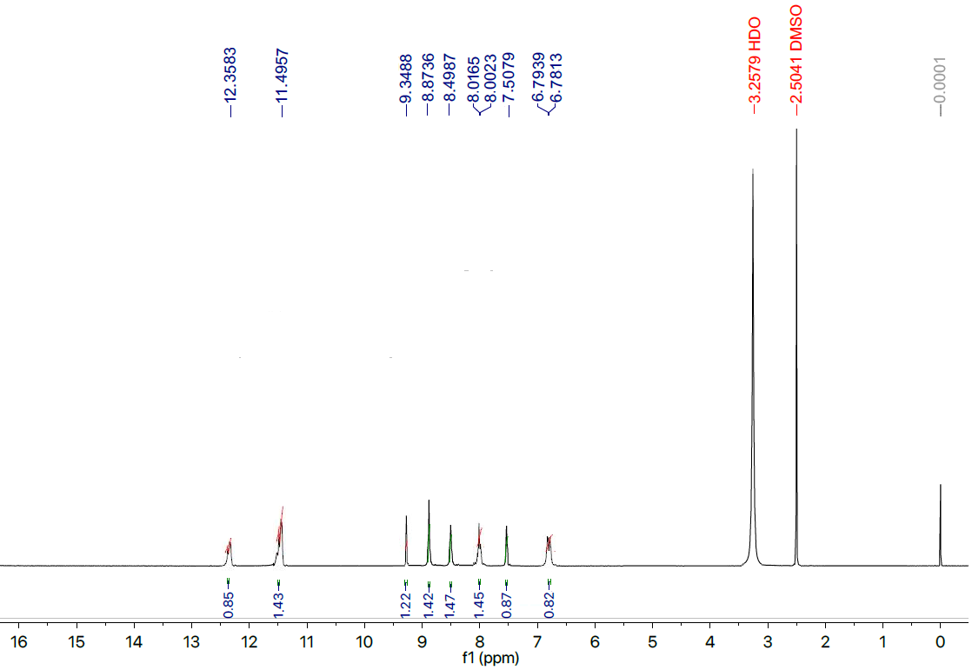
Figure S29. ¹HNMR for the compound 13 (E)-4-((4-fluoro-3-nitrobenzylidene)amino)-5-(4-nitro-1H-pyrrol-2-yl)-2,4-dihydro-3H-1,2,4-triazole-3-thione
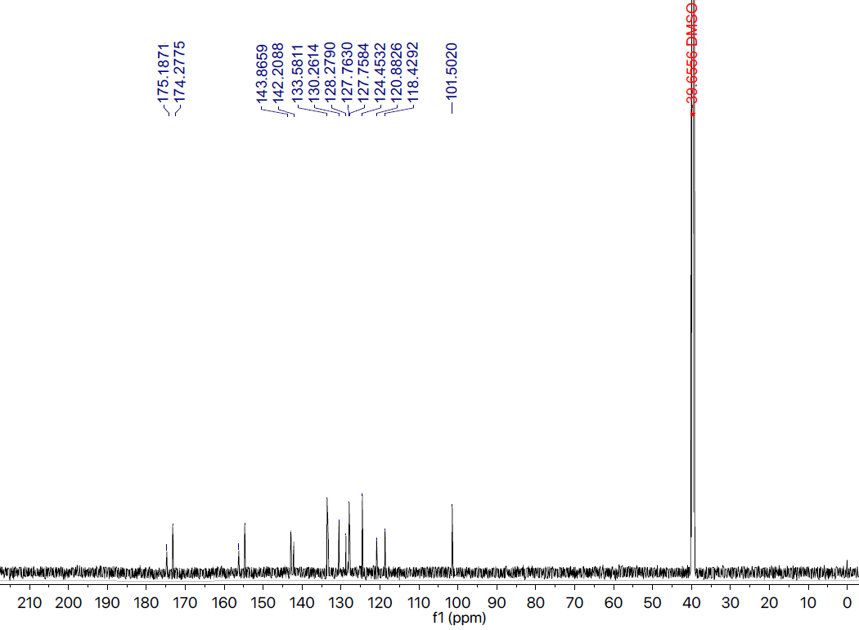
Figure S30. ¹³CNMR for the compound 13 (E)-4-((4-fluoro-3-nitrobenzylidene)amino)-5-(4-nitro-1H-pyrrol-2-yl)-2,4-dihydro-3H-1,2,4-triazole-3-thione
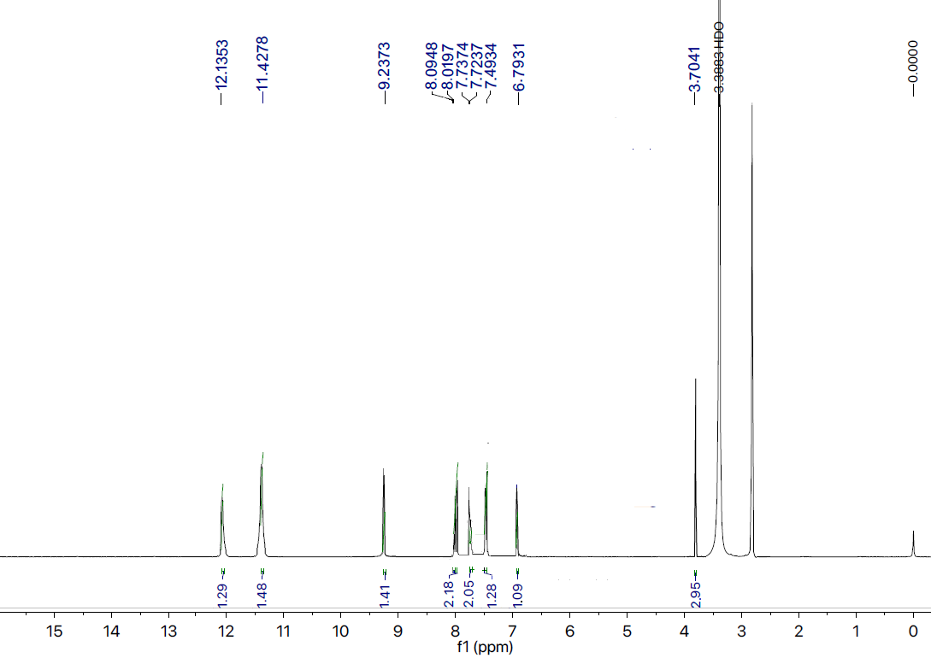
Figure S31. ¹HNMR for the compound 14 (E)-4-((4-methoxybenzylidene)amino)-5-(4-nitro-1H-pyrrol-2-yl)-2,4-dihydro-3H-1,2,4-triazole-3-thione
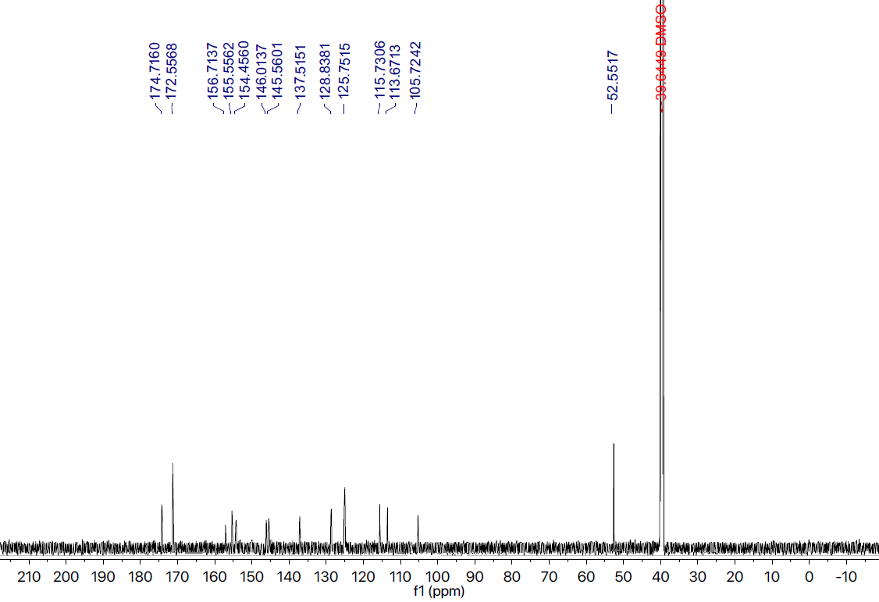
Figure S32. ¹³CNMR for the compound 14 (E)-4-((4-methoxybenzylidene)amino)-5-(4-nitro-1H-pyrrol-2-yl)-2,4-dihydro-3H-1,2,4-triazole-3-thione
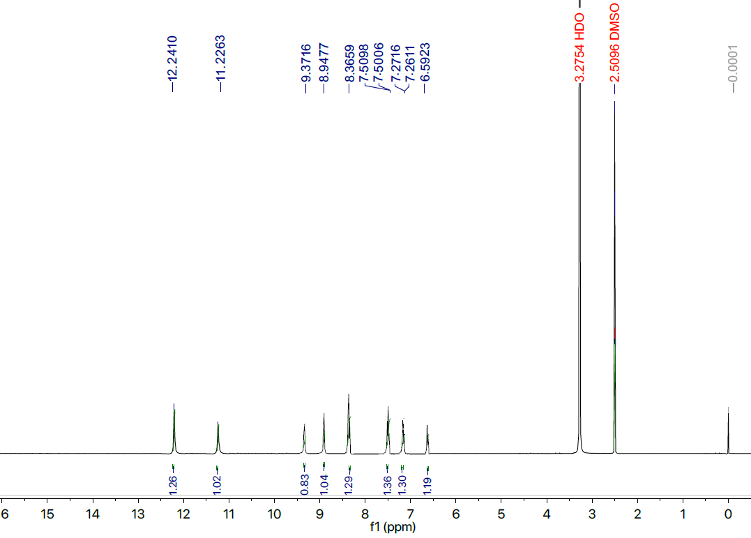
Figure S33. ¹HNMR for the compound 15 (E)-4-((3,4-dibromobenzylidene)amino)-5-(4-nitro-1H-pyrrol-2-yl)-2,4-dihydro-3H-1,2,4-triazole-3-thione
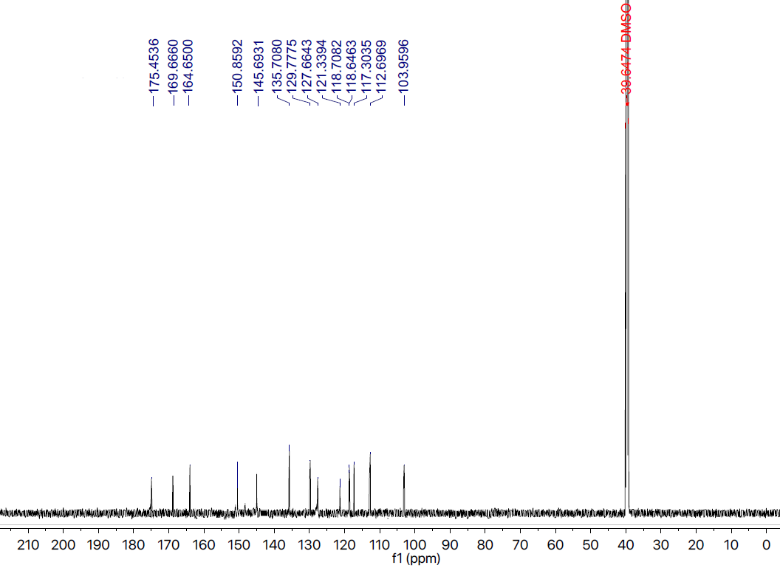
Figure S34. ¹³CNMR for the compound 15 (E)-4-((3,4-dibromobenzylidene)amino)-5-(4-nitro-1H-pyrrol-2-yl)-2,4-dihydro-3H-1,2,4-triazole-3-thione
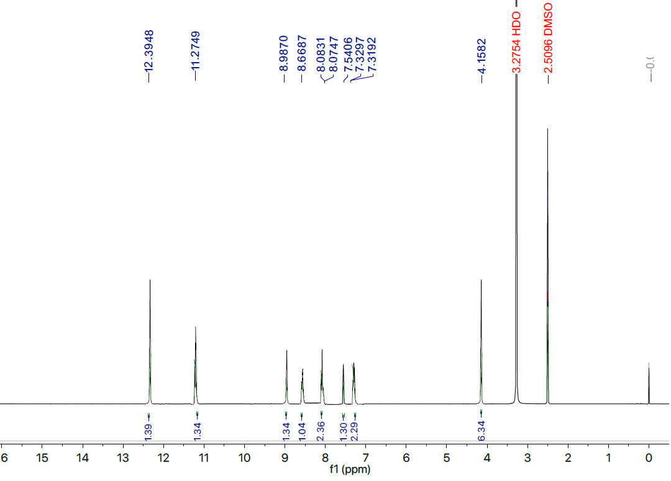
Figure S35. ¹HNMR for the compound 16 (E)-4-((4-(dimethylamino)-2-hydroxybenzylidene)amino)-5-(4-nitro-1H-pyrrol-2-yl)-2,4-dihydro-3H-1,2,4-triazole-3-thione
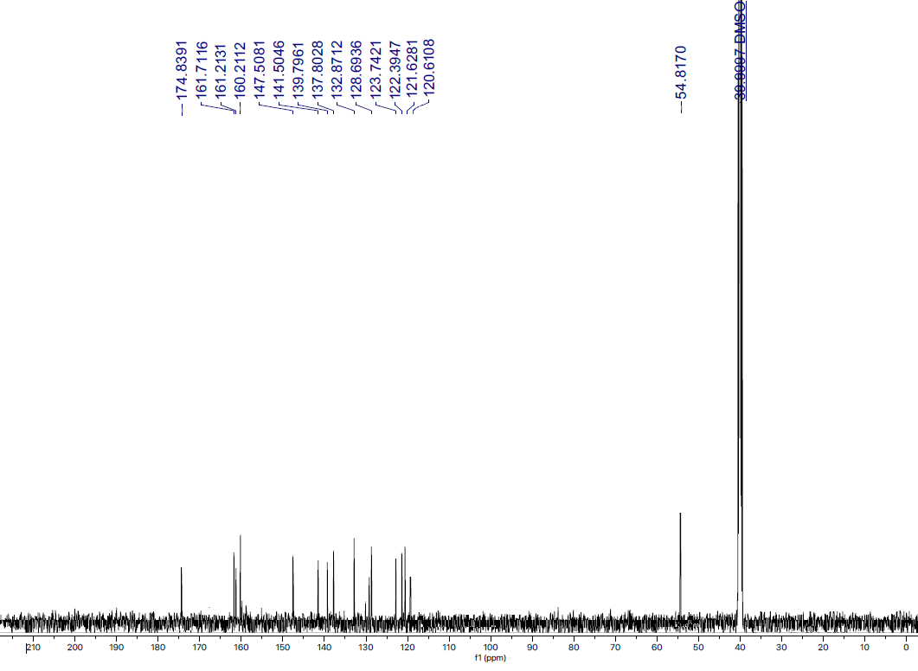
Figure S36. ¹³CNMR for the compound 16 (E)-4-((4-(dimethylamino)-2-hydroxybenzylidene)amino)-5-(4-nitro-1H-pyrrol-2-yl)-2,4-dihydro-3H-1,2,4-triazole-3-thione

References
52. Ellman GL, Courtney KD, Andres Jr V, & Featherstone RM. A new and rapid colorimetric determination of acetylcholinesterase activity. Biochem pharmacol. 1961;7(2):88-95.
53. Korb O, Stutzle T, & Exner TE. Empirical scoring functions for advanced protein− ligand docking with PLANTS. J chem inform model. 2009;49(1):84-96.

