Introducing the Carbon Footprint Reduction Index (CaFRI) as a Software-Supported Tool for Greener Laboratories in Chemical Analysis
Fotouh R. Mansour¹*, Paweł Mateusz Nowak²
¹ Department of Pharmaceutical Analytical Chemistry, Faculty of Pharmacy, Tanta University, Tanta 31111, Egypt
² Department of Analytical Chemistry, Faculty of Chemistry, Jagiellonian University in Kraków, Gronostajowa St. 2, 30-387 Kraków, Poland
Supplementary materials

The work of Challenger et al. [1] on the determination of favipiravir was evaluated using the CaFRI framework, demonstrating moderate environmental considerations alongside key sustainability gaps. The method involved high energy consumption (>1.5 kW) and likely relied on energy-intensive equipment such as fume hoods and air conditioning, with no available data on carbon footprint measurement or emission factors. Samples required storage at -80 °C and short-distance transport (<10 miles) within Liverpool. Waste generation was minimal (<10 mL per sample); however, no recycling of reagents or solvents was reported. The method was semiautomated, required 2–3 personnel, and involved moderate use of hazardous solvents, indicating opportunities for greener optimization.
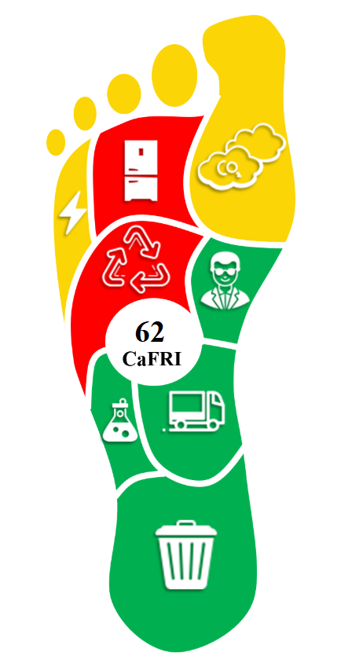
Figure S1: CaFRI assessment of the determination of favipiravir in human plasma by LC-MS/MS.

Table S1: Comparison between CaFRI and Labos 1point5.
Feature | CaFRI | Labos 1point5
Scope | Individual analytical method | Entire lab or institution
Functional unit | One analysis of a specific analyte in matrix | Yearly operation of lab or department
Output | Qualitative score (precautionary effort) | Quantitative CO₂e emissions
Use case | Awareness and guidance for greener methods | Carbon reporting and management

References
1. Challenger E, Penchala SD, Hale C, Fitzgerald R, Walker L, Reynolds H, et al. Development and validation of an LC-MS/MS method for quantification of favipiravir in human plasma. J Pharm Biomed Anal. 2023;233:115436.

