Supplementary Materials
FTIR spectroscopic studies with thermo acoustical parameters in binary and ternary liquid mixtures of amino acid and saccharide at different temperatures
Rupesh Kumar Pradhan, Sulochana Singh*
Department of Chemistry, ITER, Siksha O Anusandhan Deemed to be University, Odisha
Corresponding authors’ email id: sulochanasingh@soa.ac.in

Table S1. Pair and triplet interaction coeffiecients $K_{AB}$and $K_{ABB }$ for ions of Asp in aqueous L-arabinose and aqueous D-xylose at 293.15 -313.15 K and experimental pressure $P$ =101 kPa.

$T$ (K) | $$K_{AB}× {10}^{13}$$  $$/m^{3}kg {mol}^{-2}$$ | $$K_{ABB }× {10}^{13}$$  $${/m}^{3}{kg}^{2}{mol}^{-3}$$
Aqueous L - arabinose
293.15 K | 8.55 ± 1.63 | -21.32 ± 1.62
298.15 K | 18.65 ± 2.23 | -53.13 ± 1.65
303.15 K | 21.15 ± 1.20 | -42.10 ± 1.05
298.15 K | 12.65 ± 1.21 | -33.13 ± 1.62
313.15 K | 22.23 ± 1.27 | -44.16 ± 1.16
Aqueous D - xylose
293.15 K | 8.04 ± 1.11 | -19.45 ± 1.01
298.15 K | 12.93 ± 1.01 | -26.29 ± 1.15
303.15 K | 15.82 ± 1.11 | -32.15 ± 1.05
298.15 K | 17.87 ± 1.85 | -34.29 ± 1.13
313.15 K | 19.66 ± 1.17 | -35.44 ± 1.23

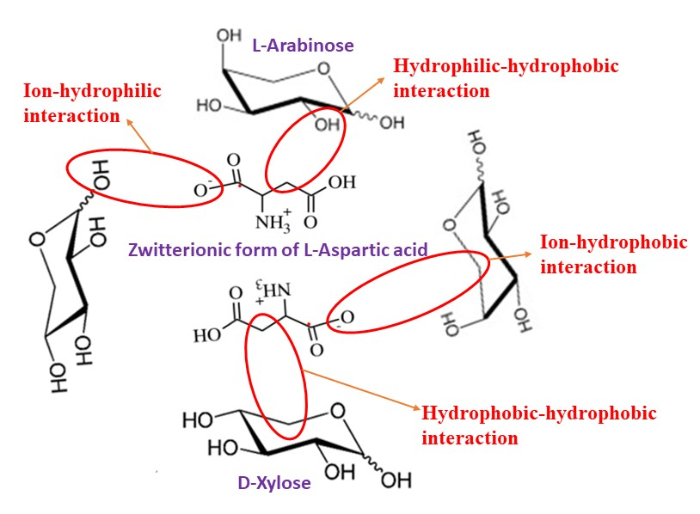

Fig. S1. Interactions of zwitterionic form of Asp with L-arabinose$/$D-xylose in aqueous medium.

Fig. S2. Variation of free length, $L_{f}$ with molality, m of Asp in aqueous L-arabinose$/$D-xylose at 298.15 K .

Fig. S3. Variation of acoustic impedance ($Z$) with molality ($m$) of Asp in aqueous L-arabinose$/$D-xylose at 298.15K.

Uncertainty in ultrasonic velocity (U)

Uncertainty in molality, temperature, frequency, wavelength have to be considered
- molality = $±0.001$mol/kg
By regression method d(u)/d(m) = 160 (it is the slope of a linear plot of U against molality)
Uncertainty in U from molality = 160 x 0.001 = 0.16m/s
- T = $±0.01$K
Sound velocity in water varies 2.5 m/s for for 1 degree rise (${24-25}^{0}C)$
Uncertainty in U from temperature = 2.5 x 0.01 = 0.025m/s
- f = $±$ $0.003\%$
Uncertainty in frequency = $\frac{0.003 }{100}×2$ = ${ 6x10}^{-5}m/s$
- λ = $±0.0001$m
By regression method d(U)/d(λ) = 2000 (it is the slope of a linear plot of U against wavelength)
Uncertainty in u with wavelength = 2000 x 0.0001 = 0.2 m/s = 0.02%
As, U= f x λ
$∂(u)$ = $0.003+0.020$= 20% = 0.023m/s
Combined uncertainty $u_{c}$(U) = 0.16 + 0.025 + 0.023 = $±$0.2 m/s

