Design, Synthesis, Biological Assessments and Computational Studies of 3-Substituted Phenyl Quinazolinone Derivatives as a Promising Anti-Cancer Agents
Maryam Moghtader Mansouri¹, Leila Emami², Zahra Rezaei¹, Soghra Khabnadideh^{1,2∗}
¹Department of Medicinal Chemistry, Faculty of Pharmacy, Shiraz University of Medical Sciences, Shiraz, Iran.
²Pharmaceutical Sciences Research Center, Faculty of pharmacy, Shiraz University of Medical Sciences, Shiraz, Iran.

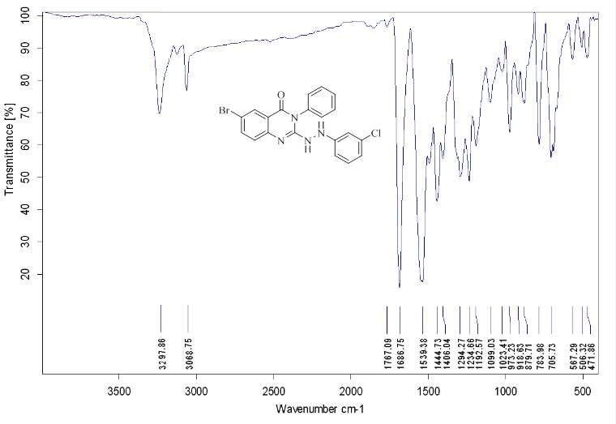
Figure S1. IR spectrum of 7a.

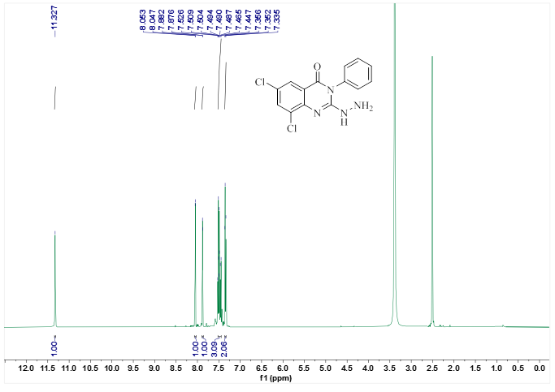

Figure S2. ¹H-NMR spectrum of 7a.

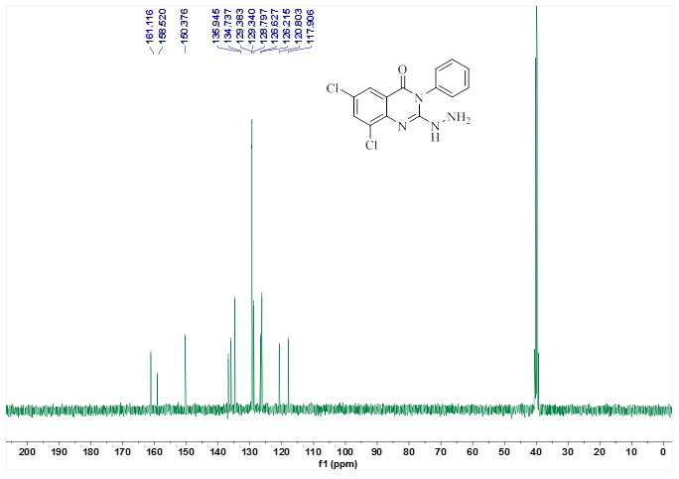

Figure S3. ¹³C-NMR spectrum of 7a.

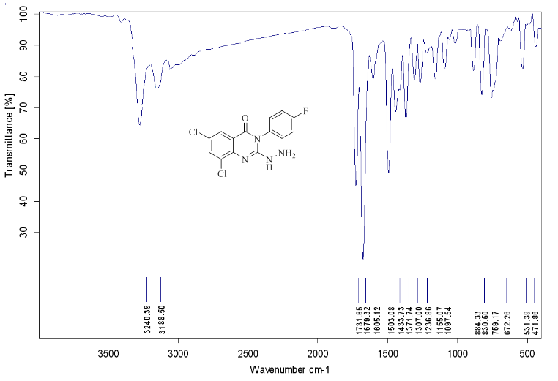
Figure S4. IR spectrum of 7b.

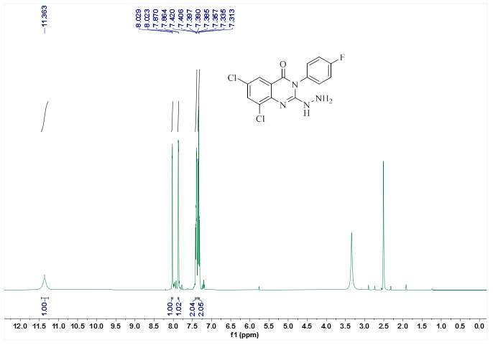

Figure S5. ¹H-NMR spectrum of 7b.
.

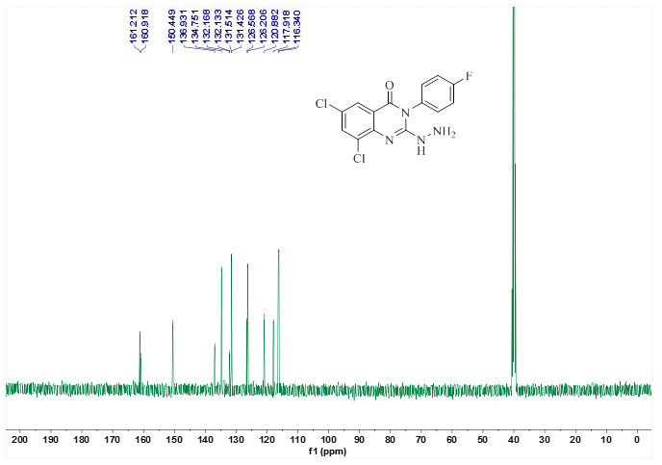

Figure S6. ¹³C-NMR spectrum of 7b.

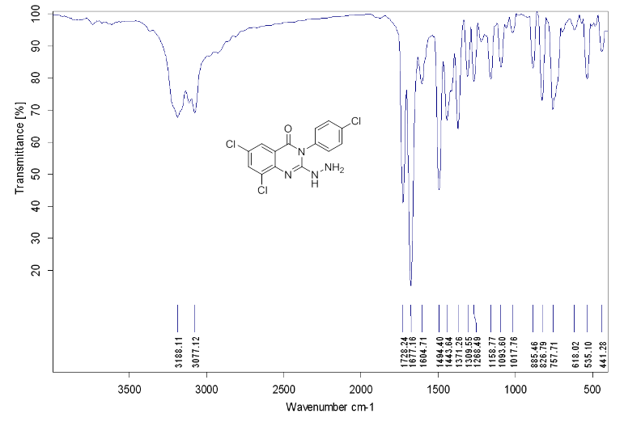
Figure S7. IR spectrum of 7c.

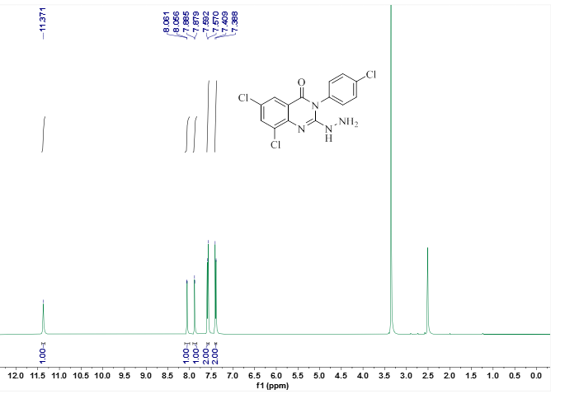

Figure S8. ¹H-NMR spectrum of 7c.

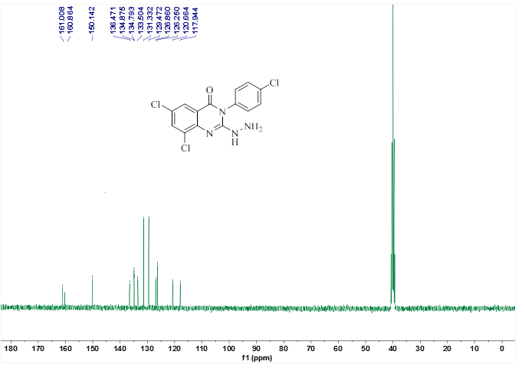

Figure S9. ¹³C-NMR spectrum of 7c.

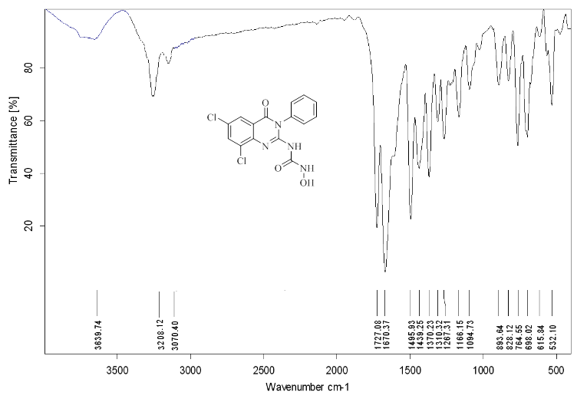
Figure S10. IR spectrum of 7d.

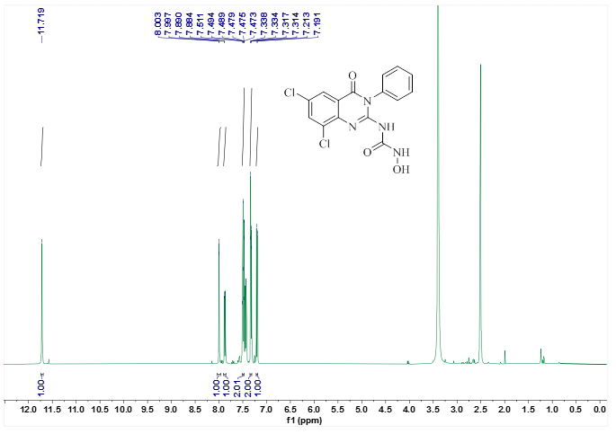

Figure S11. ¹H-NMR spectrum of 7d.

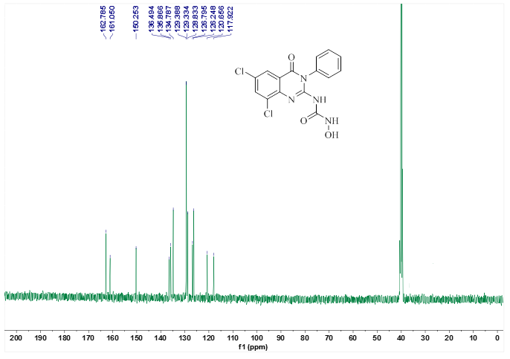

Figure S12. ¹³C-NMR spectrum of 7d.

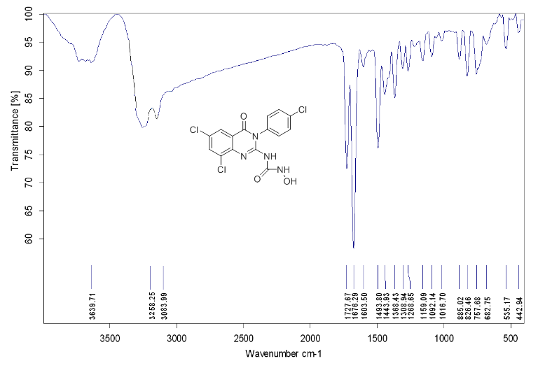

Figure S13. IR spectrum of 7e.

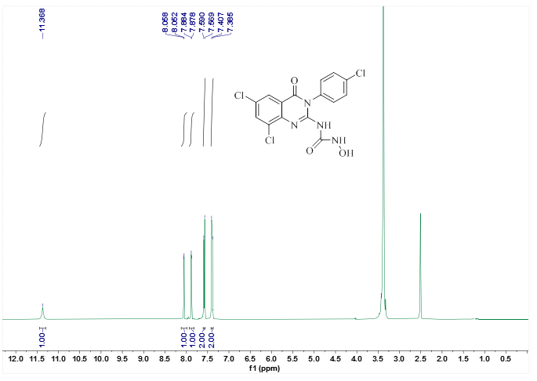
Figure S14. ¹H-NMR spectrum of 7e.

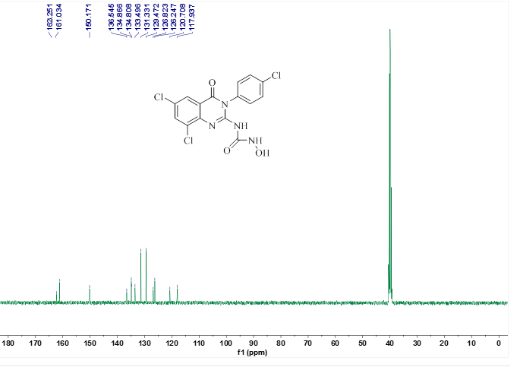

Figure S15. ¹³C-NMR spectrum of 7e.

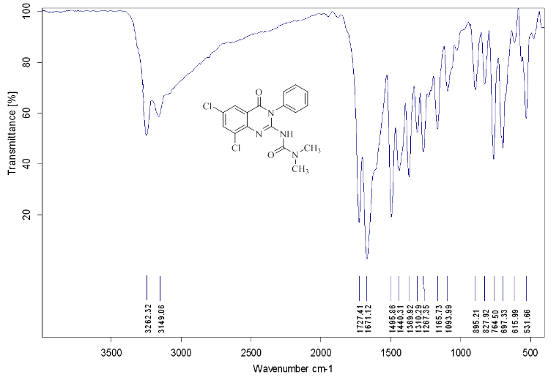
Figure S16. IR spectrum of 7f.
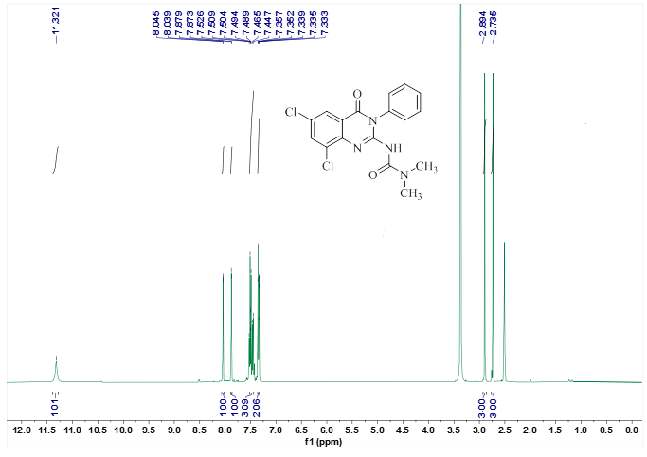
Figure S17. ¹H-NMR spectrum of 7f.

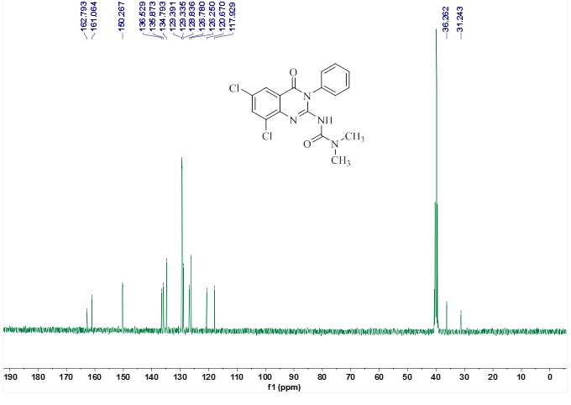
Figure S18. ¹³C-NMR spectrum of 7f.

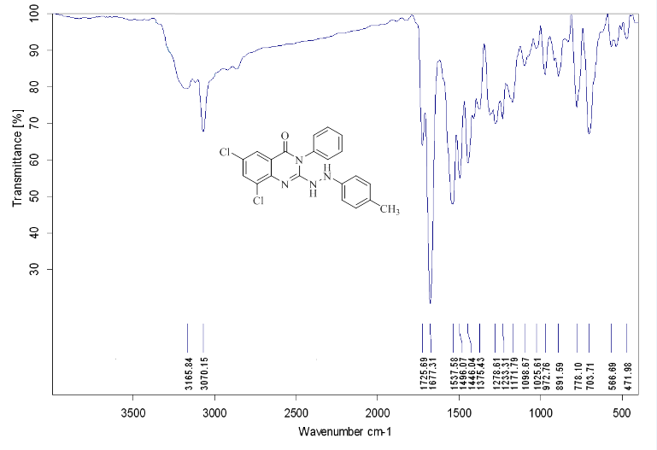

Figure S19. IR spectrum of 7g.

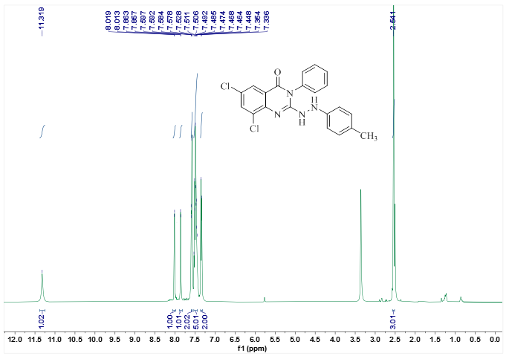
Figure S20. ¹H-NMR spectrum of 7g.

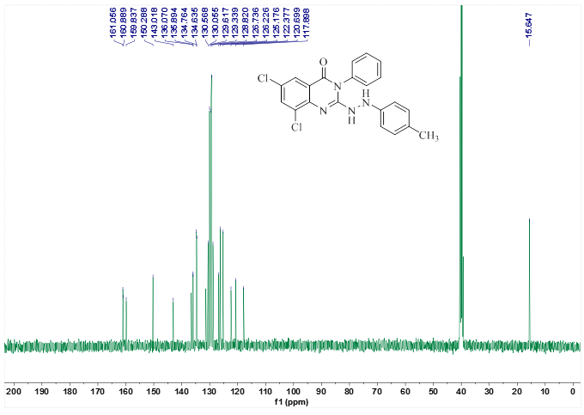
Figure S21. ¹³C-NMR spectrum of 7g.

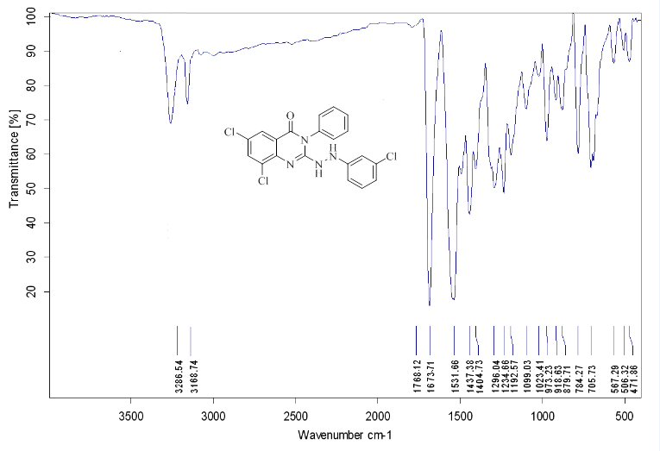

Figure S22. IR spectrum of 7h.

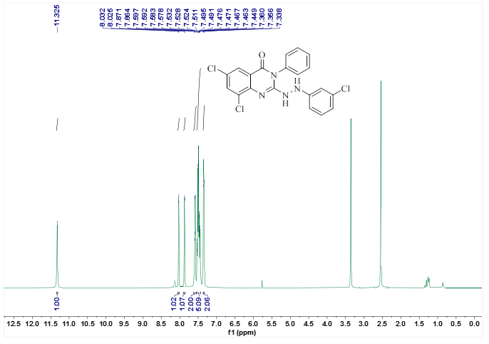
Figure S23. ¹H-NMR spectrum of 7h.

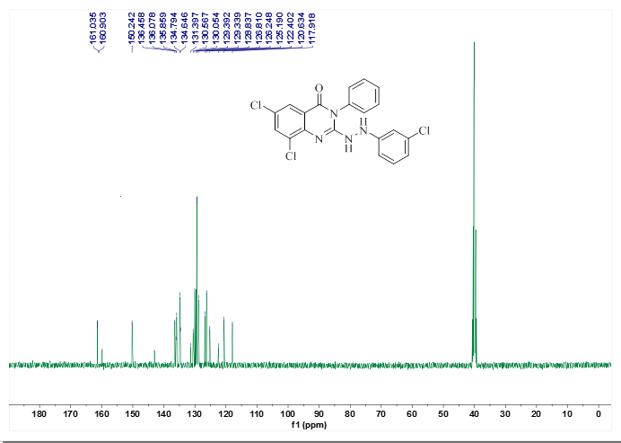
Figure S24. ¹³C-NMR spectrum of 7h.

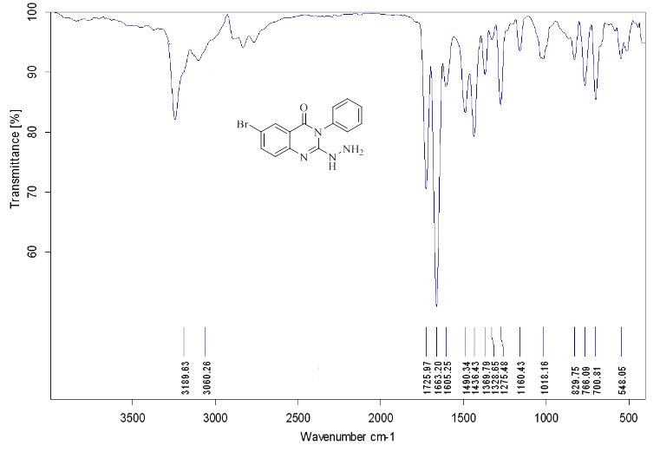

Figure S25. IR spectrum of 7i.

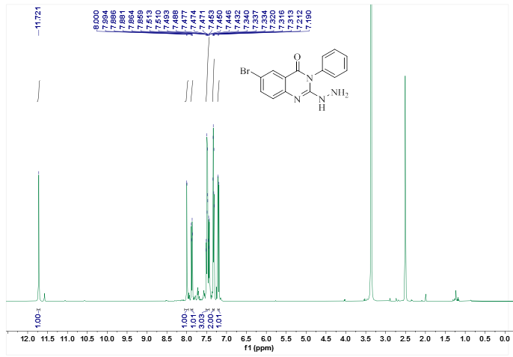
Figure S26. ¹H-NMR spectrum of 7i.

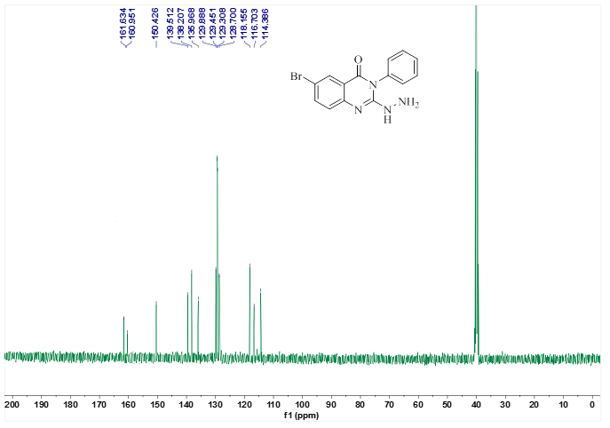
Figure S27. ¹³C-NMR spectrum of 7i.

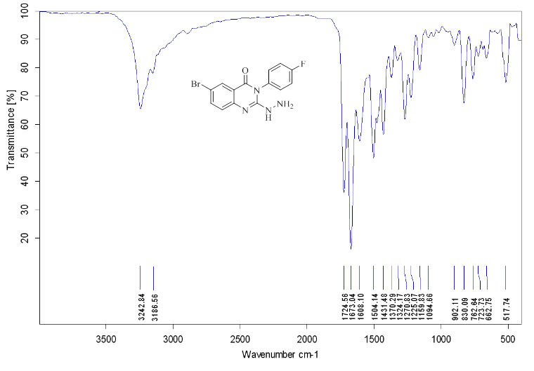
Figure S28. IR spectrum of 7j.

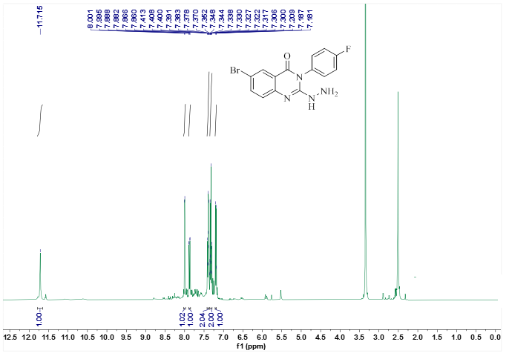
Figure S29. ¹H-NMR spectrum of 7j.

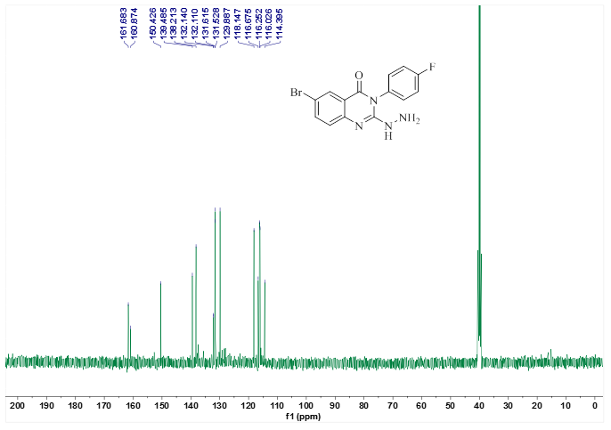

Figure S30. ¹³C-NMR spectrum of 7j.

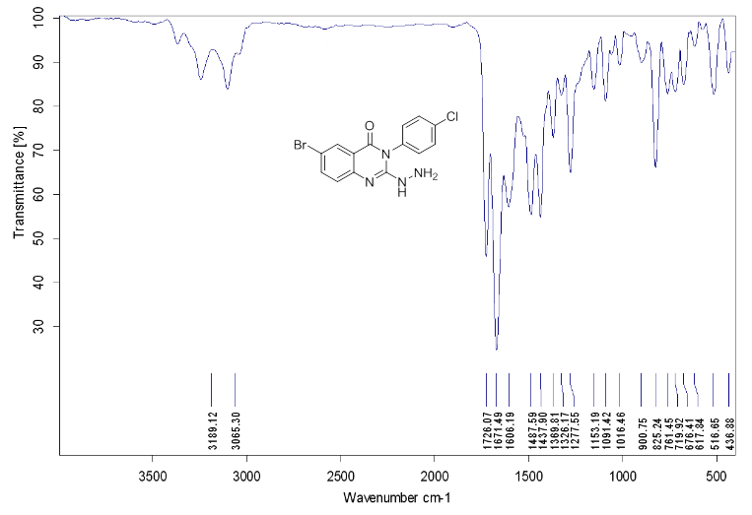
Figure S31. IR spectrum of 7k.

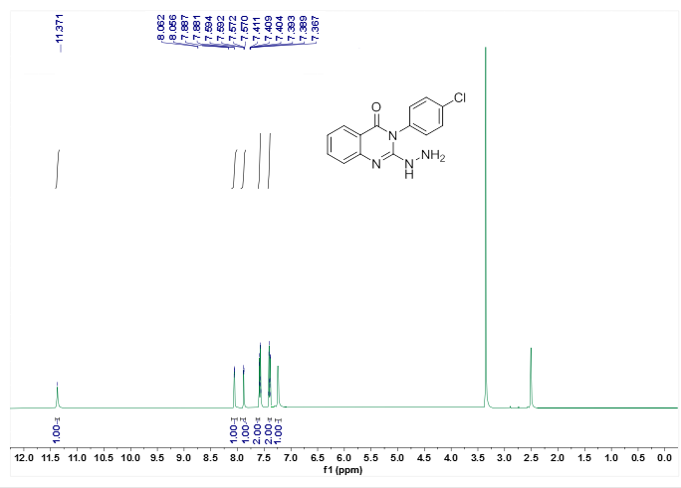
Figure S32. ¹H-NMR spectrum of 7k.

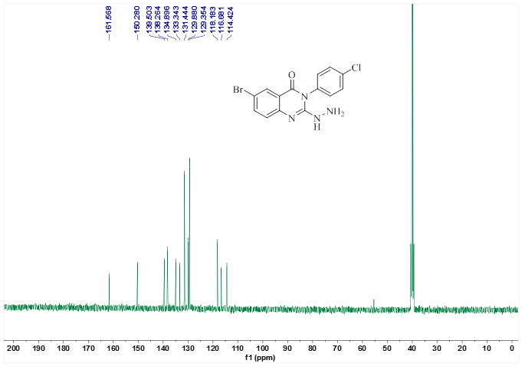
Figure S33. ¹³C-NMR spectrum of 7k.

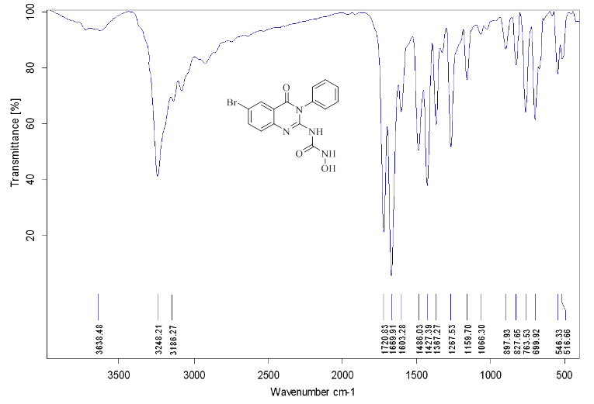

Figure S34. IR spectrum of 7l.

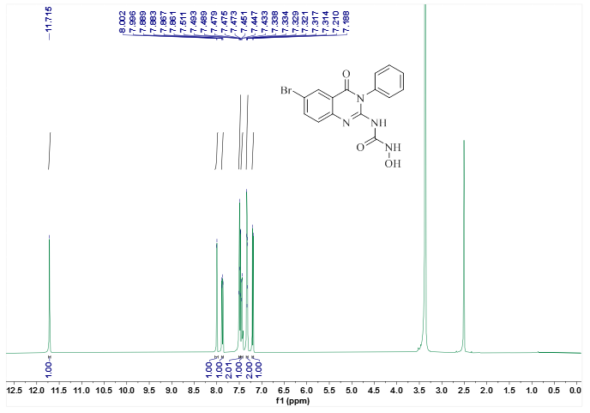
Figure S35. ¹H-NMR spectrum of 7l.

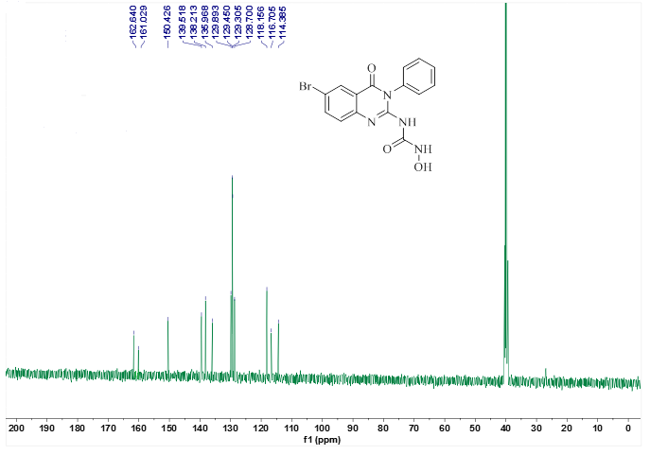

Figure S36. ¹³C-NMR spectrum of 7l.

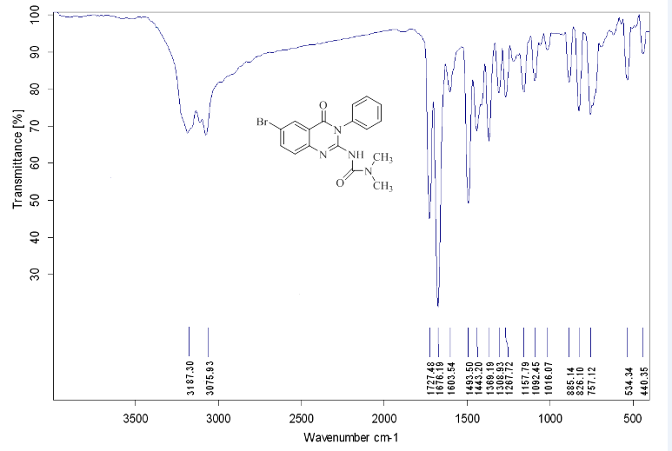

Figure S37. IR spectrum of 7m.

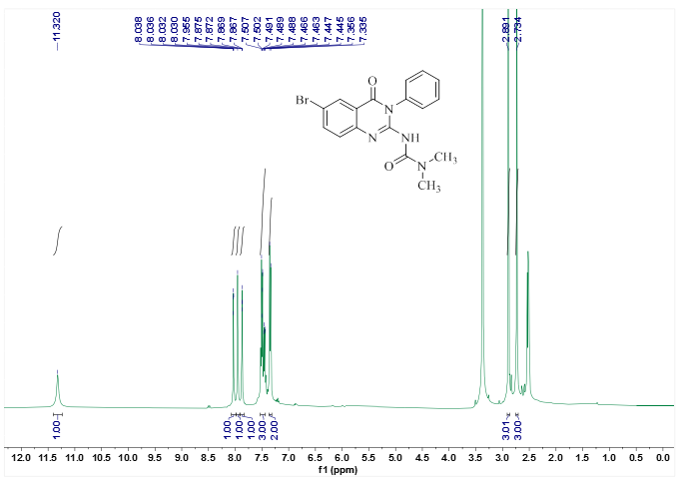

Figure S38. ¹H-NMR spectrum of 7m.

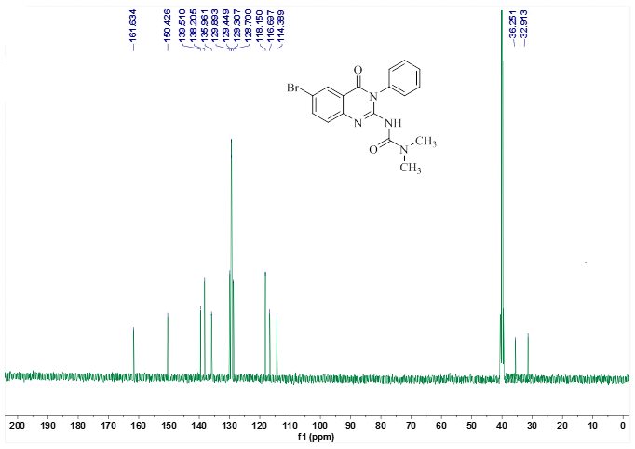

Figure S39. ¹³C-NMR spectrum of 7m.

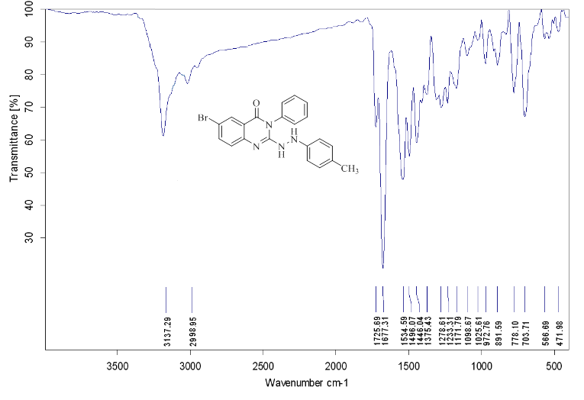

Figure S40. IR spectrum of 7n.

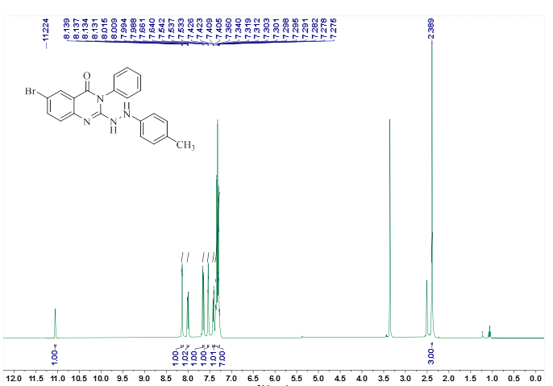
Figure S41. ¹H-NMR spectrum of 7n.

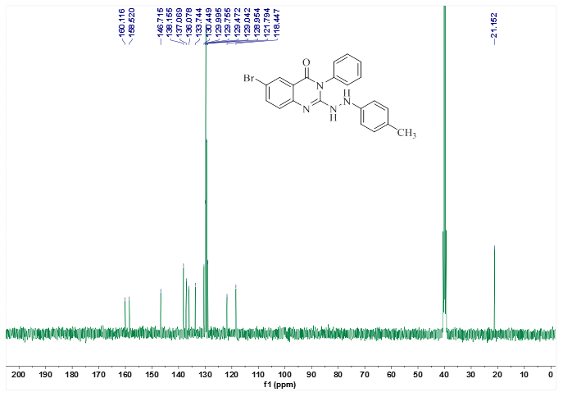

Figure S42. ¹³C-NMR spectrum of 7n.

Figure S43. IR spectrum of 7o.

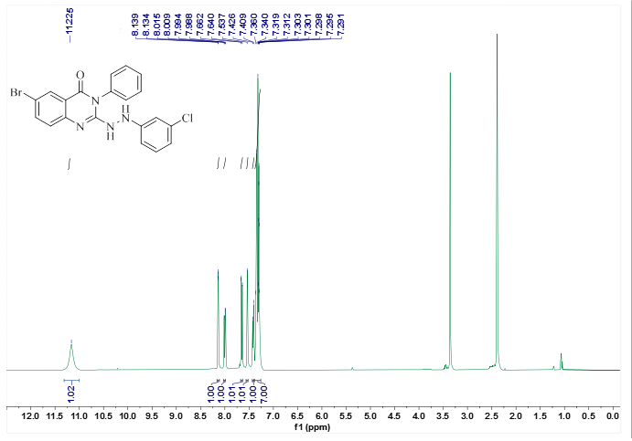

Figure S44. ¹H-NMR spectrum of 7o.

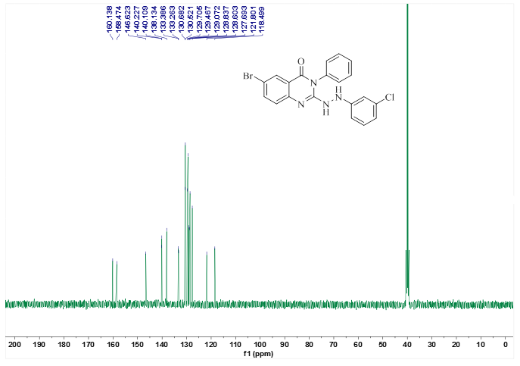
Figure S45. ¹³C-NMR spectrum of 7o.

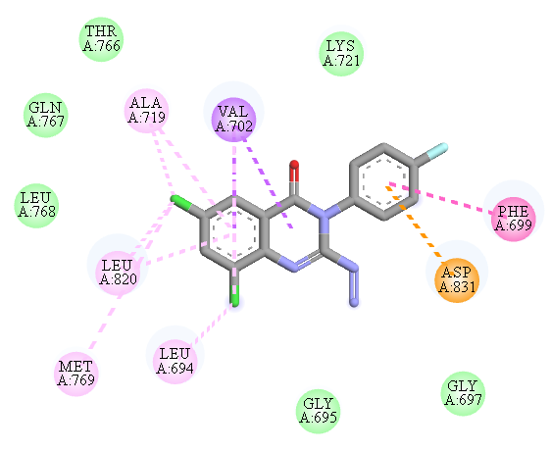
7b

Figure S46. 2D interaction pattern of 7b in the EGFR active site.
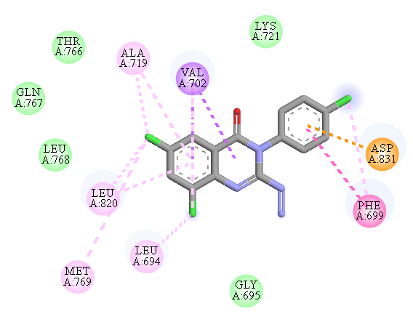
7c

Figure S47. 2D interaction pattern of 7c in the EGFR active site.

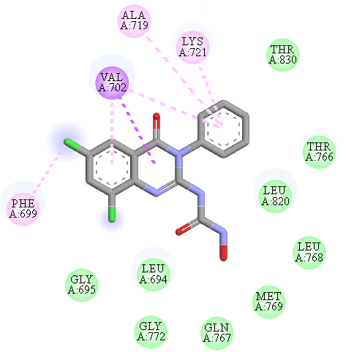
7d

Figure S48. 2D interaction pattern of 7d in the EGFR active site.

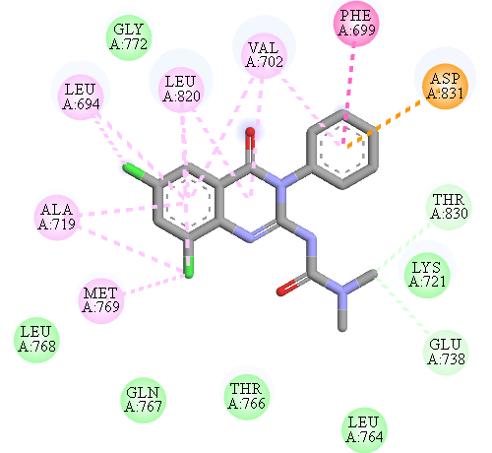
7f

Figure S49. 2D interaction pattern of 7f in the EGFR active site.

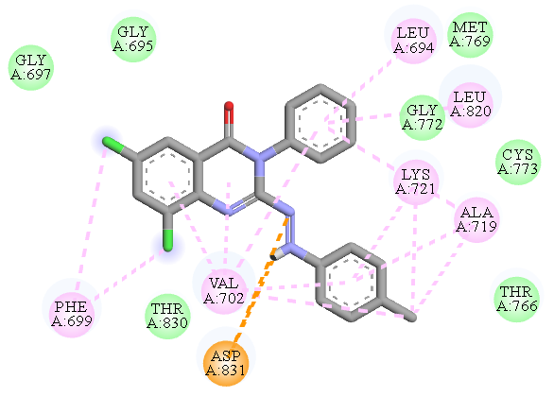
7g

Figure S50. 2D interaction pattern of 7g in the EGFR active site.

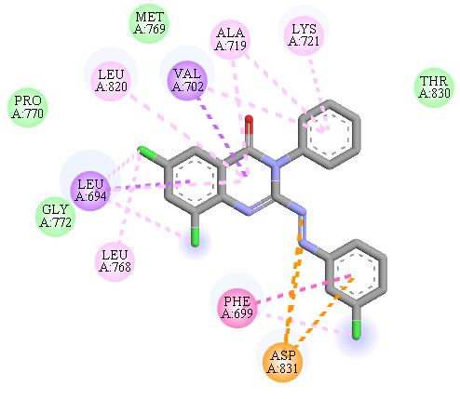
7h

Figure S51. 2D interaction pattern of 7h in the EGFR active site.
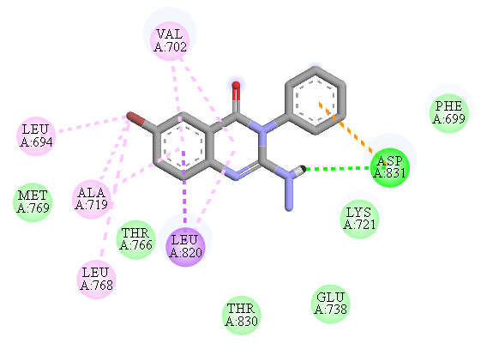
7i

Figure S52. 2D interaction pattern of 7i in the EGFR active site.
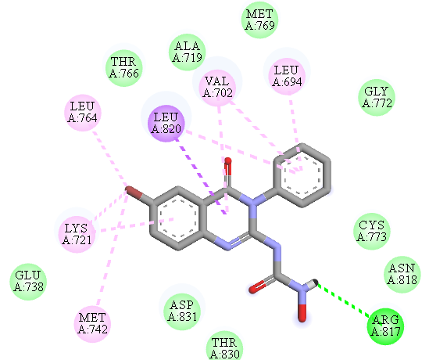
7l

Figure S53. 2D interaction pattern of 7l in the EGFR active site.

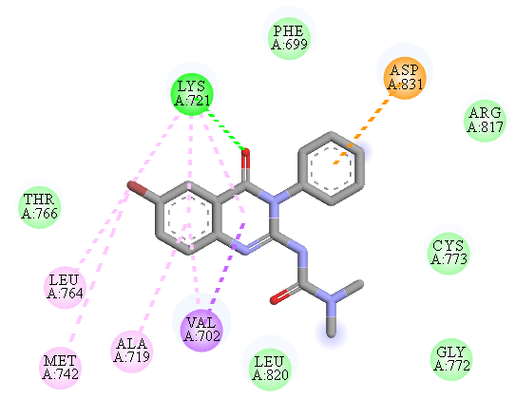
7m

Figure S54. 2D interaction pattern of 7m in the EGFR active site.
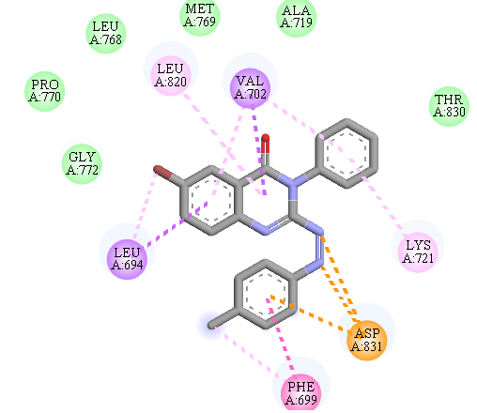
7n

Figure S55. 2D interaction pattern of 7n in the EGFR active site.

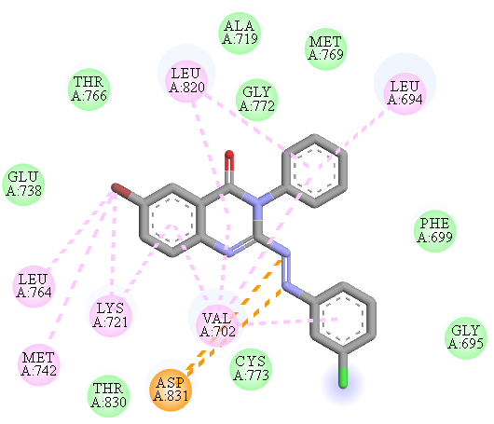
7o

Figure S56. 2D interaction pattern of 7o in the EGFR active site.

*Corresponding authors: Soghra Khabnadideh, E-mail: khabns@sums.ac.ir, Tel: +98-71-32424127-8; Fax: +98-71-32424126;

