Supplementary file
Figure S1: ¹H NMR (left) and ¹³C NMR (right) spectra of quinazolines derivatives; [a] QD-1, [b] QD-2, [c] QD-3 and [d] QD-4.
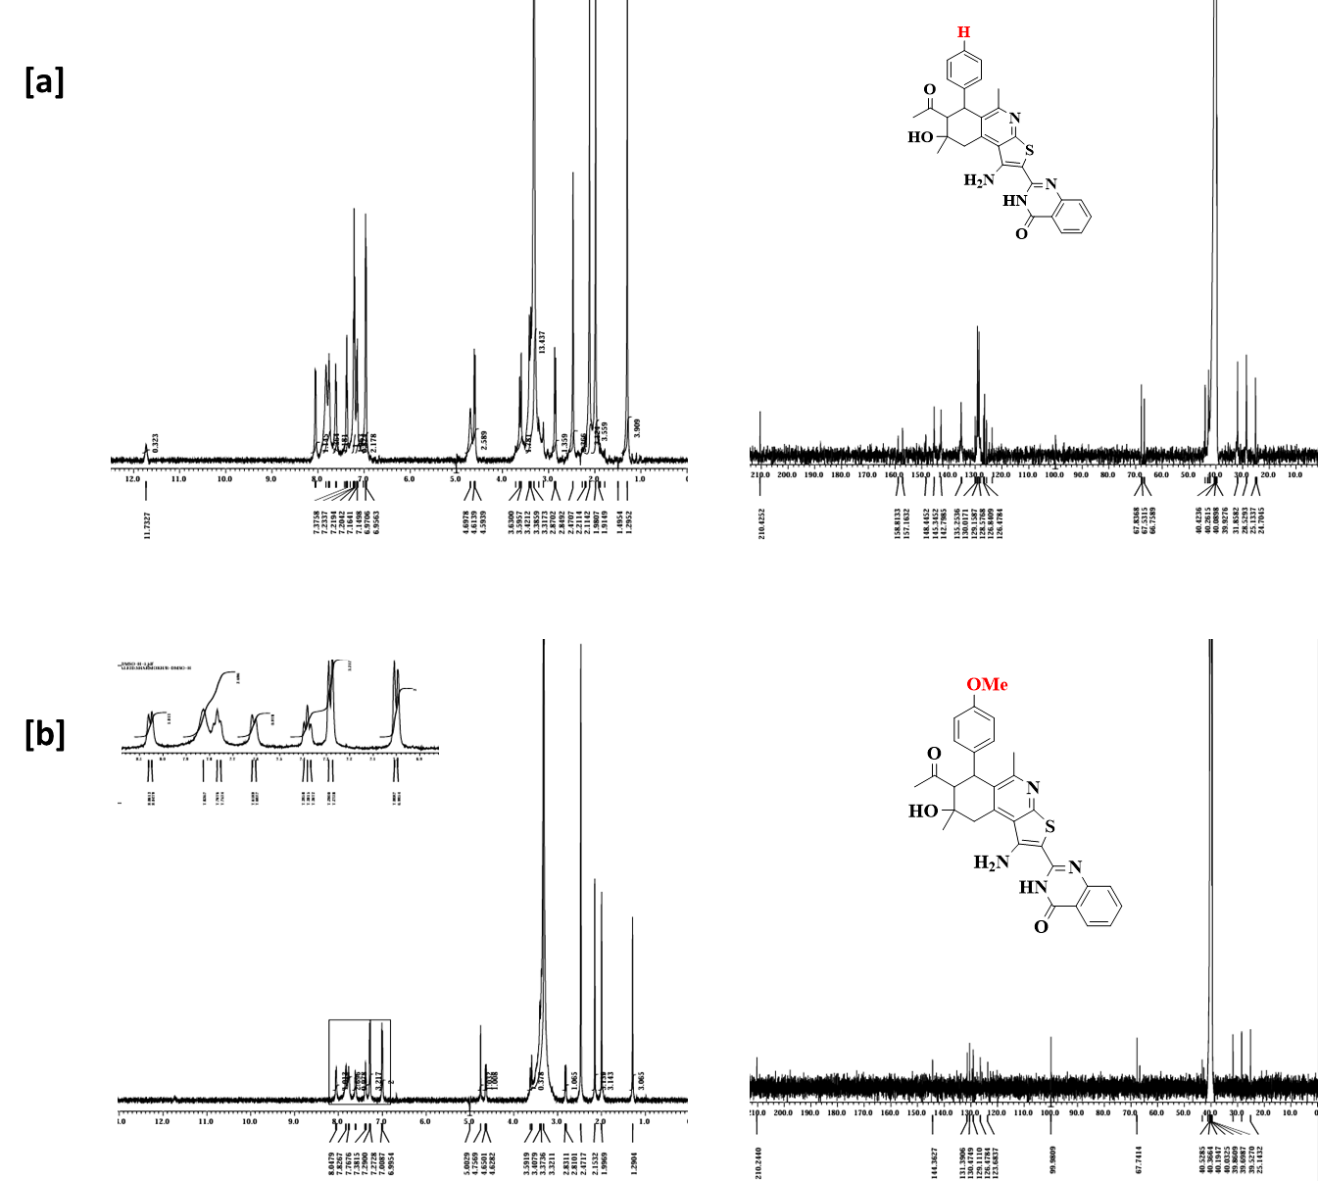

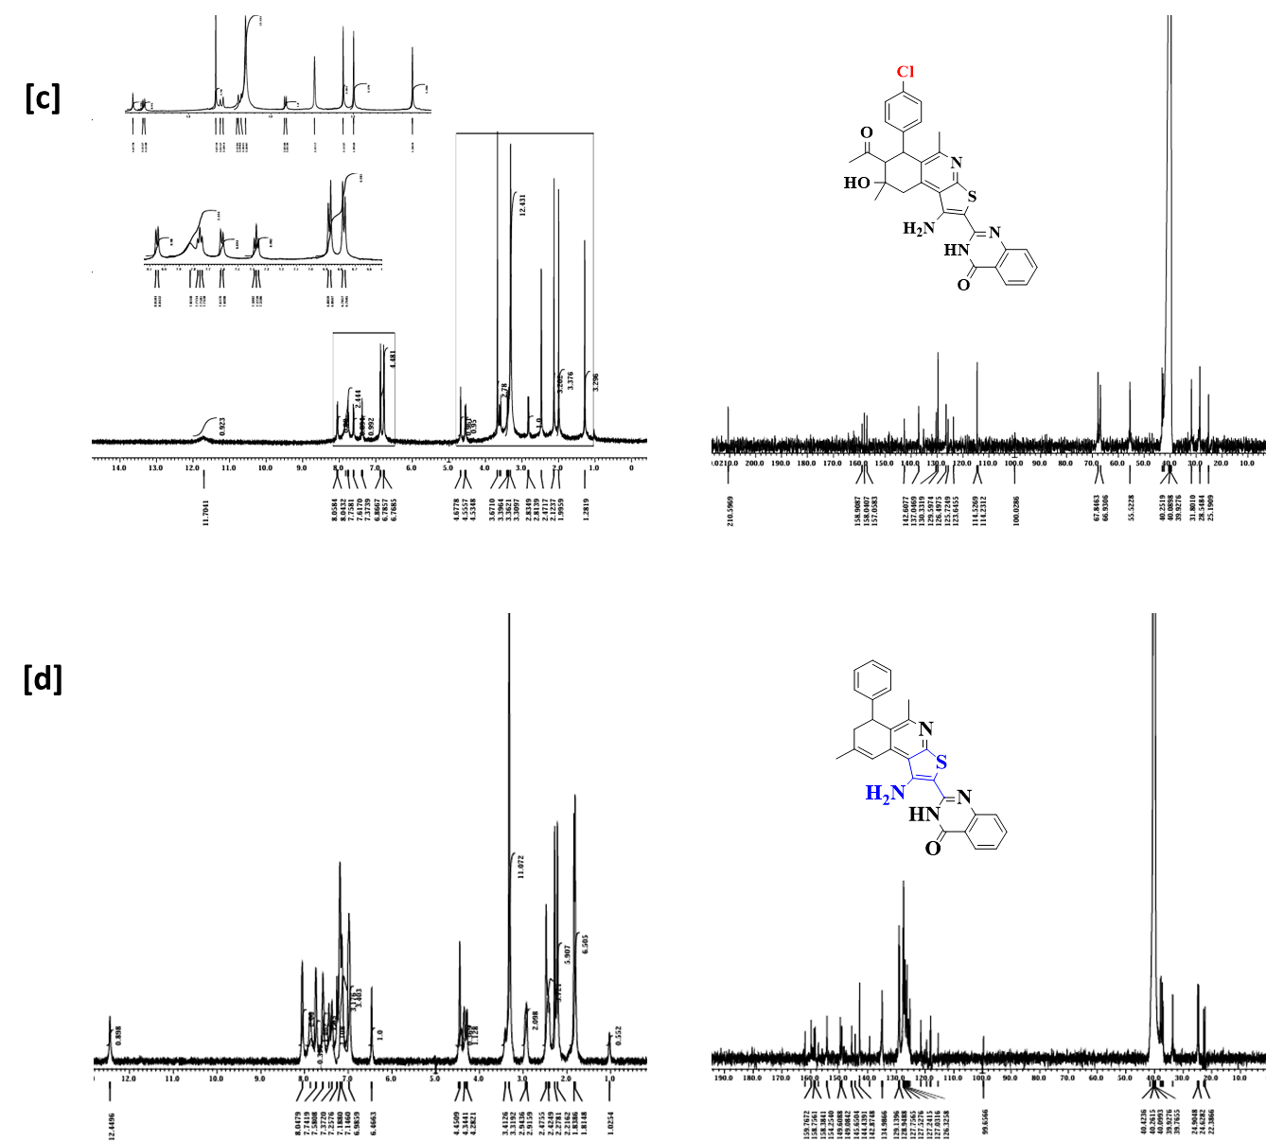

Figure S2: Elemental mapping for QDs@Q-cotton fabrics; [a] QD-1@Q-cotton, [b] QD-2@Q-cotton, [c] QD-3@Q-cotton and [d] QD-4@Q-cotton.

[a] | 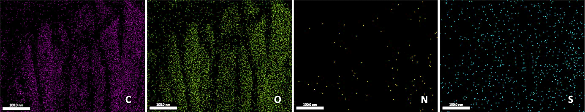
[b] | 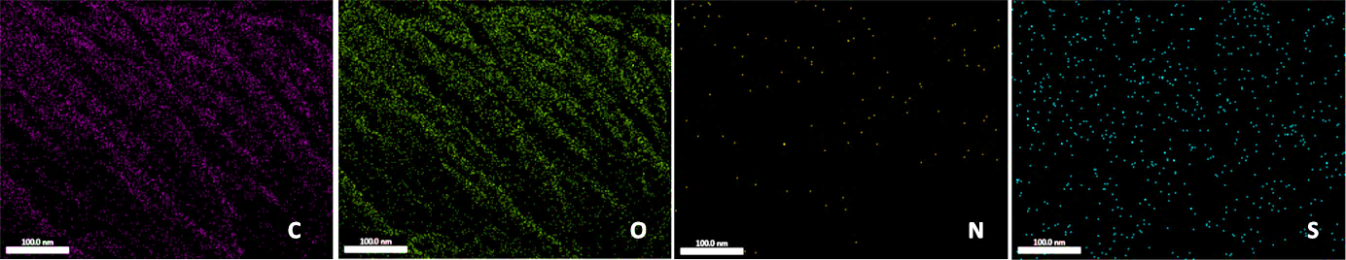
[c] | 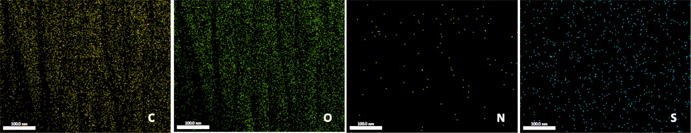
[d] | 