Supporting Information
Catechol-substituted siderophore colistin exhibits superior antimicrobial activity than its unmodified polypeptide counterpart
Sara Bescós-Ramo^{a,d}, Enrique Gámez^{a,b,*}, María del Mar Encabo-Berzosa^{c}, Milagros Piñol^{a,d}, Luis Oriol^{a,d}, Manuel Arruebo^{a,b}
ªInstituto de Nanociencia y Materiales de Aragón (INMA), CSIC-Universidad de Zaragoza, 50009 Zaragoza, Spain
^{b}Department of Chemical and Environmental Engineering. University of Zaragoza, Campus Río Ebro-Edificio I+D, C/ Poeta Mariano Esquillor S/N, 50018 Zaragoza, Spain
^{c}Instituto Aragonés de Ciencias de la Salud (IACS), Avenida San Juan Bosco, 13, 50009 Zaragoza, Spain
^{d}Departamento de Química Orgánica. Facultad de Ciencias, Universidad de Zaragoza, C/ Pedro Cerbuna 12, 50009 Zaragoza, Spain
*Corresponding author: engahe@unizar.es (E. Gámez)

1. Structural characterization
Figure S1. ¹H NMR spectrum of compound 1 (CDCl₃, 400 MHz).
Figure S2. ¹³C NMR spectrum of compound 1 (DMSO-d₆, 100 MHz).
Figure S3. ¹H NMR spectrum of compound 2 (DMSO-d₆, 400 MHz).
Figure S4. ¹³C NMR spectrum of compound 2 (DMSO-d₆, 100 MHz).
Figure S5. ¹H NMR of colistin sulphate is represented as reference (D₂O, 400 MHz). For the sake of clarification, protons located in the same area of the spectrum are labelled with the same letter. Spectroscopic data matched reported data for this compound [1].

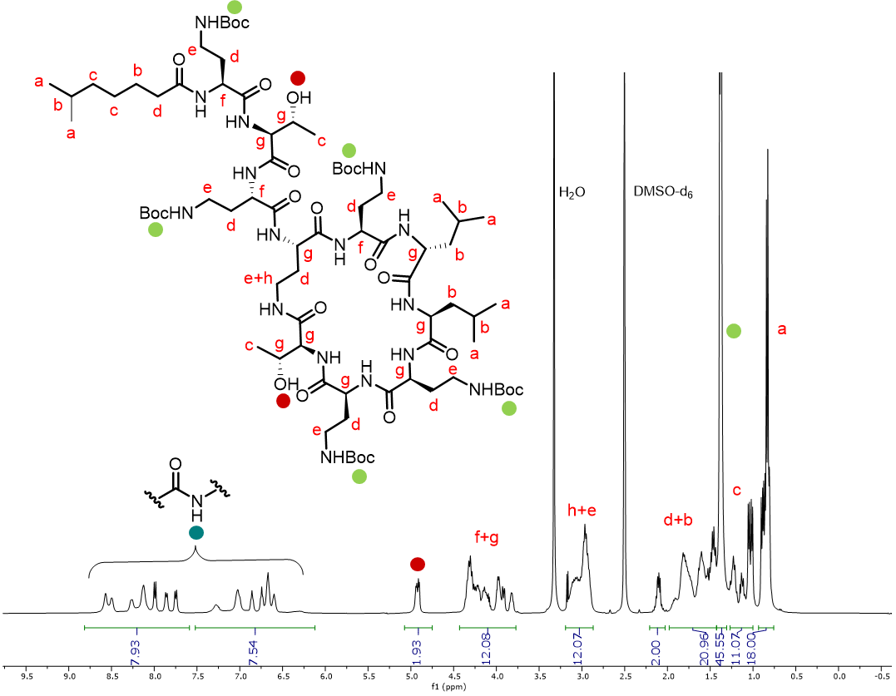
Figure S6. ¹H NMR spectrum of 3 (DMSO-d6, 400 MHz). For the sake of clarification, unaltered protons of the original compound (colistin sulphate) are labelled with the same letter as in Figure S5, whereas those that appear after structural modification are labelled with a colored circle.
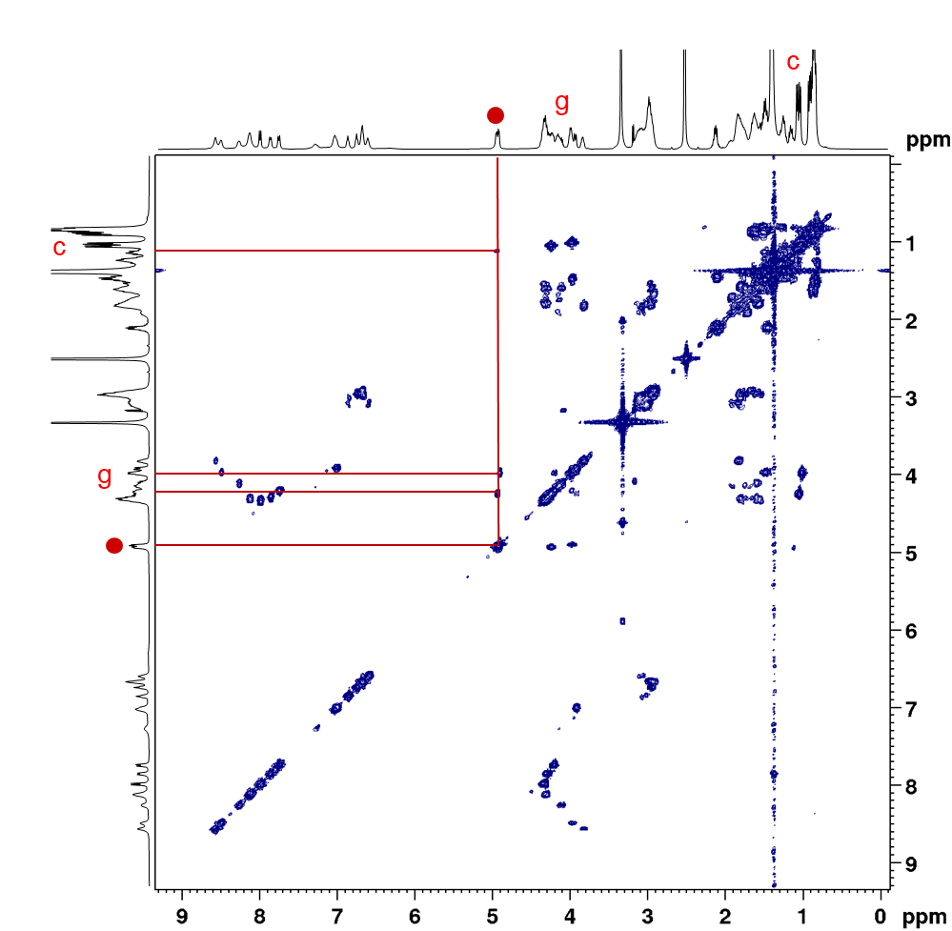
Figure S7. ¹H-¹H COSY of 3 (DMSO-d6, 400 MHz). Only significative correlations have been indicated for clarification purposes.
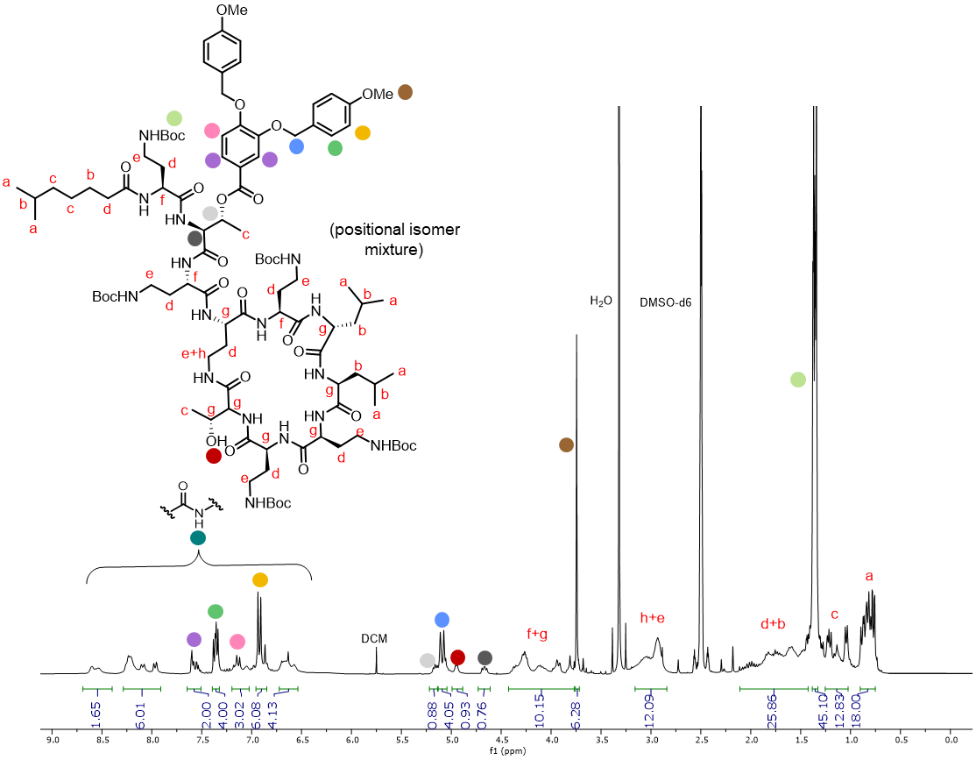Figure S8. ¹H NMR spectrum of 4 (DMSO-d6, 400 MHz). For the sake of clarification, unaltered protons of the original compound (colistin sulphate) are labelled with the same letter as in Figure S5, whereas those that appear after structural modification are labelled with a colored circle.
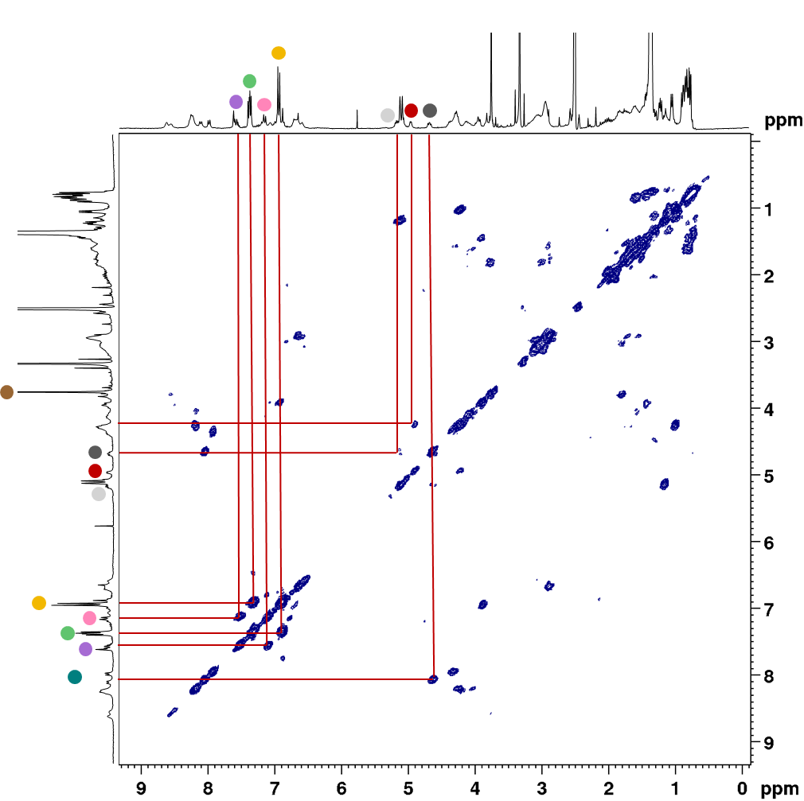
Figure S9. ¹H-¹H COSY of 4 (DMSO-d₆, 400 MHz). Only significative correlations have been indicated for clarification purposes.
Figure S10. ¹H NMR spectrum of 5 (DMSO-d₆, 400 MHz). Compound 5 was used for deprotection without further purification. For the sake of clarification, unaltered protons of the original compound (colistin sulphate) are labelled with the same letter as in Figure S5, whereas those that appear after structural modification are labelled with a colored circle.

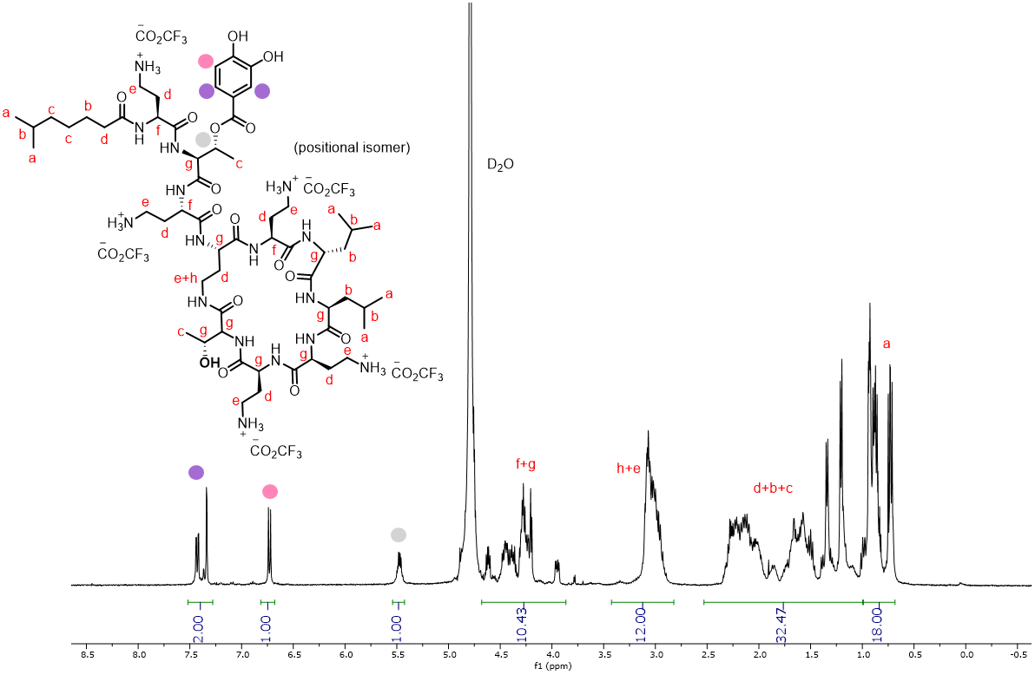
Figure S11. ¹H NMR spectrum of monoEST-COL (6) (D₂O, 400 MHz). Trifluoroacetate anions are represented as counterion according to the unique signal observed in the ¹⁹F-NMR spectrum, in which no trifluoroacetic acid traces are detected. It is assumed that after Sephadex® column with ammonium acetate buffer, a mixture of trifluoroacetate and acetate counterion is present in the molecule. For the sake of clarification, unaltered protons of the original compound (colistin sulphate) are labelled with the same letter as in Figure S5, whereas those that appear after structural modification are labelled with a colored circle.

Figure S12. ¹H NMR spectrum of diEST-COL (7) (D₂O, 400 MHz). For the sake of clarification, unaltered protons of the original compound (colistin sulphate) are labelled with the same letter as in Figure S5, whereas those that appear after structural modification are labelled with a colored circle.

2. Synthesis of AMI-COL: Optimization of experimental conditions
General procedure
Figure S13. Synthesis scheme for the synthesis of AMI-COL.
3,4-Dihydroxybenzoic acid (or derivative) was dissolved in the selected solvent. Activating system was also dissolved and added dropwise to the reaction mixture. The pH of the solution was adjusted to approx. pH 5 with HCl aqueous solution (1 M), and then it was allowed to stir for 1 h at room temperature until no unreacted acid was detected by thin layer chromatography (TLC). Afterwards, colistin sulfate was solubilized and dropwise added to the reacting mixture. The pH was then adjusted to approx. pH 9 with NaOH aqueous solution (1 M, maximum basic pH before colistin precipitation) and the reaction was kept stirring at room temperature overnight. The residue was evaporated to dryness and re-dissolved in 0.5 mL of water. Then, it was precipitated in cold acetone (2.5 mL) three times, isolating the product by centrifugation. Final compound was dried under vacuum overnight, obtaining a white powder.
Conditions for the screening. Experimental conditions
Attempts for optimization of colistin amidation are summarized in Tables S1-S4. Each entry corresponds to the different experimental conditions tested. Conversion (Conv. %) was calculated by ¹H NMR spectra, using a as standard for proton integration (a = 18H) and aromatic signals from catechol motif for the estimating the conversion (see Figure 4 a in the main text). Initially, different protecting groups were evaluated (Table S1). While protecting the dihydroxyl groups with acetate enhanced the conversion, their deprotection could not be achieved under the conditions tested. Therefore, 3,4-dihydroxybenzoic acid (R = H in Figure S13) was used in the following experiments. Subsequently, various activating agents (Table S2) and solvents (Table S3) were assessed, with EDC/NHS and a DMF/H₂O (1/1) mixture selected for yielding the highest conversion. Finally, acid-to-colistin ratio was increased (Table S4).
Table S1. Protecting groups screening. Conditions: 1 mmol colistin, 1 mmol acid, activating agents EDC/NHS, 24h, rt.
Attempt | R_{x} | Solvent (v/v) | Colistin concentration (M)^{d} | Conv.  (%, NMR)
1 | H | DMF/H₂O (1/1) | 0.04 | 30
2 | PMBª | DMF/H₂O^{c} | - | -
3 | PMBª | DMSO/H₂O (0.25/0.75) | 0.007 | -
4 | PMBª | THF/H₂O (1/1) | 0.007 | -
5 | Ac^{b} | THF/H₂O (1/1) | 0.02 | 50
a) PMB = p-methoxybenzyl
b) Ac = Acetyl. After amidation, deprotection of acetate groups was not possible under the tested conditions
c) DMF/H₂O ratios from 0.25/0.75 to 0.75/0.25 were tested, but no solvent mixture or concentration in which both PMB-protected acid and colistin were soluble was found
d) Concentration of colistin to ensure max. solubilization of the reactants

Table S2. Activating agents screening. Conditions: 1 mmol colistin, 1 mmol 3,4-dihydroxybenzoic acid (R = H), 24h, rt.
Attempt | Activating agents | Solvent (v/v) | Colistin concentration (M)^{b} | Conv.  (%, NMR)
1 | EDC/NHS | DMF/H₂O (1/1) | 0.04 |  | 30
6 | EDC/NHS-sodium salt | H₂O | 0.04 |  | -
7 | EDC/NHS-sodium salt | DMF/H₂O (1/1) | 0.04 |  | 20
8 | EDC/HOBtª | Propanol/H₂O (1/1) | 0.03 |  | 30
a) HOBt = Hydroxybenzotriazole
b) Concentration of colistin to ensure max. solubilization of the reactants

Table S3. Solvent screening. Conditions: 1 mmol colistin, 1 mmol 3,4-dihydroxybenzoic acid (R = H), activating agents EDC/NHS, 24h, rt.
Attempt | Solvent (v/v) | Colistin concentration (M)ª | Conv. (%, NMR)
1 | DMF/H₂O (1/1) | 0.04 | 30
9 | THF/H₂O (1/1) | 0.07 | 20
a) Concentration of colistin to ensure max. solubilization of the reactants

Table S4. Acid-to-colistin ratio screening. Conditions: 1 mmol colistin, DMF/H₂O (1/1), activating agents EDC/NHS, 24h, rt.
Attempt | mmol acid | Colistin concentration (m)ª | Conv. (%, NMR)
1 | 1 | 0.04 | 30
10 | 2 | 0.05 | 30
11 | 3 | 0.07 | -
12 | 5 | 0.007 | -
a) Concentration of colistin to ensure max. solubilization of the reactants

3. Organoids derivation from human tissues
Human tissues
All human adult samples were collected from the Biobank of the Aragon Health System. All the patients signed an informed consent. Briefly, the kidneys were opened in the Pathological Anatomy laboratory and a small part of the kidney cortex was selected. The tissue was maintained in Advanced F-12 medium at 4°C until processing.
Tissue processing
The selected tissue was minced in ~1 mm³ pieces and then digested in 1 mg mL⁻¹ collagenase solution (Sigma, C9407) and 10 µM Y-27632 (Abmole) during 45 min at 37°C shaking the tube by inversion every 5 minutes. Next, the suspension was washed with Advanced F-12 medium and centrifuged at 300×g 5 min, RT. In case of a visible red pellet, erythrocytes were lysed in 1 mL red blood cell lysis buffer (Roche) for 5 min, RT, before the addition of 10 mL Advanced F-12 medium. Then, the samples were centrifuged at 300×g, 5 min, RT. Finally, the cell pellets were seeded in Cultrex growth factor-reduced BME-2 (Biotechne) and cultured in kidney organoid complete medium [2,3].
References
[1] W. Tegge, G. Guerra, A. Höltke, L. Schiller, U. Beutling, K. Harmrolfs, L. Gröbe, H. Wullenkord, C. Xu, H. Weich, M. Brönstrup, Selective Bacterial Targeting and Infection-Triggered Release of Antibiotic Colistin Conjugates, Angew. Chemie Int. Ed. 60 (2021) 17989–17997. https://doi.org/https://doi.org/10.1002/anie.202104921.
[2] C. Calandrini, F. Schutgens, R. Oka, T. Margaritis, T. Candelli, L. Mathijsen, C. Ammerlaan, R.L. van Ineveld, S. Derakhshan, S. de Haan, E. Dolman, P. Lijnzaad, L. Custers, H. Begthel, H.H.D. Kerstens, L.L. Visser, M. Rookmaaker, M. Verhaar, G.A.M. Tytgat, P. Kemmeren, R.R. de Krijger, R. Al-Saadi, K. Pritchard-Jones, M. Kool, A.C. Rios, M.M. van den Heuvel-Eibrink, J.J. Molenaar, R. van Boxtel, F.C.P. Holstege, H. Clevers, J. Drost, An organoid biobank for childhood kidney cancers that captures disease and tissue heterogeneity, Nat. Commun. 11 (2020) 1310. https://doi.org/10.1038/s41467-020-15155-6.
[3] F. Schutgens, M.B. Rookmaaker, T. Margaritis, A. Rios, C. Ammerlaan, J. Jansen, L. Gijzen, M. Vormann, A. Vonk, M. Viveen, F.Y. Yengej, S. Derakhshan, K.M. de Winter-de Groot, B. Artegiani, R. van Boxtel, E. Cuppen, A.P.A. Hendrickx, M.M. van den Heuvel-Eibrink, E. Heitzer, H. Lanz, J. Beekman, J.-L. Murk, R. Masereeuw, F. Holstege, J. Drost, M.C. Verhaar, H. Clevers, Tubuloids derived from human adult kidney and urine for personalized disease modeling, Nat. Biotechnol. 37 (2019) 303–313. https://doi.org/10.1038/s41587-019-0048-8.

