Supplementary material

A novel hybrid approach for predicting and optimizing the adsorption of methyl orange and Cr(VI) removal from aqueous solutions using fungal-cross linked chitosan integrated into graphene oxide as a cost-effective adsorbent

Mohammed T.M. H.Hamad
Central Laboratory for Environmental Quality Monitoring, National Water Research Center, Egypt
Corresponding author:
Mohammed T.M.H.Hamad
e-mail: mohamed_taha@nwrc.gov.eg

Contents
Fig. S1 Phylogenetic tree of the fungal isolate Trichoderma sp
Fig.S2. FTIR spectra of (a)Cs; (b) GO @Cs-GLA-TiO₂ composite; (c) TiO₂; (d) GO @Cs-GLA-TiO₂ composite after dye (e ) MO and(f) Cr(VI).
Fig. S3. (a-b-c-d) the XRD images of GO, TiO₂,CS, and GO @Cs-GLA-TiO₂ composite
Fig.S4 (a)The actual vs predicted removal percentage, (b) The normal probability vs the plot of the studentized residuals, (c),(d) The cook’s distance for each of the experimental runs, Box–Cox plot (e,f) each of the variables for the removal of MO and Cr(VI) adsorption on GO@Cs-GLA-TiO₂.

Fig.S5 (a)The actual vs predicted removal percentage, (b) The normal probability vs the plot of the studentized residuals, (c),(d) The cook’s distance for each of the experimental runs, each of the variables for the removal of MO adsorption on fungal@Cs-GLA-GO.

Fig. S6 Response surface graph for the removal of MO (%) by biosorbent with interactions between(a) temperature and dosage, (b) pH and dosage, and (c) initial concentration of MO (d) pH and temperature, and(e) initial concentration of MO and temperature, and (fl) pH and initial concentration of MO, and (m) desirability ramps for numerical optimization of four independent variable.

Fig. S7. RSM-ANN model: (a) Linear regression for the ANN-MO model training, verification, testing, and combined input data sets, (b) error histogram, and (c) MSE plot for training, validation, testing, and all data and(d) The percentage of the prediction error of the MO-ANN model.

Fig. S8 Time of the lag phase (t0) versus the initial MO concentration (a), and (b) (S₀) maximum specific growth rate μm versus the time of the lag phase t₀ for S₀ below
Fig. S9 Experimental and predicted speciﬁc substrate consumption rates at diﬀerent MO concentrations due to diﬀerent models.

Table S1(a) Coded levels and design range of variables.

Table S2. Characterization methods and analyzed properties

Table S3 Kinetic models and their linearized expressions in the adsorption of MO/Cr(VI)by GO@Cs-GLA-TiO₂.

Table S4 Isotherm models and their linearized expressions in the adsorption of MO and Cr(VI) onto GO@Cs-GLA-TiO₂ adsorbent.

Table S5(a) Coded levels and design range of variables.
Table S5 (b)The ANOVA results for the response surface model for the removal of MO dye.

Table S5c Box–Behnken design-based experimental conditions and results for MO adsorption activity of composites fungal @fungal@Cs-GLA-GO.

Table S6 Various kinetic models for effect of substrate on growth rate.

Table S7 Comparative study for different biomass based adsorbents applied for methyl orange adsorption.

Table S8 Cost analysis of materials used for adsorption using GO @Cs-GLA-TiO₂.

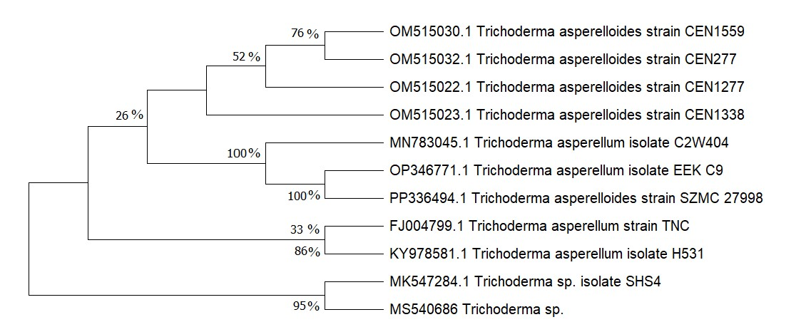
Fig. S1 Phylogenetic tree of the fungal isolate Trichoderma sp

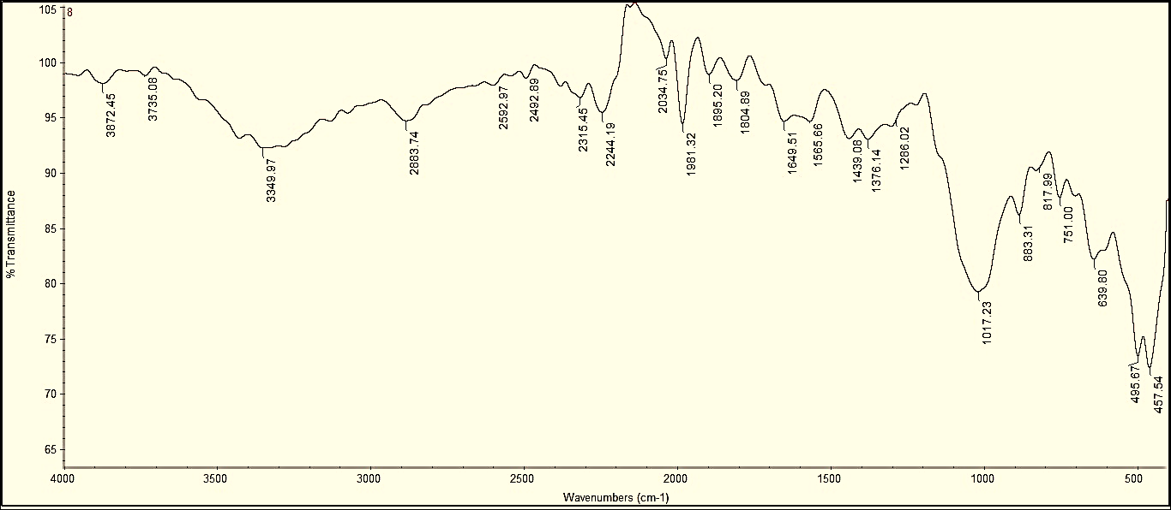
a
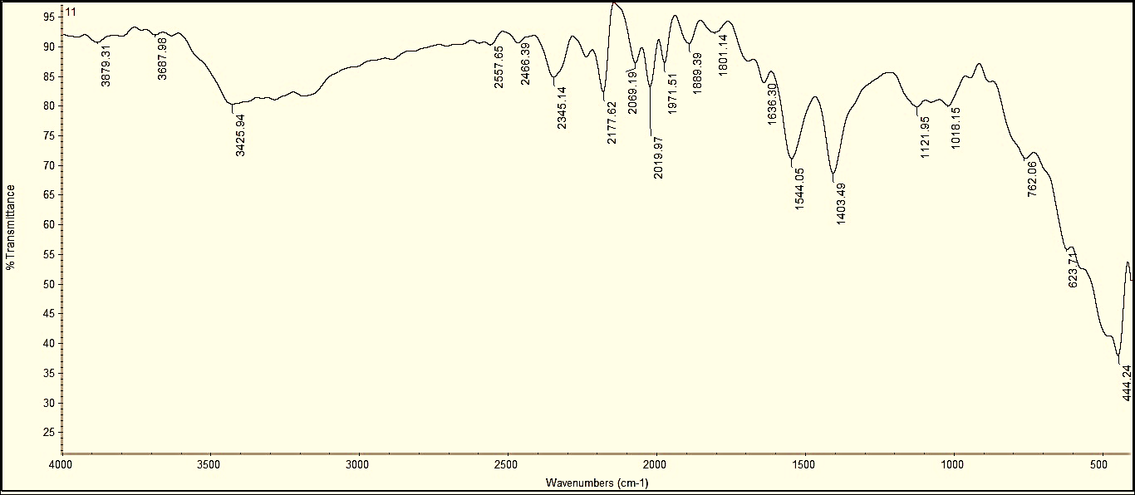
b
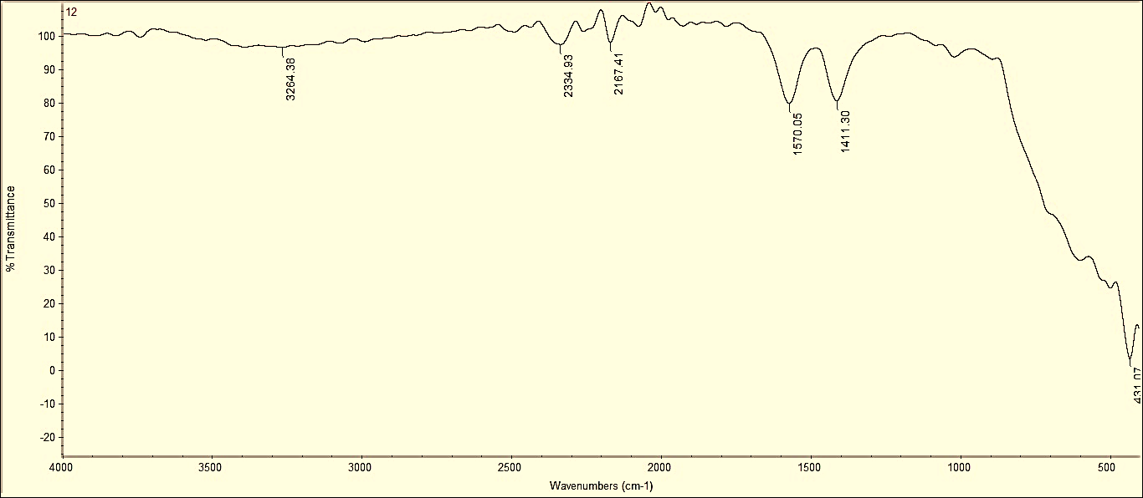
c
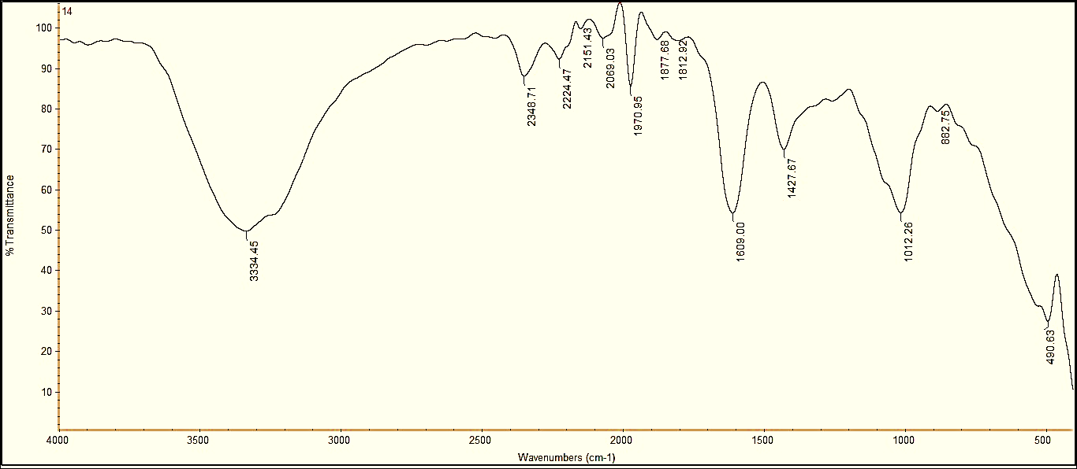
d
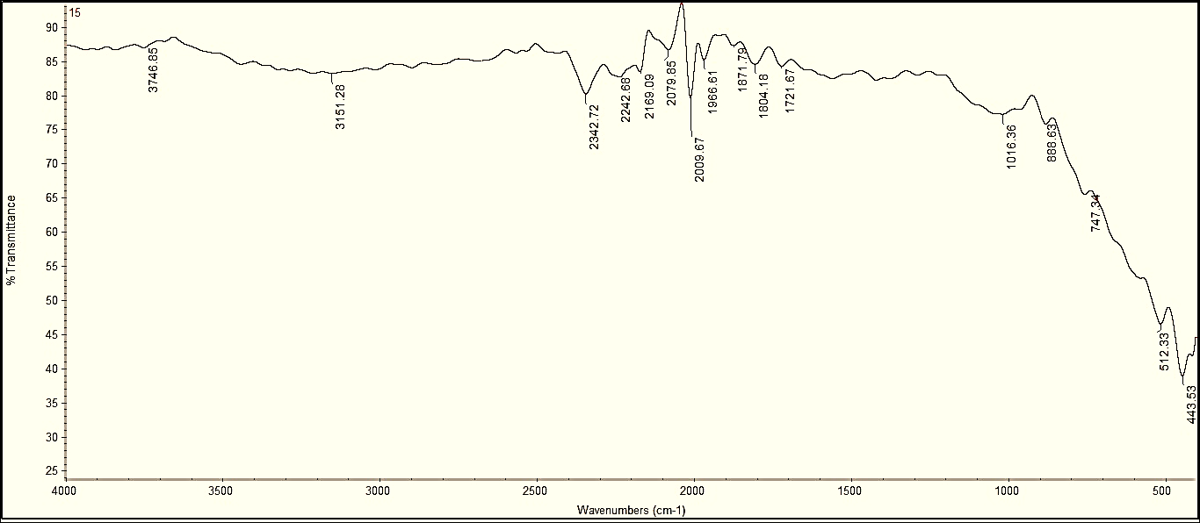
e
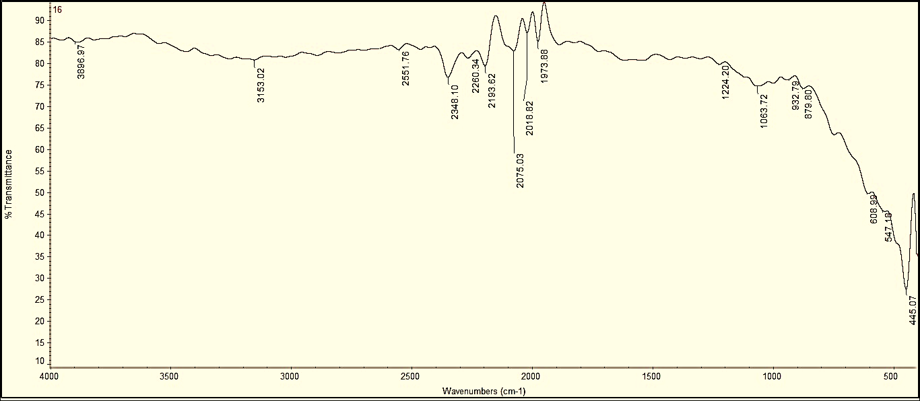
f
Fig.S2. FTIR spectra of (a)Cs; (b) GO @Cs-GLA-TiO₂ composite; (c) TiO₂; (d) GO @Cs-GLA-TiO₂ composite after dye (e ) MO and(f) Cr(VI).

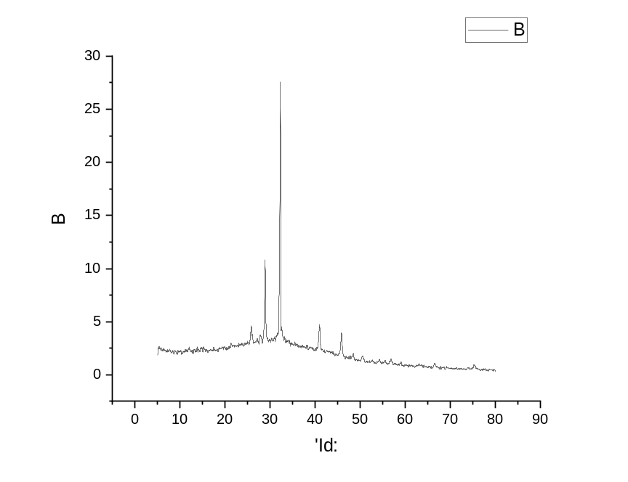
a
Intensity(a.u.)
2θ (degree)

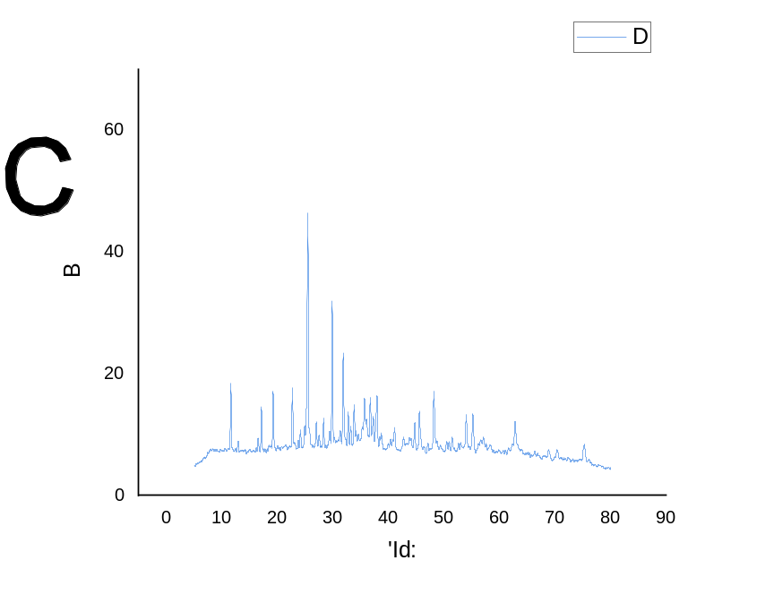
Intensity(a.u.)
b
2θ (degree)
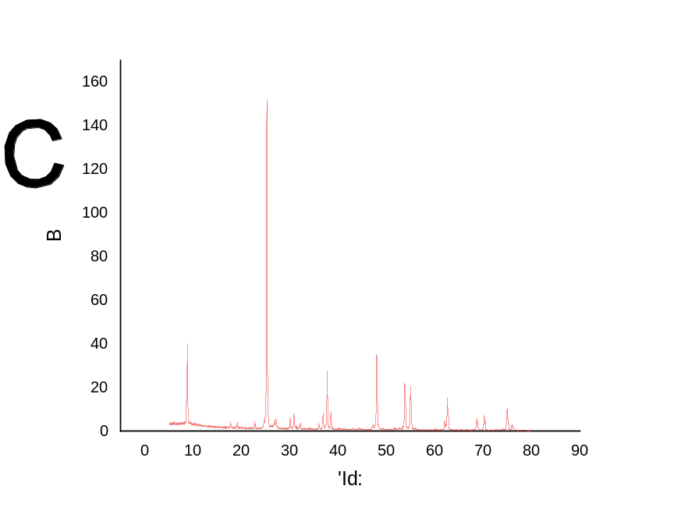
Intensity(a.u.)
c
2θ (degree)

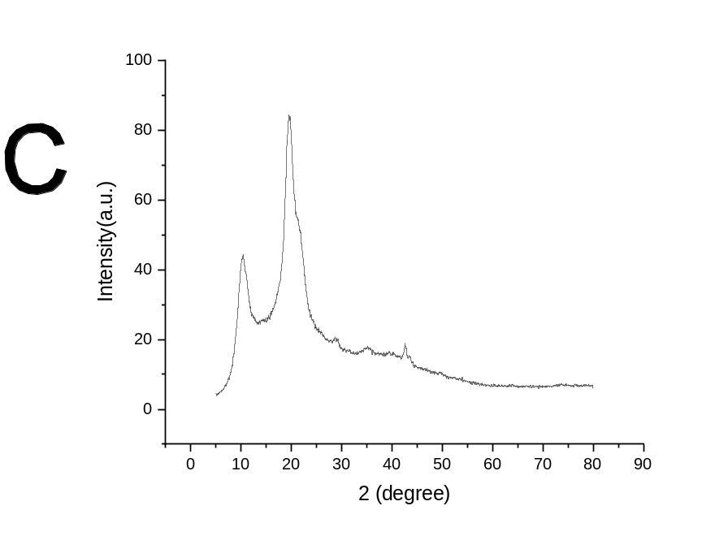
d
Intensity(a.u.)
2θ (degree)

Fig. S3. (a-b-c-d) the XRD images of GO, TiO₂,CS, and GO @Cs-GLA-TiO₂ composite.

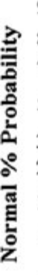
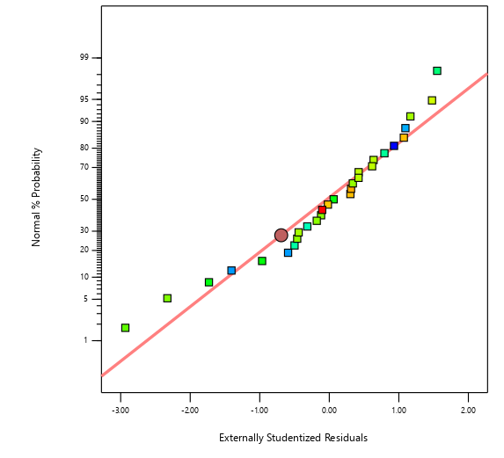
b
a
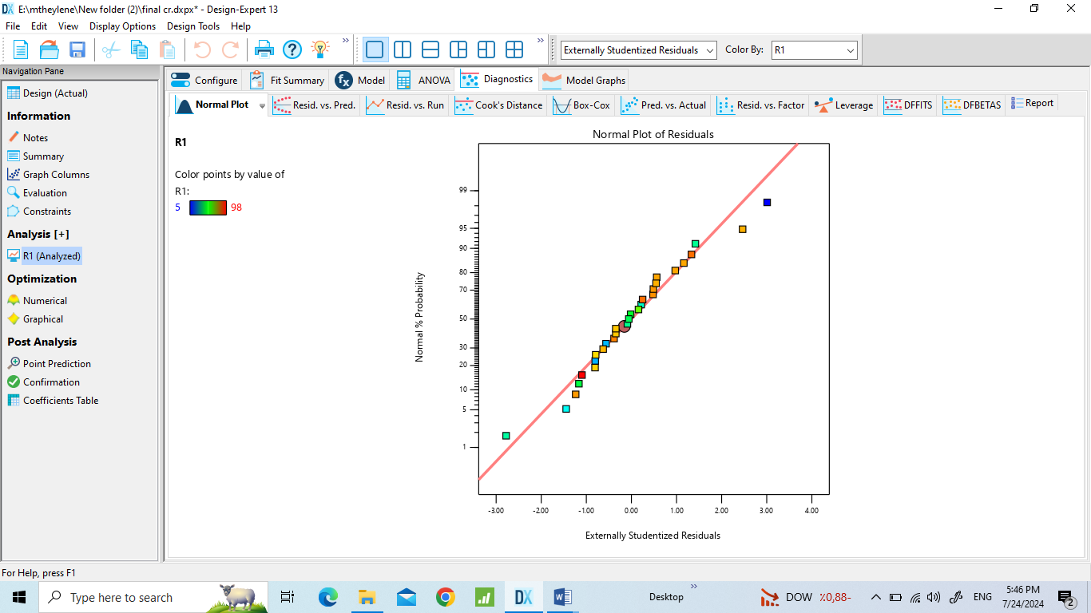
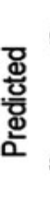
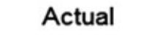
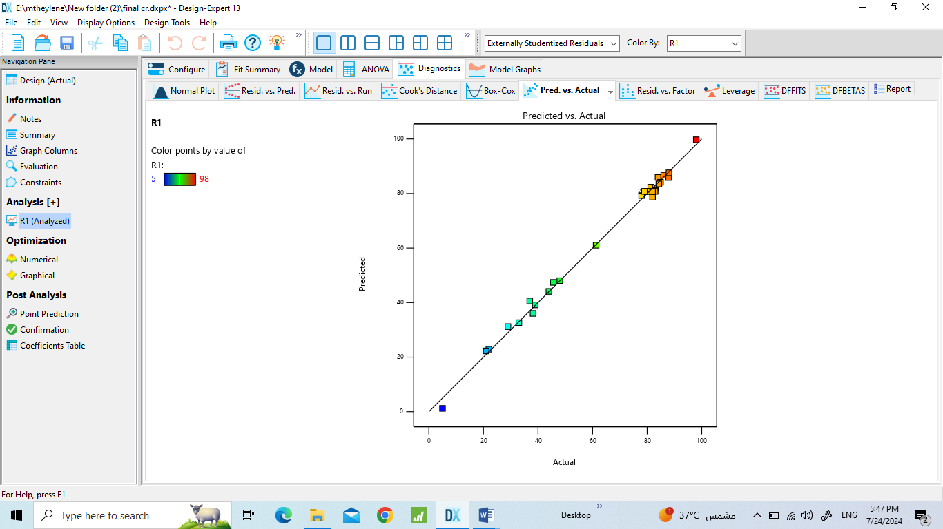
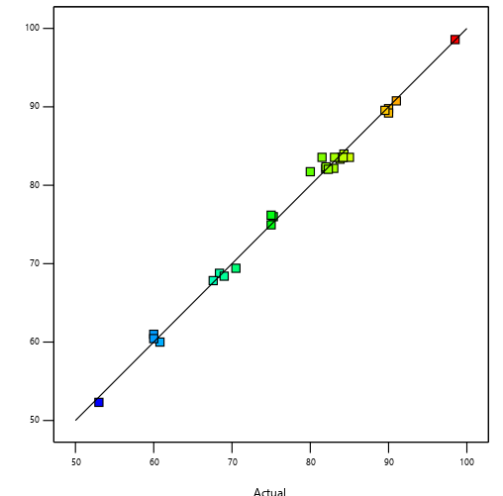
d
c

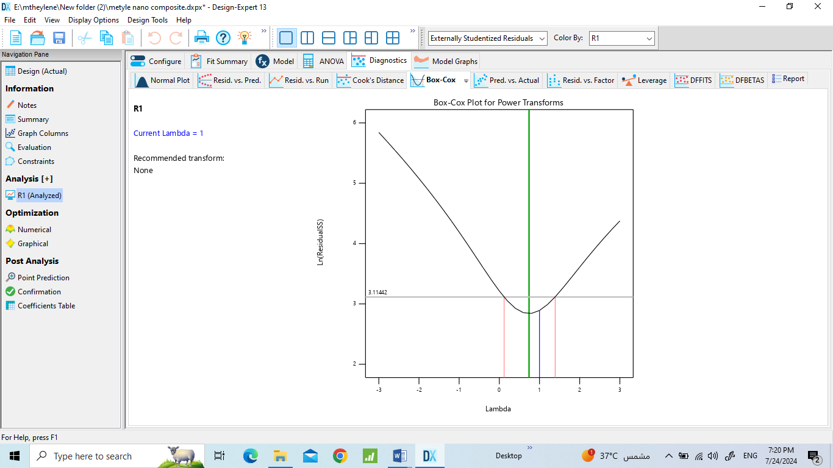
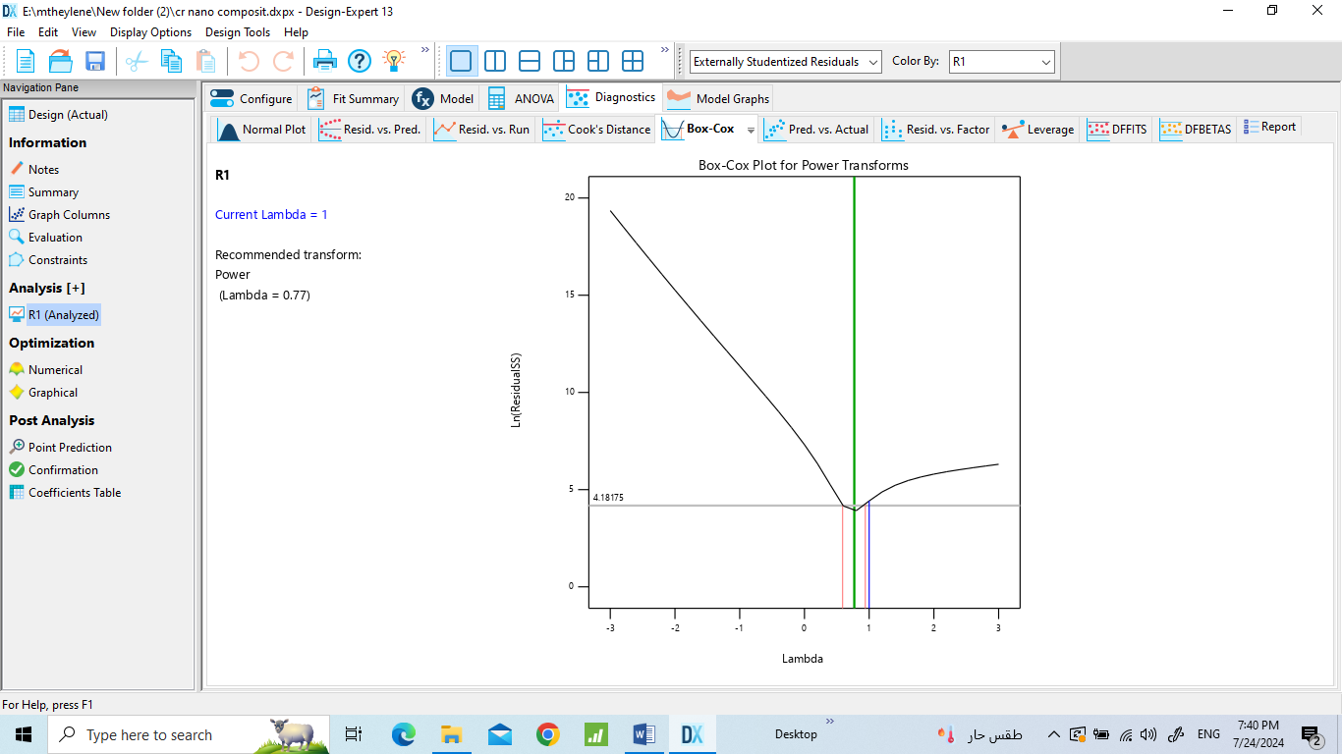
c
e
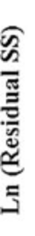
f

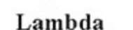

Fig.S4(a)The actual vs predicted removal percentage, (b) The normal probability vs the plot of the studentized residuals, (c),(d) The cook’s distance for each of the experimental runs, Box–Cox plot (e,f) each of the variables for the removal of MO and Cr(VI) adsorption on GO@Cs--GLA-TiO₂.

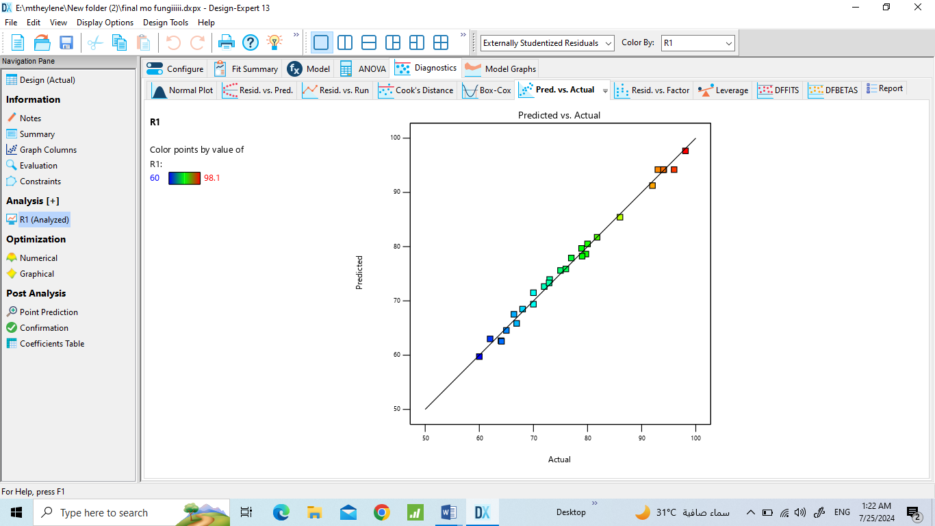
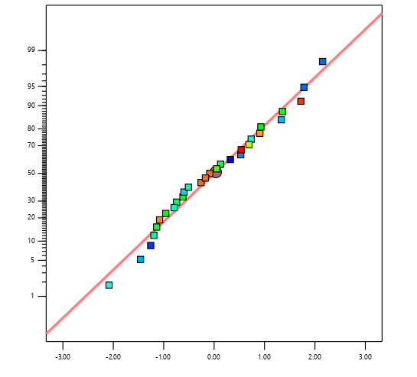

b
a

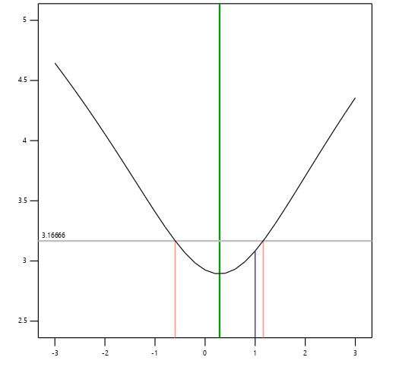

c

Fig.S5 (a)The actual vs predicted removal percentage, (b) The normal probability vs the plot of the studentized residuals, (c),(d) The cook’s distance for each of the experimental runs, each of the variables for the removal of MO adsorption on fungal@Cs-GLA-GO.

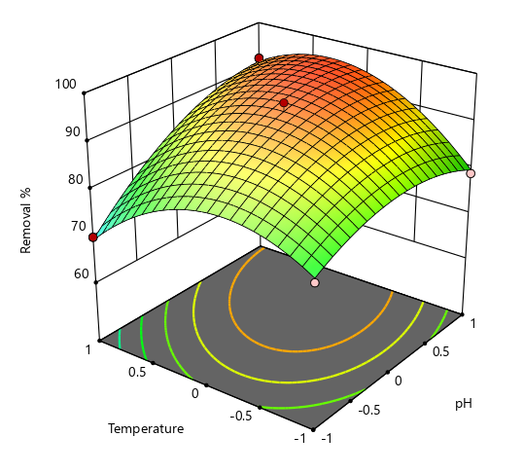
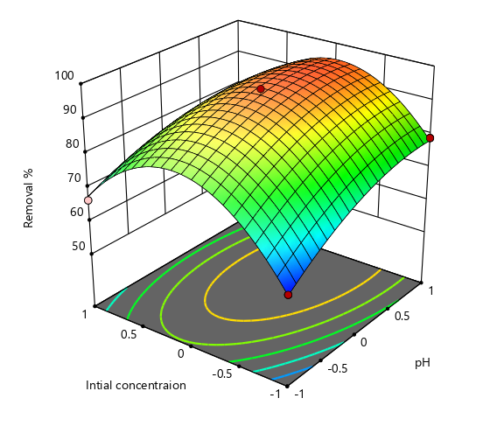
Removal %
Removal %

b
a
Contact Time

Temperature
pH
Contact Time

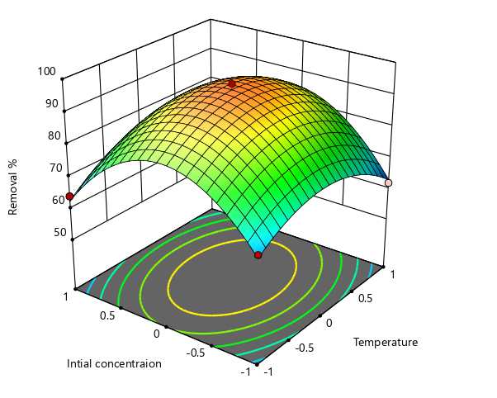
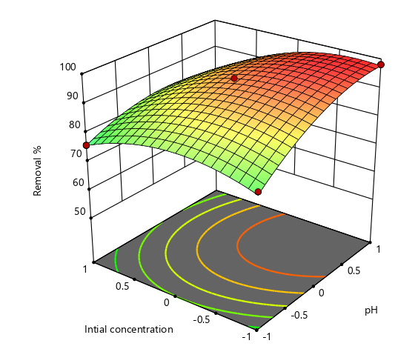
Removal %
Removal %

d
c

Temperature
Initial concentration
pH
Contact Time

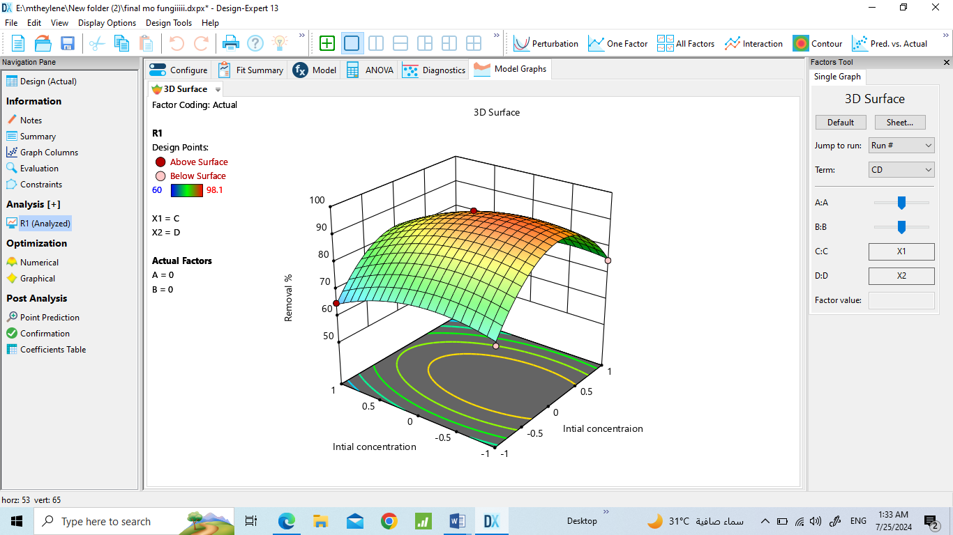
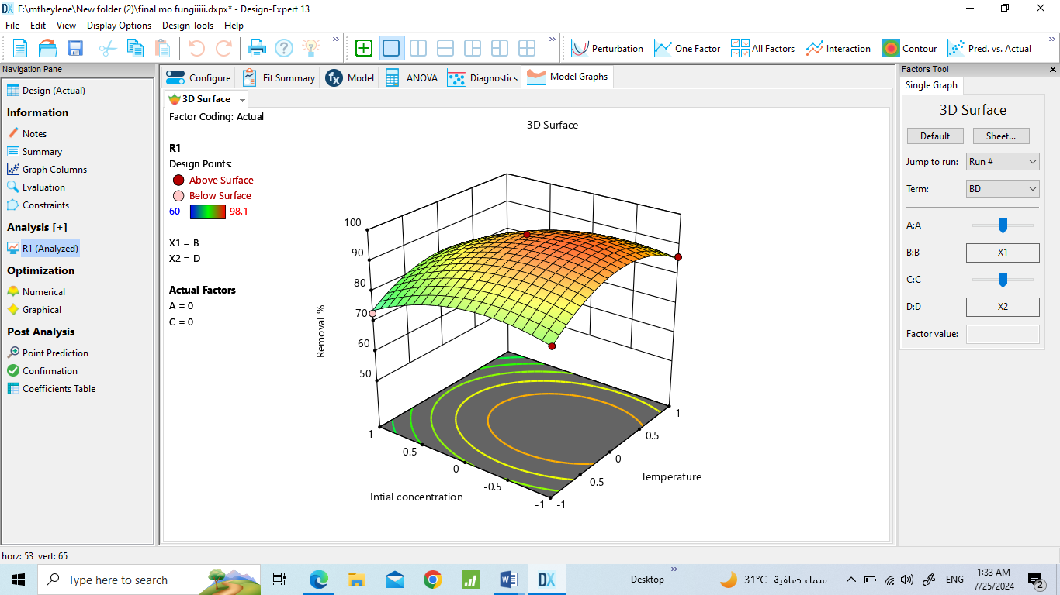
Removal %
Removal %
f
Temperature
e

Initial concentration
Initial concentration
pH

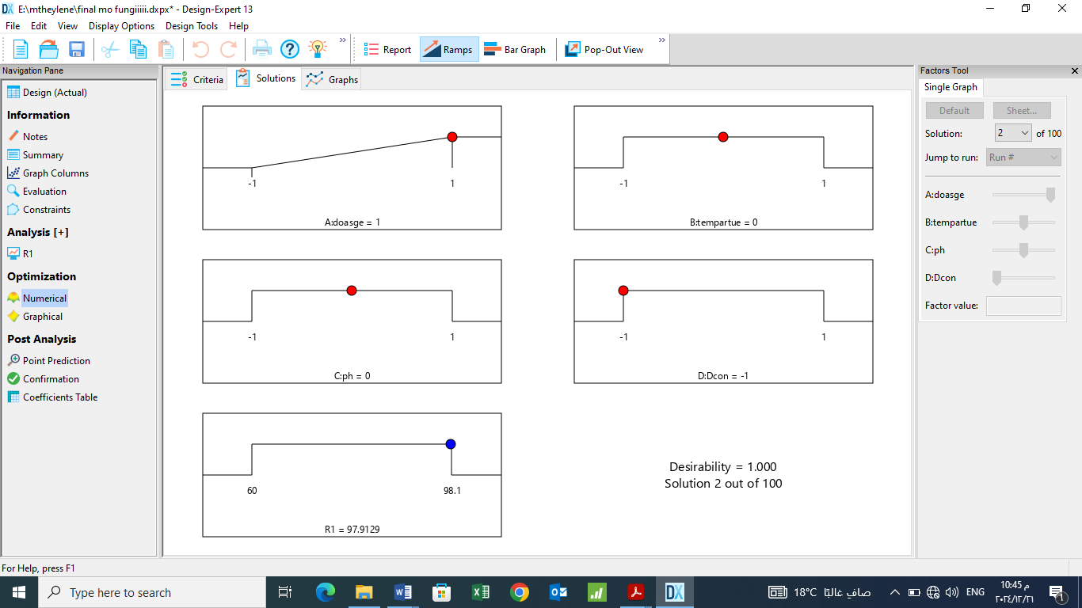
Fig. S6 Response surface graph for the removal of MO (%) by biosorbent with interactions between(a) temperature and dosage, (b) pH and dosage, and (c) initial concentration of MO (d) pH and temperature, and(e) initial concentration of MO and temperature, and (fl) pH and initial concentration of MO, and (m) desirability ramps for numerical optimization of four independent variable.

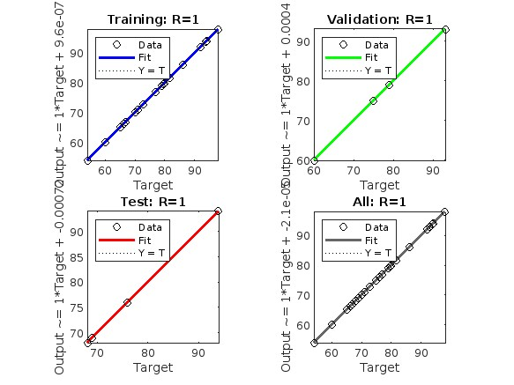
a

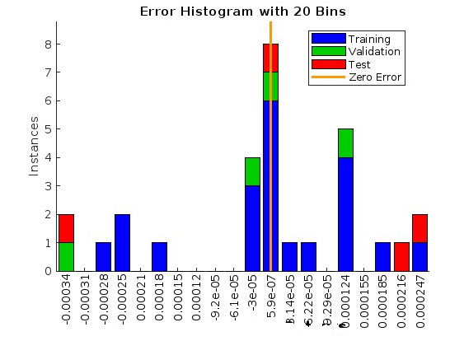
b

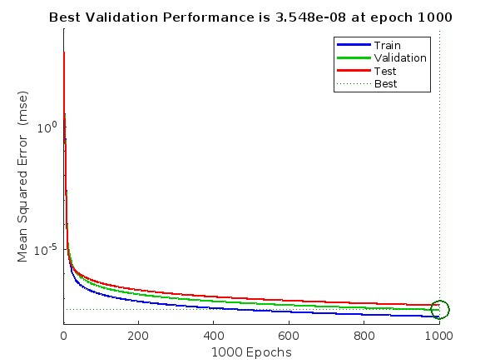
c
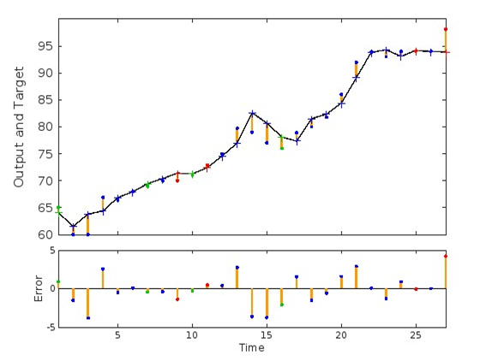
d
Fig. S7. RSM-ANN model: (a) Linear regression for the ANN-MO model training, verification, testing and combined input data sets, (b) error histogram, and (c) MSE plot for training, validation, testing, and all data and(d) The percentage of the prediction error of the MO-ANN model.

a
b
Fig. S8 Time of the lag phase (t0) versus the initial MO concentration (a), and (b) (S₀) maximum specific growth rate μm versus the time of the lag phase t₀ for S₀ below
a

b

c

d

e
Fig. S9 Experimental and predicted speciﬁc substrate consumption rates at diﬀerent MO concentrations due to diﬀerent models.

Table S1 Coded levels and design range of variables.
Factor | Code | -1 | 0 | 1
Adsorbent dose(g) | A | 0.4 | 0.6 | 0.8
Contact time(min) | B | 40 | 60 | 80
pH | C | 2 | 3 | 4
Initial concentration (MO/Cr(VI)) (mgL⁻¹) | D | 10 | 15 | 20

Table S2. Characterization methods and analyzed properties
Method | Properties to be Analyzed
SEM Particle shape, size and morphology.  EDX | Energy-dispersive X-ray spectroscopy (EDX) was performed for the semi-quantitative test of the prepared catalysts using scanning electron microscope coupled with EDX unit (Quanta FEG250, FEI Company
XRD Extent of Crystallization of the sample. | X-ray diffraction (XRD) analysis was performed on X-ray diffractometer (PANalytical X’Pert Pro, United Kingdom.
FT-IR | The Fourier- transformed infrared (FTIR) spectra of the synthesized catalysts were obtained using Bruker-VERTEX 80V to identify the surface functional groups at ambient conditions within the wavelength range from 400 to 4000 cm⁻¹.

Kinetic models | Linear expression | Plot | Parameters
Pseudo-first order | ln(q_{e} − q_{t}) =lnq_{e} − k_{1p}t eq.4 | ln(q_{e} − q_{t}) vs.t | q_{e} = exp(intercept),  k_{1p} = −(slope)
Pseudo-second  Order | t/q_{t} = 1/k₂pq_{e}² + t/qe  eq.5 | t/q_{t} vs. t | qe= slope⁻¹,  k_{2p} = (slope²)/intercept
Intraparticle diffusion | q_{t} = K_{p}t^{1∕2} eq.6 | q_{t} vs t^{1/2} | k_{iP} = slop  C =intercept
Elovich | q_{t}=1βln(αβ) +1βln(t)eq.(7) | q_{t} vs t

Table S3 Kinetic models and their linearized expressions in the adsorption of MO/Cr(VI)by GO@Cs-GLA-TiO₂.

Table S4 Isotherm models and their linearized expressions in the adsorption of MO and Cr(VI) onto GO@Cs-GLA-TiO₂ adsorbent.

Isotherms | Equations | Linear expression | Description | Plot | Parameters
Langmuir | q_{e}=(q_{m}K_{L}C_{e})/(1 +K_{L}C_{e}) eq.3  $R_{L}=\frac{1}{1+K_{L}C_{°}}$ eq.(8) | C_{e}/q_{e} = (1/KLq_{m}) + (C_{e}/q_{m}) | qmax (mg/  g) = maximum adsorption capacity.  K_{L} (L/mg) = constant of Langmuir (free energy of adsorption) | (C_{e}/q_{e}) vs. C_{e} | q_{m}= (slope)⁻¹  K_{L}= slope/intercept
Freundlich | q_{e}=K_{F}(C_{e})^{1/n} eq.9 | $$lnq_{e}=lnK_{F}+\frac{1}{n}lnC_{e}$$ | KF (mL/g) = constants of Freundlich (the adsorption volume of the adsorbent)  1/n = constants (intensity of the analytes’ sorption) | ln q_{e} vs. ln C_{e} | K_{F}= exp(intercept), n = (slope)⁻¹
Temkin | q_{e}=q_{m} ln(KTC_{e}) eq. 10 | q_{e}=q_{m} ln KT + q_{m} ln C_{e} | ΔQ = variation of adsorption energy (ΔH)  K₀ = constant of Temkin. T = temperature (K)  R (8.314 J/mol) K = universal gas constant. | q_{e} vs. ln C_{e} | q_{m}= slope  KT= exp(intercept/slope
 | qe =KRp Ce/ 1+αRP (Ce ^{β} ) | ln KRP/ qe ⁻¹ = βln (Ce)+ln( α RP)

Factor | Code | -1 | 0 | 1
pH | A | 5 | 7 | 9
Temperature(^{O}C) | B | 20 | 30 | 40
Contact time(day) | C | 3 | 6 | 9
Initial concentration (mgL⁻¹) | D | 10 | 30 | 50

Table S5(a) Coded levels and design range of variables.

Table S5 (b)The ANOVA results for the response surface model for the removal of MO dye.

Source | Sum of Squares | df | Mean Square | F-value | p-value
Model | 3701.07 | 14 | 264.36 | 169.60 | < 0.0001 | significant
A-A | 418.90 | 1 | 418.90 | 268.74 | < 0.0001
B-B | 7.10 | 1 | 7.10 | 4.55 | 0.0510
C-C | 3.63 | 1 | 3.63 | 2.33 | 0.1493
D-D | 296.71 | 1 | 296.71 | 190.35 | < 0.0001
AB | 101.00 | 1 | 101.00 | 64.80 | < 0.0001
AC | 44.89 | 1 | 44.89 | 28.80 | < 0.0001
AD | 51.84 | 1 | 51.84 | 33.26 | < 0.0001
BC | 19.36 | 1 | 19.36 | 12.42 | 0.0034
BD | 4.69 | 1 | 4.69 | 3.01 | 0.1049
CD | 9.00 | 1 | 9.00 | 5.77 | 0.0307
A² | 164.52 | 1 | 164.52 | 105.55 | < 0.0001
B² | 598.11 | 1 | 598.11 | 383.70 | < 0.0001
C² | 2497.89 | 1 | 2497.89 | 1602.46 | < 0.0001
D² | 232.74 | 1 | 232.74 | 149.31 | < 0.0001
Residual | 21.82 | 14 | 1.56
Lack of Fit | 17.00 | 10 | 1.70 | 1.41 | 0.3958 | not significant
Pure Error | 4.82 | 4 | 1.21
Cor Total | 3722.90 | 28

Table S5c Box–Behnken design-based experimental conditions and results for MO adsorption activity of composites fungal@Cs-GLA-GO.

 | Factor 1 | Factor 2 | Factor 3 | Factor 4 | Response 1
Run | A:A | B:B | C:C | D:D | R1
1 | 0 | 0 | 1 | 1 | 64
2 | 0 | -1 | 1 | 0 | 64.1
3 | 0 | 0 | -1 | 1 | 65
4 | 0 | 1 | -1 | 0 | 62
5 | -1 | 0 | -1 | 0 | 60
6 | 0 | -1 | -1 | 0 | 66.9
7 | -1 | 0 | 1 | 0 | 66.4
8 | 0 | 1 | 1 | 0 | 68
9 | 1 | 0 | 1 | 0 | 72
10 | -1 | 1 | 0 | 0 | 70
11 | 0 | 0 | -1 | -1 | 70
12 | 0 | -1 | 0 | 1 | 73
13 | 0 | 1 | 0 | 1 | 72.9
14 | 0 | 0 | 1 | -1 | 75
15 | -1 | 0 | 0 | -1 | 79.7
16 | 1 | 0 | -1 | 0 | 79
17 | -1 | -1 | 0 | 0 | 77
18 | -1 | 0 | 0 | 1 | 76
19 | 1 | -1 | 0 | 0 | 78.9
20 | 1 | 0 | 0 | 1 | 80
21 | 0 | -1 | 0 | -1 | 81.77
22 | 0 | 1 | 0 | -1 | 86
23 | 1 | 1 | 0 | 0 | 92
24 | 0 | 0 | 0 | 0 | 93.9
25 | 0 | 0 | 0 | 0 | 93
26 | 0 | 0 | 0 | 0 | 96
27 | 0 | 0 | 0 | 0 | 94.1
28 | 0 | 0 | 0 | 0 | 94
29 | 1 | 0 | 0 | -1 | 98.1

Table S6: Various kinetic models for the effect of substrate on growth rate

Models | Equation | μmax (hr^{–1}) | Ks (mg/L) | Ki | RMSE | AICc | R²
Haldane | $μ =\frac{μmaxS}{(S+KS+\frac{S^2}{Ki})}$ eq.(16) | 0.5 | 30 | 100 | 0.009 | -30.9 | 0.95
Han and Levenspiel | $μ =\frac{μmaxS\left[1-\left(\frac{S}{Sm}\right)\right]n}{\left(S+KS-\right)\left[1-\left(\frac{S}{Sm}\right)\right]m}$ eq.(17) | 1 | 30 |  | 0.022 | -29.02 | 0.91
Luong | $μ =\frac{μmaxS\left[1-\left(\frac{S}{Sm}\right)\right]n}{(S+KS)}$ eq.(18) | 0.7 | 15 |  | 0.05 | -26.4 | 0.90
Aiba | $μ=\frac{μmaxS exp(- S/Ki)}{ (S + KS)}$ eq.(19) | 1.3 | 10 | 40 | 0.04 | -20.7 | 0.85
Monod | $μmax=\frac{S}{KS}$ eq.(20) | 0.9 | 5 |  | 0.23 | -14.2 | 0.53

Qmax: Maximal Reduction Rate (h⁻¹)
ks :Half saturation constant for maximal reduction (mg/dm³)
RMS: Residual mean square

Table S7 Comparative study for different biomass-based adsorbents applied for methyl orange adsorption.

Adsorbents | Removal efficiency/adsorption capacity MO/Cr(VI) | References
Powdered Rumex abyssinicus | 98.5 % (3.7mg/g) (MO) | (Abewaa et al., 2023)
CO₃O₄ nanoparticles | 15% (46.08 mg/g) MO | (Baig et al., 2020)
CuO-ZnO composite | 78% 63.25 mg/g MO | (Najafidoust et al., 2024)
Graphene oxide/ZnO | 95% (Cr(VI) (125mg/g) | (Asl et al., 2013)
zero-valent iron (S-nZVI) supported on hydrogel | 87.7%(Cr(VI) | (Zhang et al., 2019)
PANI@WH composites | 98.5% (31 mg/g)(Cr(VI) | (Kumari et al., 2022)
Nnano-magnetic Enteromorpha prolifera hydrogel | 73% (231 mg/g) of MO/ Cr(VI)  54.2 mg/g. 25% | (Yang et al., 2023)
GO/ZnO nanocomposites | MO (88%) | (Moradi et al., 2022)
Biopolymer chitosan | 78.12 mg g-1 (80%)MO | (Khalil et al., 2021)
Jackfruit leaves powder | (78%)MO | (Dutta et al., 2022)
GO @Cs-GLA-TiO₂ | 277.7 mg/g) of MO/ Cr(VI)  33.89 mg/g | This study

Table S8 Cost analysis of materials used for adsorption using GO @Cs-GLA-TiO₂

Cost of preparing GO @Cs-GLA-TiO₂ for one adsorption | The raw materials used for preparing | Unit price (EGP/kg) | ($/kg) | Amount of raw material required for one adsorption(Kg)
 | NaOH (99.3%) | 500 | 10 | 100X10⁻³
 | GO | 1500
 | Distilled water for washing | 1.08 | 0.0216 | 100X10⁻³
 | GLA | 2500 | 0.8
 | Cs | 600 | 12
 | TiO₂ | 5000 | 100
Cost of electrical energy consumption during drying at 80^{O}c for 4h($) |  | 3.58 | 0.286
The estimated total cost for GO @Cs-GLA-TiO₂ ($)+ raw materials cost($) + cost of electrical energy($) |  |  | 0.123

