Flufenamic Acid-Based Sulfonohydrazide and Acetamide Derivatives NSAI as Inhibitors of Multi-Targets COX-1/COX-2/5-LOX: Design, Synthesis, in-silico ADMET and Binding Mode Studies

Shaimaa Hussein ª, Eman A. Fayed ^{b*}, Ahmed Ragab ^{c,d}, Moustafa S. Abusaif ^{c}, Yousry A. Ammar ^{c}, Reda El-Sayed Mansour^{e}, Arafa Musa ^{f}, Triveena M. Ramsis ^{g*}
ª Department of Pharmacology, College of Pharmacy, Jouf University, Sakaka 72341, Aljouf, Saudi Arabia; ^{b} Department of Pharmaceutical Organic Chemistry, Faculty of Pharmacy (Girls), Al-Azhar University, Cairo 11754, Egypt; ^{c} Department of Chemistry, Faculty of Science (Boys), Al-Azhar University, Nasr City 11884, Cairo, Egypt; ^{d} Chemistry Department, Faculty of Science, Galala University, Galala City, 43511, Suez, Egypt; ^{e}Department of Pharmaceutical Medicinal Chemistry and Drug Design, Faculty of Pharmacy (Girls), Al-Azhar University, Cairo 11754, Egypt; ^{f} Department of Pharmacognosy, College of Pharmacy, Jouf University, Sakaka, Aljouf 72341, Saudi Arabia; ^{g} Department of Pharmaceutical Chemistry, Faculty of Pharmacy, Sinai University-Kantara Branch, Ismailia, 41636, Egypt.

Corresponding authors; Eman A. Fayed (Ph. D.) Tel.: + 202 01221330523; E-mail: alfayed_e@azhar.edu.eg & alfayed_e@yahoo.com; Triveena M. Ramsis (Ph.D); E-mail: triveena.farid@su.edu.eg & triveenaramsis@gmail.com

Supplementary Information

General Chemical Details
All commercial solvents and reagents were purchased from generic chemical companies and utilized just as is, without any purification. The melting points were recorded uncorrected using the Electrothermal LA 9000 SERIS, Digital Melting Point Apparatus. The IR spectra (KBr) (cm⁻¹) were measured on a JASCO spectrophotometer. ¹H NMR spectra were recorded on Bruker spectrometer (at 500 MHz) and are reported relative to deuterated solvent signals in deuterated chloroform (CDCl₃). ¹³C NMR spectra were recorded on Bruker Spectrometers (at 125 MHz) in deuterated chloroform (CDCl₃) at the Main Chemical Warfare Laboratories, Chemical Warfare Department, Ministry of Defense. Chemical shifts were calculated in ppm relative to TMS as the internal standard.

Spectral Data
Compound 14
Compound 15
Compound 16
Compound 17
Biology
Measurement of mTOR and Nrf2 protein expression
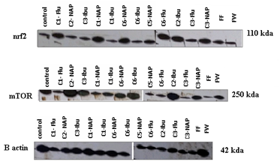
Figure S1: Effect of novel hybrids on nrf2 and mTOR expression levels.
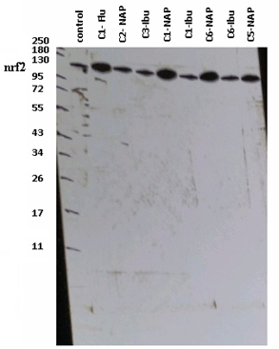 | 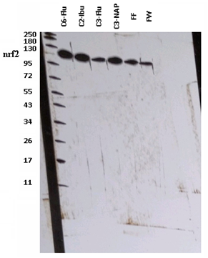
Figure S2: Raw data of gel images of nrf2 expression levels.
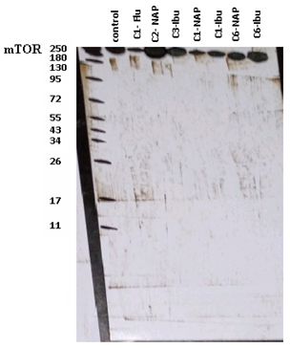 | 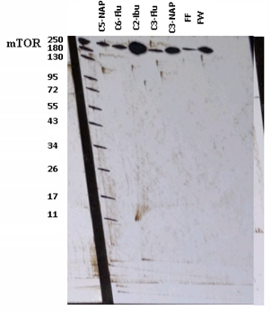
Figure S3: Raw data of gel images of mTOR expression levels.

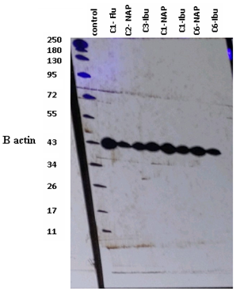 | 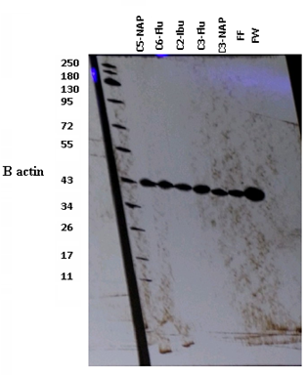
Figure S4: Raw data of gel images of ꞵ-actin expression.

Molecular Docking

Figure S5: Overlay between co-crystallized ligand (yellow) and re-docked pose (cyan) of Indomethacin deriv. (RMSD= 0.39 Å)
Figure S6: Ligand Interactions between the complex overlay and COX-1 pocket (PDB ID: 2OYE)
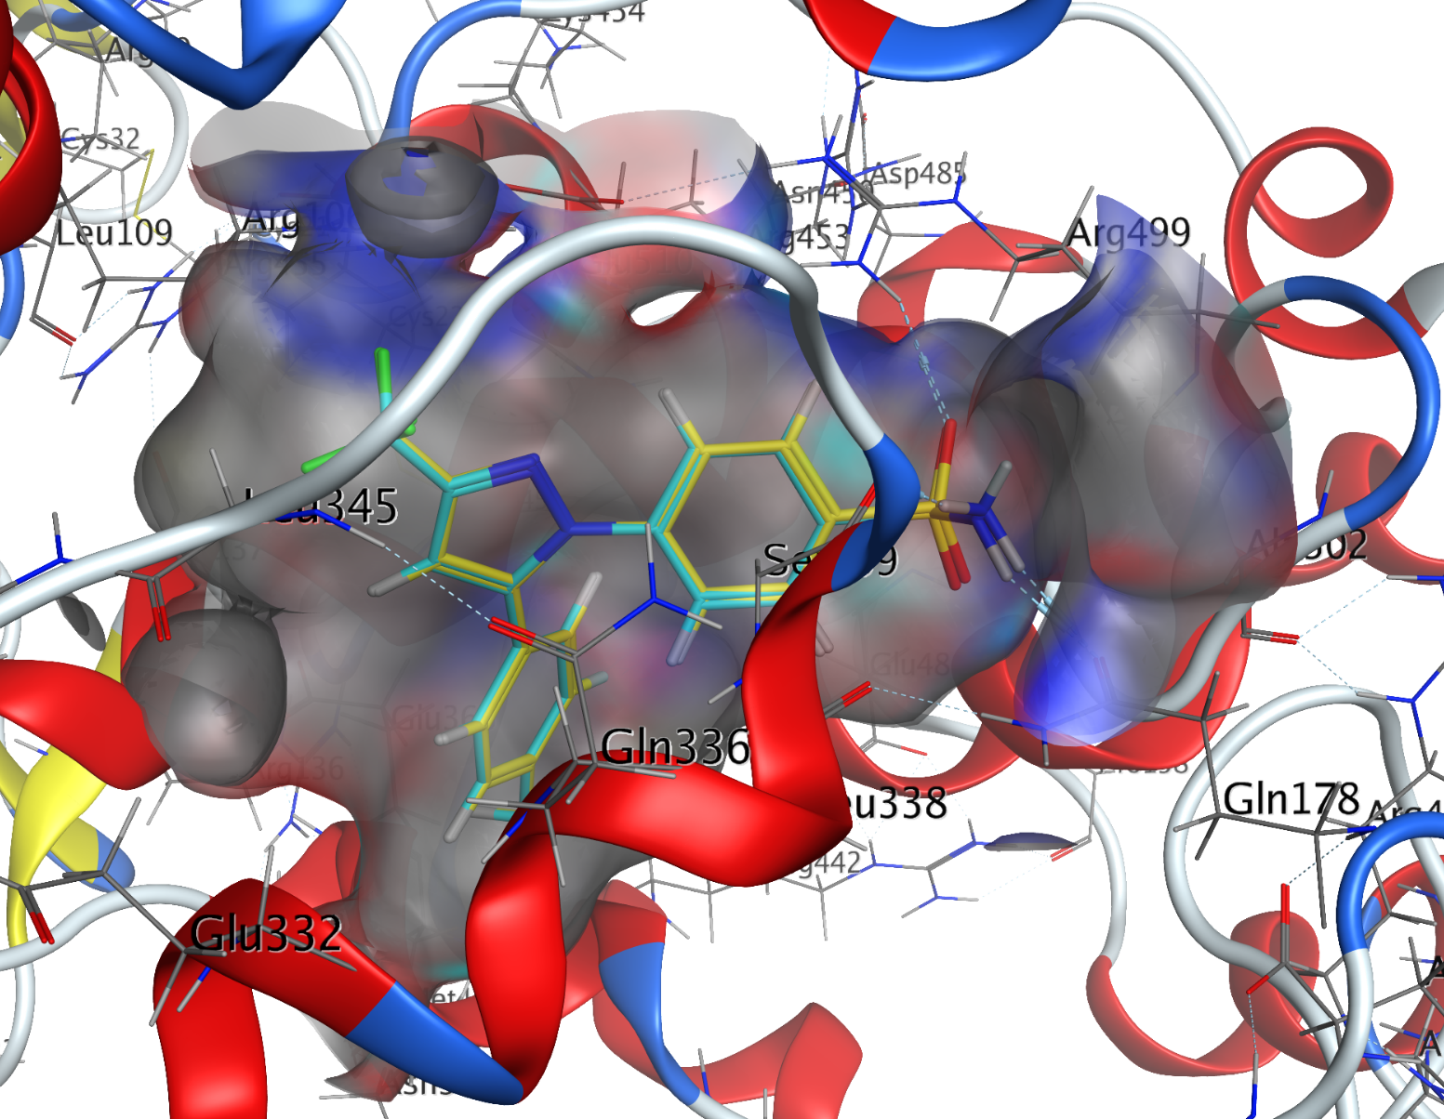
Figure S7: Overlay between co-crystallized ligand (yellow) and re-docked pose (cyan) of Celecoxib (RMSD= 0.087 Å)
Figure S8: Ligand Interactions between the complex overlay and COX-2 pocket (PDB ID: 3LN1)

Figure S9: 3D binding mode of 14 with COX-1 (PDB ID: 2OYE)
Figure S10: 2D ligand interactions of 14 with COX-1 (PDB ID: 2OYE)

Figure S11: 3D binding mode of 15 with COX-1 (PDB ID: 2OYE)

Figure S12: 2D ligand interactions of 15 with COX-1 (PDB ID: 2OYE)
Figure S13: 3D binding mode of 16 with COX-1 (PDB ID: 2OYE)

Figure S14: 2D ligand interactions of 16 with COX-1 (PDB ID: 2OYE)
Figure S15: 3D binding mode of 17 with COX-1 (PDB ID: 2OYE)

Figure S16: 2D ligand interactions 17 with COX-1 (PDB ID: 2OYE)

Figure S17: 3D binding mode of 14 with COX-2 (PDB ID: 3LN1)
Figure S18: 2D ligand interactions of 14 with COX-2 (PDB ID: 3LN1)

Figure S19: 3D binding mode of 15 with COX-2 (PDB ID: 3LN1)

Figure S20: 2D ligand interactions of 15 with COX-2 (PDB ID: 3LN1)

Figure S21: 3D binding mode of 16 with COX-2 (PDB ID: 3LN1)

Figure S22: 2D ligand interactions of 16 with COX-2 (PDB ID: 3LN1)

Figure S23: 3D binding mode of 17 with COX-2 (PDB ID: 3LN1)

Figure S24: 2D ligand interactions of 17 with COX-2 (PDB ID: 3LN1)

Figure S25: 3D binding mode of 14 with 5-LOX-1 (PDB ID: 3V99)

Figure S26: 2D ligand interactions of 14 with 5-LOX-1 (PDB ID: 3V99)

Figure S27: 3D binding mode of 15 with 5-LOX-1 (PDB ID: 3V99)

Figure S28: 2D ligand interactions of 15 with 5-LOX-1 (PDB ID: 3V99)

Figure S29: 3D binding mode of 16 with 5-LOX-1 (PDB ID: 3V99)

Figure S30: 2D ligand interactions of 16 with 5-LOX-1 (PDB ID: 3V99)

Figure S31: 3D binding mode of 17 with 5-LOX-1 (PDB ID: 3V99)

Figure S32: 2D ligand interactions of 17 with 5-LOX-1 (PDB ID: 3V99)

Figure S33: 3D binding mode of Zileuton with 5-LOX-1 (PDB ID: 3V99)

Figure S34: 2D ligand interactions of Zileuton with 5-LOX-1 (PDB ID: 3V99)

