Multi Spectroscopic Investigations with Molecular Docking and Molecular Dynamics Simulation of the Binding Mechanism of Molnupiravir to Bovine Serum Albumin
Supplementary data:

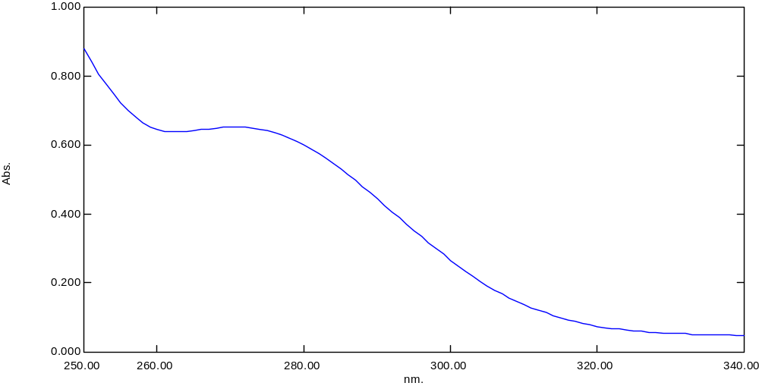
Fig. S1. UV spectra of molnupiravir (80 μM) in water, pH = 7.4.

Fig. S2. Modified Stern-Volmer plot of log[(F₀–F)/F] against log [Q] at different temperatures and pH 7.4.

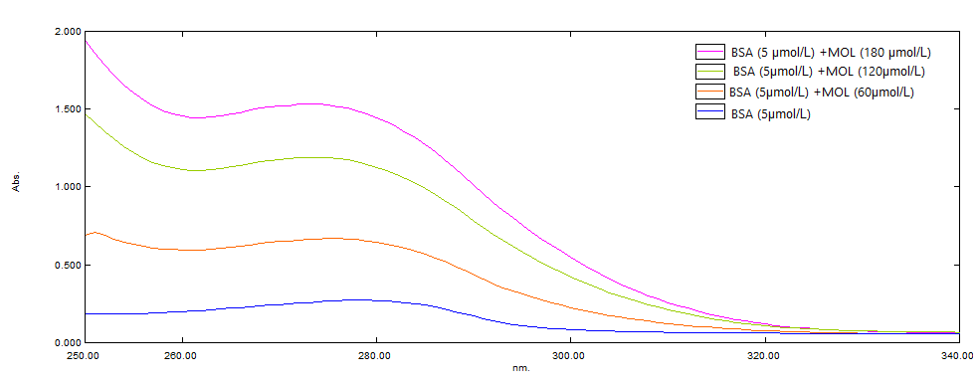
Fig. S3 UV spectra for BSA (5 μM) alone and with increasing concentrations of MOL (0, 60, 120, and 180 μM) at 295 K, pH = 7.4.

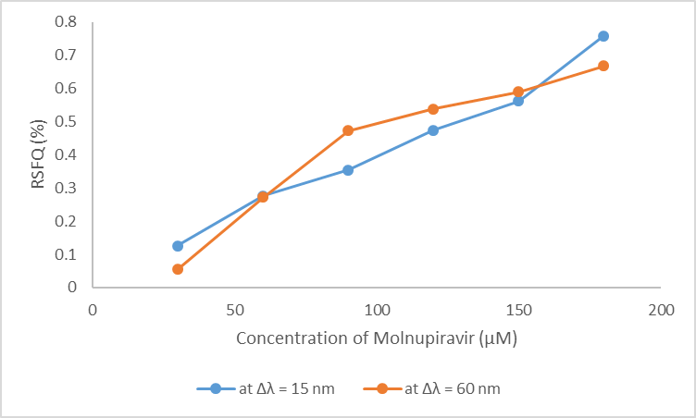

Fig. S4. Comparative analysis of MOL (30-180 μM) effect on the RSFQ% of BSA (3 μM) at pH = 7.4
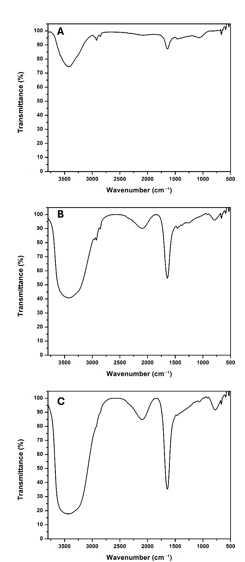
Fig. S5. The FT-IR spectra of (A) BSA (3 μM) in the tris-HCl buffer, (B) a mixture of BSA (3 μM) with MOL (180 µM) and (C) MOL (180 µM) in water at pH 7.4.

Fig. S6. Logarithmic plots of log[(F0–F)/F] against log[Q] in the presence and absence of site markers at 295 K, pH = 7.4.

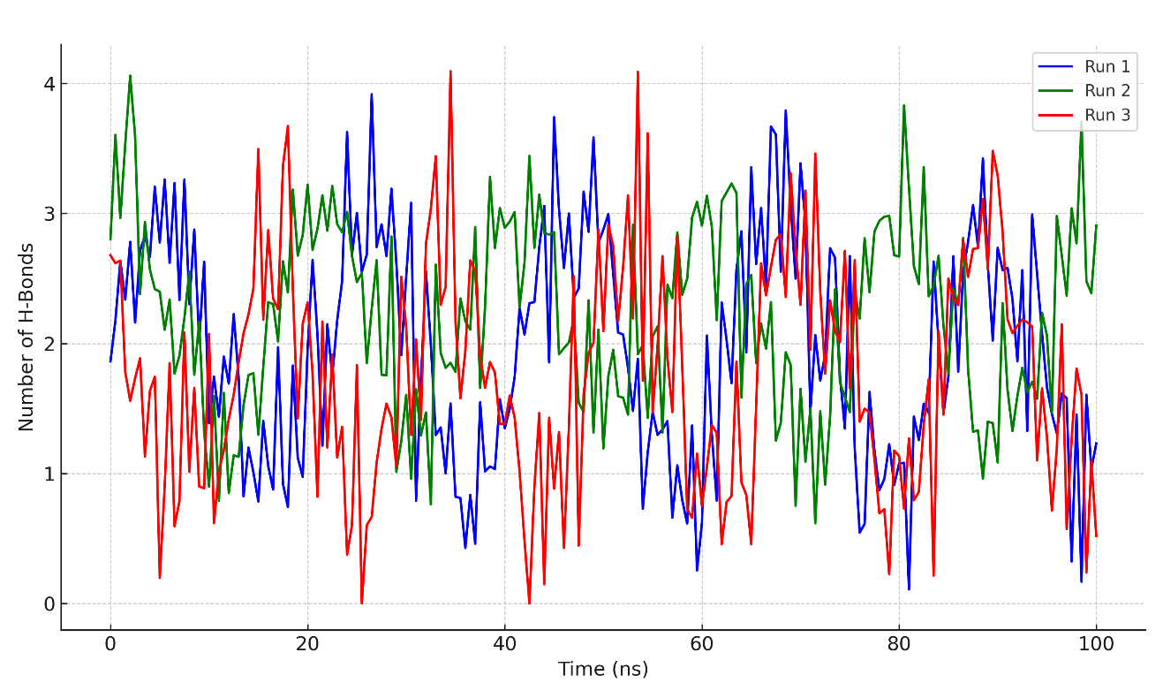
Fig. S7. Number of hydrogen bonds between MOL and BSA (Triplicate).
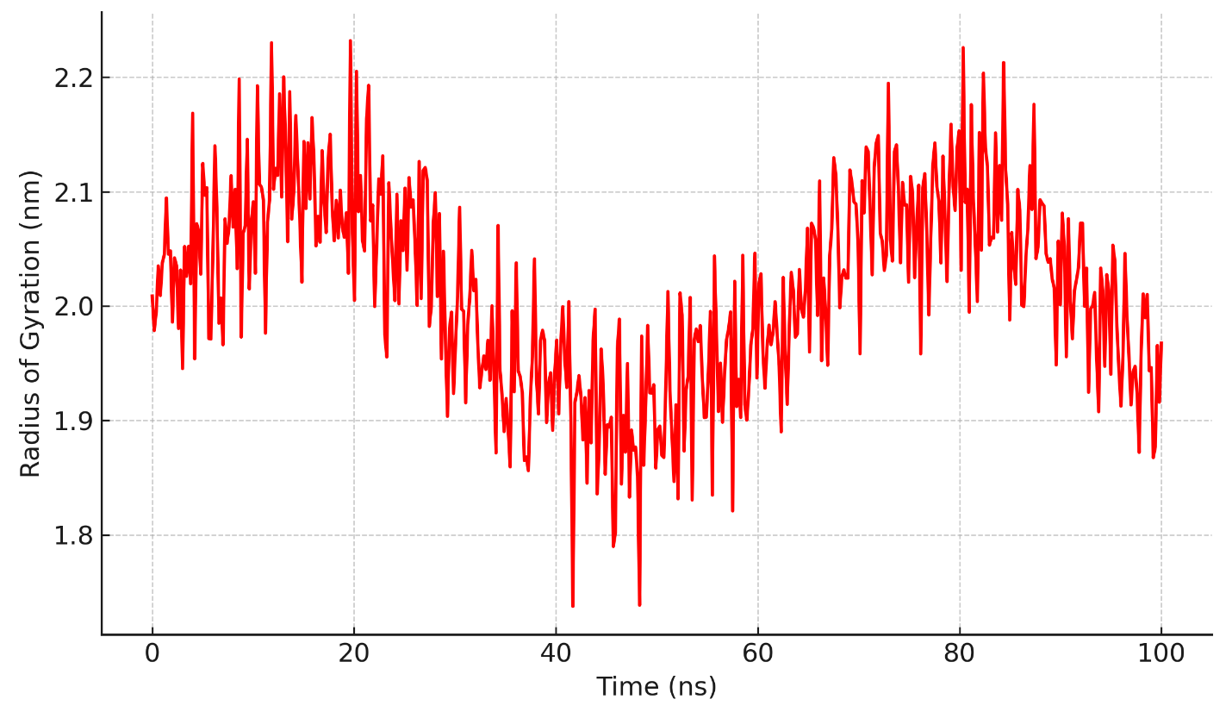
Fig. S8. Radius of gyration of BSA during MD simulation.

Table. S1. Binding constant of MOL with BSA in the presence of common ions at 297 K and pH 7.4.
Ion added | Log K_{a} | K_{a}’(L/mol) | K_{a}’/ Ka | r
No ion | 3.2151 | 1640.967 | 1 | 0.9914
Ca²⁺ | 3.1716 | 1484.567 | 0.9046 | 0.993
Cu²⁺ | 2.6257 | 422.376 | 0.2573 | 0.9911
Co²⁺ | 3.4255 | 2663.79 | 1.6233 | 0.9958

K𝑎′/𝐾𝑎 is the binding constant divided by the binding constant in the absence of the ion; r is the correlation coefficient.

Table. S2. Mean ± SD values of key MD parameters for the BSA–Molnupiravir complex over the last 50 ns of triplicate simulations.

Parameter | Run 1 | Run 2 | Run 3 | Mean ± SD (All Runs)
Backbone RMSD (nm) | 0.25 | 0.27 | 0.26 | 0.26 ± 0.03
Radius of Gyration, Rg (nm) | 2.04 | 2.06 | 2.05 | 2.05 ± 0.04
Hydrogen Bonds (count) | 2.4 | 2.1 | 2.3 | 2.3 ± 0.6

