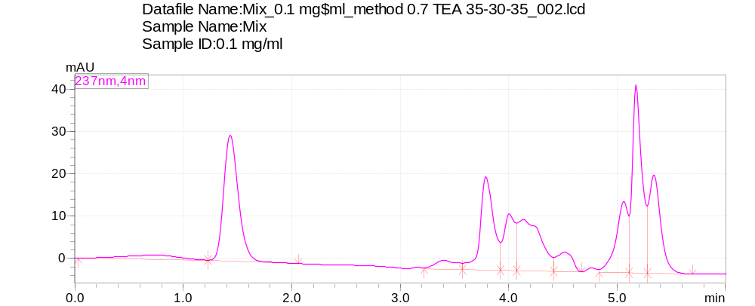
Fig S1: Chromatographic column Luna С8 (100 mm х 4.6 mm 3 μm) and mobile phase - ACN-MetOH-0.5% TEA pH 3.06 (35-30-35)
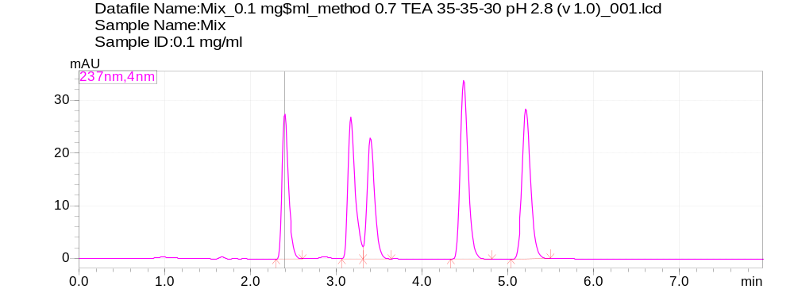
Fig S2: Chromatographic column Luna С8 (100 mm х 4.6 mm 3 μm) and mobile phase - ACN-MetOH-0.7% TEA pH 2.8 (35-35-30)
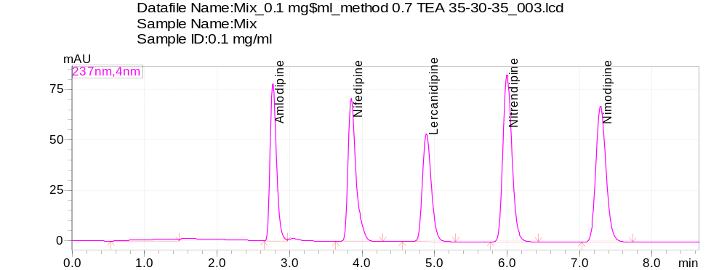
Fig S3: Chromatographic column Luna С8 (100 mm х 4.6 mm 3 μm) and mobile phase - ACN-MetOH-0.7% TEA pH 3.06 (30-35-35)

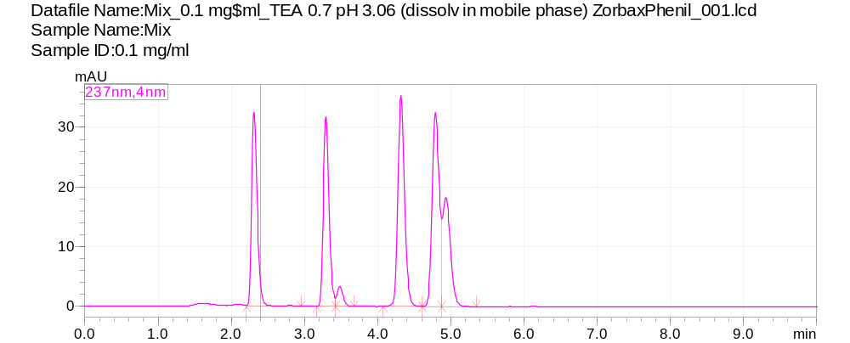
Fig S4: Chromatographic column Zorbax SB-Phenyl (150 mm х 4.6 mm 3.5 μm)
ACN-MetOH-0.7% TEA pH 3.06 (30-35-35)
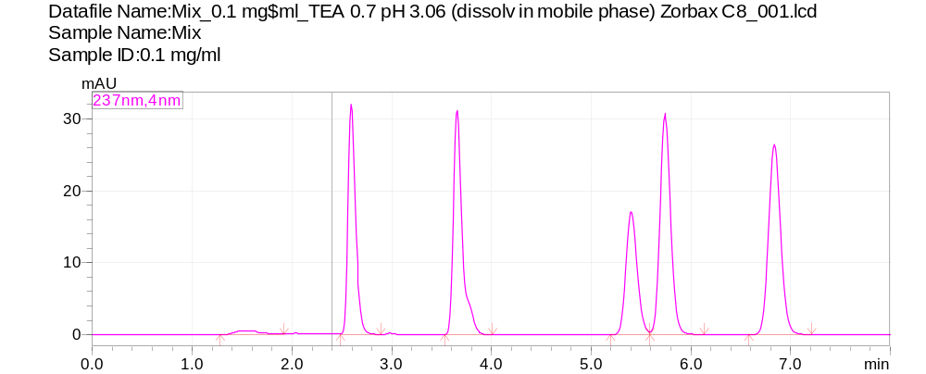
Fig S5: Chromatographic column Zorbax SB-C8 (150 mm х 4.6 mm 3.5 μm)
ACN-MetOH-0.7% TEA pH 3.06 (30-35-35)
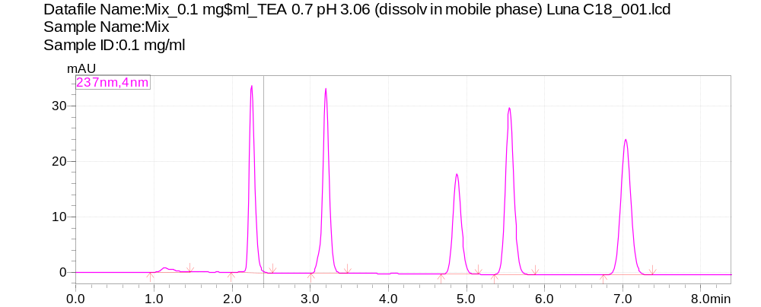
Fig S6: Chromatographic column Luna С18 (100 mm х 4.6 mm 3 μm)
ACN-MetOH-0.7% TEA pH 3.06 (30-35-35)
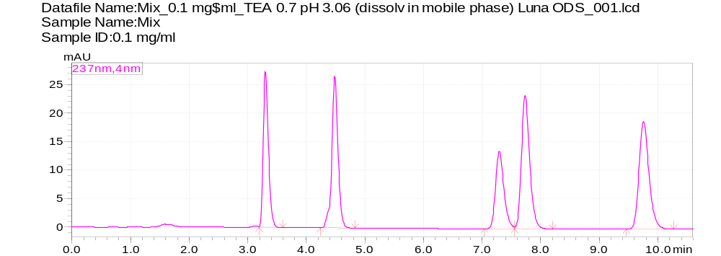
Fig S7: Chromatographic column InertClone ODS (150 mm х 4.6 mm 3 μm)
ACN-MetOH-0.7% TEA pH 3.06 (30-35-35)

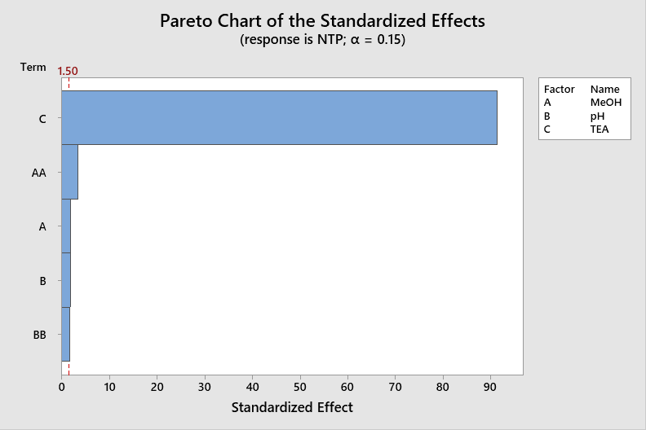 | 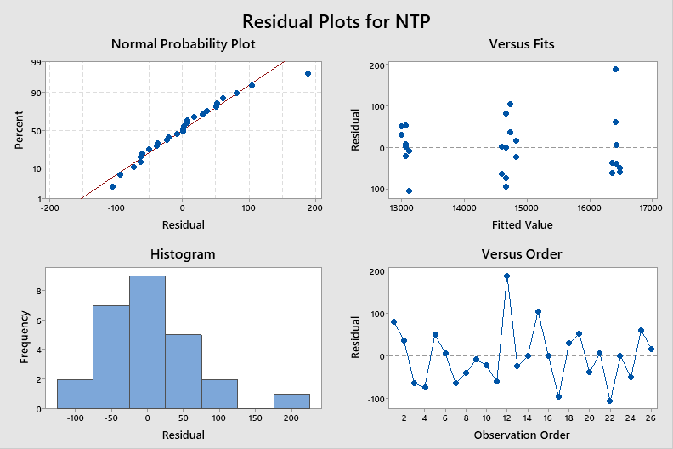

Fig S8: Pareto chart of the standardized effects and residual plots for NTP
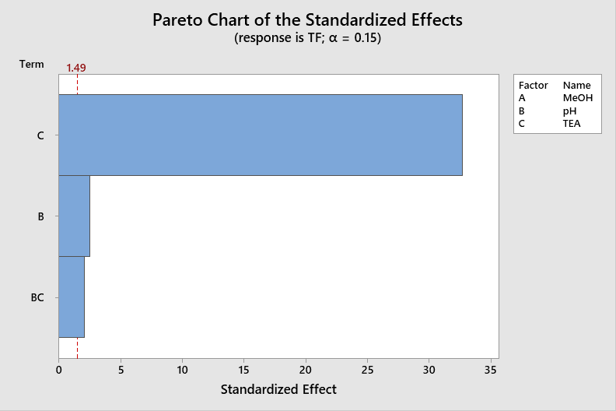 | 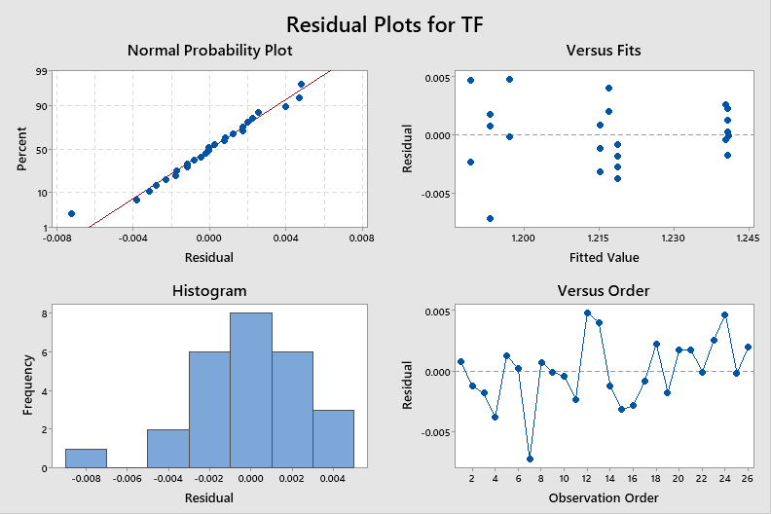

Fig S9: Pareto chart of the standardized effects and residual plots for TF
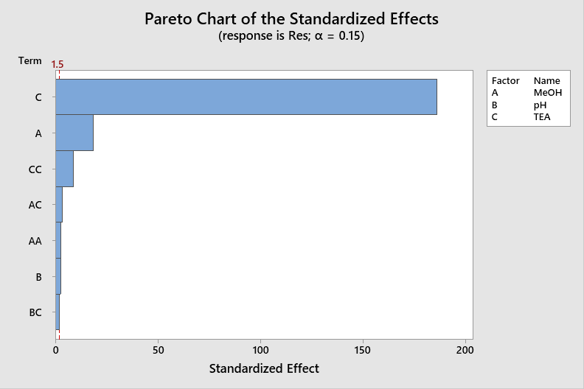 | 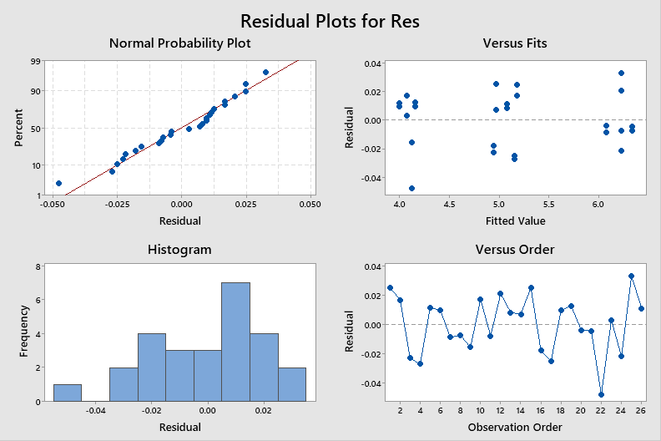

Fig S10: Pareto chart of the standardized effects and residual plots for Rs

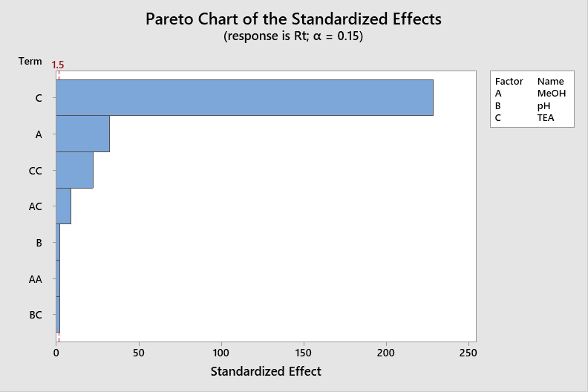 | 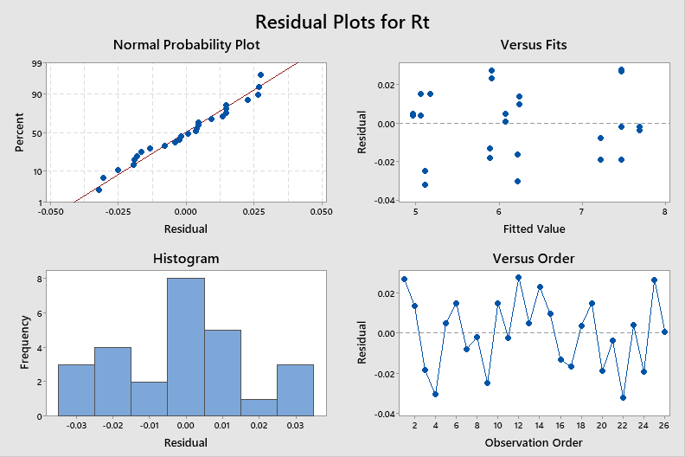

Fig S11: Pareto chart of the standardized effects and residual plots for Rt

Table S1: Preliminary studies in HPLC method development
Chromatographic condition  Parameters | ACN-MeOH-0.7 % TEA pH 3.06 (35:35:30)  T 30° C, 1 ml/min | ACN-MeOH-0.7 %TEA pH 3.06  (30:35:35)  T 30° C, 1 ml/min | ACN-MeOH-0.7 % TEA pH 3.06 (35:30:35)  T 30° C, 1 ml/min | ACN-MeOH-0.7 %TEA pH 3.06  (30:35:35)  T 28° C, 1 ml/min | ACN-MeOH-0.7 %TEA pH 3.06  (30:35:35)  T 32° C, 1 ml/min | ACN-MeOH-0.7 %TEA pH 3.06  (30:35:35)  T 30° C, 0.8 ml/min | ACN-MeOH-0.7 %TEA pH 3.06  (30:35:35)  T 30° C, 1.2 ml/min | ACN-MeOH-0.7 %TEA pH 2.71  (30:35:35)  T 32° C, 1.2 ml/min | ACN-MeOH-0.7 %TEA pH 2.91  (30:35:35)  T 32° C, 1.2 ml/min | ACN-MeOH-0.7 %TEA pH 3.06  (30:35:35)  T 32° C, 1.2 ml/min | Acceptability criteria
Tailing F | AML- 1.37  NIF- 0  LER- 0  NIT- 1.27  NIM- 1.22 | AML- 1.38  NIF- 1.41  LER- 1.24  NIT- 1.20  NIM- 1.17 | AML- 1.24  NIF- 0  LER- 0  NIT- 0  NIM- 0 | AML- 1.35  NIF- 1.35  LER- 1.23  NIT- 1.22  NIM- 1.18 | AML- 1.39  NIF- 1.45  LER- 1.24  NIT- 1.22  NIM- 1.18 | AML- 1.37  NIF- 1.41  LER- 1.23  NIT- 1.17  NIM- 1.15 | AML- 1.35  NIF- 1.25  LER- 1.39  NIT- 1.16  NIM- 1.2 | AML- 1.41  NIF- 1.45  LER- 1.23  NIT- 1.21  NIM- 1.18 | AML- 1.35  NIF- 1.25  LER- 1.39  NIT- 1.16  NIM- 1.2 | AML- 1.43  NIF- 1.46  LER- 1.23  NIT- 1.22  NIM- 1.17 | 0.8-1.5
Resolution | AML-  NIF- 5.39  LER- 1.49  NIT- 6.73  NIM- 4.18 | AML-  NIF- 6.46  LER- 5.48  NIT- 6.70  NIM- 6.37 | AML-  NIF- 10.426  LER- 0  NIT- 0  NIM- 0 | AML-  NIF- 6.43  LER- 5.90  NIT- 6.52  NIM- 6.45 | AML-  NIF- 6.45  LER- 5.47  NIT- 6.54  NIM- 6.27 | AML-  NIF- 6.82  LER- 6.03  NIT- 6.86  NIM- 6.67 | AML-  NIF- 6.08  LER- 5.04  NIT- 6.25  NIM- 5.99 | AML-  NIF- 6.04  LER- 5.20  NIT- 6.17  NIM- 5.96 | AML-  NIF- 6.02  LER- 4.76  NIT- 6.50  NIM- 5.94 | AML-  NIF- 5.96  LER- 5.63  NIT- 5.63  NIM- 5.95 | > 2.0
K’ («died» volume 1.278) | AML- 0.87  NIF- 1.48  LER- 1.66  NIT- 2.51  NIM- 3.08 | AML- 1.15  NIF- 2.11  LER-2.89  NIT- 3.95  NIM- 5.06 | AML- 0.12  NIF- 1.97  LER- 2.24  NIT- 3.05  NIM- 3.18 | AML- 1.41  NIF- 2.16  LER- 3.03  NIT- 4.08  NIM- 5.25 | AML- 1.27  NIF- 2.08  LER- 2.84  NIT- 3.84  NIM- 4.92 | AML- 1.85  NIF- 2.86  LER- 3.87  NIT- 5.14  NIM- 6.53 | AML- 0.87  NIF- 1.55  LER- 2.18  NIT- 3.02  NIM- 3.91 | AML- 0.89  NIF- 1.56  LER- 2.20  NIT- 3.03  NIM- 3.92 | AML- 0.89  NIF- 1.54  LER- 2.13  NIT- 3.00  NIM- 3.89 | AML- 0.88  NIF- 1.54  LER- 2.13  NIT- 3.00  NIM- 3.89 | 1-10
Retention time, min | AML- 2.40  NIF- 3.17  LER- 3.40  NIT- 4.48  NIM- 5.20 | AML- 2.93  NIF- 3.98  LER- 4.98  NIT- 6.32  NIM- 7.75 | AML- 1.43  NIF- 3.79  LER- 4.14  NIT- 5.18  NIM- 5.34 | AML- 2.99  NIF- 4.04  LER- 5.15  NIT- 6.49  NIM- 7.99 | AML- 2.90  NIF- 3.93  LER- 4.91  NIT- 6.19  NIM- 7.56 | AML- 3.64  NIF- 4.93  LER- 6.22  NIT- 7.85  NIM- 9.62 | AML- 2.40  NIF- 3.26  LER- 4.06  NIT- 5.14  NIM- 6.28 | AML- 2.42  NIF- 3.27  LER- 4.09  NIT- 5.15  NIM- 6.29 | AML- 2.41  NIF- 3.25  LER- 4.00  NIT- 5.12  NIM- 6.25 | AML- 2.40  NIF- 3.25  LER- 4.00  NIT- 5.12  NIM- 6.25 | -
NTP | AML- 4849  NIF- 7237  LER- 7374  NIT- 11674  NIM- 13069 | AML- 5936  NIF- 8394  LER- 10485  NIT- 14951  NIM- 16404 | AML- 553  NIF- 5209  LER- 0  NIT- 15457  NIM- 0 | AML- 6034  NIF- 8410  LER- 10618  NIT- 14906  NIM- 16241 | AML- 6073  NIF- 8586  LER- 10634  NIT- 15044  NIM- 16565 | AML- 6673  NIF- 9646  LER- 11714  NIT- 16328  NIM- 17898 | AML- 5247  NIF- 7580  LER- 9317  NIT- 13474  NIM- 14925 | AML- 5365  NIF- 7625  LER- 9436  NIT- 13399  NIM- 14838 | AML- 5280  NIF- 7541  LER- 9291  NIT- 13332  NIM- 14840 | AML- 5290  NIF- 7602  LER- 9612  NIT- 13369  NIM- 14889 | >2000

Table S2: The choice of injection volume
Injection volume, µL | 3 | 4 | 5 | Acceptability criteria
Tailing F | AML- 1.39  NIF- 1.46  LER- 1.22  NIT- 1.21  NIM- 1.16 | AML- 1.39  NIF- 1.38  LER- 1.24  NIT- 1.22  NIM- 1.17 | AML- 1.40  NIF- 1.43  LER- 1.25  NIT- 1.21  NIM- 1.17 | 0.8-1.5
Resolution | AML-  NIF- 5.95  LER- 5.44  NIT- 6.03  NIM- 6.02 | AML-  NIF- 5.85  LER- 4.91  NIT- 6.29  NIM- 5.93 | AML-  NIF- 5.73  LER- 4.54  NIT- 6.26  NIM- 5.79 | >2.0
NTP | AML- 5595  NIF- 7836  LER- 9773  NIT- 13614  NIM- 15065 | AML- 5233  NIF- 7181  LER- 9174  NIT- 13401  NIM- 14910 | AML- 4958  NIF- 6712  LER- 8437  NIT- 12667  NIM- 14083 | >5000

Table S3: Risk assessment: Critical method variables vs HPLC method responses
No | Input method  variables (Xn) | Responses (Yn)
No | Input method  variables (Xn) |  |  |  |  |  | Consideration
No | Input method  variables (Xn) | TF | tR | Rs | NTP | A | Consideration
1 | TEA (%V/V) | H | H | H | H | M | Optimized
2 | pH | H | H | H | H | M | Optimized
3 | MeOH (%V/V) | H | H | H | H | M | Optimized
4 | Buffer concentration | H | M | M | M | M | Controlled
5 | Column temperature | M | M | M | M | M | Controlled
6 | Column make | H | H | H | H | H | Default
7 | Column type | H | H | H | H | H | Controlled
8 | Buffer type | H | H | H | H | H | Controlled
9 | Column length | M | M | M | M | M | Default
10 | Column particle size | M | M | M | M | M | Default
11 | Detector | N/A | N/A | N/A | N/A | N/A | Default
12 | Injection volume | L | L | L | L | L | Default
13 | Reagent purity | L | L | L | L | L | Controlled
14 | Vendors (reagents) | L | L | L | L | L | Controlled

