A1 1,3,8-Trihydroxy-6-methyl-9(10H)-anthracenone Rt:12.98min
MS
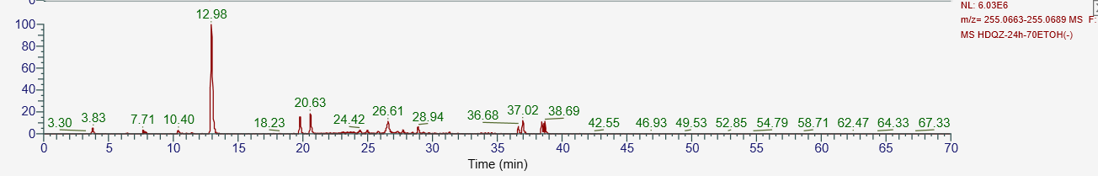
MS/MS
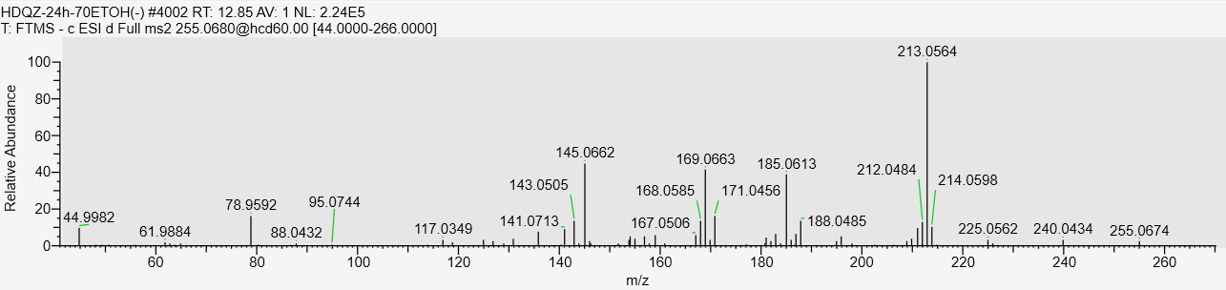
A2 1,6,8,10-tetrahydroxy-3-hydroxymethyl-9(10H)-anthracenone-glucopyranoside Rt:10.17min
MS 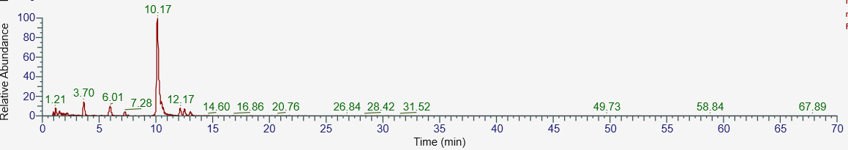
MS/MS
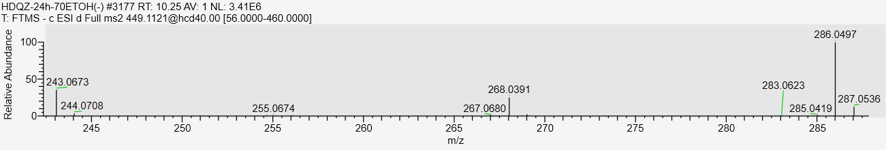
A3 Polygonumnolide B1 Rt:27.93min
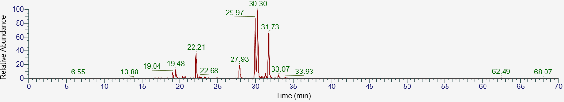
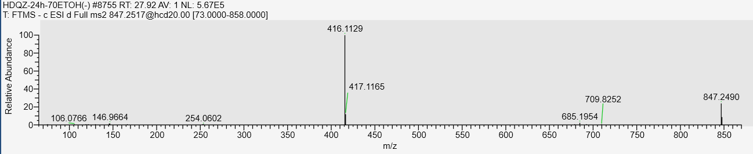
A4 Rhein-methyl ether Rt:36.79min
MS
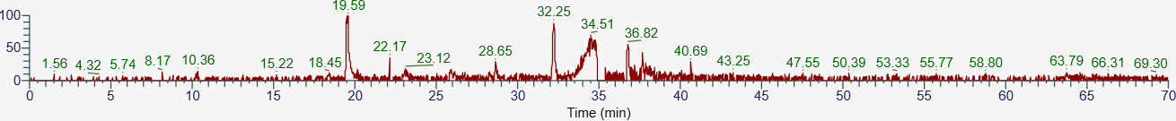
MS/MS
A5 Physcion-8-O-β-D-glucopyranoside Rt:16.03min
MS
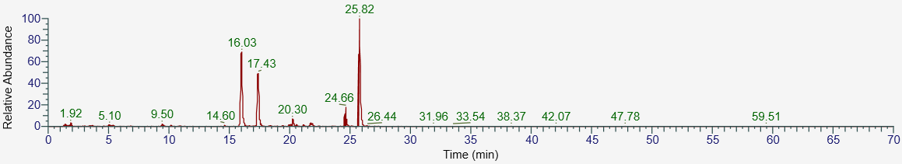
MS/MS
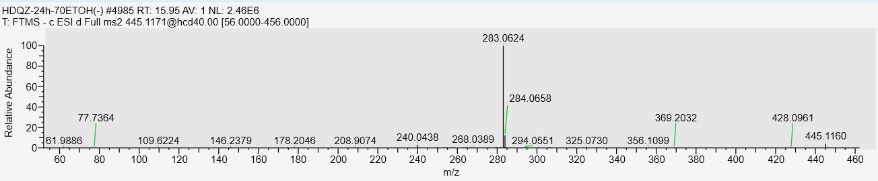
A6 Emodin-8-O-β-D-hexose-sulfate Rt：14.56min
MS
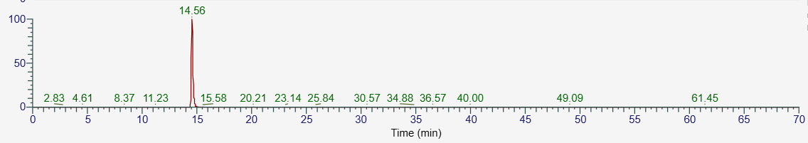
MS/MS
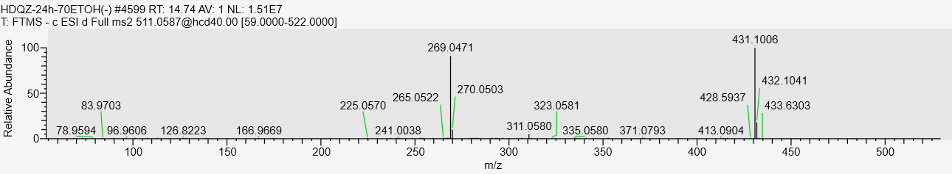
A7 Emodin Rt：35.17min
MS
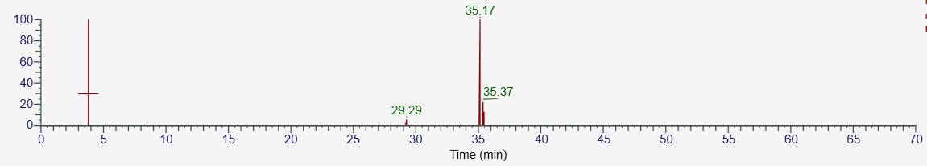
MS/MS
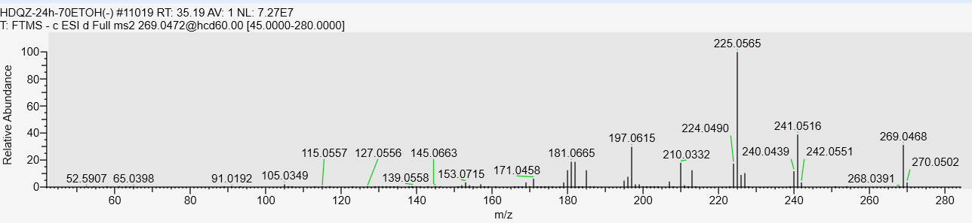
A8 Physcion Rt：37.86min
MS
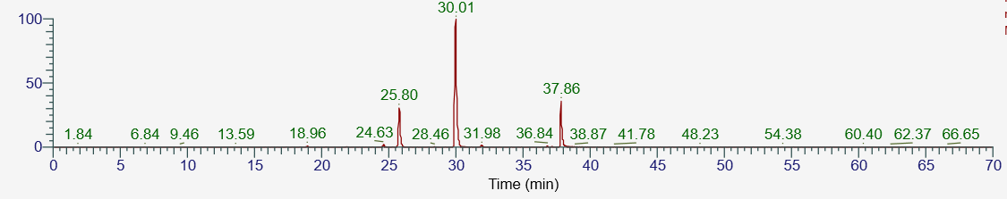
MS/MS
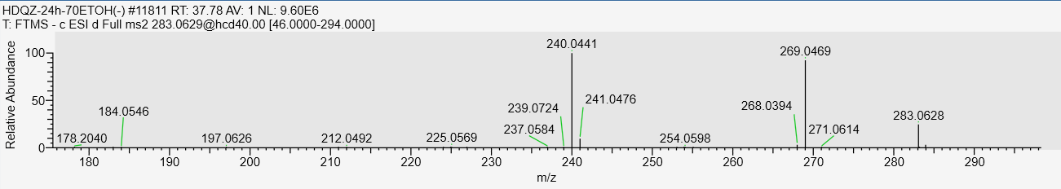
A9 emodin-8-methyl ether Rt：25.80min
MS
MS/MS
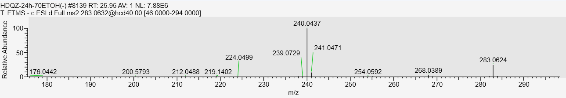
A10 Structural analogs or isomers of emodin-8-methyl ether Rt：24.63min
MS
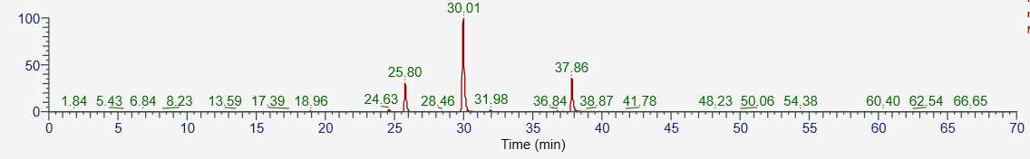
MS/MS
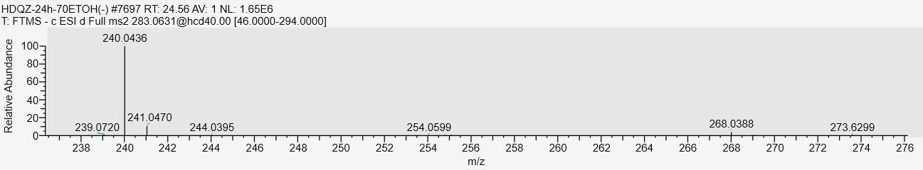
A11 questinol Rt:3.79min
MS
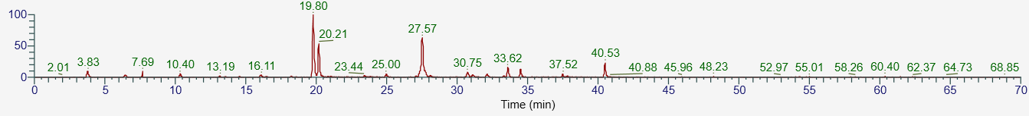
MS/MS
A12 Structural analogs or isomers of questinol Rt:10.40min
MS
MS/MS
A13 fallacinol Rt:19.80min
MS
MS/MS
A14 Structural analogs or isomers of fallacinol Rt:20.21min
MS
MS/MS

A15 emodin-emodin dianthrone-diglucopyranoside Rt：7.69min
MS
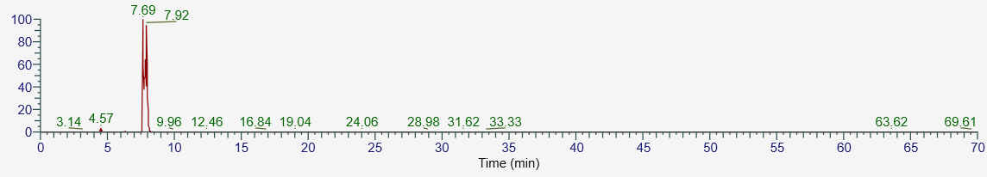
MS/MS
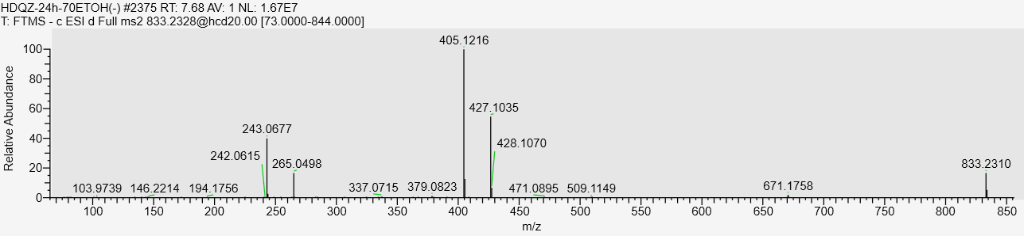
A16 emodin-emodin dianthrone-diglucopyranoside Rt：7.69min
MS
MS/MS
A17 trans-emodin physcion bianthrone Rt：38.45min
MS
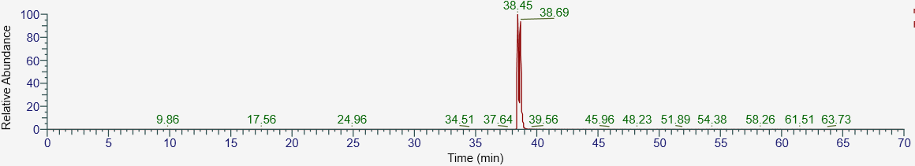
MS/MS
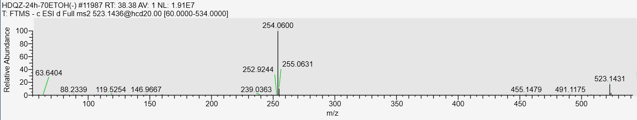
A18 cis-emodin physcion bianthrone Rt：38.91min
MS
MS/MS
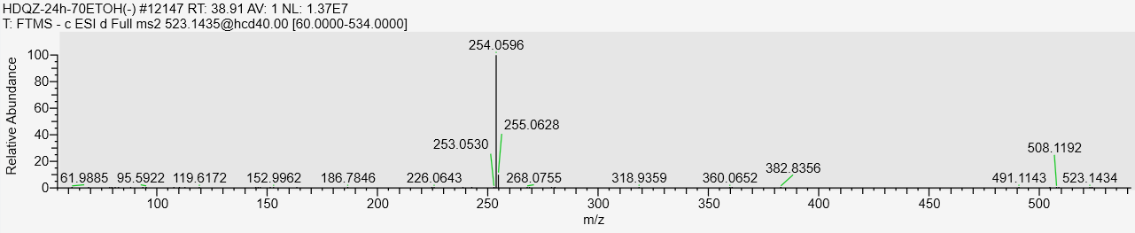
A19 2-Acetylemodin Rt：27.80min
MS
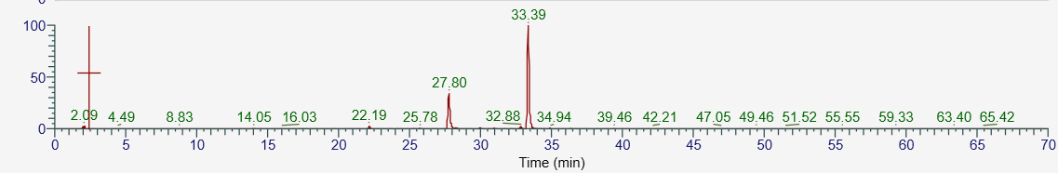
MS/MS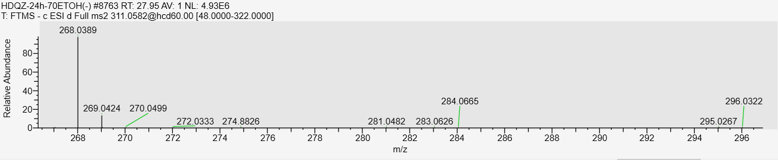
A20 Structural analogs or isomers of 2-Acetylemodin Rt：22.19min
MS
MS/MS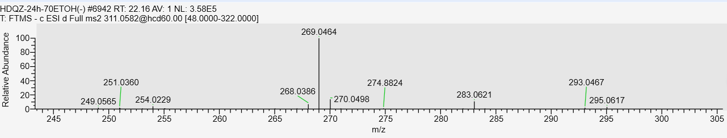
A21 Structural analogs or isomers of 2-Acetylemodin Rt：33.39min
MS
MS/MS
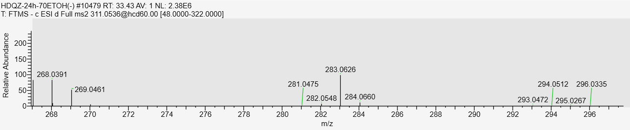
A22 Emodin-8-O-β-glucoside Rt：14.50min
MS
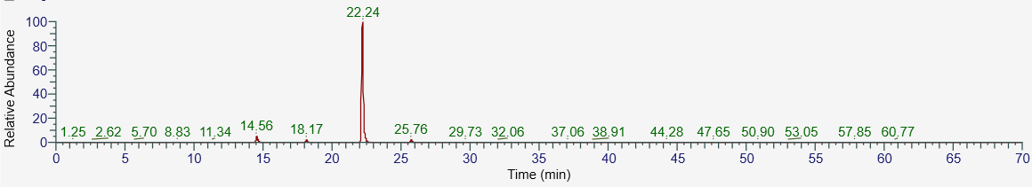
MS/MS
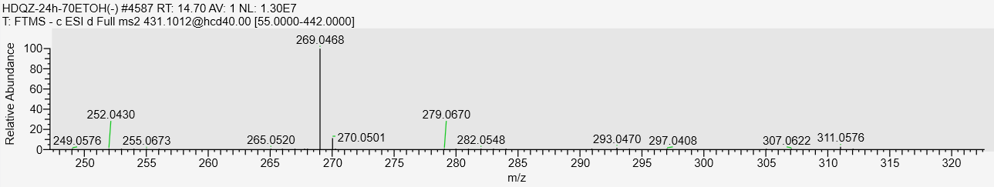
A23 emodin-1-O-β-glucoside Rt：8.43min
MS
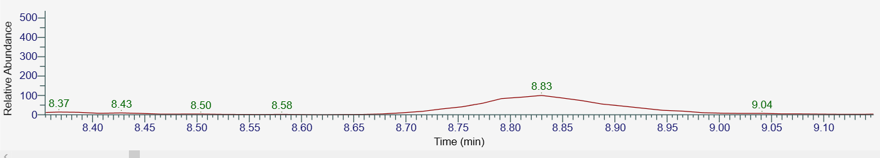
MS/MS
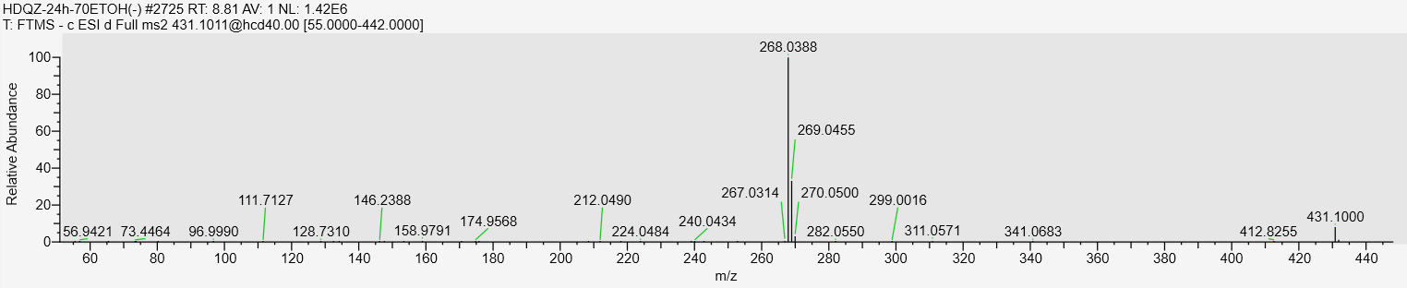
A24 Emodin-O-(malonyl)-hexoside Rt：23.92min
MS
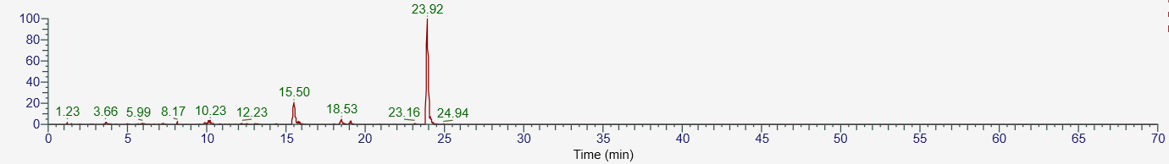
MS/MS
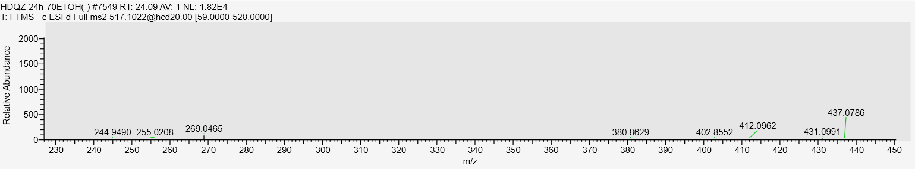
A25 6-Carboxyl emodin Rt: 22.17min
MS
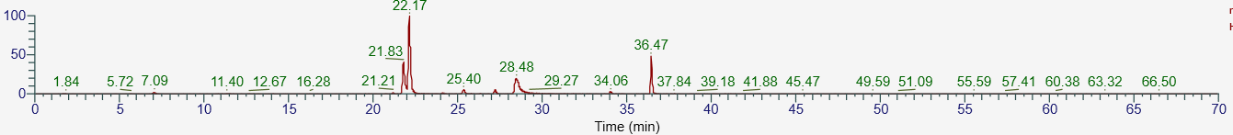MS/MS
A26 Structural analogs or isomers of 6-Carboxyl emodin Rt: 28.32min
MS
MS/MS
A27 Trans-emodin-emodin bianthrone Rt：36.64min
MS
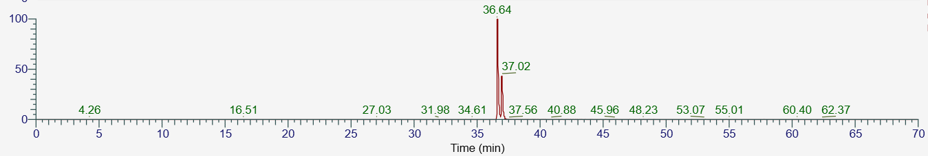
MS/MS
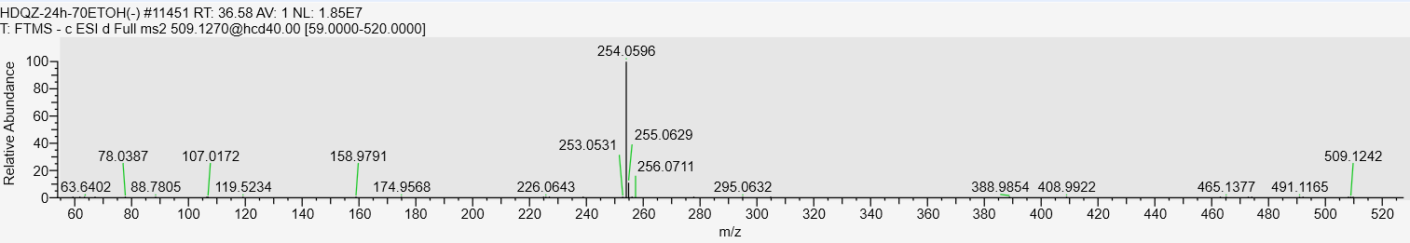
A28 Cis-emodin-emodin bianthrone Rt：37.02min
MS
MS/MS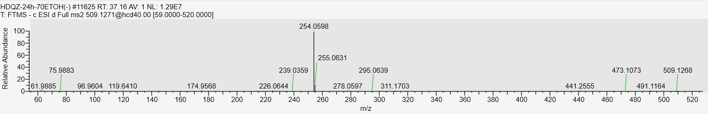
S1 pentahydroxy-phenanthrene-O- hexoside Rt：6.63min
MS
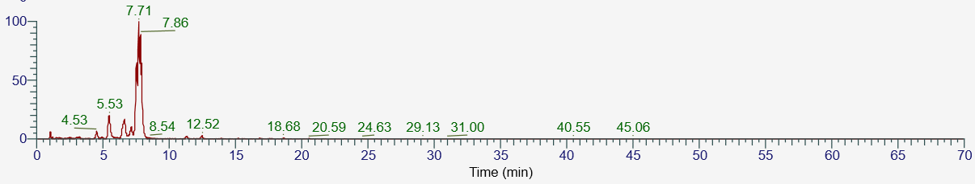
MS/MS
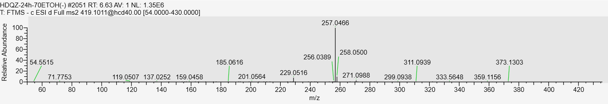S2 Structural analogs or isomers of pentahydroxy-phenanthrene-O- hexoside Rt：5.53min
MS
MS/MS
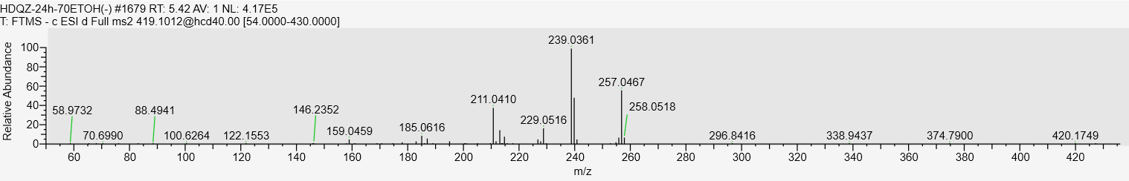
S3 Structural analogs or isomers of pentahydroxy-phenanthrene-O- hexoside Rt：7.71min
MS
MS/MS
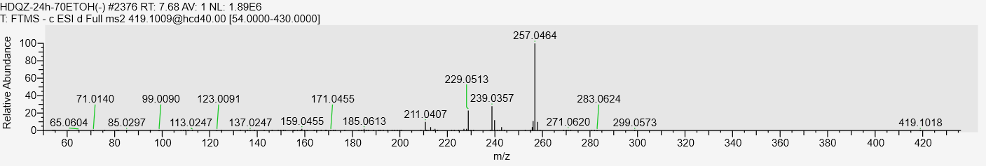
S4 2,3,5,4'-Tetrahydroxystilbene-2-O-(4-O-acetyl-β-D-glucopyranoside Rt:13.42min
MS
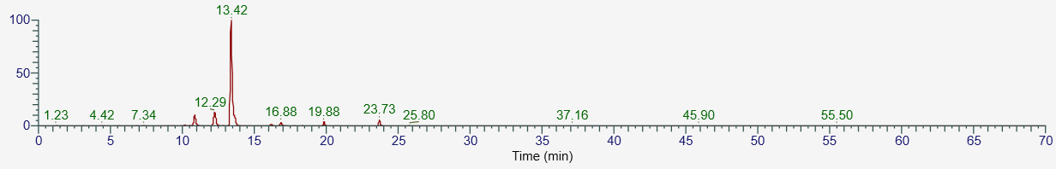
MS/MS
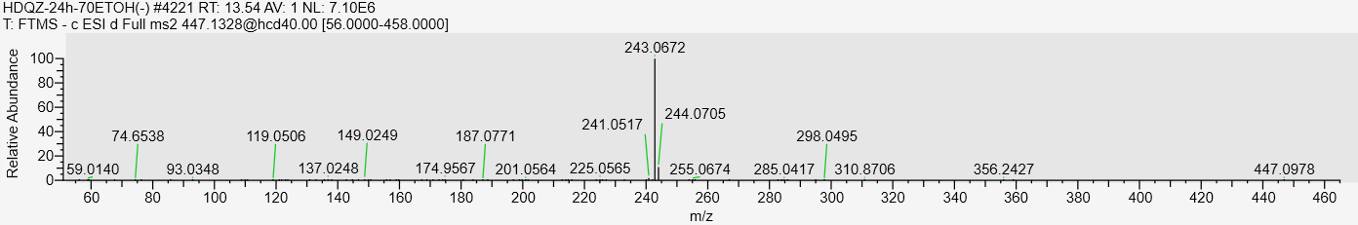
S6 2,3,5,4'-Tetrahydroxystilbene- (4'-O-acetyl)-2-O-β-D-glucopyranoside Rt:16.88min
MS
MS/MS
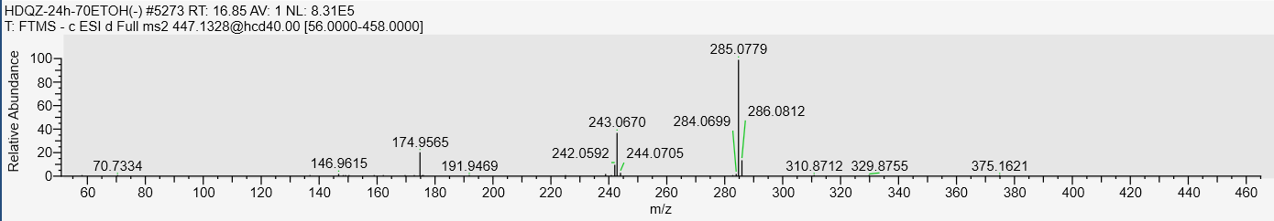
S7 Tetrahydroxystilbene-O-(aminocatecholoyl)-hexosides Rt:8.56min
MS
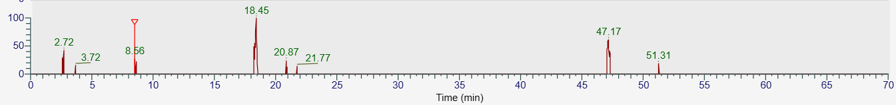
MS/MS
S8 Tetrahydroxystilbene-O-hexoside-O-2,5-bi(hydroxymethyl)-furan (phenolic hydroxyl moiety) Rt:10.00min
MS
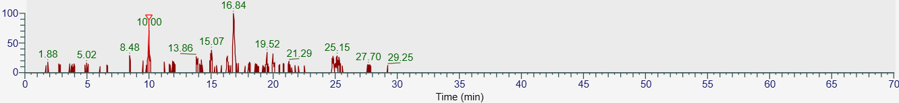
MS/MS
S9 Tetrahydroxystilbene-O-hexoside-adipic acid acyl Rt: 9.83min
MS
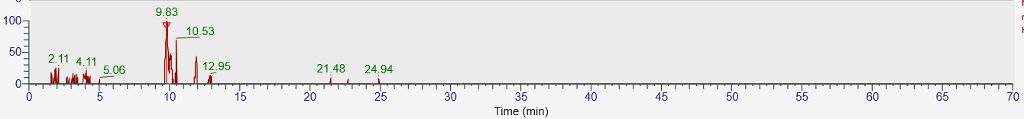
MS/MS
S10 Tetrahydroxystilbene-O-5-formylfuran-2-carboxylyl hexosides Rt:12.42min
MS
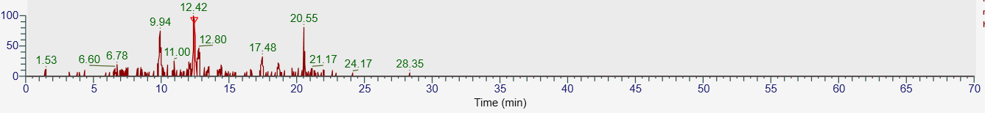
MS/MS
S12 2,3,5,4'-Tetrahydroxystilbene-(4’-O- DDMP)-2-O-β-D-glucopyranoside Rt:9.74min
MS
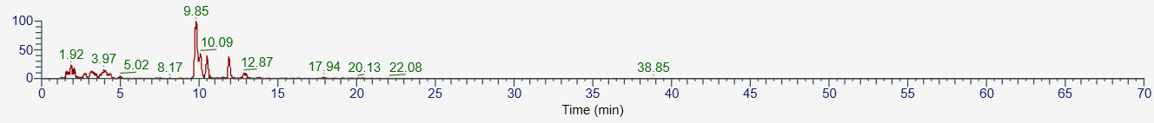
MS/MS
S13 2,3,5,4'-Tetrahydroxystilbene-2-O-(4’’-O- DDMP -β-D-hexoside) Rt:9.95min
MS
MS/MS
S16 Structural analogs or isomers of oxidized derivative of tetrahydroxystilbene glucoside Rt:0.96min
MS
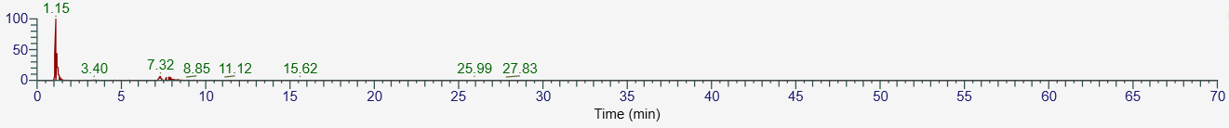
MS/MS
S17 Cis-Resveratrol Rt：6.44min
MS
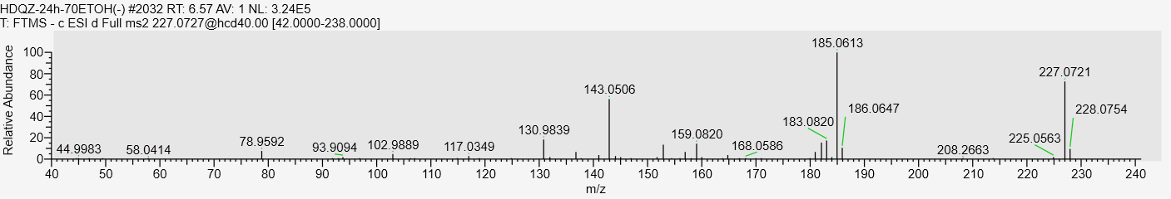
MS/MS
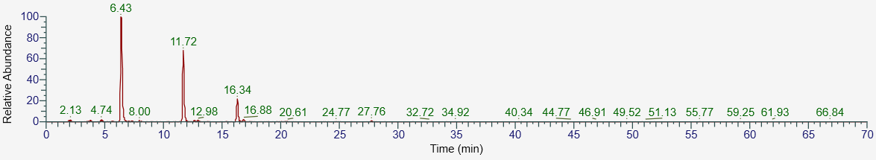
S18 Trans-Resveratrol Rt：11.72min
MS
MS/MS
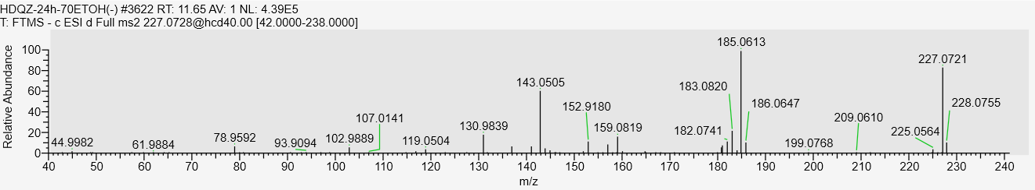
S19 oxyresveratrol Rt:4.57min
MS
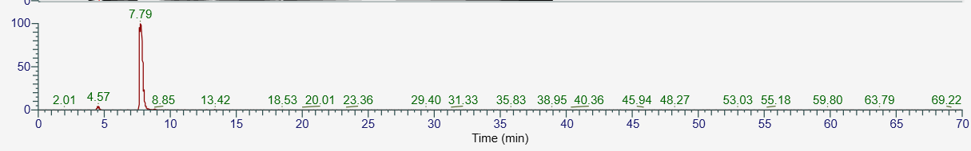
MS/MS
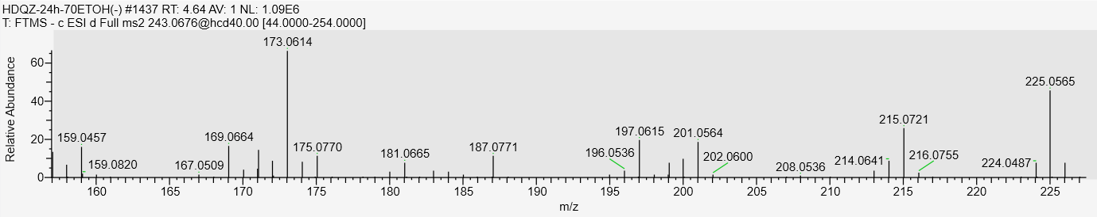
S20 Structural analogs or isomers of oxyresveratrol Rt：7.79min
MS
MS/MS
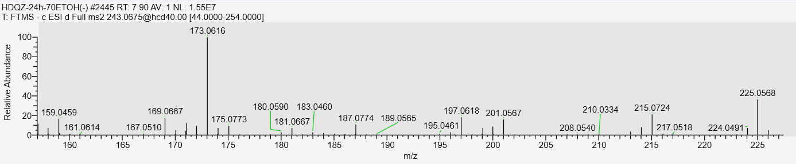
S21 Structural analogs or isomers of oxyresveratrol Rt：13.42min
MS
MS/MS
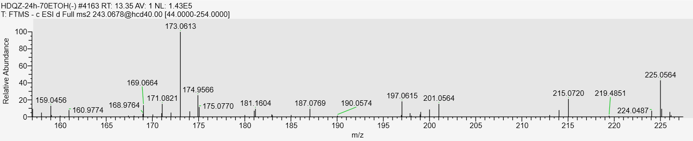
S22 Tetrahydroxystilbene-O-(5-hydroxymethylfuran-2-carboxylyl)-hexoside Rt:10.63min
MS
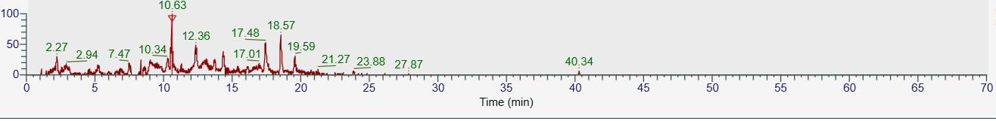
MS/MS
S23 Tetrahydroxy-phenanthrene-O-hexoside-O-p-hydroxycinnamoyl (phenolic hydroxyl moiety)
Rt：2.88min
MS
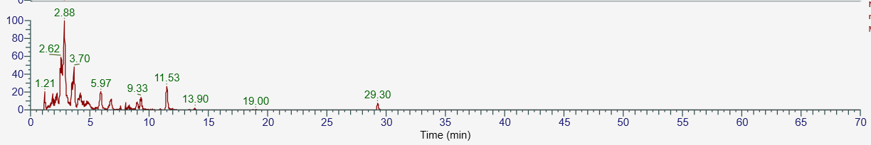
MS/MS
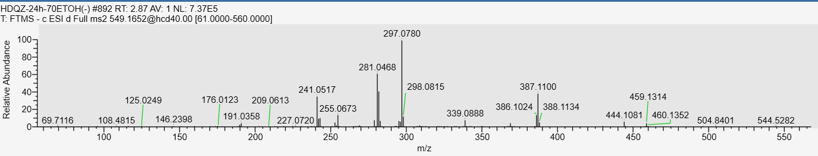
S24 Tetrahydroxystilbene-O- (4’’-O-furan-2, 5-dicarboxylic acid acyl)-hexoside Rt：9.50min
MS
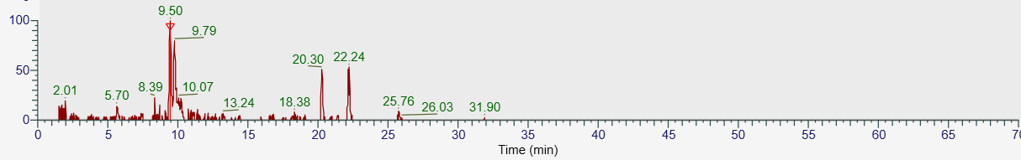
MS/MS
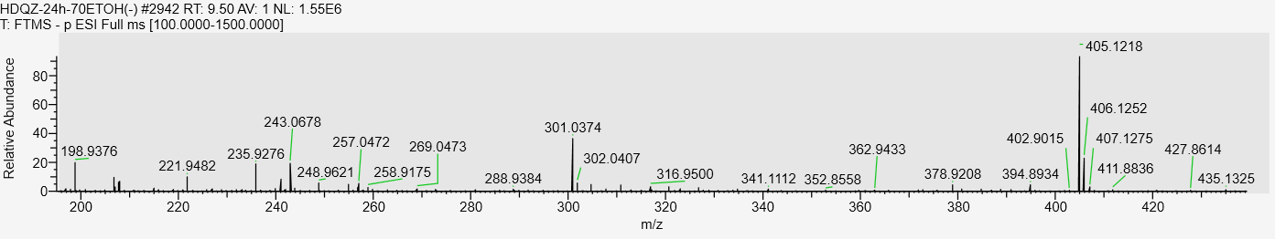
S25 Tetrahydroxystilbene-O- (5-O-furan-2, 5-dicarboxylic acid acyl)-hexoside Rt：9.79min
MS
MS/MS
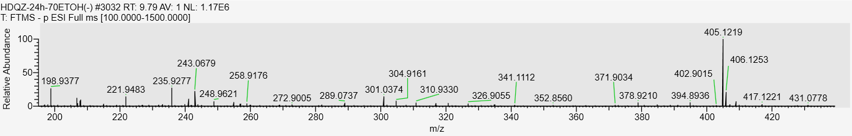
S26 Tetrahydroxystilbene-O-hexoside-O-carbonate acyl (phenolic hydroxyl moiety) Rt:3.70min
MS
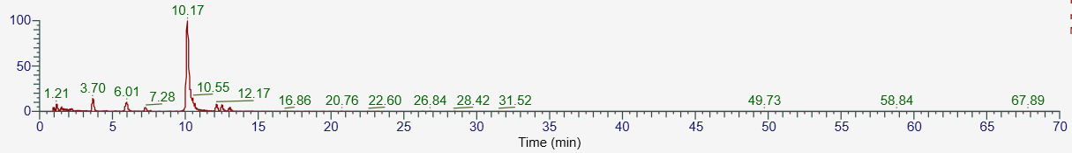
MS/MS
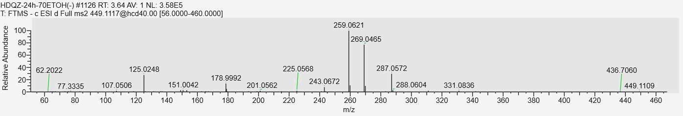
S27 Structural analogs or isomers of tetrahydroxystilbene-O-hexoside-O-carbonate acyl (phenolic hydroxyl moiety) Rt:6.01min
MS
MS/MS
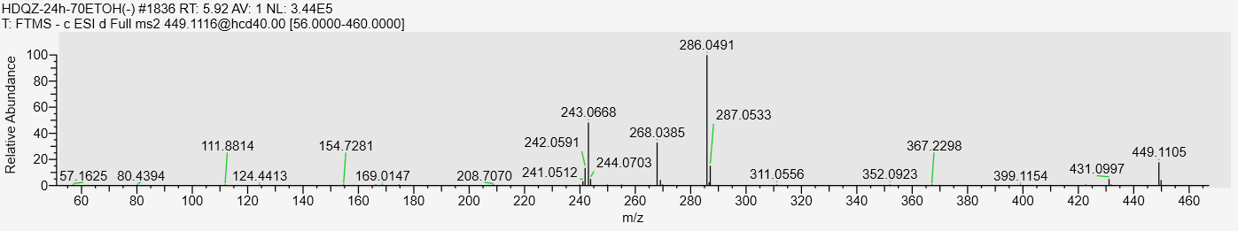
S28 Structural analogs or isomers of tetrahydroxystilbene-O-hexoside-O-carbonate acyl (phenolic hydroxyl moiety) Rt：10.17min
MS
MS/MS
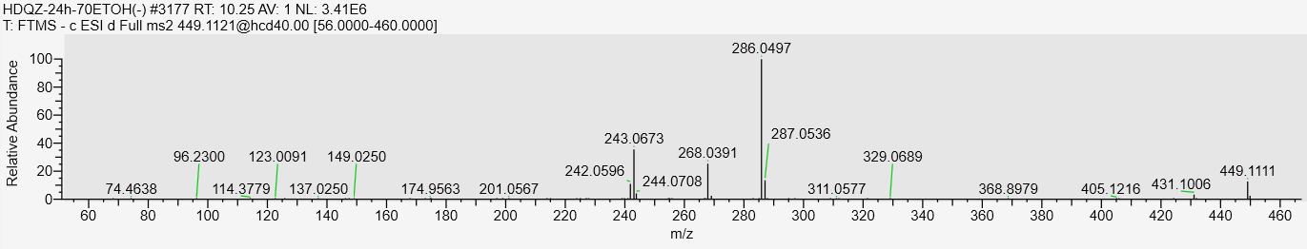
S29 Tetrahydroxystilbene-O-hexoside-O-glutaryl (phenolic hydroxyl moiety) Rt:4.67min
MS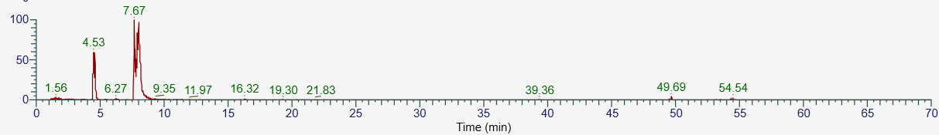
MS/MS
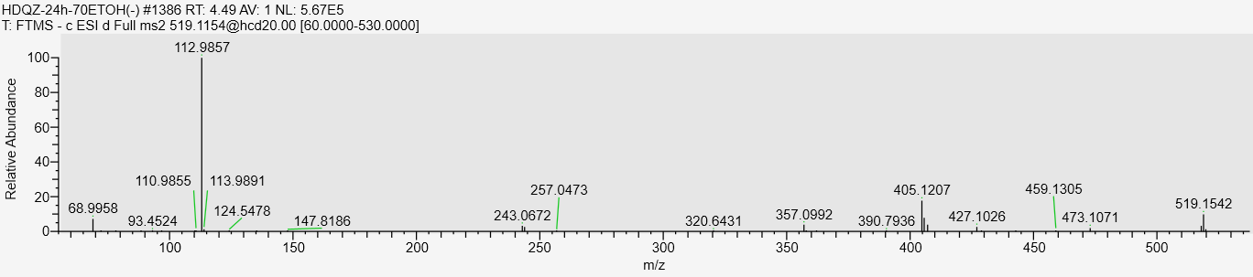
S30 tetrahydroxystilbene-O-hexoside-O-lactic acid acyl (phenolic hydroxyl moiety) Rt:7.22min
MS
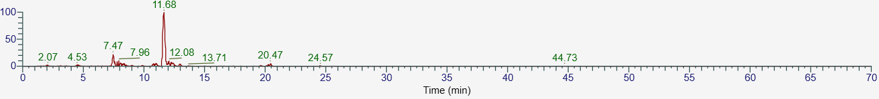
MS/MS
S31 Structural analogs or isomers of tetrahydroxystilbene-O-hexoside-O-lactic acid acyl (phenolic hydroxyl moiety) Rt:11.68min
MS
MS/MS
S32 Structural analogs or isomers of tetrahydroxystilbene-O-hexoside-O-lactic acid acyl (phenolic hydroxyl moiety) Rt:10.62min
MS
MS/MS
S33 tetrahydroxystilbene-O-hexoside-Protocatechuic acid acyl (phenolic hydroxyl moiety)
Rt：10.38min
MS
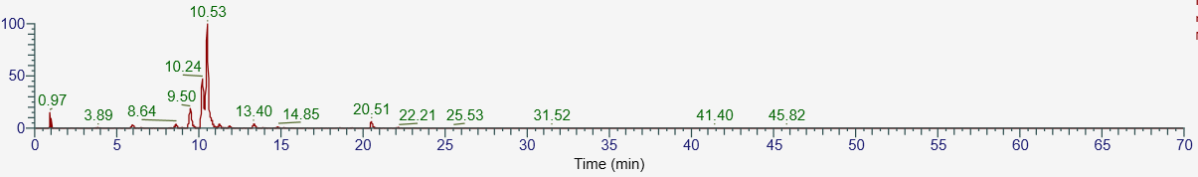
MS/MS
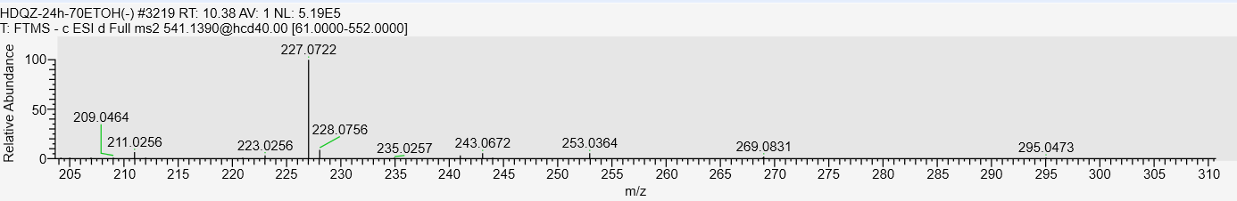
S34 Cis-2,3,5,4’-tetrahydroxystilbene-2-O-D-glucoside Rt：7.79min
MS
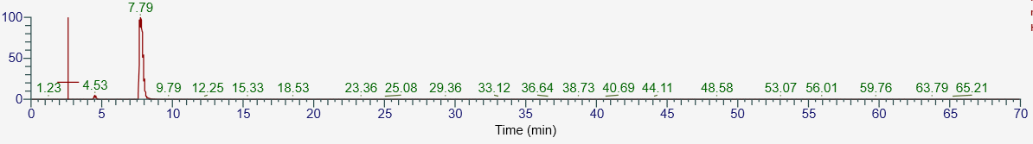
MS/MS
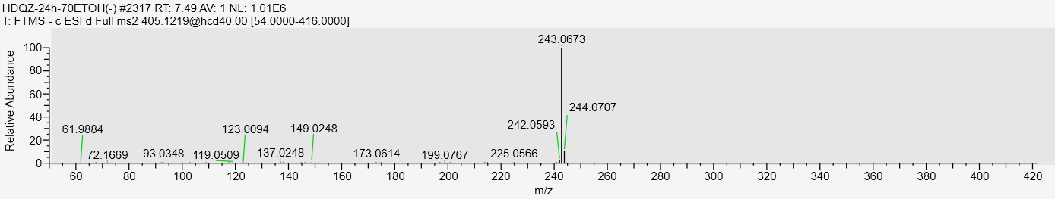
S35 Trans-2,3,5,4’-tetrahydroxystilbene-2-O-D-glucoside Rt：9.79min
MS
MS/MS
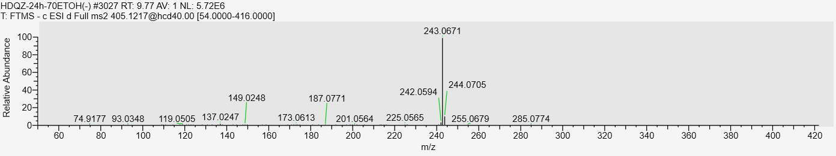
S36 Polygonumoside C Rt：1.39min
MS
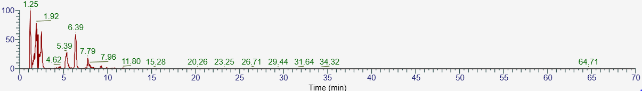
MS/MS
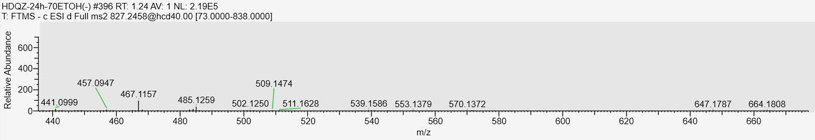
S37 Polygonumoside D Rt：5.39min
MS
MS/MS
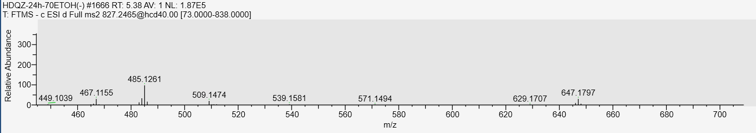
S38 tetrahydroxystilbene-O-di-hexoside Rt：7.47min
MS
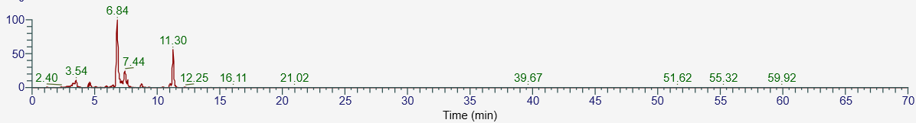
MS/MS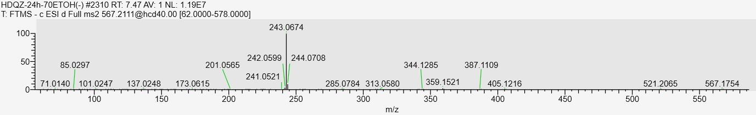
S39 Structural analogs or isomers of tetrahydroxystilbene-O-di-hexoside Rt：8.79min
MS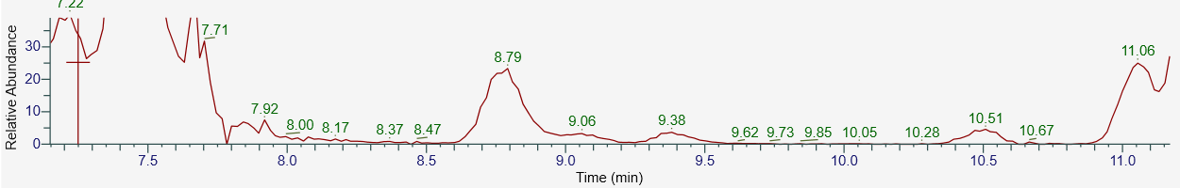
MS/MS
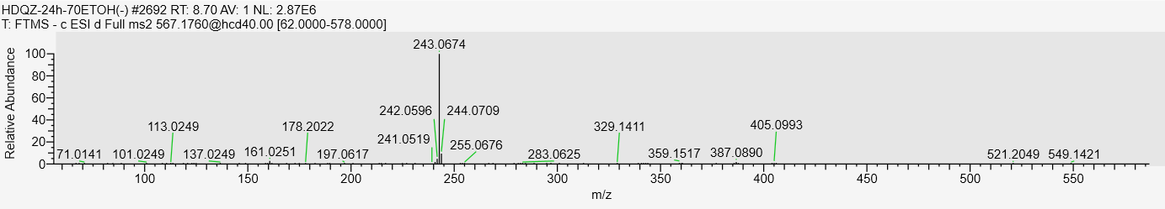
S40 2,3,5,4'-tetrahydroxystilbene-2-O-(Caffeoyl)-glucopyranoside Rt:3.50min
MS
MS/MS
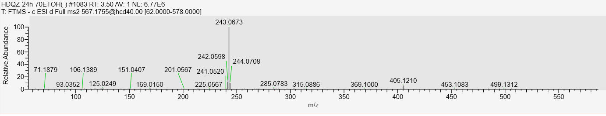
S41 Tetrahydroxystilbene-O- (glycolic acid acyl)-hexoside Rt：7.65min
MS
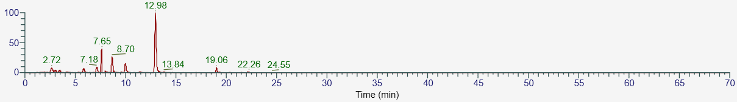
MS/MS
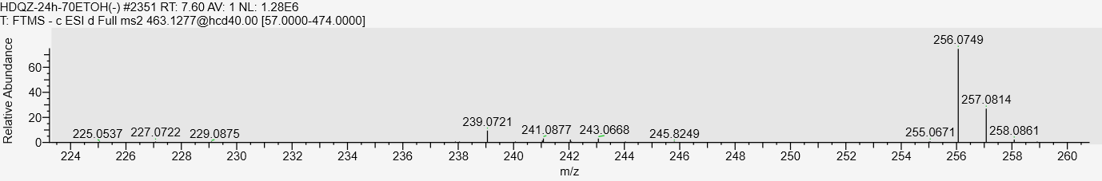
S42 Tetrahydroxystilbene-O-hexoside-O-5-HMF (phenolic hydroxyl moiety)Rt: 8.11min
MS
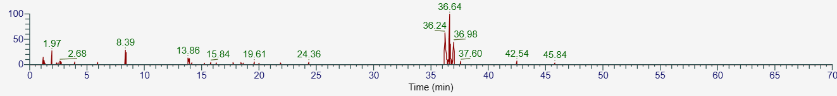
MS/MS
S43 multiflorumiside B Rt：1.75min
MS
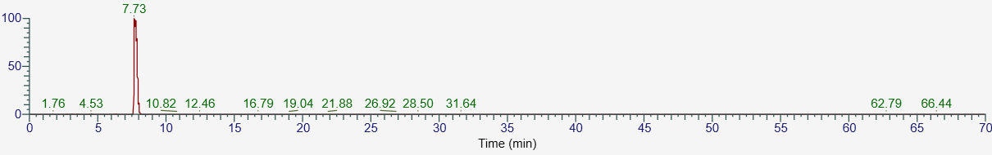
MS/MS
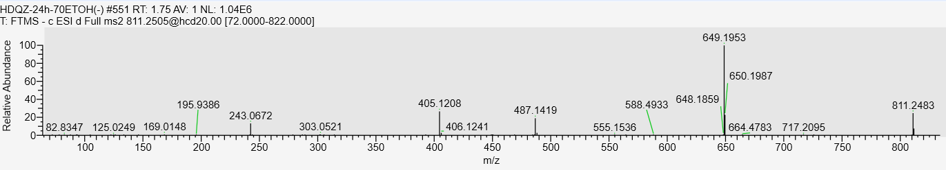

S44 Structural analogs or isomers of multiflorumiside B Rt：3.53min
MS
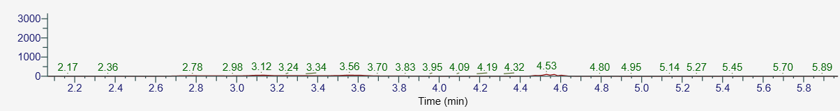
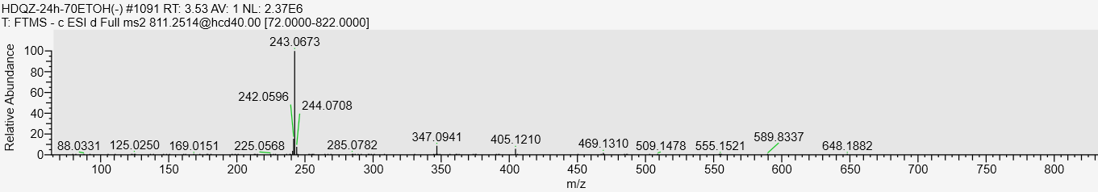
S45 multiflorumiside A Rt：7.73min
MS
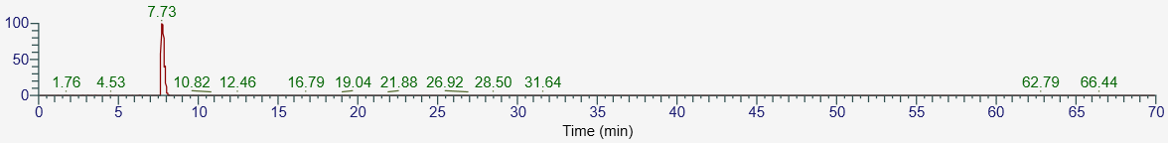
MS/MS
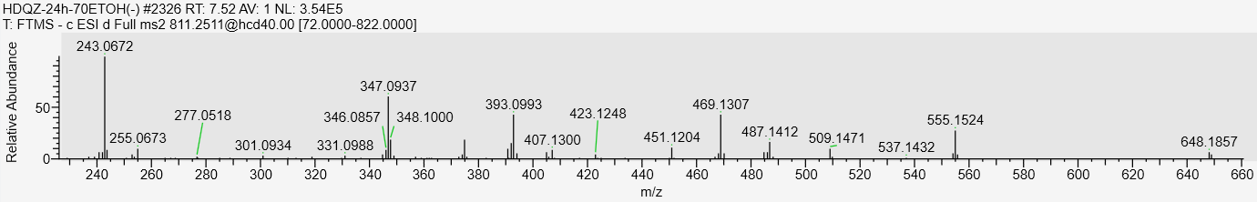
S46 Rhapontin Rt：7.65min
MS
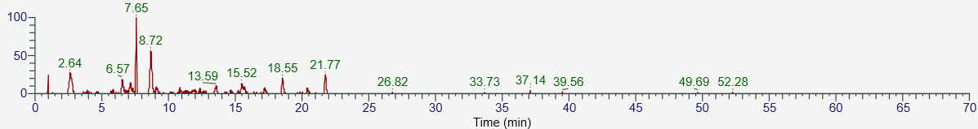
MS/MS
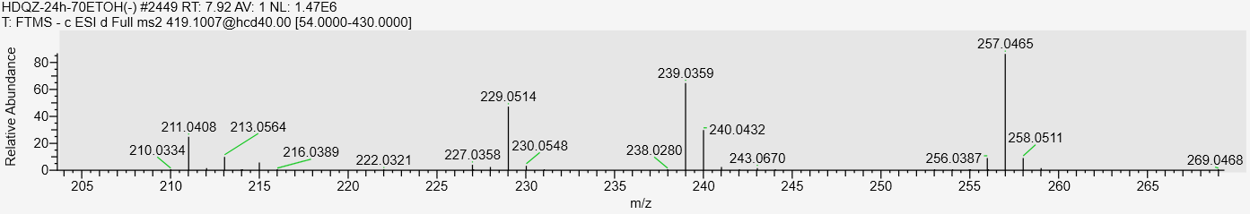
S47 polydatin Rt：6.55min
MS
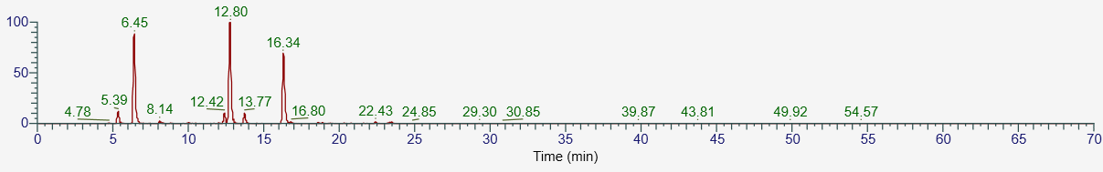
MS/MS
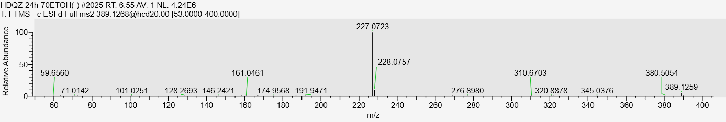
S49 Structural analogs or isomers of polydatin Rt：5.22min
MS
MS/MS
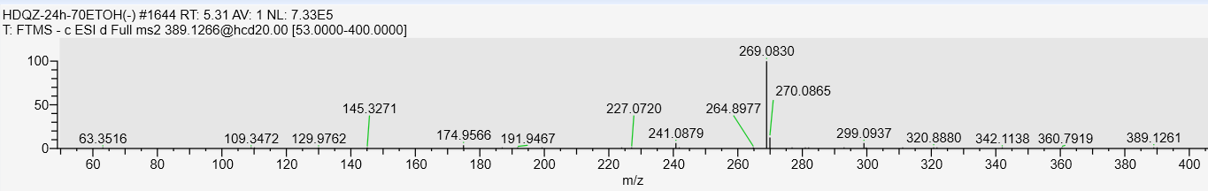
S51 Trihydroxystilbene-O-hexoside-O- acid deltique acyl (phenolic hydroxyl moiety) Rt：16.33min
MS
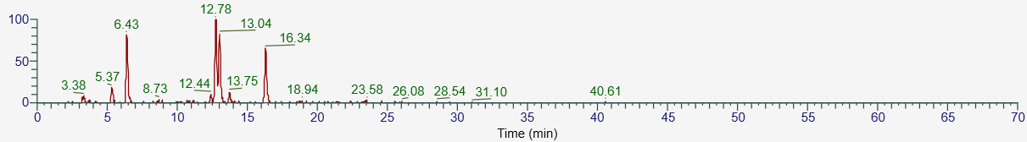
MS/MS
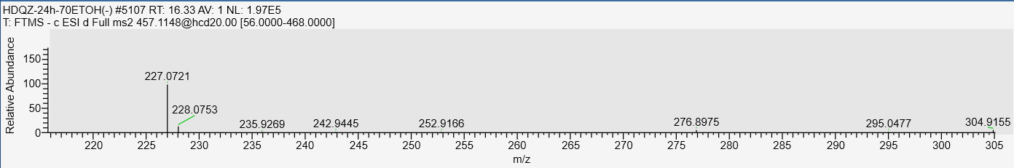
S52 Tetrahydroxystilbene-O-hexoside-O-5-hydroxyfuran-2-carbaldehyde (phenolic hydroxyl moiety) Rt:11.70min
MS
MS/MS
S53 2, 3, 5, 4’-Tetrahydroxystilbene-2-O-β-D-(2’’-O-monogalloyl ester)-glucoside
Rt:8.39min
MS
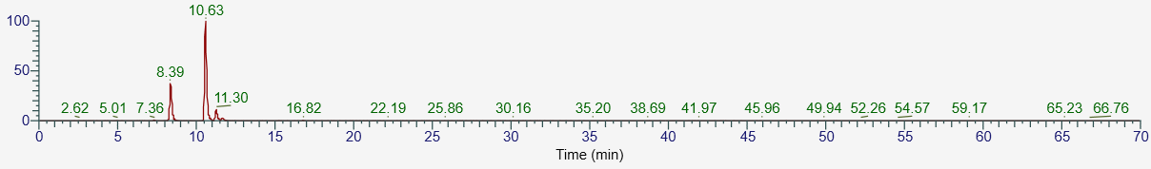
MS/MS
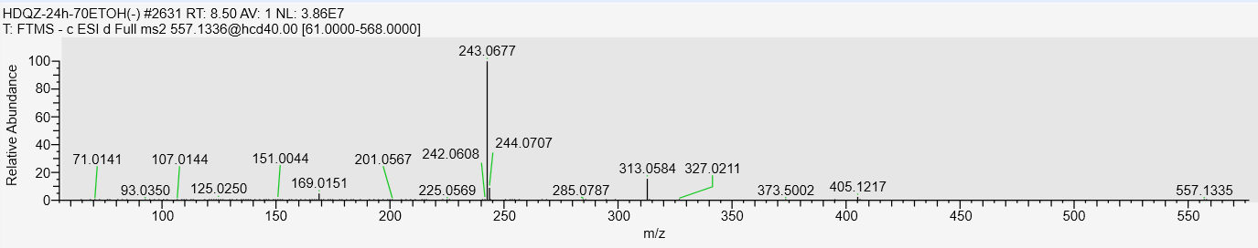
S54 2, 3, 5, 4’-Tetrahydroxystilbene-5-O-β-D-(2’’-O-monogalloyl ester)-glucoside Rt:10.85min
MS
MS/MS
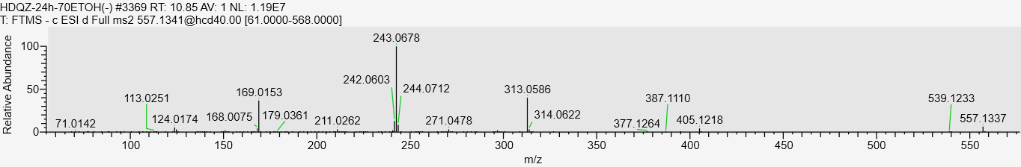
S55 2, 3, 5, 4’-Tetrahydroxystilbene-4’-O-β-D-(2’’-O-monogalloyl ester)-glucoside Rt:11.76min
MS
MS/MS
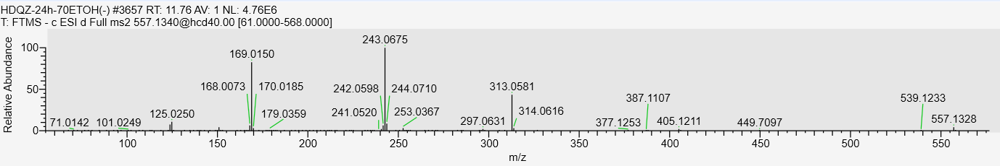
S56 2,3,5,4’-tetrahydroxystilbene-2-O-β-(3-O-monogalloyl ester)-glucoside Rt:7.27min
MS
MS/MS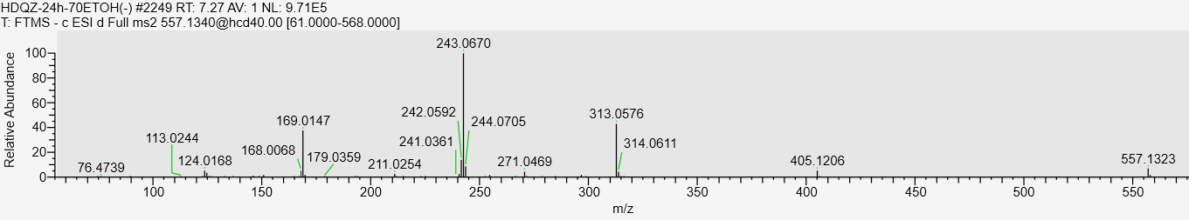
S57 tetrahydroxystilbene-O-(5-hydroxyfuran-2-carboxylic acid)-hexoside Rt:11.06min
MS
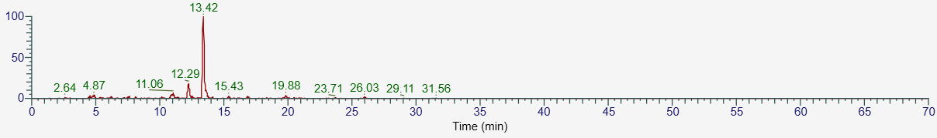
MS/MS
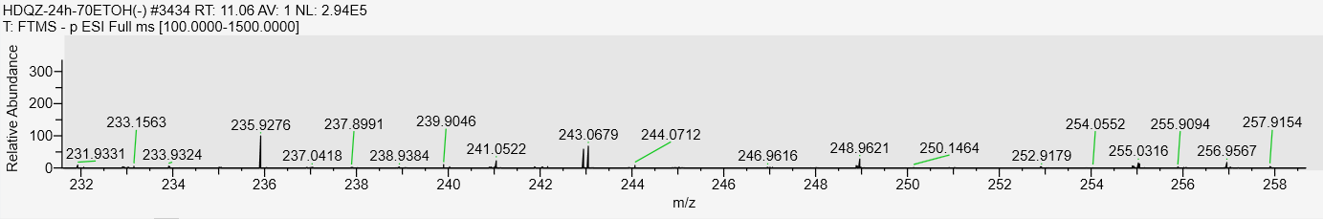
S58 Structural analogs or isomers of tetrahydroxystilbene-O-(5-hydroxyfuran-2-carboxylic acid)-hexoside Rt:13.35min
MS
MS/MS
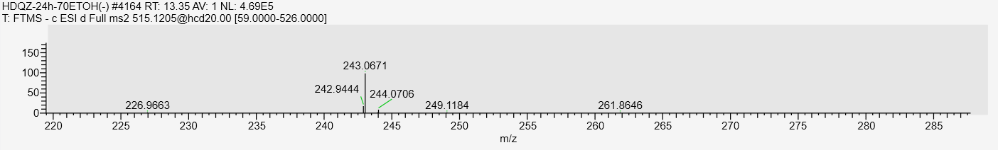
S59 Dihydrotetrahydroxystilbene-O-hexoside Rt:20.30min
MS
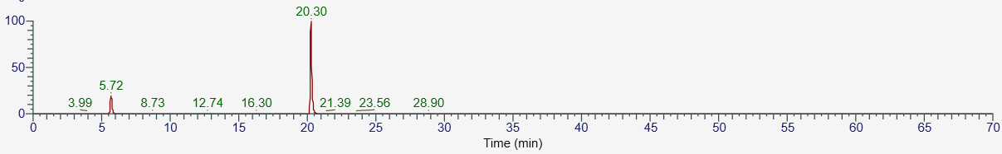
MS/MS
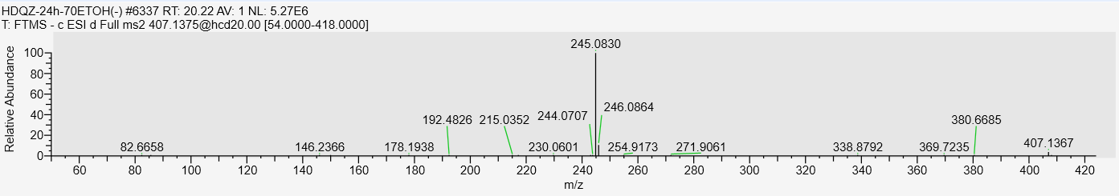
S60 Multiflorumiside H Rt:7.67min
MS
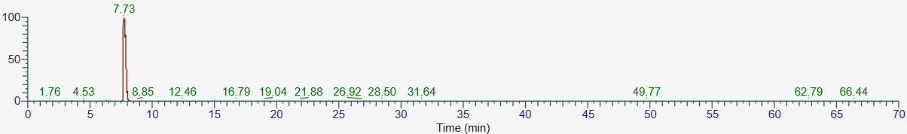
MS/MS
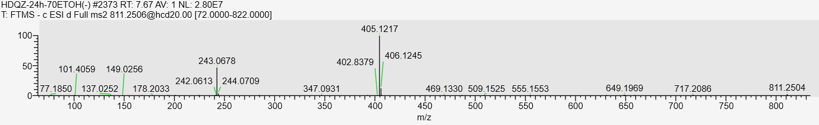
S61 polygonumosides A Rt:15.96min
MS
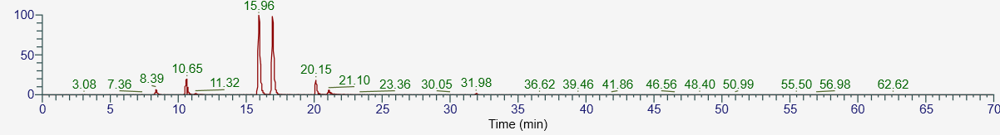
MS/MS
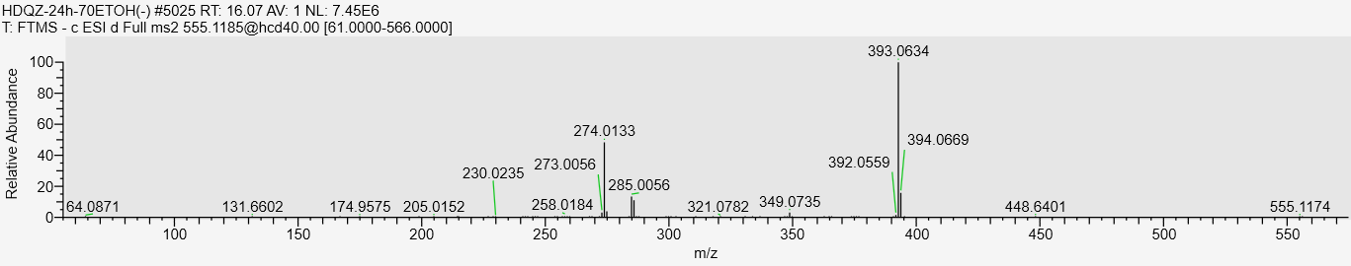
S63 oxidized derivative of tetrahydroxystilbene glucoside Rt:1.10min
MS
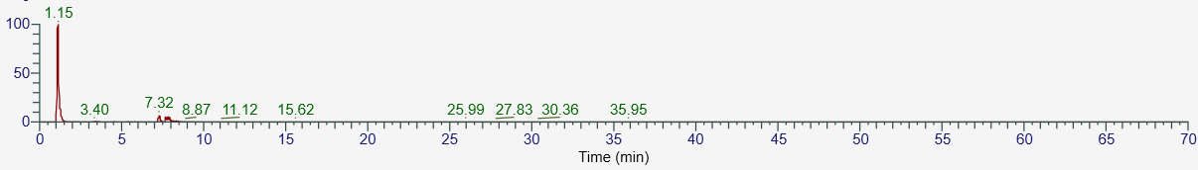
MS/MS
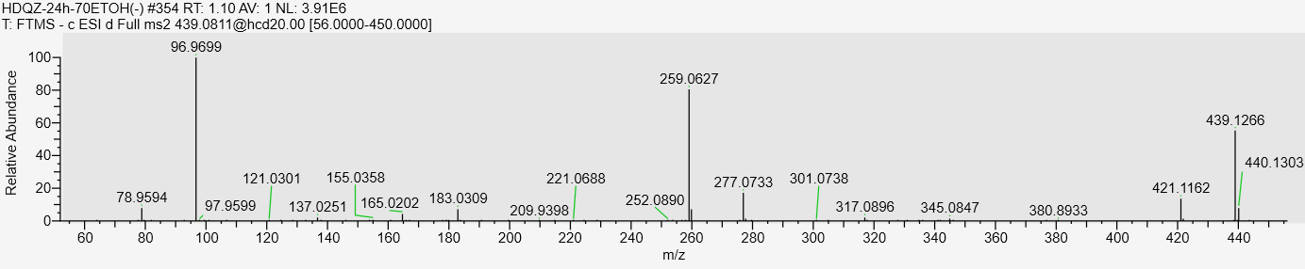
P1 Quinic acid Rt:1.70min
MS
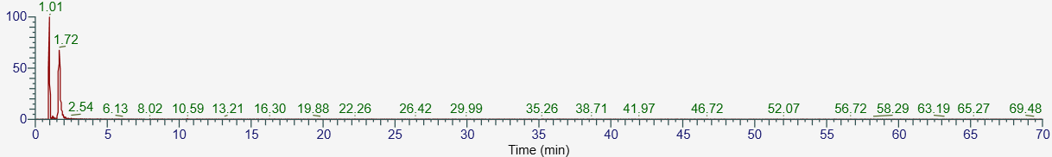
MS/MS
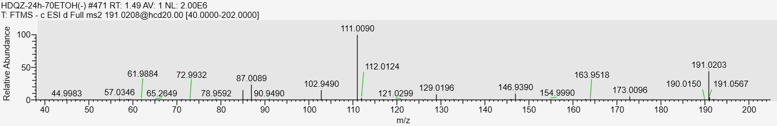
P2 pyrogallol Rt:5.66min
MS
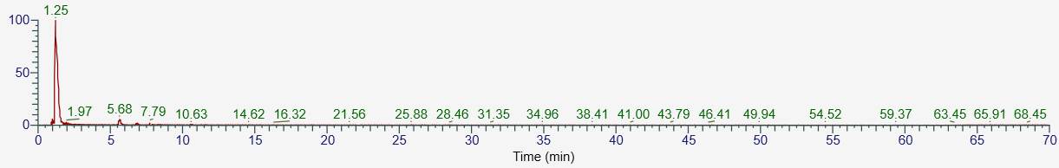
MS/MS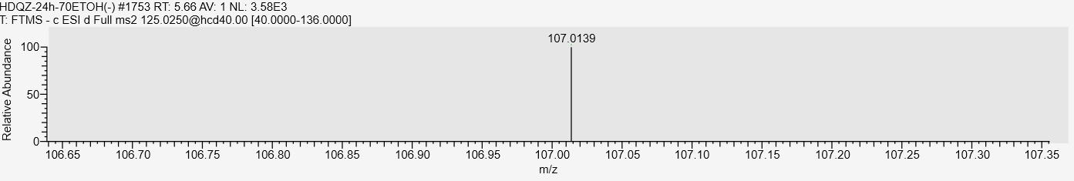P3 Structural analogs or isomers of pyrogallol Rt:1.41min
MS
MS/MS
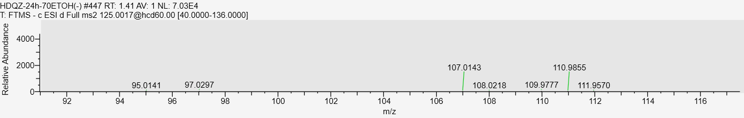
P4 vanillin Rt:3.34min
MS
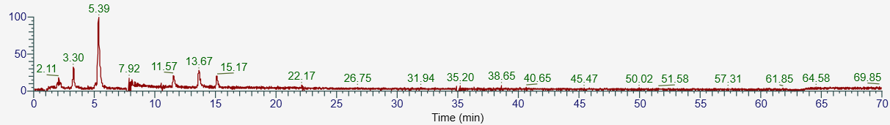
MS/MS
P5 Structural analogs or isomers of vanillin Rt:5.35min
MS
MS/MS
P6 vanillic acid Rt:5.65min
MS
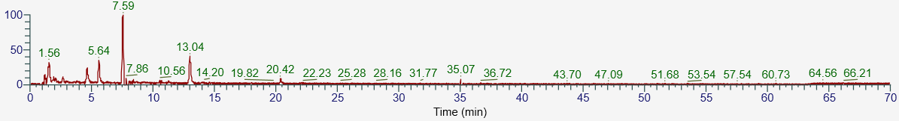
MS/MS
P7 Structural analogs or isomers of vanillic acid Rt:7.59min
MS
MS/MS
P8 Structural analogs or isomers of vanillic acid Rt:13.03min
MS
MS/MS
P9 veratric acid Rt:2.39min
MS
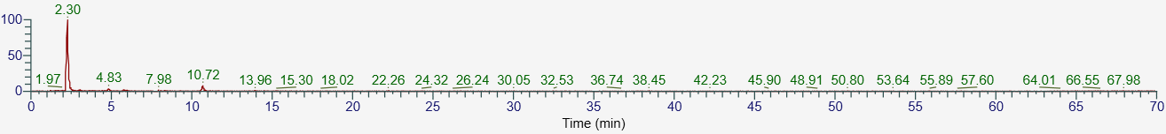
MS/MS
P10 Structural analogs or isomers of veratric acid Rt:4.83min
MS
MS/MS
P13 Syringic acid Rt:5.52min
MS
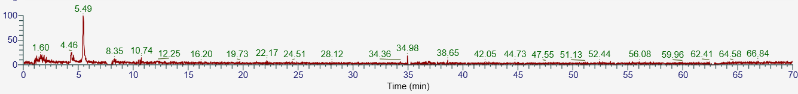
MS/MS
P14 carboxy vanillic acid Rt:1.21min
MS
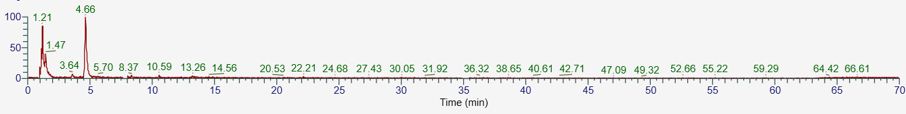
MS/MS
P15 Structural analogs or isomers of carboxy vanillic acid Rt:1.42min
MS
MS/MS
P16 Structural analogs or isomers of carboxy vanillic acid Rt:4.66min
MS
MS/MS
P17 caffeic acid Rt:3.72min
MS
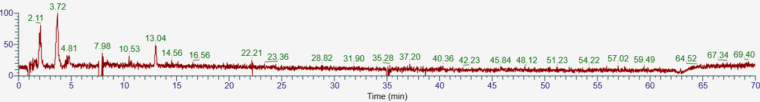
MS/MS
P18 3’-β-D-glucopyranosyloxy-4’, 5’-dihydroxyacetophenone Rt:2.30min
MS
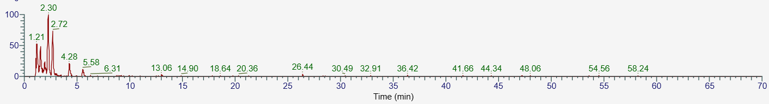
MS/MSP19 Structural analogs or isomers of 3’-β-D-glucopyranosyloxy-4’, 5’-dihydroxyacetophenone Rt:2.76min
MS
MS/MS
P20 2,3,4,6-tetrahydroxyacetophenone-O-glucopyranoside (Polygoacetophenoside) Rt:5.56min
MS
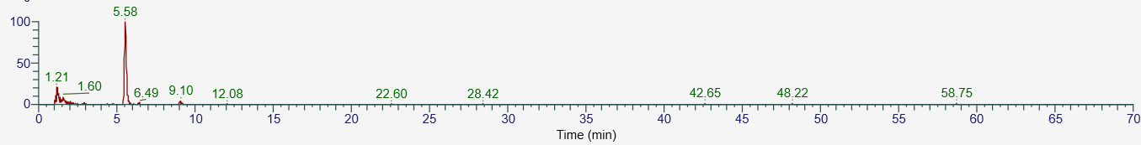
MS/MS
P21 6’-Methoxypolygoacetophenoside Rt:1.93min
MS
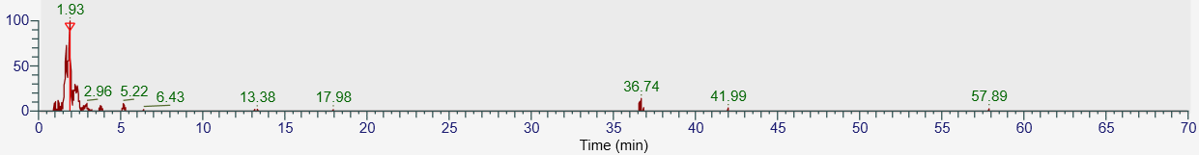
MS/MS
P22 Structural analogs or isomers of 6’-Methoxypolygoacetophenoside Rt:5.22min
MS
MS/MS
P23 3,5-dihydroxyphenol-1-O-β-D-(6’’-O-galloyl)-glucopyranoside Rt:1.57min
MS
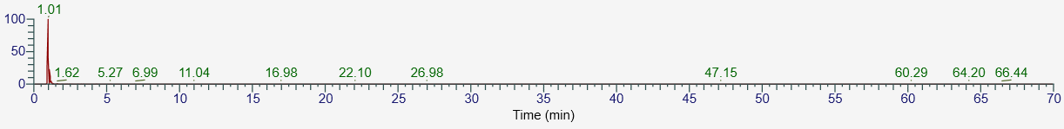
MS/MS
P24 Structural analogs or isomers of 3,5-dihydroxyphenol-1-O-β-D-(6’’-O-galloyl)-glucopyranoside Rt:1.01min
MS
MS/MS
P26 (+)-lyoniresinol-2α-O-β-glucoside Rt:6.80min
MS
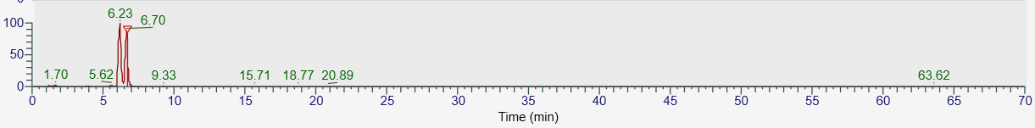
MS/MS
P27 1,2,6-galloyl-hexose Rt:4.55min
MS
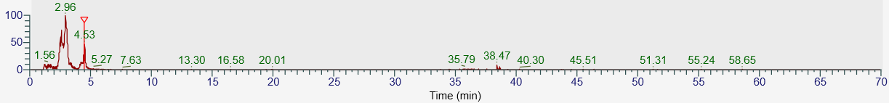
MS/MS
P28 3,4-Dihydroxybenzal dehyde Rt:2.02min
MS
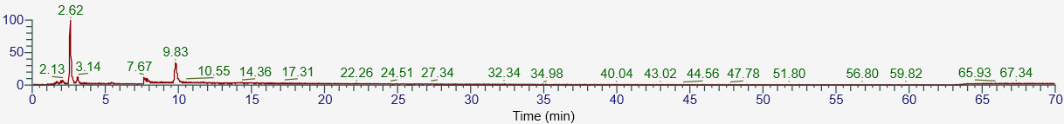
MS/MS
P28 Structural analogs or isomers of isomer of 3,4-Dihydroxybenzal dehyde Rt:3.10min
MS
MS/MS
P30 Structural analogs or isomers of 3,4-Dihydroxybenzal dehyde Rt:9.83min
MS
MS/MS
P31 protocatechuic acid Rt:1.48min
MS
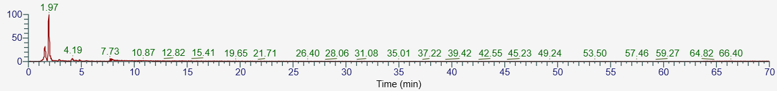
MS/MS
P32 Structural analogs or isomers of Protocatechuic acid Rt:1.97min
MS
MS/MS
P33 Structural analogs or isomers of Protocatechuic acid Rt:4.12min
MS
MS/MS
P34 gentistic acid Rt:7.77min
MS
MS/MS
P35 Coumaric acid Rt:6.21min
MS
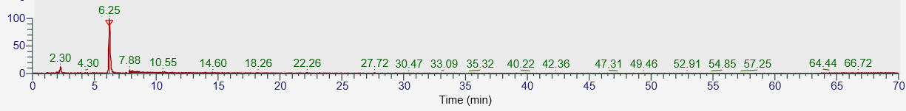
MS/MS
P36 gallic acid Rt:1.19min
MS
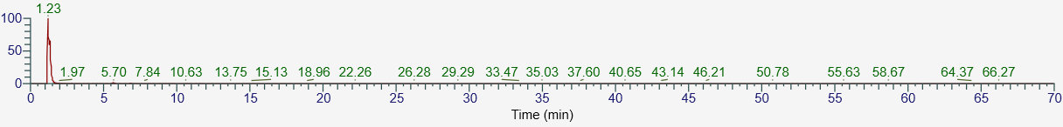
MS/MS
P38 2,4-Dihydroxy-6-[(1E)-2-(4-hydroxyphenyl) ethenyl] phenyl beta-D-xylopyranoside Rt:8.87min
MS
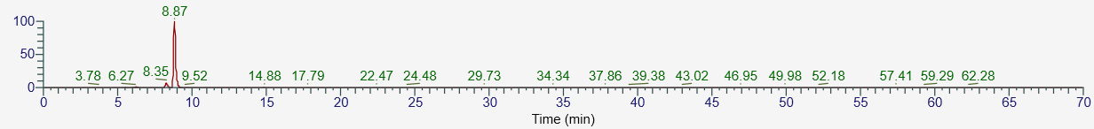
MS/MS
P39 di-O-caffeoylquinic acid Rt:10.45min
MS
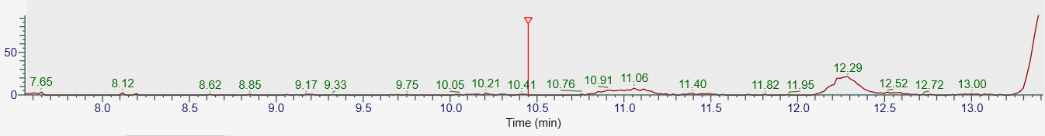
MS/MS
P40 Structural analogs or isomers of di-O-caffeoylquinic acid Rt:11.07min
MS
MS/MS
P41 Isoferulic acid Rt:4.76min
MS
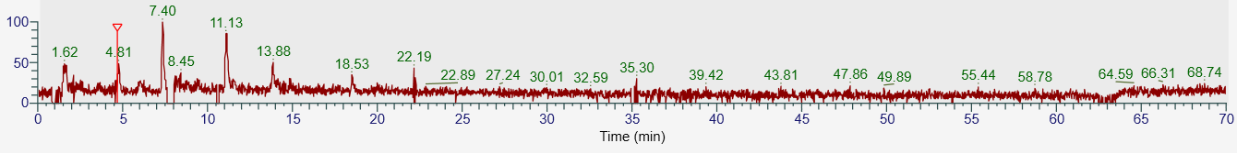
MS/MS
P42 P-coumaric acid Rt:6.19min
MS
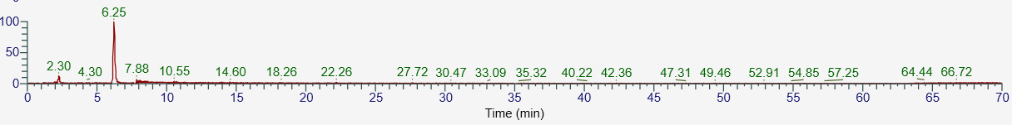
MS/MS
P43 protocatechuic acid hexose Rt：7.86min
MS
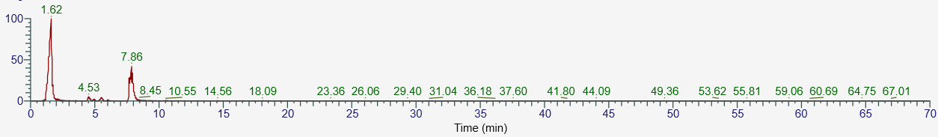
MS/MS
P45 Structural analogs or isomers of protocatechuic acid hexose Rt：1.62min
MS
MS/MS
AM3 L-phenylalanine Rt：5.91min
MS
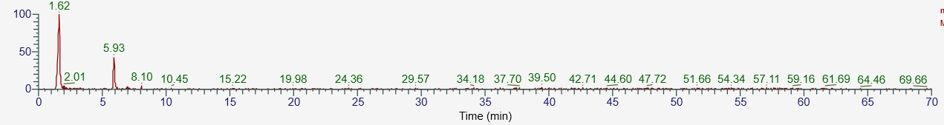
MS/MS
AM4 Structural analogs or isomers of L-phenylalanine Rt：1.85min
MS
MS/MS

AM6 Structural analogs or isomers of piscidic acid 1.72min
MS
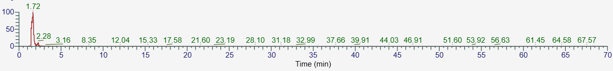
MS/MS
AM7 Structural analogs or isomers of piscidic acid 2.28min
MS
MS/MS
AM10 Structural analogs or isomers of 1-Piperidinepentanoic acid, α-amino-δ-oxo-, (S)- Rt:1.80min
MS
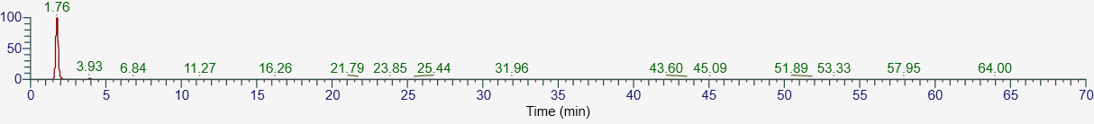
MS/MS
AM11 Structural analogs or isomers of 1-Piperidinepentanoic acid, α-amino-δ-oxo-, (S)- Rt:3.93min
MS
MS/MS
AM13 Gamma-L-Glutamyl-L-pipecolic-acid Rt：1.92min
MS
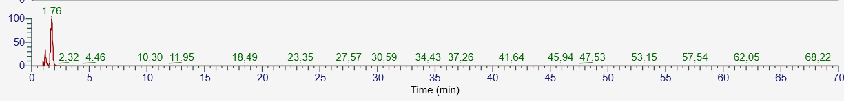
MS/MS
AM15 Structural analogs or isomers of N-L-Glutamate-L-leucine Rt：2.53min
MS
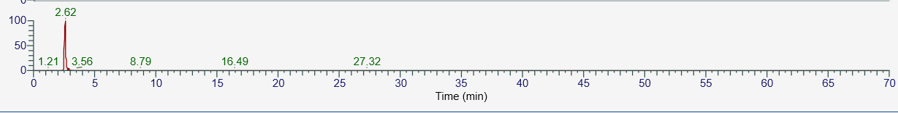
MS/MS
AM16 Structural analogs or isomers of N-L-Glutamate-L-leucine Rt：2.88min
MS
MS/MS
AM17 gamma-L Glutamyl-L pipecolic-acid glucopyranoside Rt：6.63min
MS
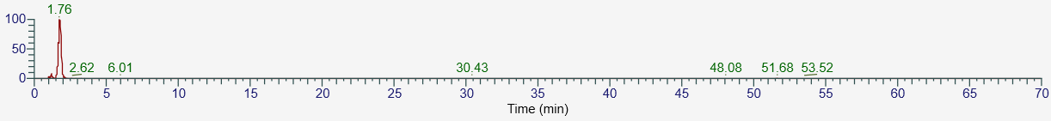
MS/MS
AM18 L-phenylalanine Rt:2.21min
MS
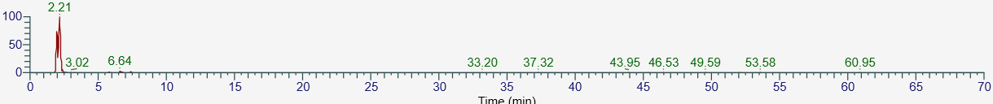
MS/MS
AL1 hydroxy-methylglutaric acid Rt:1.29min
MS
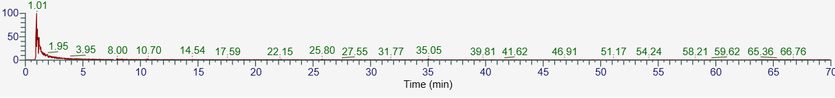
M/MS
AL2 Structural analogs or isomers of hydroxy-methylglutaric acid Rt:1.89min
MS
MS/MS
AL3 Hydocerol A Rt:3.97min
MS
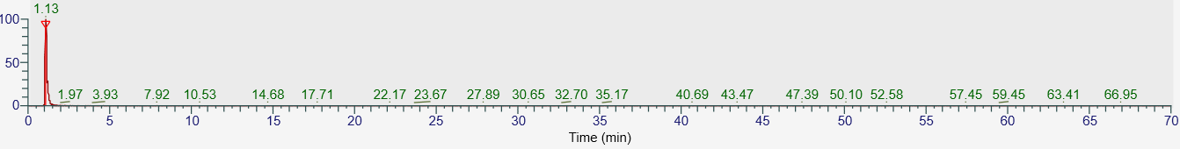
MS/MS
AL4 Structural analogs or isomers of hydocerol A Rt:1.13min
MS
MS/MS
AL5 Structural analogs or isomers of hydocerol A Rt:7.92min
MS
MS/MS
F1 Shikimic acid Rt:1.12min
MS
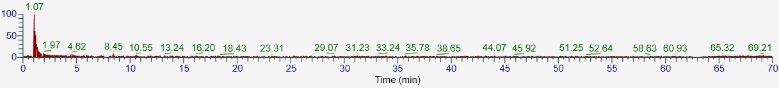
MS/MS
F2 9,12,13-TriHOME Rt:32.65min
MS
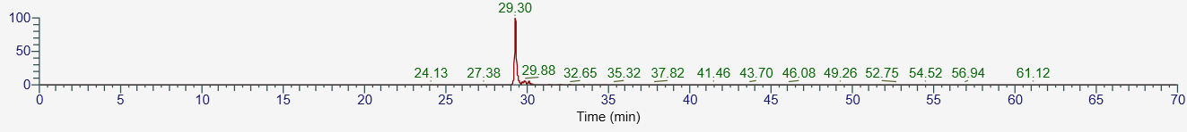
MS/MS
F3 Structural analogs or isomers of 9,12,13-TriHOME Rt:29.88min
MS
MS/MS
F4 Structural analogs or isomers of 9,12,13-TriHOME Rt:29.42min
MS
MS/MS
F5 Azelaic acid Rt:14.61min
MS
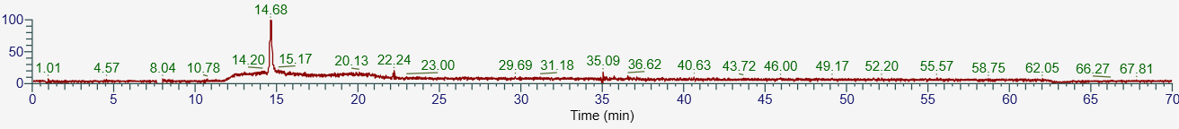
MS/MS
C1 altechromone A Rt:2.24min
MS
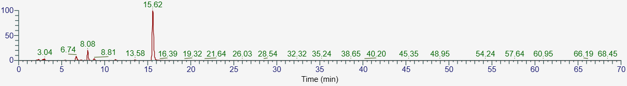
MS/MS
C2 Structural analogs or isomers of altechromone A Rt:6.63min
MS
MS/MS
C3 Structural analogs or isomers of altechromone A Rt:8.01min
MS
MS/MS
C4 Noreugenin Rt:13.58min
MS
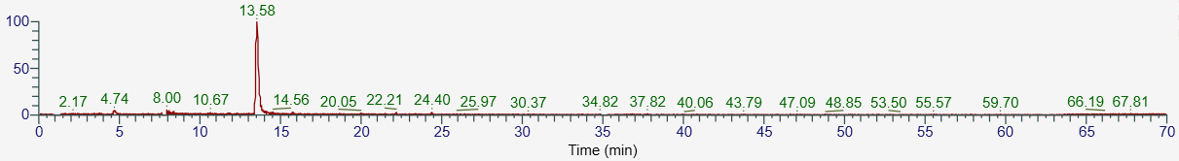
MS/MS
C5 thunberginol C-6-O-β-D glucoside Rt:7.06min
MS
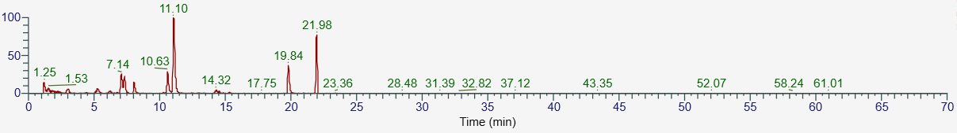
MS/MS
C6 Structural analogs or isomers of thunberginol C-6-O-β-D glucoside Rt:10.66min
MS
MS/MS
FL2 catechin glucopyranoside Rt:1.50min
MS
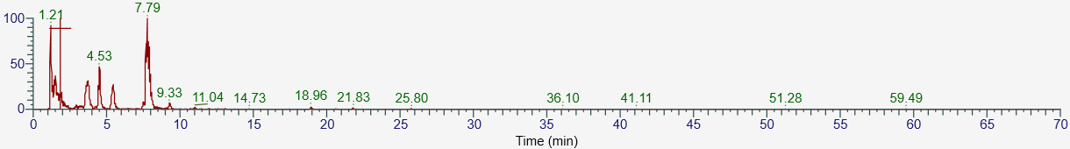
MS/MS
FL3 Structural analogs or isomers of catechin glucopyranoside Rt:7.81min
MS/MS
MS/MS
FL4 Procyanidin C1 galloyl ester Rt:1.27min
MS
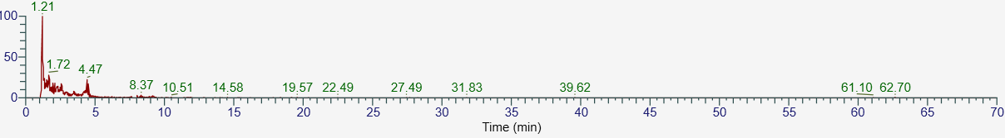
MS/MS
FL5 daidzein Rt:34.22min
MS
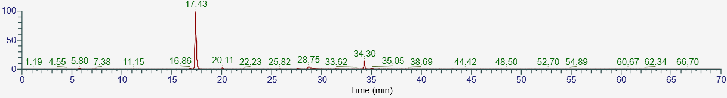
MS/MS
FL6 Structural analogs or isomers of daidzein Rt:17.43min
MS
MS/MS
FL7 kaempferol Rt:25.25min
MS
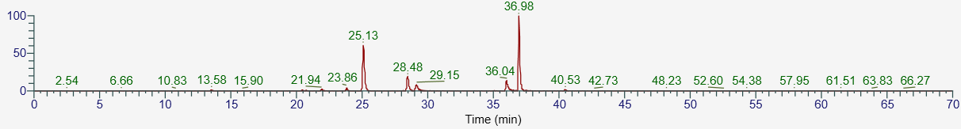
MS/MS
FL8 Structural analogs or isomers of kaempferol Rt:28.48min
MS
MS/MS
FL9 Structural analogs or isomers of kaempferol Rt:36.14min
MS
MS/MS
FL11 Structural analogs or isomers of procyanidin B Rt:1.90min
MS
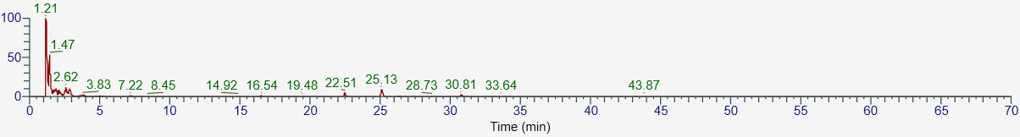MS/MS
FL12 Structural analogs or isomers of procyanidin B Rt:2.51min
MS
MS/MS
FL13 catechin gallyl ester Rt:7.65min
MS
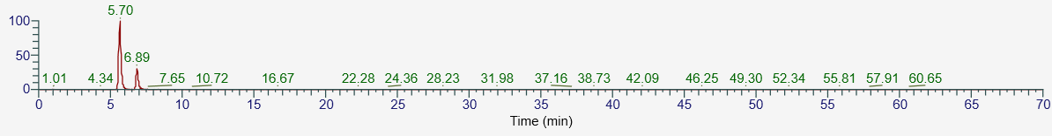
MS/MS
FL14 Structural analogs or isomers of catechin gallyl ester Rt:5.78min
MS
MS/MS
FL15 Structural analogs or isomers of catechin gallyl ester Rt:6.89min
MS
MS/MS
FL16 quercitrin Rt:12.58min
MS
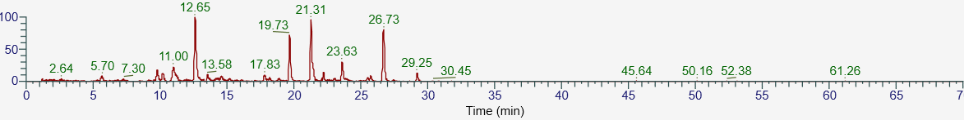
MS/MS
FL17 Structural analogs or isomers of quercitrin Rt:11.05min
MS
MS/MS
FL18 Apigenin-7-O-glucoside Rt:22.24min
MS
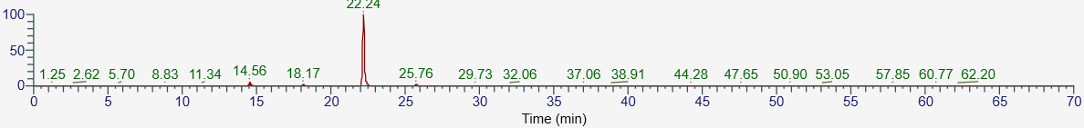
MS/MS
FL19 polygonflavanol A Rt:3.93min
MS
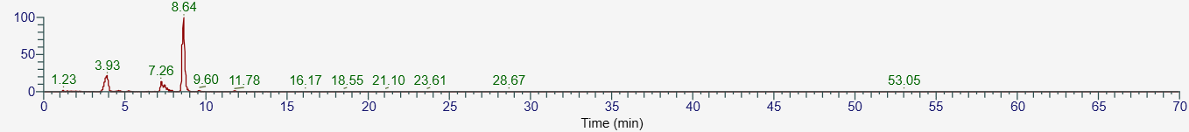
MS/MS
FL20 Structural analogs or isomers of polygonflavanol A Rt:7.26min
MS
MS/MS
FL21 quercetin Rt:19.00min
MS
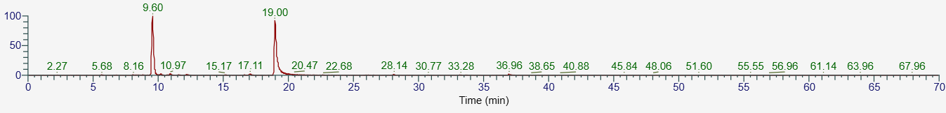
MS/MS
FL22 2’, 4’, 5, 5’, 7-Pentahydroxyflavone Rt:9.50min
MS
MS/MS
FL25 Acetyl-epicatechin-O-glucoside Rt:10.83min
MS
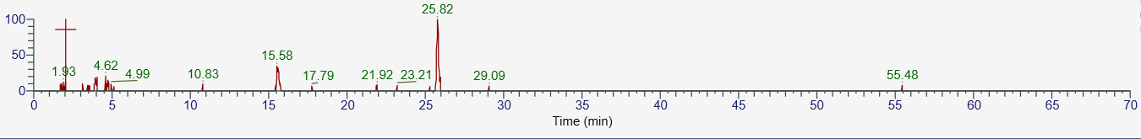
MS/MS
FL26 new compound-2 Rt:1.56min
MS
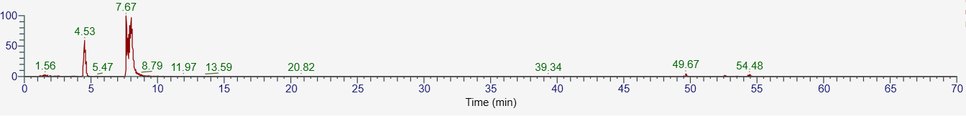
MS/MS
FL27 Structural analogs or isomers of new compound-2 Rt:4.53min
MS
MS/MS
FL28 Structural analogs or isomers of new compound-2 Rt:8.02min
MS
MS/MS
FL29 epicatechin Rt:2.11min
MS 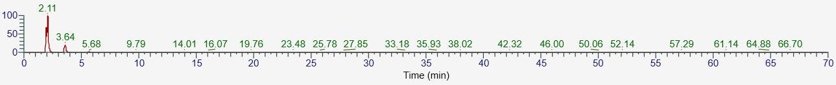
MS/MS
FL30 Structural analogs or isomers of epicatechin Rt:3.66min
MS
MS/MS
FL31 Structural analogs or isomers of epicatechin Rt:5.58min
MS
MS/MS
FL32 di-O-galloyl procyanidin Rt:3.04min
MS
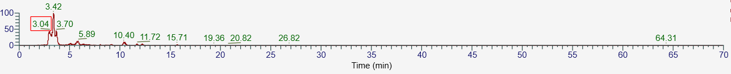
MS/MS
FL33 Structural analogs or isomers of di-O-galloyl procyanidin Rt:3.70min
MS
MS/MS
FL34 Structural analogs or isomers of di-O-galloyl procyanidin Rt:5.91min
MS
MS/MS
FL35 Viterxin Rt:22.24min
MS
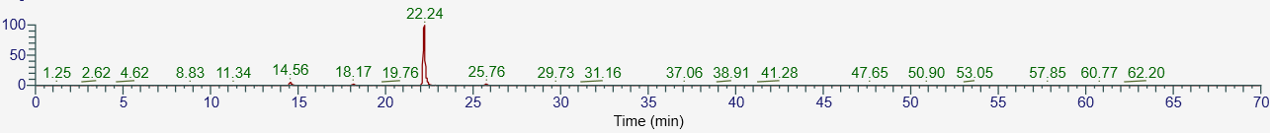
MS/MS
FL36 mono-O-galloyl-procyanidin B Rt:1.86min
MS
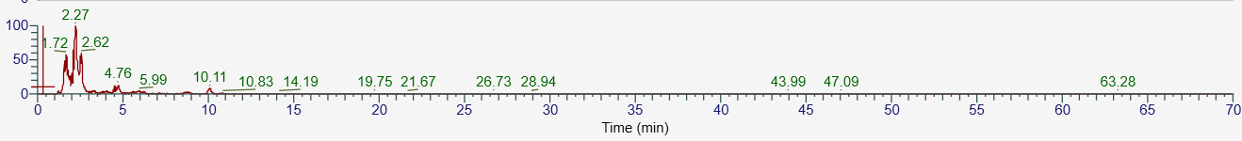
MS/MS
FL37 3-O-galloyl-procyanidin Rt:4.76min
MS
MS/MS
FL38 Dihydroquercetin Rt:11.68min
MS
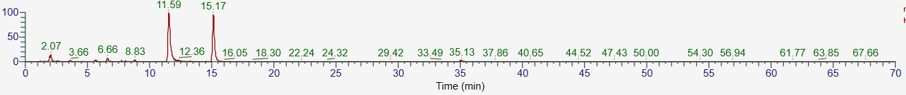
MS/MS
N1 Torachrysone Rt:20.30min
MS
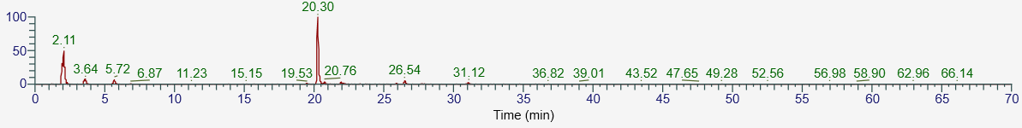
MS/MS
N2 6-methoxyl-2-acetyl-3-methyljuglone-8-O-glucopyranoside Rt:5.57min
MS
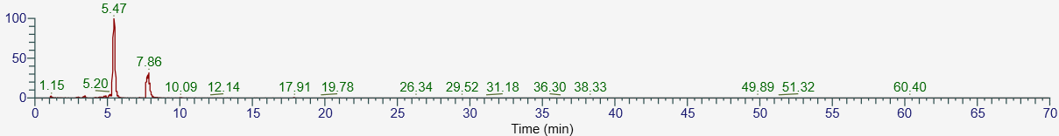
MS/MS
N3 Structural analogs or isomers of 6-methoxyl-2-acetyl-3-methyljuglone-8-O-glucopyranoside Rt:7.79min
MS
MS/MS
N4 6-methoxyl-2-acetyl-3-methyl-1,4-Naphthoquinone-8-O-β-D-glucopyranoside
Rt:1.15min
MS
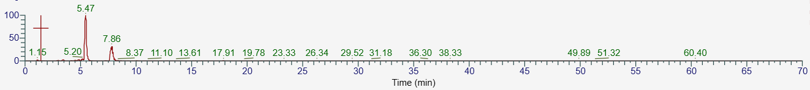
MS/MS
N5 Structural analogs or isomers of 6-methoxyl-2-acetyl-3-methyl-1,4-Naphthoquinone-8-O-β-D-glucopyranoside Rt:7.86min
MS
MS/MS
N6 Structural analogs or isomers of 6-methoxyl-2-acetyl-3-methyl-1,4-Naphthoquinone-8-O-β-D-glucopyranoside Rt:5.57min
MS
MS/MS
N7 Torachrysone -8-O-β-D- glucopyranoside Rt:20min
MS
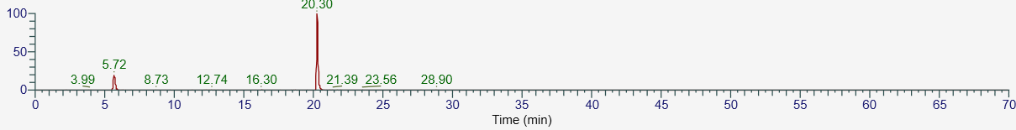
MS/MS
ALK1 N, N-dimethyl tryptophan methylester Rt:1.80min
MS
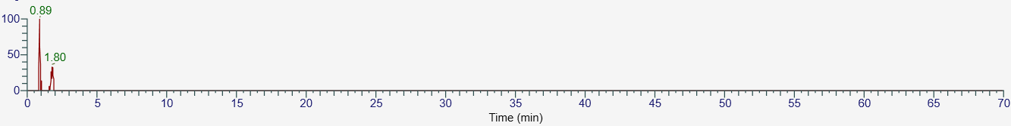
MS/MS
ALK2 N-trans-Feruloyltyramine Rt:16.02min
MS
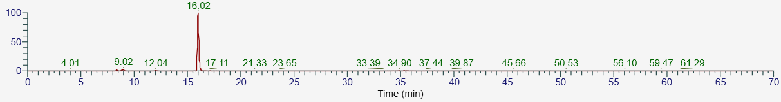
MS/MS
O3 3，8-Dihydroxy-1-methoxyxanthone Rt:27.01min
MS
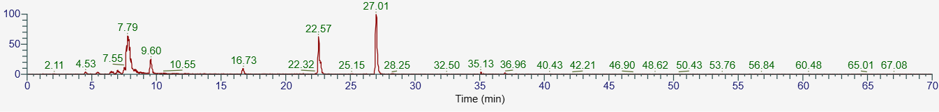
MS/MS
O4 Structural analogs or isomers of 3，8-Dihydroxy-1-methoxyxanthone Rt:22.57min
MS
O5 1,2,4,6-Tetrahydroxy-1-glucoside-phenanthrene Rt:2.28min
MS
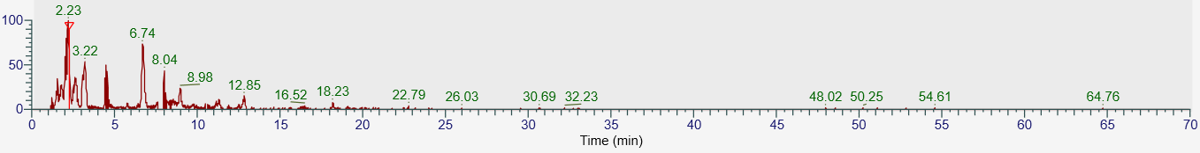
MS/MS
O6 P-hydroxybenzaldehyde Rt:8.18min
MS
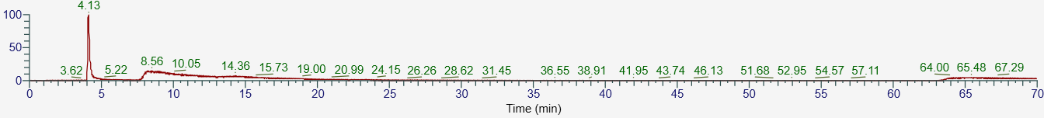
MS/MS
O7 Structural analogs or isomers of p-hydroxybenzaldehyde Rt:3.59min
MS
MS/MS
O8 Structural analogs or isomers of p-hydroxybenzaldehyde Rt:4.32min
MS
MS/MS
O9 ethyl ferulate Rt:19.27min
MS
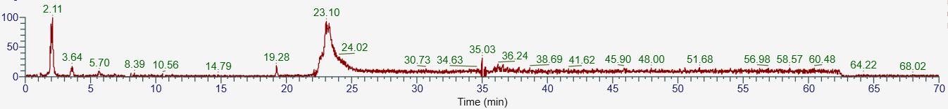
MS/MS
O10 Structural analogs or isomers of ethyl ferulate Rt:23.10min
MS
MS/MS
O11 Citropten Rt:9.32min
MS
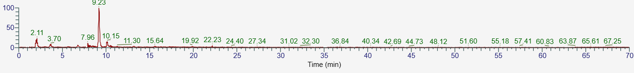
MS/MS
O12 Methyl-4-hydroxy-3-methoxycinnam Rt:3.14min
MS
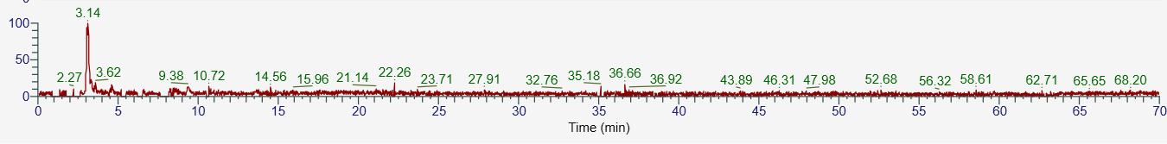
MS/MS

