Supplementary materials
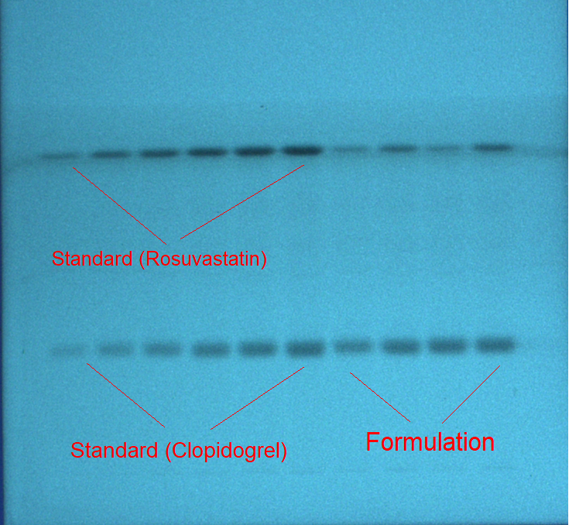
Figure S1. The representative TLC image showing the spots for standard CLOP, ROS, and commercial fixed-dose combination (FDC) capsules established utilizing EtOH-H₂O-NH₃ (70:25:5 v/v/v) as an eco-friendly developing system for the present methodology.
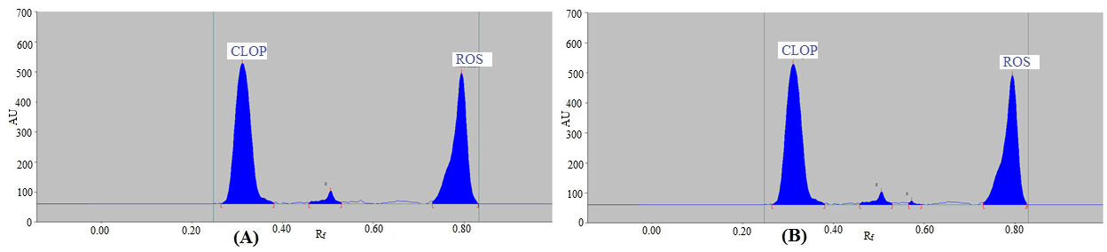Figure S2. Representative chromatogram of CLOP and ROS in (A) FDC capsule brand A and (B) FDC capsule brand B.

