Supplementary Material
Bacterial cellulose nanofibers decorated with graphene/Cu-Mg MOF for sorption of zirconium, yttrium, and strontium ions from multicomponent system
E.M. Abu Elgoud* ¹, Aya M. Matloob ², Deyaa Abol-Fotouh ³, H.F. Aly ¹,
& Ola E. A. Al-Hagar ⁴

¹⁾ Nuclear Fuel Chemistry Department, Hot Laboratories Center, Egyptian Atomic Energy Authority, 13759, Egypt.
²⁾ Refining department, Egyptian Petroleum Research Institute (EPRI), Naser City, 11727, Cairo, Egypt.
³⁾ Advanced Technology and New Materials Research Institute (ATNMRI), City of Scientific Research and Technological Applications (SRTA-City), New Borg El-Arab City, Alexandria 21934, Egypt.
⁴⁾ Plant Research Department, Nuclear Research Center, Egyptian Atomic Energy Authority, Cairo 13759, Egypt.
∗Corresponding author, email: elsayedmustafa36@yahoo.com, Tel. (+2) 01552734381

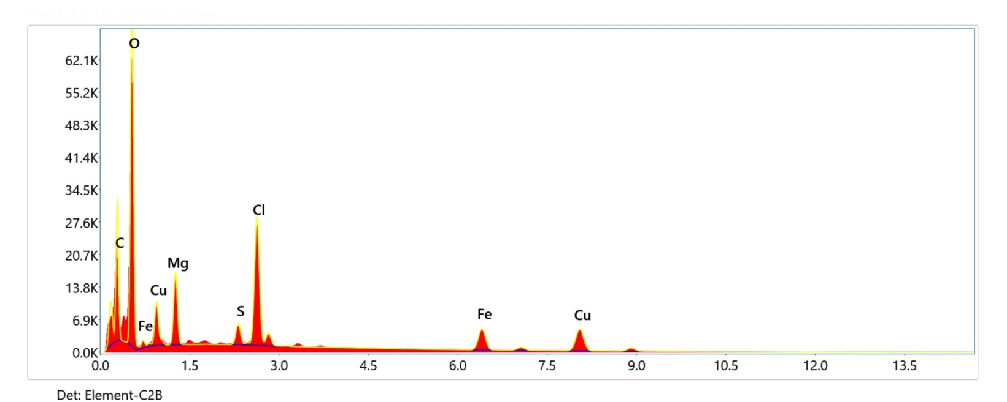
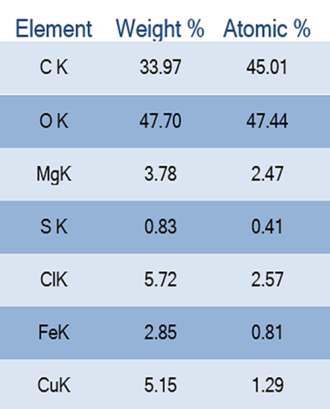
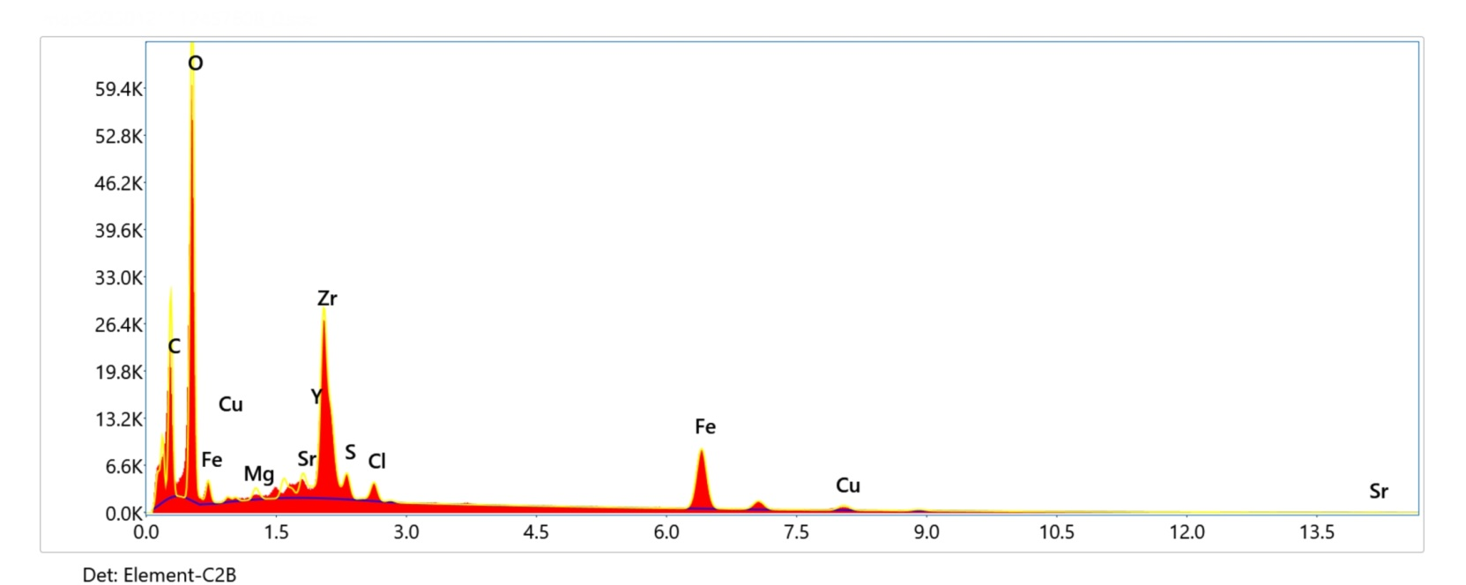
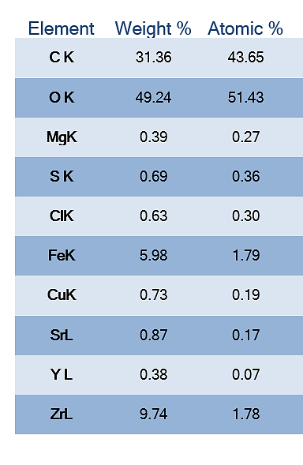
Figure S1: A & B represent the EDX analysis of the BC/Gr/Cu-Mg MOF before and after
treatment of aqueous solution includes zirconium, yttrium, and strontium ions, respectively.
A
B

