A Multi-Faceted Study Combining Quantum Chemical, Hammett Parameters , and Antibacterial assessment for Imidazole - Based Green Ionic Liquids Corrosion Inhibition
Amira H. E. Moustafa , Hanaa H. Abdel-Rahman , Mohamed Hagar , Sherif A. A. Bishr
Chemistry Department, Faculty of Science, Alexandria University, P.O. 426 Ibrahemia,
Alexandria 21321, Egypt.

Characterization of imidazolium-based ionic liquids 3a-d
- Characterization of 1-acetyl-3-benzoyl-1H-imidazol-3-ium chloride (ACIM-H)
Colorless oil, m.p. = 15-17 °C, yield 94%. IR (υ, cm⁻¹): 3075 (C-H ar), 2930 (C-H al), 1710 (C=O), 1620 (C=N), 1550 (C=C). ¹H NMR (400 MHz, DMSO-d₆): δ_{H} = 8.35-8.31 (2H, m, Ar-H), 8.14-8.11 (2H, m, Ar-H), 8.00 (1H, d, J = 12 Hz, Ar-H), 7.81 (1H, d, J = 12 Hz, Ar-H), 7.49-7.30 (2H, m, Ar-H), 2.52 (3H, s, CH₃ overlapped with DMSO-d₆). Molecular formula is C₁₂O₂N₂H₁₁Cl with molecular weight = 250.5 g/ mol, In Mass spectrometry = 249.08572 m/z.
- Characterization of 1-acetyl-3-(2-chlorobenzoyl)-1H-imidazol-3-ium chloride (ACIM-Cl)
White pellets, m.p. = 44-45 °C, yield 93%. IR (υ, cm⁻¹): 3050 (C-H ar), 2910 (C-H al), 1700 (C=O), 1615 (C=N), 1565 (C=C); ¹H NMR (400 MHz, DMSO-d₆): δ_{H} = 8.11 (1H, s, Ar-H), 8.00-7.91 (2H, m, Ar-H), 7.82-7.77 (2H, m, Ar-H), 7.50-7.30 (2H, m, Ar-H), 2.52 (3H, s, CH₃ overlapped with DMSO-d₆); ¹³C NMR (125 MHz, DMSO-d6) δ_{C}: 167.6 (C=O), 133.2, 131.9, 131.7, 131.2, 131.1, 127.8 (Ar-C). Molecular formula is C₁₂O₂N₂H₁₀Cl₂ with molecular weight = 285 g/ mol, In Mass spectrometry = 283.03210 m/z.

- Characterization of 1-acetyl-3-(3,4,5-trimethoxybenzoyl)-1H-imidazol-3-ium chloride (ACIM-OMe)
White pellets, m.p. = 67-69 °C, yield 91%. IR (υ, cm⁻¹): 3080 (C-H ar), 2975 (C-H al), 1715 (C=O), 1625 (C=N), 1560 (C=C). ¹H NMR (400 MHz, DMSO-d₆): δ_{H} = 8.37-8.30 (2H, m, Ar-H), 8.13-8.09 (1H, m, Ar-H), 7.19 (2H, s, Ar-H), 3.78 (6H, s, 2 x OCH₃), 3.68 (3H, s, OCH₃), 2.50 (3H, s, CH₃ overlapped with DMSO-d₆). Molecular formula is C₁₅O₅N₂H₁₇Cl with molecular weight = 340.5 g/ mol, In Mass spectrometry = 338.06540 m/z.
- Characterization of 1-acetyl-3-(4-nitrobenzoyl)-1H-imidazol-3-ium chloride (ACIM-NO₂)
White pellets, m.p. 56-58 °C, yield 93%. IR (υ, cm⁻¹): 3035 (C-H ar), 2945 (C-H al), 1710 (C=O), 1610 (C=N), 1555 (C=C). ¹H NMR (400 MHz, DMSO-d₆): δ_{H} = 8.36-8.32 (2H, m, Ar-H), 8.15-8.12 (2H, m, Ar-H), 7.76-7.67 (2H, m, Ar-H), 7.29-7.26 (1H, m, Ar-H), 2.41 (3H, s, CH₃); ¹³C NMR (125 MHz, DMSO-d6) δ_{C}: 166.8 (C=O), 150.3, 137.2, 134.2, 131.1, 124.1, 119.7 (Ar-C). Molecular formula is C₁₂O₄N₃H₁₀Cl with molecular weight = 295.5 g/ mol, In Mass spectrometry 294.80680 m/z.

Sup. Fig 1: FT-IR spectrum of compound ACIM-H.
Sup. Fig 2: FT-IR spectrum of compound ACIM-OMe.
Sup. Fig 3: FT-IR spectrum of compound ACIM-Cl.
Sup. Fig 4: FT-IR spectrum of compound ACIM-NO₂.
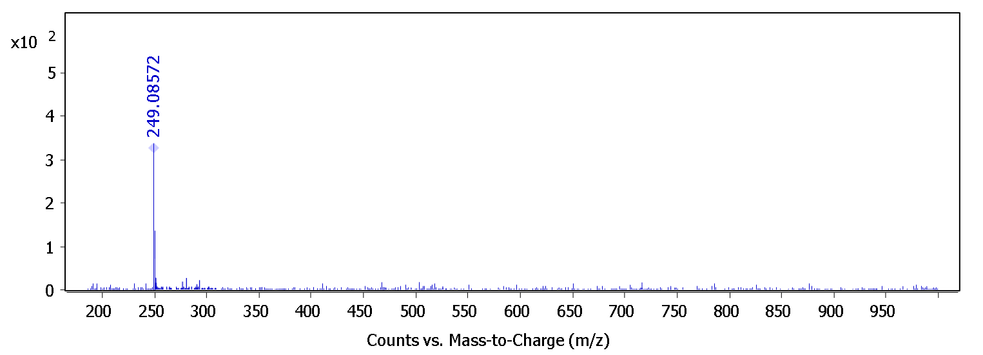
Sup. Fig 5: Mass spectrometry of compound ACIM-H.
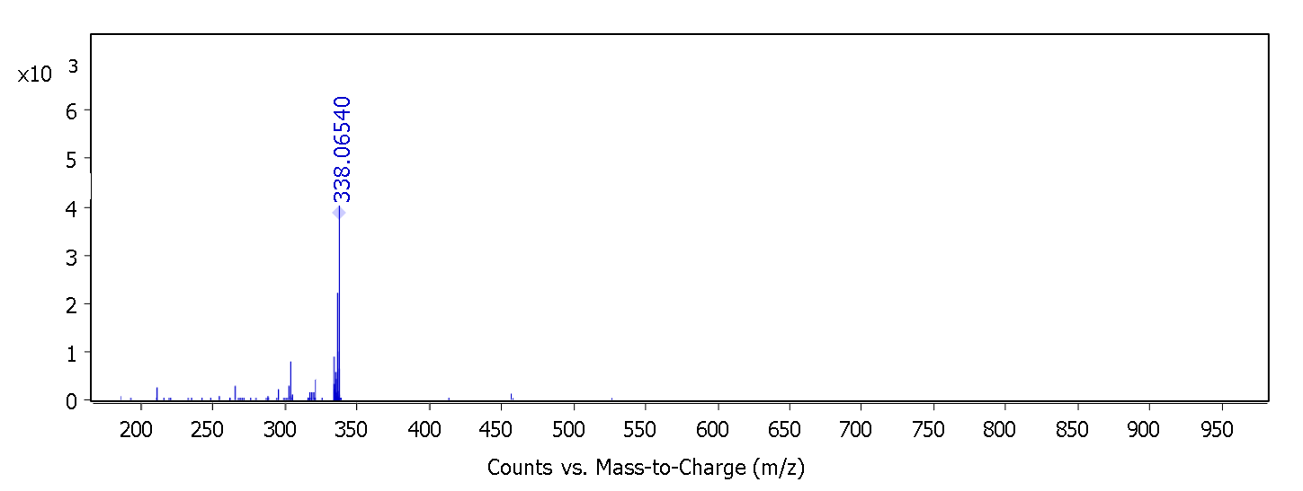
Sup. Fig 6: Mass spectrometry of compound ACIM-OMe.
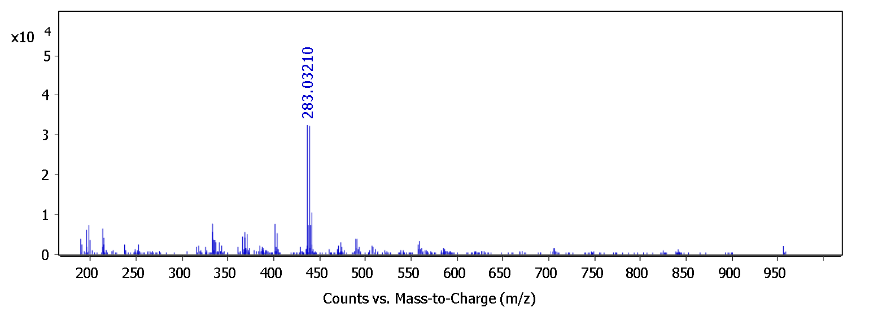
Sup. Fig 7: Mass spectrometry compound ACIM-Cl.

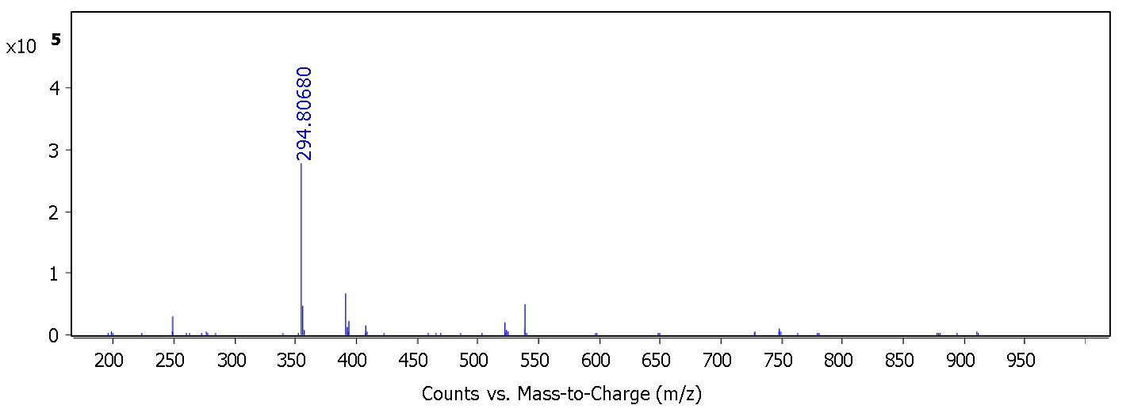
Sup. Fig 8: Mass spectrometry compound ACIM- NO₂.

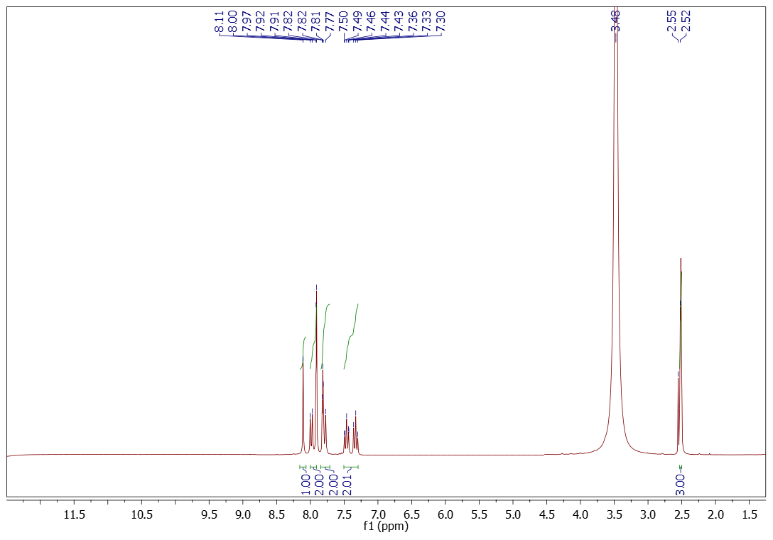
Sup. Fig 9: ¹H NMR spectrum of compound ACIM-Cl.
Sup. Fig 10: C¹³ NMR spectrum of compound ACIM-Cl.

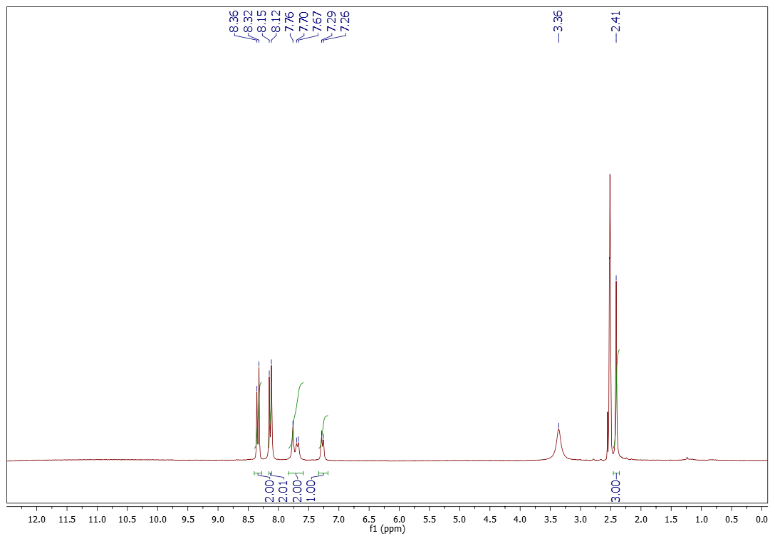
Sup. Fig 11: ¹H NMR spectrum of compound ACIM-NO₂.
Sup. Fig 12: C¹³ NMR spectrum of compound ACIM-NO₂.

Sup. Fig 13: Polarization curve of the tested CS: at different concentrations for ACIM-H at 298 K.

Sup. Fig 14: Polarization curve of the tested CS: at different concentrations for ACIM-Cl at 298 K.

Sup. Fig 15: Polarization curve of the tested CS: at different concentrations for ACIM-NO₂ at 298 K.

Sup. Fig 16: Polarization curve of the tested CS: at temperatures for concentration 20.58 x 10⁻⁵ M for ACIM-H.

Sup. Fig 17: Polarization curve of the tested CS: at temperatures for concentration 20.58 x 10⁻⁵ M for ACIM-Cl.

Sup. Fig 18: Polarization curve of the tested CS: at temperatures for concentration 20.58 x 10⁻⁵ M for ACIM-NO₂.

Sup. Fig 19: El-Awady model for different concentrations and temperatures for ACIM-H.

Sup. Fig 20: El-Awady model for different concentrations and temperatures for ACIM-Cl.

Sup. Fig 21: El-Awady model for different concentrations and temperatures for ACIM-NO₂.

Sup. Fig 22: Free energy vs T to calculate Enthalpy and Entropy for ACIM.

Sup. Fig 23: Arrhenius diagrams for calculating activation energy based on the relationship between temperature and limiting current with and without ACIM-H.
.

Sup. Fig 24: Arrhenius diagrams for calculating activation energy based on the relationship between temperature and limiting current with and without ACIM-Cl.

Sup. Fig 25: Arrhenius diagrams for calculating activation energy based on the relationship between temperature and limiting current with and without ACIM-NO₂.

Sup. Table 1: The equations are used to compute the additional parameters for ACIM.
I = $-$ E_{HOMO} | A = $-$ E_{LUMO} | X =$\frac{(I + A) }{2}$
μ = $-$ X | ƞ = $\frac{(I - A) }{2}$ | σ =$\frac{1}{ƞ}$
∆E_{b.d} $=\frac{-ƞ}{4}$ | ω = $\frac{μ^{2}}{2ƞ}$ | ω⁻ = $\frac{{(3I+A)}^{2}}{16(I-A)}$
ω⁺ = $\frac{{(I+3A)}^{2}}{16(I-A)}$ | ∆ω± = (ω⁺- (-ω⁻)) | ∆ω± = (ω⁺- $\frac{1}{ω^{-}}$)
∆N = $\frac{\left(X_{Fe} - X\right)}{2\left(ƞ_{Fe} + ƞ\right)}$ | ∆E_{steel/inh} = $\frac{{\left(X_{Fe} - X_{inh}\right)}^{2}}{4\left(ƞ_{Fe} + ƞ_{inh} \right)}$

Sup. Table 2: Fukui indices, local dual descriptors, and Mulliken charges of various atoms in ACIM-OMe in the gaseous state.

Sup. Table 3: Fukui indices, local dual descriptors, and Mulliken charges of various atoms in ACIM-OMe in the aqueous state.
Sup. Table 4: The equations are used to calculate Fukui indices and local dual descriptors parameters for ACIM-OMe.

f_{k}⁺ = ρ_{k} (N+1) $-$ ρ_{k} (N) (nucleophilic attack)
f_{k}⁻ = ρ_{k} (N) $-$ ρ_{k} (N-1) (electrophilic attack)
∆f = (f_{k}⁺) $-$ (f_{k}⁻)
∆ σ = (σ_{k}⁺) $-$ (σ_{k}⁻)
∆ ω = (ω_{k}⁺) $-$ (ω_{k}⁻)

