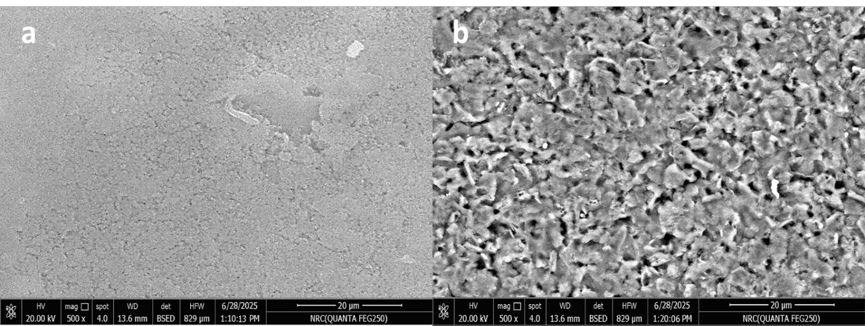
Figure S1: SEM micrograph of the, a) bare SPCEs, and b)drop-casted SPCEs working zone with rGO(20.0%)-CuONPs nanohybrid

Figure S2: EDX of the rGO (20%)-CuONPs-SPCEs

Table S3: EDX parameters of the rGO-CuONPs based screen printed sensors
Element | Wt % | At %
C K | 80.00 | 90.50
O K | 12.00 | 7.00
Cu K | 8.00 | 2.50
 | 100.00 | 100.00

Figure S4: a) Cyclic voltammograms and b) Nyquist plots recorded for the bare screen printed sensors nd those enriched with rGO(20%)-CuONPs nanohybrid. Supporting electrolyte is 5.0×10⁻³molL⁻¹K₄Fe(CN)₆/0.1molL⁻¹ KCl. The potential of the working electrode is measured against the Ag/AgCl/3MKCl reference electrode.

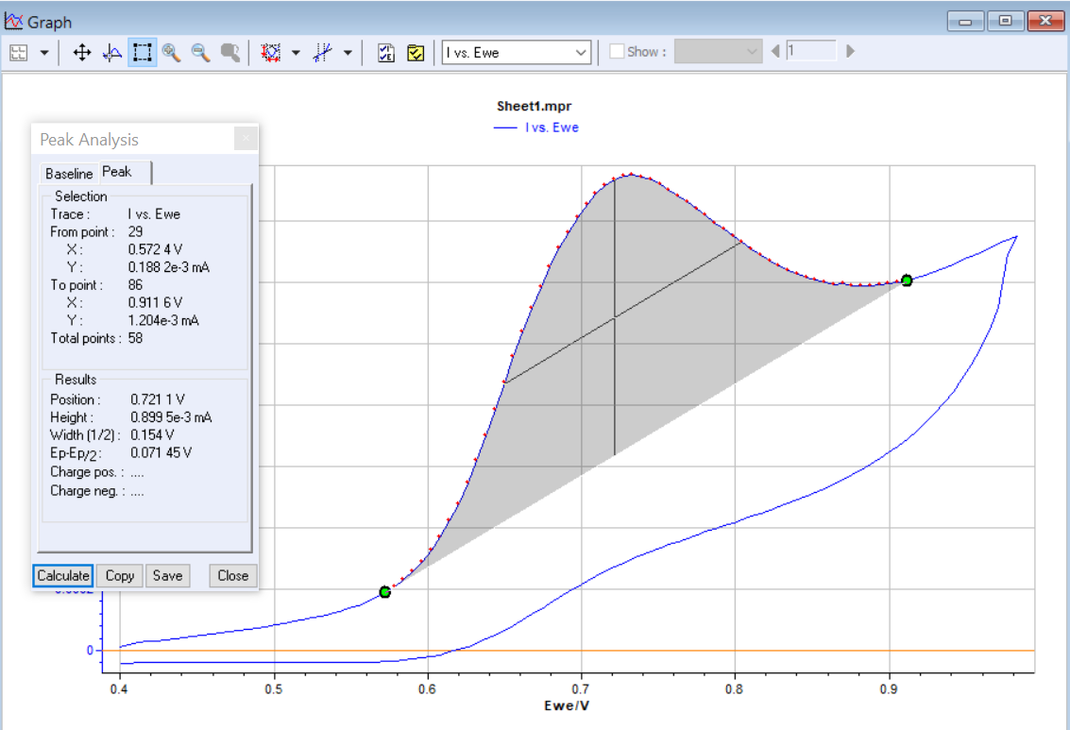
Figure S5: Estimation of the Ep and E_{1/2} for the cyclic voltammograms recorded in the in the presence of 2.0µgmL⁻¹ ULP at scan rate value 40mVs⁻¹ according to the EC-Lab V10.40 software.

Figure S6: Cyclic voltammogram at 10mVs⁻¹ in BR buffer pH 5 containing 2.0μgmL⁻¹ ULP at rGO(20.0%)-CuONPs-SPEs. Inset show the Tafel plot derived from the CV.

Table S7: Summary of Electrochemical Parameters for Ulipristal Acetate Oxidation
Parameter | Symbol | Value | Units
Peak Potential | Ep​ | 0.715 | V (vs. SCE)
Charge Transfer Coefficient | α | 0.67 | -
Number of Electrons | n | ~2 | -
Active Surface Area | A | 0.24 | cm²
Bulk Concentration | C | 4.20 × 10⁻⁹ | mol cm⁻³
Diffusion Coefficient | D | 6.6 × 10⁻⁶ | cm² s⁻¹
Tafel Slope | - | 118.66 | mV decade⁻¹
Apparent Formal Potential | E0′ | 0.5738 | V
Exchange Current | i0​ | 2.97 × 10⁻⁶ | A
Heterogeneous Rate Constant | k0 | 1.55 × 10⁻² | cm s⁻¹

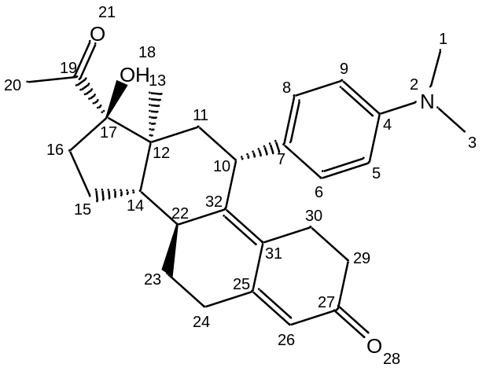 | 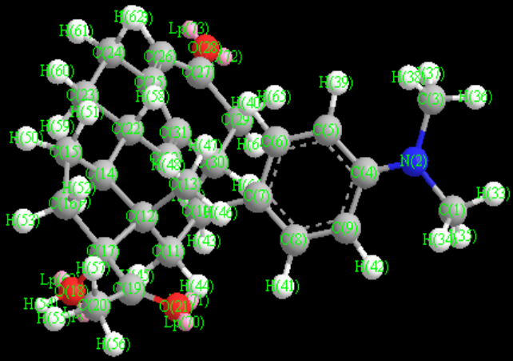
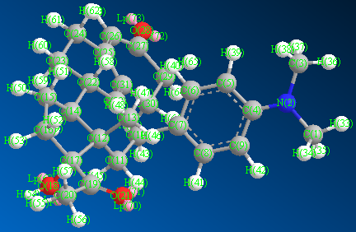 | 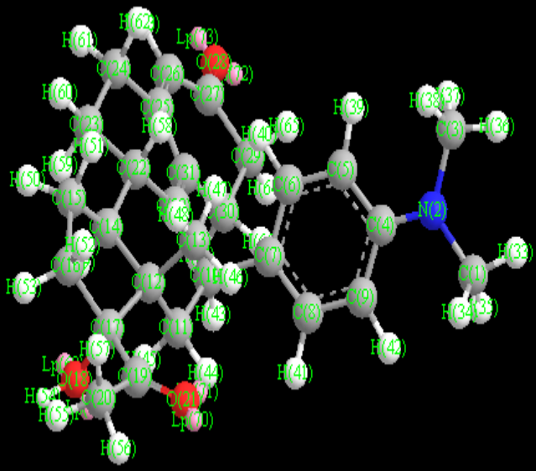
Figure S8: Chemical formula of ULP molecule

Table S9: Computed molecular orbital calculations of ULP molecule
Atom | Atom Type (MM2) | Charge (MM2) | Mulliken Charges  (Mopac Interface) | Mopac Interface: Electrostatic Potential(Mopac Interface) | Atom Type (MMFF94) | Charge (MMFF94)
C(1) | C Alkane | 0 | -0.3093 | -0.1291 | ALKYL CARBON, SP3 | 0.3691
N(2) | N Enamine | 0 | -0.58982 | -0.2976 | ENAMINE OR ANILINE NITROGEN, DELOC. LP | -0.8382
C(3) | C Alkane | 0 | -0.30799 | -0.1371 | ALKYL CARBON, SP3 | 0.3691
C(4) | C Alkene | 0 | 0.330268 | 0.2803 | AROMATIC CARBON, E. G. IN BENZENE, PYRIDIN | 0.1
C(5) | C Alkene | 0 | -0.36642 | -0.316 | AROMATIC CARBON, E. G. IN BENZENE, PYRIDIN | -0.15
C(6) | C Alkene | 0 | -0.10856 | -0.0236 | AROMATIC CARBON, E. G. IN BENZENE, PYRIDIN | -0.15
C(7) | C Alkene | 0 | -0.12471 | -0.2455 | AROMATIC CARBON, E. G. IN BENZENE, PYRIDIN | -0.1435
C(8) | C Alkene | 0 | -0.12607 | 0.0165 | AROMATIC CARBON, E. G. IN BENZENE, PYRIDIN | -0.15
C(9) | C Alkene | 0 | -0.3693 | -0.3374 | AROMATIC CARBON, E. G. IN BENZENE, PYRIDIN | -0.15
C(10) | C Alkane | 0 | -0.14104 | 0.4474 | ALKYL CARBON, SP3 | 0.2817
C(11) | C Alkane | 0 | -0.38878 | -0.3991 | ALKYL CARBON, SP3 | 0
C(12) | C Alkane | 0 | 0.021961 | -0.0628 | ALKYL CARBON, SP3 | 0
C(13) | C Alkane | 0 | -0.60069 | -0.3654 | ALKYL CARBON, SP3 | 0
C(14) | C Alkane | 0 | -0.1755 | -0.2055 | ALKYL CARBON, SP3 | 0
C(15) | C Alkane | 0 | -0.36271 | -0.1094 | ALKYL CARBON, SP3 | 0
C(16) | C Alkane | 0 | -0.38286 | -0.1881 | ALKYL CARBON, SP3 | 0
C(17) | C Alkane | 0 | 0.170452 | 0.3299 | ALKYL CARBON, SP3 | 0.341
O(18) | O Alcohol | 0 | -0.58617 | -0.3498 | ALCOHOL OR ETHER OXYGEN | -0.68
C(19) | C Carbonyl | 0 | 0.464102 | 0.079 | KETONE OR ALDEHYDE CARBONYL CARBON | 0.448
C(20) | C Alkane | 0 | -0.70196 | -0.3179 | ALKYL CARBON, SP3 | 0.061
O(21) | O Carbonyl | 0 | -0.46627 | -0.2315 | CARBONYL OXYGEN IN ALDEHYDES AND KETONES | -0.57
C(22) | C Alkane | 0 | -0.17587 | 0.1823 | ALKYL CARBON, SP3 | 0.1382
C(23) | C Alkane | 0 | -0.36238 | -0.2424 | ALKYL CARBON, SP3 | 0
C(24) | C Alkane | 0 | -0.39693 | -0.1699 | ALKYL CARBON, SP3 | 0.1382
C(25) | C Alkene | 0 | 0.122223 | 0.1511 | VINYLIC CARBON, SP2 | -0.1382
C(26) | C Alkene | 0 | -0.43184 | -0.3111 | VINYLIC CARBON, SP2 | -0.1356
C(27) | C Carbonyl | 0 | 0.518567 | 0.2784 | KETONE OR ALDEHYDE CARBONYL CARBON | 0.4946
O(28) | O Carbonyl | 0 | -0.49583 | -0.3051 | CARBONYL OXYGEN IN ALDEHYDES AND KETONES | -0.57
C(29) | C Alkane | 0 | -0.47483 | -0.1831 | ALKYL CARBON, SP3 | 0.061
C(30) | C Alkane | 0 | -0.34179 | 0.0606 | ALKYL CARBON, SP3 | 0.1382
C(31) | C Alkene | 0 | -0.11434 | -0.1371 | VINYLIC CARBON, SP2 | -0.1382
C(32) | C Alkene | 0 | 0.010078 | -0.2274 | VINYLIC CARBON, SP2 | -0.2764

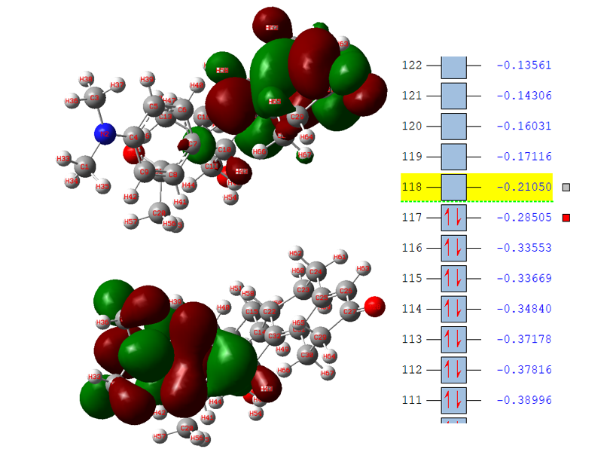
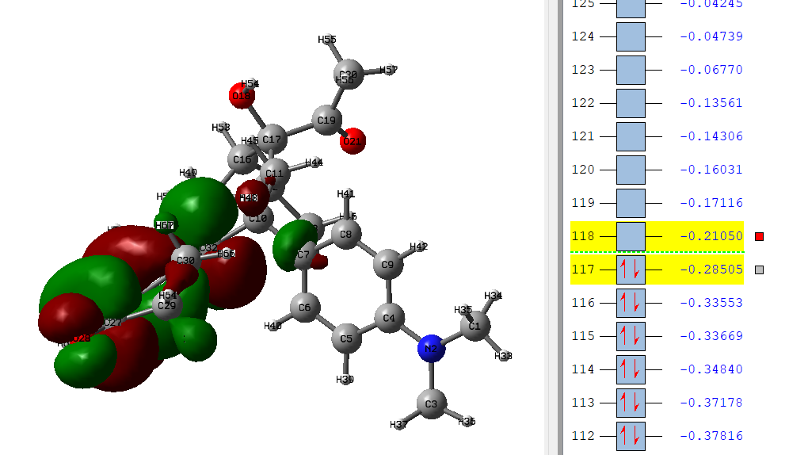
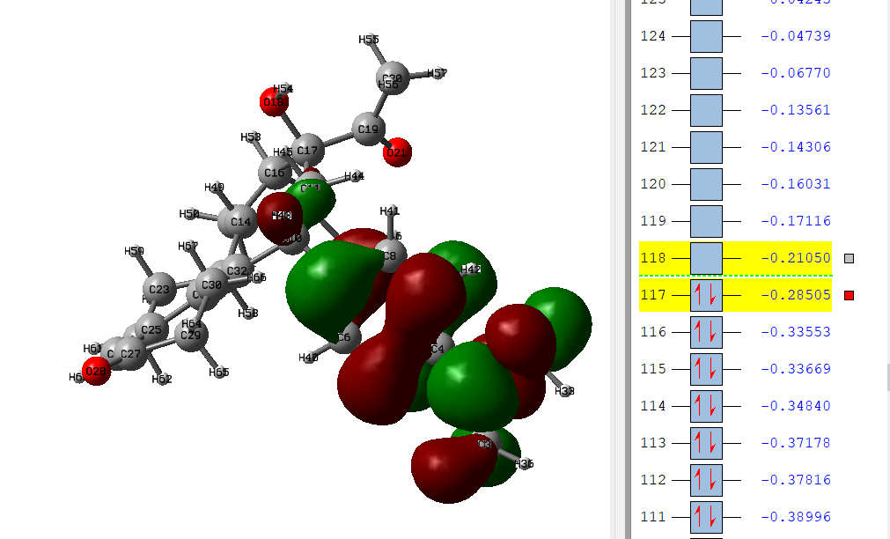
Figure S10: LUMO and HOMO structures of ULP molecule

Figure S11: Differential pulse voltammograms for 2.7µgmL⁻¹ ULP at rGO-CuONPs-SPCEs after different shelf lifetime intervals. pH 5 applying the same electrode surface.

Table S12: Correlation between Green Analytical Chemistry (GAC) Principles, Eco-Scale Criteria, and Comparison between the Proposed Voltammetric Method and HPLC
GAC Principle No. | GAC Principle Description | Voltammetric Method (Implementation) | Eco-Scale Criterion (Voltammetry) | HPLC Method (Comparison)  [Ref. 49] | Eco-Scale Criterion (HPLC)
1 | Minimal sample preparation | Direct measurement with minimal pre-treatment | Sample preparation (−4) | Multistep sample prep (protein precipitation + filtration) | Sample preparation (−6)
2 | Minimal sample size | Microliter-scale volumes | Organic solvent <10 mL (−2) | Milliliter-scale injections and mobile phase | Organic solvent >10 mL (−6)
3 | In situ analysis | Direct analysis in an electrochemical cell | No transfer steps (0) | Sample injected into a pressurized chromatographic system | Not applicable (−)
4 | Avoidance of toxic reagents | No toxic or carcinogenic reagents used | Absence of hazardous chemicals (0) | Use of organic solvents (MeOH/ACN) | Organic solvents (−6)
5 | Reduction of reagents and solvents | Supporting electrolyte only | Methanol <10 mL/run (−2) | Continuous mobile phase consumption | Methanol/ACN-buffer system (−6)
6 | Use of safer solvents | Mainly aqueous buffer | Ammonium acetate buffer (−2) | Buffer + organic modifier | Buffer + organic solvent (−6)
7 | Minimal waste generation | Very low waste per analysis | Waste <100 g (−4) | Significant liquid waste | Waste >500 g (−6)
8 | Multi-analyte capability | Selective electrochemical response without separation | No extra materials (0) | Requires column-based separation | Column materials (−4)
9 | Energy efficiency | Low-power potentiostat | Energy consumption (−1) | Pumps, detectors, column ovens | High energy consumption (−2)
10 | Operator safety | No high pressure or volatile vapor exposure | Reduced risk (0) | High pressure + solvent vapors | Increased exposure risk (−)
11 | Miniaturization and automation | Disposable screen-printed electrodes | SPCE replaces Ag/AgCl & Pt (−4) | Conventional electrodes & columns | Reference/counter electrodes (−4)
12 | Real-time analysis | Rapid response (minutes) | Short analysis time (0) | Long run times | Extended analysis time (−)
— | Total Penalty Points | — | 24 | — | 48
— | Final Eco-Scale Score | — | 76 (Excellent green method) | — | 52 (Acceptable method)

Table S13: Comparison of the presented voltammetric method with the reported ULP methods
Parameter | Present work | [9] | [50] | [51] | [6] | [10] | [5]
Techniques | DPV  (rGO-CuONPs-SPCEs) | Fluorescence | UV Visible  (302nm) | UV visible  (640nm) | HPLC | RP-HPLC  (UV 304nm) | LC-MS/MS
Linear range (µg mL⁻¹) | 0.010-5.04 | 0-11.89 | 5-20 | 2.5-15 | 0.03-6 | 5-50 mgmL⁻¹ | 0.001-0.250
LOD (µg mL⁻¹) | 0.003 | 0.0052 | 0.0068 | 0.012 | 0.006 | 0.075 mgmL⁻¹ | 0.000025
LOQ (µg mL⁻¹) | 0.010 | 0.017 | 0.0187 | 0.058 |  | 0.25 mgmL⁻¹ | 0.0001
Media | BR buffer  (pH 5) | Phosphate buffer  (pH 7.2) | methanol | HCl (0.1N) | Methanol: TEA | Methanol: TEA Phosphate buffer 4.6 | Acetonitrile/H₂O/formic acid
Sample Analysis | Pharmaceutical, biological | Pharmaceutical | Bulk  Pharmaceutical | Bulk  Pharmaceutical | Pharmaceutical, biological | Pharmaceutical | pharmacokinetics
DFT studies | Done | ----------------- | ----------------- | ----------------- | ----------------- | ----------------- | -----------------

Table S14: Selectivity Evaluation of the Analytical Method for the Quantification of Ulipristal Acetate (1.62µgmL⁻¹) in the Presence of Common Excipients and Potential Interferents
Interfering molecule/excipient | Concentration/Ratio | ΔI for detection of 1.62 µgmL⁻¹ UPA at optimal potential (µA)* | % Relative error in current
Lactose monohydrate | 1:150 | -0.02 | 1.5
Microcrystalline cellulose | 1:150 | -0.02 | 0.85
Magnesium stearate | 1:150 | -0.01 | 1.62
Croscarmellose sodium | 1:150 | -0.02 | 2.6
Colloidal silicon dioxide | 1:150 | -0.03 | 0.78
Starch | 1:150 | -0.03 | 1.48
Povidone | 1:150 | -0.03 | 1.8
Talc | 1:150 | -0.05 | 0.85
Titanium dioxide | 1:150 | -0.03 | 1.41
Glucose | 1:150 | -0.02 | 0.76
Sucrose | 1:150 | -0.02 | 1.22
Fructose | 1:150 | -0.01 | 0.67
Potential Biological/Environmental Interferents
Ascorbic acid | 5.0 × 10⁻⁶ M | -0.08 | 3.6
Albumin (from Bovine Serum) | 1:100 | -0.05 | 4.2
Uric acid | 1:100 | -0.02 | 1.62
Urea | 1:100 | -0.02 | 1.65
Progesterone | 5.0 × 10⁻⁶ M | -0.05 | 3.15
Levonorgestrel | 5.0 × 10⁻⁶ M | -0.04 | 2.8
Estradiol | 5.0 × 10⁻⁶ M | -0.03 | 2.7
* DPV current of UPA in the absence of any interference was 1.22 µA.

