Supporting Information

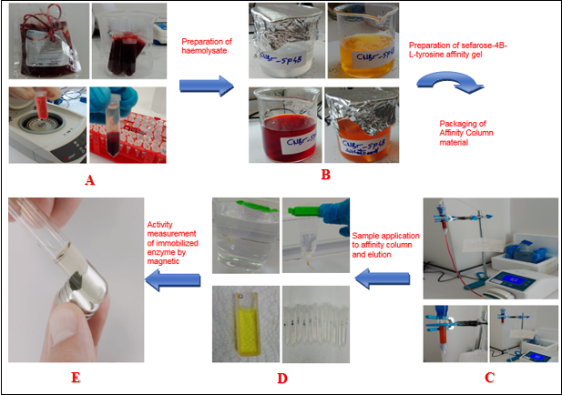
Figure 1. Workflow of the study

A: Collection of bovine blood samples and preparation of haemolysate
B: Preparation of Sepharose 4B-L-tyrosine affinity gel, tyrosine attachment to CNBr-activated Sepharose-4B and Sulfanilamide clamping
C: Packaging of affinity column material, sample application and elution on affinity column
D: Dialysis of tubes with high absorbance values, sodium dodecylsulfate-polyacrylamide gel electrophoresis (SDS-PAGE) for enzyme purity control and protein determination by Bradford method using serum albumin
E: Activity measurement of immobilised enzyme by magnetic separation

