AQbD-Driven RP-HPLC Method for Complete Resolution of Pantoprazole Regioisomeric Impurities with Integrated Multi-Dimensional Sustainability Assessment
Thirupathi Reddy Gaddam^{a,b}, Chinna Gangi Reddy Nallagondu^{b*}, Narendra Kumar Masaniª, Aparna Devi Karetiª, Hanuman Reddy Vemulapatiª, Hemanth Kumar Chanduluru^{c*}
ª Apitoria Pharma Research Centre, Survey No:71 & 72, Indrakaran Village, Kandi Mandal, Sanga Reddy-502329, Telangana, India
^{b} Green and Sustainable Synthetic Organic Chemistry Laboratory, Department of Chemistry, Yogi Vemuna University, Kadapa-516005, Andhra Pradesh, India
^{c}Department of Pharmacy Research, SRM College of Pharmacy, SRM-Medical and Health Sciences, SRM Institute of Science and Technology, Kattankulathur, Chengalpattu, Tamil Nadu, India 603203.

*Corresponding Authors:
NallaGondu Chinna Gangi Reddy- ncgreddy1981@gmail.com
Dr. Hemanth Kumar Chanduluru, Email: hemanthk@srmist.edu.in

Table S1: Chemical structures and sources of pantoprazole and its related substances (A–F).
Impurity Name | Source of impurity | Structure
PTZ | API | 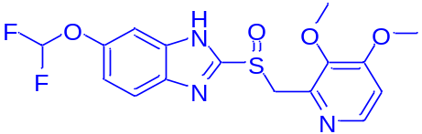
Related compound-A | Synthesis | 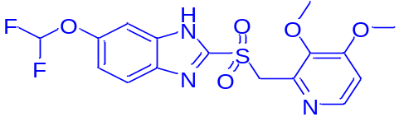
Related compound-B | Synthesis | 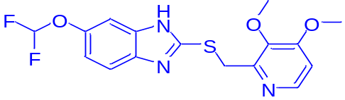
Related compound-C | Synthesis/degradant impurity | 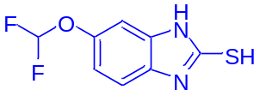
Related compound-D | Synthesis | 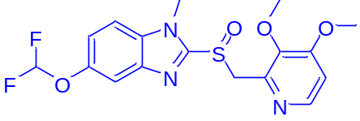
Related compound-E | Synthesis | 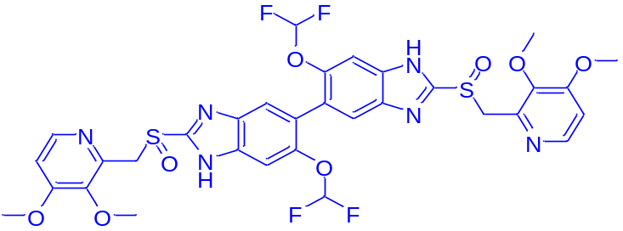
Related compound-F | Synthesis | 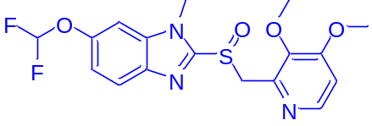

Table S2: Detailed AGREE and MoGAPI scoring criteria, method conditions, and principle-wise assessment values.
MoGAPI |  |  | AGREE
Pictogram Name | Sub Part no and name | Method Condition | Principle | Method Condition | Principle Score
Sample sourcing | - Collection | Off-Line | 1. Sample treatment | Off-line analysis | 0.48
Sample sourcing | - Preservation | None | 2. Sample Amount | 0.5 g | 0.98
Sample sourcing | - Transport | None | 3. Device Positioning | Off-line | 0.0
Sample sourcing | - Storage | Normal Condition | 4. Sample Prep. Stages | 3 or fewer | 1.0
Method type | - Direct/Indirect | Simple Preparation | 5. Automation, miniaturization | Automatic, none or miniaturized | 1.0
Sample preparation | - Scale of extraction | None | 6. Derivatization | NA | 1.0
Sample preparation | - Solvents/Reagents | Non- Green | 7. Waste | 25 mL | 0.26
Sample preparation | - Additional treatments | None | 8. Analysis Throughput | 6 | 0.65
Reagents and chemicals used | - Amount | <10 mL | 9. Energy consumption | HPLC | 0.50
Reagents and chemicals used | - NFPA health hazard value | Acetonitrile:2 | 10. Source of reagents | No reagents | 1.0
Reagents and chemicals used | - NFPA flammability value | Acetonitrile:3 | 11. Toxicity | None | 1.0
Instrumentation | - Energy usage | <0.1 KWh per sample | 12. Operator safety | Highly flammable | 0.6
Instrumentation | - Occupational hazard | Evoporate vapors to the atmosphere | Method AGREE Score |  | 0.71
Instrumentation | - Waste | >10 mL
 |  | None
Symbol | O-Present | Qualitative and Quantitative

Table S3. Comparative multi-dimensional sustainability assessment of the proposed and reported HPLC methods using AGREE, MoGAPI, BAGI, and RAPI tools.
S.No | AGREE | MoGAPI | BAGI | RAPI | References
1 | 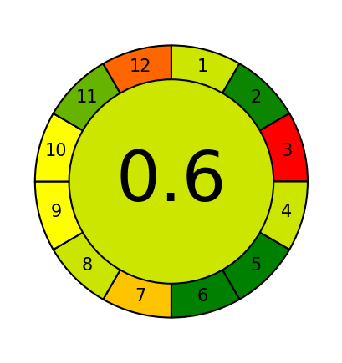 | 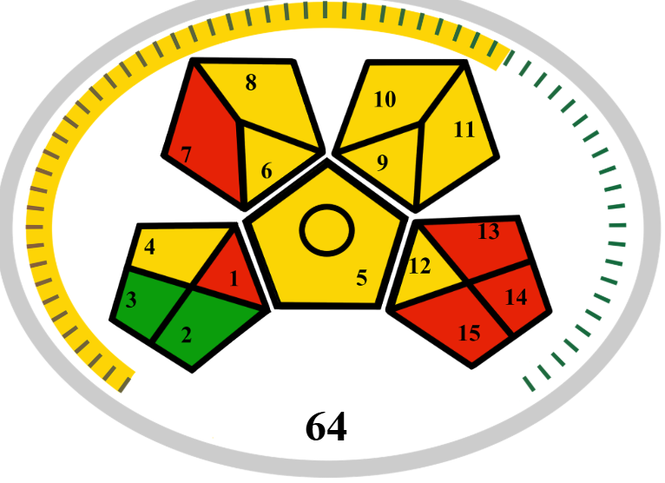 | 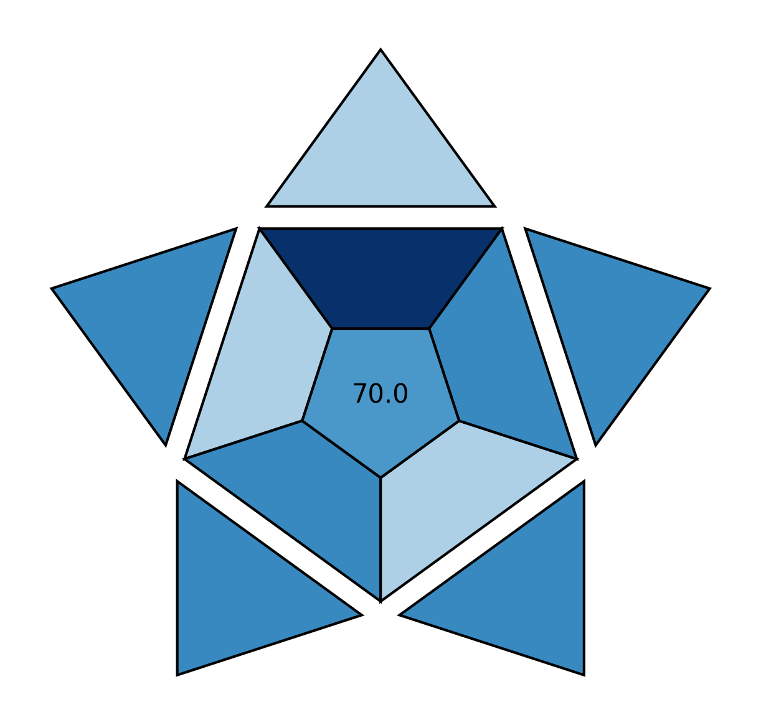 | 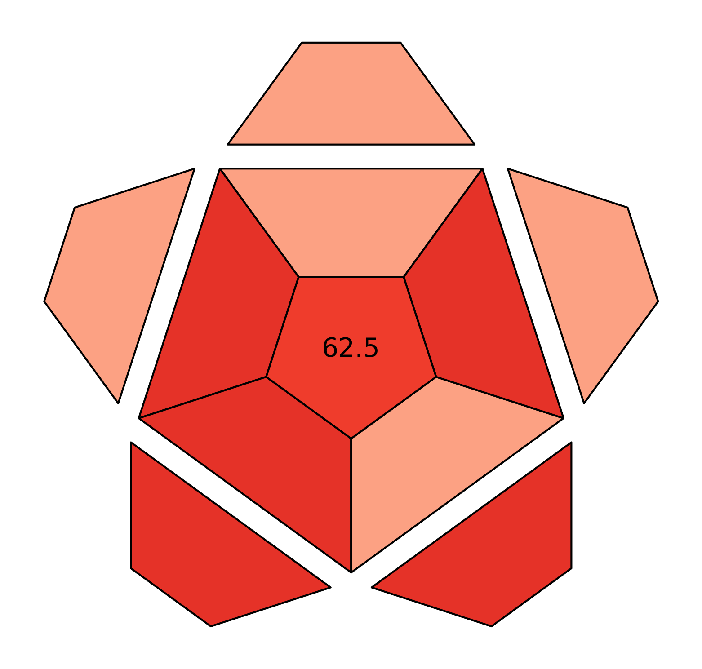 | USP monograph  [5]
2 | 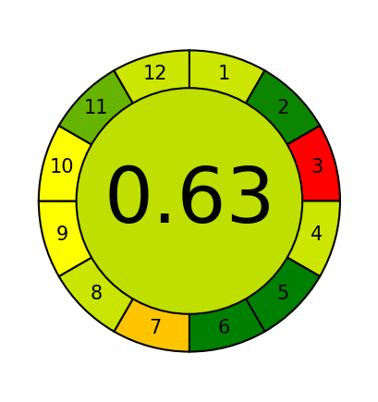 | 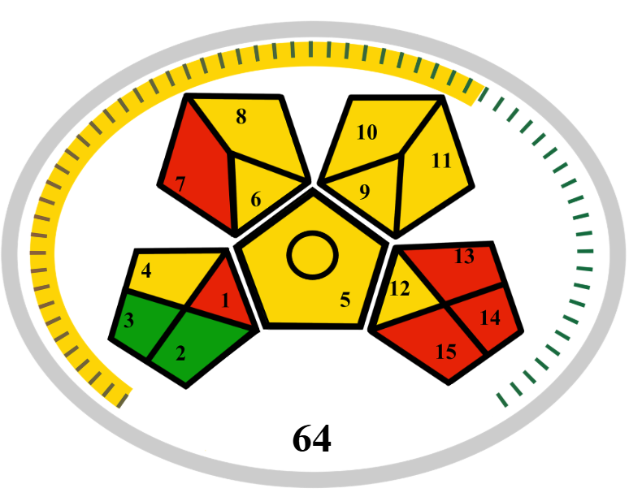 | 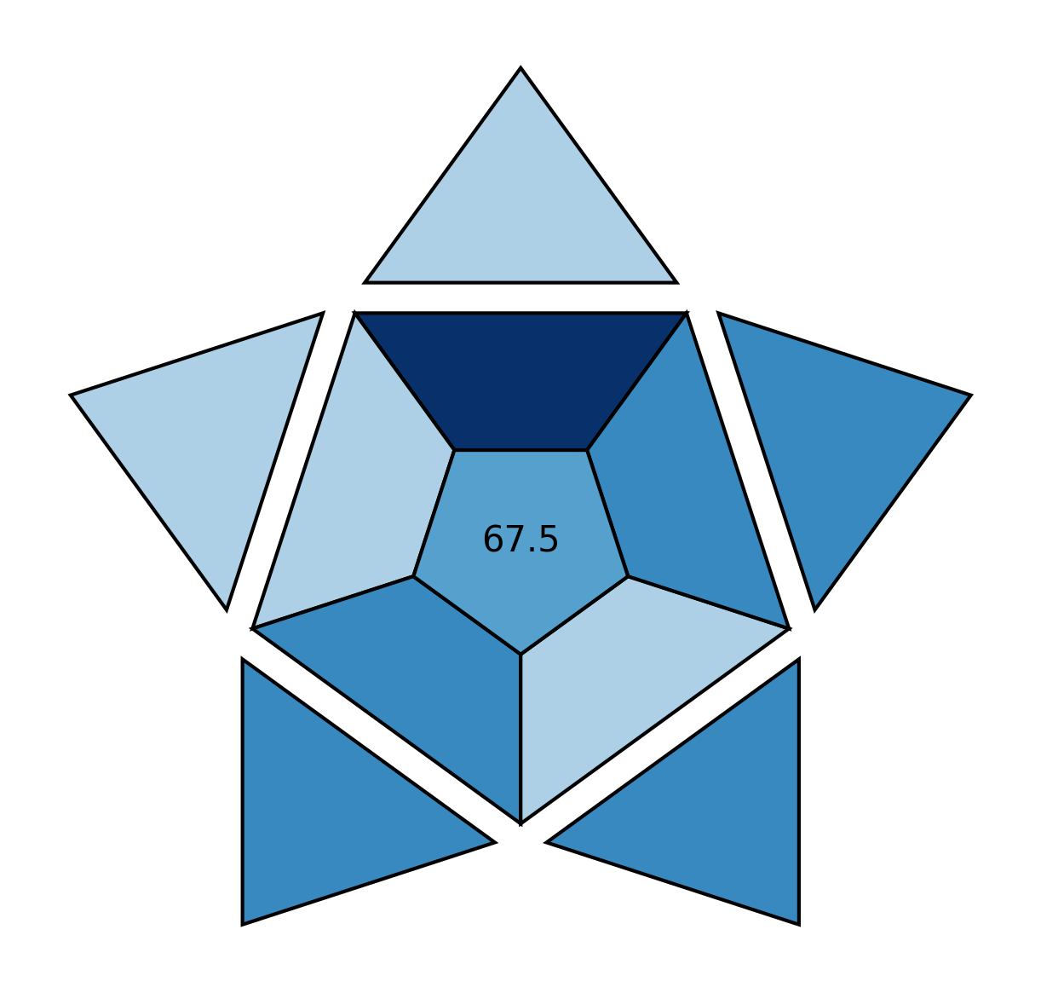 | 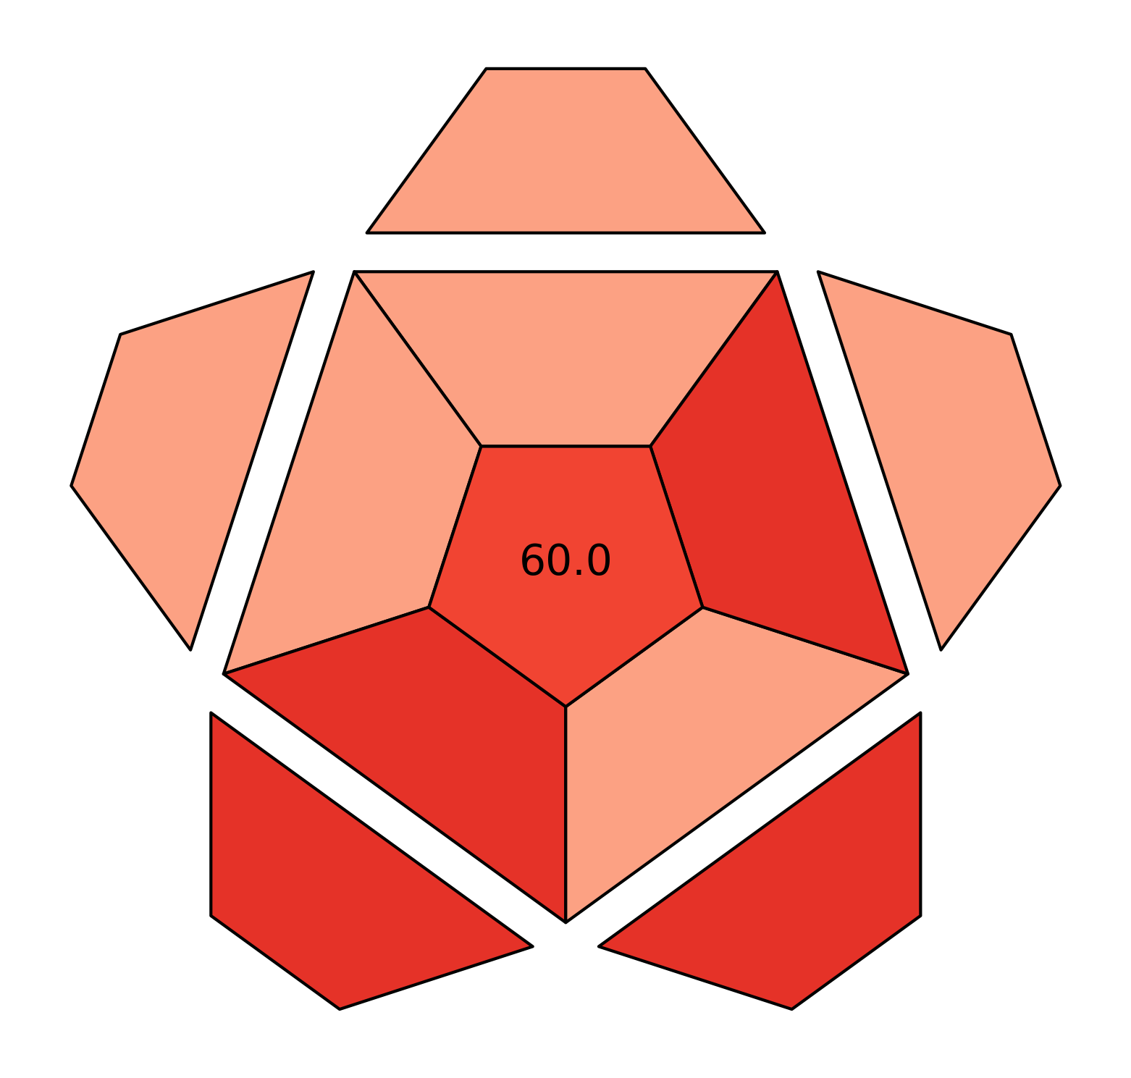 | EP monograph  [6]
3 | 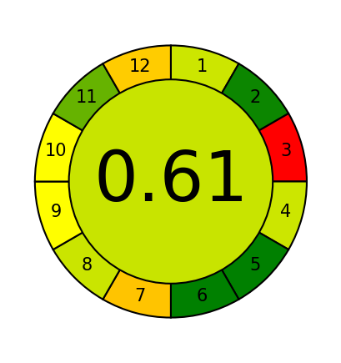 | 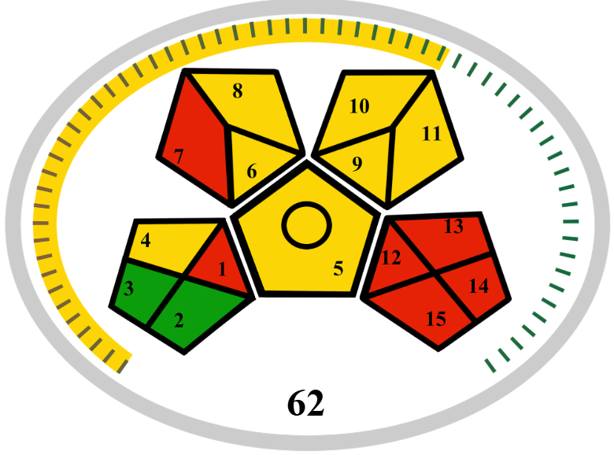 | 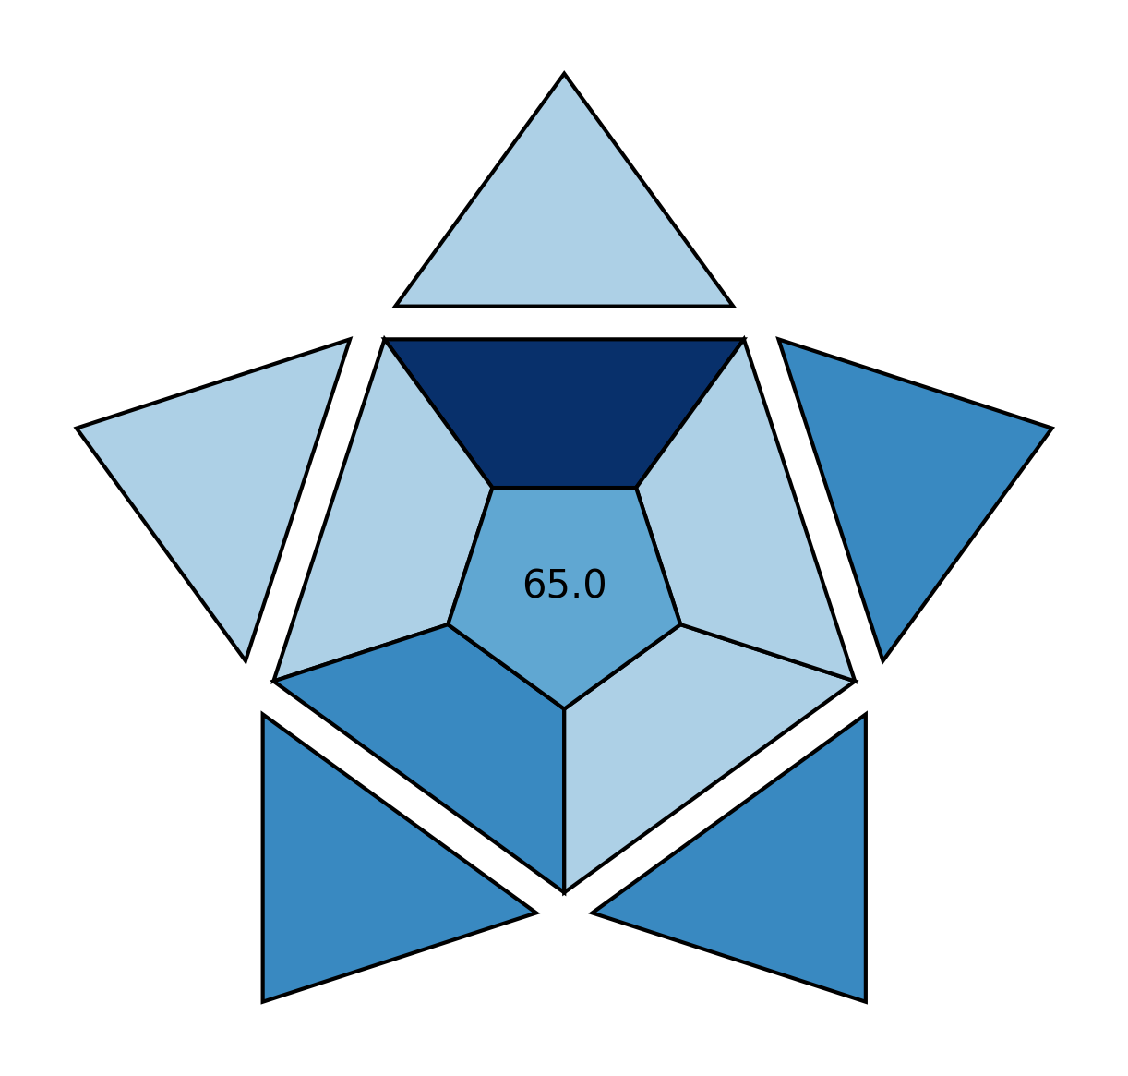 | 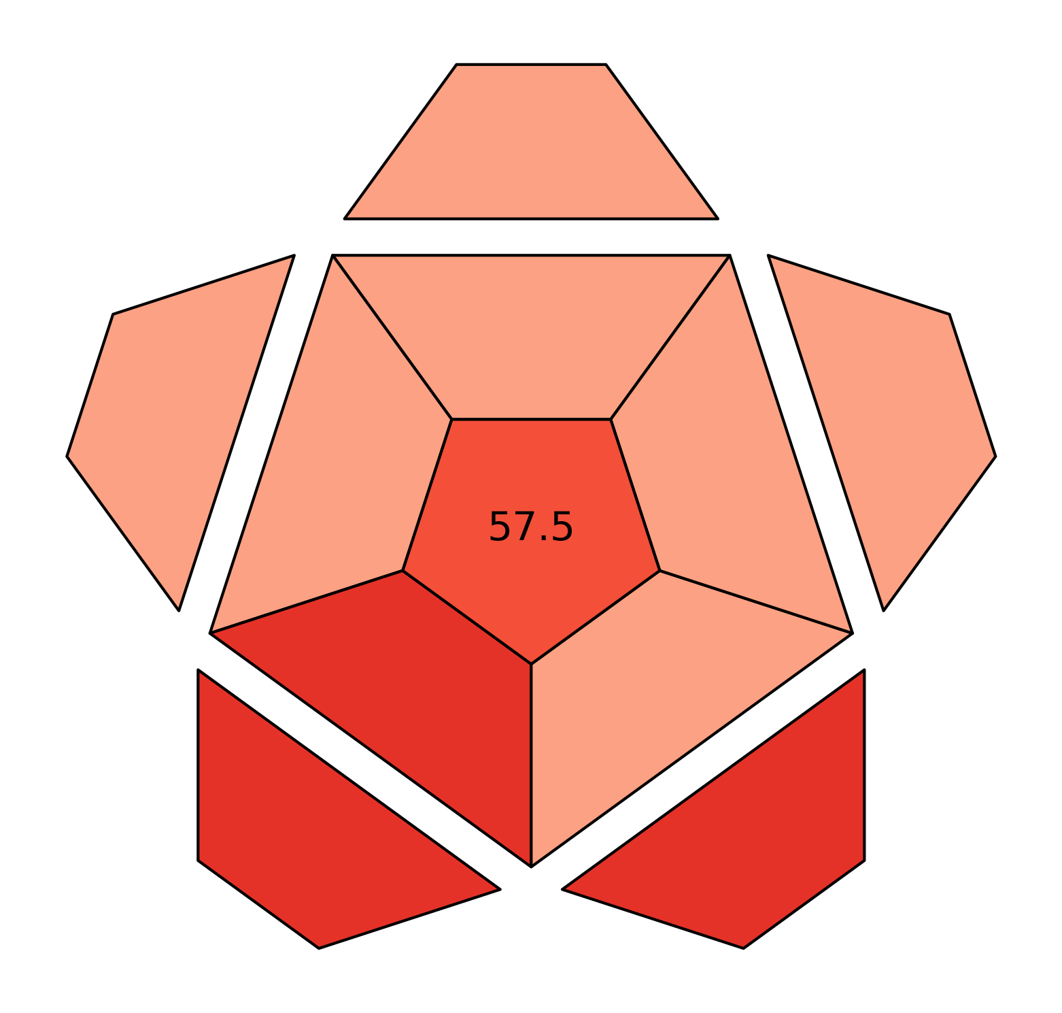 | [7]
4 | 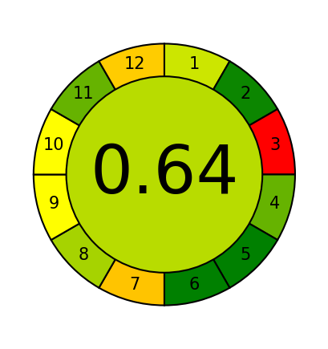 |  | 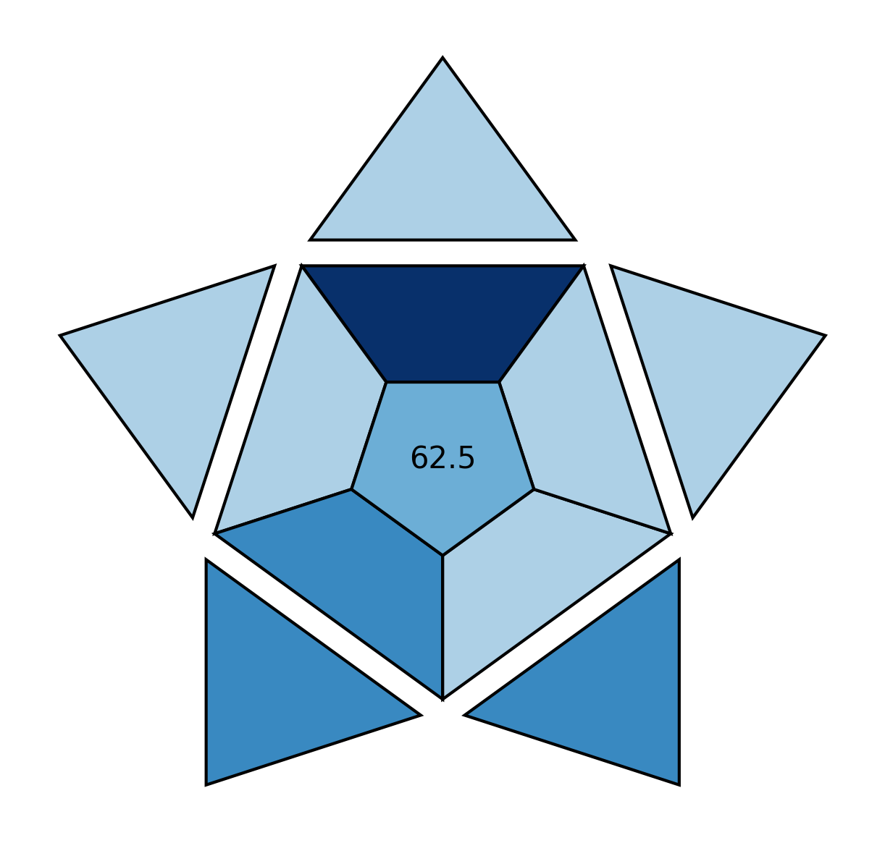 | 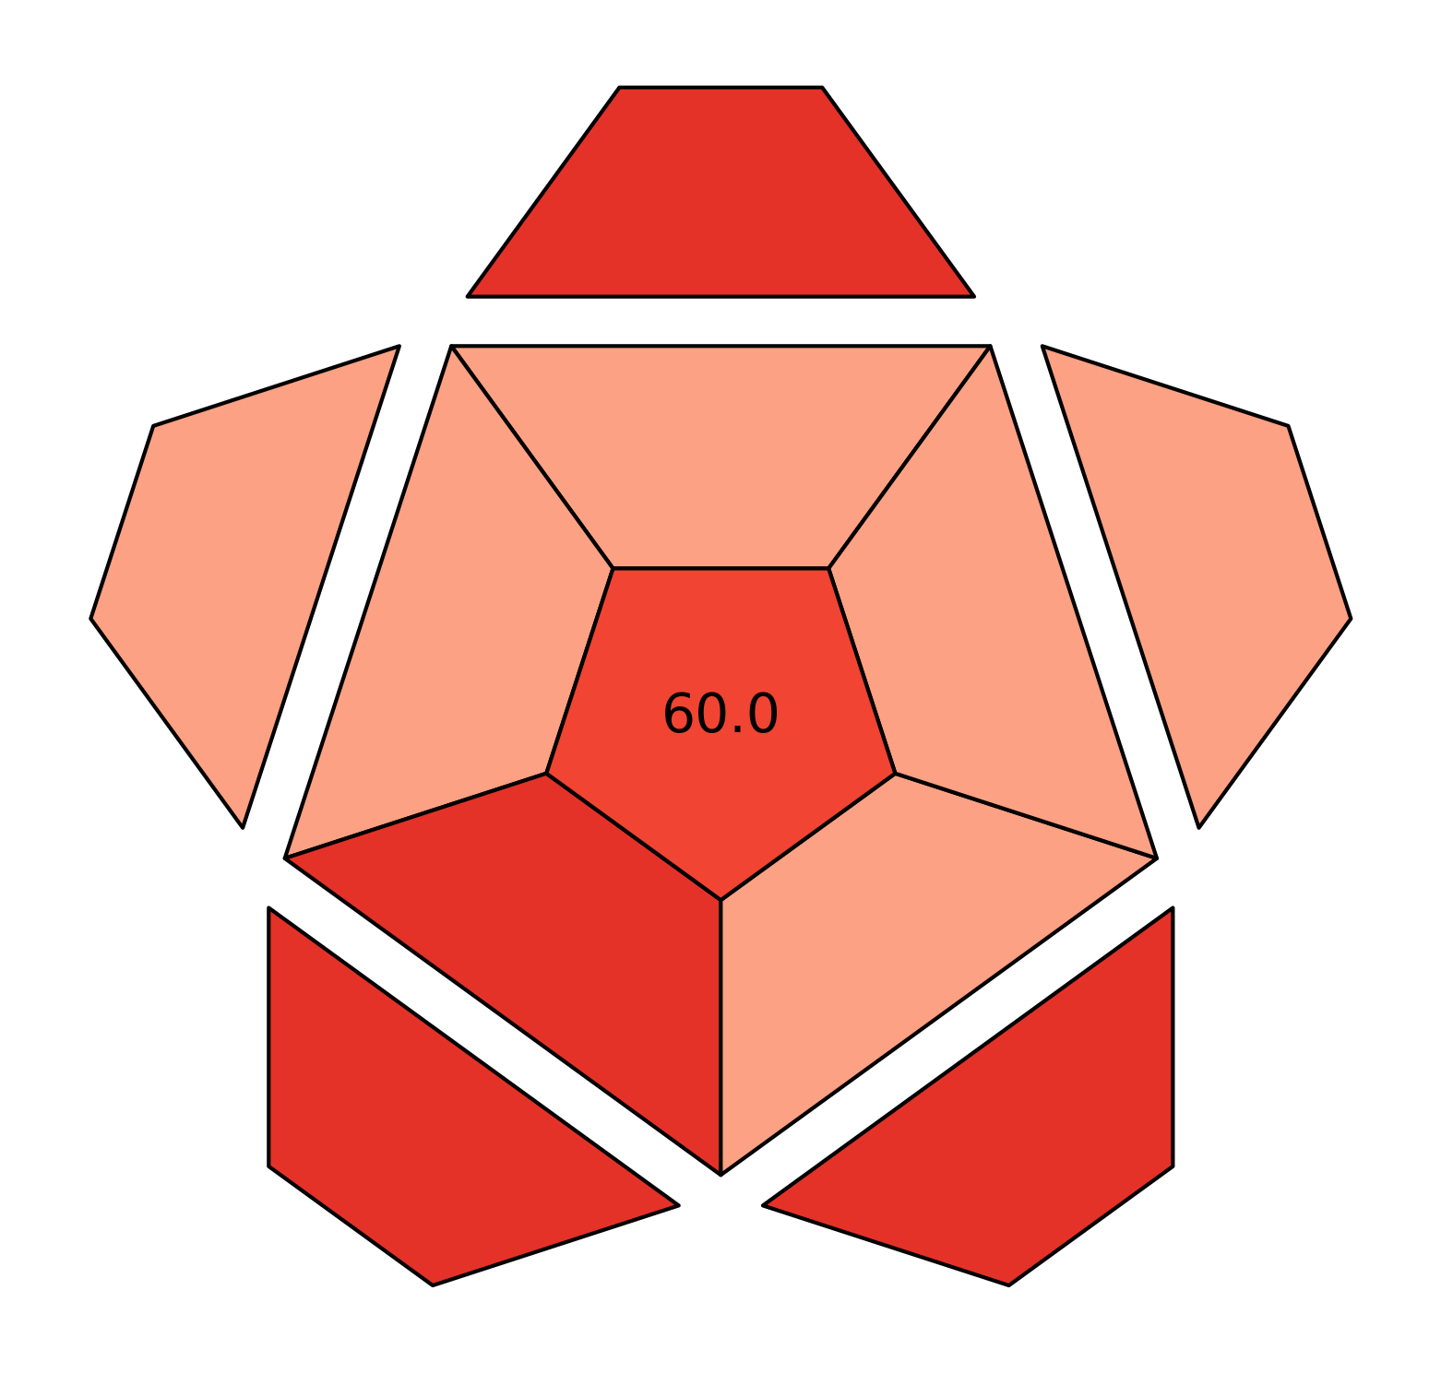 | [8]
5 |  |  |  |  | [9]
6 |  |  |  |  | [10]

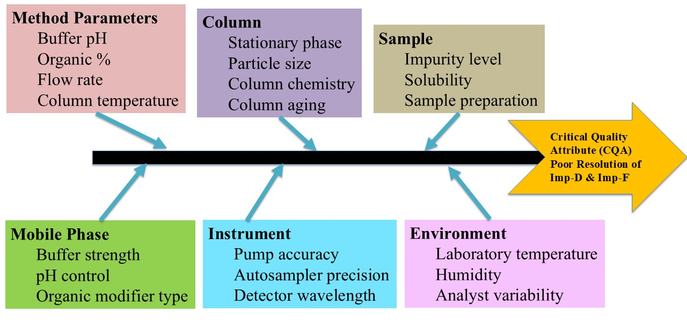
Figure S1. Ishikawa (fishbone) diagram illustrating potential sources of variability affecting chromatographic performance, categorized into method parameters, instrument conditions, sample characteristics, and environmental factors.
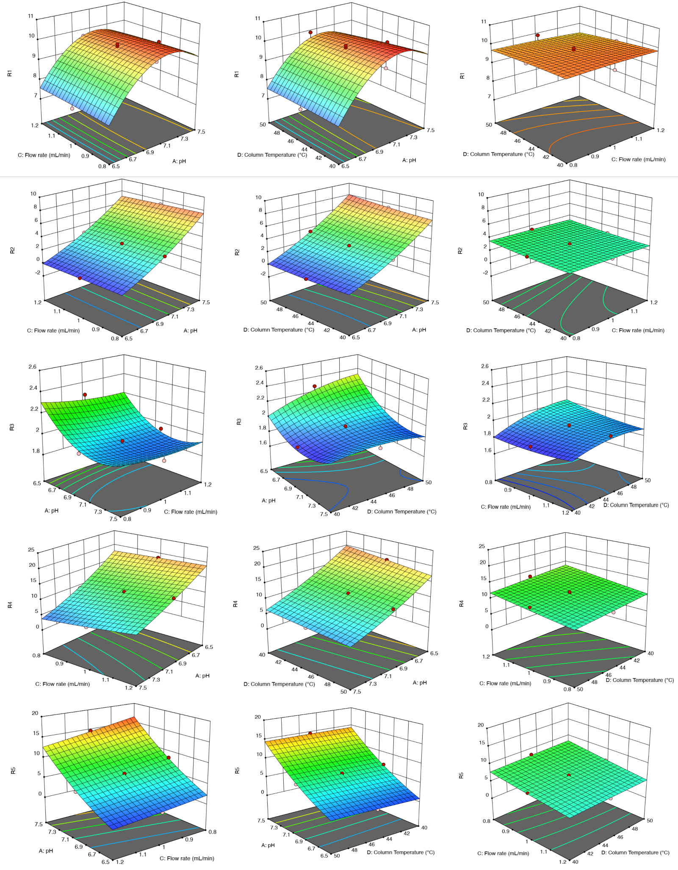
Figure S2. Perturbation plots illustrating the sensitivity of critical method attributes to variations in method parameters, highlighting the dominant influence of buffer pH and acetonitrile composition.

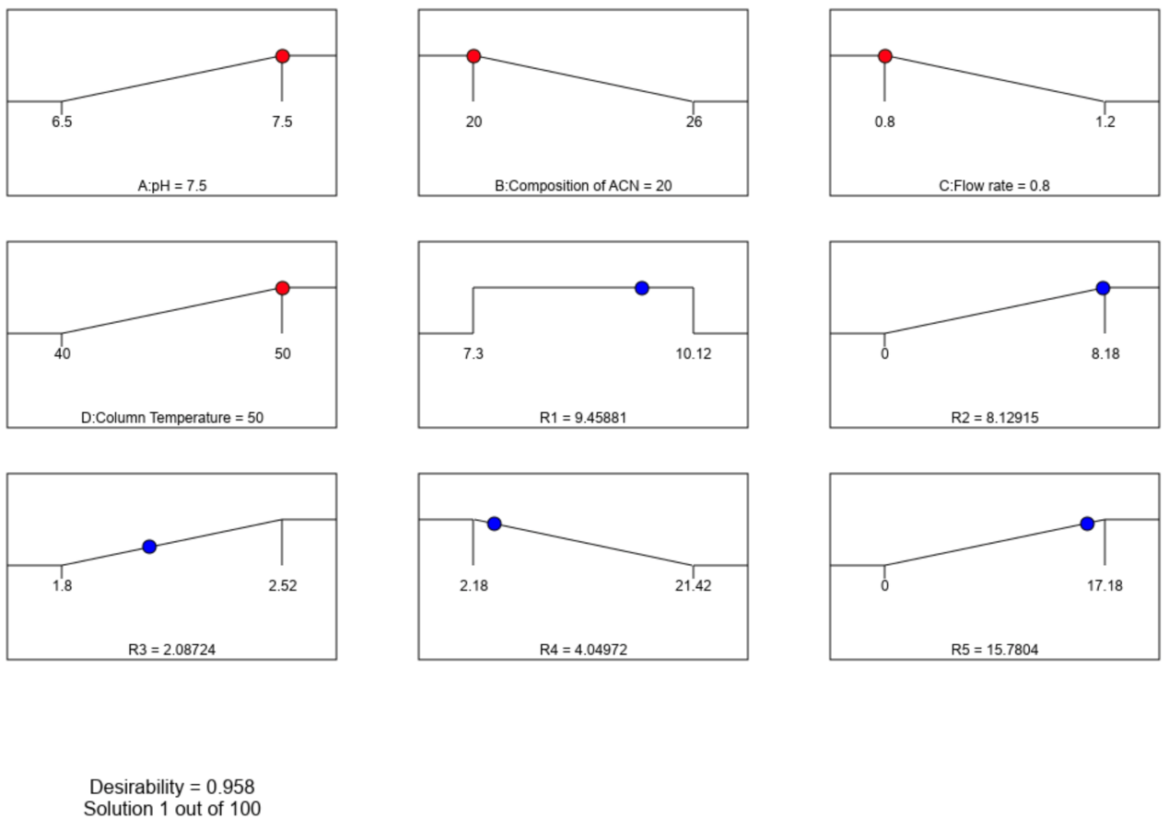
Figure S3. Desirability function plot used to identify optimal chromatographic conditions by simultaneously maximizing resolution and minimizing runtime.

