Supplementary Information
Antimicrobial, Antioxidant, and Antidiabetic Activities of Mycosynthesized Copper Oxide Nanoparticles from Ganoderma lucidum

Meltem Tümerª, Aslı Göçenoğlu Sarıkayaª*
ªFaculty of Arts and Science, Department of Chemistry, Bursa Uludag University, Bursa, Turkey
*agocenoglu@uludag.edu.tr
*ORC-ID: 0000-0002-7161-7003

The type of substance used (mycosynthesized CuO NPs and acarbose) has a statistically significant effect on α-amylase inhibition. In general, acarbose exhibits higher inhibitory activity than mycosynthesized CuO NPs. Concentration has a statistically significant effect on α-amylase inhibition. As concentration increases, the inhibition percentage for both mycosynthesized CuO NPs and acarbose increases. There is a statistically significant interaction between substance type and concentration. This indicates that an increase in concentration does not have the same effect on mycosynthesized CuO NPs and acarbose, the two substances respond differently to changes in concentration.
The results of the two-way analysis of variance (Two-Way ANOVA) showed that the type of substance had a significant effect on α-amylase inhibition, F(1,24) = 1355.38, p < .001. Furthermore, concentration was also found to have a significant effect on inhibition, F(5,24) = 5923.04, p < .001. The interaction between substance type and concentration was also statistically significant, F(5,24) = 8.82, p < .001 (Table SI1). As seen in the graph (FigSI1), the percentage of α-amylase inhibition by acarbose is higher than that of mycosynthesized CuO NPs at all concentrations. However, in both cases, the inhibition percentage increased with concentration, and the two substances responded differently to concentration.

Table SI1. Results of a two-way analysis of variance for α-amylase inhibition.
ANOVA - Inhibition %
 | Sum of Squares | df | Mean Square | F | p
Sample | 642.5 | 1 | 642.496 | 1355.38 | <.001
Concentration | 14038.7 | 5 | 2807.732 | 5923.04 | <.001
Sample ✻ Concentration | 20.9 | 5 | 4.181 | 8.82 | <.001
Residuals | 11.4 | 24 | 0.474

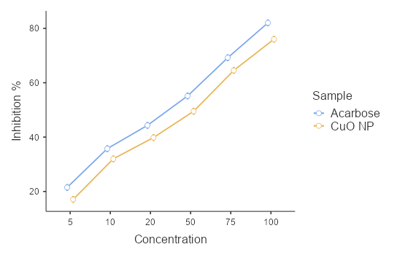
FigSI1. Comparison of the α-amylase inhibitory activities of acarbose and mycosynthesized CuO NPs at different concentrations.

The type of sample used (mycosynthesized CuO NPs and acarbose) had a statistically significant effect on α-glucosidase inhibition. In general, acarbose exhibited higher inhibitory activity than mycosynthesized CuO NPs. Concentration has a statistically significant effect on α-glucosidase inhibition. For both acarbose and mycosynthesized CuO NPs, the percentage of inhibition increased steadily as the concentration increased. There was no statistically significant interaction between substance type and concentration (F(5,24)=1.42, p=.254). This indicates that an increase in concentration had a similar effect on both mycosynthesized CuO NPs and acarbose. Acarbose exhibits higher inhibition than mycosynthesized CuO NPs at all concentrations. In both samples, the inhibition percentage increases with concentration. Since the two curves are approximately parallel, the effect of increasing concentration on both substances is similar.
According to the results of the two-way analysis of variance, sample type had a significant effect on α-glucosidase inhibition (F(1,24)=276.10, p<.001). Furthermore, concentration had a significant effect on the percentage of inhibition (F(5,24)=3769.90, p<.001). In contrast, the interaction between sample type and concentration was not statistically significant (F(5,24)=1.42, p=.254). These findings indicate that acarbose provides greater α-glucosidase inhibition than mycosynthesized CuO NPs at all concentrations, but that increasing concentration enhances inhibition similarly for both substances (TableSI2).
Mycosynthesized CuO NPs inhibit the α-glucosidase enzyme in a concentration-dependent manner. Although the positive control, acarbose, exhibits higher inhibitory activity, mycosynthesized CuO NPs also demonstrated a significant inhibitory effect at all concentrations. The lack of a significant interaction suggests that the trend of increasing inhibitory activity with rising concentration observed for mycosynthesized CuO NPs is similar to that of acarbose (FigSI2).
Table SI2. Results of a two-way analysis of variance for α-amylase inhibition.
ANOVA - Inhibition %
 | Sum of Squares | df | Mean Square | F | p
Sample | 210.25 | 1 | 210.250 | 276.10 | <.001
Concentration | 14353.91 | 5 | 2870.782 | 3769.90 | <.001
Sample ✻ Concentration | 5.39 | 5 | 1.079 | 1.42 | .254
Residuals | 18.28 | 24 | 0.762

FigSI2. Comparison of the α-glucosidase inhibitory activities of acarbose and mycosynthesized CuO NPs at different concentrations.

A statistically significant effect of sample type (mycosynthesized CuO NPs and ascorbic acid) on ABTS radical scavenging activity was observed (F(1,24)=389.80, p<.001). In general, ascorbic acid exhibited a higher inhibition percentage than mycosynthesized CuO NPs. A statistically significant effect of concentration on the inhibition percentage was found (F(5,24) = 2499.88, p < .001). For both ascorbic acid and mycosynthesized CuO NPs, ABTS radical scavenging activity increased as the concentration increased. A statistically significant interaction between sample type and concentration was identified (F(5,24)=4.58, p=.004). This finding indicates that an increase in concentration does not have the same magnitude of effect on mycosynthesized CuO NPs and ascorbic acid.
At all concentrations, ascorbic acid exhibits higher ABTS radical scavenging activity than mycosynthesized CuO NPs. In both samples, the inhibition percentage increases steadily as the concentration increases. The antioxidant activity of mycosynthesized CuO NPs increases significantly with concentration.
According to the results of the two-way analysis of variance, sample type was found to have a significant effect on ABTS radical scavenging activity (F(1,24)=389.80, p<.001). In addition, concentration was found to have a significant effect on the percentage of inhibition (F(5,24)=2499.88, p<.001). The interaction between sample type and concentration was also found to be statistically significant (F(5,24) = 4.58, p = .004) (Table SI3). Ascorbic acid exhibited higher ABTS radical scavenging activity than mycosynthesized CuO NPs at all concentrations. However, in both samples, the inhibition percentage increased as the concentration increased, although the magnitude of this increase differed depending on the sample type (FigSI3).
These results demonstrate that mycosynthesized CuO NPs possess significant ABTS radical scavenging activity; however, ascorbic acid—used as a positive control at the same concentrations—exhibited higher antioxidant activity. Nevertheless, the significant concentration-dependent increase in activity observed in mycosynthesized CuO NPs suggests that these nanoparticles possess antioxidant properties and may hold promise for biological applications.
TableSI3. Results of a two-way analysis of variance for ABTS radical scavenging activity.
ANOVA - Inhibition
 | Sum of Squares | df | Mean Square | F | p
Sample | 458.6 | 1 | 458.60 | 389.80 | <.001
Concentration | 14705.5 | 5 | 2941.10 | 2499.88 | <.001
Sample ✻ Concentration | 27.0 | 5 | 5.39 | 4.58 | .004
Residuals | 28.2 | 24 | 1.18

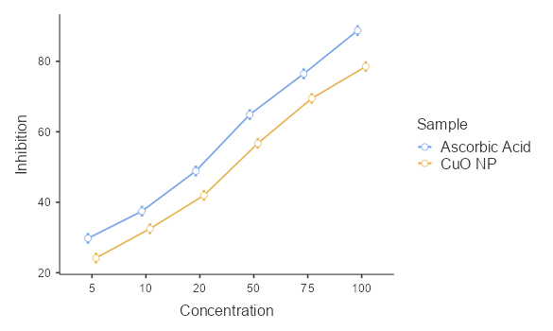
FigSI3. Comparison of the ABTS radical scavenging activities of ascorbic acid and mycosynthesized CuO NPs at different concentrations.

A statistically significant effect of sample type (mycosynthesized CuO NPs and ascorbic acid) on DPPH radical scavenging activity was observed (F(1,24) = 489.94, p < .001). In general, ascorbic acid exhibited a higher inhibition percentage than mycosynthesized CuO NPs. A statistically significant effect of concentration on DPPH inhibition was found (F(5,24) = 3758.82, p < .001). For both ascorbic acid and mycosynthesized CuO NPs, DPPH radical scavenging activity increased significantly as concentration increased. No statistically significant interaction was found between sample type and concentration (F(5,24) = 1.38, p = .267). This indicates that an increase in concentration produces a similar effect on both mycosynthesized CuO NPs and ascorbic acid (Table SI4).
At all concentrations, ascorbic acid exhibits higher DPPH radical scavenging activity than mycosynthesized CuO NPs. In both samples, the percentage of inhibition increases steadily as the concentration increases. The fact that the curves are approximately parallel indicates that an increase in concentration has a similar effect on both samples (FigSI4).
According to the results of the two-way analysis of variance, the sample type was found to have a significant effect on DPPH radical scavenging activity (F(1,24) = 489.94, p < .001). Furthermore, concentration was found to have a significant effect on the percentage of inhibition (F(5,24) = 3758.82, p < .001). In contrast, the interaction between sample type and concentration was not statistically significant (F(5,24) = 1.38, p = .267). At all concentrations, ascorbic acid exhibited higher DPPH radical scavenging activity compared to mycosynthesized CuO NPs. However, in both samples, the percentage of inhibition increased in a similar trend as the concentration increased.
These results indicate that mycosynthesized CuO NPs can effectively scavenge DPPH free radicals in a concentration-dependent manner; however, ascorbic acid, used as a positive control at the same concentrations, exhibits a higher antioxidant capacity. The lack of a significant interaction suggests that mycosynthesized CuO NPs and ascorbic acid respond similarly to increases in concentration.
Table SI4. Results of a two-way analysis of variance for DPPH radical scavenging activity.
ANOVA - Inhibition
 | Sum of Squares | df | Mean Square | F | p
Sample | 402.40 | 1 | 402.404 | 489.94 | <.001
Concentration | 15436.07 | 5 | 3087.214 | 3758.82 | <.001
Sample ✻ Concentration | 5.66 | 5 | 1.132 | 1.38 | .267
Residuals | 19.71 | 24 | 0.821

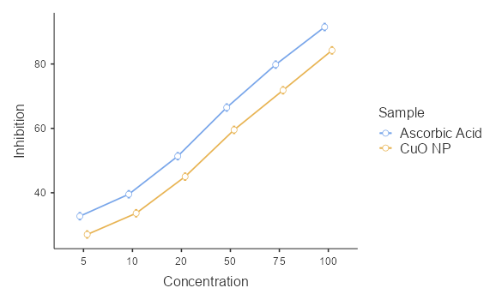
FigSI4. Comparison of the DPPH free radical scavenging activities of ascorbic acid and mycosynthesized CuO NPs at different concentrations.

When all results were analyzed together, it was observed that mycosynthesized CuO NPs exhibited concentration-dependent activity in all biological assays, although the positive controls generally showed higher activity; in contrast, in some experiments (α-amylase and ABTS), an increase in concentration had a different magnitude of effect on mycosynthesized CuO NPs and the positive control, while in others (α-glucosidase and DPPH), a similar trend was observed.

