Supplementary Materials
Construction of ZnO/SnO₂ heterostructure nanocomposites for enhancing the visible-light-driven photocatalytic degradation of alizarine yellow R dye

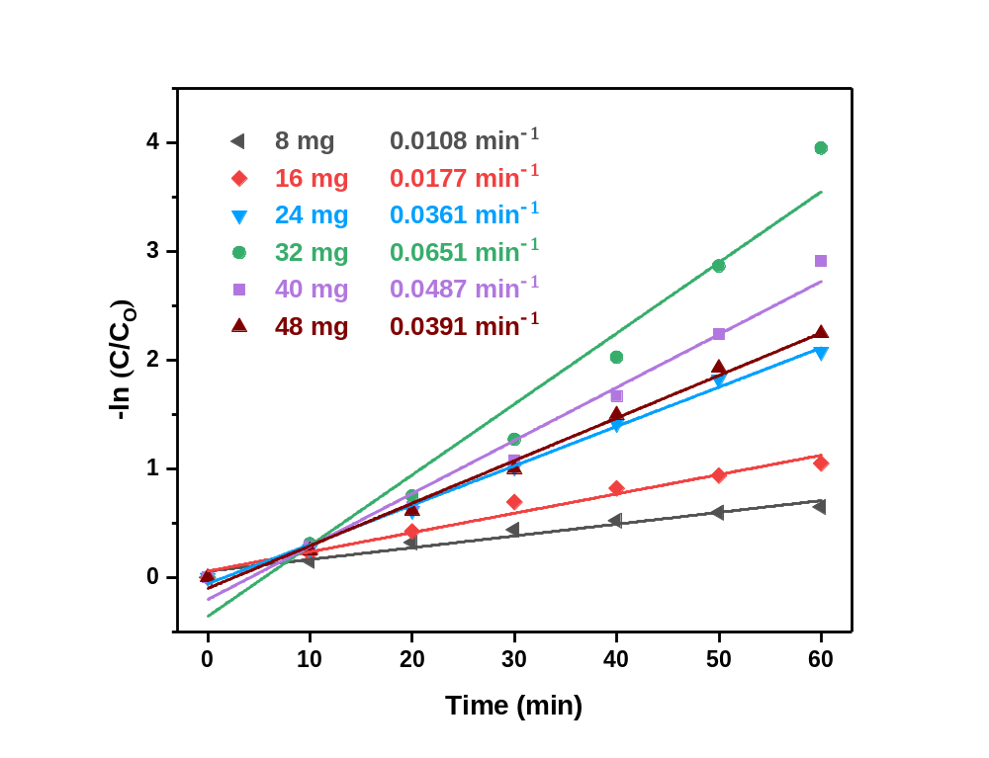
Fig. S1. Pseudo-1st-order kinetics for AYR degradation over ZnO/SnO₂ heterostructure photocatalyst using various catalyst dosages. Parameters: photocatalyst = 8-48 mg, AYR concentration = 24 ppm, pH = 5, T = 30 °C.

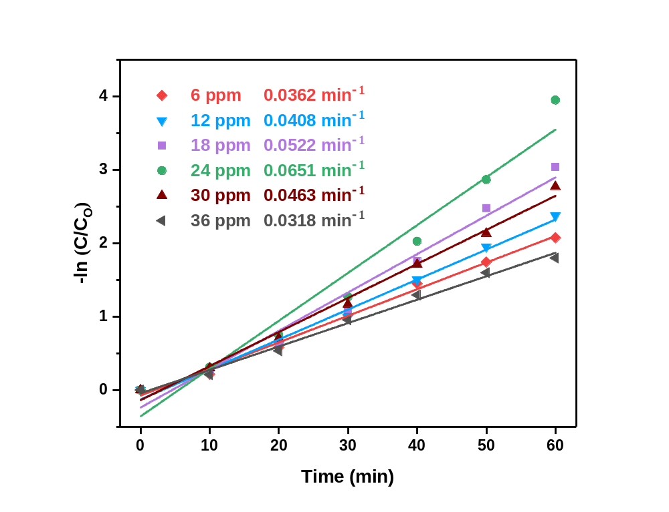
Fig. S2. Pseudo-1st-order kinetics for AYR degradation over ZnO/SnO₂ heterostructure photocatalyst using various initial concentrations of dye. Parameters: photocatalyst = 32 mg, AYR concentration = 6-36 ppm, pH = 5, T = 30 °C.

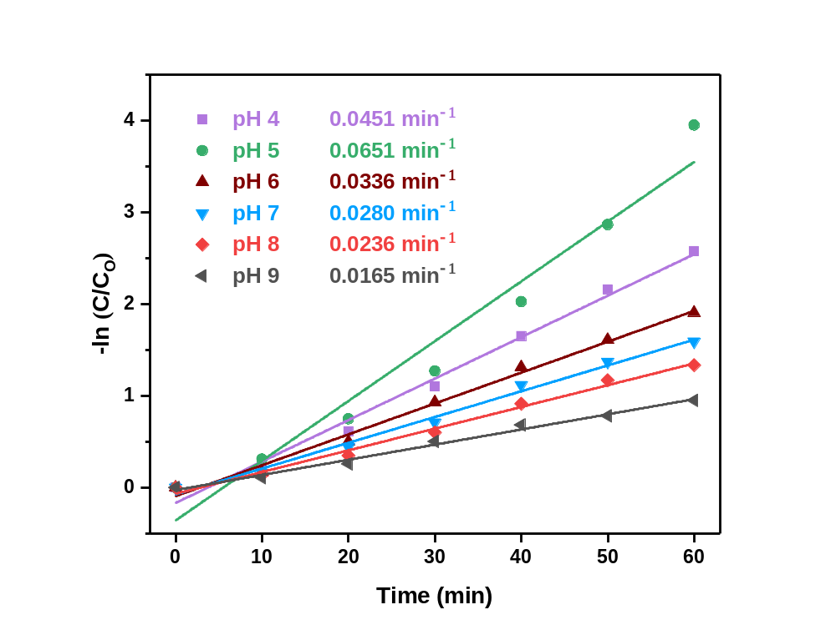
Fig. S3. Pseudo-1st-order kinetics for AYR degradation over ZnO/SnO₂ heterostructure photocatalyst using various solution pH. Parameters: photocatalyst = 32 mg, AYR concentration = 24 ppm, pH = 4-9, T = 30 °C.

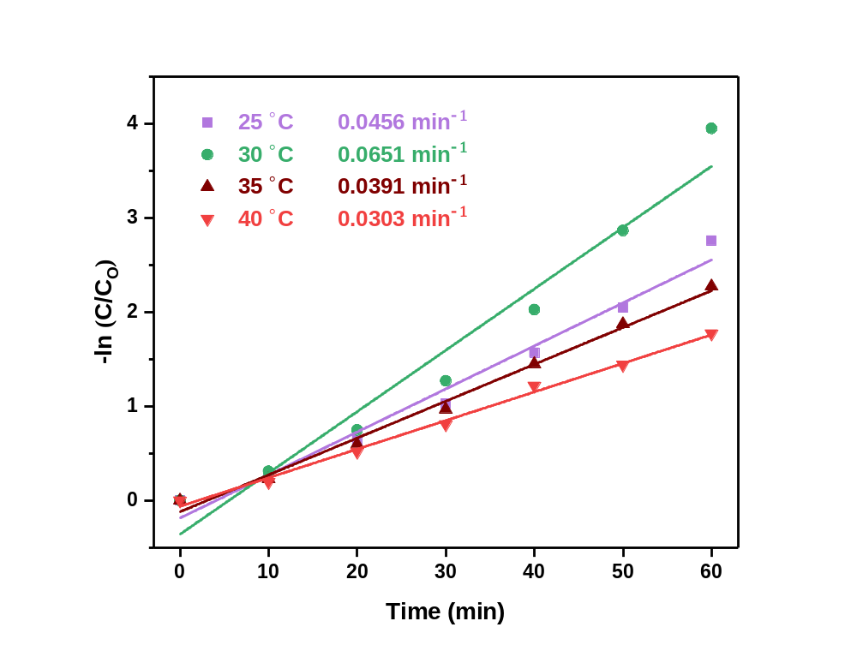
Fig. S4. Pseudo-1st-order kinetics for AYR degradation over ZnO/SnO₂ heterostructure photocatalyst using various temperatures. Parameters: photocatalyst = 32 mg, AYR concentration = 24 ppm, pH = 5, T = 25-40 °C.

