Additional file
New steady-state microbial community compositions and process performances in biogas reactors induced by temperature disturbances
Gang Luo^{*1,2}, Davide De Francisci², Panagiotis G. Kougias², Treu Laura², Xinyu Zhu², Irini Angelidaki²
¹ Shanghai Key Laboratory of Atmospheric Particle Pollution and Prevention (LAP3), Department of Environmental Science and Engineering, Fudan University, 200433, Shanghai, China
²Department of Environmental Engineering, Technical University of Denmark, DK-2800, Kgs Lyngby, Denmark

Sample name | Total high quality sequences | Bacteria | Archaea
A1 | 77666 | 77277 | 389
A2 | 109677 | 109238 | 439
A3 | 108885 | 108449 | 436
A4 | 102608 | 101479 | 1129
B1 | 99381 | 98884 | 497
B2 | 101229 | 100520 | 709
B3 | 69379 | 68962 | 417
B4 | 91529 | 90430 | 1099
C1 | 116719 | 116252 | 467
C2 | 109065 | 108628 | 437
C3 | 89792 | 88983 | 809
C4 | 103910 | 102559 | 1351
Table S1 Number of the high quality sequences and the sequences assigned to bacteria and archaea based on RDP classification

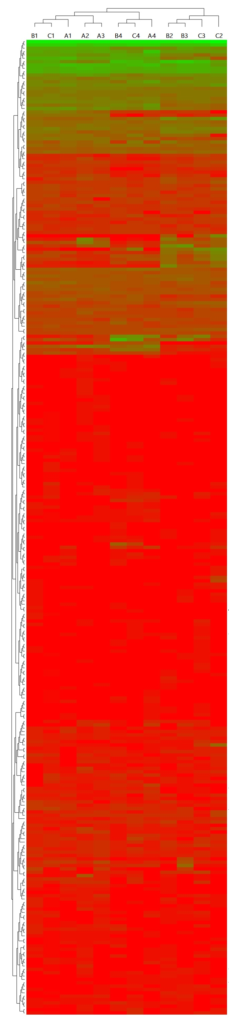

Fig S1 Hierarchical cluster analysis of all the samples in genus level.

