Supplemental material
Table S1. Composition of water soluble fraction of winter rye samples.
 | Glucose | Fructose | Arabinose | Protein | Mass bal
Apr 16-0N | 18.4% | 45.1% | 0.6% | 20.6% | 84.6%
Apr 16-60N | 18.8% | 40.4% | 0.5% | 22.9% | 82.6%
Apr 27-0N-wilted | 22.1% | 48.7% | 0.6% | 17.4% | 88.8%
Apr 27-0N | 22.0% | 46.0% | 0.5% | 17.0% | 85.5%
Apr 27-60N | 21.5% | 41.5% | 0.4% | 17.6% | 81.0%
May 4-0N | 18.9% | 38.6% | 0.6% | 21.9% | 80.0%
May 4-60N | 19.0% | 39.3% | 0.6% | 20.1% | 79.0%
May 10-0N | 19.4% | 40.1% | 0.5% | 17.4% | 77.4%
May 10-60N | 20.8% | 41.5% | 0.4% | 16.4% | 79.2%

Table S2. Composition of water insoluble fraction of winter rye samples.
 | Glucan | Xylan | Arabinan | Acetyl | Lignin | Protein | Ash | Mass bal
Apr 16-0N | 34.3% | 27.2% | 3.7% | 3.4% | 14.4% | 1.9% | 0.8% | 85.8%
Apr 16-60N | 35.4% | 26.7% | 3.5% | 3.6% | 16.5% | 2.0% | 0.8% | 88.4%
Apr 27-0N-wilted | 34.4% | 25.4% | 3.0% | 3.4% | 17.2% | 1.9% | 1.2% | 86.6%
Apr 27-0N | 37.1% | 26.3% | 3.0% | 3.7% | 16.5% | 2.4% | 0.8% | 89.7%
Apr 27-60N | 36.6% | 25.6% | 2.9% | 3.6% | 17.3% | 2.7% | 0.8% | 89.6%
May 4-0N | 37.7% | 25.9% | 2.8% | 3.7% | 18.1% | 2.2% | 0.8% | 91.1%
May 4-60N | 37.7% | 25.3% | 2.8% | 3.5% | 18.0% | 2.9% | 0.8% | 90.9%
May 10-0N | 38.8% | 25.1% | 2.4% | 3.5% | 16.3% | 2.3% | 0.8% | 89.3%
May 10-60N | 38.7% | 24.7% | 2.5% | 3.4% | 17.1% | 3.1% | 0.7% | 90.1%

Table S3. Raw data carbohydrate solubilization.
 | Inititial weight, g | Moisture content | C. therm residual Carbohydrate, g |  |  | SSCF residual Carbohydrate, g
 | Inititial weight, g | Moisture content | Glucan | Xylan | Arabinan | Glucan | Xylan |  | Arabinan
Apr 16-0N | 0.75 | 8.7% | 0.042 | 0.036 | 0.0024 | 0.092 | 0.080 |  | 0.016
Apr 16-60N | 0.75 | 7.3% | 0.053 | 0.043 | 0.0029 | 0.103 | 0.083 |  | 0.016
Apr 27-0N-wilted | 0.75 | 6.5% | 0.061 | 0.048 | 0.0033 | 0.122 | 0.094 |  | 0.015
Apr 27-0N | 0.75 | 7.0% | 0.072 | 0.055 | 0.0038 | 0.129 | 0.098 |  | 0.015
Apr 27-60N | 0.75 | 7.0% | 0.082 | 0.059 | 0.0041 | 0.135 | 0.100 |  | 0.015
May 4-0N | 0.75 | 7.8% | 0.104 | 0.073 | 0.0051 | 0.169 | 0.119 |  | 0.015
May 4-60N | 0.75 | 7.5% | 0.109 | 0.076 | 0.0055 | 0.168 | 0.117 |  | 0.015
May 10-0N | 0.75 | 7.6% | 0.134 | 0.088 | 0.0063 | 0.187 | 0.124 | 0.014
May 10-60N | 0.75 | 7.2% | 0.133 | 0.086 | 0.0064 | 0.198 | 0.131 | 0.014

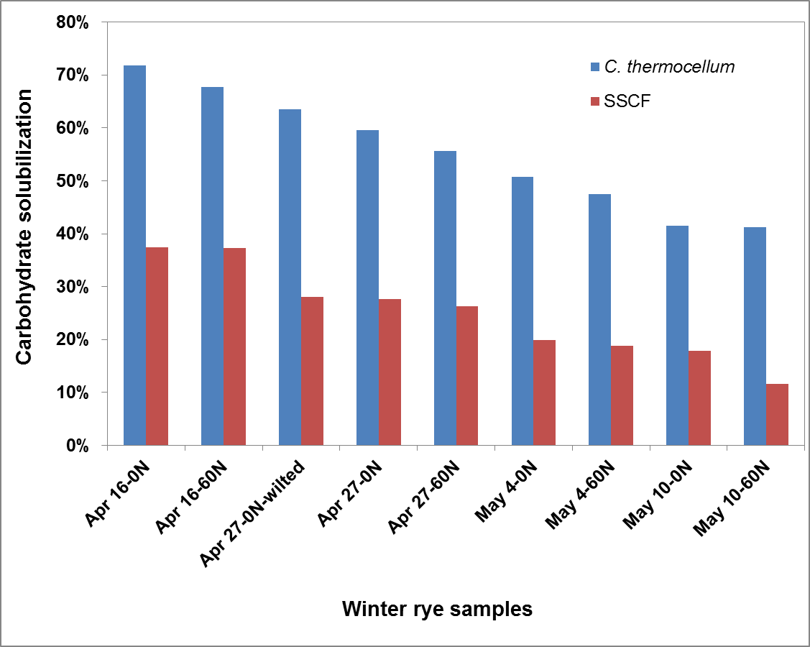
Figure S1. Overall carbohydrate solubilization of the water insoluble fraction.
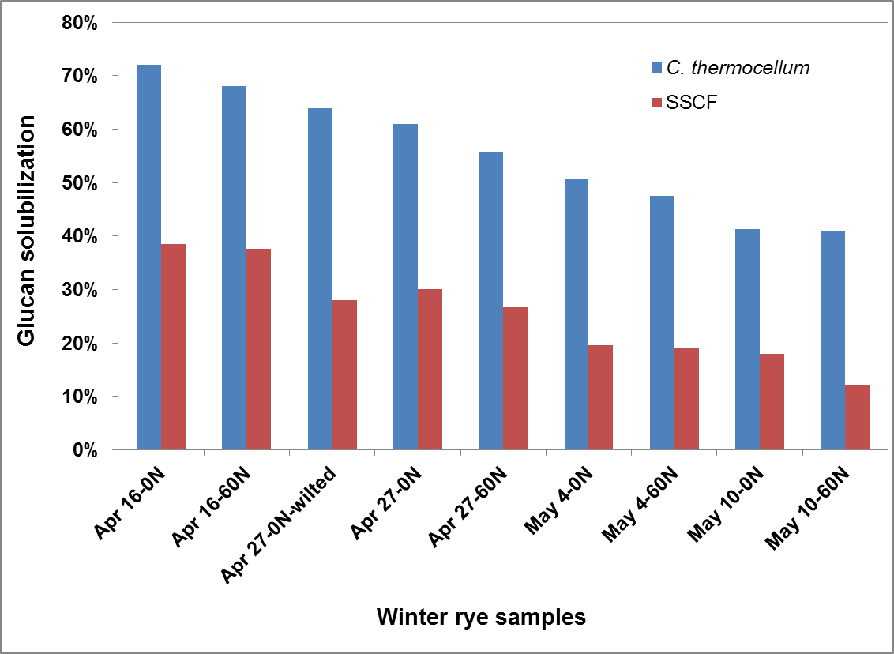
Figure S2. Glucan solubilization of the water insoluble fraction.
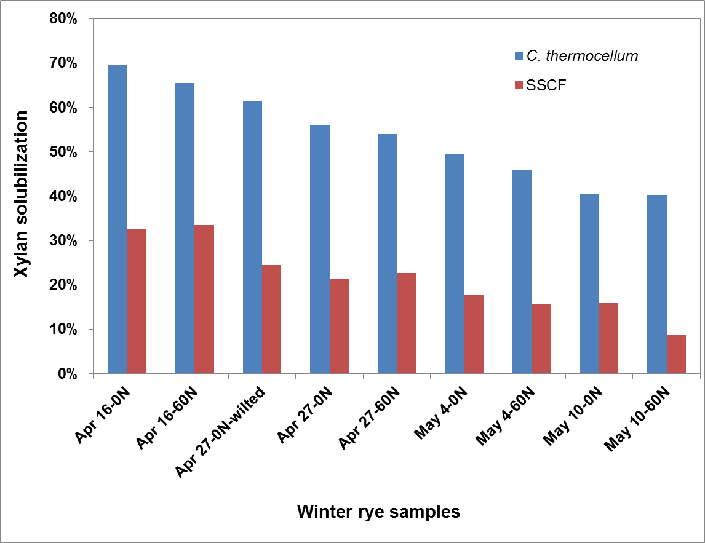
Figure S3. Xylan solubilization of the water insoluble fraction.
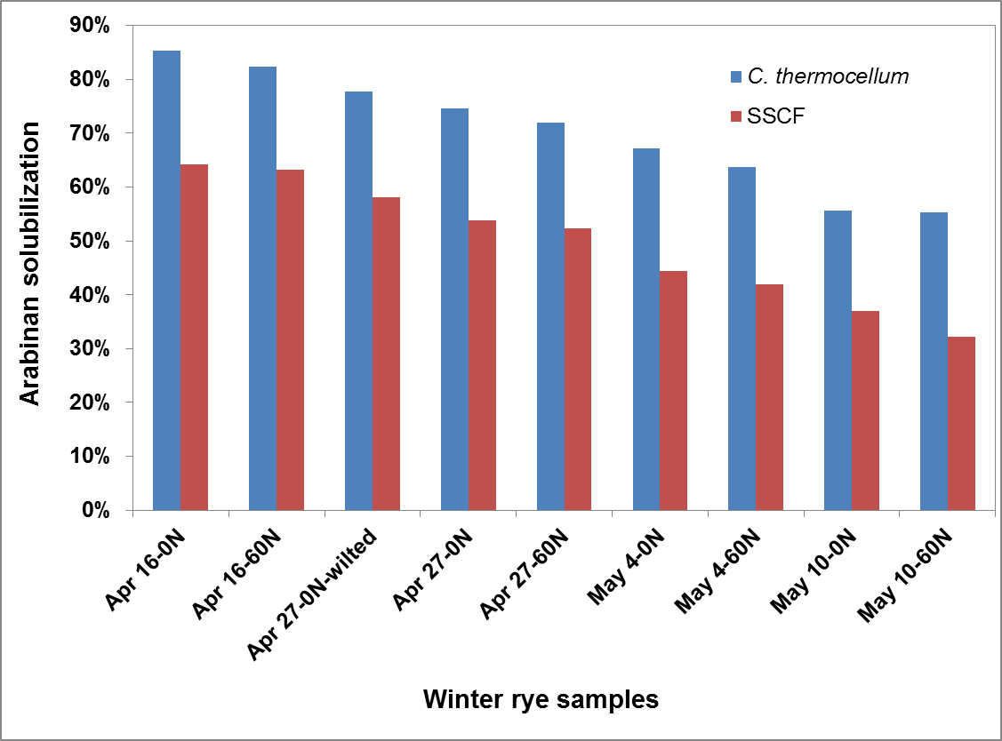
Figure S4. Arabinan solubilization of the water insoluble fraction.

