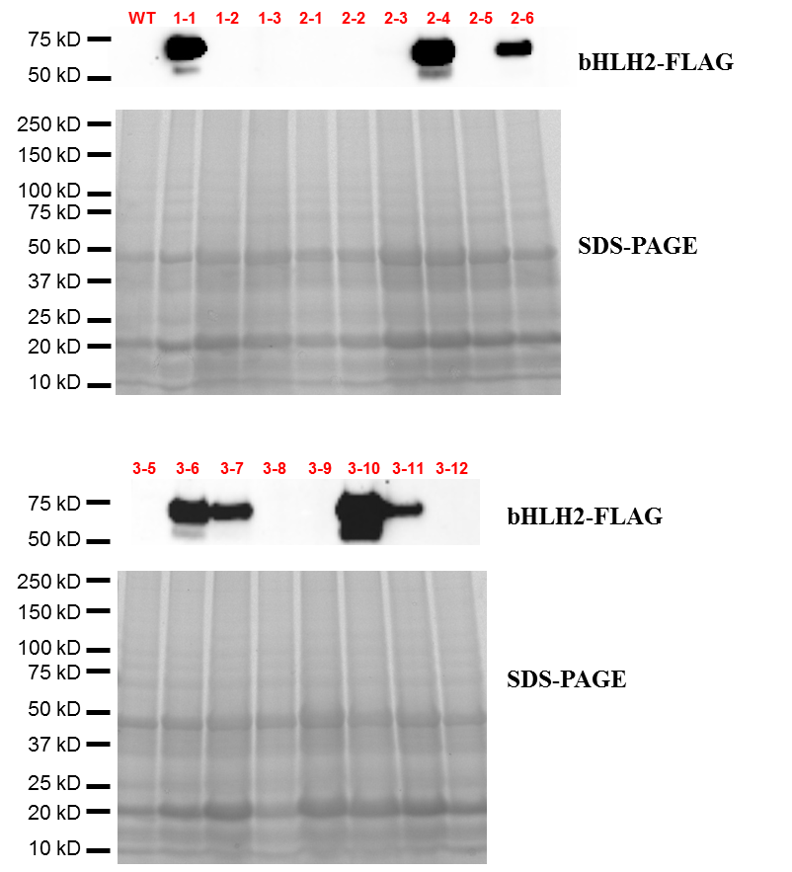
Figure S2. Western blotting of FLAG-tagged NsbHLH2. Stain-free SDS-PAGE gel image using ChemiDoc (Bio-Rad) showed similar loading of protein samples. The expected size of FLAG-tagged NsbHLH2 was 65 kD.

