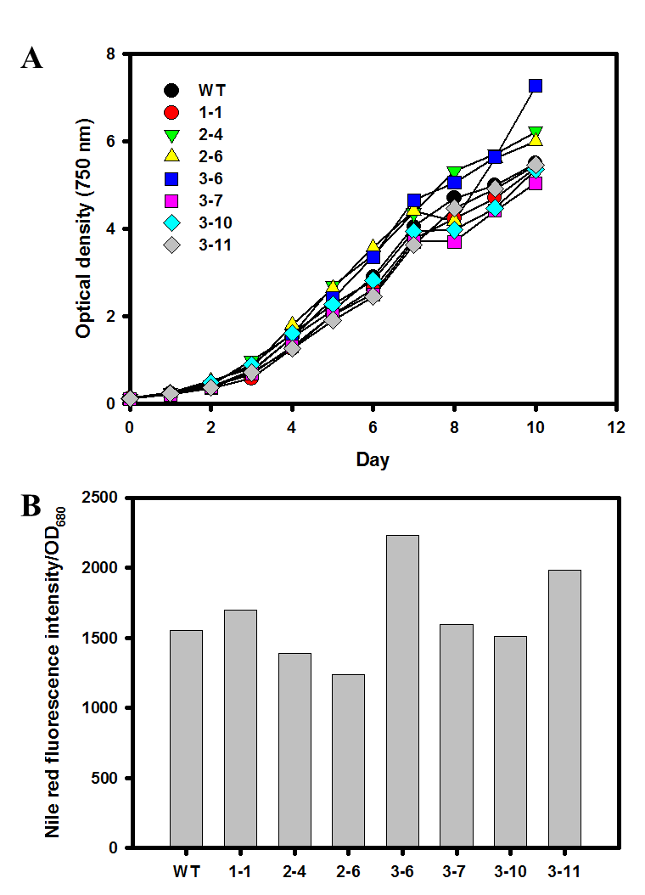
Figure S3. Phenotype screening of NsbHLH2 transformants. (A) Growth curve by optical density at 750 nm. (B) Relative neutral lipid contents by Nile red fluorescence intensity.

