Additional file 5 Impact of maintenance coefficient on accuracy of model predictions
The estimated maintenance coefficient (m_{s}) of this study (0.093 mmol_{ph} g⁻¹ h⁻¹, Additional file 1: Sect. S1.2) is lower than the m_{s} reported for Chlamydomonas reinhardtii (3.08 mmol_{ph} g⁻¹ h⁻¹) [1] , Chlorella sorokiniana (2.84 mmol_{ph} g⁻¹ h⁻¹) [2] and Nannochloropsis salina (7.62 mmol_{ph} g⁻¹ h⁻¹) [3] under N-replete conditions. Two possible explanations for such difference are: 1) The published maintenance coefficient include the efficiency of photosynthesis during the measurements and will thus, due to inherent losses, have a higher requirement compared to our maintenance coefficient, which is modeled separately from photosynthesis. 2) Likely the maintenance coefficient of N-starved cells is lower than that of N-replete cells, possibly because of a reduced metabolic activity.
Nevertheless, the model is able to adequately describe the experimental data (Fig. S5.1) when the average of the published maintenance coefficients (i.e. 4.51 mmol g⁻¹ h⁻¹) was used and the other model parameters were fitted on our batch nitrogen run-out dataset. Parameter estimation was performed as described in Additional file 1: Sect. S1.2, yielding values of 0.038 mol g⁻¹ h⁻¹ for the maximum photosynthetic rate of nitrogen-replete cells, 0.016 g g⁻¹ for the minimum cellular nitrogen content and 0.31 (batch) or 0.17 (repeated-batch) g g⁻¹ for the residual biomass fraction made during nitrogen starvation.
Furthermore, we found that, for the original set of model parameters, the maintenance coefficient would have to be increased by a factor 12 to 25 in order to have a 10 - 15% reduction in TAG yield on light (Fig. S5.2). This shows that the model is not very sensitive to the maintenance coefficient.

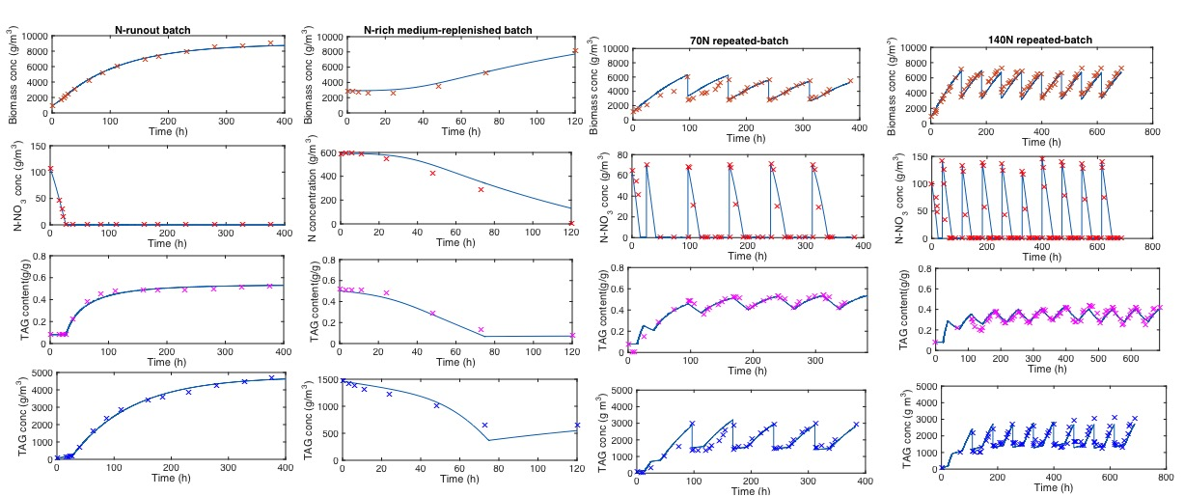
Figure S5.1 Model simulations and experimental data
Model simulations (lines) and experimental data (symbols) of biomass, external N-NO₃⁻ and TAG concentrations as well as TAG content for the N-run-out batch, N-rich medium-replenished batch, 70 mg_{N} L⁻¹-rich medium (70N) repeated-batch and 140 mg_{N} L⁻¹-rich medium (140N) repeated-batch cultivations. As described in the main text, model simulations were performed fixing the maintenance coefficient to the average value reported in literature.

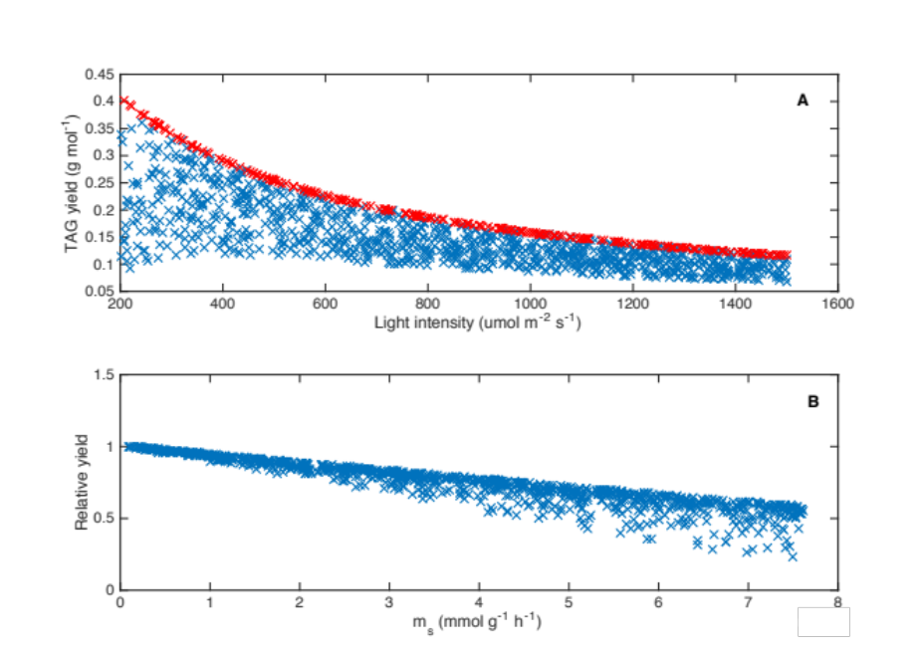
Figure S5.2 Output of Monte-Carlo-sampled simulations
(A) Impact of light intensity and maintenance coefficient (m_{s}) on batch TAG yield on light. Red symbols represent the TAG yield on light calculated keeping m_{s} at the value estimated in our study To illustrate the individual contribution of m_{s} (B), the TAG yield is normalized to the yield (red symbols) predicted at the same incident light intensity and with the value of m_{s} as estimated in our study.

References
1. Vejrazka C, Janssen M, Benvenuti G, Streefland M, Wijffels RH: Photosynthetic efficiency and oxygen evolution of Chlamydomonas reinhardtii under continuous and flashing light. Appl Microbiol Biotechnol 2013, 97:1523–1532.
2. Kliphuis AMJ, Janssen M, van den End EJ, Martens DE, Wijffels RH: Light respiration in Chlorella sorokiniana. J Appl Phycol 2011, 23:935–947.
3. Sforza E, Calvaruso C, Meneghesso A, Morosinotto T, Bertucco A: Effect of specific light supply rate on photosynthetic efficiency of Nannochloropsis salina in a continuous flat plate photobioreactor. Appl Microbiol Biotechnol 2015, 99:8309–18.

