Identification of key levers for reducing recalcitrance in poplar

Samarthya Bhagia^{1,2,4}, Muchero Wellington^{3,4}, Rajeev Kumar^{2,4}, Gerald A. Tuskan^{3,4}, and Charles E. Wyman^{1,2,4}

¹Department of Chemical and Environmental Engineering, Bourns College of Engineering, University of California Riverside, 900 University Ave, Riverside, CA 92521, USA
²Center for Environmental Research and Technology, Bourns College of Engineering, University of California Riverside, 1084 Columbia Ave, Riverside, CA 92507, USA
³Biosciences Division, Oak Ridge National Laboratory, Oak Ridge, TN 37831, USA
⁴BioEnergy Science Center (BESC), Oak Ridge National Laboratory, PO Box 2008 MS6341, Oak Ridge, TN 37831, USA

Additional Table 1. List of poplar variants
Field Sites | Clatskanie, OR
1 | BESC-35
2 | BESC 35-II
3 | BESC-283
4 | BESC-352
5 | BESC-876
6 | BESC-877
7 | GW-9920
8 | BESC-5
9 | BESC-8
10 | BESC-100
11 | BESC-167
12 | BESC-292
13 | GW-9782
14 | GW-9947
15 | GW-11054
16 | CHWH-27-2
17 | CHWH-27-3
18 | SKWE-24-2
Comparators
High Lignin | BESC-316
Low Lignin | GW-11012
 | BESC-97
 | GW-9762

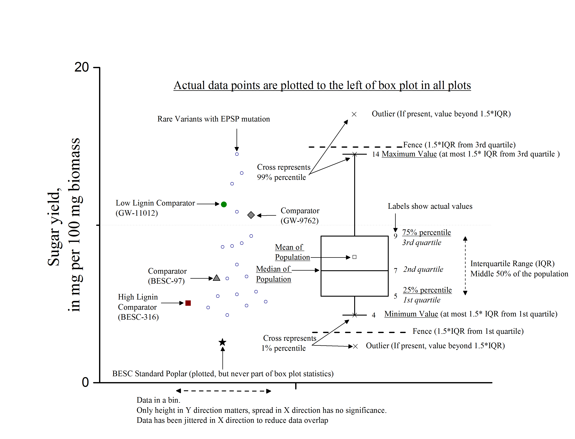

Additional Figure 1. Understanding box plots used in this study.
Additional Table 2. Average imprecision % in measurement.
Condition |  | Glucan | Xylan | Glucan + Xylan | Lignin
 | Composition | 0.19 | 0.06 | 0.20 | 0.33
A | No pretreatment enzymatic hydrolysis | 0.13 | 0.05 | 0.14 | N/A
B | HTPH 140°C logR₀ = 3.6 | 0.59 | 0.35 | 0.69 | N/A
C | HTPH 160°C logR₀ = 3.6 | 0.72 | 0.37 | 0.81 | N/A
D | HTPH 180°C logR₀ = 3.6 | 0.97 | 0.42 | 1.05 | N/A
E | HTPH 180°C logR₀ = 4.0 | 0.49 | 0.23 | 0.54 | N/A
N/A- not applicable
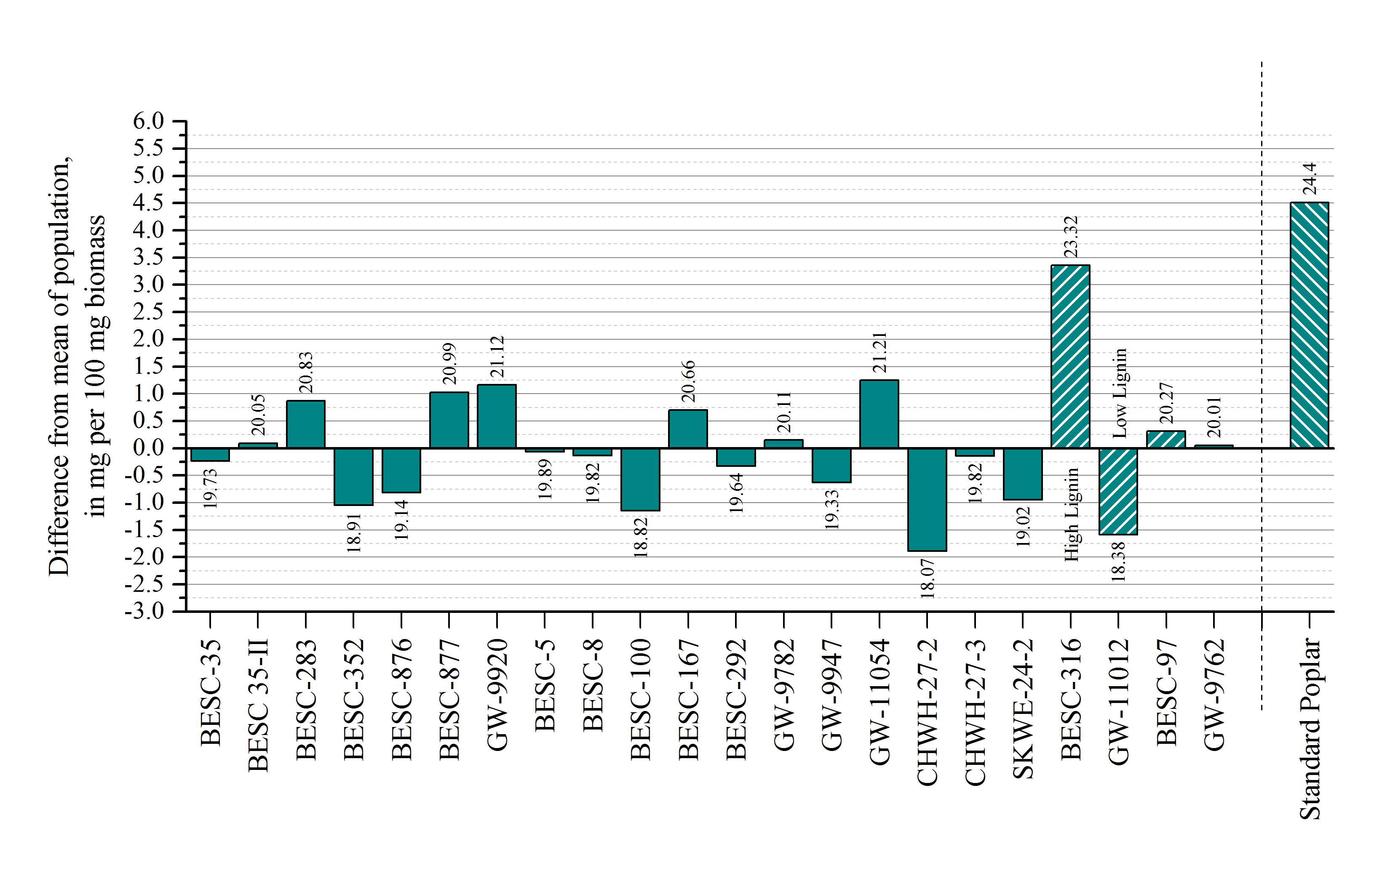
Additional Figure 2. Klason lignin composition of Clastkanie plants and BESC standard poplar, units in mg per 100 mg biomass (dry basis). Columns are represented as percent relative difference from mean of the population. Column data labels show actual Klason lignin values. Population mean is 19.96%. Average imprecision in measurement is 0.35%. Columns with pattern are comparators and do not have the natural mutation. BESC standard poplar, shown for comparison, was not part of the statistic, and was not grown in Clatskanie, OR.

