DNA Microarray of Global Transcription Factor Mutant Reveals Membrane-Related Proteins Involved in n-Butanol Tolerance in Escherichia coli

Supplementary Online Material
Additional file 2. Volcano plot of global gene expression differences between σ⁷⁰ mutant B8 and WT upon butanol challenge. X axis: Log₂ (Fold Change); Y axis: -Log10 (p-value). Green lines parallel to X axis represents p-value=0.05. The left red zone denotes the number of down-regulated genes; the right red zone denotes the number of up-regulated genes (p<0.05; FC≥2). (Fig. S2)

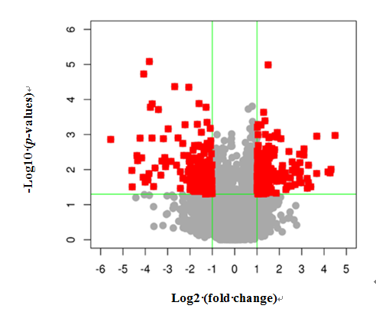
Fig. S2

