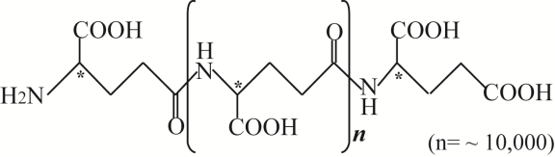
Fig. S1 Molecular structure of γ-PGA (chiral carbons are indicated with asterisks)⁸³.

