Supporting Figures
Figure S1. X-ray diffraction patterns and CrI (%) values of untreated Avicel, switchgrass solids and pretreated switch grass by [TBA][OH] at 50⁰C pretreatment conditions.
Figure S2. Normalized SEC chromatograms of EMAL- switchgrass and L_{1.}

Figure S3. HSQC spectra correspond to the color coded substructures.

Supporting Fig. S4. Relative abundances in lignin interunit linkages in switchgrass EMAL and L₁.

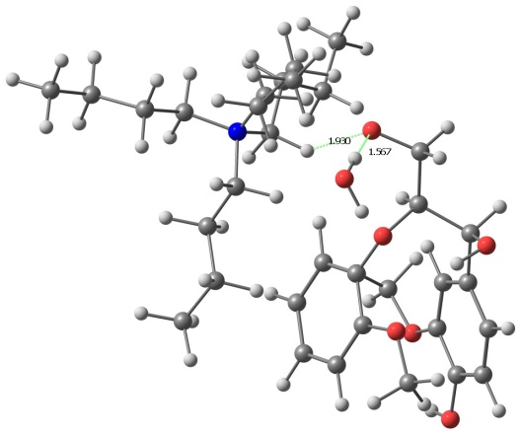 | 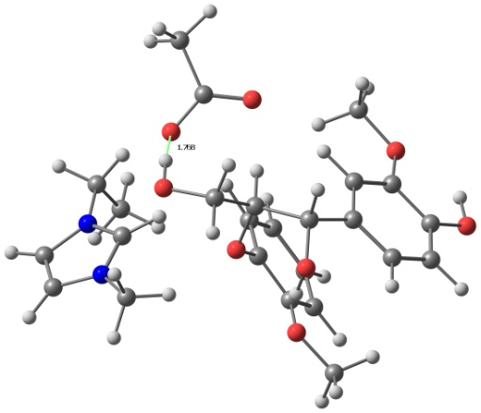
[TBA][OH]— dilignol | [C₂C₁Im] [OAc]— dilignol

Figure S5. Optimized geometries of dilignol with IL complexes.

Table S1: Detailed list of cell wall glycan-directed monoclonal antibodies (mAbs) used for glycome profiling analyses. The groupings of antibodies are based on a hierarchical clustering of ELISA data generated from a screen of all mAbs against a comprehensive panel of plant polysaccharide preparations[1, 2] that clusters mAbs according to the predominant polysaccharides that they recognize. The majority of listings link to the WallMabDB plant cell wall monoclonal antibody database (http://www.wallmabdb.net) that provides detailed descriptions of each mAb, including immunogen, antibody isotype, epitope structure (to the extent known), supplier information, and related literature citations.

Glycan Group Recognized mAb Names

Non-Fucosylated  Xyloglucan-1 | CCRC-M95
Non-Fucosylated  Xyloglucan-1 | CCRC-M101
Non-Fucosylated  Xyloglucan-2 | CCRC-M104
Non-Fucosylated  Xyloglucan-2 | CCRC-M89
Non-Fucosylated  Xyloglucan-2 | CCRC-M93
Non-Fucosylated  Xyloglucan-2 | CCRC-M87
Non-Fucosylated  Xyloglucan-2 | CCRC-M88
Non-Fucosylated  Xyloglucan-3 | CCRC-M100
Non-Fucosylated  Xyloglucan-3 | CCRC-M103
Non-Fucosylated  Xyloglucan-4 | CCRC-M58
Non-Fucosylated  Xyloglucan-4 | CCRC-M86
Non-Fucosylated  Xyloglucan-4 | CCRC-M55
Non-Fucosylated  Xyloglucan-4 | CCRC-M52
Non-Fucosylated  Xyloglucan-4 | CCRC-M99
Non-Fucosylated  Xyloglucan-5 | CCRC-M54
Non-Fucosylated  Xyloglucan-5 | CCRC-M48
Non-Fucosylated  Xyloglucan-5 | CCRC-M49
Non-Fucosylated  Xyloglucan-5 | CCRC-M96
Non-Fucosylated  Xyloglucan-5 | CCRC-M50
Non-Fucosylated  Xyloglucan-5 | CCRC-M51
Non-Fucosylated  Xyloglucan-5 | CCRC-M53
Non-Fucosylated  Xyloglucan-6 | CCRC-M57
Fucosylated  Xyloglucan | CCRC-M102
Fucosylated  Xyloglucan | CCRC-M39
Fucosylated  Xyloglucan | CCRC-M106
Fucosylated  Xyloglucan | CCRC-M84
Fucosylated  Xyloglucan | CCRC-M1
Xylan-1/XG | CCRC-M111
Xylan-1/XG | CCRC-M108
Xylan-1/XG | CCRC-M109
Xylan-2 | CCRC-M119
Xylan-2 | CCRC-M115
Xylan-2 | CCRC-M110
Xylan-2 | CCRC-M105
Xylan-3 | CCRC-M117
Xylan-3 | CCRC-M113
Xylan-3 | CCRC-M120
Xylan-3 | CCRC-M118
Xylan-3 | CCRC-M116
Xylan-3 | CCRC-M114
Xylan-4 | CCRC-M154
Xylan-4 | CCRC-M150
Xylan-5 | CCRC-M144
Xylan-5 | CCRC-M146
Xylan-5 | CCRC-M145
Xylan-5 | CCRC-M155
Xylan-6 | CCRC-M153
Xylan-6 | CCRC-M151
Xylan-6 | CCRC-M148
Xylan-6 | CCRC-M140
Xylan-6 | CCRC-M139
Xylan-6 | CCRC-M138
Xylan-7 | CCRC-M160
Xylan-7 | CCRC-M137
Xylan-7 | CCRC-M152
Xylan-7 | CCRC-M149
Galactomannan-1 | CCRC-M75
Galactomannan-1 | CCRC-M70
Galactomannan-1 | CCRC-M74
Galactomannan-2 | CCRC-M166
Galactomannan-2 | CCRC-M168
Galactomannan-2 | CCRC-M174
Galactomannan-2 | CCRC-M175
Glucomannan | CCRC-M169
Glucomannan | CCRC-M170
β-Glucan | LAMP
β-Glucan | BG1
HG  Backbone-1 | CCRC-M131
HG  Backbone-1 | CCRC-M38
HG  Backbone-1 | JIM5
HG  Backbone-2 | JIM136
HG  Backbone-2 | JIM7
RG-I  Backbone | CCRC-M69
RG-I  Backbone | CCRC-M35
RG-I  Backbone | CCRC-M36
RG-I  Backbone | CCRC-M14
RG-I  Backbone | CCRC-M129
RG-I  Backbone | CCRC-M72
Linseed Mucilage  RG-I | JIM3
Linseed Mucilage  RG-I | CCRC-M40
Linseed Mucilage  RG-I | CCRC-M161
Linseed Mucilage  RG-I | CCRC-M164
Physcomitrella  Pectin | CCRC-M98
Physcomitrella  Pectin | CCRC-M94
RG-Ia | CCRC-M5
RG-Ia | CCRC-M2
RG-Ib | JIM137
RG-Ib | JIM101
RG-Ib | CCRC-M61
RG-Ib | CCRC-M30
RG-Ic | CCRC-M23
RG-Ic | CCRC-M17
RG-Ic | CCRC-M19
RG-Ic | CCRC-M18
RG-Ic | CCRC-M56
RG-Ic | CCRC-M16
RG-I/Arabinogalactan | CCRC-M60
RG-I/Arabinogalactan | CCRC-M41
RG-I/Arabinogalactan | CCRC-M80
RG-I/Arabinogalactan | CCRC-M79
RG-I/Arabinogalactan | CCRC-M44
RG-I/Arabinogalactan | CCRC-M33
RG-I/Arabinogalactan | CCRC-M32
RG-I/Arabinogalactan | CCRC-M13
RG-I/Arabinogalactan | CCRC-M42
RG-I/Arabinogalactan | CCRC-M24
RG-I/Arabinogalactan | CCRC-M12
RG-I/Arabinogalactan | CCRC-M7
RG-I/Arabinogalactan | CCRC-M77
RG-I/Arabinogalactan | CCRC-M25
RG-I/Arabinogalactan | CCRC-M9
RG-I/Arabinogalactan | CCRC-M128
RG-I/Arabinogalactan | CCRC-M126
RG-I/Arabinogalactan | CCRC-M134
RG-I/Arabinogalactan | CCRC-M125
RG-I/Arabinogalactan | CCRC-M123
RG-I/Arabinogalactan | CCRC-M122
RG-I/Arabinogalactan | CCRC-M121
RG-I/Arabinogalactan | CCRC-M112
RG-I/Arabinogalactan | CCRC-M21
RG-I/Arabinogalactan | JIM131
RG-I/Arabinogalactan | CCRC-M22
RG-I/Arabinogalactan | JIM132
RG-I/Arabinogalactan | JIM1
RG-I/Arabinogalactan | CCRC-M15
RG-I/Arabinogalactan | CCRC-M8
RG-I/Arabinogalactan | JIM16
Arabinogalactan-1 | JIM93
Arabinogalactan-1 | JIM94
Arabinogalactan-1 | JIM11
Arabinogalactan-1 | MAC204
Arabinogalactan-1 | JIM20
Arabinogalactan-2 | JIM14
Arabinogalactan-2 | JIM19
Arabinogalactan-2 | JIM12
Arabinogalactan-2 | CCRC-M133
Arabinogalactan-2 | CCRC-M107
Arabinogalactan-3 | JIM4
Arabinogalactan-3 | CCRC-M31
Arabinogalactan-3 | JIM17
Arabinogalactan-3 | CCRC-M26
Arabinogalactan-3 | JIM15
Arabinogalactan-3 | JIM8
Arabinogalactan-3 | CCRC-M85
Arabinogalactan-3 | CCRC-M81
Arabinogalactan-3 | MAC266
Arabinogalactan-3 | PN 16.4B4
Arabinogalactan-4 | MAC207
Arabinogalactan-4 | JIM133
Arabinogalactan-4 | JIM13
Arabinogalactan-4 | CCRC-M92
Arabinogalactan-4 | CCRC-M91
Arabinogalactan-4 | CCRC-M78
Unidentified | MAC265
Unidentified | CCRC-M97

References
1. Pattathil S, Avci U, Baldwin D, Swennes AG, McGill JA, Popper Z, Bootten T, Albert A, Davis RH, Chennareddy C: A comprehensive toolkit of plant cell wall glycan-directed monoclonal antibodies. Plant physiology 2010, 153(2):514-525.
2. Pattathil S, Avci U, Miller JS, Hahn MG: Immunological approaches to plant cell wall and biomass characterization: glycome profiling. In: Biomass Conversion. Springer; 2012: 61-72.

