Supplemental data
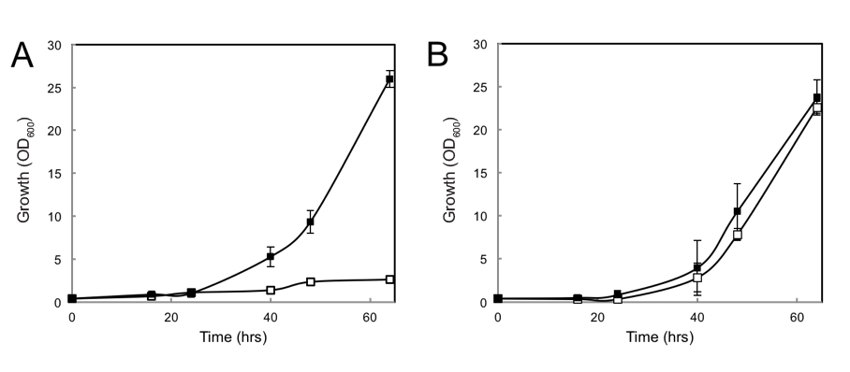
Figure S1. Growth of the DS68625 strain expressing Hxt1 (A) and Hxt5 (B) on 2 % D-xylose. Depicted as closed squares are the N-terminally lysine mutants (4K and 7K for Hxt1 and Hxt5, respectively) and as open squares for the corresponding parental strains.
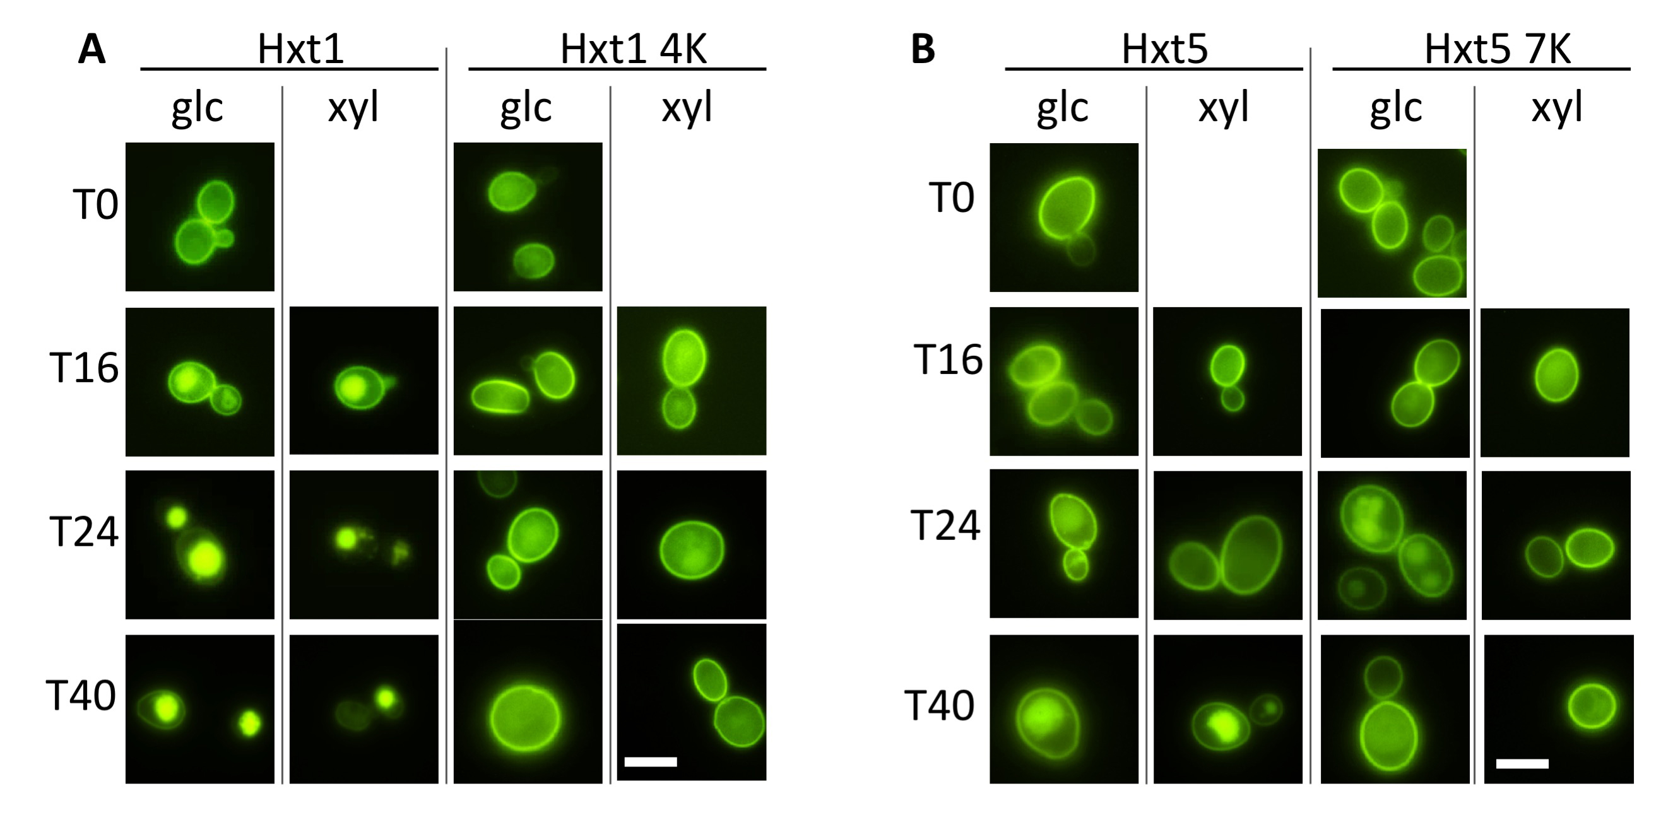

Figure S2. Membrane localizationof Hxt1 and Hxt1 4K (A) and Hxt5 and Hxt5 7K (B) fused at the C-terminus to GFP and expressed in strain DS68625 that was grown on minimal medium with 2% D-glucose and 2% D-xylose for a period up to 40 hrs.
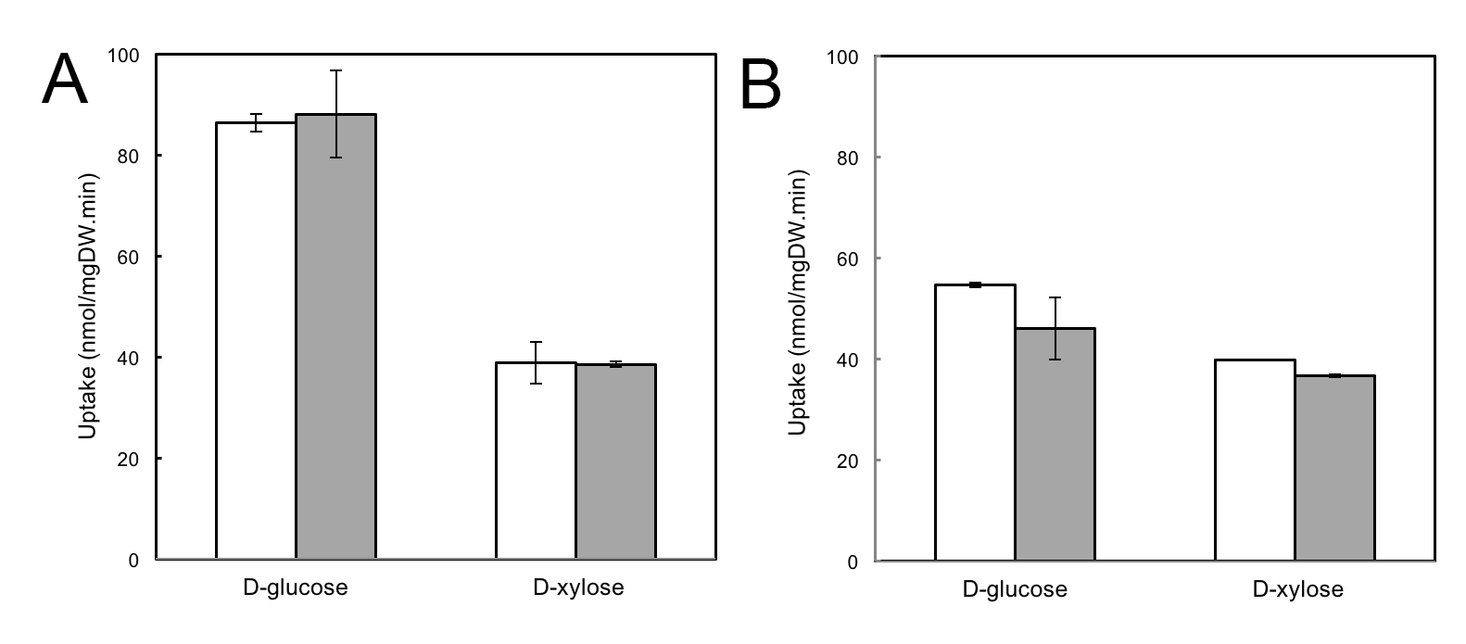
Figure S3. Uptake of 100 mM D-glucose or D-xylose by strain DS68625 expressing HXT1 (A) and HXT5 (B). White bars indicate the wild-type hexose transporters and the grey bars correspond to Hxt1 4K and Hxt5 7K, respectively. Errors are the standard deviation of two independent experiments.
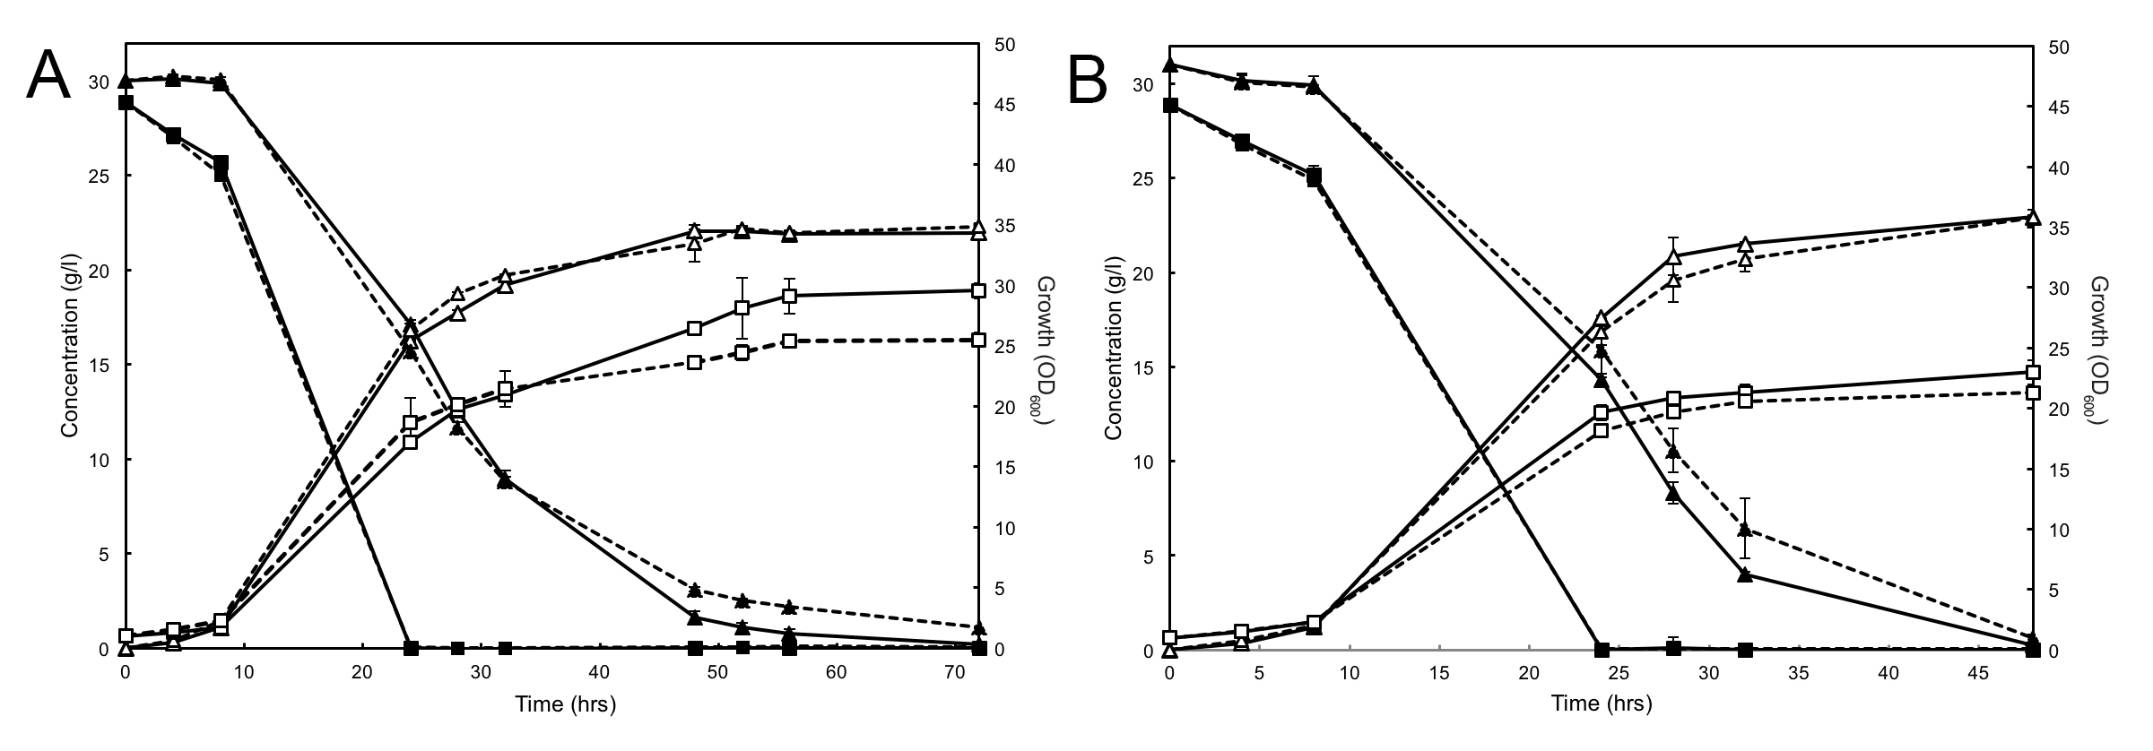

Figure S4. Fermentation of D-glucose and D-xylose by strain DS68625 expressing Hxt1 and Hxt1-4K (A) and Hxt5 and Hxt5-7K (B). Symbols depicted show growth (OD₆₀₀; open squares), ethanol (open triangles), D-glucose (closed squares) and D-xylose (closed triangles). The lysine mutants are show as solid lines, and the parental Hxt transporters are indicated with dashed lines. Errors are the standard deviation of two independent experiments.

Table S1. Oligonucleotides used for cloning.
Name | Sequence (5’ 3’)
F HXT36 BcuI | GCATACTAGTATGAATTCAACTCCCGATCTAATATC
F Hxt36 Bcui A | TCTAGAACTAGTATGAATTCAACTCCAGATTTAATATCTCCACAAAGGTCAAGTG
R Hxt36 BC | GCACCTCTACCTGTATTTGGGTTGGTAAGTACTTGGTCGGCCTCAGCTTGGAAATCATCTTGAACACCTCTTTCTTCAGG
F Hxt36 BC | CCTGAAGAAAGAGGTGTTCAAGATGATTTCCAAGCTGAGGCCGACCAAGTACTTACCAACCCAAATACAGGTAGAGGTGC
R Hxt36 DE | GGCAGACCTCCATGGTAGAACACCTTCTTCCCACATGGTGTTGACTTCTTCCAAAGTCAAACCCCTAGTTTCTGG
F Hxt36 DE | CCAGAAACTAGGGGTTTGACTTTGGAAGAAGTCAACACCATGTGGGAAGAAGGTGTTCTACCATGGAGGTCTGCC
R Hxt36 BamHI | ACGTGGATCCTTATTTGGTGCTGAACATTCTCTTGT
R Hxt36 -stop BamHI | CCATGGATCCTTTGGTGCTGAACATTCTCTTGTAC
R Hxt36 BamHI FGH | CCGGGGGATCCTTATCTGGTGCTGAACATTCTCCTGTACAATGGCCTATCATCGTG
R Hxt36-stop BamHI FGH | CCGGGGGATCCTCTGGTGCTGAACATTCTCCTGTACAATGGCCTATCATCGTG
F Hxt1 XbaI | GCATTCTAGAATGAATTCAACTCCCGATCTAATATC
F Hxt1 XbaI 1k | AAAATCTAGAATGAATTCAACTCCCGATCTAATATCTCCTCAGAGATCCAATTC
R Hxt1 2k3k | CTTTCATTTCTACCTTCTGGAGTATTCATGGCCCTTGAACG
F Hxt1 2k3k | CGTTCAAGGGCCATGAATACTCCAGAAGGTAGAAATGAAAG
R Hxt1 4k | CGTTACGTAGACACCTCTTCCG
F Hxt1 4k | CGGAAGAGGTGTCTACGTAACG
R Hxt1 Cfr9I | GCAGCCCGGGTTATTTCCTGCTAAACAAAC
R Hxt1-stop Cfr9I | GCAGCCCGGGTTTCCTGCTAAACAAAC
F Hxt5 XbaI | AAAATCTAGAATGTCGGAACTTGAAAACGC
R Hxt5 1k | CGAGTTTCCTGACCTCTCGTTG
F Hxt5 1k | CAACGAGAGGTCAGGAAACTCG
R Hxt5 2k3k | CGTCTCTGGGAGGGCCTTCATGGGAAATGTAACTTGAGACGGGTCTAGC
F Hxt5 2k3k | GCTAGACCCGTCTCAAGTTACATTTCCCATGAAGGCCCTCCCAGAGACG
R Hxt5 4k5k6k7k | CCGACCTCGATCTCCTCTCTAGTTGGTTGTCAACCTCCCTCTG
F Hxt5 4k5k6k7k | CAGAGGGAGGTTGACAACCAACTAGAGAGGAGATCGAGGTCGG
R Hxt5 Cfr9I | GCAGCCCGGGTTATTTTTCTTTAGTGAAC
R Hxt5 -stop Cfr9I | GCAGCCCGGGTTTTTCTTTAGTGAAC
Underlined, restriction site; Bold, introduced mutation.

Table S2. Ethanol Yield, production rate and productivity of strain S. cerevisiae DS68625 expressing different transporters and grown on mixed and single sugars.

 | Hxt36 | Hxt36-3K | Hxt36 N367A | Hxt36 N367A-3K | Hxt11 * | Hxt11 N366T *
3 % D-glucose and 3 % D-xylose
Y_{EtOH} | 0.39 ± 0.01 | 0.39 ± 0.02 | 0.39 ± 0.01 | 0.39 ± 0.02 | 0.43 ± 0.01 | 0.41 ± 0.02
Q_{EtOH} | 0.75 ± 0.08 | 0.74 ± 0.06 | 0.74 ± 0.1 | 0.72 ± 0.06 | 0.76 ± 0.02 | 0.72 ± 0.06
EtOH prod. | 0.48 ± 0.04 | 0.54 ± 0.03 | 0.53 ± 0.02 | 0.52 ± 0.07 | 1.56 ± 0.35 | 1.36 ± 0.29
3 % D-xylose
Y_{EtOH} | 0.39 ± 0.02 | 0.39 ± 0.02 | 0.40 ± 0.02 | 0.40 ± 0.01 | n.d. | n.d.
Q_{EtOH} | 0.09 ± 0.01 | 0.21 ± 0.02 | 0.11 ± 0.04 | 0.23 ± 0.01 | n.d. | n.d.
EtOH prod. | 0.08 ± 0.03 | 0.27 ± 0.04 | 0.06 ± 0.03 | 0.29 ± 0.05 | n.d. | n.d.
3 % D-glucose
Y_{EtOH} | 0.38 ± 0.01 | 0.38 ± 0.02 | 0.39 ± 0.02 | 0.39 ± 0.01 | n.d. | n.d.
Q_{EtOH} | 0.55 ± 0.06 | 0.59 ± 0.06 | 0.65 ± 0.02 | 0.60 ± 0.03 | n.d. | n.d.
EtOH prod. | 0.45 ± 0.02 | 0.42 ± 0.06 | 0.40 ± 0.05 | 0.45 ± 0.02 | n.d. | n.d.

The ethanol yield (Y_{EtOH} in g/g sugar) was determined for the complete fermentation profile which concerned 48 hours for growth on 3 % D-glucose and 3 % D-xylose, and on 3 % D-xylose alone; and 25 hours on 3 % D-glucose alone. The ethanol production rate (Q_{EtOH} in g/gDW.hr) was determined during the first 25 hours of the fermentations and the maximal ethanol productivity (in g/l.hr) was determined for 3 % D-glucose and 3 % D-xylose, 3 % D-xylose or 3 % D-glucose at time points 41, 41 and 25 hours, respectively.
*Hxt11 and Hxt11 N366T cells were grown on 7 % D-glucose and 3 % D-xylose (32).
n.d., not determined.

