Supplementary figure 1: sugar concentration over time during fermentation

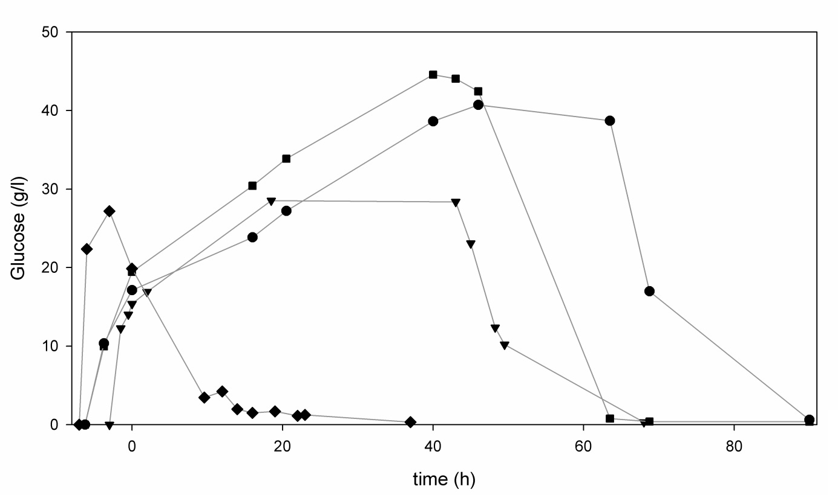
Figure A: Simultaneous Saccharification and Fermentation (SSF) experiments performed using 200 g/l acid pretreated bagasse DW and 10.5-15.8 FPU/g DW bagasse GC220 enzyme cocktail in pH controlled fermentations with a start volume of 1 litre. As inoculum, either furfural containing or reference preculture was used. The bagasse was either added in one batch or in two stages. Glucose was measured using HPLC. The following experiments were performed: : batch SSF solubilised with liquid fraction, inoculated with reference preculture, : batch SSF solubilised with liquid fraction, inoculated with furfural preculture, : batch SSF solubilised with water, inoculated with furfural preculture (15% V/DW enzymes), : two-stage SSF solubilised with water, inoculated with furfural preculture.

