Appendix A

Table S1: Primers and PCR fragments amplified/used in this work. P_{XXX}, promoter of gene XXX; T_{XXX}, terminator of gene XXX; Y-GDNA, CEN.PK113-7D genomic DNA; sequence annealing to template in primers is shown in red and italics; over-lap sequence for over-lap extension PCR and Gibson Assembly is underlined; restriction sites used in cloning are shown in bold.
No. | PCR fragment | Over-lap extension PCR fragment | Primer | Sequence (5’ -> 3’)
1 | EfmvaS- T_{EFM1} from pPMVAu8 | P_{CUP1}- EfmvaS- T_{EFM1} | PM4pRS423s | TAAATCAGCTCATTTTTTAACCAATAGGCCGAAATCGGCAAAATCCCTTATAAGGATCCA
 |  |  | PPM8+EFM1tas | CGGCAAAATCCCTTATAAGGATCCAGGTACCTACTGAAATTCATGACACAAATAAC
 |  |  | PPM8+EfmvaSaa | GAATTCAAAATGACCATCGGTATTGACAAAATCTCC
 | P_{CUP1} from Y-GDNA |  | PPM8+TEF1pas | AAAAGGAGATTTTGTCAATACCGATGGTCATTTTG
 |  |  | PPM8+CUP1pa-s | GTCAATACCGATGGTCATTTTGAATTCTTTATGTGATGATTGATTGATTGATTG
 |  |  | PPM8+CUP1pa-a | CAATTCCTTAAGCTTATCTATCCTCGAGTAAGCCGATCCCATTACCGACATT
 |  |  | PPM8+MCSa | GCATGCCTTACGACTTAGTCGACAATTCCTTAAGCTTATCTATCC
2 | P_{CUP1} from Y-GDNA | P_{CUP1}-EfmvaE- T_{EBS1} | PPM8+MCSs | CTCGAGGATAGATAAGCTTAAGGAATTGTCGACTAAGTCGTAAGG
 |  |  | PPM8+CUP1pss | ATTGTCGACTAAGTCGTAAGGCATGCTAAGCCGATCCCATTACCGACATT
 |  |  | PPM8+CUP1ps-a | CTATTATTACTACAGTCTTCATTTTACTAGTTTTATGTGATGATTGATTGATTGATTG
 |  |  | PPM8+TEF1psa | TCAATGCGTCTATTATTACTACAGTCTTCATTTTAC
3 | EfmvaE- T_{EBS1} from pPMVAu8 |  | PPM8+EfmvaEss | ACTAGTAAAATGAAGACTGTAGTAATAATAGACGCATTGAG
 |  |  | PM4pRS423a | ACGCCAAGCGCGCAATTAACCCTCACTAAAGGGAACAAAAGCTGGA
4 | P_{GAL1/10} from Y-DNA | P_{GAL1/10}-ACS2-P_{GAL2} | PMsuGAL1-10ps | TCAATACCGATGGTCATTTTGAATTCTATAGTTTTTTCTCCTTGACGTTA
 |  |  | PMsuGAL1-10pa | TTATGTTCCTTGATTGTCATTTTGTCGACTTATATTGAATTTTCAAAAATTCTTACTT
 | ACS2 from Y-DNA |  | PMsuACS2s | TTGAAAATTCAATATAAGTCGACAAAATGACAATCAAGGAACATAAAGTAG
 |  |  | PMsuACS2a | GTAAACCTCCTTGGATTAGTACAGCATGCATTACTTTATTCCCACTATAGG
 | P_{GAL2} from Y-DNA |  | PMsuGAL2ps | AGTGGGAATAAAGTAATGCATGCTGTACTAATCCAAGGAGGTTTACG
 |  |  | PMsuGAL2pa | CTATTATTACTACAGTCTTCATTTTACTAGTTATGAAAGAATTATTTTTTTTATTATGTT
5 | HMG2-U [HMG2(-309, -153)] from Y-DNA |  | PIM1HMG2ps | TTTTAACCAATAGGCCGAAATCGGCAAAATCCCTTATTTAAATAGACCATTGATCGTTAG
 |  |  | PIM1HMG2pa | TCATTCTGAACGAGGCGCGCTTTCTGTGGTAGGTTCTTGAGGTGATTTAG
6 | HIS3 from Y-DNA |  | PIM1HIS3s | TCAGAAGGCCGTTTTCTAAATCACCTCAAGAACCTACCACAGAAAGCGCGCCTCGTTCAG
 |  |  | PIM1HIS3a | ATGTCGTTATTTGTGTCATGAATTTCAGTAGGATCCTAGTACACTCTATATTTTTTTATG
7 | P_{GAL7} from Y-DNA |  | PIM1GAL7ps | TTCTTTGGATCAGATACAAAATCTGGTTTGAACGCGAGCTCTTTGCCAGCTTACTATCCT
 |  |  | PIM1GAL7pa | TATCGTTCTTAAGGGAAGTGACATTTTTGAGGGAATATTCAACTGTTTTT
8 | HMG2^{K6R}(1, 292) from Y-DNA |  | PIM1HMG2K6As | AAAACAGTTGAATATTCCCTCAAAAATGTCACTTCCCTTAAGAACGATAG
 |  |  | PIM1HMG2K6Aa | GGTTCCTGGCCTTTTGCTGGCCTTTTGCTCACATGTATTTAAATATCGGCGGCTTCTTTA
9 | PDC5  (-277, -32) from Y-GDNA | PDC5(-277, -32)-HIS3- PDC5  (95, 373) | PI3PDC5Us | TAAAACGACGGCCAGTGAATTCGTTTAAACTAATACGTAAACCTGCATTAAGGT
 |  |  | PI3PDC5Ua | ACTCCTAGCGCGGCCGCTTTCCTGCAGGCTCTTTGAGATTGATTATGTGAAATAAGTGT
 | HIS3 from pRS423 |  | PI3HIS3s | ATCAATCTCAAAGAGCCTGCAGGAAAGCGGCCGCGCTAGGAGTCACTGCCAGGTA
 |  |  | PI3HIS3a | TCATAAAGCTTATCCAAAAGAGATTTAAATGAGCTGATTTAACAAAAATTTAACG
 | PDC5  (95, 373) from Y-GDNA |  | PI3PDC5Ds | GTTAAATTTTTGTTAAATCAGCTCATTTAAATCTCTTTTGGATAAGCTTTATGAAGTC
 |  |  | PI3PDC5Da | ATGATTACGCCAAGCTTGCATGCGTTTAAACAGTGAAGTCACCGTTACC
10 | P_{TEF1} from Y-GDNA | P_{TEF1}-ERG12-T_{NAT5} | PM32TEF1ps | GCAAAATCCCTTATAACCTGCAGGGTATAAACAATGCATACTTTGTACGT
 |  |  | PM32TEF1pa | GCAGAAGTTAAGAACGGTAATGACATTTTGTAATTAAAACTTAGATTAGATTGC
 | ERG12-T_{NAT5} from pPMVAd3 |  | PM32ERG12s | AATCTAAGTTTTAATTACAAAATGTCATTACCGTTCTTAACTTCTGC
 |  |  | PM3NAT5ta | As above
11 | P_{TEF2} from Y-GDNA | P_{TEF2}- ERG8- T_{IDP1} | PM32TEF2ps | AGAATCACGAAGAGCTGAGCTCACTTTGTTATGTAGAGTTTTTTTAGC
 |  |  | PM32TEF2pa | CTGAAGGCTCTCAACTCTGACATGTTTAGTTAATTATAGTTCGTTGAC
 | ScERG8- T_{IDP1} from pPMVAd3 |  | PM32ERG8s | GTCAACGAACTATAATTAACTAAACATGTCAGAGTTGAGAGCCTTCAG
 |  |  | PM3IDP1ta | As above
12 | TRP1 from pRS423 |  | PI3ToTRP1ps | GTGGTGGCACTACCAGCGGCCGCGTTAACGACATTACTATATATATAATATAGG
 |  |  | PI3ToTRP1pa | TCATAAAGCTTATCCAAAAGAGATTTAAATGAGCTGATTTAACAAAAATTTAACGC
13 | P_{TEF2} from Y-GDNA | P_{TEF2}- MVD1- T_{IDP1} | PPM3+TEF2ps1 | CTTACATAGGTGGTGGCACTACCAGTCGACACTTTGTTATGTAGAGTTTTTTTAGCTACC
 |  |  | PPM3+TEF2pa | GATGCTGTGTAAACGGTCATGTTTAGTTAATTATAGTTCGTTG
 | MVD1-T_{PRM9} from pPMVAd3 |  | PPM3+MVD1s | CAACGAACTATAATTAACTAAACATGACCGTTTACACAGCATC
 |  |  | PPM3+MVD1a1 | GCTGTTCTAATTCGTCCAAAAGTTACTAGTTGTTTCAATTACGCAGGACCCTTTTACGAT
14 | P_{TEF1} from Y-GDNA | P_{TEF1}- IDI1- T_{RPL15A} | PPM3+TEF1ps | AAAGCGGCCGCGTATAAACAATGCATACTTTGTACGTTC
 |  |  | PPM3+TEF1pa | ATACTATTGTTGTCGGCAGTCATTTTGTAATTAAAACTTAGATTAGATTG
 | ScIDI1- T_{RPL15A} from pPMVAd3 |  | PPM3+IDI1s | CAATCTAATCTAAGTTTTAATTACAAAATGACTGCCGACAACAATAGTAT
 |  |  | PPM3+IDI1a | AAAGTCGACTGGTAGTGCCACCACCTATGTAA
15 | P_{CUP1} from Y-GDNA | P_{CUP1}-ERG12-T_{NAT5} | PM36CUP1ps | TAACCTGCAGGTAAGCCGATCCCATTACCGACATT
 |  |  | PM36CUP1pa | GCAGAAGTTAAGAACGGTAATGACATTTTATGTGATGATTGATTGATTG
 | ERG12-T_{NAT5} from pPMVAd3 |  | PM36ERG12s | CAATCAATCAATCATCACATAAAATGTCATTACCGTTCTTAACTTCTGC
 |  |  | PM3NAT5ta | CCGTGTGTACTCCTCTGGAGCTCTTCGTGATTCTCCTGCAGTGGAAC
16 | P_{GAL2} from Y-GDNA | P_{GAL2}-ERG12-T_{NAT5} | PMd38GAL2ps | ATAACCTGCAGGTGTACTAATCCAAGGAGGTTTACG
 |  |  | PMd38GAL2pa | GCAGAAGTTAAGAACGGTAATGACATTATGAAAGAATTATTTTTTTTATTATGTT
 | ERG12-T_{NAT5} from pPMVAd3 |  | PMd38ERG12s | AACATAATAAAAAAAATAATTCTTTCATAATGTCATTACCGTTCTTAACTTCTGC
 |  |  | PM3NAT5ta | As above
17 | P_{ADH1} from Y-GDNA | P_{ADH1}-MVD1-T_{IDP1} | PPM39ADH1ps | CTTACATAGGTGGTGGCACTACCAGTCGACGCTCTTTTCCGATTTTTTTCTAAAC
 |  |  | PPM39ADH1pa | CGGATGCTGTGTAAACGGTCATTGTATATGAGATAGTTGATTGTATGCT
 | MVD1-T_{PRM9} from pPMVAd3 |  | PPM39MVD1s | AGCATACAATCAACTATCTCATATACAATGACCGTTTACACAGCATCCGT
 |  |  | PPM3+MVD1a1 | As above
18 | T_{RPL3} from Y-GDNA | P_{CUP1}- ScERG20- T_{RPL3} | PJT1pRS425s | GGCCAGTGAGCGCGCGTAATACGACTCACTATAGGGCGAATTGGGTACCGGG
 |  |  | PJT+PRL3aa | GGGCGAATTGGGTACCGGGCCCATTGTAGCAAAGATTGTAAGGAAATAGCA
 |  |  | PJT+PRL3as | AAGCAAATAATAGTGACCTGCAGGAAGTTTTGTTAGAAAATAAATCATTTTTTAATTGAG
 | ERG20 from Y-GDNA |  | PJT+ERG20s | ATTTATTTTCTAACAAAACTTCCTGCAGGTCACTATTATTTGCTTCTCTTGTAAACTTTG
 |  |  | PJT+ERG20a | AATCAATCATCACATAAAGCTAGCAAAATGGCTTCAGAAAAAGAAATTAGGA
 | P_{CUP1} from Y-GDNA |  | PJT+CUP1pa-s | CTTTTTCTGAAGCCATTTTGCTAGCTTTATGTGATGATTGATTGATTGATTG
 |  |  | PPM8+CUP1pa-a | As above
 |  |  | PPM8+MCSa | As above
19 | P_{CUP1} from Y-GDNA | P_{CUP1}-AcNES1- T_{RPL4A1B} | PPM8+MCSs | As above
 |  |  | PPM8+CUP1pss | As above
 |  |  | PJT+CUP1ps-a | CTGCTGCGGTAGCCATTTTGGATCCTTTATGTGATGATTGATTGATTGATTG
 | AcNES1 (Artificially synthesized ) |  | PJT+AcNES1s | CAATCATCACATAAAGGATCCAAAATGGCTACCGCAGCAGGTCCTATC
 |  |  | PJT+AcNES1a | CTCTCAATCCGCCATGGTCACTATTATAAAGATGTGTTATAGATCATTGCCT
 | T_{RPL41B} from Y-GDNA |  | PJT+RPL41Bs | TAACACATCTTTATAATAGTGACCATGGCGGATTGAGAGCAAATCGTTAAGT
 |  |  | PJT1RPL41Bta | TGGAGCTCCACCGCGGACGCCACAGAAACCTCAGAATAAGCTA
 |  |  | PJT1pRS425a | CAAGCGCGCAATTAACCCTCACTAAAGGGAACAAAAGCTGGAGCTCCACCGCGGACG
20 | P_{GAL1} from Y-GDNA | P_{GAL1}-ald6-P_{GAL2} | PJT8GAL1-10ps | TAATTTCTTTTTCTGAAGCCATTTTGCTAGCTATAGTTTTTTCTCCTTGACGTTA
 |  |  | PJT8GAL1-10pa | TGTCAAAGTGTAGCTTAGTCATTTTACTAGTTTATATTGAATTTTCAAAAATTCTTACTT
 | Partial ald6 from Y-GDNA |  | PJT9Isos | AGTAAGAATTTTTGAAAATTCAATATAAACTAGTAAAGCCCTATACTTTGCTTCTTTATG
 |  |  | PJT8ALD6a | GTAAACCTCCTTGGATTAGTACACTCGAGGTTAGTTTTCTTTGGATATAGCAGT
 | P_{GAL2} from Y-GDNA |  | PJT8GAL2ps | CTATATCCAAAGAAAACTAACCTCGAGTGTACTAATCCAAGGAGGTTTACG
 |  |  | PJT8GAL2pa | GCTGCGGTAGCCATTTTGGATCCTATGAAAGAATTATTTTTTTTATTATGTT
21 | ERG9^{C-terminal}-CLN2^{PEST}-T_{URA3}-LoxP-KlURA3-LoxP-T_{ERG9} |  | PPGErg9-Cln2s | TTATTATATATACACTTTACACAGAGCGGCTGTAGGTTCTGGATCCTCTAAAGGTGAAGA
 |  |  | PRSERG9Cra | AGGATAGGCCTCTACCTATTATGTAAGTACTTAGTTATTGTTCGGAGTTGTTTGTTTATG
22 | Verify ERG9 c-terminal modification |  | PQvERG9s | AGAAATGTACCAGGATAAATTACCTCC
 |  |  | PQvERG9a | AACAGGACGGCGAAACTTTAATACG
23 | LoxP-KanMX4-loxP from pUG6 |  | PdGAL80s | CAGCGTATACAATCTCGATAGTTGGTTTCCCGTTCTTTCCAGCTGAAGCTTCGTACGCTG
 |  |  | PdGAL80a | TATAAACGCTCTCGATTAACCTGTGTAATATCAGAGCATCATAGGCCACTAGTGGATCTG
24 | Verify gal80 disruption |  | PVdGAL80s | ACTGCTGGTCCTTGCCGAC
 |  |  | PVdGAL80a | CCAAGCACAGGGCAAGATGC
25 | P_{GAL10} from Y-GDNA |  | PPGGAL10ps | TTTGTCGACTATAGTTTTTTCTCCTTGACGTTAAAG
 |  |  | PPGGAL10pa | TTTGGATCCCATTTATATTGAATTTTCAAAAATTCTTACTT
26 | P_{GAL2} from Y-GDNA |  | PPGGAL2ps | AAAGTCGACTGTACTAATCCAAGGAGGTTTAC
 |  |  | PPGGAL2pa | AAAGGATCCCATTATGAAAGAATTATTTTTTTTATTATGTTAATC
27 | P_{GAL7} from Y-GDNA |  | PPGGAL7ps | AAAGTCGACTTTGCCAGCTTACTATCCTTC
 |  |  | PPGGAL7pa | AAAGGATCCCATTTTTGAGGGAATATTCAACTG
28 | Verify ura3 locus modification |  | PPGura3Fs | ATGTGGCTGTGGTTTCAGGGTC
 |  |  | PPGura3Fa | TTCAATGCGTCCATCTTTACAGTCCT
29 | PRTACT1s |  |  | ATGCAAACCGCTGCTCAA
 | PRTACT1a |  |  | AGTTTGGTCAATACCGGCAGA
30 | PRTPDA1s |  |  | TTGATTGATCTAGGTATTGCCACTG
 | PRTPDA1a |  |  | AATTTGGCTTCTGGAGGAGGA
31 | PRTACS2s |  |  | CTCCATACACCAAAGTTCAATCTG
 | PRTACS2a |  |  | CAAAGCTGGCTTGTCGGGATTAG
32 | PRTHMG2s |  |  | AGTTCCCAGGACGAGCCTATC
 | PRTHMG2a |  |  | GGCAGTTTACCGTTGACGACA
33 | PRTERG12s |  |  | GCGGTTGCTCTTTGACTTTGT
 | PRTERG12a |  |  | GTCCCACCCAAGTCTGTTTCA
34 | PRTERG8s |  |  | AAACTAGCTTATTGGATGATTGCC
 | PRTERG8a |  |  | TAGCGGTTTGAGCCCTAAGAT
35 | PRTMVD1s |  |  | CAGCTTGAGGCTTTCAACCAT
 | PRTMVD1a |  |  | TGTGGGCCTGAACCGACTT
36 | PRTIDI1s |  |  | GTTAGAGACTTCAAATGGGTTTC
 | PRTIDI1a |  |  | GTCATCTAATTGCTCCCACCAG
37 | PRTERG20s |  |  | TTCCGCAGAACAAAGAAAGAC
 | PRTERG20a |  |  | GGCAATAGACTCTTCATATTCGTG
38 | PRTEfmvaEs |  |  | CTGCTTCATGTCACGCTTTCG
 | PRTEfmvaEa |  |  | CTAAGGCCAATGGAACGGATA
39 | PRTEfmvaSs |  |  | GAATCCATCATATACAGTAGAAGAG
 | PRTEfmvaSa |  |  | CAACTGCACCTGAACCATAAGAA
40 | PRTAcNES1s |  |  | TCAGCCAAAGATGAAGACCAAG
 | PRTAcNES1a |  |  | TCAAACATTTCCATGCTTCGG

Table S2: Molecular construction of plasmids used in this work.
Plasmid | Construction process
pPMVAugw | P_{CUP1}-EfmvaS-T_{EFM1}, P_{CUP1}-EfmvaE-T_{EBS1} and PsiI/SacI-digested pRS423 were co-transformed into the trp1-deleted CEN.113-7D strain to assemble pPMVAugw. The plasmid was recovered by transforming total yeast genomic DNA into E.coli.
pIMVAu1 | P_{GAL1/10}-ACS2-P_{GAL2} was cloned into SpeI/EcoRI sites of pPMVAugw to generate pPMVAusu; HMG2-U, HIS3, P_{GAL7}, HMG2^{K6R}(1, 292), and BamHI/SacI-digested pPMVAusu were co-transformed into the his3-deleted CEN.113-7D to assemble pIMVAu1. The plasmid was recovered by transforming total yeast genomic DNA into E.coli.
pPMVAd36 | PDC5(-277, -32)-HIS3- PDC5(95, 373) was cloned into SphI/EcoRI pUC19 to generate the plasmid pIToPDC5. The larger fragment from NotI/SbfI digestion of pPMVAd3 was cloned into NotI/SbfI sites of pIToPDC5 to generate pIMVAd3. SbfI/SacI-digested P_{TEF1}-ERG12-T_{NAT5} was cloned into SbfI/SacI sites in pIMVAd3 to generate pIMVAd31. SacI/SpeI-digested P_{TEF2}- ERG8- T_{IDP1} was cloned into SacI/SpeI sites of pIMVAd31 to generate pIMVAd32. P_{RPL3}- MVD1- T_{IDP1} was cloned into SpeI/SalI sites of pIMVAd32 through in-vitro Gibson assembly to generate pIMVAd33. TRP1 from pRS424 was cloned into NotI/SwaI sites of pIMVAd33 through in-vitro Gibson assembly to generate pIMVAd33T. NotI/SalI-digested P_{TEF1}- IDI1- T_{RPL15A} was cloned into NotI/SalI sites of pIMVAd33T to generate pIMVAd34T. P_{TEF2}- MVD1- T_{PRM9} was cloned into SpeI/SalI sites of pIMVAd34T through in-vitro Gibson assembly to generate pIMVAd35T. The larger fragment of NotI/SbfI digestion of pIMVAd35T was ligated with the smaller fragments of NotI/SbfI digestion of pPMVAd3 to generate pPMVAd35. SbfI/SacI-digested P_{CUP1}-ERG12-T_{NAT5} was cloned into SbfI/SacI sites in pIMVAd35T to generate pIMVAd36T.The larger fragment from NotI/SbfI digestion of pIMVAd36T was ligated with the smaller fragments of NotI/SbfI digestion of pPMVAd3 to generate pPMVAd36.
pIMVAd39T | P_{GAL2}-ERG12-T_{NAT5} was cloned into SbfI/SacI sites of pIMVAd35T to generate pIMVAd38T. P_{ADH1}-MVD1-T_{PRM9} was cloned into SpeI/SalI sites of pIMVA38T through in-vitro Gibson assembly to generate pIMVAd39T.
pJT3 | P_{CUP1}- ERG20-T_{RPL3}, P_{CUP1}-AcNES1-T_{RPL41B} and SacI/ApaI-digested pRS425 were co-transformed into CEN.PK113-16B to assemble pJT3. The plasmid was recovered by transforming total yeast genomic DNA into E.coli.
pJT9R | P_{GAL1}-ald6-P_{GAL2} was cloned into BamHI/NheI sites of pJT3 through in-vitro Gibson assembly to generate pJT9R.
pILGFPB6S | P_{GAL10} was cloned into XhoI/BamHI sites of pILGFP3 (1) to generate pILGFPB6S.
pILGFPQ3S | P_{GAL2} was cloned into XhoI/BamHI sites of pILGFP3 (1) to generate pILGFPQ3S.
pILGFPQ4S | P_{GAL7} was cloned into XhoI/BamHI sites of pILGFP3 (1) to generate pILGFPQ4S.

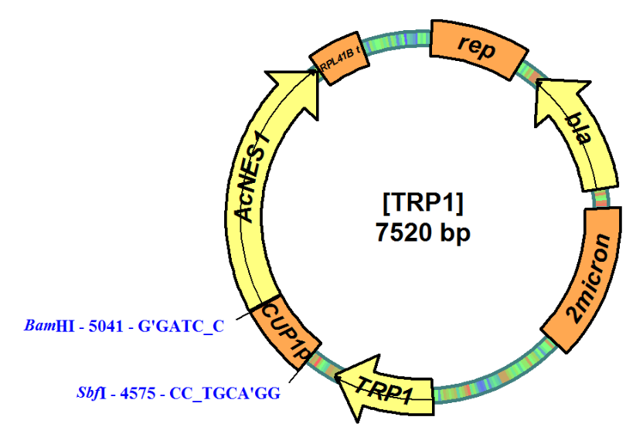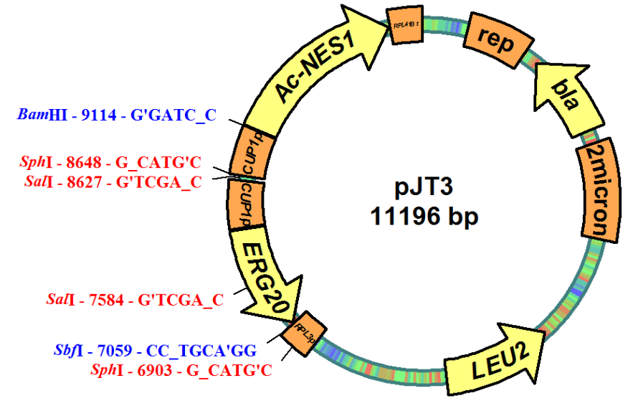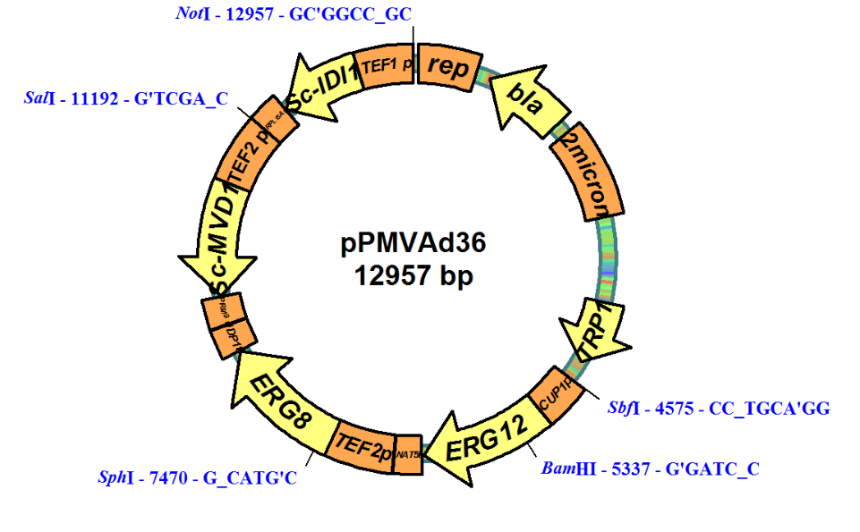
Confirmed by DNA sequencing
Plasmid rearrangement
1 2 M 3
Lane 1 & 2, digested TRP1 plasmids recovered from NC1D; Lane M, Thermo Scientific GeneRuler 1kb DNA Ladder (10000, 8000, 6000, 5000, 4000, 3500, 3000, 2500, 2000, 1500, 1000, 750, 500, 250 bp from top to bottom); Lane 3, digested pPMVAd36
Fig. S1 Plasmid rearrangement in the strain NC1D. Plasmid pPMVAd36 and [TRP1] from NC1D were digested by restriction enzymes NotI, SalI, SphI, BamHI and SbfI and gel figure was shown as the right-bottom figure.

Fig. S2 The growth profile of strain GH4 [CEN.PK113-5D derivative; ura3(1, 704 )::KlURA3] (1) on sucrose. The cells were pre-cultured on 40 g L⁻¹ glucose. Mean values from duplicate experiments are shown.

Fig. S3 Logic charts for fed-batch feeding scripts: (a) carbon-source-restricted/DO-triggered fed-batch cultivation; (b) carbon-source-overflowed/carbon-source-pulsing fed-batch cultivation. F_{s}, feeding flow storage value; DO_{t}, dissolved oxygen on-line value at time t; DO_{L}, lowest dissolved oxygen storage value; T1, storage time; t, on-line time; μ, specific rate of feeding flow increasement; N, agitatation speed; N_{max}, the maxium agitation speed; FV_{s}, feeding volume storage value; FV_{t}, feeding volume on-line value; V_{t}, culture volume on-line value.

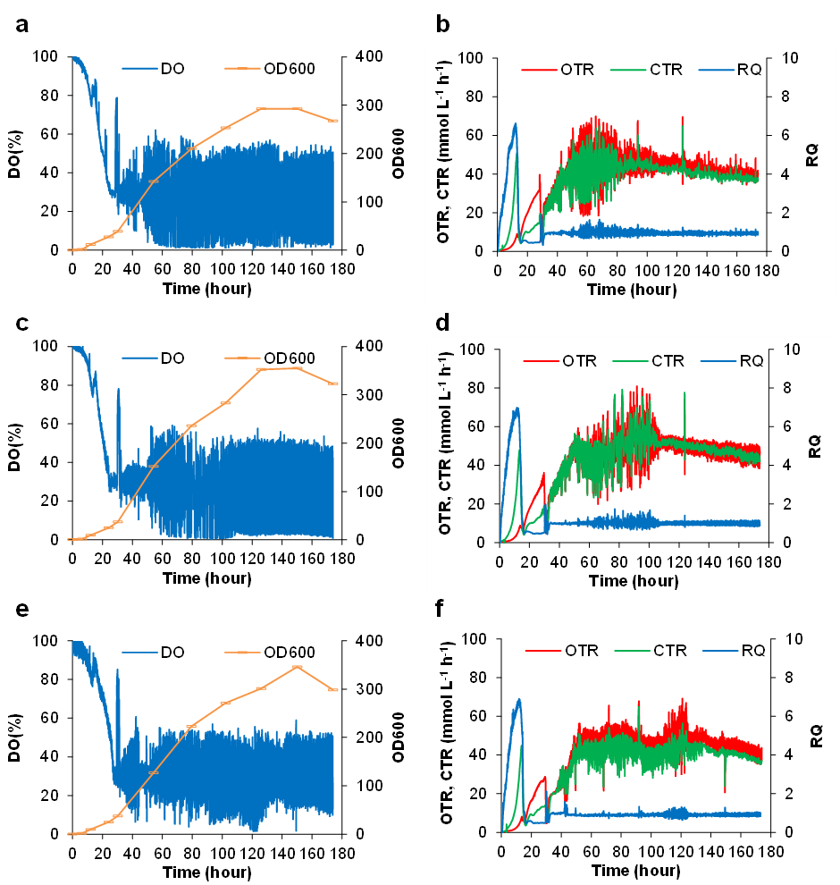
Fig. S4 Growth (OD600) and process values (Dissovled oxygen, DO; oxygen transfer rate, OTR; carbon transfer rate; CTR; respiration quotient, RQ) in fed-batch cultivation for strain N391DA, with feeding logics in Fig. S1a employed. (a&b), 600 g L⁻¹ glucose feeding; (c&d), 600 g L⁻¹ sucrose feeding; (e&f), 400 g L⁻¹ glucose and 158 g L⁻¹ ethanol feeding.

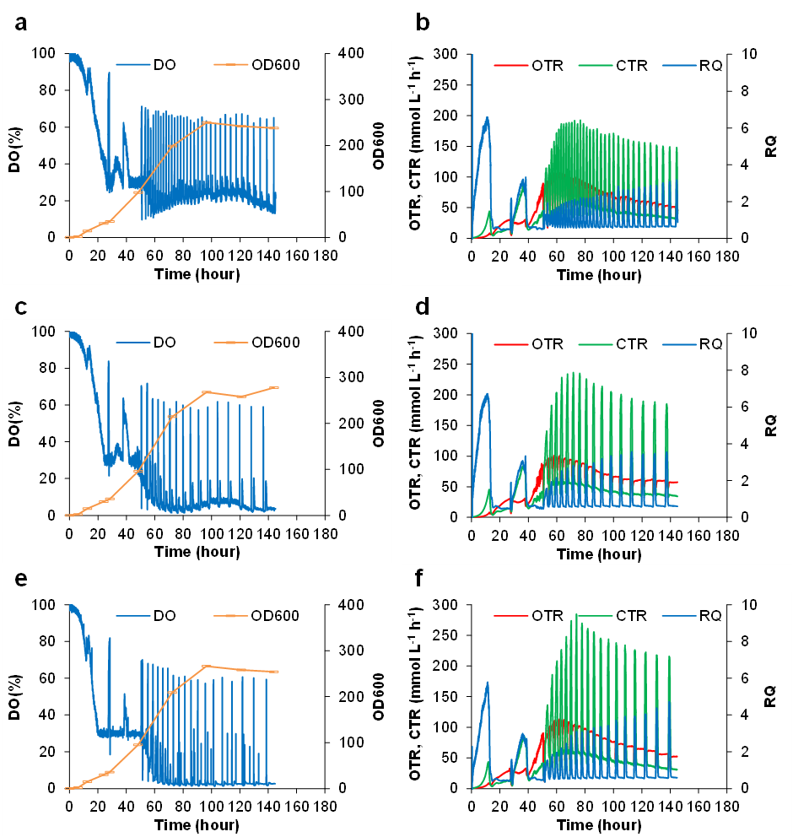
Fig. S5 Growth (OD600) and process values (Dissovled oxygen, DO; oxygen transfer rate, OTR; carbon transfer rate; CTR; respiration quotient, RQ) in fed-batch cultivation for strain N391DA, with feeding logics in Fig. S1b employed. (a&b), 600 g L⁻¹ glucose feeding with 10 g L⁻¹ glucose pulse; (c&d), 600 g L⁻¹ glucose feeding with 20 g L⁻¹ glucose pulse; (e&f), 600 g L⁻¹ sucrose feeding with 20 g L⁻¹ sucrose pulse.

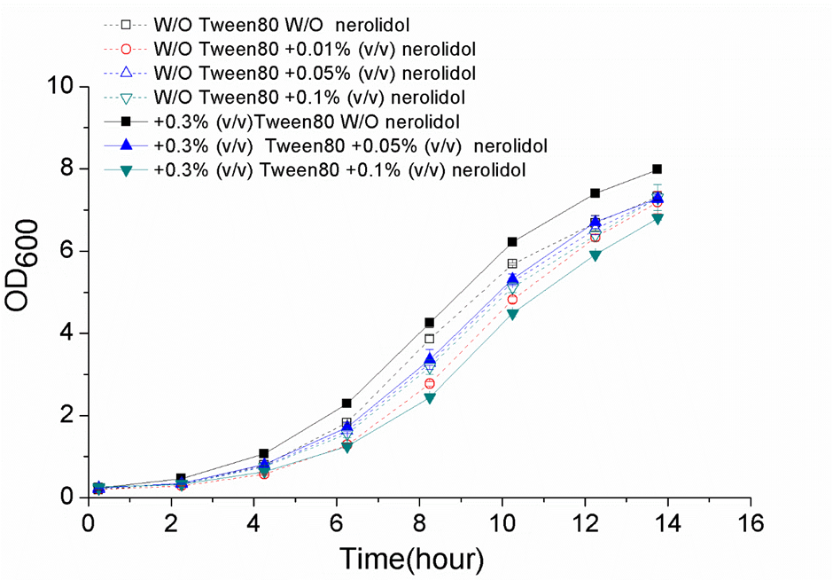
Fig. S6 The influence of nerolidol on yeast growth. Synthetic minimal medium was used, which contained 6.7 g L⁻¹ yeast nitrogen base (Sigma-Aldrich #Y0626; pH 6.0) and 20 g L⁻¹ glucose. Isomer-mixed nerolidol (Sigma-Aldrich #H59605) was used. Tween 80 was added to homogenize nerolidol into liquid medium. Mean values ± standard deviations are shown (N = 3).
Reference
1. Peng, B., Williams, T., Henry, M., Nielsen, L. and Vickers, C. (2015) Controlling heterologous gene expression in yeast cell factories on different carbon substrates and across the diauxic shift: a comparison of yeast promoter activities. Microbial cell factories, 14, 91.

