Supplementary figures

Figure S1: DSC analysis of a) NaOH, b) Na₂SO₃ and c) Na₂SO₄ (heating curve is blue)

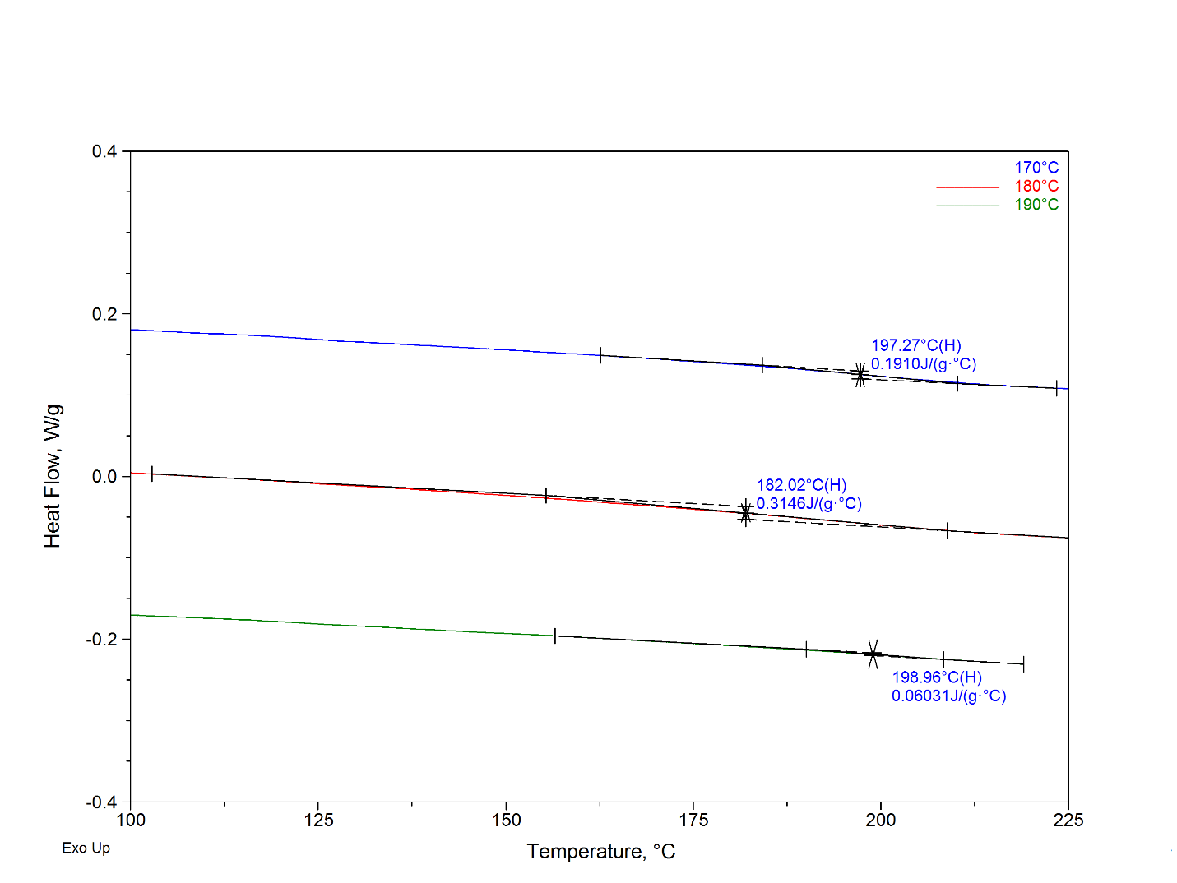
Figure S2: Heat flow of purified precipitates made from soda liquor

