Visual observation of the sporulation behavior of C. kluyveri

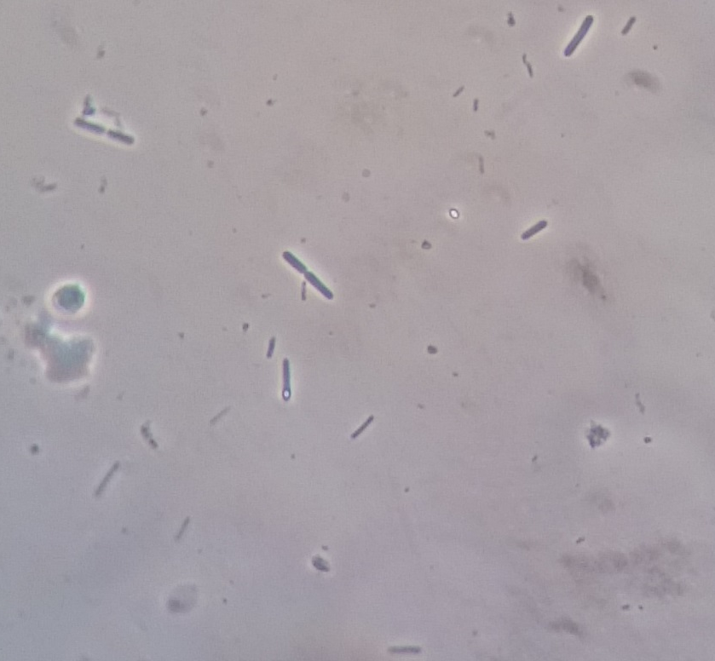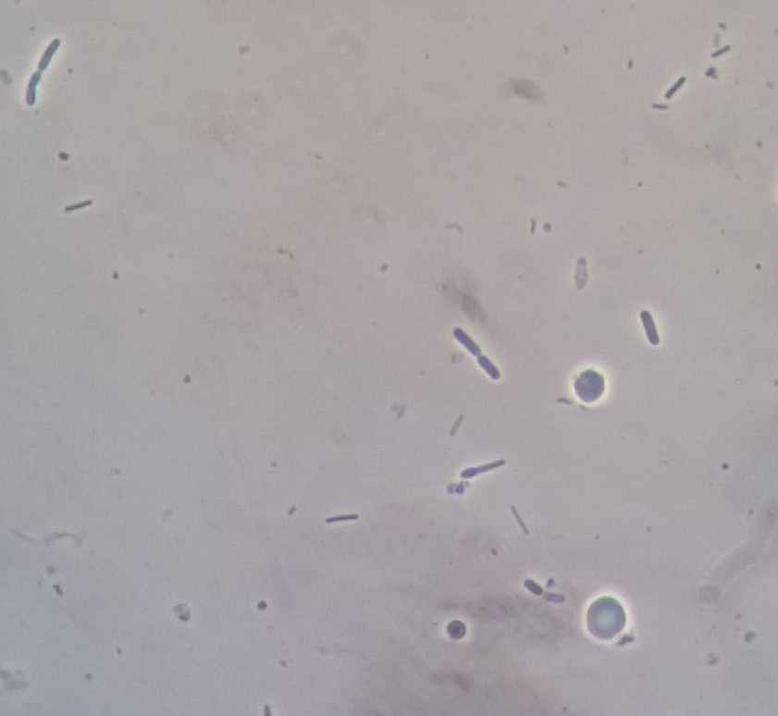
C. kluyveri, dividing cells
C. kluyveri, outgrowing spore
Outgrown spore, new cell
B
A
C. kluyveri, dividing cells
Spore formed inside cell
spore
Figure S2 - Light microscopy pictures of bioreactor BP (with pertraction) on day 64 to illustrate the different stages of sporulation of C. kluyveri. Photo A: Actively dividing cells; spore being formed inside a cell; free spore. Photo B: Actively dividing cells; outgrowing spore; new cell (from outgrown spore).

