SUPPLEMENTARY MATERIALS

Supplementary Tables

- Supplementary table 1 Primers used for gene specific amplification and quantitative real time PCR analysis of Acetyl-CoA carboxylase (accD) gene (Y=C/T, R=A/G, N=A/T/G/C, H=A/C/T, W=A/T, D=A/G/T)
- Supplementary tables 2 Relationship of accD gene of test organism as done by BLAST search results and the accession numbers:
- Supplementary table 3 ProtParam analysis for fetching the physicochemical parameters of predicted protein of Oscillatoria sp. (SP8).
- Supplementary table 4 Secondary structural features of SP8 protein.
- Supplementary table 5 ProtParam analysis for fetching the physicochemical parameters of predicted protein of Microcoleus sp. (SP18).
- Supplementary table 6 Secondary structural features of SP18 protein.

Supplementary table 1 Primers used for gene specific amplification and quantitative real time PCR analysis of Acetyl-CoA carboxylase (accD) gene (Y=C/T, R=A/G, N=A/T/G/C, H=A/C/T, W=A/T, D=A/G/T)
S. No. | Primers name | Purpose | Primer sequence-Forward/Reverse  (5’-3’) | Amplicon size (bp) | Melting Point (ºC)
1. | SP8-PCR | Standard PCR | F: ATGTCYYTRTTYGATTGGTT  R: CGNTCRAAACGRTACRAHCC | 950 | 58
2. | SP18-PCR | Standard PCR | F: ATGGCWAACAACGAAGARTC  R:GDATYTTNGCCATYTGCAT | 1150 | 56
3. | SP8-qPCR | Real Time PCR | F:AGTCCCGAACGAATTCAACAA  R:CACCAGAAGCACAGACAATA | 107 | 62
4. | SP18-qPCR | Real Time PCR | F:AGTCCCGAACGAATTCAACAA  R:CGCTATATTGCTTGCGGTCT | 109 | 62

Supplementary table 2 Relationship of accD gene of test organism as done by BLAST search results and the accession numbers:

Cyanobacterial Species | Gene | Accession No.
Oscillatoria sp.  (SP8) | beta subunit gene for acetyl- Co A carboxylase, Carboxyl transferase | LN606590
Microcoleus sp. (SP18) | beta subunit gene for acetyl- Co A carboxylase, Carboxyl transferase | LN606589

Supplementary table 3 ProtParam analysis for fetching the physicochemical parameters of predicted protein of Oscillatoria sp. (SP8).

Amino acid composition, frequency & percentage
S.No | ! | * | # | $
1 | Ala | (A) | 9 | 4.60%
2 | Arg | (R) | 13 | 6.70%
3 | Asn | (N) | 4 | 2.10%
4 | Asp | (D) | 12 | 6.20%
5 | Cys | (C) | 7 | 3.60%
6 | Gln | (Q) | 17 | 8.80%
7 | Glu | (E) | 12 | 6.20%
8 | Gly | (G) | 15 | 7.70%
9 | His | (H) | 2 | 1.00%
10 | Ile | (I) | 8 | 4.10%
11 | Leu | (L) | 18 | 9.30%
12 | Lys | (K) | 12 | 6.20%
13 | Met | (M) | 9 | 4.60%
14 | Phe | (F) | 4 | 2.10%
15 | Pro | (P) | 9 | 4.60%
16 | Ser | (S) | 13 | 6.70%
17 | Thr | (T) | 10 | 5.20%
18 | Trp | (W) | 3 | 1.50%
19 | Tyr | (Y) | 4 | 2.10%
20 | Val | (V) | 13 | 6.70%

! Amino acid three letter
* Amino acid single letter
# Frequency of particular amino acid
$ Percentage of particular amino acid

Supplementary table 4 Secondary structural features of SP8 protein.

Number of alpha and beta helices sheets |  | Start position | End position
alpha helices sheet | 1st | LYS 4 | GLN 16
 | 2nd | THR 37 | ASN 43
 | 3rd | SER 58 | GLN 64
 | 4th | ASP 88 | ASP 101
 | 5th | SER 137 | GLN 152
 | 6th | GLY 171 | SER 190

Supplementary table 5 ProtParam analysis for fetching the physicochemical parameters of predicted protein of Microcoleus sp.(SP18).

Amino acid composition, frequency & percentage
S.No | ! | * | # | $
1 | Ala | (A) | 8 | 5.30%
2 | Arg | (R) | 11 | 7.30%
3 | Asn | (N) | 2 | 1.30%
4 | Asp | (D) | 10 | 6.60%
5 | Cys | (C) | 4 | 2.60%
6 | Gln | (Q) | 11 | 7.30%
7 | Glu | (E) | 8 | 5.30%
8 | Gly | (G) | 15 | 9.90%
9 | His | (H) | 2 | 1.30%
10 | Ile | (I) | 7 | 4.60%
11 | Leu | (L) | 13 | 8.60%
12 | Lys | (K) | 9 | 6.00%
13 | Met | (M) | 9 | 6.00%
14 | Phe | (F) | 4 | 2.60%
15 | Pro | (P) | 10 | 6.60%
16 | Ser | (S) | 8 | 5.30%
17 | Thr | (T) | 6 | 4.00%
18 | Trp | (W) | 1 | 0.70%
19 | Tyr | (Y) | 2 | 1.30%
20 | Val | (V) | 11 | 7.30%

! Amino acid three letter
* Amino acid single letter
# Frequency of particular amino acid
$ Percentage of particular amino acid
Supplementary table 6 Secondary structural features of SP18 protein.

Number of alpha and beta helices sheets |  | start position | end position
alpha helices sheet | 1st | SER 14 | LEU 21
 | 2nd | ARG 45 | LYS 58
 | 3rd | SER 93 | LYS 109
 | 4th | MET 128 | ARG 146
beta helices sheet | 1st | VAL 65 | GLY 68
 | 2nd | GLY 70 | LEU 72
 | 3rd | LEU 75 | MET 82
 | 4th | VAL 113 | VAL 116

Supplementary Figures

- Supplementary Fig. 1 Amplification of accD gene in SP8 and SP18.
- Supplementary Fig. 2 3D protein structure of Oscillatoria sp. (SP8).
- Supplementary Fig. 3 3D protein structure of Microcoleus sp.(SP18).

Supplementary Fig.1 Amplification of accD gene.

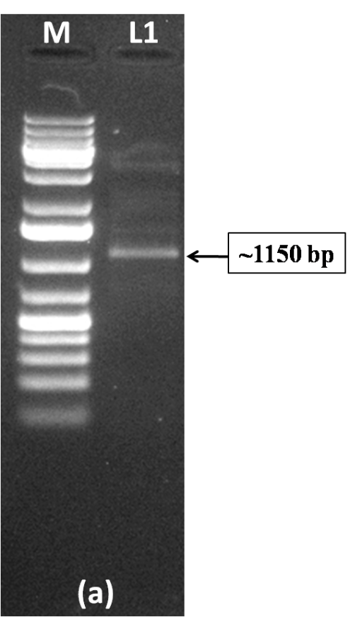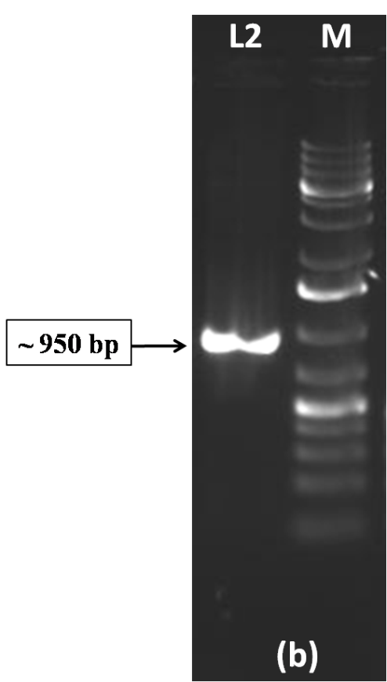

Supplementary Fig. 2 3D protein structure of Oscillatoria sp. (SP8).
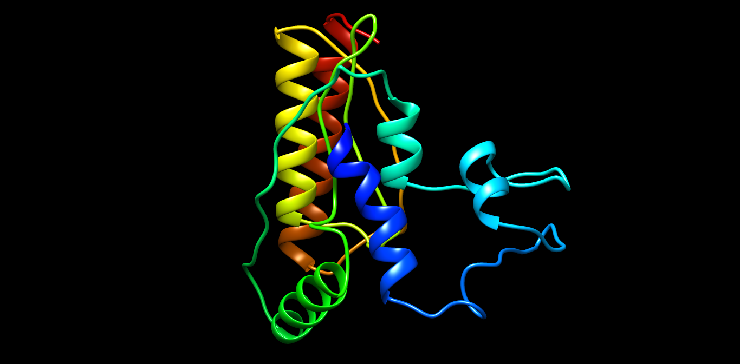

Supplementary Fig. 3 3D protein structure of Microcoleus sp. (SP18).
