ESI to Biotechnology for Biofuels

Bioprocessing of tea oil fruit hull with acetic acid organosolv pretreatment in combination with alkaline H₂O₂
Song Tang ^{1,2}, Rukuan Liu ³, Fubao Fuelbiol Sun ^{1*}, Chunying Dong ³, Rui Wang ³, Zhongyuan Gao ^{1,4}, Zhanying Zhang ⁵, Zhihong Xiao ³, Changzhu Li ³ and Hui Li ^{3*}
¹ Key Laboratory of Carbohydrate Chemistry and Biotechnology, Ministry of Education, School of Biotechnology, Jiangnan University, Wuxi 214122, China.
² State Key Laboratory of Pulp and Paper Engineering, South China University of Technology, Guangzhou 510640, China.
³ National Engineering Research Center for Oil-tea Camellia, Hunan Academy of Forestry, Changsha 410004, China.
⁴ Key Laboratory of Advanced Textile Materials and Manufacturing Technology, Ministry of Education, Zhejiang Sci-Tech University, Hangzhou 310018, China.
⁵ Centre for Tropical Crops and Biocommodities, Queensland University of Technology, Brisbane, QLD 4001, Australia.
*Corresponding Author
Fubao Fuelbiol Sun (FFS)
Key Laboratory of Carbohydrate Chemistry and Biotechnology, School of Biotechnology, Jiangnan University, Wuxi 214122, China; fubaosun@jiangnan.edu.cn ;
Hui Li (HL)
Hunan Academy of Forestry, Changsha 410004, China
Email: lihuiluoyang@163.com
Co-authors:
Song Tang (ST), tangsongfuelbiol@163.com
Rukuan Liu (RL), liurukuan@gmail.com
Chunying Dong (CD), 1219921705@qq.com
Rui Wang (RW), gjyoucha@163.com
Zhongyuan Gao (ZG), 490509257@qq.com
Zhanying Zhang (ZZ), jan.zhang@qut.edu.au
Zhihong Xiao (ZX), xzhh1015@163.com
Changzhu Li (CL), lichangzhu2013@aliyun.com

Table title and legend
- PBD experimental design of the AAO pretreatment.
- Analysis of PBD design on optimization of each variables.
- Experimental range and levels of independent variables.
- Full factorial CCD matrix of three variables in coded units and the experimentally observed response.
- ANOVA results for the quadratic equation for the delignification.
- Model coefficient estimated by multiple linear regression for the delignification.
- Crystalline of the lignocellulosic biomass before and after the two-stage pretreatment.

Tab. S1 PBD experimental design of the AAO pretreatment
Variables | Symbol | Code levels
Variables | Symbol | Lower (-1) | Higher (+1)
Time (h) | X₁ | 0.5 | 2
Acetic acid concentrations (%, v/v) | X₂ | 20 | 60
H₂SO₄ addition (%, w/v) | X₃ | 0.2 | 0.7
Pretreatment temperature (°C) | X₄ | 115 | 135

Tab. S2 Analysis of PBD design on optimization of each variables
Factors | Cellulose retention |  | Hemicellulose retention |  | Delignification |  | Pretreatment yield
Factors | T | P | T | P | T | P | T | P
X₁ | 1.3 | 0.098 | -21.1 | 0.006 | 8.9 | 0.034 | -14.7 | 0.003
X₂ | 1.2 | 0.121 | -13.3 | 0.043 | 14.2 | 0.004 | -10.5 | 0.015
X₃ | 1.5 | 0.063 | -16.0 | 0.021 | 9.5 | 0.027 | -11.2 | 0.011
X₄ | -0.2 | 0.810 | -11.4 | 0.072 | 4.9 | 0.189 | -8.0 | 0.044
Significance of the model | 91.7 | 0.103 | 59.2 | 0.008 | 31.0 | 0.008 | 65.1 | 0.003
Significance of the model | No significance |  | Significance |  | Significance |  | Significance
T, P and F means coefficient estimate, prob and response significance, respectively
Tab. S3 Experimental rang and levels of independent variables
Variables | Symbol | Code levels
Variables | Symbol | -1 | 0 | 1
Time (h) | X₁ | 1.4 | 1.6 | 1.8
Acetic acid concentrations (%, v/v) | X₂ | 45 | 50 | 55
H₂SO₄ addition (%, w/v) | X₃ | 0.51 | 0.58 | 0.64

Tab. S4 Full factorial CCD matrix of three variables in coded units and the experimentally observed response
Run | X₁ | X₂ | X₃ | Delignification (%)
1 | 1.9 | 50.0 | 0.58 | 64.5
2 | 1.6 | 50.0 | 0.58 | 64.0
3 | 1.6 | 41.6 | 0.58 | 50.4
4 | 1.8 | 55.0 | 0.51 | 64.8
5 | 1.8 | 55.0 | 0.64 | 68.7
6 | 1.6 | 50.0 | 0.58 | 65.4
7 | 1.8 | 45.0 | 0.64 | 65.0
8 | 1.4 | 55.0 | 0.51 | 50.2
9 | 1.6 | 50.0 | 0.58 | 65.5
10 | 1.6 | 50.0 | 0.58 | 66.1
11 | 1.8 | 45.0 | 0.51 | 54.0
12 | 1.6 | 50.0 | 0.58 | 63.2
13 | 1.6 | 50.0 | 0.47 | 48.7
14 | 1.4 | 45.0 | 0.64 | 58.9
15 | 1.4 | 45.0 | 0.51 | 41.6
16 | 1.6 | 50.0 | 0.68 | 69.1
17 | 1.4 | 55.0 | 0.64 | 61.7
18 | 1.6 | 50.0 | 0.58 | 65.5
19 | 1.6 | 58.4 | 0.58 | 65.3
20 | 1.3 | 50.0 | 0.58 | 48.7

Tab. S5 ANOVA results for the quadratic equation for the delignification
 | Sum of squares | Freedom degrees | Mean square | F-value | P
Model | 1217.73 | 9 | 135.30 | 96.21 | < 0.0001
Residual(error) | 14.06 | 10 | 1.41 | Not clear | Not clear
Lack of fit | 8.24 | 5 | 1.65 | 1.41 | 0.3566 > 0.1
Pure error | 5.83 | 5 | 1.17 | Not clear | Not clear
Total | 1231.79 | 19 | Not clear | Not clear | Not clear
R²=0.989; CV=1.97%; Adj R²=0.978; Pred R²=0.942; Adeq Precision=34.196
Tab. S6 Model coefficient estimated by multiple linear regression for the delignification
Term | Coefficient | F-value | P
Intercept | 64.91 | No clear | No clear
X₁ | 4.88 | 231.53 | < 0.0001
X₂ | 3.74 | 135.54 | < 0.0001
X₃ | 5.72 | 317.60 | < 0.0001
X₁X₂ | 0.40 | 0.91 | 0.3631
X₁X₃ | -1.74 | 17.27 | 0.002
X₂X₃ | -1.62 | 14.87 | 0.0032
X₁² | -2.79 | 79.84 | < 0.0001
X₂² | -2.34 | 56.28 | < 0.0001
X₃² | -1.98 | 40.34 | < 0.0001

Tab. S7 Crystalline of the lignocellulose before and after the two-stage pretreatment
Intensity | Crystal size (002) |  | Crystalline (%)
Intensity | 2θ (°) | Size (nm) | Crystalline (%)
The original | 21.1 | 1.5 | 21.3
AAO pretreated | 21.8 | 1.9 | 41.3
AAO-AHP pretreated | 21.9 | 3.8 | 52.1

Figure title and legend
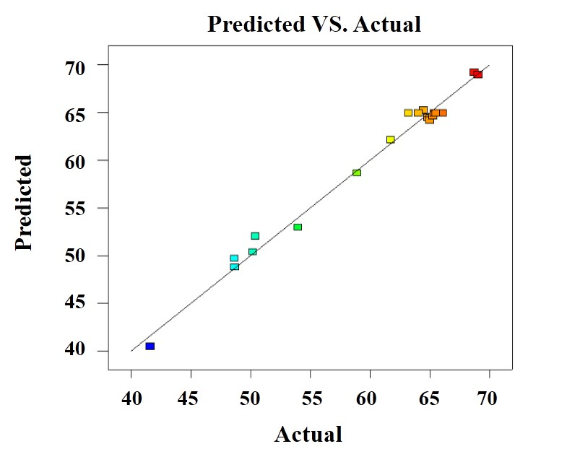
Figure S1 Predicted values versus experimental values of CCD on the delignification (R²= 0.978).

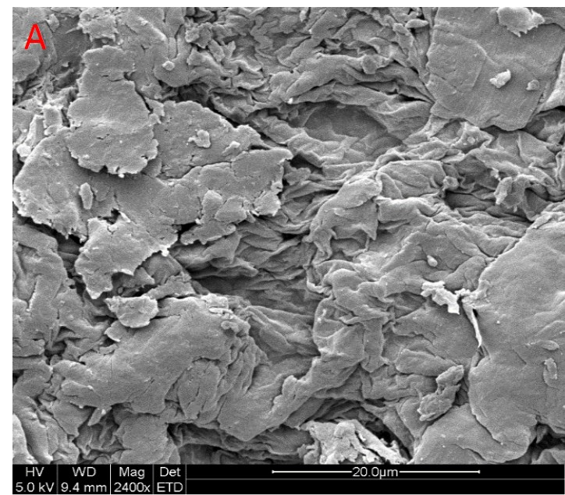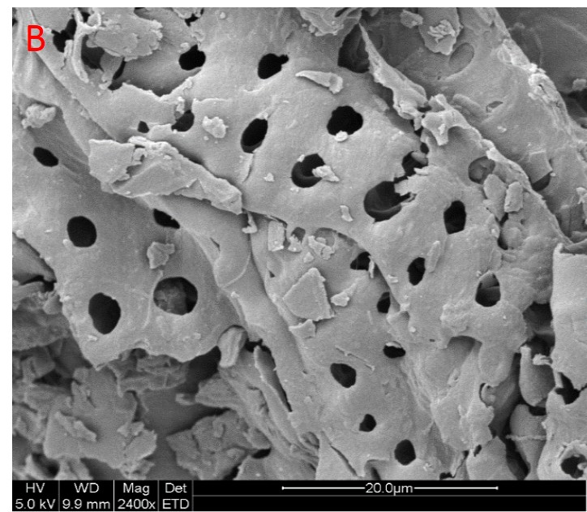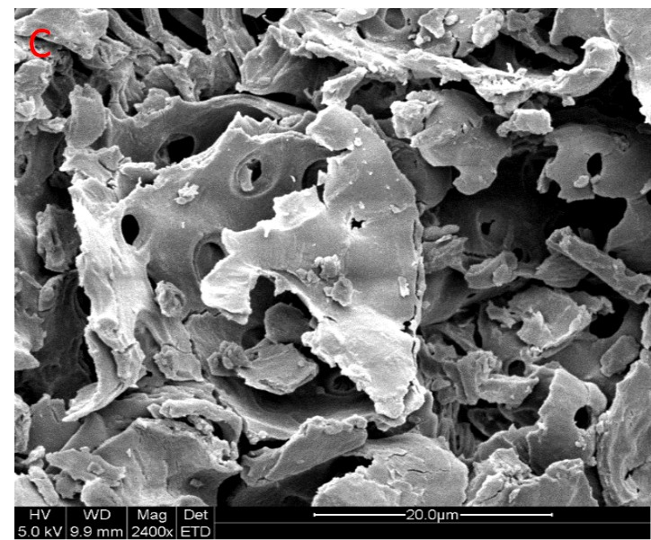

Figure S2 SEM images of material before and after the AAO and AAO-AHP pretreatment. A, B and C means the original, AAO pretreated and AAO-AHP pretreated substance, respectively.

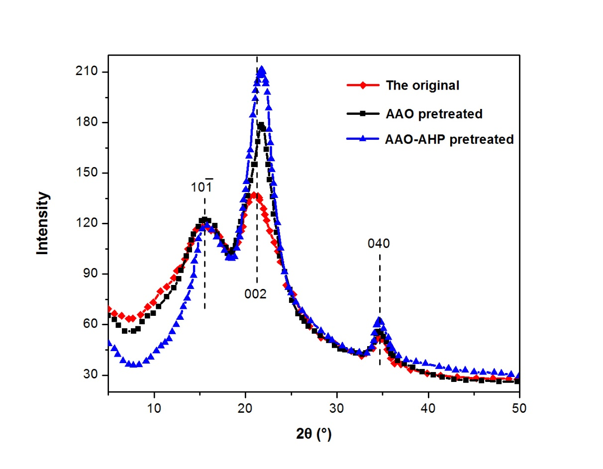
Figure S3 X-ray diffraction patterns of the substance before and after the AAO and AAO-AHP pretreatment.

