Improving Saccharomyces cerevisiae ethanol production and tolerance via RNA Polymerase II subunit Rpb7
Zilong Qiu, Rongrong Jiang*

PDC activity assay
Cell extract was prepared by ultrasonication with 0.6 mm diameter glass beads at 0°C for 2 min with an ultrasonic processor (UP200S, Hielscher, Germany) following Flikweert’s approach (Flikweert et al., 1996). Pyruvate decarboxylase activity was assayed at 25 °C by monitoring the rate of the pyruvic-acid-dependent oxidation of NADH (340 nm), with ADH as a coupling enzyme using a Shimadzu UV-1800 spectrometer (Shimadzu Inc., Kyoto, Japan). The assay mixture (1 mL) consisted of: 40 mM pH 6.5 imidazole-HCI buffer, 0.15 mM NADH, 0.2 mM-thiamine pyrophosphate, alcohol dehydrogenase 88 U mL⁻¹ (Sigma Aldrich, St. Louis, MO, USA), 5 mM MgCl, and cell free extract. The reaction was initiated by the addition of 50 mM pyruvate. Enzyme activity was normalized by total protein concentration measured by Braford assay.

Flikweert MT, Van Der Zanden L, Janssen WM, Steensma HY, Van Dijken JP, Pronk JT. Pyruvate decarboxylase: an indispensable enzyme for growth of Saccharomyces cerevisiae on glucose. Yeast. 1996; 12: 247-57.

Table S1 Primers used in plasmid construction and error-prone PCR
Primer | Sequence
1 | GCAGGCGGATCCCTCAATTTCTGAGAATGTT
2 | GCGCCGGAATTCCAAGTGAT TAAATAGCACC
3 | C GAGCTC CGGGGTTCTTCGGGCCAAATGAA
4 | C GGATCC TCTCAGAAATTGAGTTATTTATA
5 | CCGTTTCTCCTCCTACACCATTCT
6 | GGACCTAGACTTCAGGTTGTCTAA

Table S2 Primers used in qRT-PCR
Primer | Sequence
URA3-F | GTGGTGGGCCCAGGTATTGTTA
URA3-R | CACCGGGTGTCATAATCAACCA
URA1-F | CCATGGGTTTACCAAACGAAGG
URA1-R | ACTTGTGGTTTCCCAGGCACAT
URA2-F | TGGGAGGTTTAGGTTCCGGTTT
URA2-R | AGATGGGGCTACAACGATGGAA
RND18-F | TTAATGACCCACTCGGCACCTT
RND18-R | GGTGAGTTTCCCCGTGTTGAGT
FBA1-F | GCCGCTATGGACCAATGGTTAG
FBA1-R | GCGATGTCACCAGCGTACAAAC
MDH2-F | CGGTGGTGATGAAGTGGTCAAG
MDH2-R | TGGGGAAGTTGTTCGCATCTTT
TDH3-F | CAGCTAACTTGCCATGGGGTTC
TDH3-R | ATGGAGCCAAACAGTTGGTGGT
ITR1-F | TAAACCCGTGAACGACGAGGAT
ITR1-R | GGTAGCCGCAGTGACAATTTCC
ENO2-F | CCTTCGCTGAAGCCATGAGAAT
ENO2-R | TCGTGACCAGCAGCCTTGATAG
PDC1-F | AAGGAAGCCGTTGAATCTGCTG
PDC1-R | TGGGACAGCAACTGGCTTGTAA
PDC5-F | CGCTCCAGCTGAAATTGACAGA
PDC5-R | GAAGCACAAGCATCAGCCAAGA
ERG20-F | GGTTGGTGCATTGAGTTGTTGC
ERG20-R | GGTTTGGAAGGTGACCTCATGG
FEN1-F | TGTTCGAGCGTTATCCCCAAC
FEN1-R | AGGGGGCAAAGTGCTTAATGG

Table S3 Comparison between DNA microarray and qRT-PCR results on selected genes from M1 after 12h VHG fermentation.
Gene Symbol | DNA Microarray |  | qRT-PCR
 | Log2 fold change | p-value | Log2 fold change | p-value
URA3 | +13.15578449 | 6.93E-04 | +10.479 | 0.0049
PDC5 | +3.629911 | 0.016687 | +1.826 | 0.000153988
ENO2 | +2.05134 | 0.001484 | +0.898 | 0.04774966
ERG20 | +1.010312659 | 5.78E-04 | +3.976 | 0.03387
FEN1 | +1.163127384 | 0.006871 | +0.801 | 0.045055
ITR1 | +1.048042232 | 4.46E-05 | +0.685 | 0.011993
PDC1 | +2.143487 | 0.047585 | +2.483 | 6.54026E-05
TDH3 | +2.108383 | 0.009277 | +2.033 | 0.015969
MDH2 | -1.240953431 | 0.004 | -1.682 | 0.06595
URA1 | -2.439799814 | 0.001739 | -2.133 | 0.007919
URA2 | -2.467311386 | 0.001129741 | -3.02 | 0.00598
FBA1 | +2.045623 | 0.020591116 | +1.011 | 0.005983

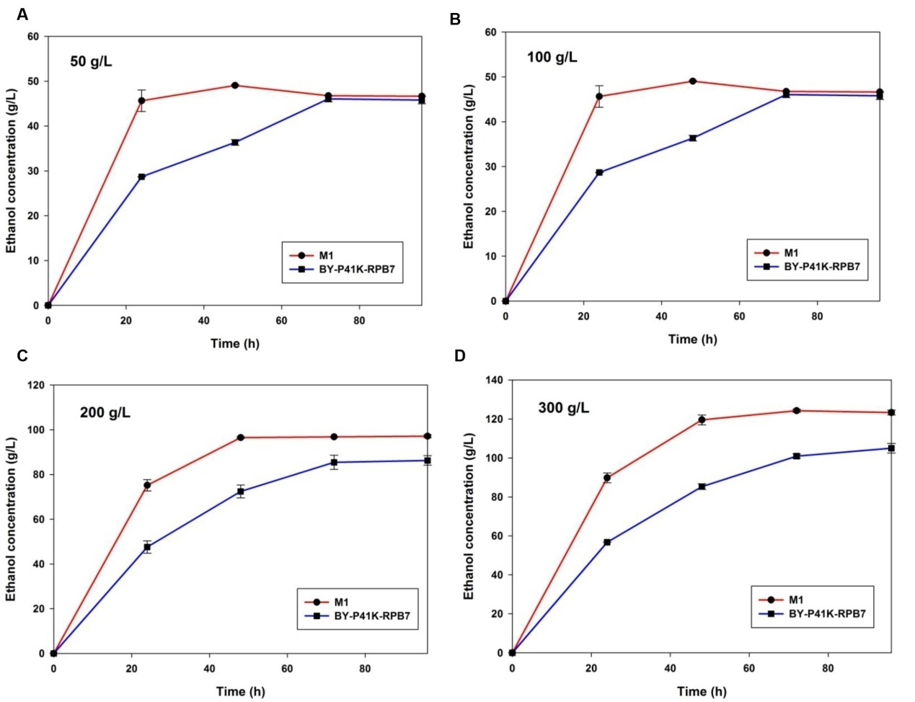
Figure S1 Ethanol profile with varying initial glucose supply under VHG fermentation (A) 50 g/L glucose; (B) 100 g/L glucose; (C) 200 g/L glucose; (D) 300 g/L glucose.
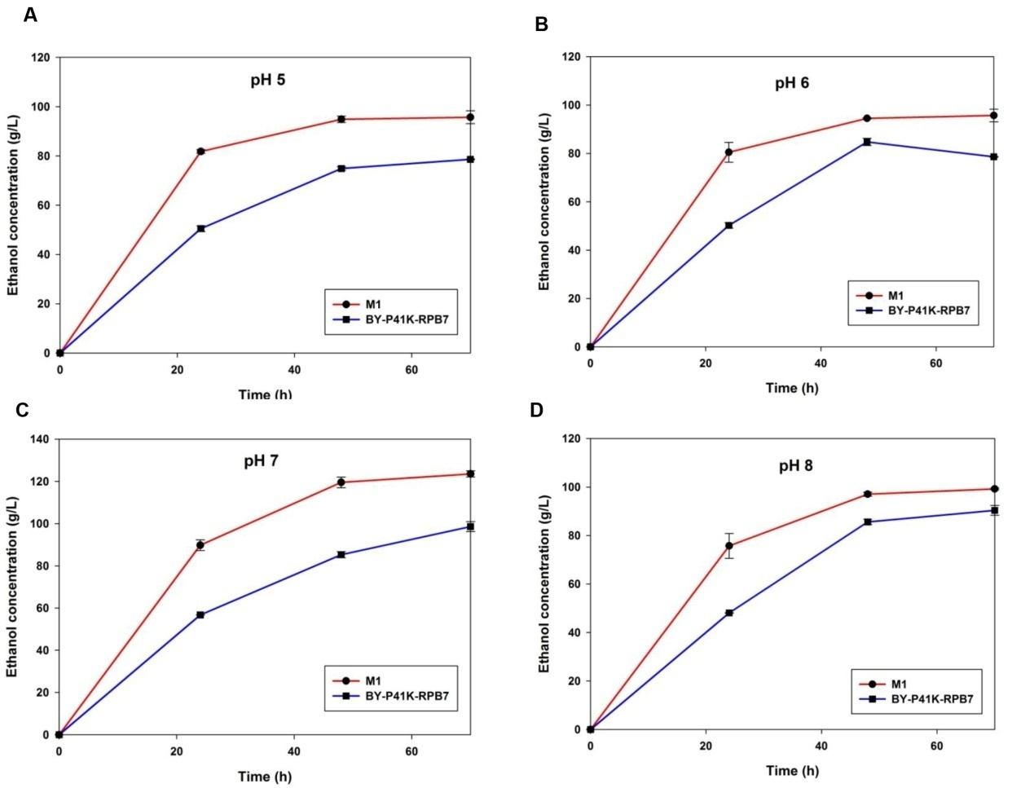
Figure S2 Ethanol profile with varying initial pH under VHG fermentation. (A) pH 5; (B) pH 6; (C) pH 7; (D) pH 8.

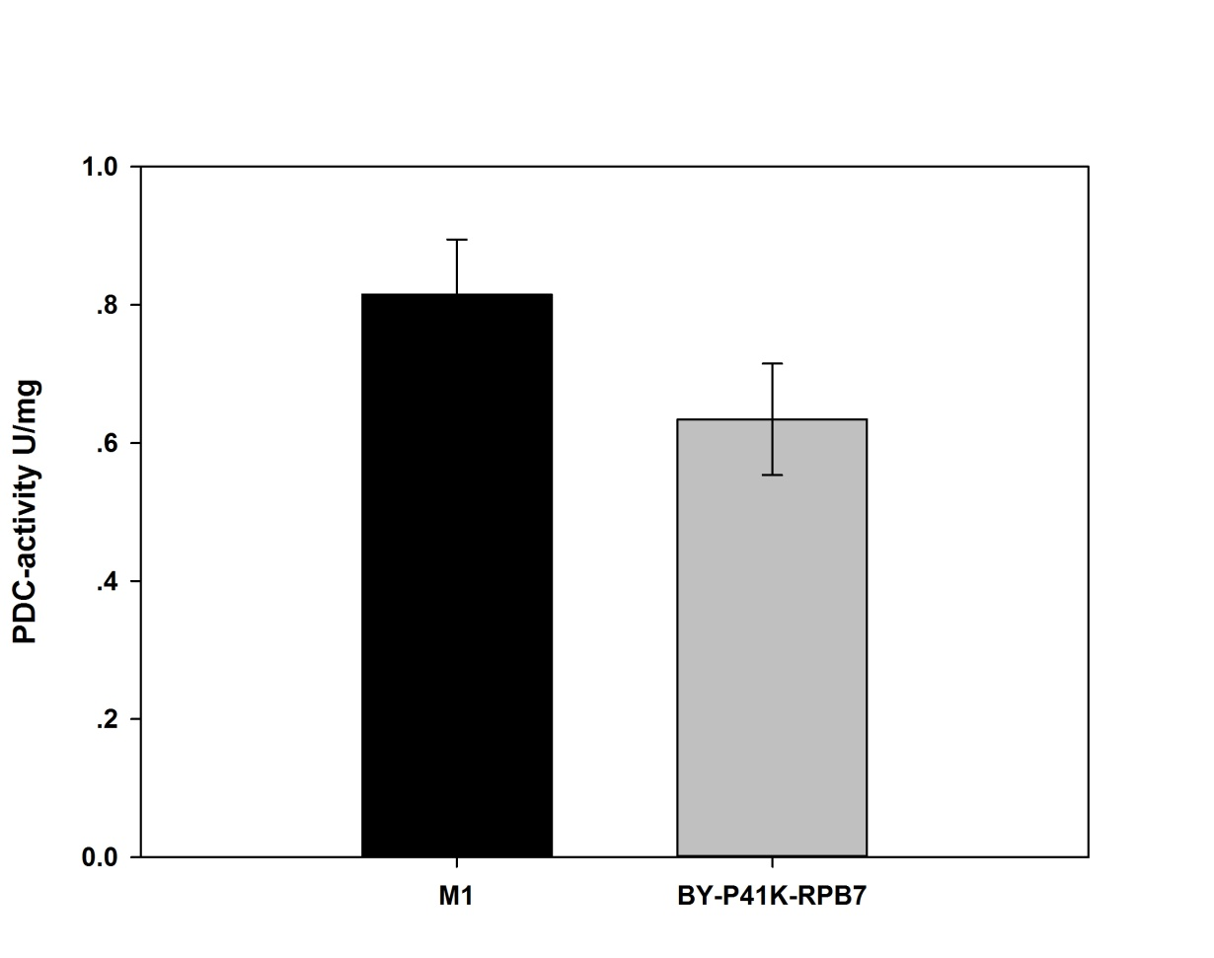
Figure S3 PDC activity in M1 and the control after 12h VHG fermentation.

