Supplementary Information

Dynamics of two methanogenic microbiomes incubated in polycyclic aromatic hydrocarbons, naphthenic acids, and oil field produced water
Bonahis J. Oko, Yu Tao, David C. Stuckey*
Department of Chemical Engineering, Imperial College London, South Kensington Campus, SW7 2AZ London, the UK

*Corresponding author: David C. Stuckey
E-mail: d.stuckey@imperial.ac.uk;
Tel: +44 207 5945591

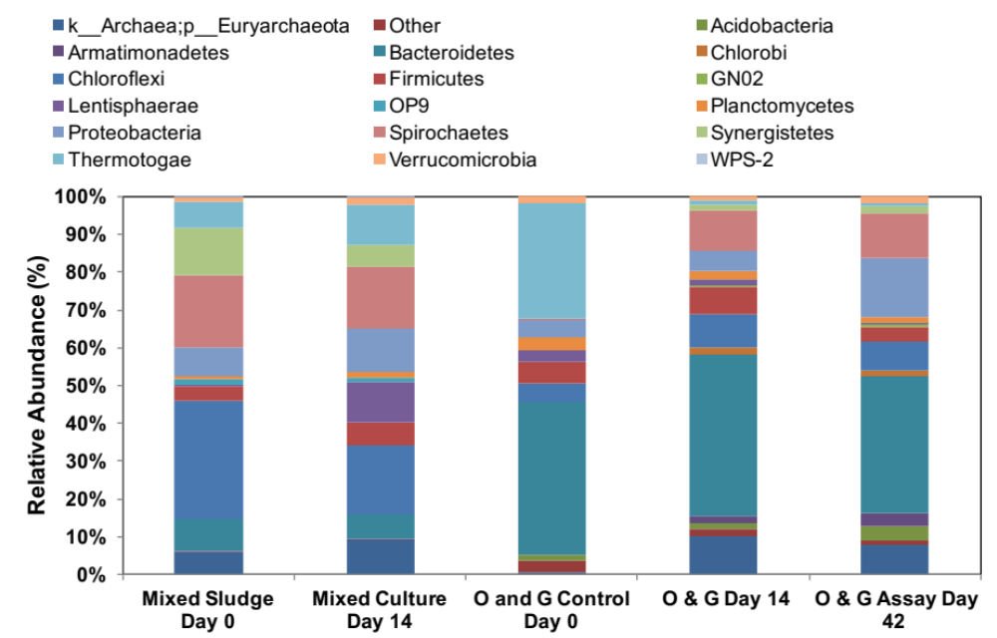
Fig. S1

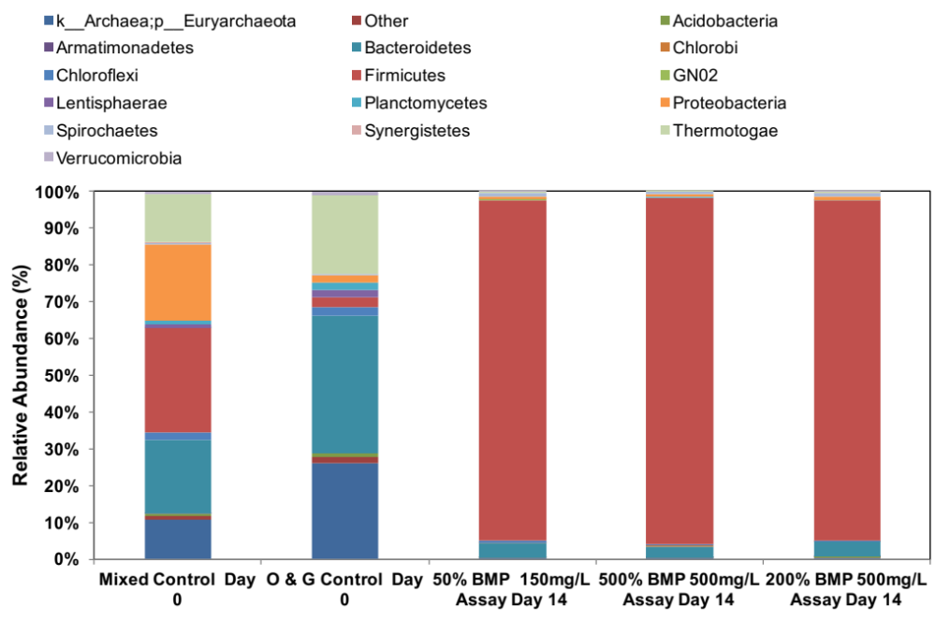
Fig. S2

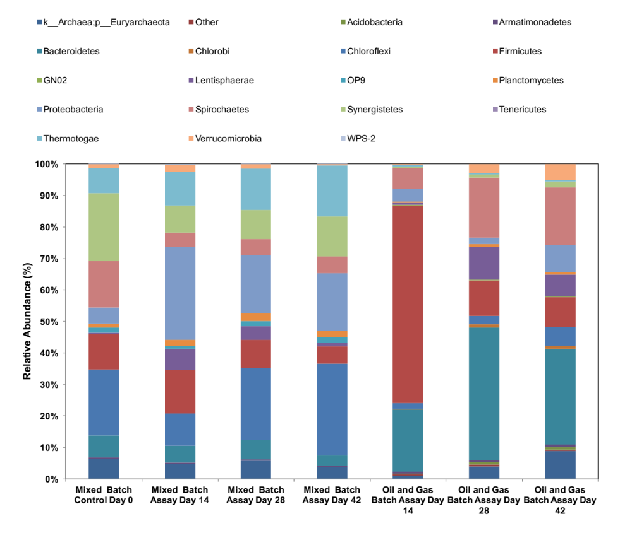
Fig. S3

