Stimulation and inhibition of enzymatic hydrolysis by organosolv lignins as determined by zeta potential and hydrophobicity
Yang Huang¹, Shaolong Sun², Chen Huang¹, Qiang Yong^{1,*}, Thomas Elder³, Maobing Tu^{2,*}

¹College of Chemical Engineering, Nanjing Forestry University, Nanjing 210037, China
²Department of Biomedical, Chemical and Environmental Engineering, University of Cincinnati, 2901 Woodside Drive, Cincinnati, Ohio, 45221, United States.
³USDA-Forest Service, Southern Research Station, 521 Devall Drive, Auburn, Alabama 36849, United States

* Corresponding author
Email address: tumg@uc.edu or swhx@njfu.com.cn
Tel: +1 513 556 2259; or +86 25 85427702

Table S1: Assignments of ¹³C-¹H cross-signals in 2D-HSQC NMR spectra of EOL lignins
Figure S1: Effect of different concentration of added lignin on enzymatic hydrolysis of Avicel
Figure S2: SEM images of EOL lignins
Figure S3: Particle size distribution of EOL lignins
Figure S4: Main structures of EOL lignins: (A) β-aryl-ether units (β-O-4); (B) resinol substructures (β-β); (C) phenylcoumaran substructures (β-5); (G) guaiacyl units; (S) syringyl units; (S′) oxidized syringyl units bearing a carbonyl at C_{α}; (PB) p-Hydroxybenzoate units.

Table S1 Assignments of ¹³C-¹H cross-signals in HSQC spectra of EOL lignins
Lables | δ_{C}/δ_{H} (ppm) | Assignments
C_{β} | 53.0/3.45 | C_{β}−H_{β} in phenylcoumaran substructures (C)
B_{β} | 53.5/3.04 | C_{β}−H_{β}in β-β (resinol) substructures (B)
−OCH₃ | 55.7/3.73 | C−H in methoxyls
A_{γ} | 59.8/3.60 | C_{γ}−H_{γ} in β-O-4 substructures (A)
C_{γ} | 62.7/3.71 | C_{γ}−H_{γ}in phenylcoumaran substructures (C)
A′_{α}-OEt | 63.7/3.33 | C−H in α-OEtβ-O-4′ substructures (A′)
B_{γ} | 71.2/3.82−4.18 | C_{γ}−H_{γ}in β-βresinol substructures (B)
A_{α} | 71.9/4.88 | C_{α}−H_{α} in β-O-4 substructures (A)
E_{α} | 78.3/5.57 | C_{α}−H_{α} in α,-β-diaryl ethers (E)
A′_{α} | 79.9/4.50 | C_{α}−H_{α} in α-ethoxylated β-O-4 substructures (A′)
A_{β(G)} | 83.3/4.29 | C_{β}−H_{β} in β-O-4 linked to G unit (A)
A′_{β(G)} | 82.2/4.39 | C_{β}−H_{β} in β-O-4 linked to G unit (A′)
B_{α} | 85.1/4.65 | C_{α}−H_{α} in β-β resinol substructures (B)
A_{β(S)} | 86.1/4.14 | C_{β}−H_{β}in β-O-4 linked to a S unit (A)
A′_{β(S)} | 84.7/4.20 | C_{β}−H_{β}in β-O-4 linked to a S unit (A′)
C_{α} | 87.2/5.48 | C_{α}−H_{α}in phenylcoumaran substructures (C)
S_{2,6} | 103.7/6.68 | C_{2,6}−H_{2, 6} in syringyl units (S)
S′_{2,6} | 106.5/7.33 | C_{2,6}−H_{2,6} in oxidized S units (S′)
G₂ | 111.4/6.95 | C₂−H₂ in guaiacyl units (G)
G₅ | 115.0/6.75 | C₅−H₅ in guaiacyl units (G)
G₆ | 119.9/6.85 | C₆−H₆ in guaiacyl units (G)
PB_{2,6} | 131.3/7.62 | C_{2,6}−H_{2, 6} in p-hydroxybenzoate substructures (PB)

Fig.S1 Effect of different concentration of added lignin on enzymatic hydrolysis of Avicel

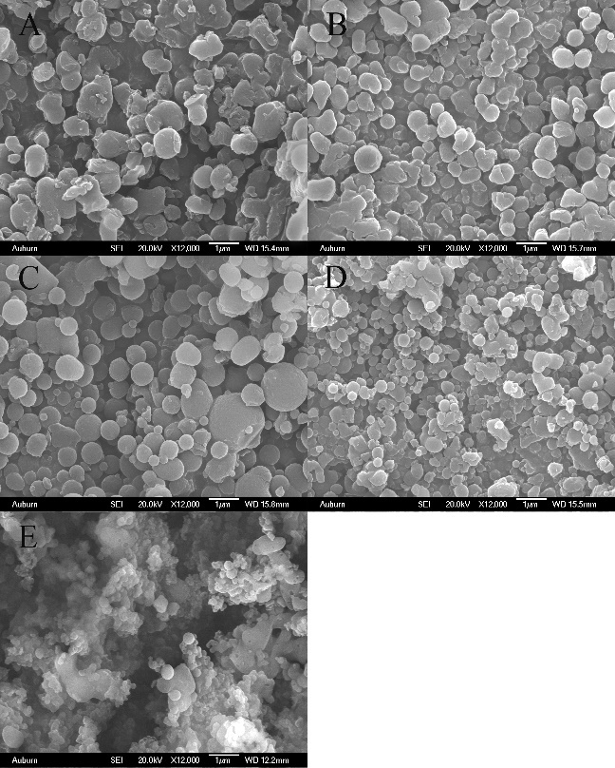

Fig.S2 Scanning electron microscopy (SEM) images of EOL lignins. Lignin preparations were obtained from organosolv pretreated aspen (A), black willow (B), cottonwood (C), eucalyptus (D) and loblolly pine (E).

A | B
C | D
E
Fig.S3 Particle size distribution of isolated lignins. Lignin preparations were obtained from organosolv pretreated aspen (A), black willow (B), cottonwood (C), eucalyptus (D) and loblolly pine (E).

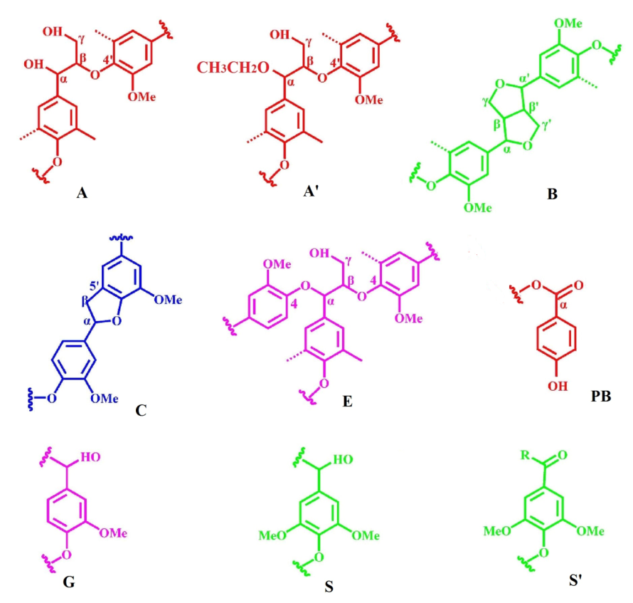
Fig.S4 Main structures in the organosolv lignins: (A) β-aryl-ether units (β-O-4); (B) resinol substructures (β-β); (C) phenylcoumaran substructures (β-5); (G) guaiacyl units; (S) syringyl units; (S′) oxidized syringyl units bearing a carbonyl at C_{α}; (PB) p-Hydroxybenzoate units.

