Supplementary information

Highly efficient methane generation from untreated microalgae biomass

Viktor Klassen¹, Olga Blifernez-Klassen¹, Daniel Wibberg¹, Anika Winkler¹, Jörn Kalinowski¹, Clemens Posten², Olaf Kruse¹*

¹ Bielefeld University, Department of Biology/Center for Biotechnology (CeBiTec), Universitätsstrasse 27, 33615 Bielefeld, Germany
² University of Karlsruhe, Institute of Life Science Engineering (KIT), Bioprocess Engineering, Fritz-Haber-Weg 2, 76131 Karlsruhe, Germany

Corresponding author: olaf.kruse@uni-bielefeld.de, Tel: +49-(0)521-106-12258, Fax: +49-(0)521-106-12290

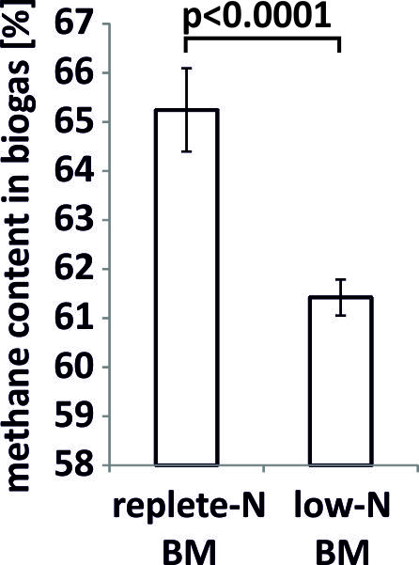
Figure S1: Methane concentration in the biogas, produced during the fermentation of replete-N and low-N algae biomass (replete-N BM and low-N BM, respectlively). Statistics: two-sample t-test with 95% confidence interval.

Figure S2: Concentration of total carbon and nitrogen during the experimental time course in replete-N BM digester (A) and low-N BM digester (B). Concentration of total organic and inorganic carbon (TOC and TIC) is shown for replete-N BM digester (C) and low-N BM digester (D). Measurements were performed in three replicates; error bars represent standard deviation (SD).

Figure S3: Concentration of volatile and total solids (VS and TS, respectively) during the experimental time course in replete-N BM digester (A) and low-N BM digester (B). Measurements were performed in at least three replicates; error bars represent standard deviation (SD).

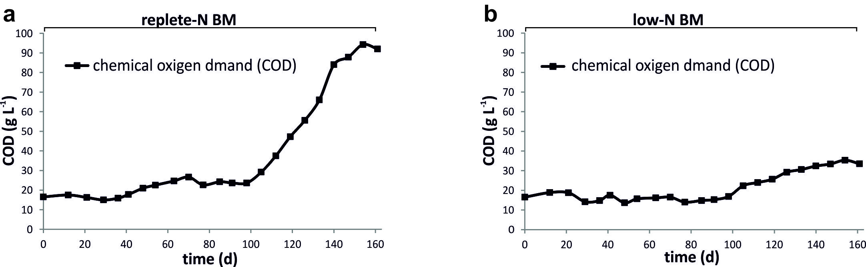

Figure S4: Concentration of chemical oxygen demand (COD) during the experimental time course in replete-N BM digester (A) and low-N BM digester (B). Measurements were performed in three technical replicates; error bars represent standard deviation (SD).

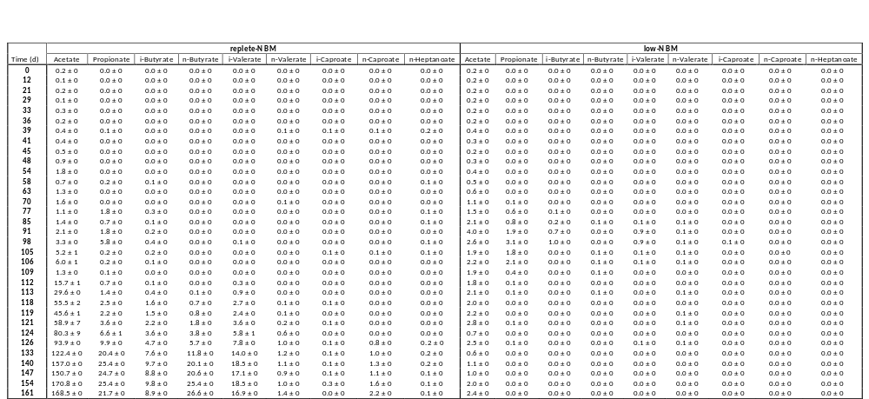
Table S1: Analysis of the volatile fatty acid (VFA) content during the time course of the experiment. The identification and quantification of the intermediate fermentation products (mM) was determined via GC-FID. The indicated error (±) represents standard deviation (SD, n = 2).

Table S2: Filtered sequences during amplicon processing. OTU=operational taxonomic unit, N=nitrogen, sd=standard deviation, OLR=organic loading rate, rep=replicate
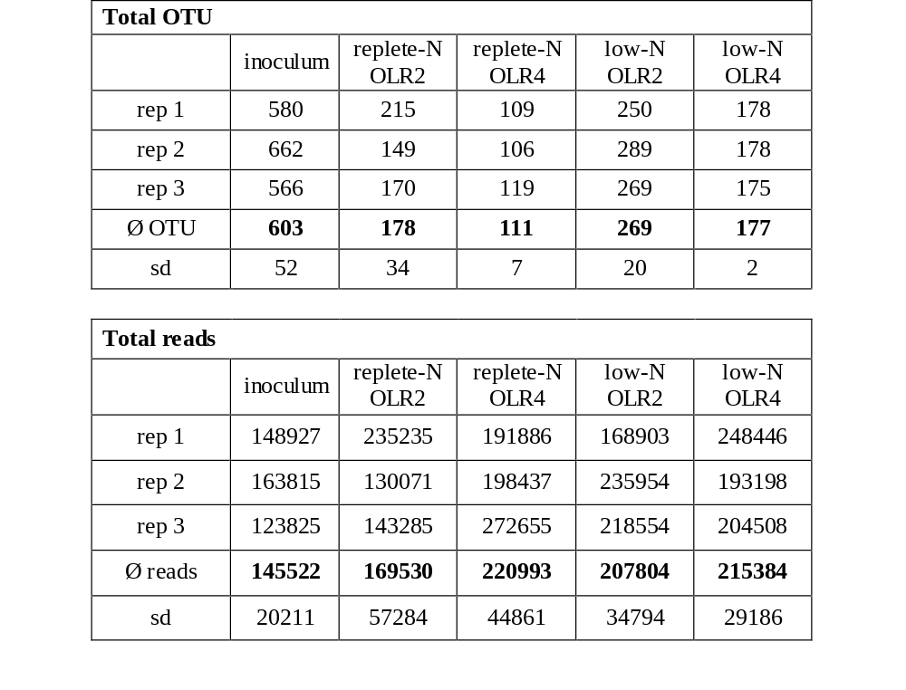

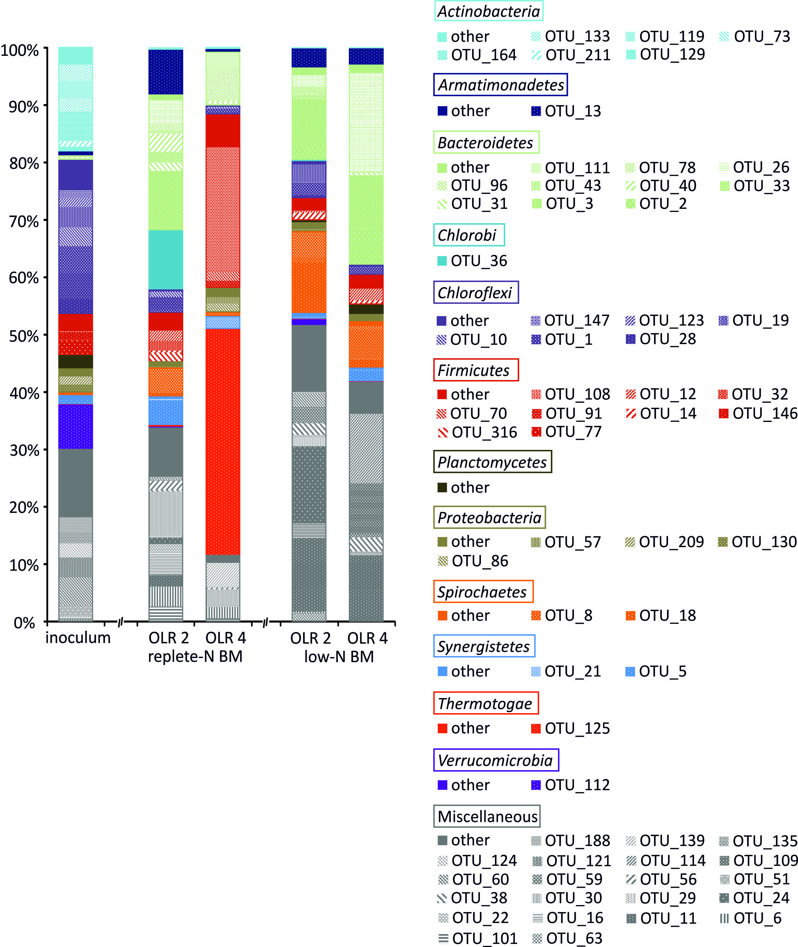
Figure S5: Bacterial diversity dynamics as assessed by high-throughput 16S rRNA amplicon sequencing and represented at the OTU level. The reactors, fed with biomass cultivated in media with replete and low nitrogen content (replete-N BM and low-N BM) were exposed to increasing organic loading rates of 2 and 4 g VS L⁻¹ d⁻¹ (OLR 2 and OLR 4, respectively). The inoculum and the sampling periods at the end of each OLR were chosen for microbial community monitoring.

