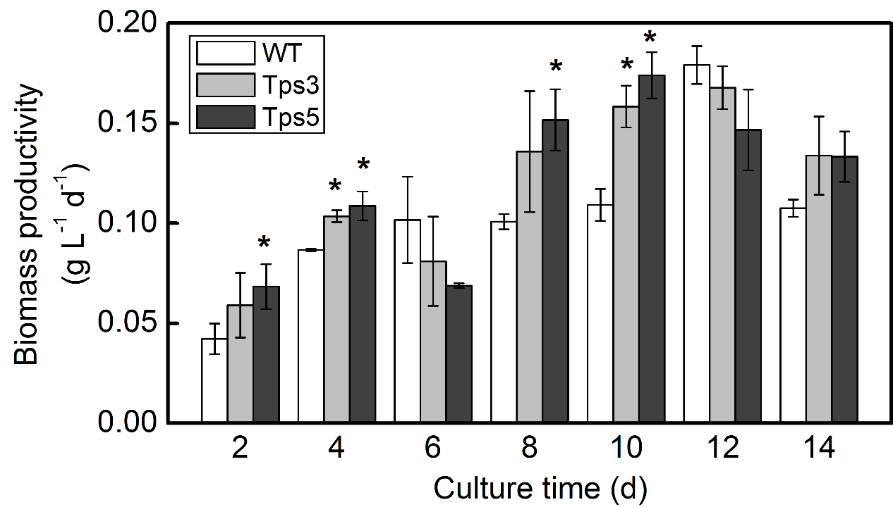
Fig. S1. Daily biomass productivities during cultivation of transgenic lines Tps3 and Tps5 and wild-type (WT) cells under controlled growth conditions (ambient CO₂ concentration and continuous light of 40 μmol m⁻² s⁻¹). Error bars represent s.d. (n=3). An asterisk shows significant difference from WT cells (t-test, *P<0.05).

